MELTING OF CONTAMINATED METALS FOR CLEARANCE AND RECYCLING, 30+ YEARS OF PRACTICAL EXPERIENCE
Arne LARSSON, Gregor KRAUSE, Maria LINDBERG, Roger MATSSON, Anders STENMARK
Cyclife Sweden AB, Nykoping, Sweden
Email: arne.larsson@cyclife-edf.com

Abstract

Treatment of contaminated metals by melting in Sweden started 1987 as a joint initiative by the licensee at that time (Studsvik) and the regulators in Sweden. Since 2016, the metal treatment facility is owned and operated by Cyclife Sweden, a company within the EDF Group.
Over the years the facility and the operations has developed, including extensions of the cutting and segregation areas, a larger furnace hall, installation of abrasive decontamination units as well as advanced equipment for treatment of large components. The treatment methods have been extended and enhanced over the years, as well as the type of metals possible to treat aiming for clearance.
The installation of the advanced mechanical decontamination technology in year 2000 increased the potential for clearance of contaminated metals after treatment significantly to the benefit of the licensees in the countries sending scrap metals and redundant large components to the Swedish facility for treatment. Their common objective has always been to reduce the amount of radwaste for disposal as radioactive waste. As an average, more than 95% of the metals sent for treatment have been subject to clearance.
One of the largest projects performed was the shipment of 15 Magnox boilers from the UK for treatment in Sweden. Other projects which have been discussed broadly are the PWR steam generator treatment campaigns.
The paper summarises the experiences from more than 30 years of operational experience, how the introduction of the waste hierarchy and focus on sustainability have affected the decisions within the nuclear industry etc. The paper will also discuss how to optimise the management of large components and scrap metals in power upgrade and decommissioning projects to make management of the contaminated materials even more sustainable and the projects more cost efficient.

INTRODUCTION
The waste treatment facilities at the Studsvik Technology Park outside Nykoping in Sweden has been in operation for several decades. The incineration facility was commissioned in 1977 and the facility for treatment of metals was commissioned in 1987, as a result of a joint initiative by the licensee at that time and the Swedish regulators. The overall aim of the treatment facilities was do reduce the volume of the waste to be disposed. Later on, environmental and sustainability aspects governed by the Waste Hierarchy has been added and are today very much in focus.
Initially the operations were conducted in small scale in an existing building. Over the years the facility and the operations has developed, the facility has been extended in several steps as described in the following chapters. The treatment methods have also been extended and enhanced over the years, both in terms of what can be welcomed for treatment and in terms of processing result. In the beginning only steel was welcomed for treatment, today most of the metals which exist in large quantities at a nuclear installation can be shipped for treatment.
Over the years more than 50,000 tonnes of metal have been treated aiming for clearance or volume reduction only. Most of the metals have been melted. For certain objects, or parts of objects, decontamination and clearance of the material in its original shape has been applied. The melting for volume reduction a small fraction of the total amount of metals treated, mainly the tube bundles from steam generators and other tubular heat exchangers with a high radioactivity inventory. A few components, including a BWR steam dryer, which have been melted just to reduce the volume and to homogenise and bind the radioactivity in the metal structure.
As an average, more than 95% of the metals sent for treatment have been subject to clearance.

The site and the facility
The Cyclife site at the Studsvik Technology Park contains treatment facilities, buffer storage areas for material to be treated and for residual waste to be return to customers as well as storage areas for metal ingots awaiting shipment to the metal industry, is in the process of clearance or is stored for the decay of Co-60. The site is accessible by road and by water. The later is important when large components are shipped for processing as exemplified in Figure 1.

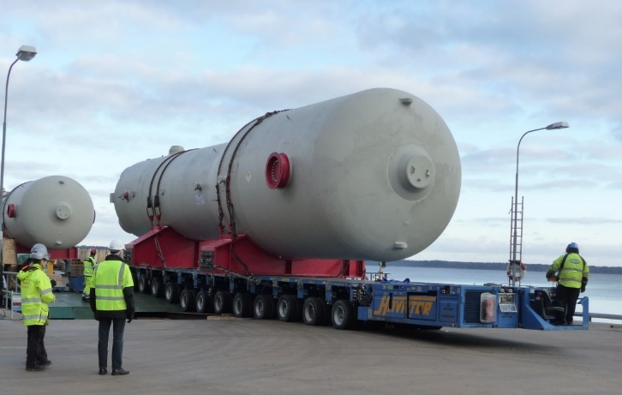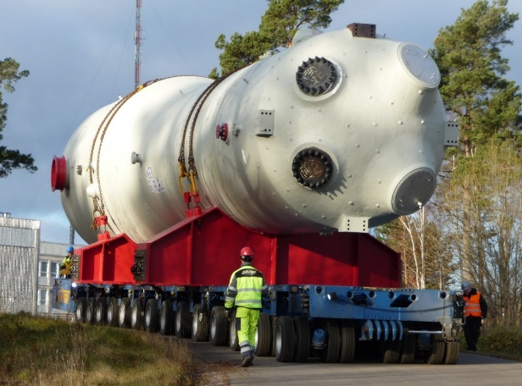
Figure 1. Steam generator unloaded from sea going vessel (left) and transported to the buffer storage (right).

The metal treatment facility was at the time of start-up in year 1987 a small scale operation. In 1994 the facility was extended with a segmentation hall. A major modernisation and extension of the facility took place in 1999 when a new furnace hall was built, mechanical decontamination equipment was installed and the old part of the facility was modernised. In 2007 the large component hall was commissioned. With the availability of this hall, large components could be process in a more efficient way.
The facility as it looks today, see Figure 2 can be divided into three main sections; (1) pre-treatment areas, (2) the furnace hall and (3) auxiliary areas.

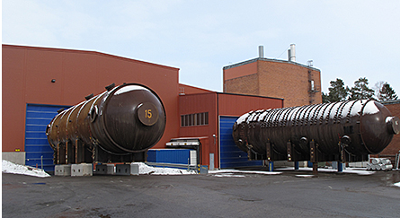
Figure 2: Boilers awaiting treatment outside Cyclife metal treatment facility.

The largest areas are required for the pre-treatment activities, i.e. disassembly and segmentation, sorting and segregation as well as decontamination. Even though mechanical disassembly operations take place, most objects are segmented by the cold or thermal cutting techniques available in the facility. The thermal cutting techniques are performed in a dedicated hall with a high retention of the air to keep the build-up of smoke at low levels. The facility is provided with a set of band saws of different sizes and other cold cutting equipment.
The furnace hall is the area where the actual melting takes place. The furnace hall is equipped with two induction furnaces, 3.5 tonnes each. The furnace technology used has been properly selected to secure a full homogenisation of the metal bath as well as to transfer some of the key nuclides and other impurities to the slag.
The auxiliary areas contain for example the different ventilation and filter arrangements, material storage areas, a workshop, a development hall as well as dressing rooms and offices for the staff.

the metal treatment process
The metal treatment process is utilising a well-structured multi-step approach with several lines of defence to secure that the material shipped for treatment can be processed in a safe manner, that the final treatment result will be forecasted with a high level of accuracy and that the metals are safely cleared and recycled back to the conventional industry. To meet these objectives, the approach includes several lines of defence, as described in the following sections.

The typical metal treatment process can be divided into the following steps
- Pre-shipment activities
- Shipment and arrival of material for treatment
- Pre-treatment operations
- Melting
- Post-treatment activities
- Reporting
- Return of residual waste

Figure 3 illustrates the main activities after the arrival of containerised material for treatment.
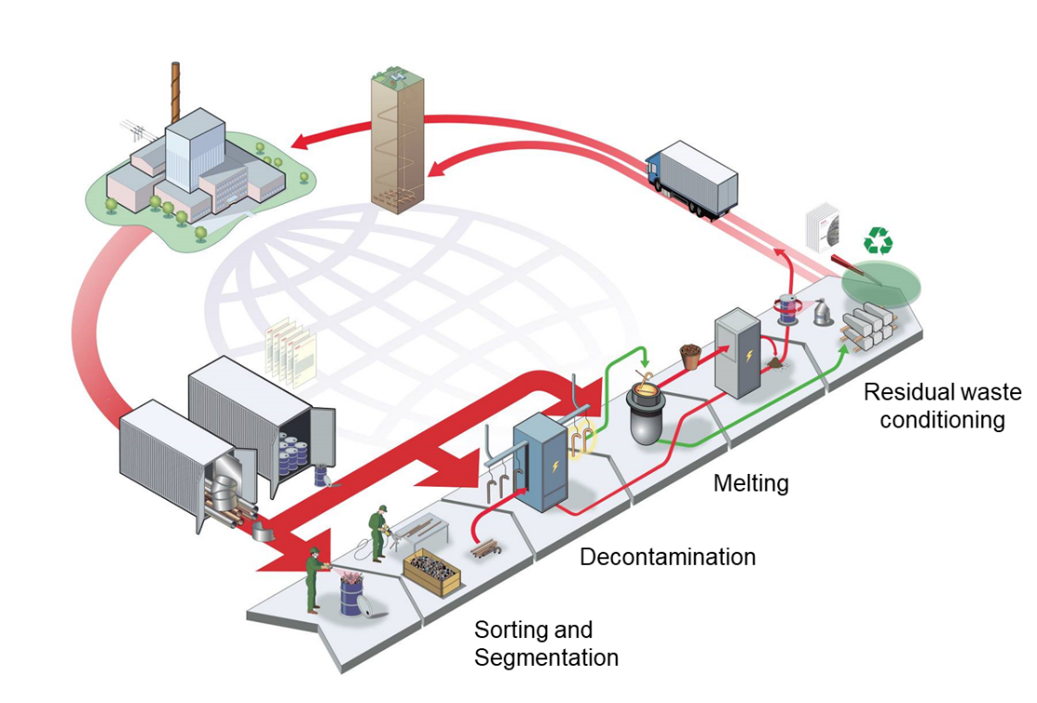
Figure 3: Schematic view of the scrap metal treatment process at Cyclife site.

Pre-shipment activities
The typical project starts with that a licensee who has redundant metallic material, or components which have reached end of life, contacts Cyclife. The potential customer is asked to provide radiological and physical data for the objects and to confirm that the material meet the Waste Acceptance Criteria for the melting services, see Figure 4. If so, a tender will be submitted for evaluation and further discussions. This is the first layer of defence.
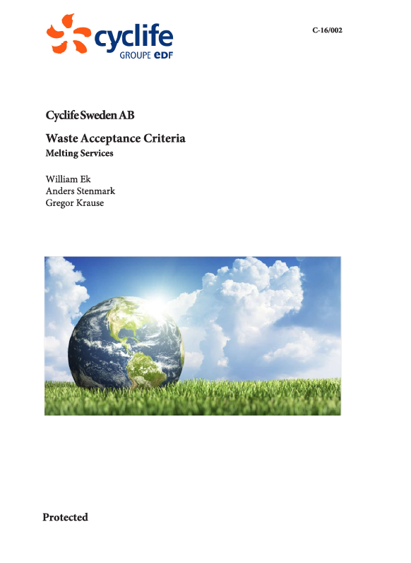
Figure 4: Cover page of Waste Acceptance Criteria for treatment at Cyclife

Prior to shipment, a treatability review of the detail data provided by the customer for the potential shipment of material will be performed by Cyclife. The data for the review and the review result is then the foundation for a written statement by Cyclife that the material is accepted for treatment. This is the second layer of defence.
Another important pre-shipment activity is to secure that all required licenses are applied for and achieved. Mandatory is also that the owner of the material to be shipped for treatment will sign the “waste return guarantee” to secure that all residual waste after treatment, i.e. all but the material subject to clearance for recycling, can be shipped back to the owner upon completion of the campaign. The waste return guarantee is to be counter signed by the competent authority in country of origin.

Shipment and arrival of material for treatment
The material for treatment is either shipped in ISO sea containers (or equal packages) or sent as large components. Depending on the radiological properties, the large components can either be shipped as they are or be wrapped in for example a tailormade tarpaulin.
The transport classification is in most cases SCO I to III (Surface Contaminated Objects) as per the transport regulations. Some material may, due to a very low activity content, not have to be classified.
At arrival and when applicable when opening the transport containers, the health physicists will perform verification measurements, see Figure 5. The inspections and measurements at arrival/start of treatment do serve as the third layer of defence.

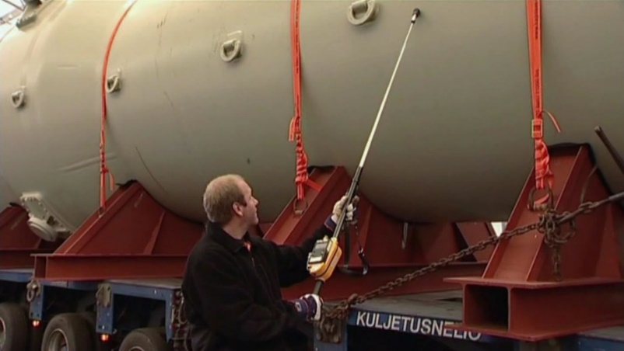
Figure 5. Arrival inspection of a large heat exchanger.

Pre-treatment operations
The set-up of the pre-treatment operations varies depending on the physical and radiological properties of the objects. It may contain disassembly and segmentation operations, segregation and sorting activities as well as different types of decontamination operations aiming to reduce the radioactivity concentration as well as to remove paint and other surface coatings from the material. Cold cutting and thermal cutting operations are exemplified in Figure 6.
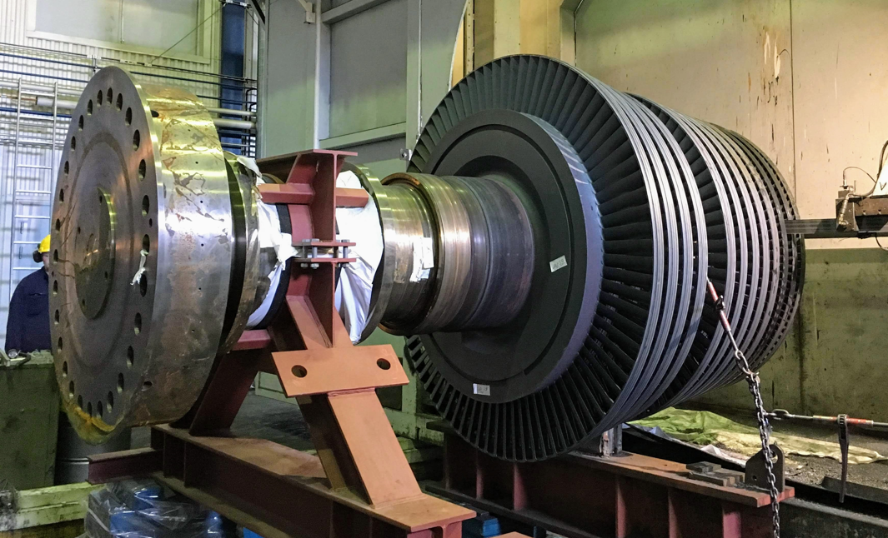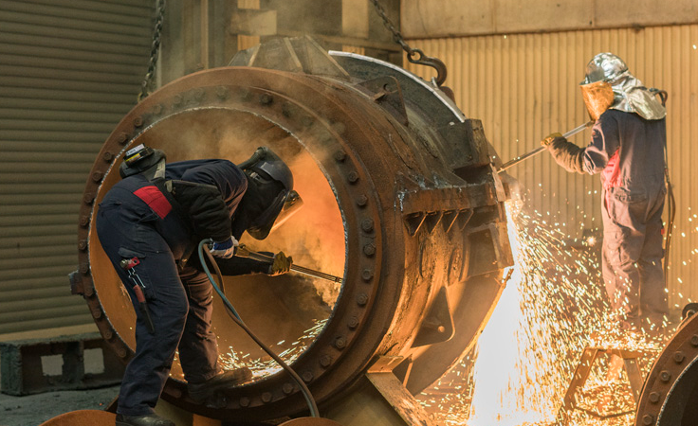
Figure 6. Cold and thermal cutting operations.

For certain key nuclides which alloy with the metal, like Co-60, the residual activity in the material must be reduced down below the clearance threshold values in the pre-treatment operations. Of this reason, the visual inspection and the verification measurements after the decontamination operations are essential, see Figure 7, do serve as a layer of defence.

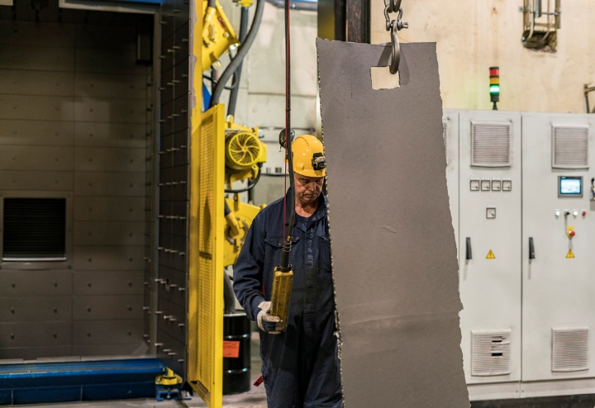
Figure 7. Verification of decontamination result.

Prior to releasing the material for melting, it is mandatory with a safety inspection to verify that the metallic objects do not contain any closed compartment. A closed compartment filled with water, or any other liquid, can cause very dangerous situations in the melting operations.

Melting
The melting in the induction furnaces within the facility homogenies the metal, makes certain key nuclides transfer to the slag or to the off-gas filters at the same time as it densifies the material. Prior to slag removal and casting of the molten metal, sampling is performed. Thanks to the stirring, the samples taken are proven representative for the whole melting batch. Figure 8 shows the sampling of the metal.

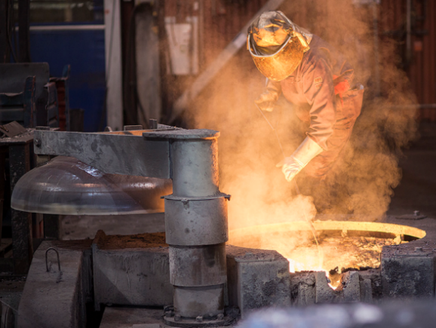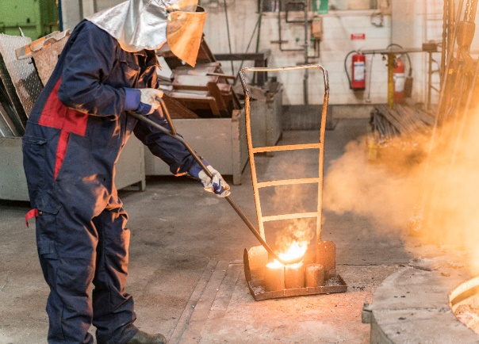
Figure 8: Sampling of the melting batch.

Post-treatment activities
The post treatment activities can be divided in to three parts, (1) management of the residual waste, (2) clearance of metal and (3) reporting.

Management of the residual waste
The residual waste from the treatment operations, as an average approximately 5% of the initial weight, is collected, packed into drums or other suitable packages. The measured content of gamma emitting nuclides, dose rate, weight and filling level in the package are recorded.

Clearance of metal
Thanks to the sampling during the melting process, each melting batch get a set of fully representative samples. Those samples are after the initial preparation sent to the on-site laboratory for analysis of the gamma emitting nuclides, alpha emitting nuclides and, when required, selected pure beta emitters.
The results from the analyses are then together with the specific nuclide vector used for the assessment of the total remaining radioactivity in the ingots. If the activity concentration is below the threshold values, the ingots will become subject to unconditional or conditional clearance for recycling back to the conventional industry for manufacturing of new products. This is the second last layer of defence.
Prior to finalization of the clearance process, the ingots will be surveyed with regards to surface contamination. The measurements are also indirectly confirmation measurements that the ingots do not contain elevated concentration of radioactivity and do by then serve as the final layer of defence.

Reporting
The treatment campaign is recorded in a comprehensive treatment report, which describes the operations performed, radiological and physical data for the ingots produced and the residual waste generated. The report is the foundation for the preparations of the repatriation of the residual waste and the closing of the treatment campaign.

Return of residual waste
Any material belonging to the shipment of material that is not subject to clearance, is to be returned to the customer for interim storage and final disposal. As mentioned above, the amount of residual waste is as a global average in the order of 5% (weight). For material sent as “ready for melt”, the amount of residual waste is estimated to be lower.

BENEFITS with treatment for CLEARANCE by Melting
Melting of contaminated metals aiming for clearance brings several advantages and is considered to be a proven and robust method to convert a liability to an asset. Below are a few examples of the benefits listed.

More metal can be subject to clearance and recycling instead of being isolated
Thanks to the separation of certain critical radionuclides, lower uncertainties and to certain extent the higher clearance threshold values, more metal can become subject to clearance (in comparison with clearance of the material as is).

Separation of critical nuclides
In the steel melting process, certain key nuclides as the alpha emitters, Cs-134/137 and Sr-90 will separate from the metal and are captured either in the slag or in the off-gas filters. In many cases, this separation of certain nuclides in the melting step is in many cases the only way to make the material subject to clearance.

Representative sampling and high precision analysis
Thanks to the stirring in the induction furnace, it is well demonstrated that sampling from the molten metal is fully representative for the entire melting batch. In addition, the samples with a fix geometry allows for high precision analysis for clearance. This together gives significantly lower uncertainties, and by then a larger “clearance window”, compared to other clearance options.

Homogenisation of the residual radioactivity in the metal matrix
The homogenisation of the residual activity in the matrix will keep the dose rates from the ingots in the further handling very low. Compared to all activity on the surface, homogenisation gives a dose rate from an ingot which is about seven times lower.

Minimisation of radioactivity release during the further handling and melting of the metal
In comparison with surface contaminated material which has been released, there is a significantly lower risk for spread of or concentration of radioactivity during the handling of material prior to it is melted again.
Since the radionuclides which separate in the metal melting process already have been separated from the metal when the material is melted in the Cyclife furnaces, there should be no concern for any increase in activity concentration in the slag or the off-gas when the material is melted for fabrication of new products.

case studies
Hundreds of metal treatment projects have been conducted in the metal treatment facility which now is owned and operated by Cyclife Sweden. Below are a few key reference projects summarised.

Magnox boilers and gas ducts
Studsvik (today Cyclife) was awarded a contract to transport 15 decommissioned Magnox boilers, each 310 tonnes, from the Berkeley Nuclear Licensed Site in the UK to Sweden for metal treatment and recycling, see Figure 9.

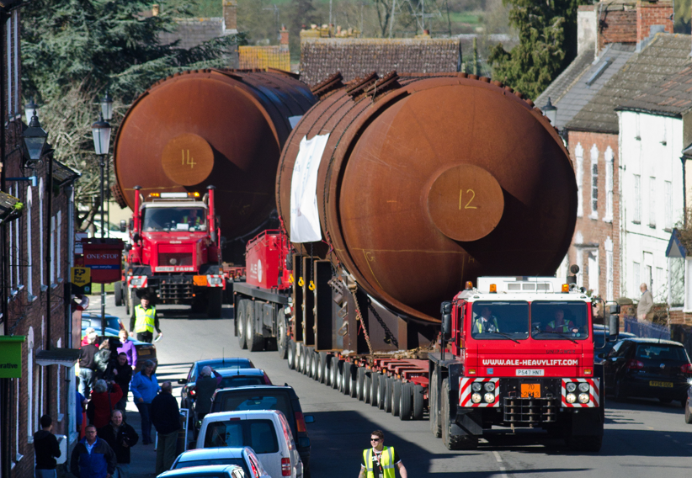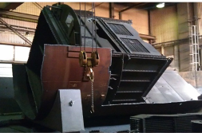
Figure 9: Transport of Boilers (left) and partly segmented boiler (right).

TABLE 1. Treatment results – Berkeley Boilers

Treated units | Initial weight each unit | Initial volume  each unit | Waste for final storage each unit | Recycling  each unit | Waste for final disposal  each unit
15 | 310 t | 600 m³ | 8 m³ (1.3 %) | 296 t | 19 t (6%)

Cyclife was in 2018 awarded a contract to transport 820 tonnes of gas duct assemblies from the Magnox Site Chapelcross to Sweden for metal treatment and recycling, see Figure 10. The gas ducts are connecting the reactor with the boilers.

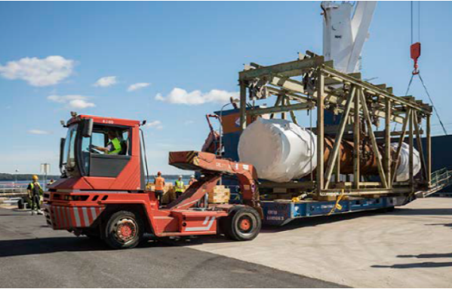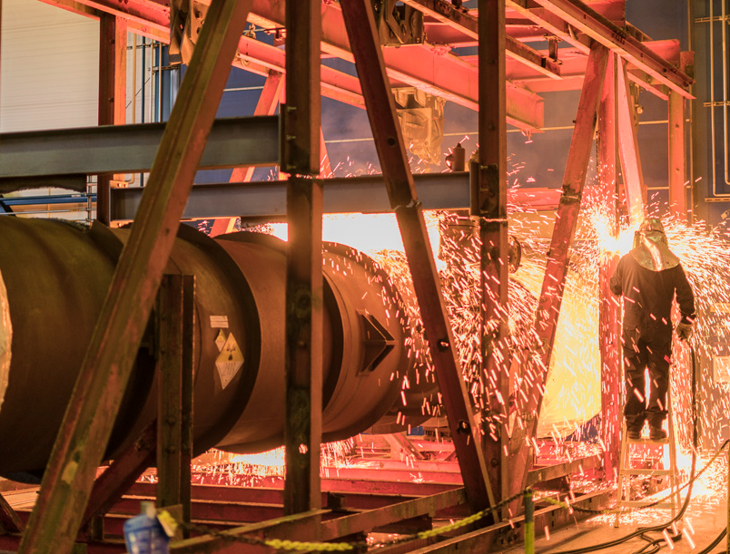
Figure 10: Transport of Top Gas duct (left) and segmentation of gantry (right).

TABLE 2. Treatment results – Chapelcross top ducts

Tonnage processed  in Sweden | Waste for return | Ingots subject to recycling | Recycling rate in the melting process
765 t | 61 t (8%) | 98.4% | 96.4 %
Remark: Materials not subject to melting (insulation etc.) are included in the waste for return numbers.

NPP Ringhals steam generators
A unique technical concept for treatment of PWR steam generators has been developed by developed by Cyclife. In total 9 steam generators have been replaced at the Ringhals NPP. All those steam generators have been shipped to Cyclife for treatment. Six of those were decayed on NPP site prior shipment. The remaining 3 arrived shortly after the steam generator exchange project. The projects resulted in significant volume reduction and weight reduction. More than 70% of the initial tonnage became subject to clearance and recycling. The residues were well conditioned in packages for interim storage and final disposal. The majority of the waste for disposal was the volume reduced tube material.

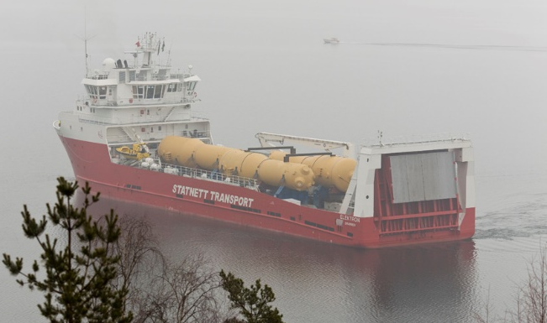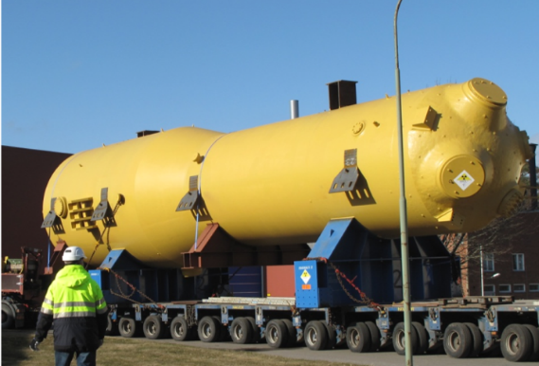
Figure 11: Arriving vessel with 3 steam generators (left) and SG outside the treatment hall (right).

NPP Forsmark 1-3 turbine island components
The three NPPs Forsmark were modernised and upgraded some years back. One part of the program was the upgrade of the turbine island on all three stations. A large fraction of the replaced large, contaminated components, including turbine parts, heat exchangers etc., was shipped to Cyclife for treatment. In total 1 320 tonnes were shipped for treatment resulting in a clearance ratio of 95%, i.e. only 5% of the initial mass had to be sent to the final repository for disposal.

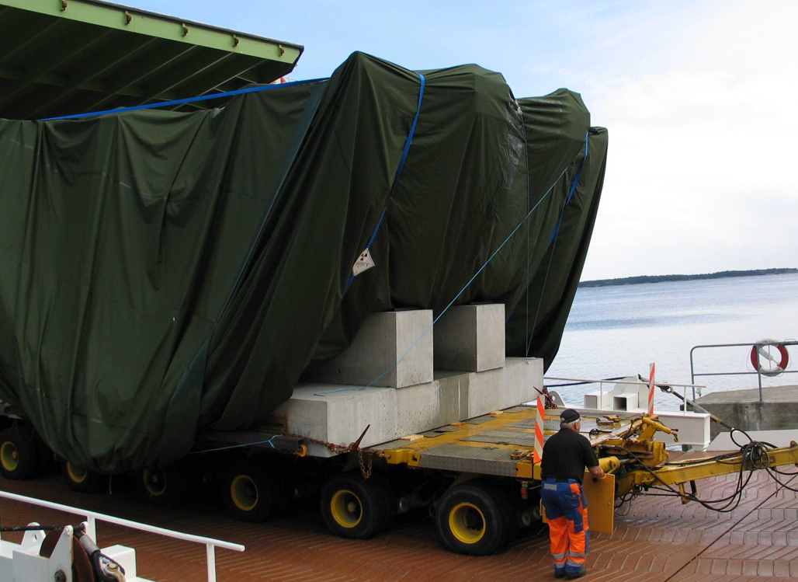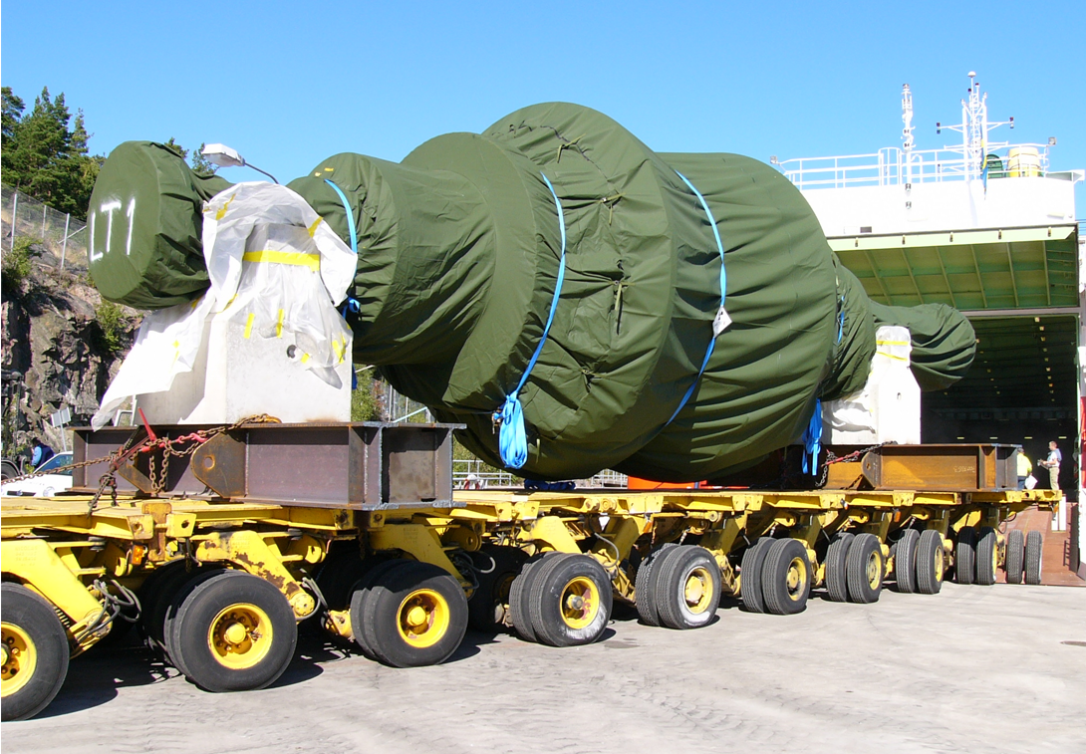
Figure 12: Arrival of BWR turbine casing and turbine rotor for treatment.

Large components and containerised scrap metal from NPP Würgassen
During the decommissioning of the NPP Würgassen in Germany, several thousand tonnes of contaminated metals has been sent to Cyclife for treatment. Most material has been shipped in ISO containers but also large components like turbine casings have been shipped for treatment, see Figure 13, and heat exchangers. After treatment including segmentation, decontamination and melting, almost all metal has been the subject to clearance, either directly or after a limited decay storage.

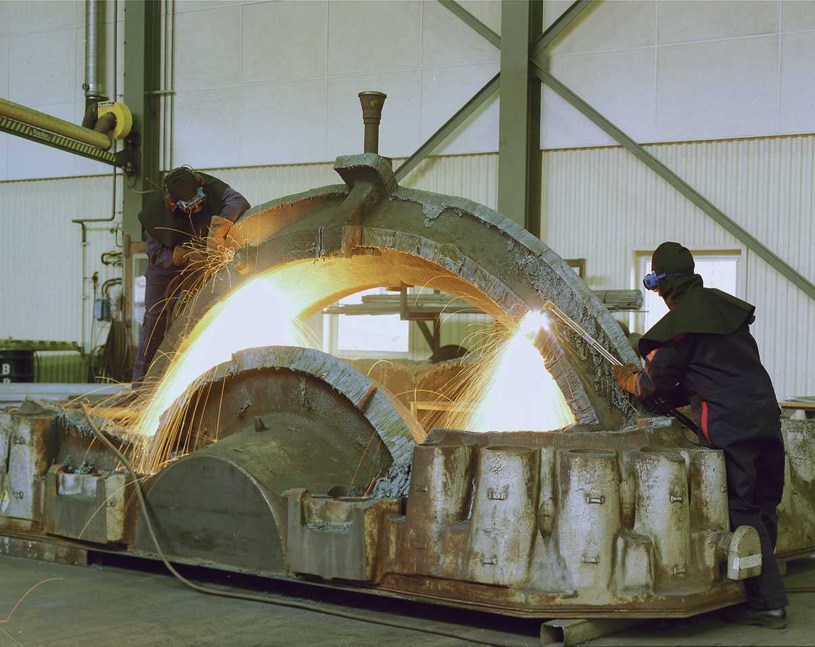
Figure 13: NPP Würgassen turbine casing during segmentation at Cyclife site.

discussion
The decision more than 30 years ago to build up a metal treatment facility on the Studsvik industrial site in Sweden with the ambition to recycle the metal instead of disposing it must be considered spot on. The metal processing services has been beneficial for many owners of nuclear installations throughout Europe, not at least when facilities are to be modernised or decommissioned. The records from more than three decades of operation, shows that treatment of metals aiming for clearance by abrasive decontamination and melting is a safe, efficient and robust process. The possibility to forecast the results is high, not at least thanks to the experience built up.
With the good possibility to forecast both the result and the cost for treatment, it is easy to make a cost benefit analysis and comparison with alternative treatment processes and with direct disposal. History tells that the costs and risks related to the alternatives to clearance, in many cases have been underestimated. In most countries, both the qualification and the disposal of radioactive waste is a complex and costly process. Of that reason, any material which can be decontaminated to reach clearance leads to, in many countries, to a cost and risk reduction.
A metal treatment campaign, aiming for clearance of the metal, can be done in alternative ways. An approach generating the lowest amount of residual waste for disposal is typically more costly than an approach generating somewhat more waste for disposal. It’s therefor of importance that the customer has analysed the marginal waste cost and in confidence communicate it with the supply chain. This to guide Cyclife and other processing companies in the tailoring of the most beneficial treatment concept.
Finally, the positive message sent to the stakeholders when a liability (radioactive waste for disposal) is converted to an asset (metal for manufacturing of new products), leading to a reduction of the final disposal volume as well as an alignment with the Waste Hierarchy should not be underestimated.

conclusions
The nuclear industry’s demand for environmentally sound and cost-effective management of all kinds of contaminated scrap and components is becoming increasingly important. The NPP upgrade programs as well as the strategy for immediate decommissioning applied by an increasing number of utilities are creating additional requests for effective off-site waste treatment facilities.
Through systematic development of treatment technologies, Cyclife has established a technological sector for treatment of contaminated metals aiming for clearance and recycling back to the conventional industry.
Clearance and recycling of metals and other back-end materials originating from the nuclear installations is an important part of the demonstration of the nuclear industry implementation of the waste hierarchy and a circular approach.

