Hot Resin Compaction

Tobias Unfried
NUKEM Technologies Engineering Services GmbH
Alzenau, Germany
Email: tobias.unfried@nukemtechnologies.de

Abstract

Ion exchange resins (IEX) which are used in nuclear power plants have to be treated and dried, in order to ensure a safe storage in future. A main advantage of the hot resin compaction during mentioned treatment process, is the saving of limited storing capacities in comparison to non-compacted IEX based on the enlarged volume reduction factor (VRF) of compacted IEX. Supplied and temporarily stored IEX have to be transported as IEX / water mixture by piping systems and pass various treatment steps as part of the conditioning process. Some of these processes are necessary preparations for hot resin compaction. Mentioned preparations includes for example the grinding of resins via mill. The grinding process is necessary in order to avoid a possible spring-back effect of the IEX. The mentioned effect can cause the IEX to return into their original form which leads to deformation and expansion of compacted pellets. Ground IEX are transported to be dried before they are filled fully automatically into a compactable drum. Afterwards, the drum has to be transferred to the high force compactor (HFC). After entering the high force compactor, the drums are compacted before the resulting pellets are going through the last process steps as part of their treatment and subsequent storage. Various test series were necessary to adjust the individual process steps and develop the overall process. The hot resin compaction as a part of the waste conditioning and the executed test series are described more in detail in the paper. Based on experiences and successful design, the hot resin compaction process was successfully implemented in Tianwan, People´s Republic of China by NUKEM Technologies Engineering Services.

Introduction
Ion exchange resins exists as cation and anion exchanger. Nuclear power plants use IEX to ensure water and steam with a high purity to avoid corrosion and incrustations inside the nuclear power plant. The spent IEX must be treated as a part of radioactive waste conditioning in order to enable a volume reduced storage. The following chapter describes the spent IEX treatment in principle.

Spent Resin Treatment Process
Spent ion exchange resins were supplied from power plant transported to the treatment center and temporarily stored in receiving tanks. The transport can be for example fulfilled via special transport trucks or pipelines. An IEX to water ratio of approximately 1 / 1 has to be set for the further process and to ensure the transportability via pipelines. The mixture can be adjusted by using sieves which are included in the receiving tanks. The mixture has to be transported by piping systems to the grinding process via mill. This process is necessary in order to avoid a possible spring-back effect of the IEX after compaction. The mentioned effect can cause the IEX to return into their original form which leads to deformation and expansion of compacted pellets. Afterwards, the finally ground IEX which are stored in buffer tanks must be dried. Therefore, the ground IEX has to be transported via pipes to the drying system. During the drying process, free water is evaporated before the IEX must be further dried until reaching the required residual moisture content. The dried and still hot IEX are filled fully automatically into a compactable 165 L steel drum. The filling device connects the dryer with the mentioned steel drum and ensure a dust free emptying. Afterwards, the drum has to be transferred to the high force compactor, where it is compacted. The transport can be fully automatically fulfilled via conveying system. The resulting pellets are transported to the pellet optimizing station by crane and gripper. The pellet optimizing station is used to ensure the best possible and most compact filling of the 200 L storage drums for pellets. The optimization is done via parameter measurement like height and weight of the pellets. Afterwards they are filled into 200 L storage drums, can be radiological measured and transported via roller conveyors to the cementation unit. After grouting, lidding and curing of the storage drum it will finally passed on to the storage.

Spent Resin Test Series
An efficient compaction of hot spent ion exchange resins is based on previous process steps which have an effect on the compaction and its resulting pellets. The following chapter describes the carried-out test series with bead cation exchange resins in unladen condition.

Test series and parameters
Various tests were carried out as a part of the process design and engineering for the spent ion exchange resins compaction. The specified test series included for example:

- Drying tests.
- Compaction tests.
      - Compaction in test-size scale;
      - Compaction in full-scale tests.

During compaction tests in test-size scale, a factory press with a maximum attainable press capacity of F= 50 t were used. The used ground bead cation exchange resin has to be compacted into a self-constructed compression mould with an inner diameter of dinner= 80 mm afterwards. An example of a compacted and stable pellet is shown in Fig. 1. The IEX was used in unladen and inactive condition.

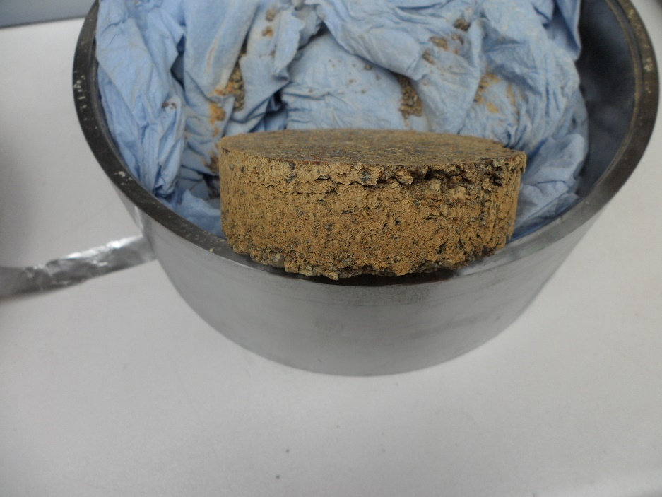
FIG. 1. IEX Pellet – test-size scale.

Full-scale tests with bead cation ion exchange resin in 200 L steel drums were realised via the high force compactor (HFC) with a press capacity of F= 20000 kN which is designed and successfully used at the radioactive waste treatment centre in Tianwan, People´s Republic of China. See Fig. 2.

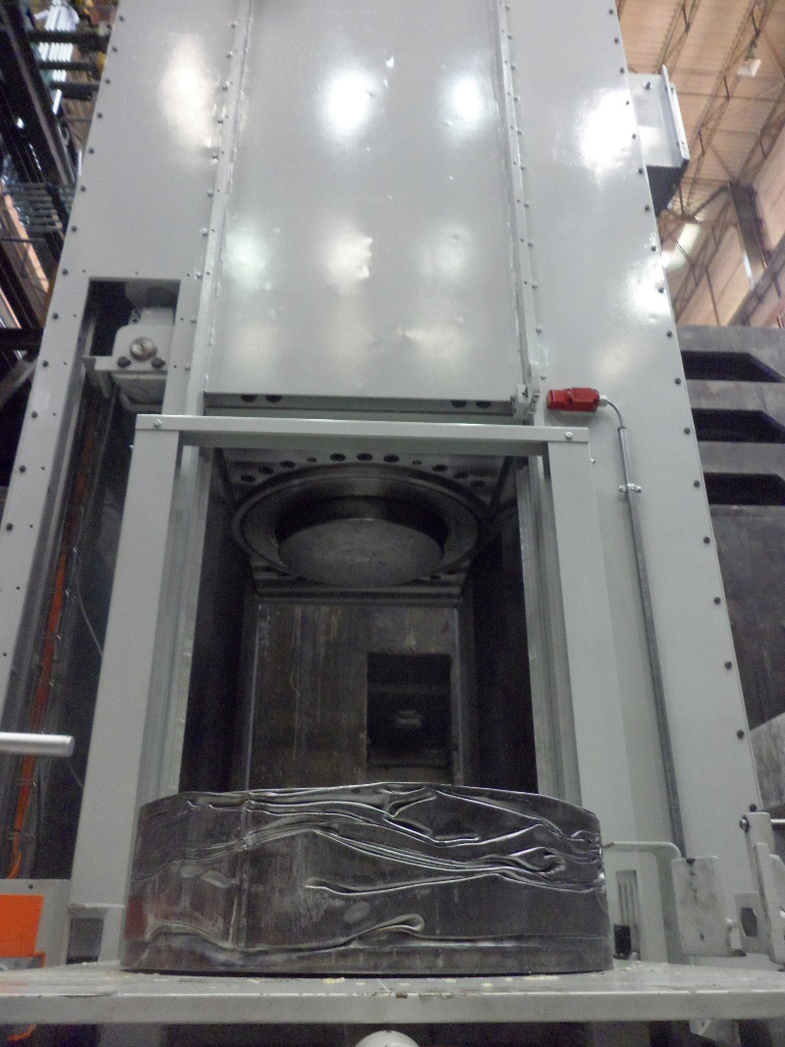
FIG. 2. IEX pellet and HFC – full-scale tests.

Full-scale tests were fulfilled with the same bead cation IEX type which was used during test-size scale. Different test parameters were determined for various test series to ensure comparable results. The specified test parameters included for example:

- Drying tests.
      - To obtain dried IEX with required residual moisture content.
- Compaction tests.
      - To analyse a possible spring-back effect after compaction;
      - To analyse the IEX characteristics after compaction;
      - To analyse the behaviour of renewed moisture absorption after compaction;
      - To analyse the volume reduction factor during different test series.

Test series results
Finally ground IEX were dried during different drying tests via conical dryer. The IEX were dried until a residual moisture in a range of 2 % w/w to 3 % w/w but smaller than 4 % w/w. The lowest residual moisture achieved was around 1.5 % w/w. The moisture content of the ground cation IEX was detected with an analytical balance which includes a moisture measuring device during test series.

Compaction test series were executed in test-size scale and full scale. During test-size scale, a compression mould was used with an inner diameter of d_{inside}= 80 mm. Only the ground and dried IEX was compacted in test-size scale. Full scale tests were executed in 165 L steel drums. The filling degree of mentioned drums was in a range of 15 % up to 33 %. Following Table 1 shows one test run for each test scale.

TABLE 1. TEST SERIES DATA

No. | Test series type | Test-No. | V_{bulk freight}  [L] | V_{pellet}  [L] | VRF | ϑ_{resin} [°C] | t_{press}  [min.]
1 | Test-size scale | V 4.4 | 0.186 | 0.128 | 1.45 | 139.7 | 10
2 | Full-scale test | C48 | 54.07 | 37.36 | 1.45 | 108 | 10

The volume reduction factor (VRF) is calculated by V_{bulk freight} / V_{pellet}. Minor inaccuracies of the shown VRF have to be taken into account. Minor inaccuracies can be based on rounding errors or measurement inaccuracy of the IEX inside the compression mould and drum. The VRF of shown test series are comparable. The compaction time is also equal. The resin temperature at the beginning of the compaction process differs to each other. The main reason for temperature differences is the longer needed time to remove the IEX out of the heating cabinet and preparation of the compaction process during full-scale tests.

During the carried-out test series, pellets were cut open in order to analyze the compacted IEX. See Fig. 3.

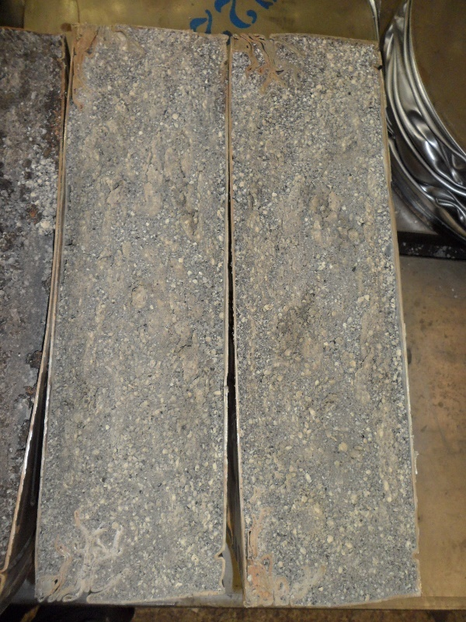
FIG. 3. Cut pellet.

The pellet shows a homogenous distribution of the IEX. No significant free space is visible.

In addition, tests were carried out with IEX which had a significantly higher residual moisture than 4 % w/w. IEX of two different drying batches were chosen.

- Residual moisture content Batch 1: 24.5 % w/w;
- Residual moisture content Batch 2: 16.2 % w/w.

After compaction process, the pellet and HFC were examined. The water leakage is shown in Fig. 4.

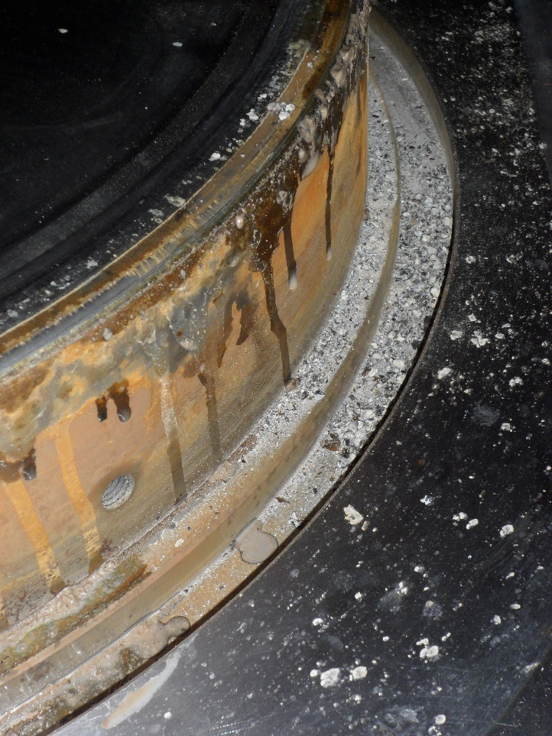
FIG. 4. Water outlet out of pellet.

With reference to the subsequent grouting and storage, this experiment demonstrated the importance of a low residual moisture content inside the IEX.

Another important test was the verification that the previous grinding process has a positive effect on preventing a renewed growth and analyze a possible spring back effect. Therefore, a pellet was stored in water to investigate a possible renewed expansion of the pellet. The pellet was completely covered with water. The results are shown in Table 2.

TABLE 2. WATER STORAGE RESULTS

Day | Time of measurement | h_{pellet}  [cm]
1 | 2:10 pm | 12.5
2  5 | 9:45 am  9:05 am | ~ 13.0  ~ 13.0

An increase in height of approximately 0.5 cm was measured during storage in water. This difference can also be attributed to a slightly different measurement point, as the marking slightly blurred in the water. The test result shows that there was no significant increase in height based on a renewed water absorption of the IEX.

Hot REsin compaction
The following chapter shows the successful design, installation and commissioning of hot resin compaction based on results and received information during normal operation in the treatment centre for radioactive waste in Tianwan, People´s Republic of China.

Spent Resin Treatment requirements and normal operation
The results and findings of executed test series served as an essential basis for the design, installation, successful commissioning and normal operation of spent resin treatment, to ensure a volume reduced waste storage. In particular, the findings from grinding, drying and compaction test series had an important effect on the decisions which are made during the technical design stage. The following Table 3 describes a selection of current set points for normal operation of spent ion exchange resin treatment in the treatment centre in Tianwan, People´s Republic of China.

TABLE 3. Selected set points for normal operation

No. | Type | Set point | explanation
1  2  3  4 | IEX / Water mixture  Coarseness setting of ground IEX  Residual moisture content of dried IEX  Compaction Time | Ratio around 2 / 3  d₅₀  content range about 2 - 3 % w/w  10 min. | The IEX / Water mixture is adjusted before grinding. Adjustment of the ratio based on changed d₅₀ value  The d₅₀ was adjusted on site  The process is adjusted. No sampling necessary to measure the residual water content. The process finish based on stop criterion settings  Compaction in automatic mode

Mentioned set points are necessary to avoid a possible spring back effect and ensure a safer and volume reduced storage in future. The results are shown and described in following chapter 3.2 Results.

Results
Since end of 2019, the volume of 28.3 m³ spent ion exchange resins has been treated in the treatment centre in Tianwan, People´s Republic of China. The volume of the IEX is measured and calculated inside the spent resin receiving tanks which are used as an intermediate storage for the received IEX / water mixture.

185 pellets were produced by the high force compactor. The average height of the pellets is around 40.0 cm. Two pellets of compacted 165 L steel drums were filled into one 200 L steel drum. The pellet optimizing device is used to ensure an optimally packing of the pellets into the 200 L steel drums before grouting, as one of the last process steps before Customer handover.

The volume parameter of 200 L steel drums is 18.5 m³. This value based on the fact that 185 pellets were compacted, and two pellets were filled into a 200 L steel drum which has a volume of 0.2 m³. The VRF is afterwards calculated as follows.

$$VRF= \frac{V_{start}}{V_{end}}$$

$$VRF=\frac{28.3 m^{3}}{18.5 m^{3}}=1.53$$

The volume reduction from received amount of spent IEX (V_{start}) to the conditioned amount of waste which are stored in 200 L steel drums (V_{End}), represents the VRF. The average achieved VRF is 1.53. Please see following Fig. 5 for a compacted pellet from normal operation on site.

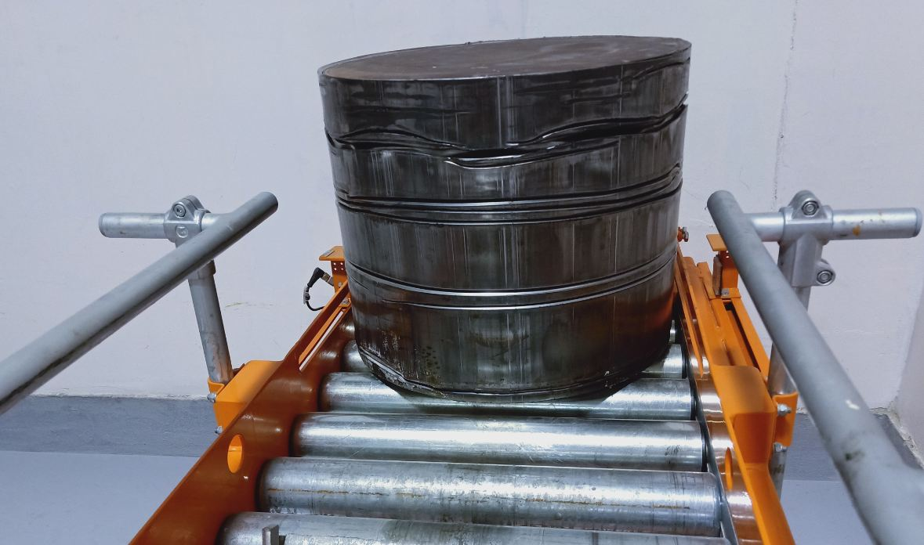
FIG. 5. IEX pellet during normal operation

Process limitations and outlook
Despite the successful implementation of normal operation, essential experience was recorded during previous test series, commissioning and operation. These experience shows limitations and potential for optimization in order to improve the process from planning until operation on site.

Experience in practice during grinding, drying and discharging has shown that the type of used IEX (in relation to the manufacturer as well as the type of IEX itself) can have a possible impact on the process parameters to be set and its process results. Mentioned process parameters are for example changed circulating pressure inside the mill. The earlier it is known which IEX has to be treated on site, the sooner future adjustments can possibly avoid. In best case, IEX which are used in the power plant, can be used in unladen state during test series and commissioning as well. This must be especially taken into account in case of increased personnel placement during hot start-up or normal operation.

The selection of components such as the type of measuring instrument with reference to the measuring principle or the type and material of gaskets can be improved based on experience. With view to future activities in IEX treatment, test series with a changed IEX / water ratio can be considered. It is important to test the transportability of the IEX through the pipelines and possible impacts on the grinding process and its results. Furthermore, a lower amount of free water reduces the drying process in case if this change will be possible regarding mentioned prior process steps.
ACKNOWLEDGEMENTS
I would like to take the opportunity to thank the contact person of the Customer from in Tianwan, People´s Republic of China for the support to prepare the paper based on provided data and information from operation on site.

