# Characterisation of radioactive boundary

# wastes; a bayesian solution

P. HILLER

National Nuclear Laboratory

Warrington, United Kingdom

Email: peter.hiller@uknnl.com

C. PYKE

National Nuclear Laboratory

Warrington, United Kingdom

K. YOSHIKAZU

Japan Atomic Energy Agency / International Research Institute for Nuclear Decommissioning

Tokyo, Japan

O. KEIICHI

Japan Atomic Energy Agency / International Research Institute for Nuclear Decommissioning

Tokyo, Japan

**Abstract**

Bayesian statistics is highly complementary to the Data Quality Objectives (DQO) approach due to their underlying iterative principles. For waste characterisation this provides an opportunity for greater information for decision makers when analytical data approaches a waste boundary. The Bayesian t-test is analogous to the current statistical approach advised by CL:AIRE (Contaminated Land: Applications in Real Environments) with the benefit of more completely using Prior information and allowing for the introduction of adaptive sampling strategies based on developing knowledge. This iterative approach provides a more fully underpinned justification for sampling numbers and provides increased flexibility for the DQO team than the more traditional statistical approach. Developed in a UK regulatory context and translated to a specified waste stream (fallen trees) from the Fukushima Daiichi Nuclear Power Station, this paper demonstrates potential benefits of this methods for a waste nearing the characterisation boundary and shows how the approach can be used to support decision making on radioactive waste disposal in a global context.

## INTRODUCTION

### Disposal of Radioactive Waste in the UK

The disposal of radioactive waste requires the waste to be characterised sufficiently to allow the most appropriate route for disposal to be determined. In the UK, there are four broad categorisations of radioactive waste. These are shown in Fig. 1. This shows the waste disposal categories, where the treatment of waste per unit volume becomes increasingly more complex and expensive the higher the waste categorisation.

The strict limits specified [1] for the categorisations of very low level waste (VLLW) and low level waste (LLW) require statistical evidence, from sampling and hypothesis testing [2]. This is relatively simple for waste well below the boundary limits (e.g. where the average is much less than 200 Bq/g for VLLW or much less than 4 Gbq/t total α and/or 12 Gbq/t (total βγ for LLW). However, for wastes that appear to be much closer to the boundary, planning for a sampling campaign requires a balance of judgement between the cost of sampling and likelihood and benefit of demonstrating that the waste is acceptable for disposal in the lower category.

Such decisions on sampling campaigns typically require a decision-making framework, and because of the closeness with environmental monitoring the Data Quality Objectives (DQO) approach developed by the United States of America’s Environmental Protection Agency (US EPA) [3] is naturally used to plan such projects.

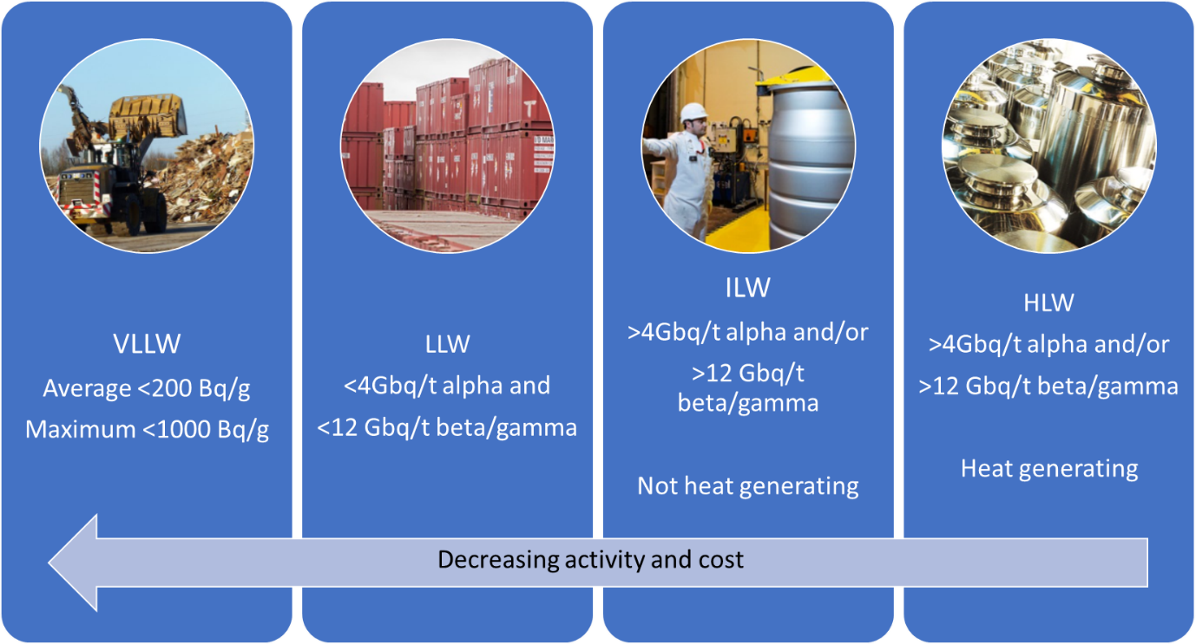

*FIG. 1 Waste Categories (UK)* [1]

### Fukushima Waste Management, Japan

Our case study arises from engagement with the Japanese Atomic Energy Authority (JAEA) in their pursuit of the decommissioning of Fukushima Daiichi Nuclear Power Station (NPS), owned by Tokyo Electric Power Company Holdings Inc. (TEPCO). Decommissioning and works completed to date have resulted in a large amount of radioactive waste [4]. Concerning waste management, TEPCO is intently working on safe storage including dehydration of secondary waste from water decontamination as well as on volume reduction of combustible waste by incineration. In parallel, research and development (R&D) for future processing and disposal of the waste is in progress. To provide essential information with respect to waste properties for R&D, radiochemical analysis has been carried out [5].

The long-term management approach to safely manage the waste originating from the severe nuclear reactor accident has not yet been established. To explore appropriate methodologies to support the development of sampling and waste management strategies, some of the waste has been explored using the UK context. The waste presented here is for fallen trees.

This has provided a unique opportunity to revisit the standard approaches used within the UK and explore recent advances in complementary methods.

## methods

### DQO and the challenge of chasing p-values

The DQO process that uses systematic planning and data review to guide sampling strategies for a wide range of purposes. The DQO methodology was originally developed by the USEPA as their recommended planning process when using data to select between two opposing conditions (such as in decision making) [3]. As such it is commonly used for waste classification. It is used here to demonstrate the decision-making process.

Fig. 2 shows a generalised flow-diagram outlining a DQO type framework for waste management. The yellow diamonds show where decisions must be made about whether there is sufficient information already available to categorise the waste as <VLLW or <LLW. This is usually supported by statistical hypothesis testing of the available data using Frequentist statistics, which returns a p-value (probability that the difference observed has occurred by chance). If the p-value is less than 0.05 then this is usually accepted by stakeholders as sufficient evidence that the waste is less than the specified boundary. However, when the p-value is small (e.g. 0.08) but not sufficiently small to dip below this 0.05 threshold, decision makers are faced with a challenge, they either accept the data presented and categorise the waste as >VLLW or >LLW or they must consider the collection of more samples. The research team must now address the challenge of multiple hypothesis testing; that is, a chance finding becomes more likely the more times you test a hypothesis. The solution to this is to adjust the threshold value, typically reducing it by half [6]. On the second time around the iterative sampling, the threshold p-value is 0.025. This is a more difficult threshold to achieve for boundary wastes (where activity levels are very close to a waste classification boundary). Imagine the frustration for decision makers if the inclusion of a second set of data resulted in a p-value of 0.04, but this could not be used as evidence for disposal as VLLW or LLW.

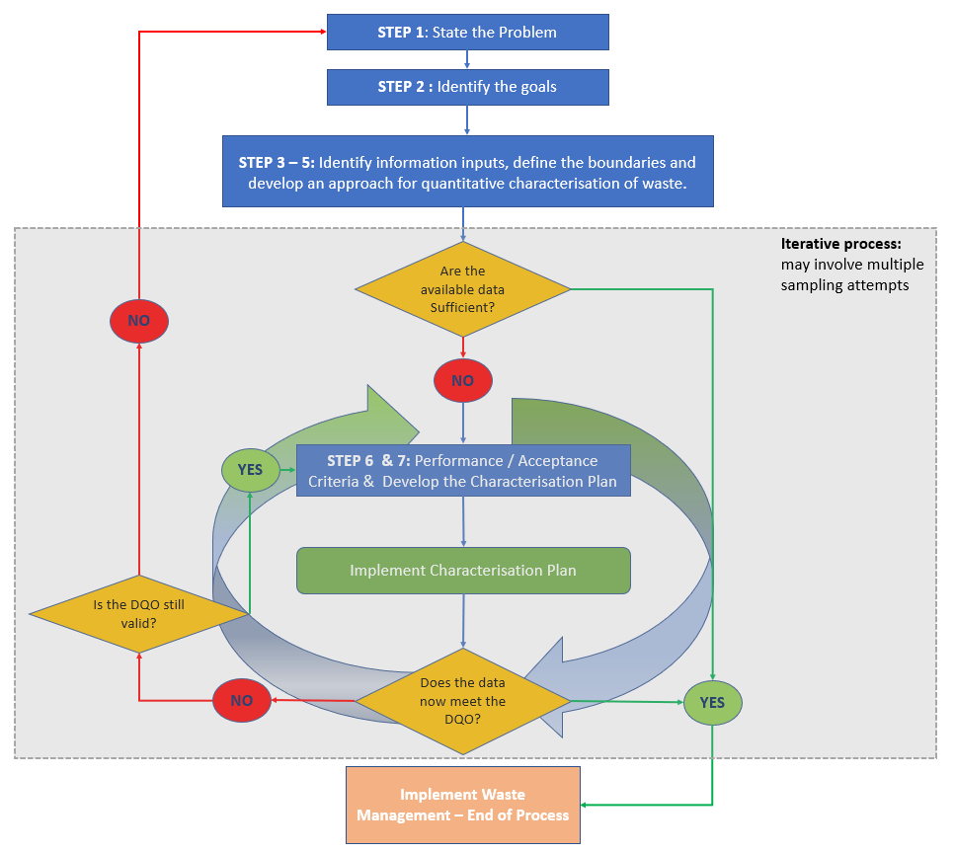

*FIG. 2 Summary of Data Quality Objectives (DQO) process as part of Waste Management*

For boundary wastes, or wastes where there is very little available information, there is a driver to perform iterative sampling in order to confidently demonstrate whether the waste is less than the VLLW or LLW threshold. An iterative approach to sampling could deliver significant cost and time savings, in addition to lowering the dose burden to sampling and analysis staff, if the waste can be sufficiently characterised using the lowest possible number of samples. For this a suitably flexible statistical methodology is required.

### Introducing Bayesian Statistics

This paper is not intended to provide a tutorial in the application of Bayesian statistics, rather to provide an outline of the general concept of Bayesian statistics to give the reader an appreciation of its appropriateness as an iterative data analysis method. The Bayesian iterative process is described graphically in Fig. 3.

Step1. begins by defining a “Prior”. For waste characterisation this is a baseline understanding of the shape and scale of the mean of the waste. This information might come from some initial sampling, expert opinion or inferences from the known source of the waste. The prior may be as simple as an assumption that it lies between two values, but with no information on any point being more likely than another (illustrated by the green line).

Step 2. Is to collect some data. This will ideally be physical samples taken at random from the population of interest.

Step 3. A likelihood is generated for the data collected in Step 2. The likelihood is independent from the prior. This gives the “likelihood” or probability of our mean (or any statistic of interest) taking each value given the observed data.

Step 4 is to establish a “posterior” distribution, this is the evidence used to generate Credible Intervals (the Bayesian equivalent to Frequentist Confidence Intervals). These Credible Intervals are used to make inferences about the waste. The posterior distribution is proportional to the “prior” multiplied by the “likelihood”.

Step 5 is to use the “posterior” distribution in relation to the set criteria to guide decision making. Namely to implement the agreed waste management strategy or to revisit the DQO and move through the Bayesian cycle once more. For the later decision, the posterior distribution becomes the new prior and the cycle is repeated. This can happen multiple times without ever needing to consider a p-value.

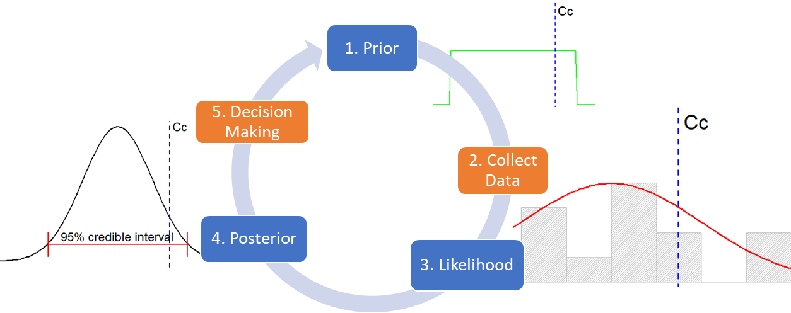

*FIG. 3 Bayesian iterative cycle*

## results

### Demonstration based on accident waste

On the Fukushima site, trees were cut down to aid in facilitating the response to the accident. These trees comprise 134,000 m3 [7] of waste. The trees were separated into two sub-categories of waste for temporary storage. The leaves, small twigs and branches comprising the most contaminated materials were chipped and placed in covered rows and the less contaminated trunks were stored separately, whole and open to the atmosphere. It is planned to incinerate the trunks when a new incineration facility is built in 2025 [8]. Leaf and branch of living trees inside the site were sampled and subject to radiochemical analysis [9]. This represents the only direct sampling information available on the trees. No samples have been taken of the trunks.

### Problem Statement

The high-level problem statement developed at Step 1 of the DQO process was defined as, *“To provide relevant information to characterise the properties (radiological, chemical & physical) of fallen trees for incineration and disposal via available UK routes.”*

The Bayesian/DQO approach presented herein will focus on the radiological (beta/gamma) understanding of the waste in relation to the VLLW boundary for incinerated tree trunks only. Here the specific question being asked is, “*Is the average activity (beta/gamma) for incinerated tree trunks less than 200 Bq/g?*”

### Prior information

The final waste product will be incinerated trunks. No data is available for this product. Instead prior information comes from a small number of samples (n=7) taken from leaves, twigs and branches pre-incineration. Two data processing steps were required to convert these sample results into results suitable for the incinerated trunk product.

Firstly, since no analytical data was available for the trunks a conversion factor has been used based on [10]. This is assumed to be:

$$Activity in Trunks= 0.001×Activity in leaves/branches$$

Secondly, if incinerated, the volume of the waste for disposal would be reduced to 0.5% of the original waste volume [11]. It is conservatively assumed that all activity within the waste remains within the ash (there would be no loss of activity up the stack during incineration), hence the activity is assumed to increase:

$$Activity in Incinerated Trunks=Activity in Trunks/0.05$$

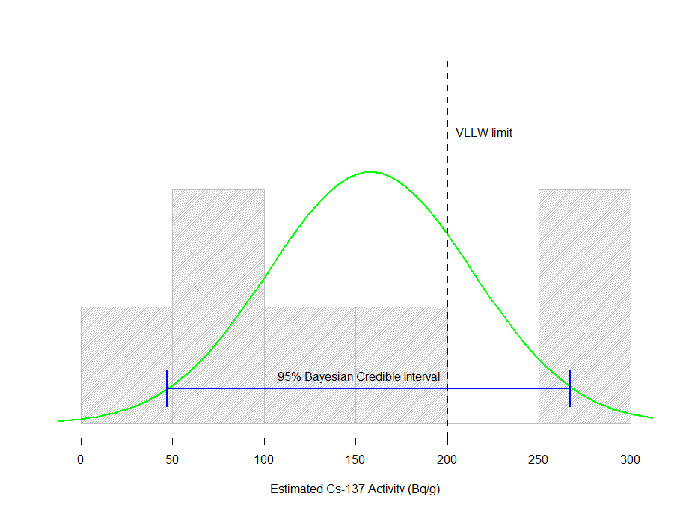Finally, it is noted that Cs-137 was used as a proxy for the total activity, since this was the dominant radioactive species present. Based on this information the ash was estimated to be classified as approximately VLLW as shown in Fig. 5 with a mean activity of 159 Bq/g and a standard deviation of 103 Bq/g.

*FIG. 4 Available data and Prior distribution for the mean*

The Bayesian Prior for the mean was determined to be 158 with a credible interval of (47, 267) based on a Gaussian (normal) distribution. This is slightly wider than the frequentist confidence interval (63, 254) around the mean, which gives a corresponding t-value of -1.054 (p=0.1661), when compared with the critical value of 200 Bq/g. This means that the difference between the mean value and the VLLW limits has a 0.1661 probability of having occurred by chance. Both statistical methods indicated that more data is required to confidently determine if the true mean is in fact less than the Critical criteria (Cc) value.

### Bayesian & Frequentist Power and Sample Sizes

Power was calculated for various sample sizes (n) for both the Frequentist and equivalent Bayesian approaches and these are presented in Fig. 6. Typically, 80-90% power is considered an appropriate threshold to have confidence in the findings from the analysis of a set of data.

For the Frequentist approach, this level of power is achieved at approximately n=60. However, for the Bayesian method, this power level is not achieved even with a sample size of 200 samples. The difference here arises from the fact that Bayesian Power calculations incorporates information about reliability of using a small sample size (n=7) to establish $μ$ and $σ$ by simulation from the raw data. These are assumed to be fixed values in the Frequentist approach, with increased sample sizes simply leading to increased precision.

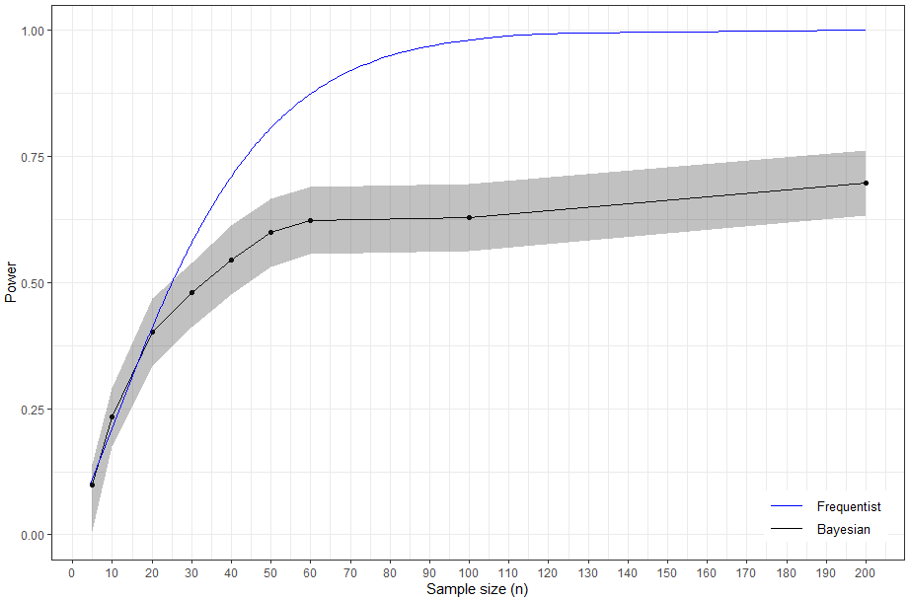The Bayesian power indicates that it is much more difficult to be confident about the expected results from a future sampling campaign than is indicated by the simple Frequentist sample size power curve. Without this information, decision makers may be overly confident in their expectations of achieving a successful study outcome.

*FIG. 5 Power curves by sample size for round 1 sampling*

Taking such a large number of samples is unlikely to be practicable. It is also unwise, because our prior understanding is based on indirect data, extrapolated from a related population (leaves and twigs) using theoretical assumptions regarding the concentration of activity in the ash for the trunks. This is true for both Bayesian and Frequentist sample size estimates. However, a key strength of the Bayesian approach is that any new data from a further sampling campaign will improve our understanding of the mean and associated uncertainty, without risking the outcome of the project on a specific number of samples. This information allows the decision makers to be fully aware of the risk and benefits of further sampling.

The number of samples required for the first round of sampling typically depends on practical considerations and should be guided by an understanding of the Power. Beyond n=20, increasing the sample size has a relatively modest impact on the Bayesian Power and is unlikely to be defensible in terms of cost and dose burden. .

## discussion

For boundary wastes it is likely to be more appropriate to use an iterative approach to sampling. Bayesian sampling better complements the DQO methodology in these circumstances. There is a tendency for decision makers to accept sample sizes as definitive rather than a balance of uncertainty and associated probabilities. In this example the Bayesian approach provides a clearer representation of the uncertainty in the prior information which may not be overcome by simply collecting more samples. Therefore, progression to a first round of sampling is based on a balance of practical constraints and an indication from the Power plot that gains beyond that sample size are notably smaller for each additional sample. The example above presented decision makers with a clearer risk benefit understanding for moving forward with sampling. There are three potential outcomes from the first round of sampling. These are shown in Fig. 7.

Firstly, (as illustrated in scenario 1, Fig. 7), the new data gives a posterior distribution for the mean which is sufficiently less than the Critical limit of 200 Bq/g, giving clear evidence to categorise the waste as VLLW. No further work is required, and the waste would be accepted by the disposal facility. In this scenario a sample size of 20 represents a notable saving over the traditional approach.

Secondly, (as illustrated in scenario 2, Fig. 7), the best estimate of the mean could still be less than the Critical limit of 200 Bq/g but the 95% credible interval still overlaps this limit. In this circumstance the team would need to revisit the DQO process and determine how many more samples would be required to confidently narrow the credible interval allowing stakeholders to make data driven decisions. Having more appropriate prior data gives a greater understanding of perceived risk of success/failure.

Thirdly, (as illustrated in scenario 3, Fig. 7), the new data results in a posterior mean close to or greater than the Critical limit of 200 Bq/g, indicating that collecting further data would be unlikely to achieve the threshold for VLLW. As such the waste would need to be disposed of as LLW. In this scenario a sample size of 20 again represents a notable saving over the traditional approach.

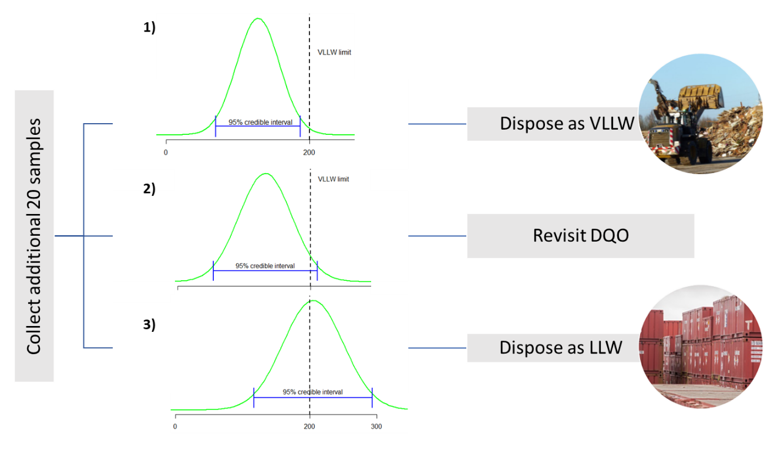

*FIG. 6 Potential outcomes from sampling*

Where the DQO is revisited and it is determined that further sampling is a proportionate next step, Bayesian statistical methods can incorporate the prior information from the first round of sampling with any new data gathered from a second round of sampling. The posterior distribution and credible intervals found from these can again be compared against the VLLW boundary limit, again as is pictured in Fig. 7. These iterations can occur as many times as is practicable without any statistical cost (inflation of the rate in false positive findings/ observing a significant difference by chance). For wastes near a classification boundary, the Bayesian iterative approach can be advantageous.

ACKNOWLEDGEMENTS

The authors wish to thank Amanda Lindsay (NNL) who compiled the data, kindly provided by JAEA, into the data set used to develop this approach. This paper includes a part of the results obtained in the work of “research and development for processing and disposal of solids waste” based on the budget of countermeasures for decommissioning and contaminated water treatment, which was entrusted to International Research Institute for Nuclear Decommissioning (IRID) from Ministry of Economy, Trade and Industry (METI), Japan

References

|  |  |
| --- | --- |
| [1] | UK Radioactive Waste Inventory, "How do we manage radioactive waste?," [Online]. Available: https://ukinventory.nda.gov.uk/about-radioactive-waste/how-do-we-manage-radioactive-waste/. |
| [2] | M. H. Ramsey, *Improving the reliability of contaminated land assessment using statistical methods: Part I - Basic principles and concepts,* CL:AIRE Technical Bulletin TB7, 2004. |
| [3] | EPA, *Guidance on Systematic Planning Using the Data Quality Objectives Process, EPA QA/G-4,* 2006. |
| [4] | "The Inter-Ministerial Council for Contaminated Water and Decommissioning Issues, "Mid-andLong-Term Roadmap towards the Decommissioning of TEPCO's Fukushima Daiichi Nuclear Power Station" The 5th Revision," [Online]. Available: https://www.meti.go.jp/english/earthquate/nuclear/decommissioning/index/html. |
| [5] | K. Yoshikazu, S. Atsuhiro and A. Takashi, "Radioactive Contamination of Several Materials following the Fukushima Daiichi Nuclear Power Station Accident," *Nuclear Materials and Energy,* vol. 10, pp. 35-41, 2017. |
| [6] | G. Li, M. Taljaard, E. R. Van den Heuvel, M. A. Levine, D. J. Cook, G. A. Wells, P. J. Devereaux and L. Thabane, "An Introduction to multiplicity issues in clinical trials: the what, why, when and how," *International Journal of Epidemiology,* vol. 46, no. 2, pp. 746-755, 2017. |
| [7] | TEPCO, "Status on management of sort of rubble, tree cut down, used protective clothing, and so on (as of 28th February 2019)," in *64th Secretariat meeting of the Team for Countermeasures against Decommissioning and Contaminated Water Treatment*, 2019. |
| [8] | Tokyo Electric Power Company Holdings, Inc, "Waste Storage Management Plan of the Fukushima Daiichi Nuclear Power Station (in Japanese)," [Online]. Available: https://www.meti.go.jp/earthquake/nuclear/decommissioning/committee/osensuitaisakuteam/2019/06/3-4-5.pdf. |
| [9] | International Research Institute for Nuclear Decommissioning, Japan Atomic Energy Agency, "Analysis of radioactivity of rubble and felled tree sampled at the site of Fukushima Daiichi NPS," in *Team for Countermeasures for Decommissioning and Contaminated Water Treatement, 2nd Secretariat meeting, 30 January 2014 (in Japanese)*, http://www.meti.go.jp/earthquake/nuclear/20140130_01.html, 2014. |
| [10] | K. Iijima, H. Funaki, T. H and S. Nakayama, "Distribution of radioactive Cesium in trees and effect of decontamination of forest contaminated by the Fukushima nuclear accident," in *ICEM2013 - ASME 2013: 15. International Conference*, 2013. |
| [11] | S. Hashimoto, S. Ugawa, K. Nanko and K. Shichi, "The Total Amounts of Radioactively Contaminated Materials in Forests in Fukushima," *Sci Rep,* vol. 2, p. 416, 2012. |