SAFETY AND SECURITY OF RADIOACTIVE SOURCES: THE ROLE OF THE RADIOACTIVE WASTE MANAGEMENT CENTRE OF GHANA
A. M. A. DAWOOD
Radiation Protection Institute, Ghana Atomic Energy Commission, Kwabenya, Accra, Ghana dawuud2000@gmail.com
Abstract
Hazards associated with ionizing radiation are deleterious to all living organisms and the environment in general. Sealed radioactive sources are the major sources of anthropogenic ionizing radiation in Ghana. They are applied in hospitals for x-ray imaging, cancer diagnosis and treatment; in industry and civil constructions for moisture and level gauge determination; and in agriculture for pest control and extension of shelf life of food-crops. Other sectors where radiation sources are used in the country include the gold mines and oil and gas exploration fields. When radioactive sources become deficient and do no longer serve the purpose for their intended manufacture, they become disused and are termed radioactive waste. Despite being disused, their activity are often high enough to cause radiation injury when mishandled or overly exposed to. Aside the safety concerns, radioactive sources are subject of national security. Their theft and unauthorized use have serious security implications. In view of these, the Radioactive Waste Management Centre (RWMC) of the of the Radiation Protection Institute (RPI) of Ghana was established with a core function of retrieving all radioactive waste generated in the country for further management. The RWMC operates a licensed Centralized Radioactive Waste Management Facility (CRWMF) where pre-disposal activities such as waste characterization, waste conditioning, re-containerization (in case of leakage) and storage are carried out. The Centre also undertakes radiation safety assessment and radiation protection training for users and transporters of radioactive sources. The ultimate goal is to build a robust management system for radioactive sources in Ghana.
Keywords: Ionizing radiation; radioactive source; radioactive waste; characterization; conditioning
- INTRODUCTION
The Radioactive Waste Management Centre (RWMC) of the Ghana Atomic Energy Commission (GAEC) is mandated by Act of Parliament of the Republic to retrieve and manage all radioactive waste or disused sources generated in the country. Thus far, it is the only institution with an authorized facility; with logistics and expertise to manage radioactive waste until their final disposal.
There are two major divisions in radioactive waste management; pre-disposal and disposal. Pre-disposal involves all the processes such as: characterization, processing, storage, conditioning etc. Disposal is the finality of the management process in which the conditioned waste are buried through a number of disposal methods including deep geological repository, near surface burrier, underground cells and in a borehole disposal system with no intention of retrieving the waste [1, 2].
The fundamental objective of radioactive waste management is to protect people and the environment from the harmful effects of ionizing radiation [1]. It is important to note that, Ghana currently undertakes only pre-disposal waste management. However, plans are advanced in building the IAEA’s approved borehole disposal system for disposal of radioactive waste in the future. It is also important to note that, Ghana does not have category 1 disused source in its waste inventory, therefore waste/ disused source in this manuscript refers to category 2 – 5 sources only.
Fundamental objective of safety and security relating to radioactive source management is achieved on the backdrop of a robust quality management system. Quality management system ensures that adequate measures are in place to address technical and administrative issues relating to protection of human health, protection of the environment, protection against theft; loss, sabotage and unauthorized use of radioactive sources [3].
The Nuclear Regulatory Authority Act, 2015 (Act 895) established the Nuclear Regulatory Authority (NRA) as the nuclear regulatory body of Ghana with the objectives to:
- Ensure that radiation and nuclear energy are used by only persons authorized under Act 895 of 2015 for peaceful purposes.
- Provide protection of persons and the environment against the harmful effects of radiation hazards
- Pursue and ensure strict compliance with Act 895 of 2015 and its regulations.

- MATERIALS AND METHOD

  - Location of facility
The CRWMF, schematically illustrated in Fig. 1 is located on the GAEC’s main site at Kwabenya, in the Ga East District of the Greater Accra Region. It lies at latitude 50 6’7”N and longitude 00 21’ W, at elevation of 64 m above sea level. The Kwabenya Township used to be a rural area at the time of establishing the GAEC. It has, however, become urbanized since the last two decades with a lot of commercial and domestic facilities found within the domain of the GAEC.
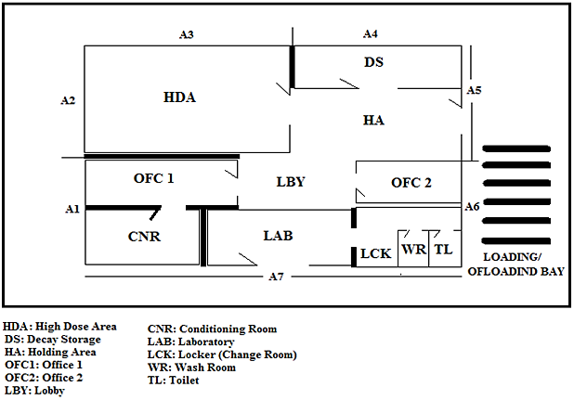
FIG 1. Sketch of the centralized waste storage and processing facility showing its various partitions (microenvironments)

  - Source characterization
Source characterization refers to full identification of the source [4]. It is an important waste management process that enables maintenance and storage of source information for future references. A combination of a source identifier (Atomtext) and a radiation meter (Radiagem) are used in this process. At the end of source characterization campaign, full information about each source are entered into the RWMC’s manual and electronic registry system. The following features and measurements are recorded in both:
- Type of source i.e. name of the device
- Name of radionuclide
- Original activity
- Current activity (at the time of characterization)
- Name of manufacturer
- Date of manufacture
- Country of origin
- Physical dimensions

  - Source conditioning
Radioactive source conditioning involves recovery or removal of the bare source from its original container; and encapsulating it in a standard stainless-steel container [5]. The aim is to significantly reduce volume and weight, and consolidate the waste before disposing them. Source conditioning is quite a tedious process which involves dismantling i.e. cutting, drilling, grating, hitting or knocking the source container in order to dislodge the bare source (illustrated in Fig. 2 and 3).
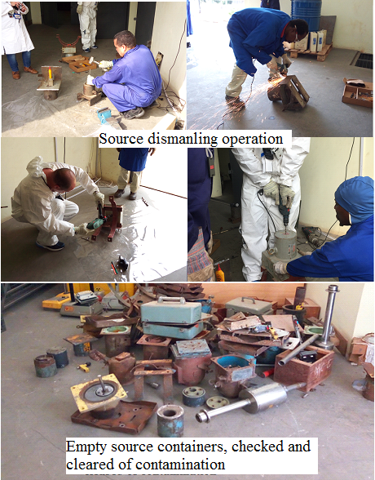
FIG 2. Dismantling: knocking, drilling and cutting through source container to retrieve the bare source
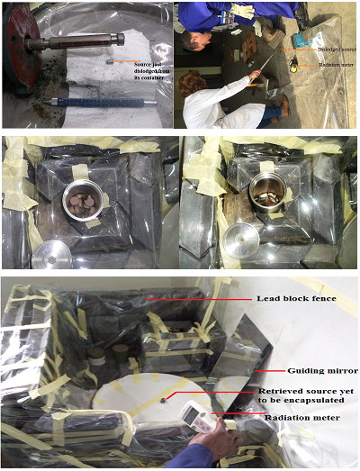
FIG 3. Retrieved sources dropped in shielded stainless steel capsule in the conditioning chamber
Source conditioning operation requires a tactical approach to avoid contamination during the dismantling of the source container. It requires the expertise of an experienced persons in the field. Materials and devices required for a successful conditioning operation include:
- 200 L (iron) drum
- Steel pipe (80 mm diameter),
- Lead sheet
- Lead blocks
- Transparent plastic sheet
- Drilling and grating devices
- Personal dosimeter (TLD badge)
- Dose rate reader (Radiagem) and
HPGe neutron and gamma detector (ICx IdentiFINDER)
  - Contamination test
After device is dismantled and source is removed, a contamination test also known as leak test is conducted to ascertain whether there was contamination in the process of dismantling and source recovery. The method of dry and wet leak tests [6] are conducted on the source container as well as the equipment used in the process.
  - Decontamination
When contamination is detected, both personnel and equipment are quickly decontaminated [7] as follows:
    - Personnel decontamination
- Decontamination is led by the RPO or as appointed by the Manager;
- Movement of persons is confined to contaminated area until they are decontaminated and cleared;
- Exterior clothing is removed if contamination exceeds operational intervention level (OIL) and put in a designated contamination bin;
- Part of body that is contaminated is identified;
- Fixed contamination levels on the skin is measured and recorded; it assists in estimating skin dose;
- Contamination by loose particles are gently collected using adhesive tape and washing surfaces thoroughly with soap and water;
- Without loosed particles, affected parts are thoroughly washed with soap and tepid water, with gentle scrubs;
- Observe dose rates of affected parts and surfaces, they should be equal or close to background dose otherwise repeat point vi and/or vii.

    - Equipment decontamination
- Wear clean gloves;
- Use a clean piece of dry cloth to wipe surfaces of contaminated equipment;
- Dampen another clean piece of cloth with an organic solvent and use it to wipe contaminated surface;
- If equipment is waterproof, wash whole equipment with soap and water;
- Throw all disposables after decontamination into the ‘contamination bin’.

- RESULTS AND DISCUSSION
The resultant of the pre-disposal radioactive waste management processes described above is to build a robust radioactive waste management system. A system that guarantees safety of humans and the environment from the harmful effects of ionizing radiation. A system that will ensure occupational and public safety; and a system that will ensure security of the sources – preventing thefts, losses, unauthorized application and radiological incidents and/or accidents.
All decommissioned and/or disused sources have successfully been retrieved from the various end-users and safely been transported to the CRWMF for further management until disposal. These sources have been characterized in accordance with national and international regulations; and all records kept in the RWMC’s electronic and manual registry. About 90% of retrieved disused sources have successfully been conditioned.
The radioactive source inventory is dominant with gamma sources of which ²⁴¹Am and ¹³⁷Cs are more than half the inventory; alpha and neutron sources are almost of same quantities. Activity concentrations of alpha, neutron and gamma sources at the time of writing this manuscript are 1.62 x 10¹⁰ Bq/cm², 1.75 x 10¹⁰ Bq/cm² and 9.66 x 10¹⁰ Bq/cm², respectively. Summary of the source inventory is given in Fig. 4.

FIG 4. Overview of Ghana’s radioactive source inventory

ACKNOWLEDGMENT
Author is grateful to the Ghana Atomic Energy Commission and the International Atomic Energy Agency for logistical support.
REFERENCES
- INTERNATIONAL ATOMIC ENERGY AGENCY, Geological Disposal of Radioactive Waste, IAEA Safety Standards Series No. WS-R-4, IAEA, Vienna, (2006).
- INTERNATIONAL ATOMIC ENERGY AGENCY, Near Surface Disposal Facilities for Radioactive Waste IAEA Safety Standards Series No. SSG-29 IAEA, Vienna, (2014).
- INTERNATIONAL ATOMIC ENERGY AGENCY, International Basic Safety Standards for Protection against Ionizing Radiation and for the Safety of Radiation Sources, Safety Series No. 115, IAEA, Vienna, (1996).
- INTERNATIONAL ATOMIC ENERGY AGENCY, Locating and characterizing disused sealed radioactive sources in historical waste, IAEA Nuclear Energy Series No. NW-T-1.17, Vienna, (2008).
- INTERNATIONAL ORGANIZATION FOR STANDARDIZATION, Radiation Protection — Sealed Radioactive Sources — Leakage Test Methods, ISO 9978:1992, ISO, Geneva (1992).
- INTERNATIONAL ATOMIC ENERGY AGENCY, Handling, conditioning and storage of spent sealed radioactive sources, IAEA TECDOC- 1145, 2000.
- INTERNATIONAL ATOMIC ENERGY AGENCY, New Methods and Techniques for Decontamination in Maintenance or Decommissioning Operations, IAEA TECDOC No. 1022, (1998).

