palm oil fuel ash (pofa)-supplemented cementitious material for containment of radium

E. PHILLIP
Nuclear Malaysia
Bangi, Selangor, Malaysia
Email: esther@nuclearmalaysia.gov.my

R. O. ABDEL RAHMAN
Hot Lab Center, Atomic Energy Authority of Egypt
Cairo, Egypt

Abstract

Safe and secure management of disused sealed radioactive sources (DSRSs) represents a challenging topic in the field of radioactive waste management. In particular the end of life-cycle management of these sources is not a straightforward problem due to the variability of the radioactivity content and the half-lives. Among the different end of life cycle management strategies for these sources, storage and disposal strategy represents an appealing solution from the technical, safety, and security points of view. In this respect, small diameter borehole disposal concept was recommended by IAEA, as an efficient, economical, and secure disposal concept for these sources. This disposal concept relies on the use of cementitious backfill, as a part of the engineering barriers, to support the structural integrity of the facility and to confine radioactivity within the facility. An integrated research project was established to support the design phase of the borehole disposal facility in Malaysia that aims to optimize the cementitious backfill barrier by investigating its mechanical and confinement performances. The mechanical performance was optimized by varying the mix design of the backfill materials. The confinement performances of radium, cesium, and strontium were studied by assessing the batch kinetic, isotherm, and equilibrium sorption behavior for optimized palm oil fuel ash (POFA)-supplemented cementitious and control OPC backfill materials toward these contaminants. In addition, diffusion experiments were carried out to study the migration of the radio-contaminants of interest. This paper is devoted to summarize some of the important findings from this integrated research project on radium containment in POFA-supplemented cementitious material. Batch investigation results will be presented, where the results of sorption equilibrium time in both POFA-supplemented cementitious and OPC materials and the controlling sorption mechanism will be summarized. The diffusion experiment setup will be presented and results will be used to calculate the diffusion coefficients in the both cementitious materials.

Keywords: Disused sealed radioactive sources (DSRSs); Radium; Palm oil fuel ash (POFA); Sorption; Containment; Diffusion

INTRODUCTION
Sealed radioactive sources (SRSs) find vast applications in numerous fields including medicine, industry and research thus generating large amount of disused sealed radioactive sources (DSRSs) that contain various types of radionuclides with a broad spectrum of radioactivity. At the end of their life cycle, DSRSs are mandatorily required to be managed safely and securely in order to protect human and environment from unnecessary radiological impacts. There are different management schemes that were proposed for these sources, among them the decay storage for short-lived radionuclides and disposal for longer-lived radionuclides. With the rising inventories of DSRSs particularly in countries where geological repositories are unavailable, the IAEA has introduced small-diameter borehole for the disposal of DSRSs and Malaysia has been privileged to benefit from the borehole disposal of disused sealed sources (BOSS) project launched by the IAEA.
The borehole disposal concept, that adopts multi-barrier system consisting of geological and engineered barriers, does rely on cementitious materials as part of the engineered barriers for the purposes of supporting the structural integrity of the facility and for confinement of radioactivity within the facility. The confinement of radioactivity is due to the presence of different phases that can sorbed many radionuclides as well as the alkaline cement environment that makes the radionuclides less soluble and mobile [1, 2]. In particular, calcium silicate hydrate (C-S-H) phases having available active sites favour the sorption of different radio-contaminants and intermolecular channels that can physically confine the radio-contaminants [3, 4]. The content of C-S-H phases could be increased when a pozzolanic supplementary material is added, where some of the formed Ca(OH)₂ reacts with silicon compounds from the supplementary material to produce more C-S-H [5].
Palm oil fuel ash (POFA)-supplemented cement has been gaining attention as a potential green cement that can support the environmental sustainability in both cement production industry as well as the construction industry. POFA, a by-product generated from palm oil processing industry, contains large amount of silica and has high potential to be used as cement replacement [6]. POFA proved its ability to improve the physical and mechanical characteristics of the hydrated cementitious materials and has shown promising sorption capacity towards different contaminants [7, 8]. An integrated research project was established to assess the feasibility of using POFA-supplemented cement as backfill material in DSSR’s borehole disposal. POFA-supplemented cementitious backfill mix design was optimized based on the mechanical and hydraulic performances of the tested formulations, then the effects of water intrusion and fractional releases of 1Ci Ra-226 source into the POFA-supplemented and Ordinary Portland Cement (OPC) cementitious materials, and the reaction kinetics at room temperature were analyzed following non-linear regression techniques [9]. A comparative analysis was held between the sorption kinetics of Cs-134 and Ra-226 onto the POFA-supplemented and OPC cementitious materials at room temperature following linear regression technique to analyse the experimental data [10]. The obtained results revealed the improved sorption characteristics of the optimized POFA-supplemented cementitious material for the containment of Cs-134 and Ra-226 at room temperature. This paper is dedicated to give insights into Ra-226 containment by presenting the kinetics of the sorption characteristics at different temperatures of interest in the disposal environment and the diffusion behaviour within this material in comparison to the reference OPC. In this respect, batch sorption kinetics experiments at different temperature were carried out and the data will be linearly analyzed to obtain the reaction rate constants and identify the controlling sorption mechanism. Diffusion experiments were conducted at room temperature for 250 day and the activity concentration profiles will be analyzed to obtain the diffusion coefficients.

Materials
Ordinary Portland Cement (OPC) type CEM I 42.5N manufactured by Tasek Corporation Berhad was used as the main binder in the formulation of POFA-supplemented cementitious backfill material. Prior to use, the OPC sample was sieved to collect particles of less than 250 μm that were further utilized in the preparation of the cementitious backfill material. Meanwhile, POFA was sampled from a palm oil mill in Jugra, Banting, Selangor, Malaysia. The POFA sample was pre-treated via drying, heat-treatment, grinding and sieving to obtain final POFA sample with particles sizes less than 250 μm. Cubes and coupons of hardened cement were prepared from OPC and POFA. The cubes were crushed, ground and sieved to obtain pulverized samples of less than 250 μm that were also used to prepare cement-equilibrated waters. The densities of the materials were determined following standard test method and the specific surface area were measured using Brunauer-Emmett-Teller (BET) gas adsorption (Model AutosorbiQ, Quantachrome Instruments). The contaminant solutions were prepared by diluting the concentrated Ra-226 solution, obtained from Eckert & Ziegler, with the cement-equilibrated waters. Radioactivity was measured using a gamma spectrometer equipped with Genie 2000Gamma Analysis software.

Sorption experiments and methodology
Batch sorption experiments were performed to investigate the sorption kinetic behaviour of Ra-226 onto the reference OPC and optimized POFA-supplemented cementitious material at varying temperatures (298-333K). A known mass of cementitious material was agitated with a measured volume of cement-equilibrated water containing known quantity of Ra-226 on an incubator shaker for a specified time at fixed temperature. The suspensions were then centrifuged at 4000 rpm for 10 minutes to separate the solid and liquid phases. Supernatants collected were analysed for Ra-226 activity using a gamma spectrometer. The concentration of the species in the supernatant was used to calculate the amount of the species sorbed by the cementitious material (q_{t}, Bq/g):

$q_{t}=\frac{\left(C_{o}-C_{t}\right)V}{m} [$Equation 1]

where C_{o} is the initial activity concentration of sorbate in the bulk solution, Bq/L, C_{t} is the activity concentration of sorbate in the bulk solution at time t, Bq/L, V is the volume of the bulk solution, L and m is the mass of the sorbent, g. The data were linearly regressed to appropriate models to calculate the reaction parameters and investigate the sorption mechanism. Table 1 lists examples of the used model equations and linear plots used to obtain the model parameters.

TABLE 1. Equations and linear plots for the used kinetic models

 | Model | Equation | Plot
Rate | Pseudo-second order | $$\frac{t}{q_{t}}=\frac{1}{k_{2}q_{e}^{2}}+\frac{1}{q_{e}}t$$  [Equation 2] | t/q_{t} against t
Mechanism | Intraparticle diffusion (IPD) | $$q_{t}=k_{ipd}t^{1/2}+θ$$  [Equation 3] | q_{t} against t^{1/2}

Diffusion experiments and methodology
Diffusivity of Ra-226 into the cement coupons was determined by through-diffusion method using Perspex diffusion cell similar to the methods adopted by [11-13]. The schematic diagram of the through-diffusion experiment is shown in Fig. 1. During the diffusion experiment, radionuclide diffused through the cementitious coupons from compartment A to compartment B. Periodically, solutions from compartment B was withdrawn for the determination of the radioactivity. Fresh distilled water was fed into compartment B immediately after the solution withdrawal. The diffusion experiments were carried out for 250 days at room temperature in saturated condition mimicking the condition in a disposal facility where radionuclide migration occurred only in liquid phase. After 250 days, solutions from both compartments were removed and the diffusion cell was left to dry at room temperature. Radionuclide penetration profiles were obtained by removing a measured layer of the cement coupon surface and the cement coupon was subsequently analysed with gamma spectrometer to determine the remaining activity in the coupons. The distribution coefficients (K_{d}, mL/g) and the retardation factors (R_{d}) were determined using:

$K_{d}=\frac{q_{e}}{C_{e}}$ $[$Equation 4]
$R_{d}=\left(1+\frac{ρ}{θ}K_{d}\right)$ $[$Equation 5]

Cementitious coupons
Ra-226 solution
Distilled water
Perspex diffusion
cell
47 mm

6 mm
Compartment B
Compartment A

FIG. 1. Schematic diagram of diffusion cell used for through diffusion experiments

The transport of Ra-226 through the coupons is attributed to the concentration gradient within the coupons. The solution of the diffusive transport equation in semi-infinite medium assuming initial radium concentration equals zero within the coupons and constant concentration at the liquid interface, yields the following equation [14]:
$\frac{C}{C_{o}}=erfc\left(\frac{x}{2\sqrt{D_{r}t}}\right)$ $[$Equation 6]

where D_{r} is the retarded diffusion coefficient, ($D_{r}=\frac{D}{R_{d}}$) m²/s, D is the apparent diffusion coefficient, and t is the time, s.

results and discussion

Characteristics of the cementitious backfill materials
Different mix designs of varying POFA and water contents were tested to evaluate their hydraulic and mechanical characteristics; the results indicated that using up to 50% POFA replacement would satisfy the mechanical and hydraulic requirements for backfill materials in retrievable radioactive waste disposal facilities. Optimized POFA-supplemented cementitious material that could give the highest strength and good workability comprised of 30% POFA replacement [9]. Density and surface area are two important physical properties of the backfill materials, where the first could be used to have insights into the materials porosity and the latter gives indication on the sorption ability. These properties of the reference OPC and optimized POFA-supplemented cementitious material are tabulated in Table 2. Lower density of the optimized POFA-supplemented cementitious material compared to that of the reference OPC reflected its higher porosity at 28 days. The investigation of the morphology of 1 year old reference OPC and optimized POFA-supplemented cementitious material indicated that the latter showed limited and smaller capillary pores than the reference OPC which entailed a good sealing potential [9]. On the contrary, the surface area of the optimized POFA-supplemented cementitious material was higher than that of the reference OPC, which reflected a better accessibility to the active sorption sites into the supplemented material.

TABLE 2. Physical properties of reference OPC and POFA-supplemented cementitious material

Sample | Physical properties
 | Density, g/cm³ | Specific surface area, m²/g
Reference OPC | 1756.8 | 20.548
POFA-supplemented cementitious material | 1662.4 | 27.137

Radium confinement performance in POFA-supplemented cementitious material
Ra-226 sorption reaction kinetics onto the cementitious backfill materials are illustrated in Fig. 2. The changes in the amount of Ra-226 sorbed (q_{t}) were characterized by short fast changes occurring at the beginning of the reaction that were attributed to the vast availability of active sorption sites, as the reaction progressed more sites are occupied thus leading to slower sorption that occurred over longer time until equilibrium is reached [15-17]. It was noted that the amount of Ra-226 sorbed by the optimized POFA-supplemented cementitious was higher than the reference OPC for the entire period investigated at all three temperatures (298 K, 313 K and 333 K).

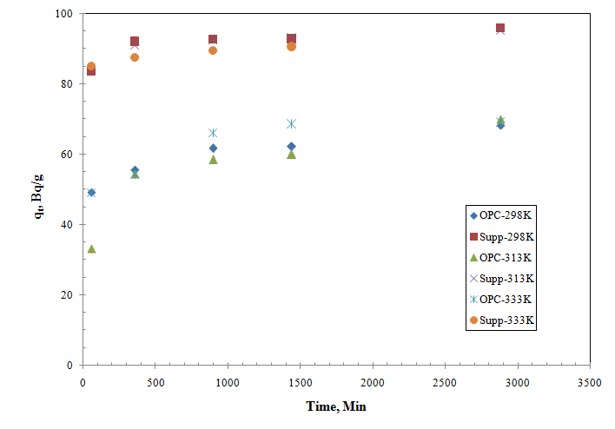
FIG. 2 Effect of contact time on the sorption of Ra-226 onto the optimized POFA-supplemented cement and reference OPC at 298 K, 313 K and 333 K

Sorption rates were determined using pseudo-second order (PSO) kinetic model and the sorption mechanisms were defined using the intraparticle diffusion (IPD) model. Results of the experimental data fitted to both models are demonstrated in Fig. 3(a,b) and Table 3. For both cementitious backfill materials, the theoretically calculated sorption capacities of Ra-226 at equilibrium using pseudo-second order model (q_{e}, Bq/g) were close to the experimental values (q_{e}(Exp.), Bq/g ) at the corresponding temperature range. Moreover, with the high correlation coefficient, R², values (> 0.99), it was clearly revealed that the sorption of Ra-226 onto both materials was well-fitted by pseudo-second order model thus suggesting that the sorption process proceeded as chemisorption that occurred either by electronic sharing or electronic exchange [9, 10, 18]. It was also noted that the q_{e} values were higher for the optimized POFA-supplemented cementitious material than for the reference OPC at all three temperatures. Meanwhile, the values of the rate constant, k₂, implied faster sorption process for the optimized POFA-supplemented cement compared to the reference OPC. In addition, it was also noted that as temperature increases from 298 K to 333 K, the sorption capacity increases, the thermodynamic analysis of these systems revealed that the reaction is spontaneous, endothermic, and independent on the degree of the surface filling [9].

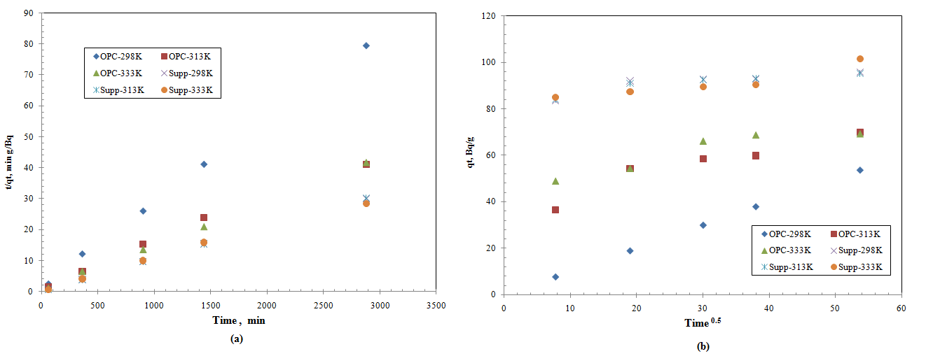
FIG. 3 Linear fitting of Ra-226 sorption kinetic data onto the reference OPC and optimized POFA-supplemented cementitious material at different temperatures (298 K, 313 K and 333 K) (Sorbent dosage 100 g/L; Initial Ra-226 concentration 6E+3 Bq/L; Agitation at 180 rpm) (a) PSO model, (b) IPD model

In order to gain insight on the sorption mechanism of Ra-226 onto the cementitious backfill materials, it is necessary to consider the effect of the micro-porosity of the cementitious materials on the sorption rate. Active sorption sites were mostly found in the inner parts of the sorbent particles. Therefore, sorbate molecules needed to diffuse through the pores of the sorbent via a process commonly known as IPD to reach the active sorption sites. The rate of the sorption process was slowed down due to the diffusion process. IPD model was therefore used to identify the rate-limiting step in a sorption process [19]. Results for the fitting of the experimental data for Ra-226 sorption onto the optimized POFA-supplemented cementitious material using IPD model was discussed earlier by Phillip et al. [10]. The results concluded that the mechanism involved was not limited to pore diffusion alone but also the boundary layer played an effect in the sorption process; this effect was more pronounced in the optimized POFA-supplemented cementitious material.

TABLE 3. Kinetic model parameters of Ra-226 sorption onto the reference OPC and optimized POFA-supplemented cementitious material

Temp, K | Pseudo-second order model |  |  | Intra-particle diffusion
 | Parameter | Optimized POFA-supplemented cementitious material | Reference OPC | Parameter | Optimized POFA-supplemented cementitious material | Reference OPC
298 | k₂, g/Bq·min | 1.4×10⁻³ | 1.52×10⁻³ | k_{ipd}, Bq/ g min^{0.5} | 0.169 | 0.212
 | q_{e}, Bq/g | 60.2 | 41.8 | θ, Bq/ g | 50.1 | 31.2
 | q_{e}(Exp.), Bq/g | 60.1 | 44.6 | R² | 0.8 | 0.71
 | R² | 1 | 1
313 | k₂, g/Bq·min | 5×10⁻⁴ | 1×10⁻⁴ | k_{ipd}, Bq/ g min^{0.5} | 0.221 | 0.655
 | q_{e}, Bq/g | 95.24 | 71.42 | θ, Bq/ g | 84.66 | 36.48
 | q_{e}(Exp.), Bq/g | 95.3 | 70.01 | R² | 0.825 | 0.86
 | R² | 0.993 | 0.999
333 | k₂, g/Bq·min | 1.2×10⁻⁴ | 2.3×10⁻⁴ | k_{ipd}, Bq/ g min^{0.5} | 0.337 | 0.48
 | q_{e}, Bq/g | 102.04 | 70.42 | θ, Bq/ g | 80.89 | 47.18
 | q_{e}(Exp.), Bq/g | 101.67 | 69.15 | R² | 0.867 | 0.845
 | R² | 0.999 | 0.995

Diffusion of radium into POFA-supplemented cementitious material
Ra-226 activity profiles within the cementitious coupons are illustrated in Fig. 4. The profiles were characterized by a reducing pattern comprising of a steep decrease followed by slightly reduced decrease. The first portion of the profile occurred within the 0.15 and 0.32 mm for the optimized POFA-supplemented cementitious material and reference OPC, respectively. It was clear that Ra-226 was totally confined within the first 0.3 mm of the optimized POFA-supplemented cementitious material. Ra-226 was also confined within 0.6 mm of the reference OPC coupons, with no activity detected in compartment B. The calculated Ra-226 distribution coefficient, K_{d}, and retardation coefficient, R_{d}, for the optimized POFA-supplemented cementitious material and reference OPC are listed in Table 4 that clearly reflected the enhanced confinement performance of the optimized POFA-supplemented cementitious material compared to the reference OPC. The data were non-linearly regressed to the diffusion model (Equation 6), and the value of the diffusion coefficient, D_{r}, were one order of magnitude lower for the optimized POFA-supplemented cementitious material. It was indicated that for a moderately sorbed element, with K_{d} of 1 ml/g, the apparent diffusion coefficient, D, were smaller than 10⁻¹² m²/s [20, 21]. Based on these data, it could be concluded that despite the greater density of the optimized POFA-supplemented cementitious material compared to the reference OPC, higher sorption capacities and slightly faster reaction contributed to a lower D.

TABLE 4. Parameters for Ra-226 diffusion onto the reference OPC and optimized POFA-supplemented cementitious material
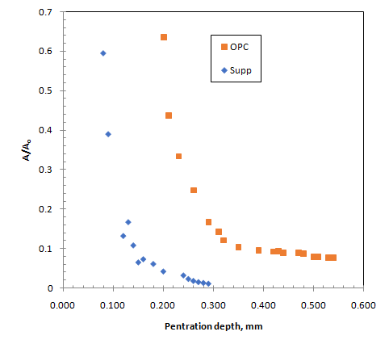
Sample | K_{d}, mL/g | R_{d} | D_{r}, m²/s | D, m²/s | R²
Reference OPC | 19.5 | 309 | 1.43×10⁻¹⁵ | 4.44×10⁻¹³ | 0.8
Optimized POFA-supplemented cementitious material | 44.21 | 455.7 | 0.24×10⁻¹⁵ | 1.10×10⁻¹³ | 0.898

FIG. 4 Ra-226 activity profile within the optimized POFA-supplemented cementitious material and reference OPC

conclusion
The study demonstrated the potential use of POFA-supplemented cement as backfill material for containment of Ra-226. For optimum POFA-supplemented cementitious backfill mix design, the confinement performance was assessed from batch sorption study in comparison with that of reference OPC material. The kinetic experimental data fitted linearly to PSO and IPD models. The data suggested that the sorption of Ra-226 onto the surface of the cement progressed via chemisorption reaction. It was also implied that pore diffusion mechanism was not the only rate limiting step that controlled the sorption. The results of the diffusion experiment indicated that Ra-226 was totally confined within the cementitious coupons during the studied time span. The optimized POFA-supplemented cementitious material showed higher distribution and retardation coefficients, and reduced apparent diffusion coefficient.
ACKNOWLEDGEMENTS
The authors would like to express their appreciation to Assoc. Prof. Dr Khoo Kok Siong from National University of Malaysia (UKM) and Dr Mohd Abd Wahab Yusof for their contribution and support.
References
- Heath, T., Schofield, J., Shelton, A., Understanding cementitious backfill interactions with groundwater components, J. Appl. Geochem. 113 (2020) 104495.
- Abdel Rahman, R.O., Metwally, S.S., El-Kamash, A.M., Improving the performance of engineering barriers in radioactive waste disposal facilities: role of nano-materials. In: Kharissova, O., Martínez, L., Kharisov, B. (Eds.), Handbook of Nanomaterials and Nanocomposites for Energy and Environmental Applications. Springer, Cham. https://doi.org/10.1007/978-3-030-11155-7_79-1 (2021).
- Tits, J., Iijima, K., Wieland, E., Kamei, G., The uptake of radium by calcium silicate hydrates and hardened cement paste, Radiochim. Acta 94 (2006) 637–643.
- Abdel Rahman, R.O., Zein, D.H., Abo Shadi,, H. Cesium binding and leaching from single and binary contaminant cement-bentonite matrices, Chem. Eng. J. 245 (2014) 276-287.
- Glasser F. P., 2013 Cements in radioactive waste disposal IAEA-TECDOC-CD—1701 (Companion CD) (International Atomic Energy Agency (IAEA)).
- Tangchirapat, W., Saeting, T., Jaturapitakkul, C., Kiattikomol, K., Siripanichgorn, A., Use of waste ash from palm oil industry in concrete, Waste Manage. 27 (2007) 81-88.
- Nagaratnam, B. H., Mannan, M. A., Rahman, M. E., Mirasa, A. K., Richardson, A., Nabinejad O., Strength and microstructural characteristics of palm oil fuel ash and flyash as binary and ternary blends in self-compacting concrete, Constr. and Building Mater. 202 (2019) 103–120.
- Yusof, M.S.M., Othman, M.H.D., Wahab, R.A., Jumbri, K., Razak, F.I.A., Kurniawan, T.A., Abu Samah, R., Mustafa, A., Rahman, M.A., Jaafar, J. & Ismail, A.F., Arsenic adsorption mechanism on palm oil fuel ash (POFA) powder suspension, Journal of Hazardous Materials 383 (2020).
- Phillip, E., Khoo, K.S., Yusof, M.A.W., Abdel Rahman, R.O., Assessment of POFA-cementitious material as backfill barrier in DSRS borehole disposal: ²²⁶Ra confinement, J. Environ. Management. 280 (2021) 111703, https://doi.org/10.1016/j.jenvman.2020.111703
- Phillip, E., Khoo, K.S., Yusof, M.A.W., Abdel Rahman, R.O., Evaluation of radium and caesium containment performance of palm oil fuel ash-supplemented cementitious backfill for borehole disposal: Kinetic investigations, IOP Conf. Series: Materials Science and Engineering 1106 (2021) 012018 doi:10.1088/1757-899X/1106/1/012018
- Goto, S., Roy, D.M., Diffusion of ions through hardened cement pastes, Cement and Concrete Research 11 5-6 (1981) 751–757.
- Numata, S., Amano, H., Minami, K., Diffusion of tritiated water in cement materials, Journal of Nuclear Materials 171 2–3 (1990) 373–380.
- Yamaguchi, T., Negishi, K., Hoshino, S., Tanaka, T., Modeling of diffusive mass transport in micropores in cement based materials, Cement and Concrete Research 39 12 (2009) 1149–1155.
- Crank, J., The Mathematics of Diffusion, Clarendon press, Oxford, 1975.
- Niu, M., Li, G., Cao, L., Wang, X., Wang, W., Preparation of sulphate aluminate cement amended bentonite and its use in heavy metal adsorption, Journal of Cleaner Production 256 (2020) 120700.
- Gasser, M.S., Mekhamer, H.S., Abdel Rahman, R.O., Optimization of the utilization of Mg/Fe hydrotalcite like Compounds in the removal of Sr(II) from aqueous solution, J Environ. Chem. Eng. 4 (2016) 4619-4630.
- Lazaridis, N.K., Karapantsios, T.D., Georgantas, D., Kinetic analysis for the removal of a reactive dye from aqueous solution onto hydrotalcite by adsorption, Water Res. 37 (2003) 3023–3033.
- Haq, A., Saeed, M., Usman, M., Ali, S., Naqvi, R., Bokhari, T. H., Maqbool, T., Ghaus, H., Tahir, T. & Khalid, H., Sorption of chlorpyrifos onto Zinc Oxide nanoparticles impregnated Pea peels (Pisum sativum L): Equilibrium, kinetic and thermodynamic studies, Environmental Technology & Innovation (2019).
- Pellicer, J.A., Rodríguez-López, M.I., Fortea, M.I., Lucas-Abellán, C., Mercader-Ros, M.T., López-Miranda, S., Gómez-López, V.M., Semeraro, P., Cosma, P., Fini, P., Franco, E., Ferrándiz, M., Pérez, E., Ferrándiz, M., Núñez-Delicado, E., Gabaldón, J.A., Adsorption properties of β- and hydroxypropyl-β-cyclodextrins cross-linked with epichlorohydrin in aqueous solution. A sustainable recycling strategy in textile dyeing process, Polymers 11 2 (2019).
- Shackelford, C.D., Laboratory diffusion testing for waste disposal – a review, J. Contam. Hydrol. 7 (1991) 177–217.
- Van Loon, L.R., Eikenberg, J., A high-resolution abrasive method for determining diffusion profiles of sorbing radionuclides in dense argillaceous rocks, Appl. Radiat. Isotopes 65 (2005) 11–21.

