# IMplementing deep borehole disposal of

# radioactive waste

***Preliminary results from a study of stakeholder views across the regulatory, policy and practitioner communities***

C. PARKER, F. BRUNDISH, J MATHIESON, B. MADRU

Deep Isolation EMEA Limited

London, UK

chris@deepisolation.com

N. CHAPMAN

University of Sheffield, UK

**Abstract**

The use of deep boreholes as a means of delivering geological disposal for higher activity radioactive waste is an option that is of increasing interest to policymakers around the world, offering a potentially attractive supplement to the established concept of geological disposal in a mined repository. Although the drilling and waste handling technologies involved are already developed and commercially deployed, deep borehole disposal (DBD) as a whole system is less mature than the mined repository concept. Against this context, the paper presents preliminary results from a survey of opinions across the regulatory, policy and practitioner communities to identify: a) the key potential opportunities and benefits that stakeholders perceive DBD to offer; and b) the policy/regulatory, technical/operational and societal challenges that remain to be addressed prior to DBD implementation. Major perceived benefits are found to include: increased choice and siting flexibility; the potential for cost reductions across national waste disposal programmes; potentially attractive features from the perspective of community consent; and potential for economies of scale around regulatory processes. The single most important challenge cited by stakeholders is the need for the large-scale demonstration of DBD in operation on a whole-system basis. Other challenges include the lack of international guidance on developing and assessing the DBD safety case, and the need for further societal research to test community knowledge and opinions on DBD. Looking to the future, four out of five surveyed stakeholders agree that national waste management programmes should work together in joint projects to address these challenges and accelerate the implementation of DBD. The paper additionally presents potential priorities for such collaboration.

## INTRODUCTION

The use of deep boreholes as a means of delivering geological disposal for higher activity radioactive waste is an option that is of increasing interest to policymakers around the world [1-6]. Significant work has been done on the generic safety case for DBD by a range of research bodies and national waste management organisations (WMOs) [7-14], supplemented in recent years by private sector involvement [4,15-18]. DBD significantly expands the range of potential locations for siting a deep repository: either by drilling vertically down into the deep crystalline basement, or by using directional drilling techniques pioneered by the oil and gas sector to create borehole repositories in selected geological formations at a greater range of depths and configurations [4,15,19]. The drilling and radioactive waste handling technologies involved are mature, and large-scale demonstration projects are under consideration. A recent paper by borehole experts under the aegis of the International Framework for Nuclear Energy Cooperation (IFNEC) estimated that the first disposal facility might be operational by around 2030 [19]. However, DBD as a whole system is less mature than the mined repository concept – which is already at an early stage of practical implementation for spent fuel disposal in Finland and being actively developed in France and Sweden. Against that context, the paper aims to establish an evidence-based view of how the international radioactive waste management community understands the challenges that need to be addressed in bringing DBD to fruition.

## METHODOLOGY

The target research group was senior-level stakeholders whose role involves specific responsibilities for geological disposal of higher activity radioactive waste, in the following five categories:

* Policymakers in national governments
* Waste Management Organizations
* Nuclear and environmental regulators
* International agencies that influence national policies
* Researchers in universities, national laboratories and other research institutions with a specific focus on radioactive waste disposal.

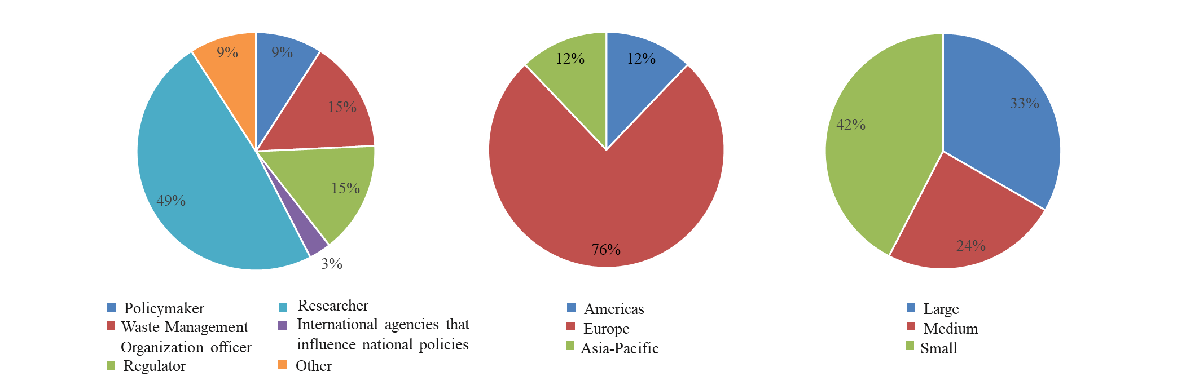The first round of data gathering for this research project into opinions on DBD is complete, with 35 people from 16 countries participating: 33 who completed an online survey (10 of whom also participated in in-depth interviews), plus 2 additional interviewees who did not complete the survey. Fig. 1 shows how respondents were split organisationally, geographically and by size of national inventory.

*FIG. 1. Respondents by organization type, region and inventory size.*

Table 1 summarizes the seven-step research process. This combined qualitative and quantitative analysis, and was informed by methodologies recommended in the *Handbook of Practical Program Evaluation* [20] (in particular, with respect to using the internet, conducting semi-structured interviews and qualitative data analysis):

1. TABLE 1. Research methodology

|  |  |
| --- | --- |
| 1. **Initial research design** | * Work within the project team, and in consultation with external DBD experts, to develop an initial research framework to explore Opportunities, Challenges and Enablers for DBD |
| 1. **Test through initial in-depth interviews** | * Undertake in-depth interviews to explore Opportunities, Challenges and Enablers for DBD with 2-3 members of the target population, using a semi-structured interview format * Use the results of these to develop and refine a) the interview format and b) the survey questionnaire to be used in quantitative research |
| 1. **Quantitative validation** | * Use a web-based survey to seek quantified and comparable views from a broader set of people in our target population |
| 1. **Preliminary analysis** | * Initial statistical analysis of quantitative results, to develop understanding of views and priorities – and how these may vary across population sub-segments * Use a web-based survey to seek quantified and comparable views from a broader set of people in our target population |
| 1. **Qualitative validation** | * Further round of in-depth interviews, exploring issues raised by preliminary analysis of the web survey results * In parallel, continue to expand numbers of people undertaking the web survey |
| 1. **Analysis and conclusions** | * Analysis of qualitative research results, to identify key themes and undertake role analysis * Iterative documentation of findings, referring back to both qualitative data and quantitative data and using both to test, substantiate and evidence the key themes |
| 1. **Quality assurance** | * Review of draft report with external experts |

## key finDings

Key findings are summarized below, combining both the quantitative results from the online survey with qualitative insights drawn from the interview programme that illuminate and give context to those results[1].

### Opportunities

There was clear consensus across participants that DBD presents national radioactive waste management programmes with significant opportunities.

As shown in Fig. 2, 73% of respondents - when asked to think at a global level - tended to agree or strongly agreed that DBD has a potential role to play in ensuring the safe geological disposal of higher activity radioactive waste. That percentage was lower (54%), when respondents were asked to consider disposal in their own country. Most of those who disagreed came from countries that already have a highly developed programme for establishing a mined repository. Others disagreed because, in the words of one interviewee: *“If you look globally, it’s easier to assess, but if you look nationally … it’s harder to foresee the future.”*

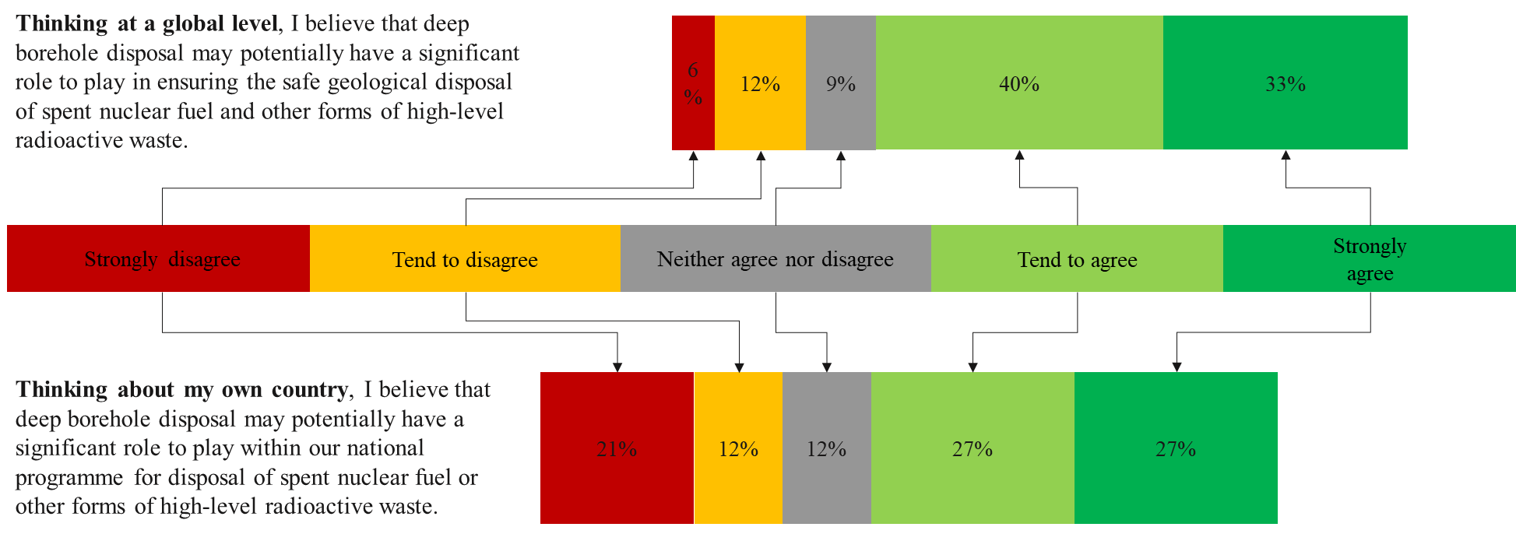

*FIG. 2. Views on potential role of DBD at global and national level*

Respondents also expressed views on the overall types of inventory where DBD offers potential opportunity. 53% of respondents considered that DBD is likely to be suitable, at least to some extent, for both small and large waste inventories. As two respondents commented:

* *“I don't think that it's only small inventory nations though; there's a lot of work that demonstrates that potential usefulness is there for the USA, for Germany - and therefore obviously for all nations.”*
* *“We shouldn't be just focusing on small inventories, small countries, sealed sources, but we should tend to focus also the biggest - nuclear [power] countries, because at the end they have inventories that are very suitable for borehole disposal.”*

The more common view, however, was that DBD has a part to play in the disposal of smaller inventories. Fig. 3 shows that 61% of respondents had a positive view of the utility of DBD in such cases, rising to 82% in relation to very small inventories that might be disposed of in a single borehole - with over half seeing DBD as likely to be highly suitable in such ‘single borehole’ cases. As one regulator put it:

* *“Some countries have to deal with wastes that are long lived and hazardous for a long time, but maybe don't have a major nuclear programme and volumes are relatively small….* *[DBD] would be an attractive option because building a mined repository for relatively small volumes can seem unfeasible.”*

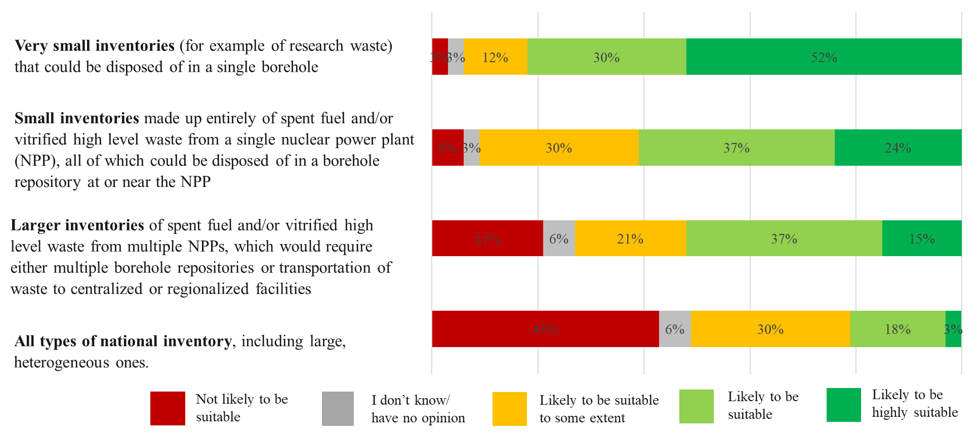

*FIG. 3. Types of national inventory perceived by respondents as most suitable for DBD*

In terms of specific waste groups, Fig. 4 shows that 50% or more of respondents agreed that DBD is likely to be suitable across five of the suggested waste groups, focused on spent fuels and vitrified HLW. The two most “highly suitable” waste group were spent fuel from research reactors and vitrified HLW.

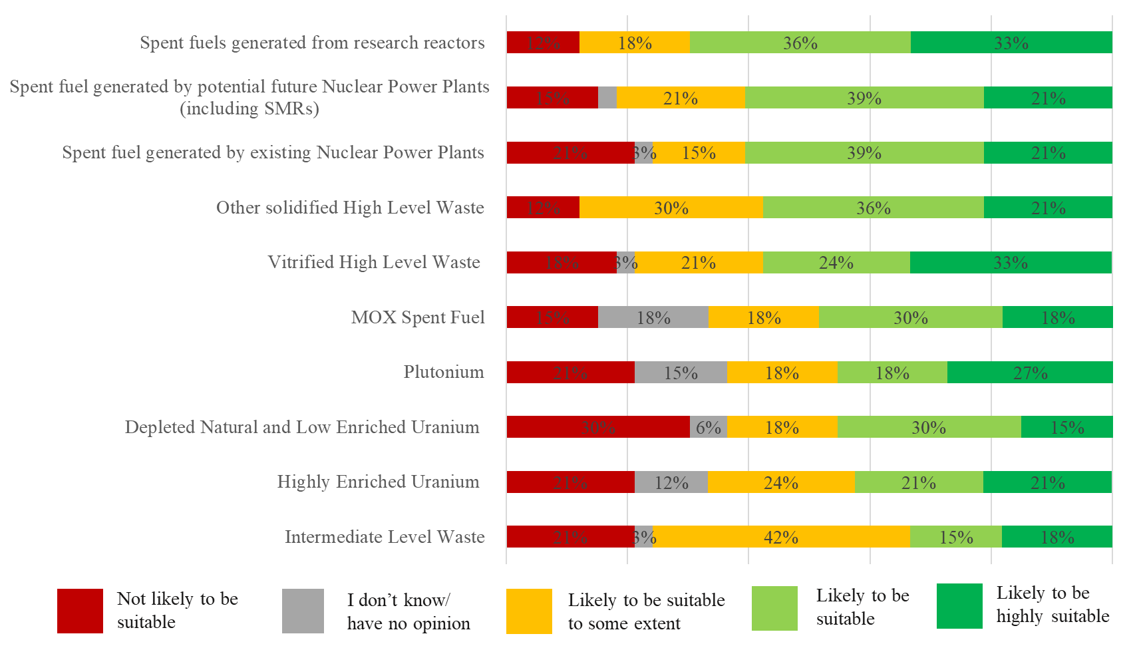

*FIG. 4. Types of radioactive material perceived as most suitable for DBD*

### Benefits

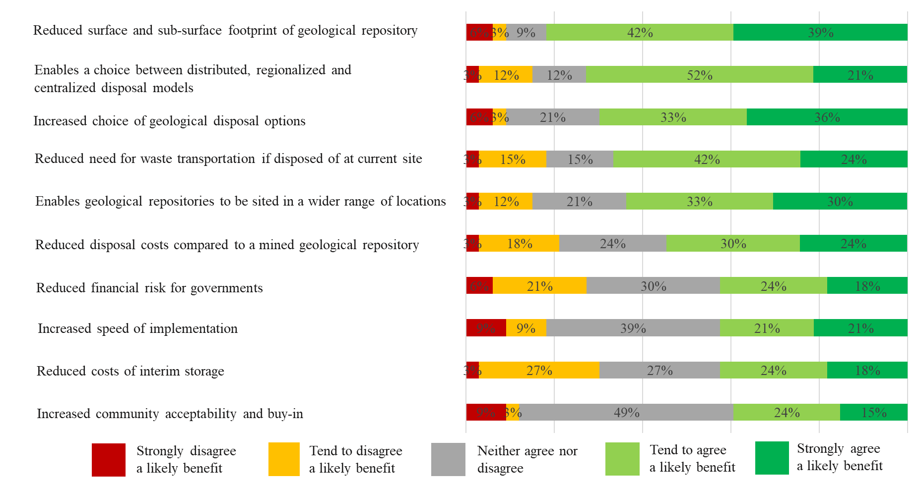 The research also sought to understand the potential benefits that DBD might deliver. Fig. 5 shows opinions on ten potential benefits. The highest rated likely benefit is the reduced physical footprint of a DBD repository. Other highly rated benefits relate mainly to siting flexibility. On the other hand, reduced costs, time and risk within a national disposal programme saw higher levels of uncertainty – and almost half of respondents said they did not know whether DBD might bring benefits in terms of increased community acceptability.

*FIG. 5. Potential benefits from DBD*

The in-depth semi-structured interviews gave a similar – although not identical - picture. Discussion of benefits in the interviews fell in four main areas. First, **choice and flexibility** was the key benefit that most interviewees raised in relation to DBD (as in the online survey results). Second, interviewees pointed to potential benefits in relation to **cost and time savings** – although most, as in the survey results - tended to see these as less significant than the choice and flexibility brought by DBD. The third area of potential benefits focused on the potential for **greater community acceptance** – although several interviewees commented that they were speculating rather than speaking from knowledge (a position reflected also in the 49% response of ‘don’t know/no opinion’ in this area of the survey.) In addition, a fourth key theme that emerged from the interviews, that was not addressed in the online survey related to **economies of scale around regulatory processes**. Insights from the interviews are presented in Table 2, grouped under these four themes.

1. TABLE 2. Stakeholder views on key potential benefits from DBD

|  |
| --- |
| **Benefit 1: Increased choice and siting flexibility** DBD is seen by all interviewees as providing a useful additional option for policy makers to consider when assessing the best approach for geologic disposal for a specific inventory and site. As one interviewee commented:   * *“I see borehole disposal as one more way of implementing geological disposal. And if you have diversity, that's always better: you can choose the right technical concept for the site [geology and location].”*   Specific aspects of this additional choice that were highlighted during the interviews focused on:   * **Siting flexibility – opened up by DBD’s suitability for a wider range of geographical locations:** * *“Even siting, could be an easier task, comparing with the conventional mined option.”* * *“One of the benefits of DBD is the much greater depth of the point where everything is going to be deposited. ... one could certainly make an argument that it is far less likely to ... have any kind of interaction with the environment, certainly the environment on the surface. For that reason, it might be much easier to site a deep borehole rather than a mined repository y: it's very deep, it could be a single shaft, versus something more complex. I would think you would have much more flexibility in siting a borehole than you would at mined repository, which is very much more dependent on the surrounding geology.”* * *“Coming back to the tectonic question, you've got countries like Japan that suffer from earthquakes and deep boreholes might offer them a much safer way of getting rid of spent nuclear fuel than a mined repository.”* * *“Well, from the siting point of view, if the depth is more flexible - [and] if the cost doesn't change as much as with a mined repository - then this is an advantage. If you can find your suitable layers not at maybe 500 meters deep, but at 1000 meter deep or more, this gives you the advantage.”* * **Potential for non-centralized siting** * *“It could not be just a centralized repository. For bigger countries ... to avoid transport costs etc, you could have more than one such location where you could dispose of waste. So it [DBD] is perhaps more suited to bigger countries, because you can site ... boreholes in the locations where the inventory exists .”* |
| **Benefit 2: Potential for cost, risk and time reductions in national disposal programmes** Most interviewees highlighted the potential for cost and time savings that are offered by DBD:   * *“In some countries that have a national policy and a strategy for early implementation (or they need a solution .... a few decades earlier), deep borehole disposal could be a very good solution…. because if it continues to advance towards implementation like it has over the last a couple of years, it could probably be implemented before any mined repository in certain contexts.”* * *The implementation time could be faster. I don't think that's necessarily the case if you're the first one to do it - but if you're the third or fourth one, at least the construction time in itself is much shorter, an order of magnitude shorter.* * *And so there's an enormous cost saving if you were to put the high-level waste and spent fuel in boreholes compared to a mined repository. Also, connected with that, you've got the upfront capital cost of a mined repository which is tremendous - whereas for a borehole it's more or less as pay-as-you-go, you don't have to invest so much up front.*   In most cases, this sort of cost/time saving was seen as important but not a decisive factor in the context of considering disposal options - it was generally seen as less significant than, for example, siting flexibility and societal consent. For some of the interviewees, however, the lower cost of borehole disposal was the single most important benefit – because they saw it potentially changing the political balance away from continued investment in storage in favour of disposal, particularly in smaller inventory countries with limited resources:   * *“Storage is going on, and disposal is being prepared and planned – but the investment decision is being postponed, postponed, postponed, postponed…. From the numbers I've seen [on borehole costs] they look promising, so it might be a factor for change, it may be enough of a price advantage to change the decision-making process.”* * *“We all should be very outspoken that there is a number of countries - tens of countries - that will never implement a mined repository, even if they need to dispose some of their waste in very deep layers of the earth. Because of other associated challenges or risks, it's difficult for them to implement such a facility in the end. And one of the advantages in using the deep borehole option is that it could be implemented for either a small inventory, or much sooner than a mined repository and cheaper.”* |

|  |
| --- |
| ***Benefit 3: Potentially attractive features from the perspective of community consent***  Some interviewees saw DBD as simply another form of geological disposal from the point of view of societal and community acceptance, with similar challenges and benefits to those faced by mined repositories:   * *“On societal acceptance, it [DBD] is still a deep geological repository. The question here is about trust in science, trust in geologists…. So here, I don't see any big advantage of one against another.”* * *“From an isolation perspective, there are theoretical advantages [in terms of societal acceptance], let's put it that way. But on the other hand, I think the base concerns in relation to social acceptance would probably be quite similar.”*   Most interviewees, however, saw potential benefits in terms of community consent that flowed from specific features of the DBD concept:   * **Perceptions of greater safety** * “*It's probably easier for a typical community or stakeholder representative to understand deep borehole disposal from the point of view of safety …, because mined repositories are complex structures… And … you can easily show that the drilling technologies - either with the same diameter or the same depths - are used worldwide every day.”* * *“I keep going back to the public though, because that always seems to be the ultimate barrier to developing these facilities. And the thought of just digging a really deep borehole and putting anything you don't want down at the bottom of it, say a few kilometres, that is I would say more …. it gives me a sense of more security than just a mined repository which is closer to the surface, it’s very dependent on the geology and engineered barriers and, depending on seismicity or other issues, it's conceivable there could be some sort of interaction with the environment. It just seems that with the deep borehole, the chances of that are much smaller, all else being equal.”* * *“It's inherently safer, because of the greater depth: you've got an order of magnitude increase in the geological barrier; you've got …. a tremendous amount of isolation. …. it's not so susceptible to tectonic events … So, it makes far more sense to put the highly active waste in deep boreholes. They’re less voluminous than the intermediate level waste, and it would significantly shrink down the size of the mined repository. It would be an easier sell on a community who were to take this repository, if you were to say “hang on, we've got a much safer way of dealing with the ‘nasties’.”* * **Reduced environmental footprint** * *“Footprint: in the sense that it's not one big repository of everything in one place…. It's less accessible and it's less of a footprint for potential disturbance in the future.”* * *“And then there's the environmental footprint, which I actually think is lower: less energy use, less mining waste.”* * **An enabler of future clean energy**   For some interviewees, DBD was also seen as an important enabler of societal acceptance not just for geological disposal, but also for investment in new nuclear power production as a future source of clean energy. As one respondent said:   * *“Globally, DBD technology has a large or significant impact to play, a really important part. It can demonstrate that it [nuclear energy] is sustainable: it can and is being managed. We take something from the ground, use it, put it back where it was taken - so zero waste production in a sense, a sustainable technology.”* |
| **Benefit 4: Potential for economies of scale around regulatory processes** A key theme from many of the interviews was the international economies of scale that could flow from the more standardized and replicable nature of DBD. Some commented on this from the perspective of the engineering and technical implementation of the repository itself - particularly for countries that do not have the extensive internal capabilities that the early adopters of mined repositories have built up over decades:   * *“If you're a smaller nuclear program, you're looking for a technology that might be either purchased or transferred, so your research investment will be smaller…. So [DBD] might be an advantage for some decision-makers, because you don't need to have your own research programme, encapsulation or mining or disposal technology.”* * *“If you have, for example, a medium-sized nuclear program, then … DBD is a good solution. You don't need to have that big facility if you can, for example, buy in the borehole technology and pay for support from outside companies.”*   Others saw the same forces for standardization applying at the level of regulatory processes:   * *“I can't imagine a standard design for a mined repository, that would apply for a license for A, B, C, D countries: it is too specific. However, for borehole disposal, I think a multinational license (or license valid in more countries at the same time), is possible. Maybe not for all parts of the project, but for the majority of the project - which is of course an advantage for licensing.”* * *“People are talking about generic type approval for certain reactor types … If we're talking about much more of an off-the-shelf concept [of geological disposal], if I may call it that - like modular reactors almost - the idea of having a type approval or at least ‘type understanding’ by regulators is something that might be helpful.”* |

### Challenges

Respondents in the online survey were asked to consider 26 potential challenges that might need to be overcome before the licensing of a DBD facility. This list covered policy/regulatory issues, technical/operational issues and societal issues, and had been drawn up in consultation with geologic disposal practitioners. Of the 26 potential challenges, the ten most significant – which were perceived to be challenges by over half of respondents 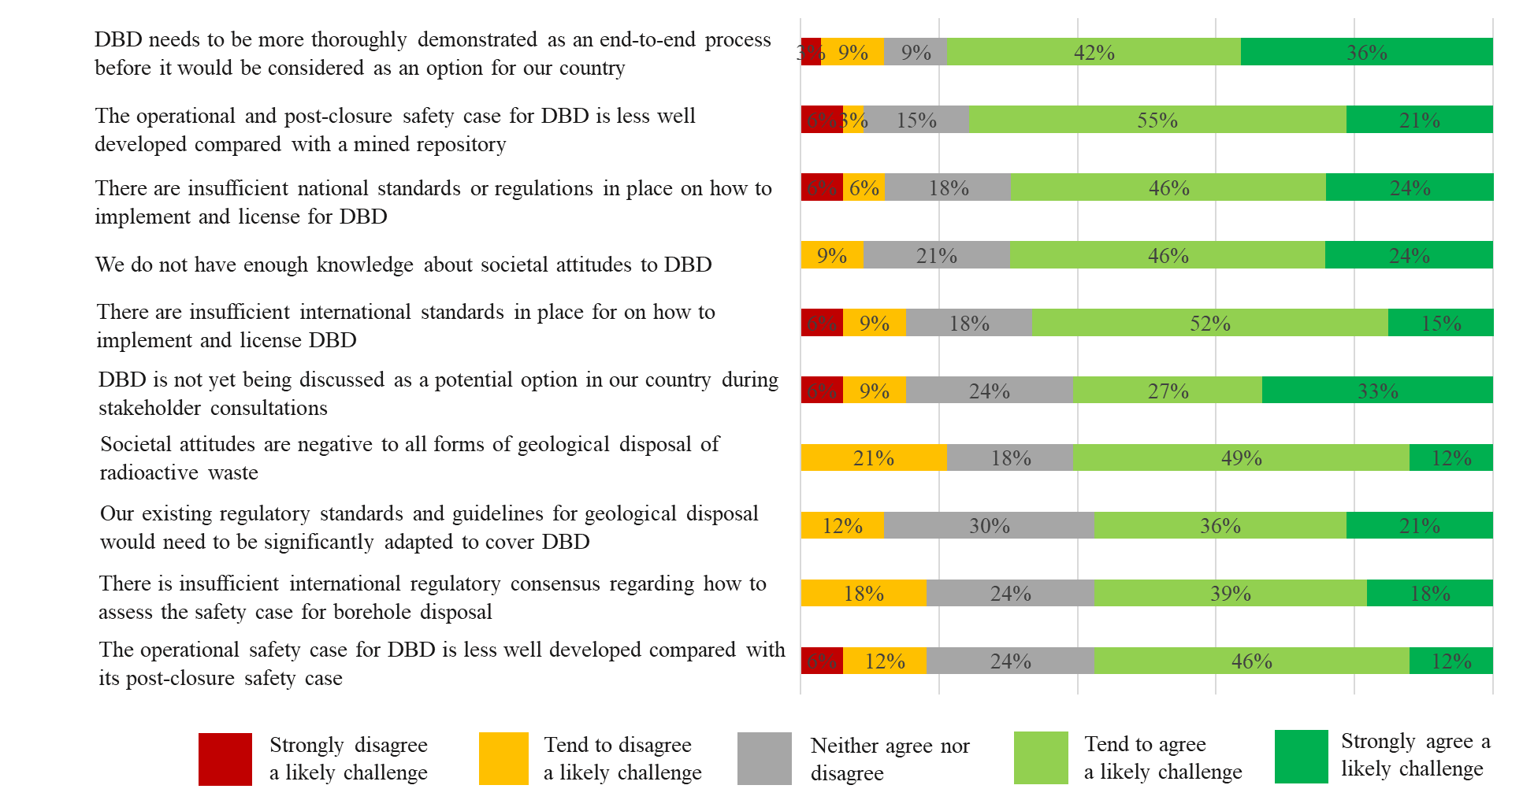- are shown in Fig. 6.

*FIG. 6. Percentage of respondents agreeing on potential challenges for DBD*

These top ten challenges focus on the need for the operational process and the overall safety case for DBD to be demonstrated on a whole-system basis, the relative lack of understanding and evidence about societal attitudes to DBD, and on the extent to which there is policy/regulatory clarity about the tests that should be met in a DBD safety case. As with our analysis of perceived benefits, these quantitative results – both the overall ranking, and the greater weight put on policy/regulatory challenges when compared to technical/operational ones - present a similar picture to the key challenges that emerged on an unprompted basis during the in-depth interviews. Insights from the interviews are explored in Table 3, grouped under three common interviewee themes.

1. TABLE 3. Stakeholder views on key challenges to address implementation of DBD

|  |
| --- |
| **Challenge 1: the need for large-scale demonstration of DBD on a whole-system basis to validate the safety case** Many interviewees made the point that DBD draws on mature technologies and processes:   * *“Literature is available to show that this is a mature technology, that deep borehole disposal is building on the experience from our oil and gas industry.”* * *“In the early days of deep borehole disposal, there was a lack of drilling technology or knowledge available, and it couldn't be really supported by the modern methodology of presenting the safety case. But with the advancement of drilling methodologies and computer codes safety case calculations, I think this is well advanced and could be one of the viable and safe and reliable options worldwide.”* * *“Drilling technology has moved on a lot: now you can do these directional boreholes that your company does; people can drill accurate vertical holes – they drill way beyond five kilometres in depth. Obviously not to that diameter, but the envelope that needs to be pushed is quite small.”* * “*The drilling techniques are mature and SF/HLW handling techniques are mature*.”   However, all interviewees stressed that they saw DBD as intrinsically less mature that the mined repository concept, because it had not been fully demonstrated as an integrated system:   * “*Somebody just needs to do it. Because there are several studies that show that this is feasible: that the actual operation is feasible, that the safety assessment is feasible, compliance with existing standards is feasible. The problem is that no one has done it.”* * *“Here, in deep borehole disposal…. the technology is developed and the next thing you need to do now is technology demonstration. And you have suppliers of technology, which are keen to work on technology demonstration and they don't need to do basic research anymore.”* * *“There's a need to make a site-specific project and actually doing the whole thing, have a demonstrator. This is where we always end up: having a full-scale scale demonstrator or even implementation, just has to be done. There have been conceptual designs, there have been generic safety assessments.... But now the underlying thing is that you have to have a desire to do it in reality.”* * *“I think the biggest barrier remains to actually show that it can be done…. Show that we’ve got the engineering to put down containers and retrieve them should one get stuck. I think people will then see that it is an off-the-shelf technology. And then beyond that, you can use the hole to test new ideas on sealing and support matrices and various sorts of thing, you can characterize the rock and the groundwater, you've got a laboratory there. So I think the biggest obstacle is not having a demonstration borehole.”* * *“Even if you had a hundred percent confidence that it would work as designed, I don't think people would be comfortable until it actually been used… So I think you would have to actually demonstrate the technology in order to gain acceptance by the entire community.”*   Specific maturity challenges that several interviewees wanted to include in any demonstration included:   * **Borehole characterisation:** *“How to characterize the bedrock at depth … because it's quite much deeper. How to model and prepare the safety assessment and safety case. Because the deeper you go, it might bring new uncertainties to safety assessment.”* * **Exception management in emplacement:** *“The deeper you go in the same borehole, if you end up with some kind of difficulties, how to resolve them: can you come into a situation that you have canisters stuck in the hole, and how to develop engineering solutions for that? Because with KBS-3 the same type of thing can also happen, but that's quite easily sorted. It might be costly, but you can always come from the next tunnel, or you can just excavate out, so it's fairly easy.”* * **Retrievability:** *“The technology for drilling deep wells like this is very mature…. I think the part of the technology that does need more work is the retrievability aspect. If you're considering using it for spent fuel or some material that you might want to retrieve at some point, I do think more experience is needed to ensure that you have a hundred percent success rate…. But having said that, again it's very promising and I'm very impressed with the progress that's been made to date just investigating how this might work.”*   A number of regulators and policymakers commented that this sort of demonstration is critical for licensing processes:   * *“One of the things you can do by having a hands-on disposal system is a verification and say, we've actually built what we said we would build …. And that's an important aspect from a regulatory perspective: verifying effectively that both the disposal and the surrounding environment are what you assume them to be.”* * *“And that's the enabler, I think: large scale demonstrations, both for the technology and for the safety, they are the key to go further. There's no way around it, because you have to have something to verify your models and the data you have used for them.”* * *“The next, very big challenge would be to have a site or to have a test demonstration facility to show that everything that is planned or is expected from the deep hole disposal option is viable, could be implemented, that the safety can be proven also by tests, not only with calculations.”* * *“All the parameters or the pre-requisites or the boundary conditions that are included in the safety case should be demonstrated - because that's the most important at the end.”* |
| **Challenge 2: lack of understanding and evidence about societal attitudes** As discussed at 3.2, 46% of survey respondents responded positively to the idea that features of DBD may be beneficial in terms of securing societal/community consent for geological disposal, but a further 46% said they did not know. And as shown at Fig. 6, 70% of respondents agreed lack of knowledge about societal attitudes to DBD is a challenge. The qualitative research confirmed that many policymakers, regulators and disposal practitioners think DBD is likely to be beneficial from this perspective - but their views (as reflected in the quotations at Table 2) tend to be guided by anecdote and personal ‘gut feelings’ rather than evidence. As two interviewees commented: “We haven't done much outreach [on DBD], so I don't really think people know anything about it.”“People might logically think that: ‘it's deeper, it's isolated more from the surface, and it's safer’. I don't know …. it’s not based on facts; it's based on impressions.” |
| **Challenge 3: relative immaturity of international guidance on developing and assessing the DBD safety case**  A key theme across the interviews was that at the level of **safety requirements** DBD is simply another form of geological disposal that is already subject to a clear regulatory framework (as set out, at international level in IAEA’s SSR 5: Disposal of Radioactive Waste) – but at the level of **supporting guidance** there is less information on how to comply with those requirements in the case of DBD, compared with the guidance that exists for mined repositories [21] and nearer-surface borehole disposal of sealed sources [22]):   * *The regulators or the regulatory framework is for now somehow suited to the mined repository option, and some kind of an adaptive process in order to include also the deep borehole disposal option should be made.* * *There could be a more targeted effort on standardizing and disseminating methods…. getting the message out that there's a standard framework for demonstrating the safety of borehole disposal. And that it's fundamentally the same thing as for mined repositories - emphasizing different aspects of the system, but it's basically the same thing.* * *“The whole national regulatory framework in most of the countries in Europe is suited or tailored to conventional mined repositories, which means that a new option like deep borehole disposal would probably need to have some adaption or some kind of, you know, a bit different approach towards regulation.”*   Opinions differed amongst interviewees about how rapidly this ‘guidance gap’ could or should be addressed. For some, it was a natural consequence of the lack of full demonstration of DBD:   * *“My understanding is that safety guidelines are developed on the backs of specific programs where it has been done. So the guidelines are a summary of best practice. And then in order to get there, you have to implement the practice.”* * *“What I don't know is how quickly one could move to having a document at IAEA level, at the safety standards level, that actually deals with this. In one sense, the Agency has had an advantage in that, people have worked on concepts for mined repositories since the eighties and before. So the guidance came after that: they learned from the experience of people trying to build safety cases before saying, this is how a safety case should look. And I think that would be necessary in order to finally land an equivalent document focused on deep borehole disposal.”*   Most however felt it was important at least to start addressing this now in order to achieve the sort of potential benefits and international economies of scale discussed at Table 2 (Benefit 4) above:   * *“International guidance or some kind of standardized ‘way of doing’: that would help in the licensing and development of the concept in different countries. Because otherwise you need to develop everything based on the country-specific regulation, which is always costly…. It’s a similar discussion that we are having with SMRs, that’s based on ‘It should be the same design in different countries, not unique nuclear facilities’”.* * *“I think creating the conditions for that kind of discussion to happen would be absolutely appropriate. Otherwise we'll keep going around in circles.”* * *“We need a regular international meeting. Now, the IFNEC webinar [19] was very useful. But we could do with something a bit broader…. That's something that the international community can do: bring together countries like South Korea, Japan, USA, Mexico, the European partners. And let's hear from waste management organizations in those countries, from academics, from nuclear power producers, let's find out what the specifics are in those countries, and let's work together on how we might fund research, how we might come together to build a regulatory framework and things like that, how we can work on safety cases…. keep the momentum going.* |

## preliminary Conclusions

This research project is continuing, and in the next phase it will aim to: expand the total number of stakeholders participating in the research process; within that, seek greater engagement in particular with stakeholders from countries in Asia and the Americas (who are under-represented in the current sample); and present a more detailed segmentation of views by region and stakeholder group than would be possible to do with the current sample size whilst preserving participants’ anonymity.

At this stage therefore, conclusions can only be tentative and preliminary. With that caveat, our preliminary conclusions are:

1. The regulatory, policymaking and practitioner communities see significant potential opportunities and benefits from having DBD available as an option within national disposal programmes for various types of inventory, while recognising the main challenges that exist.
2. The technology and supporting safety case are seen as having matured significantly in recent years, with the key next step being to tackle the associated challenges by demonstrating the technology on a whole-system basis and using the results to validate the safety case.
3. There is widespread interest in international collaboration to bring those opportunities to fruition. (Four in five respondents to the online survey[2] saw a case for greater collaboration between national radioactive waste management programmes in joint projects to address the remaining challenges and accelerate the implementation of DBD.
4. Respondents views indicate that the priorities for such collaboration should focus on:

* **Demonstration:** Establishing an end-to-end demonstration of an operational DBD repository – the action identified as the most important next step by all research participants.
* **Guidance:** Using a demonstration as the focus for international collaboration to develop improved guidance and international consensus around how to demonstrate and validate the safety case for DBD.
* **Societal research on community attitudes:** Many policymakers, regulators and disposal practitioners believe that features of DBD are likely to be beneficial in terms of securing societal/community consent for geological disposal and would welcome further research and evidence – so this seems a fruitful area for national programmes to collaborate on as they take forward their work on disposal.

References

|  |  |
| --- | --- |
|  | B. ARNOLD, P BRADY, S. BAUER, C. HERRICK, S. PYE, and J. FINGER, “Reference Design and Operations for Deep Borehole Disposal of High-Level Radioactive Waste,” Sandia National Laboratories, 2011. |
|  | E. BATES *et al.*, "Can Deep Boreholes Solve America's Nuclear Waste Problem," Energy Policy, 2014 |
|  | N. CHAPMAN, “Who might be interested in a deep borehole disposal facility for their radioactive waste?”, Energies 2019. |
|  | R. MULLER, S. FINSTERLE, J. GRIMSICH, R. BALTZER, E. MULLER, J. RECTOR, J. PAYER and J. APPS, "Disposal of High-Level Nuclear Waste in Deep Horizontal Drillholes," Energies, 2019. |
|  | T. SAANIO, T. FISCHER, A. GARDEMEISTER, A. IKONEN and T. WANNE, "Stand-alone repository DGR and Deep borehole - cost estimation," NND, 2020. |
|  | A. BESWICK, F. F. GIBB and K. TRAVIS, “Deep Borehole Disposal of Nuclear Waste: Engineering Challenges,” Proceedings of the Institution of Civil Engineers, 2014. |
|  | G. FREEZE, M. VOEGELE, P. VAUGHN, J. PROUTY, W. NUTT, E. HARDIN, S. SEVOUGIAN, “Generic Deep Disposal Safety Case,” Sandia National Laboratories, 2013. |
|  | M. RIGALI, S. PYE and E. HARDIN, “Large Diameter Deep Borehole (LDDB) Disposal Design Option for Vitrified High-Level Waste (HLW) and Granular Wastes,” Sandia National Laboratories, 2016. |
|  | G. FREEZE, E. STEIN, L. PRICE, R. MACKINNON, and J. TILLMAN, “Deep Borehole Disposal Safety Analysis,”; Sandia National Laboratories, 2016. |
|  | G. FREEZE, E. STEIN, P BRADY, C. LOPEZ, and D. SASSANI, “Deep Borehole Disposal Safety Case,”; Sandia National Laboratories, 2019. |
|  | G. BRACKE, F. CHARLIER, A. LIEBSCHER, F. SCHILLING and T. RÖCKEL, "About the Possibility of Disposal HLRW in Deep Boreholes in Germany," Geosciences, 2017. |
|  | G. K. W. BRACKE and T. ROSENZWEIG, “Status of Deep Borehole Disposal of High-Level Radioactive Waste in Germany,” Energies, 2019. |
|  | B. S. AADNØY and M. B. DUSSEAULT, “Deep Borehole Placement of Radioactive Wastes,” NND, 2020. |
|  | T. FISCHER, H.-J. ENGELHARDT and T. WANNE, “Deep Borehole Disposal Concept,” NND, 2020. |
|  | S. FINSTERLE, R. MULLER, J. GRIMSICH, J. APPS, and R. BALTZER, “Post-Closure Safety Calculations for the Disposal of Spent Nuclear Fuel in a Generic Horizontal Drillhole Repository,” Energies, 2020. |
|  | J. PAYER, S. FINSTERLE, J. APPS and R. MULLER, "Corrosion Performance of Engineered Barrier System in Deep Horizontal Drillholes," Energies, 2019. |
|  | S. FINSTERLE, R. MULLER, R. BALTZER, J. PAYER, and J. RECTOR, “Thermal Evolution near Heat-Generating Nuclear Waste Canisters Disposed in Horizontal Drillholes,” Energies, 2019. |
|  | S. FINSTERLE, C. COOPER, R. MULLER, J. GRIMSICH, and J. APPS, “Sealing of a Deep Horizontal Borehole Repository for Nuclear Waste,” Energies, 2021. |
|  | IFNEC, “Understanding Deep Borehole Disposal Technology in the context of Spent Fuel and High-Level Radioactive Waste Disposal: History, Status, Opportunities and Challenges”, webinar, November 2020. https://www.ifnec.org/ifnec/jcms/g_13596/webinar-understanding-deep-borehole-disposal-technology-in-the-context-of-spent-fuel-and-high-level-radioactive-waste-disposal-history-status-opportunities-and-challenges-november-4-and-5-2020 |
|  | K. E. NEWCOMER, H, P. HATRY and J. S. WHOLEY, “Handbook of Practical Program Evaluation,” Fourth Edition, July 2015. |
|  | Geological Disposal Facilities for Radioactive Waste, SSG-14, IAEA, Vienna (2011). |
|  | Borehole Disposal Facilities for Radioactive Waste, SSG-1, IAEA, Vienna (2009). |

1. Quotes from interviewees have been edited to clarify English, to remove references to programmes that might compromise anonymity, and to use the term “mined repository” in place of acronyms such as DGR and GDF.
2. 79% responded positively to the statement: “National radioactive waste management programmes should work together with other national programmes in joint projects to address the policy/regulatory, technical and societal challenges, and accelerate the implementation of DBD” (with equal numbers of respondents, 39.4%, saying they tend to agree or strongly agree).