Increased Safety Measures for Removal of Self-Shielded Irradiators Containing Category 1 and 2 Sealed Radioactive Sources

Authors: Temeka Taplin, National Nuclear Security Administration; John Zarling, Idaho National Laboratory

Abstract

In response to lessons learned from a 2019 contamination incident during a source removal in Seattle, WA, the National Nuclear Security Administration’s (NNSA), Office of Radiological Security’s (ORS) Off-Site Source Recovery Program (OSRP) has implemented new procedures and contracting requirements to enhance safety during the removal of self-shielded irradiators containing Category 1 and 2 sealed radioactive sources. These new measures are applied based on the complexity of each removal, which is determined by the irradiator and shipping configuration. For lowest complexity removals, the entire irradiator is packaged in a certified transportation container after the electronics and motor, etc. are removed. If the radioactive sealed sources must be removed from the source holder and packaged into a certified transportation container the recovery is considered among the highest complexity removal. NNSA is committed to completing the source recoveries using the lowest complexity procedures.

New OSRP safety requirements include submission of detailed work-control documents, including site-specific hazard analyses and emergency response plans, which are reviewed by a panel of subject matter experts. The right and responsibility of all parties, including the on-site facilities representative, contractors, and regulators, to pause work in the event of an unanticipated condition related to safety or other considerations, is explicitly stated in a document that outlines the roles and responsibilities of these stakeholders. These improvements will help prevent the recurrence of similar contamination incidents and ensure safe and secure disposition of Category 1 and 2 sealed radioactive sources.

Introduction
Radioactive sealed sources in one form or another have been produced in the U.S. and a few other countries for more than 100 years. Therefore, the problem of disused, or otherwise unwanted, radioactive material widely distributed around the world is recognized as a global threat. These unwanted sources create a supply of hazardous material that could be used in a radiological dispersal device or may simply present a health and safety hazard to the public and the environment if left unattended.

The Off-Site Source Recovery Project (OSRP) was established by Department of Energy (DOE) on November 15, 1998, as a means to address the threat presented by disused sources. Today, OSRP continues to operate at Los Alamos National Laboratory (LANL) and Idaho National Laboratory (INL) and is currently part of the National Nuclear Security Administration’s (NNSA) Office of Global Material Security. The program continues to recover and manage disused and unwanted radioactive sealed sources that pose a potential risk to national security, public health, and safety, focusing on sources with few or no commercial disposal options. The Source Collection and Threat Reduction Program (SCATR), a federally supported program, exists to facilitate the recovery and disposal of sources with commercial disposal options.

Since 1997, the program has been able to recover over 45,000 sources from more than 1,400 sites around the world. This includes all 50 States, the D.C. area, Puerto Rico, and removal of U.S.-origin material from 26 foreign countries. In total, the program has removed and secured nearly 47,600 TBq of radioactive material as of June 30, 2021. Sources containing radioactive plutonium, americium, californium, cesium, cobalt, curium, radium, strontium, and others have been recovered from medical, educational, agricultural, research, industrial, and government facilities.

In addition to direct involvement in removal of unwanted sources, OSRP team members have visited almost half of the world’s countries to promote proactive management of radioactive sources. The team has been involved with site assessments, training, consultancy meetings, inventory evaluations, source recoveries, or other missions related to source management, packaging, transportation, storage, and radiation safety.

The Incident

On May 2, 2019, a subcontractor for DOE/NNSA’s OSRP was removing a Mark 1 irradiator with an approximately 100 TBq Cs-137 source from the University of Washington (UW) Research and Training Building in Seattle Washington. During the recovery operation, the sealed source was being removed from the source holder to be placed in a special form capsule for packaging, and was breached in the process. This breach resulted in contamination within the facility, impacting multiple on-site personnel. Medical evaluations later cleared all individuals and determined the exposure did not pose a health risk to the individuals or public.

The Mark 1 Series Irradiators consist of an irradiation chamber with a door on the front side, a source holder containing the sealed source attached to the end of a source rod which moves vertically (to the “shielded” and “irradiate” positions within the source chamber), and shielding around the source and irradiation chamber, including walls and door of the irradiation chamber.

Figure 1: JLS Mark 1 Irradiator

The irradiator contained a JL Shepherd & Associates (JLS) Model 6810 sealed source. The Model 6810 Cs137 source capsule was designed for use in a number of JLS devices including Category 1 & 2 irradiators, Category 2 and 3 calibrators, as well as panoramic irradiators. A "Special Form" certification is issued by the company that provides the capsule body (usually JLS for this source model). Special form capsules must meet the requirements in 10 CFR 71.55, Qualification of special form radioactive material. The use of these capsules allows a shipper to package material with higher activities in Type A containers, using the A1 special form limits, due to the additional testing requirements for the special form capsules, instead of the A2 normal form limit for that isotope. For example, the A1 value for Cs-137 is 2.0 TBq and the A2 limit is 6.0 x10⁻¹ TBq. Higher activities would require a Type B shipping container.

United States regulations allow each offeror of special form Class 7 (radioactive) materials must maintain on file for at least two years after the offeror's latest shipment, and provide to the Associate Administrator on request, a complete safety analysis, including documentation of any tests, demonstrating that the special form material meets the requirements of § 173.469. An IAEA Certificate of Competent Authority issued for the special form material may be used to satisfy this requirement. (49CFR 173.476(a))

The identified transportation container for the Seattle recovery required the sources to be special form. As the subcontractor who attempted to recover the source did not have a complete safety analysis for the Model 6810 source, the source had to be encapsulated in a special form capsule provided by the subcontractor. The subcontractor planned to remove the source from the source holder, shown in Figure 2, with the use of the subcontractor’s mobile hot cell (MHC), shown in Figure 3. The MHC is a carbon steel box 142 cm L x 142 cm W x 117 cm H with five digital cameras and a monitor attached to the side of the MHC to allow the operators to view the MHC activities. The manipulators are inserted through unsealed ports in the top of the MHC.
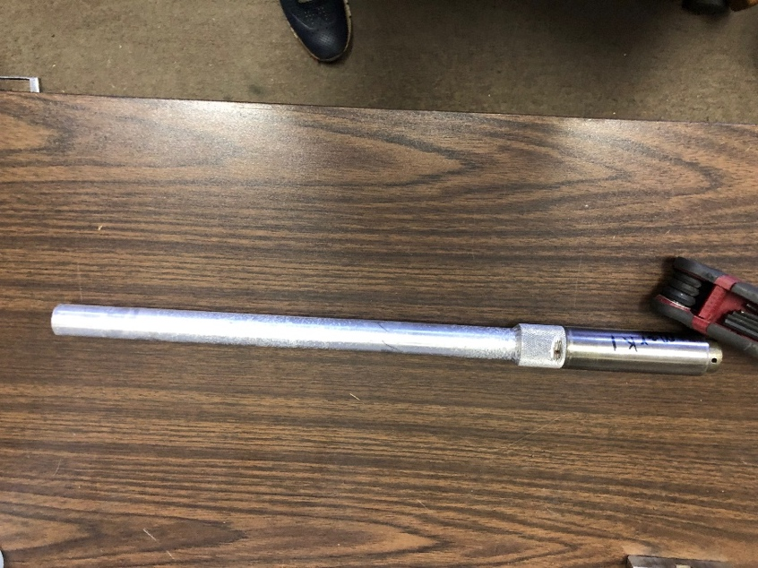
Figure 2: Example of a JLS Model 6810 source holder

During the process of removing the source from the source holder, the source was breached releasing Cs-137 into the MHC and resulting in the spread of radioactive contamination.

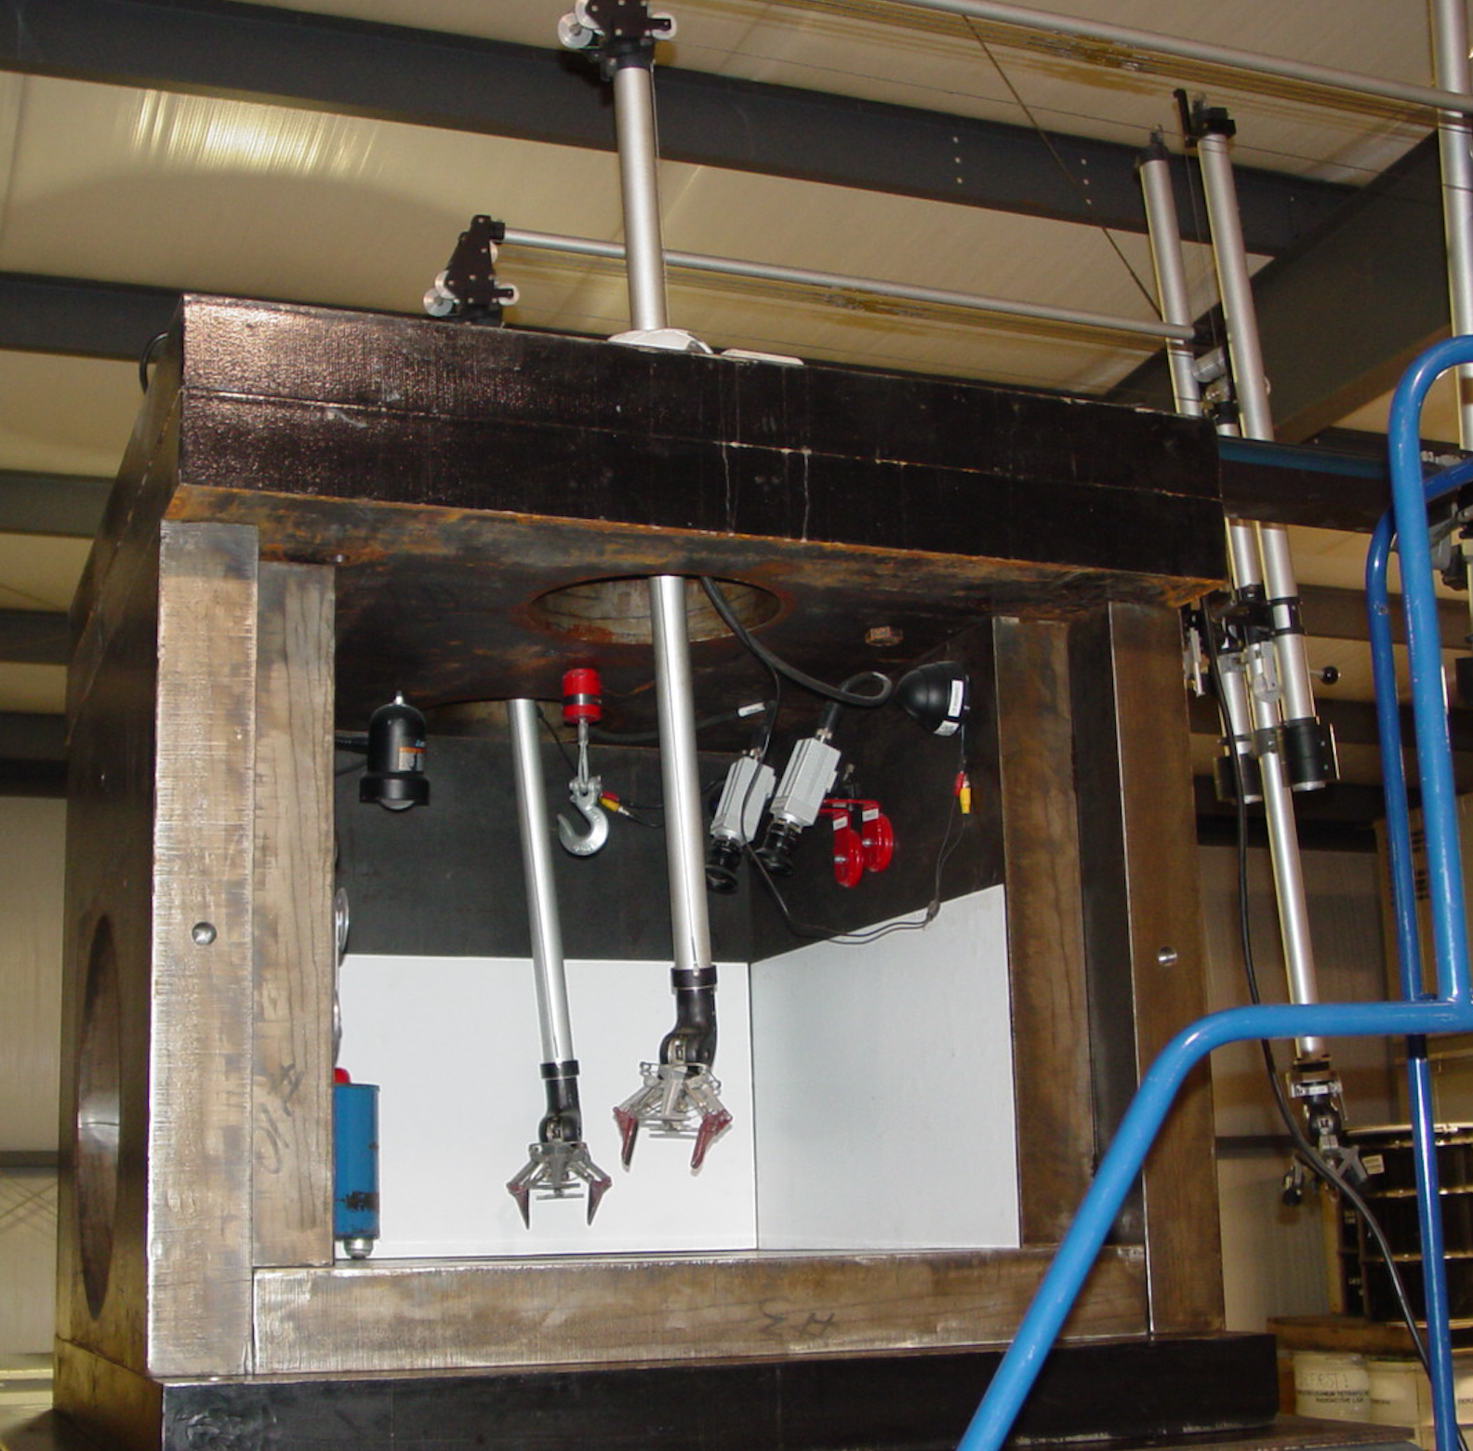
Figure 3: Contractor’s Mobile Hot Cell

A Joint Investigation Team was appointed to perform an investigation to identify root causes and Lessons Learned from the incident. This team included NNSA employees and Triad National Security, LLC (Triad) employees. The investigation found two root causes, which if corrected would prevent recurrence of the same or similar accidents.

Root Cause #1: OSRP’s contracting process did not effectively implement safety requirements for off-site work

Root Cause #2: DOE is managing work regulated by the NRC or an Agreement State without clearly defined roles and responsibilities.

Although the root causes are different, there are other examples of incidents involving radioactive materials resulting in damage. The theft of a Co-60 teletherapy source in Tepojaco, Mexico, occurred due to failures in procedures, regulatory controls, and requirements which and had severe detrimental effects. A transport security plan would have identified safe havens, appropriate rest stop for the drivers, and safe transportation routes. The International Atomic Energy Agency (IAEA) Nuclear Security Series No 9, Security of Radioactive Material in Transport, states “All shippers, carriers, receivers and others engaged in the transport of radioactive material packages assigned to the enhanced transport security level should develop, implement, periodically review as necessary and comply with the relevant provisions of a transport security plan and if a road movement cannot be completed without overnight or extended stops, then the radioactive material should be protected during such stops in accordance with a graded approach.” Additionally, “the shipper and carrier should develop and implement a contingency plan to ensure an adequate response to malicious acts”. While additional safety and security measures may not have prevented these incidents from occurring, they may have mitigated the resulting personal and economic damage.

Integrated Safety Management System

As can be seen from above one of the roots causes was ineffective implementation of safety requirements. The Department of Energy Acquisition Regulation (DEAR) requires that a contractor shall perform work safely, in a manner that ensures adequate protection for employees, the public and the environment. The DEAR also identifies the contractor, regardless of the performer of the work, as responsible for the compliance with the environmental safety and health (ES&H).

The manner that DOE meets these requirements for on-site work is through their Integrated Safety Management (ISM) System. An effective ISM System’s objective is to integrate safety into management and work practices at all levels, addressing all types of work and all types of hazards to ensure safety for workers, the public, and the environment.

There are five core functions in the ISM process. These functions are not independent, sequential functions but instead, a linked, interdependent collection of functions that often occur. The five functions are:
- Define Scope of Work
- Analyze Hazards
- Develop/Implement Hazard Controls
- Perform Work
- Feedback
The core functions are applied in a continuous cycle as shown in Figure 4

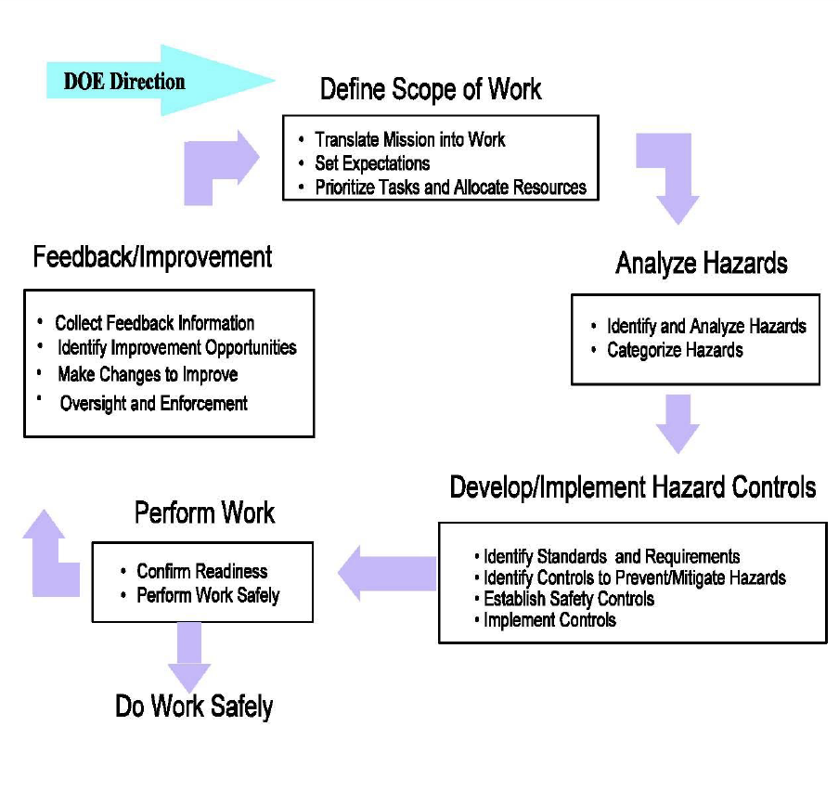
Figure 4: Integrated Safety Management Functions

One of the guiding principles of ISM Systems is clear roles and responsibilities. For example, it is important that the responsibility and authority for safety are well defined and clearly understood by all parties prior to performing the work and is integral in the performance of the work. All parties should also be knowledgeable on their roles and responsibility authorities that are clearly defined at the institutional, facility, and activity levels.

New Requirements

Using the ISM System as a guide, OSRP has instituted changes to how contracts are issued for the removal of self-shielded irradiators containing Category 1 and 2 radioactive sources to ensure the ISM principles are flowed down to its subcontractors. These new requirements ensure the full scope of work is understood by all parties, increased engagement with regulators, contractors have the license capability to complete the scope of work, all hazards are identified and appropriately mitigated, the work is performed safely in accordance with work documents, and any lessons learned are appropriately distributed. The safety changes made to the program are listed below.

Defining the Scope of Work
- A new policy was implemented to require all parties (the M&O Contractor, licensee, and subcontractor) to sign an Acknowledgement of Roles and Responsibilities.
- Subcontractors are required to submit their current license with the proposal for each subcontract to ensure the work falls within the license. In addition, subcontractors are required to provide notification of any changes to their license applicable to OSRP work. This ensures the removal contractor can complete the proposed work in accordance with their radioactive material license during the contracting process.

- Subcontractor provides the applicable regulator(s) with the site‐specific work plan so they fully understand the work to be performed

Analyzing the Hazard
- All contracts require a site-specific work plan and Hazard Analysis and Mitigation Response Plan/Health and Safety Plan to address hazards that can be reasonably expected while performing source recoveries.

Developing/Implementing Hazard Controls
- Detailed site-specific work plans and Hazard Analysis and Mitigation Response Plan/Health and Safety Plan will be reviewed by a panel of subject matter experts prior to each recovery.
Performing Work
- On-site safety oversight is required for each recovery. This individual performing oversight must be knowledgeable of the site-specific work plan and ensure all work is performed in accordance with the approved work plan. Any work deviating from the work plan will trigger a work pause to reevaluate the activity, any new health and safety hazards, and mitigation measures required for the deviation.
- All individuals (contractor, subcontractor, facility representative, regulatory authority) participating in the activity have the right to pause or stop work due to safety or other concerns.
- Subcontractors are required to have a copy of operating and emergency procedures on hand during source recovery operations.
Feedback/Improvement
- All subcontractor’s performance assessments will be completed yearly, at a minimum.
- Safety-related lessons learned will be communicated as soon as possible to all contractors.
- A lesson learned review will be completed yearly, at a minimum.

Conclusion

While the new OSRP requirements for source recoveries were instituted to address gaps identified after the breached source incident, these principles can be applied to improve all aspects of sealed source lifecycle. For instance, if a hazards analysis had been completed prior to the Tepojaco theft, increased concern may have been raised about developing an adequate transportation security plan for the shipment, identifying safe havens along the transportation route and use of a platform trailer with an integrated crane. Incorporating lessons learned from the May 2019 breached source event will make ongoing OSRP source recovery operations safer. Both successes and failures provide the necessary opportunity to evaluate and continuously improve radiation work and safety processes. Implementation of the five principles of ISM Systems (Defining the Scope of Work, Analyzing Hazards, Developing/Implementing Hazard Controls, Performing Work, and Feedback/Improvement) help ensure radioactive handling and management activities are completed safely, and that worker and public safety is continuously addressed.

