THE IAEA DATABASE ON RADIOACTIVE
DEVICES CONTAINING DEPLETED URANIUM
(DU) AS RADIATION SHIELDING

N. HAMMOUD
IAEA
Vienna, Austria
Email: N.hammoud@iaea.org

J.C. BENITEZ-NAVARRO
IAEA
Vienna, Austria
Email: J.C.Benitez-Navarro@iaea.org

W. STEWART
IAEA
Vienna, Austria
Email: W.Stewart@iaea.org

Abstract

There is a large inventory of disused sealed radioactive sources (DSRS) that have been accumulated in various Member States, and it is likely to continue increasing over time, given the current and future potential use of sealed radioactive sources worldwide. In the context of the safe management of DSRS, an important and emerging issue of immediate concern is the management of Depleted Uranium (DU) contained in radiation shielding materials. In order to enhance the safe management of devices containing DU, the IAEA has developed a database that includes information about devices which contains DU as shielding materials for sealed radioactive sources (SRS).
The Database contains basic information on more than 500 models of radioactive devices (used in medicine, industry, research and agriculture) that contains DU as shielding material. The information includes (1) the device model, (2) the manufacturer and/or distributor, (3) the amount of DU (in Kg) in each model, (4) the use of the device, and (5) Pictures of each device to facilitate the proper identification. Additional relevant information (e.g. years of production/distribution, radionuclide shielded) is included in the “comments” field.
The Database is published under the Professional Network DSRSNet, and it is readily accessible to all professionals registered users for the DSRSNet.
The Database is particularly useful for Member States to compete their national inventories of DSRS and, prepare their national strategy for the safe management of DSRS. The database also helps Member States in complying with their safeguard obligations. The database is being recurrently used by safeguard professional and inspectors in identifying such nuclear material.

INTRODUCTION
Enriched uranium used for nuclear power plants, research reactors and naval propulsions is obtained by the process of enrichment of natural uranium, where the concentration of U-235 is increased from ~0.7% to 3.0-90.0% based on the purpose of the application. The by-product of the enrichment process is depleted uranium (DU). Depleted Uranium is the remaining U-238 obtained after the enrichment process. As DU is 99.75% ²³⁸U, it is less radioactive compared to natural Uranium, it also has a high density of 19.1 g/cm3 which makes it 68.4% denser than lead, this makes it attractive as a shielding material. However, it is considered a toxic material and hazardous if inhaled or ingested ‎[1-3].

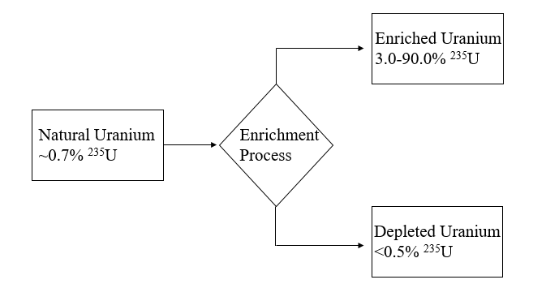
FIG. 1. This figure shows the enrichment process of natural uranium and highlights that depleted Uranium is a by-product

One of the most important features for a gamma radiation shielding material to have is a high density to attenuate radiation. As DU is a very dense material, it has been used as shielding material for civilian and military purposes. Civilian uses include medicine, space, agriculture, and other industrial applications. At the end of the service lifetime of the devices that contain DU shielding, they fall under the category of disused sealed radioactive sources (DSRS) ‎[2]‎[4]. For example, Portable industrial gamma radiography devices contain several kilograms of shielding material, consisting of DU, lead, or tungsten. Well-logging devices can contain DU as housings for the gamma sources. Teletherapy machines, used for cancer treatment, often contain DU as a shielding material, as well as use in the collimators. Considering the safe management of DSRS, the management of devices that contain depleted uranium as radiation shielding is of vital importance to ensure the shields are managed as radioactive waste. The focus of this paper is to highlight the importance of the Database of Devices Containing Depleted Uranium as Radiation Shielding developed under and available on the Disused Sealed Radioactive Sources Network (DSRSNet). Importance is given to the aims and different features of the database, highlighting the source of information, and to show case studies that will underline the importance of the database as a useful tool for IAEA Member States.

Objectives of the database
The database concept was established based on the needs of member states to be able to identify, visually, the disused sealed radioactive source devices that contain DU as radiation shielding material. The database aims are:
- to enhance the safe management of DSRS that contain DU as radiation shielding;
- to assist member states in identifying those sources/devices;
- to support member states in complying with their safeguard obligations.

The database also assists in the rapid identification of the sources and devices due to being accessible to members of the DSRSNet, it gives all required information which can be easily filtered to identify the wanted source. As the database contains more than 500 devices, it is a reliable source of information to help in identifying most sources.
Depleted uranium is included in the definition of ‘source material’ for safeguard purposes and, thus, is considered nuclear material subject to safeguards. Consequently, DU must be declared to the IAEA by Member States with a comprehensive safeguards agreements (CSA) in force. When a DU shield that is not in the national inventory is discovered or identified, the first action should always be to document the material. The DSRSNet DU database will certainly assist Member States in this endeavour.

Information source and identification process
The first step in the identification process is to recognize the presence of DU in the device shielding, in case of uncertainty, characterisation techniques such as using gamma spectrometry will be useful as a starting point‎[2]. After that, obtaining critical information, such as model type or the manufacturer will be crucial to identify the source/device by navigating the database and trying to compare the information available with suspected device/source.

The development of the database involved the collection of information available within the IAEA and from:

- Source Manufacturers and Distributors;
- Devices and Equipment Manufacturers and Distributors;
- Regulatory bodies in Member States;
- Waste Management Organizations;
- Professional Associations;
- Main users of radiation sources.

Overall, these references aided in the development of the database and ensured the most comprehensive list of devices possible.

The Database
The target user group of the database includes a broad spectrum, such as regulators, professionals dealing with orphan sources, manufacturers, distributors, emergency response professionals, users of sources/devices, law enforcement organizations, customs, production plants, and waste management companies. The database contains basic information on all models of radioactive devices (used in medicine, industry, research, and agriculture) that contain DU as shielding material. The information includes: visual aids, mass of DU in Kg, the manufacturer/distributor, usage, and additional information. The database also provides information about those devices which facilitates source identification based on limited available information from the users site and thus assists in handling the devices safely.
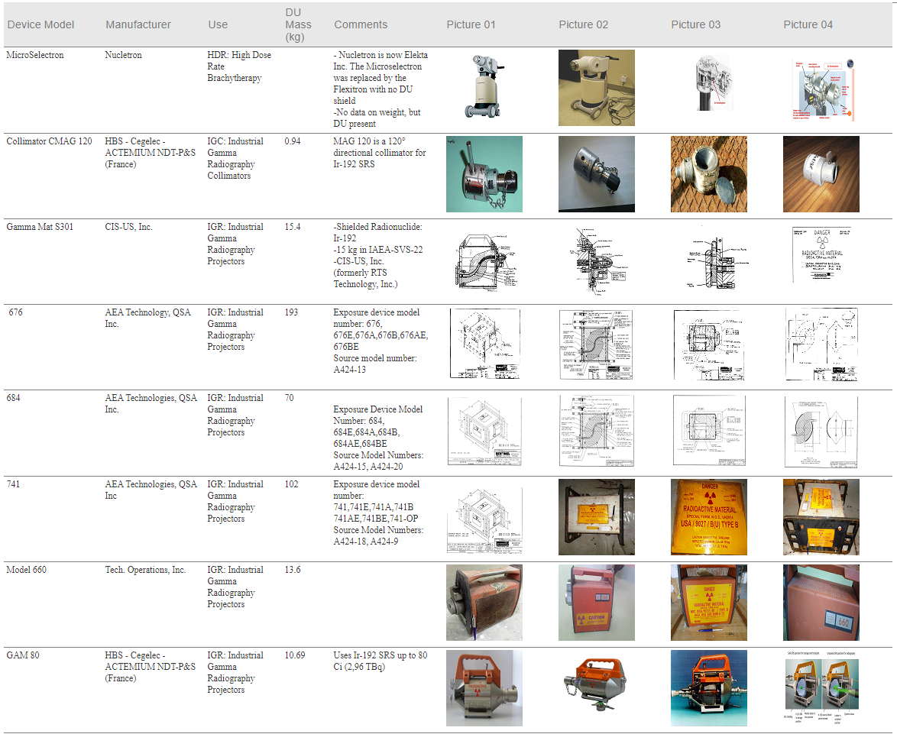
FIG. 2. A part of the Database that shows the features discussed in section 4

Prior to the DSRSNet DU database there was no such digital information source at the IAEA. The safeguard publication [Safeguards Implementation Guide for States with Small Quantities Protocol – Service Series No. 22, IAEA 2013], includes a table on devices containing DU, as examples. It is not an exhaustive database though and exists rather as listed examples. The basic information for the safeguards table was extracted from the International Catalogue of Sealed Radioactive Sources and Devices (ICSRS). The ICSRS is a more structured database providing information spanning sources, devices and suppliers with more sensitive information and linking all elements in a more complex structure which has access restrictions. The devices containing DU are not listed separately in the ICSRS, as it was not the design requirement of the ICSRS. Furthermore, the ISCRS is an access restricted Catalogue requiring a nominated contact point from each Member States, however, the DU database is accessible for all members of the DSRSNet.

Visual aids (pictures)
The Majority of the devices contained in the database have pictures to facilitate the proper identification of the device, which in some cases includes illustrations as well as previously found device images, either in the original configuration or damaged. The aim is to provide the user has a means of a basic identification process, where the user is confident with the characteristics of the device in possession, which in turn can assist with future identifications. Figures 2 and 3 show examples of visual aids for the same device from the database, where one is an illustration and the other is an image.
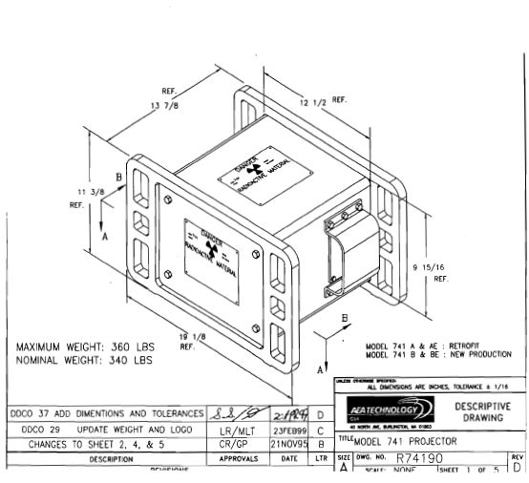
FIG.3. Illustration of model 741 Industrial gamma radiography projector

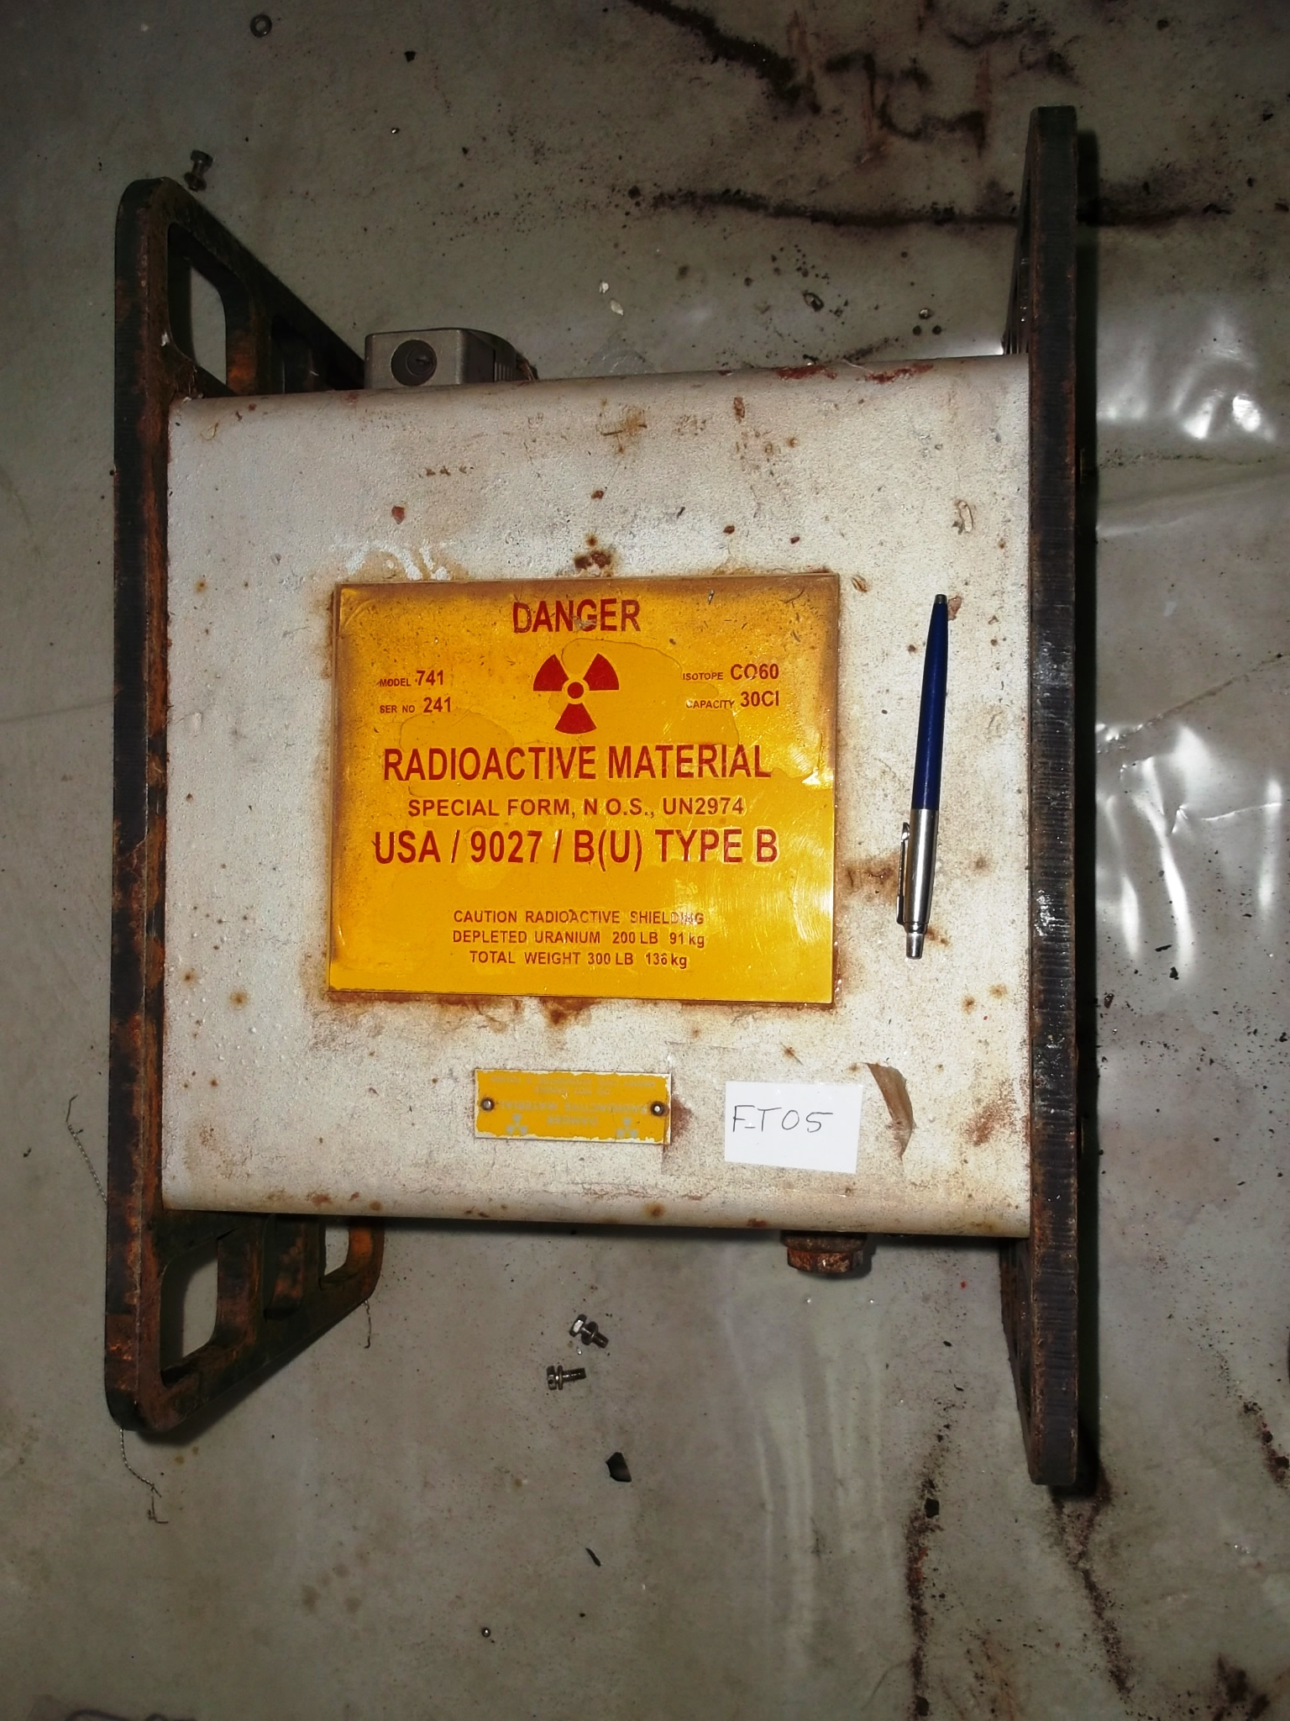
FIG. 4. Picture of a model 741 Industrial gamma radiography projector

Mass of DU (in Kg) in each model
The mass of DU present in each device helps in identifying management during the dismantling of the device and provide awareness on safe handling. For some devices, the database delineates explicit information about the mass of different parts of the device and shielding. For example, for some teletherapy machines it is specified how much DU there is in the head, the drawer, the trimmer bars, and collimators of the device.

Manufacturer and/or distributor
The database contains the names of the companies that manufactured or distributed the devices to provide assistance to the users in identifying the first contact point if they have concerns about the device. Companies captured in the database represent different countries around the world, including, but not limited to USA, Canada, Russia, China, UK and Germany.

Device model
The device model is one of the primary identification features that users will utilize to identify their device. The database contains around 680 different device models and for some of the device models the database provides the associated serial number as well, which helps to narrow the search and determine the characteristics of the device.

Use of the device
The use of the device is of a vital importance to the user as it gives them indication about the purpose the device was used for. The database covers all uses of radiation sources when DU is used for radiation shielding. In the search menu there is a dropdown including different device applications such as: teletherapy, low/high dose rate brachytherapy, industrial gamma radiography, self-shielded irradiators, collimators, and packages.

Additional information
This section provides additional indications about the device, such as years of production/distribution, information about manufacturers and company history, the shielded radionuclides, the mass of the device, the dimensions of the device, or the source of information. Any additional information is included in the “comments” field.

Examples of the Use of the DU database
The DU database has already been consulted by over hundreds of users from IAEA Member States and International Organizations. To illustrate the practical uses of the database, two examples are provided here:

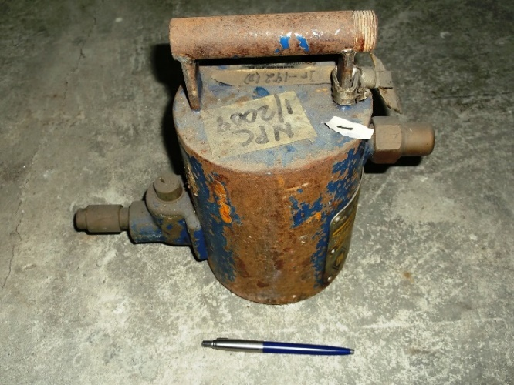
Example 01: The national organization for Radioactive Waste management in Country A has stored several gamma radiography cameras waiting for the decay of the Ir192. After several years the devices still showed measurable gamma dose rate on the surface of the device. The national operators consulted the DU Database and verified that the devices in storage contained DU as the shielding material. The DU database helped to define the proper management option for the stored disused devices. Subsequently, the operators contacted the safeguards organization in the country to inform these devices contain nuclear material to be declared and controlled under safeguard agreements.

FIG.5. A gamma radiography Camera

Example 02: With the assistance of the IAEA, Country B returned a disused teletherapy unit with Co60 source to Country C. The source was removed from the device and transported in a type B(U) package. The empty teletherapy unit containing DU as shielding material was also packaged for international transportation. The DSRSNet Database on DU was consulted for the precise amount of DU (104.3 Kg) contained in this particular model of teletherapy unit. The DU database allowed for the proper preparation of the package, the export and import documentation, as well as the proper control of the DU as nuclear material during international transfer.
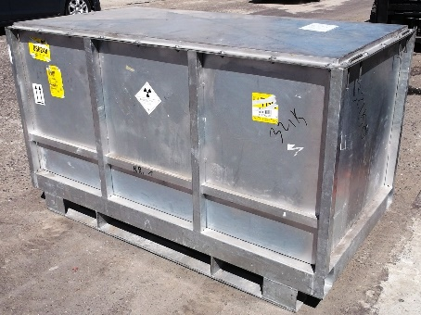
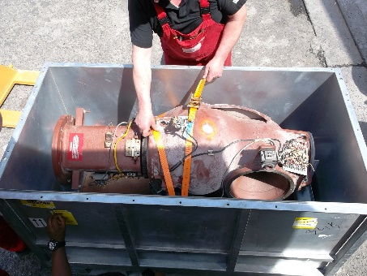
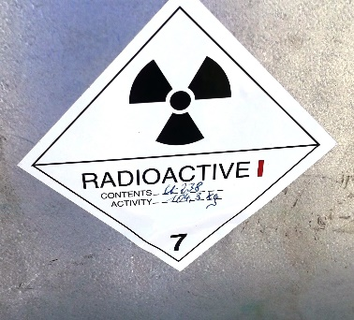
FIG. 6. Teletherapy unit packaging process

Conclusion
In the context of the safe management of disused sealed radioactive sources, an important issue of immediate concern is the management of Depleted Uranium (DU) contained as radiation shielding in some devices.
A database of information about devices which contain DU as shielding materials for sealed radioactive sources (SRS) has been developed by the IAEA. The Database is available under the Professional Network DSRSNet, and it is readily accessible to all registered users for the DSRSNet.
The Database currently contains basic information (such as device’s pictures, device use, device model, suppliers, and amount of DU contained) on more than 500 models of radioactive devices (used in medicine, industry, research, and agriculture) that contain DU as shielding material.
The Database is particularly useful for Member States to complete their national inventories of DSRS and prepare their national strategy for the safe management of DSRS. The database also helps Member States in complying with their safeguard obligations. The database is being actively used by waste management organizations, safeguards professionals, and inspectors, in identifying such nuclear material.

References
- WORLD NUCLEAR ASSOCIATION, Uranium and Depleted Uranium, (2020).
- OECD/NEA, Management of Depleted Uranium, Nuclear Development, OECD Publishing, Paris, (2001)
https://doi.org/10.1787/9789264294998-en.
- HERIOT, ID., Uranium Enrichment by Centrifuge, Report EUR 11486. Commission of the European Communities, Brussels (1988).
- BLEISE A, DANESI PR, BURKART W. Properties, use and health effects of depleted uranium (DU): a general overview. Journal of environmental radioactivity. (2003);64(2-3):93-112.

The author is currently a PhD student at the University of Manchester. Email: nehammoud@gmail.com or nour.hammoud@postgrad.manchester.ac.uk

