# Management of Liquid Radioactive Effluents from Hospitals where Public Sewage System is not established

SHIMJA BHANU. K. M

Atomic Energy Regulatory Board

Mumbai, India

Email: shimja@aerb.gov.in

G. SAHANI

Atomic Energy Regulatory Board

Mumbai, India

PANKAJ TANDON

Atomic Energy Regulatory Board

Mumbai, India

**Abstract**

## The prime source of generation of liquid radioactive waste in hospitals is radionuclide therapy facilities, as high levels of activity is handled in such facilities. The most common radionuclide therapy world-wide is radioiodine therapy and the same is the case in India too. As per the existing regulations in our country, radionuclide therapy using I-131 with activity more than 1.11 GBq (30 mCi) is carried out in isolation wards with attached toilet facilities. Plumbing lines from these toilets are connected to a delay- decay tank in order to allow the radioactive effluents to decay to an acceptable limit prior to the release to the Public Sewage System.

## Though, radioiodine therapy is a proven method for the treatment of Ca- thyroid patients, it was limited, till recent times, to hospitals in major cities mainly because of the difficulties in management of Radioactive liquid effluents arising from the therapy wards. Around 80% of the administered activity is released through patient excreta in first 48 hrs of treatment. Hence, an effective waste management system should be in place in order to reduce the environmental radiological impact.

## In India, currently there are “110” such hospitals providing high dose radioiodine therapy. Radioactive waste generated in the form of liquid effluents from these facilities is decayed using a dual delay-decay tank system before discharging to main sewage line. The capacity of each tank is 3000 litres per patient bed. The radioactivity concentration should not exceed prescribed limit of 22.2 MBq/m3 when releasing it to the main sewage system as stipulated in Atomic Energy (Safe Disposal of Radioactive Wastes) Rules, 1987.

## In few occasions, when the hospital is in the outskirts, they are not connected with the established sewage systems and hence management of such wastes becomes a challenge. In order to facilitate the patient treatment and management of radioactive waste generated in such situations, a potential alternative to public sewage system for radioiodine therapy facilities have been established. One of the solution would be that after due decay to an acceptable limit from delay-decay tank, the effluents can be transferred to a septic tank, made of concrete. Further management of these wastes from septic tank is either by manually collecting and transferring these radioactive waste to municipal sewage plants or by permanently storing in soak pits within the facility.

## INTRODUCTION

Radionuclides are widely used in Nuclear Medicine for carrying out diagnostic and therapeutic procedures. In India, there are 370 Nuclear Medicine Facilities using radionuclides for such purpose. The most commonly used radionuclides for diagnostic purpose are 99mTc, 18F, 131I and 68Ga. Commonly used radionuclides for therapy purpose include131I, 177Lu, 32P, 153Sm, and 90Y. Use of these radionuclides generates radioactive waste. Among these radionuclides, Iodine-131 is the most commonly used radionuclide for therapy and currently there are ‘110’ such hospitals in India providing radioiodine therapy to patients. As per the existing regulations in our country, patient has to be admitted in dedicated wards with attached toilet if the activity administered is more than 1.11 GBq (30 mCi). Approval for these wards, from radiological safety vie point, is a pre requisite for starting High Dose (i.e more than 1.1 GBq 131I) Therapy in any Nuclear Medicine Facility. Majority of facilities are approved with 2 wards and the authorized activity per ward is 11.1 GBq(300 mCi) per week as per the existing regulations. Hence, approximately 22.2 GBq (600 mCi) 131 I in a week i.e 1110 GBq (30 Ci) 131 I in a year is used in a High Dose Therapy facility. As 80% of this activity is eliminated through patient excreta during patient stay in hospital, this amounts to 888 GBq (24 Ci) in a year and hence the excreta of these patients cannot be released to the environment directly through common drainage lines. As per the existing regulatory requirements, this waste is managed by “delay and decay” using a dual tank system before releasing to the main sewage lines. But, there are situations which pose challenges to the regulator in case of hospitals situated in outskirts which are not connected with the established sewage systems. An efficient solution to this problem and the radiological safety aspects of the same is discussed in the paper.

## Existing regulatory requirements for management of liquid radioactive effluents

In India, the regulatory and safety requirements for management of radioactive waste from hospitals is governed by the (a) Atomic Energy (Safe Disposal of Radioactive Wastes)Rules, 1987 (b) AERB safety code for nuclear medicine facilities (AERB/RF-MED/SC-2(Rev. 2. 2011), (c) AERB Safety code on management of radioactive waste (AERB/NRF/SC/RW) and (d) AERB safety guide on “Management of radioactive waste arising from the use of radionuclide in nuclear medicine, industry, research and decommissioning of such facilities (AERB/RF/SG/RW-6, 2007)”. As per Atomic Energy (Radioactive Waste Disposal) Rules -1987 (GSR-125), the total activity discharged from hospitals should be limited to 1 Ci (37GBq) per year with the limitation of daily activity released and monthly average concentrations for various radionuclides. For 131I, these limits are 3.7 MBq and 22.2 MBq/m3 respectively. In order to ascertain these limits, excreta from patients undergoing radioiodine therapy is stored in a delay tank and released into the sewage system after measuring the activity concentration. 2 tanks, as shown in Fig 1, one for collection and one for decay, each with capacity 3000 litres (3m3) per patient bed is the existing requirement



*Fig 1.Typical diagram of Delay-Decay tank system for management of radioactive liquid effluents from a therapy facility with 2 wards. Capacity of each tank is 6000 liters (6m3) in this example*

When the first tank is full, it is closed and kept for decay while the second tank is being filled. There are level indicators connected to these tanks in order to avoid overflow of the tanks. As shown in Fig 2 entry to the delay tank area is restricted by proper fencing.

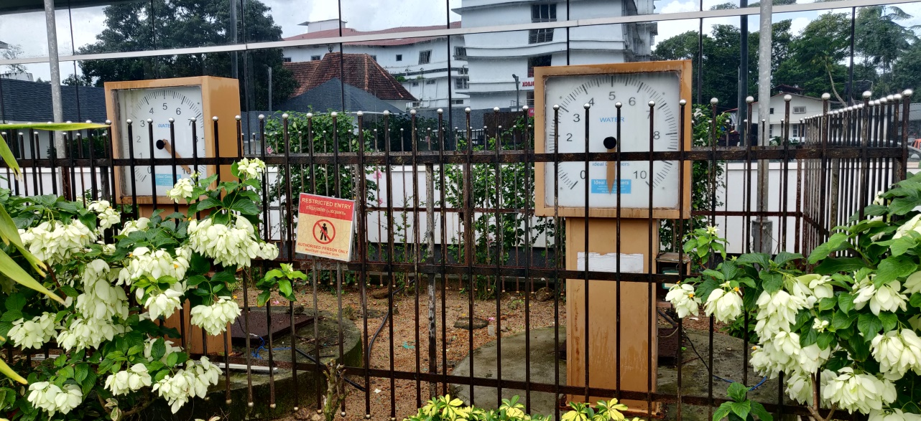

## *Fig 2. . Delay tanks with fencing and level indicators (Picture courtesy: St. Gregorios International Cancer Care Centre, Kerala, India)*

## challenges faced by hospitals located in places where public sewage system is not established

As mentioned above, the liquid effluents need to be released to the public sewage system after sufficient decay. Some hospitals located in outskirts of cities are not connected to the public sewage system and hence further management of these effluents is always a challenge. Because of this reason, radioiodine therapy was limited, till recent times, to hospitals in major cities only though it is proven as an efficient treatment for Ca-thyroid patients. In order to facilitate the patient treatment and management of radioactive waste generated in such scenarios/situations, there is a need of a potential alternative to public sewage system.

## solution to the problem

For hospitals which are not connected to the main sewage system, the radioactive waste management has to be done institutionally by the hospitals. The effluent from the delay-decay tank, after reaching the prescribed discharge limit goes to main sewage chamber; from where it is directed to an underground Concrete Septic tank. The capacity of the septic tank should be based on the anticipated waste volume and activity considering the number of patients and the delay tank capacity. The tank should be leak proof including top of the tank. Adequate shielding should be provided and there should be provision to avoid rain water seepage into the tank. Fencing should be provided around the tank in order to prevent unauthorized access.

Radioactive effluents reach the septic tank when the activity level is below discharge limit. Hence, by the time the septic tank gets filled the activity will be negligible. In some locations, these effluents are transferred manually to the municipal sewage plants for further management. It should be ensured that the activity will be equivalent to back ground level before transferring. In certain other places such manual transferring is also impractical and hence these effluents should be managed in the hospital itself. In such situations, when the septic tank fills and overflows, the effluent will go to a soak pit which is made with brick wall and filled with brickbat which allows water to slowly soak into ground dissipating into the ground water. Technical drawing of one such arrangement is shown in Fig 3.

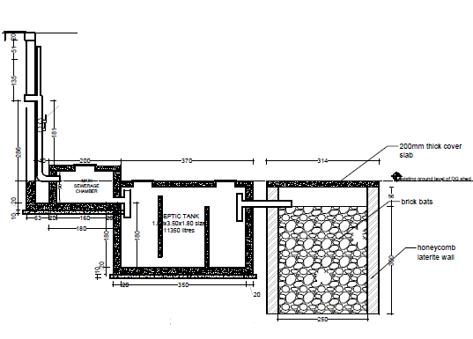

## 

*FIG. 3. Cross sectional diagram of septic tanks and soak pit (Picture Courtesy: Malabar Cancer Centre, Kerala, India)*

After sufficient decay from the delay-decay tanks, the effluents are transferred to the sewage chamber which is then flowing to the septic tank. The capacity of the septic tank is almost double of the delay-decay tank in this example (6000 litre delay tank and 11360 litres septic tank). The arrangement of septic tank and soak pit is in such a way that once the septic tank is full, its contents flow to the soak pit.

## safety assessment

A detailed radiation survey is carried out all around the soak pit for checking the external radiation level. It is found that the radiation level around the soak pit is equivalent to the background radiation level of that area

.

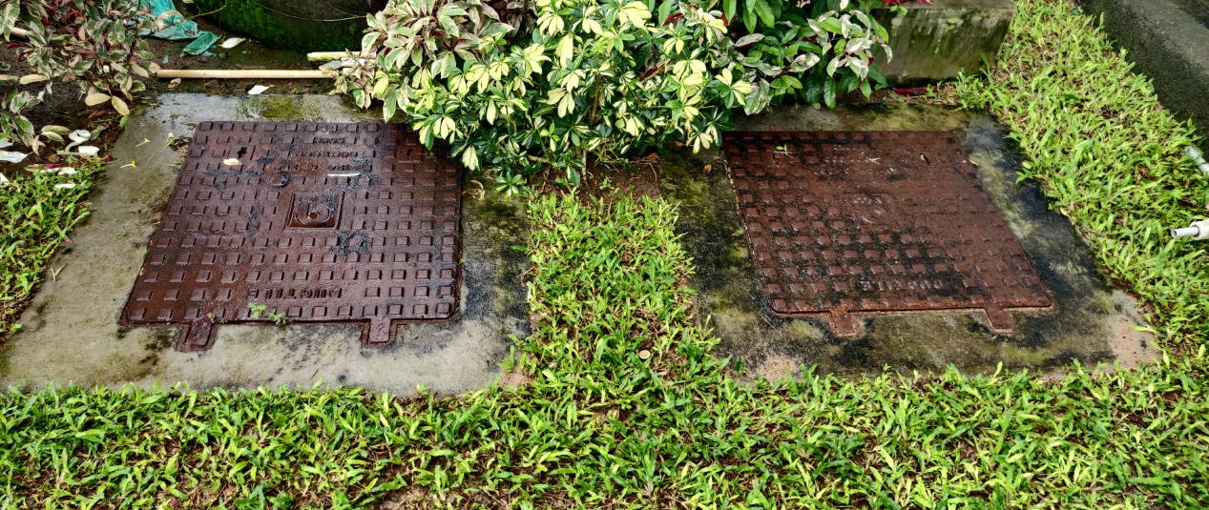

## *FIG 4*. *Soakpits provided for further management of liquid effluents from septic tank (Picture Courtesy: St. Gregorios International Cancer Care Centre, Kerala, India)*

As water from soak pit gets migrated in to the ground water, it is crucial to check the ground water contamination, especially when there are drinking water sources in the premises. The hospital under study has no drinking water wells in their campus. Even then, level of ground water contamination was checked by collecting water samples from a bore well, which is constructed for monitoring purpose. The radioactivity in the sample collected is below detectable level

## Conclusion

Management of liquid radioactive effluents resulting from Iodine therapy wards has always been a topic of great concern for the hospitals as well as the Regulators. The seriousness of this issue escalates when the hospital is not connected to the public sewage lines. Though radioiodine therapy is a proven method for the treatment of Ca- thyroid patients, it was limited, till recent times, to hospitals in major cities only mainly because of this issue. In order to facilitate the patient treatment and management of radioactive waste generated in such scenarios, a potential alternative to public sewage system for radioiodine therapy facilities have been established. Safety assessment of this alternative system, which consists of a septic tank and soak pit, proves that radiological safety is not compromised with such arrangements.

ACKNOWLEDGEMENTS

The authors acknowledge the wholehearted support and continuous encouragement offered by Dr. Dash Sharma, Head, Radiological Safety Division AERB. Mrs. Resmi. K. Bharathan, Mr. Chandran. K, Mr. Rahul. M and Dr. Rahul. A.S from Malabar Cancer Centre, Kerala are acknowledged for carrying out the water sample measurements from bore well and Mr. Arundev from St. Gregorios International Cancer Care Centre, Kerala for carrying out the radiation protection survey around the soak pit. The support offered by Dr. Reshma Bhaskaran from Govt. Medical College, Calicut, Kerala is also acknowledged.

References

1. Atomic Energy (Safe Disposal of Radioactive Wastes) Rules 1987.
2. AERB safety code for nuclear medicine facilities (AERB/RF-MED/SC-2 (Rev. 2, 2011).
3. AERB Safety code on management of radioactive waste (AERB/NRF/SC/RW).
4. TECDOC-1714, Management of discharge of low level liquid radioactive waste generated in medical, educational, research and industrial facilities, IAEA, Vienna (2013).
5. Typical layout diagram for Nuclear Medicine Facilities,

<https://www.aerb.gov.in/images/PDF/NuclearMedicine/3.6.6-Typical-layout-diagram-for-Nuclear-Medicine-Facility.pdf>