# Classification of the metallic

# radioactive waste streams of the

# different types of reactors in PREDIS

R. PLUKIENĖ, A. PLUKIS, E. LAGZDINA, M. KONSTANTINOVA

Center for Physical Sciences and Technology (FTMC)

Vilnius, Lithuania

Email: rita.plukiene@ftmc.lt

**Abstract**

Metallic radioactive waste (MRW) with a wide list of radionuclides of different concentrations is one of the important issues for every nuclear power plant under decommissioning dealing with the radioactive waste management and final disposal. The best practice is needed for optimized waste classification including the quantification of specified radionuclides but also for assessment of activity reduction and declassification possibilities in the waste materials before placement in the specific disposal sites. The classification of the MRW streams is changing together with its activity: the high and intermediate activity radioactive waste (HLW, ILW) needs classification related to radioprotection and best packaging concept, low level and very low level radioactive waste (LLW and VLLW) needs decontamination and clearance or declassification afterwards to meet the waste acceptance criteria (WAC) of the disposal site. The largest volumes of waste from the dismantling of nuclear installations is mainly be VLLW and LLW [1]. In the frame of PREDIS project, one of WP4 4.5.1 subtask is aiming to provide a scheme for classification of the reactor metallic materials regarding the level of activation: highly activated, intermediate, low activation metal constructions and non-activated materials in order to facilitate the procedure of decontamination and clearance or declassification. The methodology for characterization of the metallic waste is similar to all reactors and is based on nuclide vector (NV) determination. An essential part of the metallic waste characterization is the separation of neutron activation and surface contamination activity parts to identify the best way of management. Optimized NV is obtained by analyzing and systemizing the information about radioactive metallic waste streams, identifying the optimal list of relevant radionuclides and performing numerical analysis of activation and contamination parts for the waste streams.

## INTRODUCTION

The radioactive waste management and disposal strategy are the major issues, which are important for each member state having either operating nuclear power plants (NPP) or NPP under decommissioning. All NPPs decommissioning should be managed by using the best nuclear energy practice implementing the contemporary radioactive waste management, utilization and storage technologies, which assure the long-term safety and minimal ionizing radiation effect on the population and environment. Metallic radioactive waste is generated in a number of different kinds of facilities and it usually has a wide list of radionuclides of different concentrations. Worldwide, 11 reactors have been closed and decommissioned due to accident, 27 reactors have been closed by political decision and 156 reactors have been closed after their lifetime by September 2021 [2]. The majority of the NPP waste resulting from decommissioning and dismantling is radiologically unrestricted material i.e. waste for clearance. The remaining one-third is the radioactive material with different activity levels [3]. The MRW has to be collected, segregated, characterized, treated/decontaminated, stored and finally disposed of in special disposal facilities. Implementing effective programs for the reduction of radioactive waste, important aspects are: limiting (reduction) the size of controlled areas; decontamination and reuse of materials; waste sorting - classification according to nuclide vector technology; consistent implementation of waste reduction philosophy (waste preparation according to a quantity reduction program, modern technology implementation, regular employee training, best nuclear energy practice information dissemination).

According to EURAD project WP ROUTES analysis on categorization/classification of RWs in member states there is no completely unified approach for RW classification. Various countries apply different types of RW classification, and sometimes several types of classification are used simultaneously in the same country [4].

In general, the PREDIS project targets innovation and break-through technologies for safer, more efficient, cost-effective, and environmentally friendly handling of metallic, liquid organic wastes and solid organic wastes radioactive wastes. The main aim of the 4.5.1 subtask of PREDIS is to provide a scheme for the classification of the reactor metallic materials regarding the level of activation: highly activated, intermediate, low activation metal constructions and non-activated materials in order to facilitate the procedure of decontamination and clearance or declassification. The methodology for characterization of the metallic waste is similar to all reactors and is based on nuclide vector (NV) determination. The main steps include:

1. Pre-dismantling: classification of MRW using modelling by obtaining neutron activation map in the 3D of reactor core and peripheral hardware and/ or using sampling methods where applicable.

2. Detailed characterization of MRW during dismantling via experimental measurements applying non-destructive and destructive measurement techniques (analysis of measurement results of the samples).

3. Optimized characterization: determination of Nuclide Vectors for MRW stream. Combination of modelling and experimental measurements allows the separation of waste streams to homogeneously activated MRW, mixed (activated and surface contaminated) MRW and surface contaminated metallic waste.

Optimized NV is obtained by analysing and systemizing the information about radioactive metallic waste streams, identifying the optimal list of relevant radionuclides, describing inter-correlations between key nuclides and difficult to measure nuclides including multivariate analysis of the already measured data at the sites and numerical analysis of activation and contamination parts for the waste streams.

## Radionuclide generation and distribution in METALLIC WASTE at the different nuclear reactors

Regarding radionuclide generation and distribution in MRW at the different nuclear reactors, there are certain similarities and differences which depends on particular reactor type, fuel and moderator material applied, operation history etc. Pre-dismantling classification of MRW using modelling allows preliminary evaluation of the size of controlled areas and expected activities. Due to the structural design of the different reactors, as Channel Reactor of High Power (RBMK), Boiling Water Reactor (BWR), Canada Deuterium Uranium (CANDU) and Pressurized Water Reactor (PWR) or Russian type of PWR - VVER, the radiation control area for MRW is different. In PWR technology, where only the reactor building and the reactor auxiliary building are in radiation control area, while in BWR also the turbines and the generator are located in radiation control area, for CANDU activated metal pressure tube, calandria tube, reactivity device, and reactivity device supporter were classified as greater than disposal criteria, whereas the structural components such as the calandria tank, reactivity device supporters, and side structural components was classified as low- and intermediate-level waste, for RBMK zones of different metal construction activation are determined (see Fig. 1 later on) [4, 5]. For approximate estimation of the volume and activity generated annually by 1GWe in different type NPP, one can refer the information on long-lived ILW in [6] - the highest volumes and activities (~1PBq) belongs to Gas Cooled Reactor (GCR) (5000 m3) and RBMK (1500 m3) type reactors, the lowest activities (~0.1PBq) belongs to PWR (250 m3) and Pressurized Heavy Water Reactor (250 m3) reactors.

Similarities of radionuclide production and distribution in MRW generated at different nuclear reactors are:

* Reactor operation generates radioactive fission, activation and corrosion products.
* Methodology for characterization of the metallic waste is quite similar.
* Key and DTM radionuclides usually are the same.
* Scaling factors determination and Nuclide Vector methodology is the same.

Factors determining different radionuclide production and distribution in MRW are:

* Composition of different nuclear reactors metallic components (PWR only the reactor building, BWR - also the turbines and the generator, RBMK – fuel and control channels, reactor metal plates etc.)
* Neutron energy distribution and fluence in the reactor core.
* Reactor operation specific (normal/accident), time after reactor shutdown.
* Volume of metallic waste and activity of long-lived neutron activation products
* Volume of metallic waste and activity of neutron activated fission and corrosion products released to reactor coolant (e.g. by fuel rod damages).

### Composition of different nuclear reactors metallic components

Metallic structures are made from various grades of steel and metal alloys during the construction of nuclear reactor. The choice of a specific type of material depends on the conditions in which the reactor will operate. The most commonly used materials are stainless steel, steel and various metal alloys such as zirconium for fuel rods and assemblies as resistant material to high temperatures and neutron activation. The materials used in the construction of the reactor become radioactive during neutron activation, and also can be contaminated with radioactive elements due to fuel leakage during normal reactor operation or incident events as well as from corrosion of activated materials. The main reactor materials differ depending on the reactor type: carbon steel or stainless steel are dominant in BWRs and inconel or incoloy in PWRs. For BWR’s the main metal activation products are 60Co, 59Ni, 63Ni, 94Nb, 14C [7], for VVER also 55Fe, 54Mn, for RBMK type reactor (See TABLE 1, for the detail).

1. TABLE 1. NUCLIDE LIST – MAIN RADIONUCLIDES PRESENT IN METALLIC WASTE AT DIFFERENT NUCLEAR REACTORS [5 - 9]

| Nuclide | PWR | BWR | VVER | RBMK | CANDU |
| --- | --- | --- | --- | --- | --- |
| 14C | + | + | + | + | + |
| 54Mn |  |  |  | + |  |
| 55Fe |  |  | + | + | + |
| 60Co | + | + | + | + | + |
| 59Ni | + | + |  | + | + |
| 63Ni | + | + | + | + | + |
| 94Nb |  | + | + | + | + |
| 137Cs (FP) | + | + | + | + | + |

As an example, in TABLE 2, the structural elements of RBMK-type reactors are presented. The various metallic materials are: steel 25, steel 10HN1M, steel 08X18N10T, zirconium-niobium alloy E125, etc. for different construction elements [9].

1. TABLE 2. EXAMPLE OF RBMK METALLIC STRUCTURAL ELEMENTS [9]

|  |  |  |
| --- | --- | --- |
| Part of the reactor | Construction elements | Structure material |
| Fuel channels | Pipes in the stack  Pipes above and below the core | Zr-Nb alloy E125  Steel 08X18N10T |
| Shielding plates | Steel plates | Steel 25 |
| Support blocks | Top/ Bottom steel plates | Steel 25 |
| Metal of serpentine construction | Steel plates | Steel 10HN1M |

All these materials have impurities, the amount of which is regulated during production, and their permissible values are usually indicated in their passports. However, maximum permissible concentrations are often indicated only for main chemical elements. The other impurities can be obtained from similar reactor studies [9; 10] or can be determined from virgin samples using the instrumental neutron activation analysis or the prompt gamma activation analysis or inductively coupled plasma mass spectrometer or are measured and deducted from the comparison of modeling/measurement result [11]. Composition of activation radionuclide directly influences the choice of dismantling and management technologies afterwards.

### Neutron flux and neutron activation products in different nuclear reactors metallic components

A numerical modelling is important tool for estimation of neutron flux properties and radionuclide activation in different metallic construction of the reactor during nuclear power plant operation. The results of these calculations are important during decommissioning process. The different complicity 2D-3D models of the reactors are used for assessment of radioactive metals activation by the neutron flux in the different NPP [12, 13]. The modelling methods and code packages are chosen depending on the research needs and the goal of the particular investigation. The deterministic methods, i.e., code packages like HELIOS, SCALE, and WIMS are usually used for numerical modelling of the critical reactors [14, 15, 16], while Monte Carlo like MCNP is used for modelling both critical and sub-critical systems [17]. In all cases the modelling should be validated by the actual experimental data, to ensure that the considered model is an accurate representation of the real reactor construction. The validated calculation models for evaluation of reactor performance parameters, nuclear fuel composition and construction material neutron activation serve as a guiding tool during the change in operation parameters or fuel enrichment/design and for pre-dismantling characterization of the metallic waste without costly and complicated experiments [18, 19]. With the development of digital computer technology, the simulation models of the reactors can give the neutron flux distribution in a 3D reactor core in the reasonable time even using Monte Carlo methods. The most commonly used codes are various versions of SCALE and MCNP [14, 17]. As it was mentioned above the needed information for neutron activation calculation is as follows:

* reactor core/constructions geometry and materials (with impurities)
* fuel type/enrichment/geometry
* operation and power history, time after reactor shutdown, etc.

The reactor components materials are subjected to a neutron flux and via neutron reactions are activated, also radiation induces changes that impact their ability to function as designed. The neutron flux properties in different reactors metal constructions are presented in Fig. 1. The maximum neutron fluxes achievable in various materials of core components in RBMK, BWR, PWR and CANDU reactors are in the range of 0.2-0.4×1015 n·cm−2·s−1 for total flux, 0.04-0.1×1015 n·cm−2·s−1 for thermal neutron flux (E<0.5 eV) and 0.02-0.07×1015 n·cm−2·s−1 for fast neutron flux (E>1 MeV) [ 20, 21]. These parameters of neutron flux are determined by nuclear fuel used, reactor core construction, moderator material and coolant type.

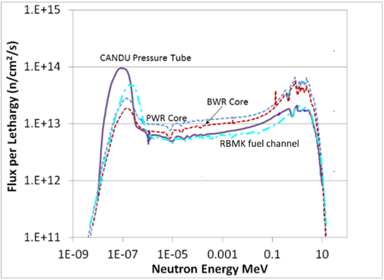

*FIG. 1. Neutron flux energy distribution for PWR, BWR, RBMK and CANDU type reactors (adapted according to L. Walters [22], RBMK case corrected according to [21]*

The optimization of neutron activation calculation model in RBMK-1500 nuclear reactor constructions was performed using MCNP6 [17] and SCALE6.2 [14] code packages. The neutron flux in the entire reactor using full scale 3D (MCNP6) model were calculated. The COUPLE code from SCALE6.2 package was used to evaluate the macroscopic cross-section of neutrons in the materials depending on the calculated neutron fluxes. Further, multigroup (252) neutron cross-section libraries were employed in the ORIGEN-S (of SCALE 6.2) for nuclide concentration evaluation in RBMK-1500 reactor construction materials including distant structures with strongly reduced neutron flux [21]. Such pre-dismantling characterization of the metallic waste using modeling approach allows sorting of reactor materials regarding the level of activation: highly activated, intermediate, low activation metal constructions and non-activated metallic waste. Neutron activation in the nuclear reactor metallic construction materials (reactor pressure vessel, pipelines, fuel channels, reactor internal constructions, CPS rods, equipment of low or medium activation) can be determind for different reactors. After validation of the models it becomes possible to classify the reactor materials regarding the level of activation (see Fig. 2 as an example of RBMK case). Furthermore, the nuclide composition in the reactor materials in the HLW and ILW can be preliminary determined. Similar approach has been used for German BWR Philippsburg 1 (KKP1) and the PWR Neckarwestheim 1 (GKN I) characterization and neutron induced activation calculations for the structural components of the reactors. This technique helps classification of higher activity RW (HLW, ILW) concerning dismantling radiation protection and best packaging concept selection and allows to predict future costs for conditioning and packaging [13].

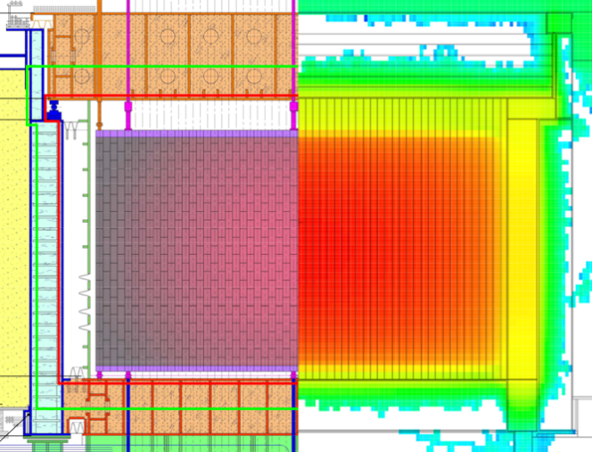

FIG. 2. *Separation of activation zones according to neutron flux intensity in RBMK-1500 reactor from MCNP6/SCALE6.2 modelling: highly activated zones (red line), zone of intermediate and low activation metal construction (green line) and non-activated materials (only surface contamination) abowe [21].*

### Neutron activation and corrosion as well as fission products released to reactor coolant in different nuclear reactors

Reactor operations generate radioactive fission, activation, and corrosion products:

* Fission products (FP) appears due to cladding defect: volatile (Cs, Ba, Sr, Ce, Pr, Zr, Ru…) and actinides and U, which normally do not migrate. Amounts of nuclides depends on the length and position of the defect and the burn-up fraction of the defective fuel rod. FP usually are incorporated in the metallic oxides of the primary circuit surfaces.
* Activation products (AP) are chemical elements of the water coolant, air, moderator, biological shield or control tools (sensors) materials activated under the neutron flux (16N,17N,3H, 41Ar, 14C, 60Co, 55Fe, 63Ni…).These activation products do not depend on fuel defect level and some of them are short-lived therefore are not a significant radiation source; Usually AP levels are determined using operating plant data. Due to the fact that uranium occurs as an impurity in the metallic materials, FP are also generated in the material itself. Like the AP, these FP are firmly embedded within the material and are not located as contamination on the surface.
* Corrosion Products (CP) come from the corrosion of the structure materials in contact with the primary coolant. The main CP responsible of dose rates are 60Co and 58Co, the others are 51Cr, 54Mn, 59Fe. The prediction of the Co sources varies depending on the uncertainties about the transport, deposition and releasing mechanisms or kinetics of the nuclides and about their soluble or particular forms. [23]

Specific activity of FP, AP and CP nuclides in reactor coolant depends on many factors, such as the number of operating defective fuel elements, reactor power history, fuel burnup and efficiency of reactor coolant purification system, on the transport processes of these nuclides: release from fuel cladding defects, transport with coolant and sedimentation on particles in the coolant or internal surfaces of tubes and also the sediments can dissolve or erode from tube surfaces back to the coolant due to changing chemical or thermal–hydraulic conditions of the coolant [24,25]. These circumstances determines the change of the scaling factors between initial activities of radionuclides in the reactor metallic constuctions. The processes are similar in BWR, PWR or RBMK in general, although due to different water chemistry, physical processes and complexity of the reactor main circulation circuit, different final contamination of the main circulation circuit tubes internal surfaces can be observed [26].

3. Nuclide Vector Determination in metallic Waste of different nuclear reactorS

Many of the important long-lived radionuclides contained in radioactive waste are difficult to measure (DTM) needing non-destructive techniques because they are low energy gamma, pure beta or alpha emitting nuclides. Identification of DTM nuclides using complex radiochemical analysis is costly, time consuming and not practical for large numbers of waste packages. This is especially important for LLW and VLLW which are the most abundant waste at the NPP site and for them decontamination and declassification would be the most preferred way before disposal. The internationally available experience [7, 27] offers the scaling factor methodology that, in many cases, can be applied for evaluation of the radioactive inventory of DTM nuclides for different waste streams. This methodology relies on establishing a correlation (scaling factor) between the DTM nuclides and easy to measure (ETM) nuclides. The inventory of the ETM nuclides in a waste package can be derived based upon external gamma radiation measurements carried out on the waste package, and the DTM nuclides can be estimated from the inventory of the ETM nuclides using established scaling factors.

Briefly, the scaling factor is based on the empirical dependence between specific activities of nuclides in the investigated sample when the main contamination source is the same.

$A_{i}=k_{i} A_{key}$, (1)

where *Ai* is the specific activity of the difficult-to-measure radionuclide, *Akey* is the specific activity of the easy-to-measure key radionuclide, *ki*is a constant called the scaling factor. The scaling factors of radionuclides, the specific activity of which can be measured by α-, β- and γ- spectrometric methods, are determined by the measurement runs and statistically processing the results according to the correlation of the investigated radionuclide with the key nuclides.

The amount of some radionuclides (for instance - actinides) can be determined using computer simulations of the evolution of nuclear fuel in a reactor and the activation of reactor structures. The relative activity *Ax* of a DTM radionuclide can be determined by multiplying the relative activity of the auxiliary radionuclide by the ratio of the activities of these two radionuclides in the nuclear fuel (or activating material):

$A_{x}=k_{x,p}×k_{p,y}×A_{y}$, (2)

where *Ay* is the activity of the auxiliary radionuclide, *kp*,*y* is the proportionality coefficient between the activities of the auxiliary and the key radionuclide, *kx*,*p* is the scaling factor between the activities of the DTM and auxiliary radionuclide.

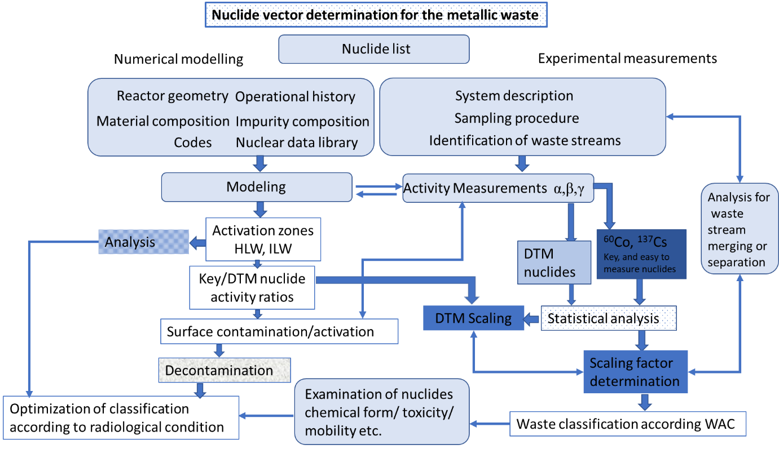FIG. 3 *Chart of Nuclide Vector determination and optimization* *of classification.*

For the determination of nuclide vectors, it is necessary to select samples from a wider range of activities, thus the parameters of the linear regression curve are determined more reliably and the measurement uncertainties of individual points have less influence. The selected samples will undergo explicit measurement procedure using available nuclear spectrometry methods, which detection limits are taken into account. Therefore, it is not appropriate to select very low activity samples, as the low activity nuclides may not be detected or detected with low precision due to limited sensitivity of the spectrometric instruments and the limited time available for each measurement. It is also inappropriate to select highly active samples in order not to create preconditions for contamination of measuring devices and to limit the radiation exposure of laboratory staff.

In order to determine a representative nuclide vector for a defined set of metallic waste components that will form a waste stream when dismantled, it is necessary to cover a larger part of the systems that make up the stream in order to increase representativeness and experimentally confirm the system division into streams. Also, in order to optimize the scope and cost of the research program, technologically similar systems (i.e, systems that are interconnected because they are affected by flow of the same technological process liquid or gas, similar form, surface contamination peculiarities etc.) are combined into a group of systems that form a stream that will be characterized with one nuclide vector.

Optimized NV is obtained by analysing and systemizing the information about radioactive metallic waste streams, identifying the optimal list of relevant radionuclides (e.g., selection of 60Co and 94Nb for ZrNb alloys), describing inter-correlations between key nuclides and difficult to measure nuclides (59Ni, 63Ni and other nuclides from the list of radionuclides to be declared for dedicated disposal site) including multivariate analysis of the already measured data at the sites and numerical analysis of activation and contamination parts for the waste streams as shown in the Fig.3 chart.

4. CONCLUSION AND OUTLOOK

In the frame of PREDIS project in the WP4 4.5.1 subtask we are developing an optimized scheme for classification of the reactor metallic materials regarding the level of activation and contamination. As the methodology for characterization of the metallic waste is similar to all reactors and is based on nuclide vector (NV) determination our main attention is paid to optimized separation of neutron activation and surface contamination activity parts by applying both modelling and measurement techniques (WP4 4.5.2 subtask) and by analysing and systemizing the information about radioactive metallic waste streams. Especially it is important to take into account the possibility of clearance after implementation of a specific decontamination process (e.g. a sand blasting, melting, radiochemical treatment (WP4 4.5.3 subtask.). NV optimization could serve also for improvement of WAC for specific landfill if taking into account MRW activation and surface contamination terms, peculiarities of nuclides (waste form/matrix/radiotoxicity etc.) and also merging/separating different reactor systems according to measurements results and analysis. At the end of the project recommendation for optimized classification of the metallic waste including assessment activation and surface contamination activity terms, estimation of possibility of decontamination: clear or declassify the waste stream will be assessed. The optimized scheme will contribute to development of safer, more efficient, cost-effective, and environmentally friendly handling of radioactive wastes.

ACKNOWLEDGEMENTS

This project has received funding from the Euratom research and training programme 2019-2020 under grant agreement No 945098. A. SAVIDOU (National Centre of Scientific Research "Demokritos" (NCSRD), Agia Paraskevi, Greece) and S. CONINX, J. FEINHALS (DMT GmbH & Co. KG, Hamburg, Germany) are partners of WP4 4.5.1 and co-authors of this paper.

References

1. INTERNATIONAL ATOMIC ENERGY AGENCY, Classification of Radioactive Waste, IAEA Safety Standards Series No. GSG-1, IAEA, Vienna (2009).
2. https://pris.iaea.org/PRIS/home.aspx
3. Stade Decommissioning and dismantling of the nuclear power plant - from the nuclear power plant to the green lawn 3 ed. (2008). INIS: http://inis.iaea.org/search/search.aspx?orig_q=RN:47065581
4. EURAD rapport: Deliverable 9.4: Overview of existing work on categorization/classification of RWs in participating states (2021).
5. DONG-KEUN C., HEUI-JOO C., RIZWAN A., GYUN-YOUNG H., Radiological characteristics of decommissioning waste from a CANDU reactor, Nuc. Eng. Techn. **43** 6 (2011) 583-592.
6. INTERNATIONAL ATOMIC ENERGY AGENCY, Estimation of Global Inventories of Radioactive Waste and Other Radioactive Materials, IAEA-TECDOC-1591, IAEA, Vienna (2010).
7. INTERNATIONAL ATOMIC ENERGY AGENCY, Determination and Use of Scaling Factors for Waste Characterization in Nuclear Power Plants, Nuclear Energy Series No. NW-T-1.18, IAEA, Vienna (2009).
8. INTERNATIONAL ATOMIC ENERGY AGENCY, The decommissioning of WWER type nuclear power plants, IAEA-TECDOC-1133, IAEA, Vienna (2000).
9. NARKUNAS E., SMAIZYS A., POSKAS P., Neutron Activation in the Metal Structures of an RBMK-1500 Reactor, Nuclear Technology **168** 2 (2009) 533–536.
10. BYLKIN, B.K., DAVYDOVA, G.B., ZVERKOV, Y.A., KRAYUSHKIN, A.V., NERETIN, Y.A., NOSOVSKY, A.V., SEYDA, V.A., SHORT S.M., Induced Radioactivity and Waste Classification of Reactor Zone Components of the Chernobyl Nuclear Power Plant Unit 1 after Final Shutdown. Nucl. Technol. **136** (2001) 76–81.
11. PLUKIENĖ R., LAGZDINA E., JUODIS L., PLUKIS A., PUZAS A., GVOZDAITĖ R., REMEIKIS V., RVAY Z., KUČERA J., ANCIUS D., RIDIKAS D., Investigation of Impurities of RBMK Graphite by Different Methods, Radiocarbon, **60** 6 (2018), 1861.
12. REMEIKIS V., GRINEVICIUTE J., DUŠKESAS G., JUODIS L., PLUKIENĖ R., PLUKIS A., Review of modeling experience during operation and decommissioning of RBMK-1500 reactors. II. Radioactive waste management, Nucl. Eng. Des. **380** (2021) 111242.
13. SCHLÖMER L., PHLIPPEN P-W, LUKAS B., Activation calculation for the dismantling and decommissioning of a light water reactor using MCNP™ with ADVANTG and ORIGEN-S. EPJ Web of Conferences 153, (2017) 05020
14. REARDEN B.T. AND JESSEE M.A., Eds., SCALE Code System, ORNL/TM-2005/39, Version 6.2.1, Oak Ridge National Laboratory, Oak Ridge, Tennessee (2016).
15. Studsvik Scandpower,“Helios methods,” (2001), program manual.
16. HALSALL M.J., 1995. WIMS A General purpose code for reactor core analysis. Introduction to the WIMS User Guide.
17. PELOWITZ D. et al, MCNP6 User’s Manual, Report LA-CP-13-00634 Los Alamos National Laboratory, New Mexico, (2013).
18. Benchmark on Computer Simulation of MASURCA Critical and Subcritical Experiments, MUSE-4 Benchmark: Final Report, Tech. Rep. NEA/NSC/DOC(2005)23.
19. REMEIKIS V., GRINEVICIUTE J., DUŠKESAS G., JUODIS L., PLUKIENĖ R., PLUKIS A., Review of modeling experience during operation and decommissioning of RBMK-1500 reactors. I. Safety improvement studies during operation, Nucl. Eng. Des. **380** (2021) 110952.
20. GRIFFITH M., WALTERS L., GREENWOOD L.R., GARNE F.A., Accelerated materials evaluation for nuclear applications, J. of Nuc. Mat. **488** (2017) 46-62.
21. A. PLUKIS, V. BARKAUSKAS, D. GERMANAS, R. PLUKIENĖ, L. JUODIS, V. REMEIKIS, Optimization the model of activation of nuclear reactor constructions, LNFK-42, Vilnius, Lithuania (2017).
22. WALTERS L., DOUGLAS S.R., GRIFFITHS M., Equivalent Radiation Damage in Zr-Alloys Irradiated in Various Reactors, 18th International Symposium. on Zirconium in the Nuclear Industry <https://www.astm.org/COMMIT/B10_Zirc_Presentations/Presentations/5-1_Walters.pdf>
23. U.S. EPR FINAL SAFETY ANALYSIS REPORT; 11.0 Radioactive Waste Management https://www.nrc.gov/docs/ML1322/ML13220A880.pdf
24. KLEVINSKAS G., JUODIS A., PLUKIS A., PLUKIENĖ R., AND REMEIKIS V., Determination of I-129 activity in the RBMK-1500 main circulation circuit, Nucl. Eng. Des. **238** 7, (2008) 1518–1524.
25. JUODIS L, MACEIKA E., PLUKIS A., DACQUAIT F., GENIN J.B., BENIERG., Assessment of radioactive contamination in primary circuit of WWER-440 type reactors by computer code OSCAR for the decommissioning case, Prog. Nuc. Energ. **110** (2019) 191-198.
26. LEWIS B. J. AND HUSAIN A., Modelling the activity of 129I in the primary coolant of a CANDU reactor, J. Nuc. Mat. **312** 1 (2003) 81–96.
27. LUKAUSKAS D., PLUKIENĖ R., PLUKIS A., GUDELIS A., DUŠKESAS G., JUODIS L., DRUTEIKIENĖ R., LUJANIENĖ G., LUKŠIENĖ B., REMEIKIS V., Method of determining the nuclide inventory for low-activity waste of the RBMK-1500 reactor, Lith. J. Phys. **46** (2006) 497-50.