# Digital tools for cemented waste package and facility monitoring and prediction

Overview of the topics handled in work package 7 of EURATOM project PREDIS

E. NIEDERLEITHINGER, V. LAY, C. KÖPP

Bundesanstalt für Materialforschung und -prüfung

Berlin, Germany

Email: ernst.niederleithinger@bam.de

**Abstract**

To provide better means for a safe and effective monitoring of cemented waste packages including prediction tools to assess the future integrity development during pre-disposal activities, several digital tools are evaluated and improved in the frame of the EC funded project PREDIS. Safety enhancement (e. g. less exposure of testing personnel) and cost effectiveness are part of the intended impact. The work includes but is not limited to inspection methods such as muon imaging, wireless sensors integrated into waste packages as well as external package and facility monitoring such as remote fiber optical sensors. The sensors applied will go beyond radiation monitoring and include proxy parameters important for long term integrity assessment (e. g. internal pressure). Sensors will also be made cost effective to allow the installation of much more sensors compared to current practice. The measured data will be used in digital twins of the packages for specific simulations (geochemical, integrity) providing a prediction of future behavior. Machine Learning techniques trained by the characterization of older packages will help to connect the models to the actual data. All data (measured and simulated) will be collected in a joint data base and connected to a decision framework to be used at actual facilities. The paper includes detailed information about the various tools under consideration, their connection and first results of our research.

## INTRODUCTION

An increasing amount of solid and liquid radioactive waste is produced world-wide by mainly the nuclear industry, healthcare and research. Before storage and disposal, this waste must be conditioned to be acceptable. Encapsulation of radioactive waste by cementitious grout is currently implemented especially for low and intermediate level radioactive waste by many EC member states. As final disposal solutions are still beyond the horizon for many European countries, the time in intermediate storage might be longer than expected. This will require monitoring of waste packages for possible degradation phenomena. If issues arise, they must be managed prior to transport to the final disposal sites.

The EURATOM project PREDIS (Pre-disposal management of radioactive waste [1]) is funded in the frame of the EURATOM NFRP-2019-2020-10 RIA call “Developing pre-disposal activities identified in the scope of the European Joint Programme in Radioactive Waste Management” (September 2019). It started on 1.9.2020 and will end on 31.08.2024. The consortium includes 47 partners from 18 Member States. PREDIS aims to develop and increase the Technological Readiness Level (TRL) of treatment and conditioning methodologies for wastes for which no adequate or industrially mature solutions are currently available, including metallic materials, liquid organic waste, and solid organic waste. PREDIS also develops innovations in cemented waste handling and pre-disposal storage by testing and evaluating, which are summarized in this paper. The project is limited to very low, low, and intermediate level waste (VLLW, LLW and ILW).

PREDIS workpackage 7 “Innovations in cemented waste handling and pre-disposal storage” (short: WP7), which will be introduced in this paper, aims at innovation around degradation prevention and early detection by means of advanced monitoring systems based on innovative techniques. It provides significant opportunities in terms of improved storage operations, reduced cost, increased safety and better understanding of the characteristics of waste prior to final disposal.

WP7 has the following objectives:

* Compile information about the state of the art of current methods and procedures for cemented waste management with specific focus on monitoring during preparation, handling and long-term storage. Identify, evaluate, and demonstrate store and package quality assurance (mainly based on non-destructive methods) and monitoring technologies.
* Demonstrate the capability of geochemical and chemo-mechanical models to describe the chemical and mineralogical evolution of cemented waste packages and to demonstrate their suitability for disposal.
* Develop, adapt, and demonstrate digital twin technology, methods for data handling and an overall digital decision framework.
* Identify opportunities for increased store automation reducing human exposure to radiation.
* Identify options for post treatment of packages and potential approaches to improve package design, construction, and maintenance.

While the first three objectives will lead to actual demonstrations at real storage sites, the latter two will be limited to desk studies due to time and budget constraints.

## State of The Art in packaging, storage, and monitoring of cemented wastes

The first important objective of the PREDIS-WP7 project on “Innovations in cemented waste handling and pre-disposal storage” was understanding and tracking the state of the art (SoTA) of current methods and procedures used for cemented waste management with specific focus on monitoring during long-term storage. The resulting report is available publicly on the PREDIS website [2] and parts of the abstract and summary are summarized here. To gather the information required for the SoTA included a questionnaire addressed to those organizations registered as end users of the project. Eleven organizations have responded and provided valuable insight into of the main aspects related to the storage of cemented waste packages such as the types of waste streams stored, waste package typologies, degradation phenomena expected or observed, storage management strategies, as well as monitoring systems currently employed. A thorough discussion with internal and external partners during project meetings and webinars provided further, more detailed insight. The SoTA will be be updated in later years of the project, if required.

The data acquired so far shows that the conditioning process of both liquid/fluid and solid waste, including sludges, fine particulates, rubbles, and metals, by cementation is largely employed for a great variety of waste streams in many countries. A high percentage of these waste streams are classified as ILW. Such waste may need long-term storage while a final disposal site is not available. Many different container types are used for storing cemented waste. The majority of containers are either metallic drums for solid and liquid waste and prismatic concrete containers for solid (mainly decommissioning) waste. Most of the respondents are using remotely operated and semi-automated systems for handling these containers. The Packages are in most cases identified by simple labels and mostly stored in controlled, ventilated areas.

The survey revealed that no End Users currently employ an approach based on sampling or instrumented waste packages for monitoring. The majority employs visual inspection on a periodic basis to identify issues such as metal corrosion, cracks, and external contamination, swelling, leakage, lifting feature deformation, and radiation. In addition, almost half of the respondents collect real time information about gas emission from packages by checking the whole storage area. While 4 out of 11 organizations monitor the internal condition of wasteforms and package by means of X-ray imaging, just about a quarter use sampling and destructive testing.

While most organizations use mainly manual data collection, less than half of the respondents apply semi-automated collection systems and only a minor amount real-time monitoring. However, digital systems have been implemented for data transfer and archiving. Data analysis performed by digital tools as well, in the majority of cases supported by expert system applications.

Most of the organizations have in the past observed waste package degradation phenomena such as internal and external corrosion, damages caused during handling of the package, alkali–silica reaction, leakages or swelling. Therefore, measures for preventive or remedial actions to be taken in connection with the extended storage of the waste packages are put into place.

## PREDIS WP7 Innovations

### Measurement techniques

A majority of end users is currently using only a limited number of measurement and monitoring technologies for package and storage management. PREDIS aims to supply the end users with a set of innovative tools, which can be grouped as follows:

* 1. Sensors inside the package
  2. Sensors permanently attached to the outside of the package
  3. Sensors to investigate or characterize packages on demand
  4. Sensors to monitor entire facilities

Groups 1 and 2 will be based on wireless RFID (Radio Frequency Identification Device) techniques. Sensors inside the package (FIG. 1) will measure properties such as temperature, humidity, electrical potential (corrosion), strain or pressure while the external ones will add a way for permanent identification. The data transfer and current supply for the internal sensors poses a main challenge in PREDIS as a metal skin shields the electromagnetic wave spectrum currently used.

Sensors to be used on demand and characterize waste packages will include affordable Gamma and Neutron detectors (including as well wireless communication) and muon tomography for scanning the interior of waste packages.

Finally, fibre optic radiation sensing will be used to monitor entire facilities with a very limited number of fibres (lots of virtual sensors can be distributed along a fibre of several hundred- or thousand-meter length).

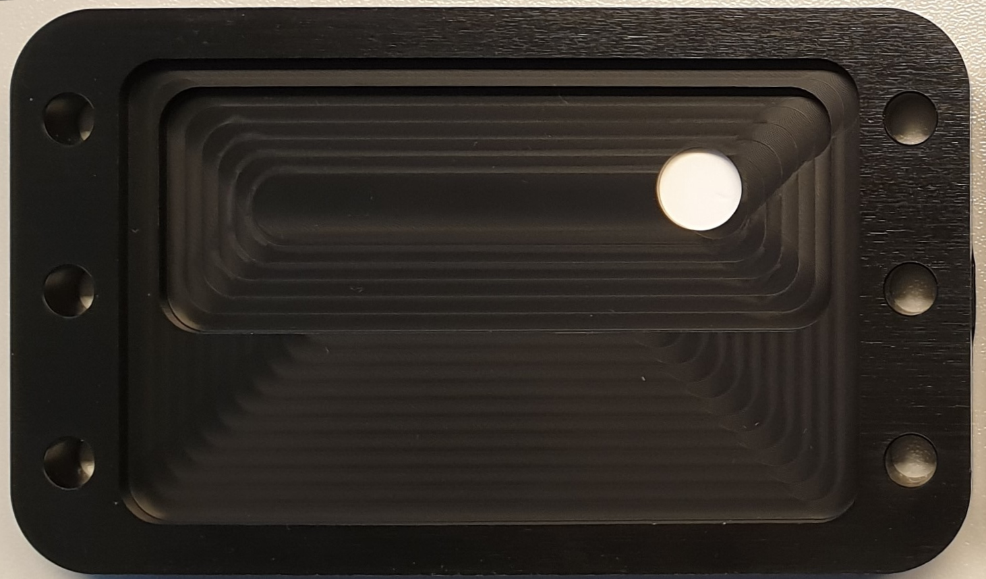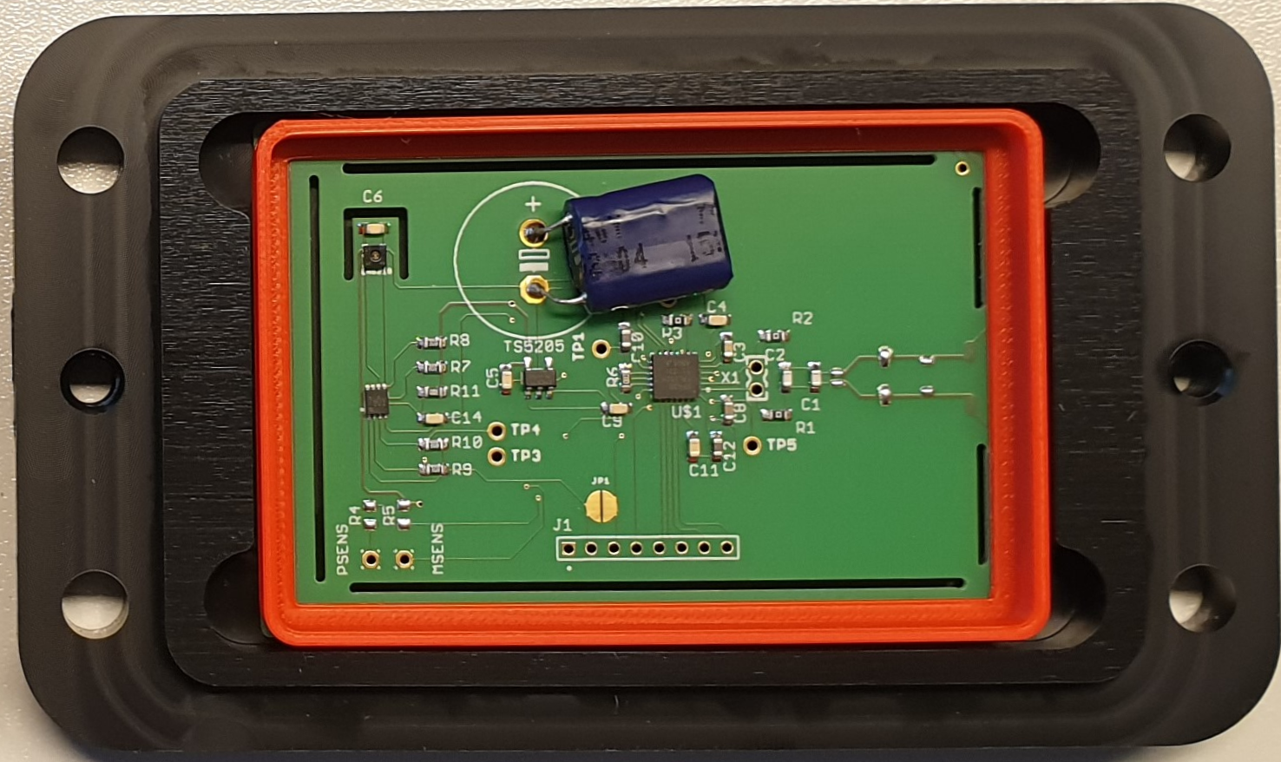FIG. . RFID sensors used for embedment in concrete (BAM). Left: Temperature and humidity sensors, RFID electronics. The red frame hides the coil used both for charging by induction and for wireless communication. Right: Cover with Teflon filter required for humidity measurements.

### Modeling and Digital Twin Technologies

A digital twin in the context of PREDIS WP7 refers to the representation of a cemented radioactive waste package using digital means (e.g., a computer model). The "digital twin" is planned to be a toolbox based on machine-learning algorithms and neural networks which will be trained with data produced by numerical tools for geochemical and mechanical integrity modelling. The models will be calibrated using data from well characterized legacy packages. These numerical tools will be validated and calibrated with information from NDE data, existing experimental data and experimental data obtained from the experimental characterization of real radioactive waste packages (*FIG. 2*).

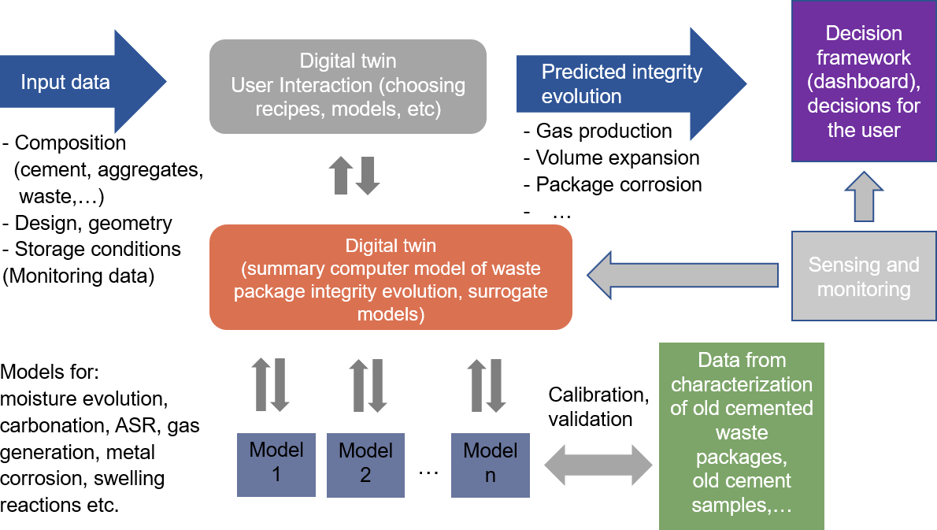

FIG. . Digital Twin Approach in PREDIS (PSI).

### Data Handling and Decision Framework

The modern monitoring methods and sensors can produce ample data. The more you measure, the more you know and decrease uncertainty. The amount of data can be so vast that humans cannot utilize the full extent without the proper tools. Thus, it is important to develop and research tools for monitoring cemented waste packages to better understand and utilize the available data, with the possibility to detect and even predict important features from the measured data: how long will the concrete last, what measurements are truly relevant and what is the current condition (*FIG. 3)*.



FIG. . Data handling, processing, and fusion approach in PREDIS (VTT).

## Validation and Demonstration

### Reference Packages and reference degradation scenarios

The technical innovations will be validated during the project using a set of mockups, which must be agreed upon in the first phase of the project. While the design was not finally mandated at the time of writing, it will be at the time of presentation.

To validate the innovations discussed in section 3, the members of the workpackage have to agree on a reference package design which will be used in experiments, developments, comparison, validation and demonstration. The consortium is aware that choosing a single design (or a set of variations of a single design) will not suit the needs of all countries and waste organizations. However, this limitation can’t be avoided due to the restrictions in budget and time and as well to connect all technical deliverables within this workpackage. The associated technical memorandum [3] will be published on the PREDIS website as soon it is confirmed by the partners and the management team.

The analysis was based on the SoTA report [2] discussed in section 2 and other sources mentioned in the memorandum [3]. While a significant amount of package designs is quite large (0.5 m³ – 6 m³) and/or use concrete as the outer skin, a common package type used in many countries has a volume of only about 200 l and a skin of (mostly stainless) steel and a matrix made from ordinary Portland cement. In addition to being used in many places, the size and cost of such a package will allow the production of several mockups within PREDIS, either to be available at the UJV site for experiments or moved to laboratories of partners for use at specific facilities such as muon imaging. While we focus on single skin packages, representing about 70 % of all package types, we will optionally include double skin packages. The planned reference package design is shown in *FIG.  4*.

Concerning degradations scenarios, in the questionnaire made for the SoTA report, six out of eight responders detailed that the following degradation mechanisms had been indicated as of interest/observed:

* Internal / external corrosion,
* Cracks,
* Alkali-silica reaction (ASR) gel formation,
* Leakage of liquids,
* Swelling,
* Chemical reactions.

|  |  |
| --- | --- |
|  | *FIG. 4. Reference package design with sensors for humidity and temperature, NNL/UJV, [3].* |

However, cracks, swelling and leakage might be considered as consequences of damage or deterioration. A literature review [3] and a discussion among the PREDIS partners resulted in the following mechanisms as of importance:

* Carbonation,
* Alkali aggregate reaction (AAR),
* Sulphate attack,
* Chloride-cement interaction
* Organic material degradation,
* Metal corrosion,
* Chloride-induced pitting corrosion,
* Radiation damage,

Volumetric expansion is the most common consequence of the degradation mechanisms listed above. This will lead to cracking of the cement matrix and potentially package deformation. Only a small amount of corrosion is required before cracking occurs in the cement matrix [4]. Internal stresses will increase with the amount of corrosion [5]. Thus, reactive metal corrosion will likely be a significant contributor to wasteform degradation. Therefore, the workpackage partners have decided to examine wasteform cracking and package deformation due to corrosion of reactive metals as the reference degradation scenario. There are two cases that can be assessed for this:

* local corrosion and expansion due to a singular large metal piece, and
* global expansion due to small pieces of metal dispersed within the grout matrix.

To have a significant amount in corrosion in a short time interval Magnox metal has been chosen to generate corrosion in a first step. This way we would have a realistic but quick way to provide mockups to test the various sensing technologies. However, as there have been concern with Magnox altering the cement chemistry and minor relevance of Magnox for many participating countries, we will use Iron as a radwaste proxy for additional mockups to test and demonstrate the full set of digital tools in PREDIS WP7. Consequently, two time two types of single drum mockups with distributed and concentrated Magnox resp. Iron will be fostered. It is expected that these type of mockups will also serve as a reference for future projects and technical developments, thus serving the European research community. However, other package types (larger size and /or concrete skin) have to be considered in future work.

### Demonstration

One of the most important parts of the project is to demonstrate the innovations at real sites. The partners representing end users in PREDIS WP7 (ORANO, SOGIN, UJV) are preparing a framework of criteria to select the most promising techniques for actual demonstration and evaluation of all techniques in the view of implementation in practice. The evaluation is not limited to scientific and technical criteria but includes economical, legal and needs associated with training or maintenance.

## Conclusion and outlook

To provide better means for a safe and effective monitoring of cemented waste packages including prediction tools to assess the future integrity development during pre-disposal activities, several digital tools are evaluated and improved in the frame of the EC funded project PREDIS. Safety enhancement (e. g. less exposure of testing personnel) and cost effectiveness are part of the intended impact.

After compiling the state of the art, performing a gap analysis and discussing both with end users, we are now in the process of refining the work plans and starting to make the actual technical developments. First lab- based demonstrations will be performed in late 2022 while actual demonstrations at real sites are to be expected from end of 2023.

ACKNOWLEDGEMENTS

**This project has received funding from the Euratom research and training programme 2019-2020 under grant agreement No 945098.** The PREDIS Workpackage 7 team consists of about 50 persons from 17 institutions. The institutions apart from BAM are VTT (Finland), Orano (France), University of Pisa (Italy), Magics Instruments (Belgium), Studiecentrum voor Kernenergie/sck cen (Belgium), Karlsruher Institut Fuer Technologie (Germany), Ansaldo Nucleare SPA (Italy), Instituto Nazionale de Fisica Nucleare (Italy), Institutt for Energiteknikk (Norway), Amphos 21 Consulting SL (Spain), SOGIN (Italy), National Nuclear Laboratory Ltd. (UK), ÚJV Řež, a. s. (Czech Republic), Galson Sciences Ltd. (UK) and Paul Scherrer Institut (Switzerland). All their contributions are deeply appreciated.

References

1. EU-project PREDIS (2021), <https://predis-h2020.eu/>
2. URAS, S., ZOVINI, C., PARATORE, A., State of The Art in packaging, storage, and monitoring of cemented  
   wastes, PREDIS Deliverable D7.1 (public report), 2021, <https://predis-h2020.eu/wp-content/uploads/2021/05/PREDIS_WP7_D7.1_V1_SOTA_2021_04_14.pdf>
3. POTTS, A., Technical Memorandum on PREDIS WP 7.2.2. Reference Package, 2021, to be confirmed and published at <https://predis-h2020.eu/>
4. PARASKEVOULAKOS, C., TANNER, D. W. J., SCOTT, T. B., Finite element modelling approach to investigate the degradation of intermediate level waste drums induced from interior metallic corrosion, *Engineering Structures*, vol. 147, pp. 385–397, Sep. 2017, doi: 10.1016/j.engstruct.2017.06.012.
5. HAYES, M., PALETHORPE, S. J., PATTERSON, G. R., WOODHOUSE, G. R., Determination of the Extent of Expansion of Residual Metallic Waste and its Effect on ILW Containers, 2014, p. 4.