**A PROTOTYPIC DESIGN OF DEPLOYABLE MOBILE HOT CELL FOR HANDLING DISUSED RADIOACTIVE SOURCES**

Blesson Isaac, Gary A. Newman, Konner Casanova, Christopher Excellent, Bryce Hillman, Steven E. Egan, Ted Reed, Kathy McBride, Kevin Kenney

Idaho National Laboratory, ID, USA

Email: [blesson.isaac@inl.gov](mailto:blesson.isaac@inl.gov); [Gary.Newman@inl.gov](mailto:Gary.Newman@inl.gov); [Konner.Casanova@inl.gov](mailto:Konner.Casanova@inl.gov); [Bryce.Hillman@inl.gov](mailto:Bryce.Hillman@inl.gov); [Steven.Egan@inl.gov](mailto:Steven.Egan@inl.gov); [Ted.Reed@inl.gov](mailto:Ted.Reed@inl.gov); [Kathryn.McBride@inl.gov](mailto:Kathryn.McBride@inl.gov); [Kevin.Kenney@inl.gov](mailto:Kevin.Kenney@inl.gov)

**Abstract**

The paper depicts an easily deployable mobile hot cell for the handling and conditioning of disused medical and industrial radioactive sources. Radioactive sources are used around the world to support lifesaving and life improving industries. However, once these sources have decayed to a no longer useful level the disposition of these sources becomes a problem. Currently many of the sources have been stored at their deployment site in their original deployment casks. The planned disposition of these disused sources is to place them in long-term storage containers or silos. To accomplish this, high activity sources will be 1) removed from their deployment shielding casks, 2) further contained in a welded capsule, and 3) consolidated (to the extent possible) to reduce the storage volume. While these operations could be accomplished in a traditional fixed hot cell, it is desirable for transportation and custodial purposes to perform these operations at the location of the disused sources. This then would require that a mobile hot cell be implemented. Mobile hot cells have been used for source conditioning in the past but suffer the limitations of long assembly times or insufficient containment of potentially breached sources. The paper discusses the development of a heavily shielded mobile hot cell that is easily deployable, maintains a contamination control barrier, and has incorporates sufficient redundancy to deal with potential equipment failure, source leakage, or unexpected source configurations.

## Introduction

Development of a mobile hot cell is a challenging task that must incorporate multiple competing requirements such as 1) easily deployable, 2) adequate shielding for operators, 3) continual contamination control, 3) flexibility and robustness of design to accommodate off-normal events. Past implementation of the mobile hot cell concept has had mixed levels of success. In 2013 a team of experts from South Africa’s Nuclear Energy Corporation (NECSA) removed 16 highly radioactive disused cobalt and cesium sources from teletherapy and industrial devices. While this was successful, the deployment time of mobile hot cell was approximately two months which is not only financially costly but limits the rate at which sources can be retrieved and stored. Another mobile hot cell developed by International Isotopes, Inc. (INIS) did not incorporate a contamination barrier in their design which resulted in a serious contamination spread when a source was unexpectedly breached. Also, the INIS did not have the shielding necessary to handle highly radioactive sources such as Cobalt-60. A common feature of the two mobile hot cells discussed above was the use of master-slave mechanical manipulators as shown in Figure 1. These manipulators are highly effective in the hands of skilled operators and are radiation resistant. However, they are large, complex, maintenance intensive, expensive, and subject to failure.

As a departure from the above discussed designs, the INL mobile hot cell is being developed using standard industrial cooperative robots to perform the source manipulations. While it is understood that these robots are sensitive to radiation effects, their cost, size, and ease of deployment make them a very attractive option. Similar to the previous mobile hot cell designs the INL mobile hot cell is a ‘black cell’ (no windows) which incorporate lights and cameras for vision. Shielding for the hot cell is accomplished by a series of nesting shells which provide an equivalent of 15 inches of steel shielding in the side walls, and 4 inches of steel in the ceiling.

Maintaining contamination control during hot cell use is maintained by virtue of a sealed cell maintained at a negative pressure by portable HEPA vacuums. Tented contamination control areas will be utilized for initial cask preparations prior to insertion into the cell. Should maned entrance into the cell be required these tented areas will provide a contamination control area.

Redundancy and off-normal contingency are a necessary feature of a mobile hot cell that has a limited timeline of operation as well as limited resource support. As such the INL mobile hot cell has three levels of redundancy, 1) the main robot, 2) an readily insertable recovery robot for making the cell safe for manned entry, and 3) a rudimentary mechanical system to render the cell safe for manned entry.

## Background

This project stems from the analysis and investigation of the contributing causes, the root cause, and the judgement of need from the incident of release of Cesium-137 on May 2, 2019 at the Sealed Source Recovery at the University of Washington Harborview Research and Training Facility. The joint investigational report submitted by National Nuclear Security Administration/Triad National Security, LLC investigation team was accepted, and the authorization to release the report for general distribution was granted on March 30th, 2020 [1]. The investigation carried out was consistent with methodology followed by Department of Energy, Accident Investigations. Cesium-137 is a radioactive isotope of cesium and is a common byproduct of nuclear fission. It is among the most problematic of the short-to-medium-lifetime fission products because it easily moves and spreads in nature due to the high-water solubility of cesium chloride. However, it is used in radiation therapy. It is also used as a radioactive tracer in geologic research to measure soil erosion and deposition [2]. Cesium-137 reacts with water and forms cesium hydroxide. The half-life of cesium-137 is 30.17 years. Experiments showed that mice dosed with 21.5 µCi/g had a 50% fatality within 30 days. For safety and security reasons, the disused cesium sources need to be conditioned. If disused sources are not properly stored, they can be a threat to human health and the environment and pose a security risk. Very few field-tested mobile hot cells exist in the world. This results in project delays, dependency on third parties, health, and safety risks due to uncertain designs. A design that integrates safety and ease of deployment to radioactive environments with advanced technologies will solve the problem faced in handling radioactive materials. The exploration mission of three meltdown reactors near Fukushima, Japan, using Quince robot offered the world an exceptional opportunity for robots to be developed and deployed in a radioactive environment [3]. The use of master/slave manipulators and collaborative robots (cobots) and the possible application of cobots in handling radioactive materials in a hot cell environment was explored and depicted in previous published manuscript [4]. The overall purpose of this project is to design and fabricate a rapidly deployable mobile hot cell. The design to achieve the goal is completed and the fabrication of the cell is being carried out. The current states-of-the-art of mobile hot cell are shown below.

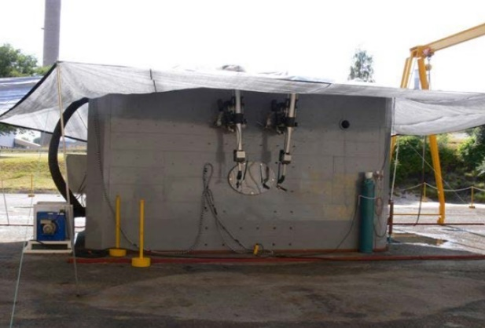

*Source: Management of Disused Sealed INIS Mobile Hot Cell*

*Radioactive Sources, Alan Carolissen, NECSA Source: Joint Investigation Report March 30, 2020*

*FIG. 1. Master-Slave mechanical manipulators used by NECSA and INIS*

## Requirements

The INL mobile hot cell has been designed around the following basic requirements:

1. The mobile hot cell shall be capable of accepting a variety of existing casks containing disused sources. The sources shall be removed from their deployed casks, welded into a sealed container, and transferred outside the hot cell into a Long-Term Storage Shield (LTSS) or other transfer/storage casks yet to be identified.
2. System shall be deployable on standard ISO containers. These containers may be 10 or 20 ft in length and may be of a closed or open deck design.
3. The weight limit of a component piece shall not exceed 10 metric tons. This is to limit the size of lifting equipment at the deployment site.
4. Shielding shall limit exposure to 5 mrem/h at 30 cm from the cell wall while exposing a 1000 Curie Cobat-60 source in the cell.
5. Mobilization and demobilization of the system shall be less than 1 week each, however shorter times are highly desirable.
6. Contamination control shall be maintained from initial cask preparation to final placement of a sealed source into a storage or transfer cask.
7. Multi-level redundancy shall be incorporated into the design to assure that a source is not left exposed in the cell for long periods of time and that the contamination control is maintained in off-normal events.
8. The INL mobile hot cell shall not require the use of specialized support equipment. The support equipment required shall be readily available throughout the world.

## Structure of Mobile Hot Cell

The cell interior dimensions are 52 x 52 x 85.5 inches. The cell interior consists of a base box which has a lead filled personnel door on one wall and a cask mate up feature on the opposite wall. Shielding is accomplished by the addition of 4 nesting steel shells which allow rapid setup and takedown of the MHC. Penetrations into the cell interior are limited to the personnel door/door frame, the cask attachment wall, and the roof. Each of the components are limited to 10 metric tons. When low activity sources are recovered all the shielding shells may not be required and need not be mobilized. The base box is attached to a steel floor to facilitate rolling casks into the cell from the personnel door. The roof provides the support for the robots and a small handling crane as may be necessary with some source cask types.

*FIG. 2. Mobile Hot Cell designed by Idaho National Laboratory*

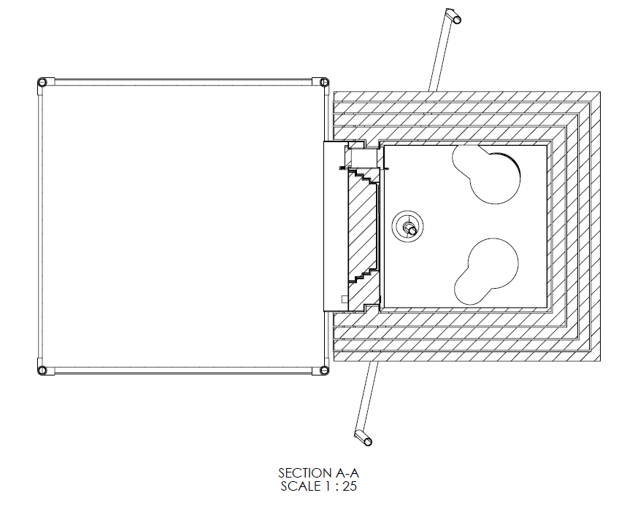



*FIG. 3. Front view, sectional view, and 3D sketch of MHC*



*FIG. 4. The overall MHC system designed by Idaho National Laboratory*

## System components of the Mobile Hot Cell

## Lighting system

Lighting system involves controlling the stratus LED using Raspberry Pi remotely and identifying the surface of the materials to be investigated. Python language is used to create programs that can be used to control the LED system. Raspbian operating system enables accessing programs and editing them as per requirements. As per identifying the surfaces, the appropriate brightness is necessary depending up on the material surfaces.

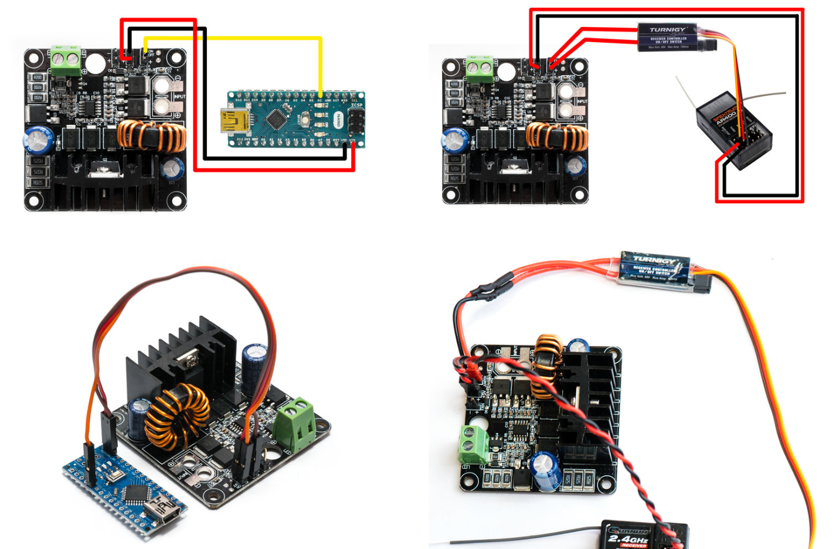 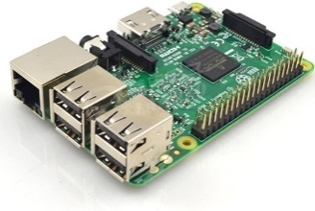 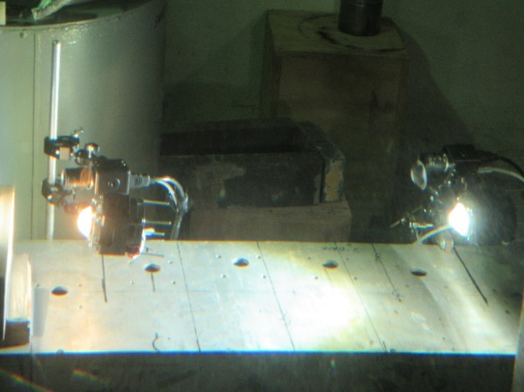

*FIG. 5. Raspberry Pi and Stratus LED*

The Raspberry pi can be networked via ethernet to the control station for the MHC where all systems are manipulated. Arduino microcontrollers have been used in the development of the lighting system but will ultimately be replaced by the Raspberry Pi.

## Camera system

Cameras will provide the operator multiple views inside the Mobile Hot Cell. Four fixed 2D cameras, and one movable inspection 2D camera will be utilized for the bulk of operations. A single 3D camera mounted on a pan-tilt head will allow the operator to view detailed operations, and inspections. The 3D Camera provides the operator with limited depth perception which greatly aids in performing intricate tasks and inspections.

The 3D camera will be displayed on an autostereoscopic monitor. This display does not require the use of glasses for the operator to view the 3D image. Using this type of display is desirable as it reduces fatigue and stress on the operator. The camera is an OEM camera which means it is supplied as bare components. No housing is supplied, and the controls for functions such as zoom, and focus are controlled via a supplied infrared remote. The remote is ineffective for our project. This detail has been addressed by interfacing a Raspberry Pi to the camera which allows the functions to be controlled via Ethernet and a custom GUI.

A housing has been designed and 3D printed for mockup purposes. A shielded housing will be fabricated for the actual installation in the MHC. 2D images will be displayed on conventional displays. Use of a matrix switch allows the operator to customize which views are displayed on the individual monitors. This customization allows the views to be optimized for the work task being performed. These images represent the types of cameras that will be used in the MHC.

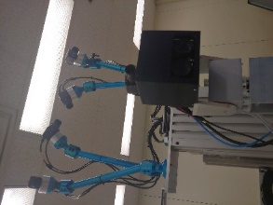 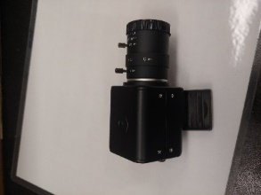 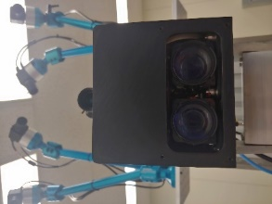 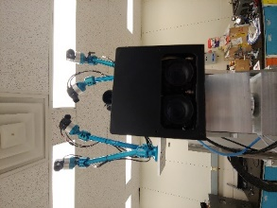

*FIG. 6. Cameras that will be used throughout the MHC.*

## Robot Radiation Resistance

A robot will be used for disassembly and repackaging of radioactive sources. The scope of sources that the MHC has been designed for is 1000 Ci Co-60 equivalent gamma emitting sources (no neutron). Gamma radiation is damaging to electronic components which makes survivability of the robot a concern. Irradiation testing of the robot concluded the robot elbow joint is most sensitive to radiation and that failure occurs between 3-5 kRad of exposure to the elbow joint of the robot. A time-motion study was performed using Monte Carlo N-Particle (MCNP) [5] for exposure rates and mockups for time for each step of the process. The time motion study concluded that to disassemble and repackage a single 1000 Ci Co-60 source would result in a cumulative 470 Rad exposure to the robot elbow which is well below the failure exposure. The figure below shows a 3D representation of the MHC and radiation fields with a 1000 Ci Co-60 source centered in the MHC.

While preliminary testing and modeling shows that the robot should survive the disassembly and repackaging process, further work is needed. A bigger robot that can handle more weight and has more sensors is currently being analyzed for use in the MHC. This robot will need irradiation testing to determine the acceptable cumulative exposure. The time and motion study will also need adjustments for changes with robot positioning, different source drawer configurations, new robot tasks, and source consolidation. Although the MHC and robot will be engineered to survive in the radiation environment, methods to replace the robot in place are being developed to recover from a robot failure.

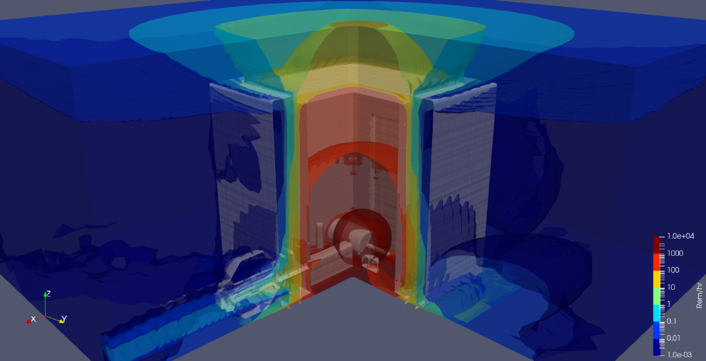

*FIG. 7. 3D representation of MHC and radiation fields with a 1000 Ci Co-60*

## Biological Shielding

The MHC is designed with nested shells of shielding to allow for variable shielding thickness depending on source strength as well as to accommodate shipping requirements. The MHC is also designed to be remote operated, eliminating the need for operators to stand near the shielding. Personnel will need to periodically be near the outer wall of the hot cell to gather swipes which requires acceptably low radiation levels outside the MHC. While the source is exposed, there are elevated radiation levels near the MHC as shown in the figure below. In case of low activity sources, these levels may be low enough that manned entry into the cell is possible. However, in the case of high activity sources personnel will not be admitted into the cell. Should a problem arise where a source is exposed in the cell and manned entry is required, a shielded container will be available in the cell to accept the source. Placement of the source into this shielded container may be accomplished by the primary robot, the recovery robot, or the manual manipulator. Manned cell entry can then correct problems that may arise.

When high activity sources are present in the MHC, the roof provides adequate shielding to prevent elevated radiation levels at ground level from sky shine but does not provide enough shielding to allow for personnel to be above the roof. Also, this means that the MHC should only be assembled in large open areas, i.e. not near building of more than a single story. The reduced shielding thickness of the roof allows for a lower weight roof with more flexibility in the type and number of penetrations that can be incorporated. The penetrations in the roof will incorporate rotating shield shutters. A significant advantage of placing robot penetrations in the roof is that the location of these penetrations can be optimized for changing accepting different source casks.

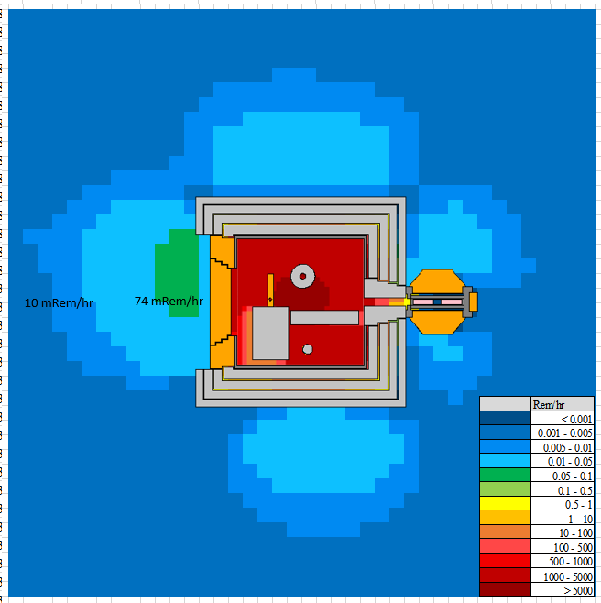

*FIG. 8. Radiation effects of source in MHC*

## Contamination Control:

Although sources are expected to be in sealed containers, there has been a least one instance where a source was inadvertently breached which required a large and widespread cleanup effort. Also, some sources have been found to be leaking due to a degradation of their containment. Therefore, contamination control is a significant feature of the MHC. To this end, a tented area is provided on the cell personnel door. Cask preparation can be accomplished in this area, thus containing any leaking sources. This tented area will also be used to maintain contamination control if a manned entry of the cell is required during operation. Both the cell and the tented area will be held below atmospheric pressure by portable HEPA vacuums. During the repackaging effort in the cell swipes will be taken to assure that contamination is not spread to the LTSS or other outgoing casks. These swipes will be passed through a double door in the cell wall and counted by a radiation technician in the tented area. A tented contamination control area may also be required opposite the personnel door if the LTSS is utilized of admitting sources into the MHC.

## Mockup and testing

During the Mockup Process, valuable positioning lessons have been learned. One task that was explored in detail is the removal of a snap ring using the UR-16e robot via tele-operation. Testing evolutions revealed that it is possible to successfully remove a snap ring. It is worth noting that the initial testing was performed under ideal conditions. That is, very few obstructions, ideal camera placement, and lighting conditions. Future testing will be performed in the MHC Mockup which will provide a more realistic operating environment which will include several obstacles, obstructed views, and shadowed lighting conditions. This complex operation will require careful planning and placement of components. Very small changes result in large advantages in the success of the snap ring removal process.

Initial testing utilized a camera with a 2.8 to 12mm lens. Moving forward multiple cameras with a wider range from 5 to 50mm lenses will be employed.

For tele-operation of the robot a 3D mouse was integrated into the robot to allow remote operation from outside the cell. The 3D mouse is commonly used for Cad modeling etc.

It was quickly realized that without the sense of feel or sound of the operation handicaps the operator’s ability to remove the snap ring.

Other methods of controlling the robot are being investigated. One such device provides haptic feedback to the operator. This feedback allows the operator to feel when the tool has engaged the snap ring.

A microphone will be incorporated in the MHC which will offer the operator auditory cues as the robot engages the tool into the snap ring.

The UR16e has been programmed with start positions near the snap ring location to reduce the operational time and limit the tele operation time. These efforts require some time upfront to configure and verify accuracy but will save significant time during operations. Testing has shown that custom tooling is mandatory, and minor modifications to “off the shelf” items improve functionality significantly thus decreasing snap ring removal time. Other useful features were locating a camera directly above the griper to provide a straight on view of the snap ring features in conjunction with a hook adjacent to the gripper fingers that allowed the operator to finish removing the snap ring as the removal pins would often slip out of the holes in the ears of the snap ring, only partially removing it.

** **

*FIG. 9. Mockup testing to remove a snap ring.*

## References

1. Joint National Nuclear Security Administration/Triad National Security, L.N.T.I.T.J. *Sealed Source Recovery at the University of Washington Harborview Training and Research Facility Results in Release of Cesium-137 on May 2, 2019*; 2020.

2. "CDC Radiation Emergencies | Radioisotope Brief: Cesium-137 (Cs-137)". CDC. Retrieved 5 November 2013.

3. Nagatani, K.; Kiribayashi, S.; Okada, Y.; Otake, K.; Yoshida, K.; Tadokoro, S.; Nishimura, T.; Yoshida, T.; Koyanagi, E.; Fukushima, M. Emergency response to the nuclear accident at the Fukushima Daiichi Nuclear Power Plants using mobile rescue robots. *Journal of Field Robotics* **2013**, *30*, 44-63.

4. Eric Egan, K.C. Collaborative Robots vs. Master/Slaves. In Proceedings of 45th Annual Waste Management Conference (WM2019), Phoenix, Arizona, USA, 3-7 March 2019.

5. T. Goorley, et al., "Initial MCNP6 Release Overview", Nuclear Technology, 180, pp 298-315 (Dec 2012)