Microwave assisted synthesis of perovskite ceramic waste form

Ritu Kumari Pilania^{1, $} and Charu Lata Dube^{1, *}
¹School of Nano Sciences, Central University of Gujarat, Gandhinagar, India.
$dubecharu@gmail.comritukumaripilania@gmail.com, *charulata.dube@cug.ac.in

Abstract
Perovskite is proposed as a potential host for immobilizing the highly active short-lived radionuclide strontium, which is discarded in the form of medical devices from the hospital. In the present work, strontium perovskite ceramic matrix has been successfully synthesized by employing a microwave (MW) assisted method at MW power of 800W and a frequency 2.45GHz in a multimode applicator. The X-ray diffractogram shows that the as-prepared ceramic by MW processing method is composed of cubic perovskite SrTiO₃ along with minor impurities of TiO₂ and SrCO₃. In order to remove impurity phases, subsequently, MW processed perovskite is calcined at 900 °C in a muffle furnace. The X-ray diffraction pattern of the calcined specimen confirms the formation of single-phase cubic strontium perovskite. The electron microscopic images indicate the uniform microstructure. The aqueous durability studies have been carried out as per MCC-1 static leach test protocol, in deionized water at room temperature and 90 °C. Attempts have been made to understand the relation between microstructure and chemical durability.
Keywords: Perovskite, waste form, strontium, chemical durability.

- INTRODUCTION
Glasses are the widely studied wasteforms and some radionuclides are immiscible which cannot be immobilised in glass waste forms [1]. Alongside glass and glass-ceramics, ceramic materials are also a promising candidate for the immobilisation of highly active waste. In order to immobilise radionuclides, synroc ceramic has been developed which contains hollandite, zirconolite, and perovskite. Zirconolite host is used to immobilise long-lived radionuclides such as Pu, Np, U, Am, etc. whereas perovskite is for short-lived radionuclides as Sr, Ba, etc. [2]. Perovskite waste forms are highly stable so this ceramic may improve the chemical durability in the aqueous environment.
Nowadays, there are several radioactive elements such as ⁹⁰Sr, ¹³⁷Cs, ⁶⁰Co, ¹⁹²Ir, and ¹⁰⁶Ru, etc. are used in medical devices. Some radioactive elements (discarded from hospitals) have a long half-life which is harmful to the environment and humankind. The discarded waste from hospitals can be immobilised in perovskite waste form. The leaching of active materials may pose threat to the environment. The interaction of waste form and groundwater can be understood in three steps, namely, diffusion of the water molecules in the waste form, hydrolysis of the network, and precipitation on the interface of waste form.
The perovskites have a structure similar to CaTiO₃. Invariably, perovskite (ABX₃) structure includes three different ion sites as A-site occupied with a monovalent inorganic or organic cation, B-site employed with divalent metal cation and X-site engaged with oxygen, halide, sulfide, or nitride. Perovskite ceramic can be synthesised with microwave-assisted method, hydrothermal method, solid-state method, polymeric precursor method, etc [3-6]. Among these, the microwave method is the efficient method to synthesize nanomaterials because it is rapid, energy-efficient, and volumetric in nature. In addition, it provides uniform heating.
Thus, strontium titanate is selected for immobilisation of strontium radionuclide. The strontium titanate has successfully been synthesised by employing microwave assisted method and subsequently calcined at 900 °C to eliminate impurities. The aqueous durability test has been performed with an as-prepared ceramic waste form.
- EXPERIMENTAL DETAILS

  - Materials
Titanium (Ⅳ) isopropoxide (Ti[OCH(CH₃)₂]₄, 99.999% purity, sigma-aldrich), strontium nitrate (Sr(NO₃)₂, ≥99% purity, sigma-aldrich), potassium hydroxide (KOH), ≥85% purity, Sigma-aldrich), isopropanol (C₃H₈O, 99% purity, SRL) were used of analytical grade without further purification.
  - Synthesis of perovskite
The perovskite was synthesised by microwave assisted method. The titanium isopropoxide and strontium nitrate were used as starting materials and KOH was used as mineralizer. Titanium isopropoxide (0.05M) dissolved in isopropanol and the aqueous solution of 0.05M Sr(NO₃)₂ was prepared. Subsequently, an aqueous solution of Sr(NO₃)₂ was added dropwise into the titanium isopropoxide-propanol solution and stirred for 1 hr to obtain a suspension. Later on, the aqueous solution of 1M KOH was added to the suspension. The resulting solution was then transferred to a beaker and placed in a domestic microwave oven (Model-CE73JD, SAMSUNG) for processing. The solutions were optimised at various MW power with different cycling modes. On completion of MW processing, the precipitate was washed with distilled water several times followed by drying at 70 °C overnight. The powder was collected and named as STO. The collected powder was then pelletised and calcined at 900 °C, named STO900C.
  - Characterisation
The X-ray diffractograms were collected on prepared ceramic samples before and after calcination on X-ray diffraction machine (XRD, Model-AXS D8 Focus P-XRD, Make-Bruker). The microstructural analysis was recorded with Field Emission Scanning Electron Microscopy (FESEM, ZEISS). All the samples were coated with gold film for the microstructure observations to avoid charge accumulation.
  - Leaching experiments
Aqueous durability of ceramic waste form was carried out as per Material Characterisation Centre (MCC-1) test at pH value 5.3. The ceramic samples were pelletised using a 10 mm stainless steel die to prepare 1mm thick pellets. These pellets were further calcined in air at 900 °C for 2 hrs. The pellets were immersed in 40 ml of deionised water in polytetrafluoroethylene (PTFE) vessels at room temperature (RT) and 90 ± 1 °C. The leachates were collected from PTFE vessel after 3, 6, 9 and 12 days. The concentration of strontium leached out in the solution was determined using an Inductively Coupled Plasma Optical Emission Spectrometer (ICP-OES, Model-7300 DV, Make-Perkin Elmer).
The normalised leach rate (g.m⁻².day⁻¹) of element i (strontium) from the ceramic matrix was calculated with the following expression:
$${NR}_{i}= \frac{C_{i}}{f_{i }× (S/{V) ×t}} (1)$$
Where $C_{i}$ is the concentration of element ‘i’ in the solution with the unit g L⁻¹, $f_{i}$ is the mass fraction of element ‘i’ in the samples (unitless), S is the surface area of the pellet (m²), V is the leachant volume (L) and t is the duration of leaching with the unit day.
- RESULTS AND DISCUSSION

  - XRD analysis
The XRD patterns of STO and STO900C are shown in fig. 1. The reflections corresponding to the perovskite phase were seen and confirming the cubic phase of perovskite. The XRD peaks were identified and matched well with JCPDS data file # 74-1296. The minor peaks were also seen at 25.80° and 25.18°, corresponding to residues SrCO₃ and TiO₂ (JCPDS No.# 21-1272), respectively [7]. After calcination at 900 °C, minor peaks got disappeared and peaks owing to only single-phase strontium titanate were present. The dominant peaks at 32.5°, 40.1°, 46.6°, 57.9°, 67.9°, and 77.3° were attributed to (110), (111), (200), (211), (220) and (310) planes of strontium titanate, respectively. The diffraction pattern indicates that the synthesized sample is highly crystalline and devoid of any other phase. The average crystallite size is calculated using the Debye-Scherrer formula and found to be 37.1nm.
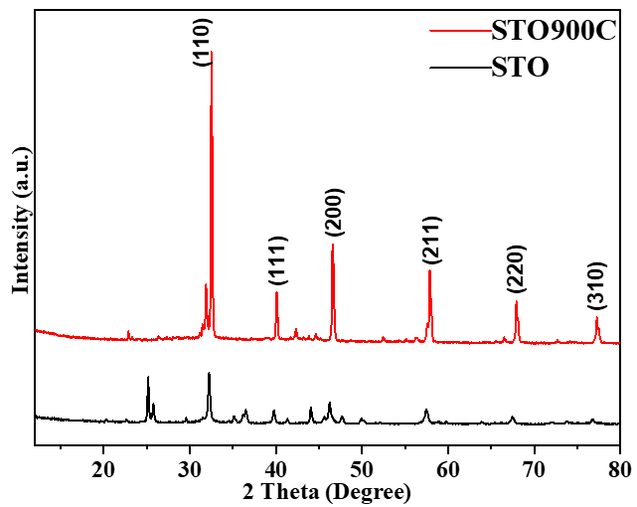
Fig. 1. XRD patterns of STO sample and calcined sample STO900C.

  - Microstructural analysis
The electron microscopic images of samples are shown in fig. 2. The rod-like structures can be seen along with nanoparticles. It is reported that TiO₂ may grow prominently in a rod-like shape. The presence of TiO₂ was also seen in the XRD pattern.
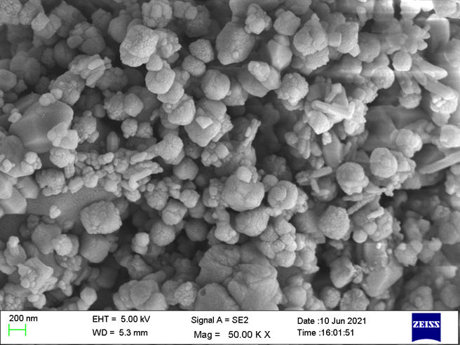
Fig. 2. FESEM micrograph of perovskite ceramic.

  - Leaching study
To evaluate the aqueous durability of the perovskite ceramic matrix, MCC-1 static test was performed at RT and 90 °C. The normalised leach rate of strontium radionuclide was calculated over a 12-day test period for the perovskite ceramic matrix. The normalised leach rate of Sr is calculated using equation 1 and the variation of normalised leach rate with respect to time is shown in fig. 3a and 3b. The leach rate is continuously decreasing over the period of 12 days at RT. On the other hand, there was difference in leach rate for sample kept at 90 °C. Initially for 6 days, the leach rate was high as compared to last 6 days. The calculated leach rates of strontium from the perovskite matrix after 12 days at RT and 90 °C are found to be $15.366 ×{10}^{-3}$ g.m⁻².day⁻¹ and $0.12106×{10}^{-3}$ g.m⁻².day⁻¹, respectively. The leaching of any element is mainly accompanied with either diffusion mechanism or surface wash off/dissolution [8].
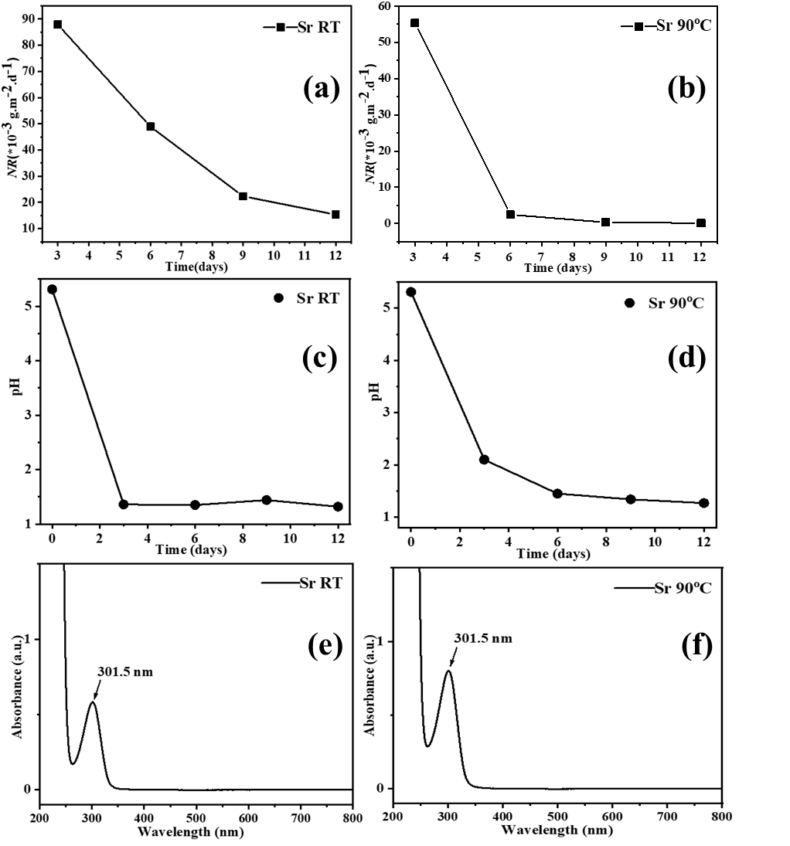
Fig. 3. Normalised leach rate of Sr, pH variation, and UV-Vis spectra at RT (a, c, e) and 90 °C (b, d, f).
The variation of pH value of the leachate with respect to days is shown in fig. 3c and 3d. It is anticipated that the high leaching during the initial days might be due to the acidic pH value. The UV spectra, shown in fig. 3e and 3f show absorption peak corresponding to strontium oxide [9]. It might be possible that after the leaching of strontium ions and oxygen ions from the perovskite ceramic matrix, they are combining in leachate and forming strontium oxide.
The clean surface of perovskite ceramic waste form before leaching can be seen in fig. 2. The high-resolution electron microscope (FESEM) images of perovskite ceramic matrix after leaching at RT and 90 °C, are shown in fig. 4a and 4b. The surface of leached waste form at RT after 12 days is homogeneously rough with some holes (encircled area in fig. 4a). It indicates significant leaching at room temperature, probably due to ${OH}^{-}$ ion attack. However, the surface is very clean having some floccules and holes (encircled area in fig. 4b) after 12 days of leaching at 90 °C. Invariably, leaching results rough surfaces [10]. Therefore, the rough surface of the perovskite ceramic matrix after leaching at RT indicates a higher leach rate at RT against 90 °C. The FESEM images are in line with normalised leach rate (fig. 3a and 3b), suggesting a higher leach rate at RT against 90 °C.
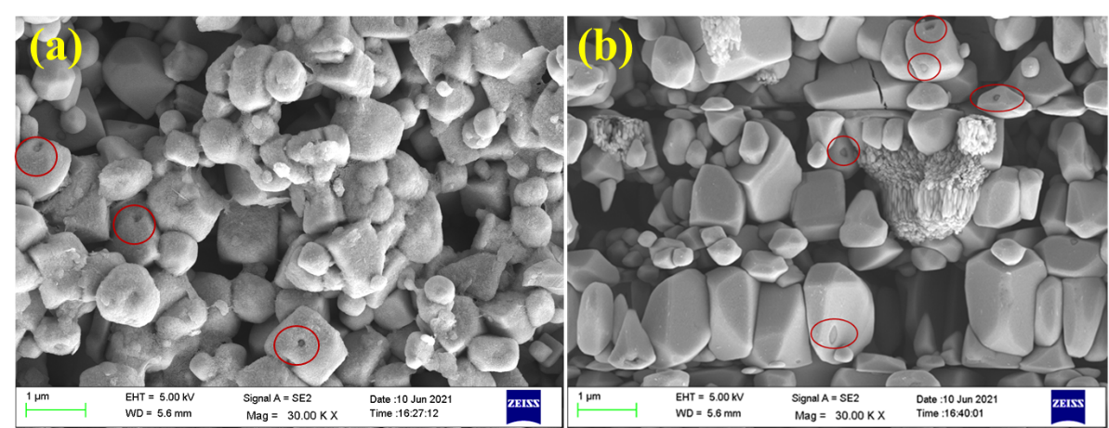
Fig. 4. FESEM images of perovskite matrix after leaching at (a) RT (b) 90 °C.
The X-ray diffraction patterns of strontium titanate ceramic after leaching study at RT and 90 °C, are shown in fig. 5. The perovskite phase is intact even after leaching and any substantial phase change is not observed. Further investigations are in progress to investigate the possibility of immobilization of radionuclide in strontium titanate ceramic waste form.
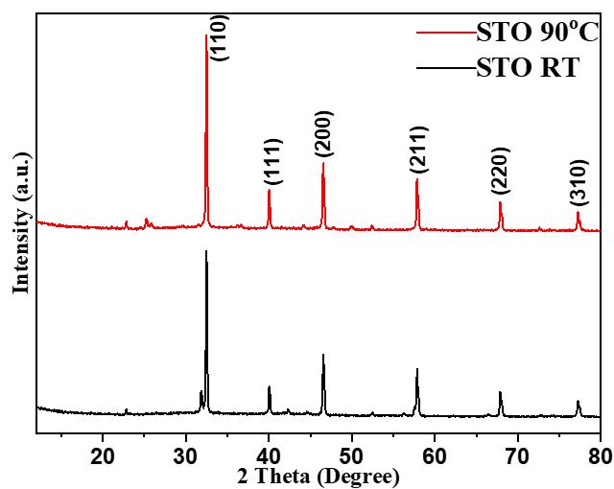
Fig. 5. XRD pattern of perovskite matrix after leaching at RT and 90 °C.
- CONCLUSION
In this report, perovskite ceramic was successfully synthesized with the microwave-assisted method. The crystal structure, morphology, and aqueous durability of synthesised perovskite ceramic matrix were investigated. Aqueous durability was performed with MCC-1 protocol at RT and 90 °C in deionized water at pH value 5.3. The obtained leaching rate was $0.12106×{10}^{-3}$ g.m⁻².day⁻¹ at 90 °C after 12 days. The leaching does not induce any structural changes to the perovskite ceramic host. The synthesised perovskite matrix can be a potential candidate to immobilise strontium radionuclide discarded from hospitals. However, further studies need to be done to explore the leaching mechanism.

ACKNOWLEDGEMENTS
Authors are thankful to Central University of Gujarat, Gandhinagar for the use of infrastructure and central instrumentation facility (CIF). We also acknowledge Dr. Mukesh Ranjan, FCIPT, Gandhinagar for providing the FESEM facility.
REFERENCES
- Marples, J. A. C., The preparation, properties, and disposal of vitrified high level waste from nuclear fuel reprocessing. Glass technology, 29(6), (1988) 230-247.
- Xu, H., & Wang, Y., Crystallization sequence and microstructure evolution of Synroc samples crystallized from CaZrTi2O7 melts. Journal of Nuclear Materials, 279(1), (2000) 100-106.
- Shen, H., Lu, Y., Wang, Y., Pan, Z., Cao, G., Yan, X., & Fang, G., Low temperature hydrothermal synthesis of SrTiO 3 nanoparticles without alkali and their effective photocatalytic activity. Journal of Advanced Ceramics, 5(4), (2016) 298-307.
- Alkathy, M. S., & Raju, K. J., Microwave-Assisted Synthesis and Characterization of Strontium Titanate Nanoparticles. Albaydha University Journal, 1(2), (2019) 235-240.
- Naidu, K. C. B., Sarmash, T. S., Maddaiah, M., Reddy, P. S., Rani, D. J., & Subbarao, T., Synthesis and characterization of MgO-doped SrTiO3 ceramics. Journal of The Australian Ceramic Society, 52(1), (2016) 95-101.
- Da Silva, L. F., Maia, L., Bernardi, M. I. B., Andres, J., & Mastelaro, V. R., An improved method for preparation of SrTiO3 nanoparticles. Materials Chemistry and Physics, 125(1-2), (2011) 168-173.
- Konstas, P.-S., Konstantinou, I., Petrakis, D., & Albanis, T., Development of SrTiO3 photocatalysts with visible light response using amino acids as dopant sources for the degradation of organic pollutants in aqueous systems. Catalysts, 8(11), (2018) 528.
- Balaji, D., & Kumar, S. P., Langbeinite phosphosilicates K2-xCsxZr2P2SiO12 (x= 0, 0.5, 1.0, 1.5, 2.0) for cesium encapsulation; synthesis, chemical durability and thermal expansion study. Ceramics International. (2021).
- Suresh, R., Role of annealing temperature on the properties of SrO nanoparticles by precipitation method. NanoNEXT, (2020) 18-23.
- Huang, Y., Zhang, T.-a., Dou, Z., Liu, J., & Tian, J., Influence of microwave heating on the extractions of fluorine and Rare Earth elements from mixed rare earth concentrate. Hydrometallurgy, 162, (2016) 104-110.

