RADIOACTIVE WASTE INCINERATION

TECHNOLOGY OF CHINA INSTITUTE FOR

RADIATION PROTECTION

Ruan Jiasheng
China Institute for Radiation Protetion
Taiyuan, China
Email: ruanjiasheng@foxmail.com

Xu Wei
China Institute for Radiation Protetion
Taiyuan, China

Chu Haoran
China Institute for Radiation Protetion
Taiyuan, China

Abstract

Incineration technology is one of the most effective ways to treat radioactive combustible waste, with high capacity reduction ratio, stable products, strong economy and mature technology. China Institute for Radiation Protection has been conducting research on radioactive waste incineration technology since the 1970s, and has developed ZRF series pyrolysis incineration technology, ZKF series compact incineration technology and ZYF series mobile incineration technology. ZRF series pyrolysis incineration technology has the characteristics of strong adaptability to waste, energy saving, high capacity reduction coefficient, high efficiency purification, etc. It can adapt to the incineration needs of waste containing a high percentage of chlorine-containing plastics and rubber, and the technology is at the international leading level, and has obtained a number of national patents and excellent invention patents, and has been applied to many domestic and foreign units. ZKF series compact incineration technology is based on ZRF series, by improving the process, under the premise that the treatment capacity remains unchanged and the tail gas emissions meet the standards, the incineration technology with compact equipment layout, small footprint, short construction cycle, easy operation and operation, etc., has been realized in the domestic engineering applications. ZYF series mobile incineration technology is based on the development of the ZKF series, through further optimization of the process, streamlining equipment, optimizing the layout, etc., to improve the material receiving capacity, reduce the generation of secondary waste, and finally achieve the device of the vehicle mobile, the technology can be more flexible to waste treatment, construction costs, floor space, the number of operating personnel to further achieve a significant reduction. At present, the key technology research of mobile incineration has been completed and the prototype has been established, with the feasibility of engineering applications.

INTRODUCTION
A significant proportion of the radioactive waste generated during the operation of nuclear facilities is low and medium radioactive combustible waste. Most of these combustible wastes are in temporary storage, and after a long period of storage, they are facing the problems of overdue and over-limited storage capacity, safety hazards such as radioactive material leakage and fire, as well as the pressure brought by maintenance and supervision. Thus, the disposal of combustible waste has become an urgent problem, which will affect the normal operation of nuclear facilities if not handled in time.
Incineration, a common treatment method for radioactive combustible waste, has been widely used in many countries as a common treatment technology internationally. The main product of incineration is inorganic ash, which is stable and only 1/120 to 1/50 of the volume of waste before treatment. Incineration has a greater advantage in treatment cost per unit volume of waste compared with other treatment technologies such as super compression and cement curing. In conclusion, for radioactive combustible waste, incineration is one of the most effective treatment methods for radioactive combustible waste because of its high volume reduction ratio, product stabilization, economy, and high technical maturity.
China Institute for Radiation Protection (CIRP) established the Incineration Technology Laboratory in 1974, which is the earliest scientific research institution in China to conduct research on radioactive waste incineration technology. For more than 40 years, CIRP has been specialized in the research and development of radioactive waste incineration technology, and has systematically carried out basic research work on a variety of combustible waste incineration treatment technologies for the characteristics of various types of radioactive combustible waste, and developed the ZRF series pyrolysis incineration technology, ZKF series compact incineration technology and ZYF series mobile incineration technology.

ZRF series pyrolysis incineration technology
A considerable amount of radioactive waste generated by the nuclear industry is low and medium radioactive combustible waste, mainly solid waste including cotton fabric, plastic, rubber, etc., waste ion exchange resin and waste oil. These wastes are in temporary storage for a long time, and the quantity increases at any time, on the one hand, there are problems such as insufficient storage capacity and heavy management burden; on the other hand, there are safety hazards such as leakage of radioactive substances due to mold and fire. Incineration as an effective way to treat low and medium-emission combustible waste, international research can be traced back to the 1940s, and by the mid-1970s more than 40 radioactive waste incineration units had been built in the world.
CIRP started the research of incineration technology from 1970s. In response to the characteristics of radioactive combustible waste in China, more and more plastic and rubber products have replaced natural materials such as cotton fabric and wood to make the proportion of plastic and rubber in the waste higher and higher, on the other hand, the environmental protection requirements for exhaust gas purification are getting higher and higher, CIRP went through a series of processes such as small laboratory experiments, bench tests, intermediate tests and engineering scale tests of some major equipment to develop the ZRF series pyrolysis incineration technology.
ZRF series pyrolysis incineration technology process system includes the main process part and auxiliary process part, where the main process part is mainly composed of waste pre-treatment system, pyrolysis incineration system, flue gas cooling and purification system, etc. The auxiliary process part is mainly composed of automatic control system, cooling water circulation system, absorption liquid circulation system, safety emergency system and other sub-systems.
Pyrolysis incineration system is the core part of the whole process system, ZRF series pyrolysis incineration technology will be divided into three steps of pyrolysis - premixing - incineration, artificially separate the pyrolysis of materials from the combustion of pyrolysis products, that is, the first material in the pyrolysis furnace in the state of oxygen deprivation low-temperature cracking, the pyrolysis gas from the pyrolysis furnace and the appropriate amount of air mixed in the combustion furnace for full combustion, as shown in Figure 1. . The waste is firstly cracked in the pyrolysis furnace to produce volatile small molecule pyrolysis gas and pyrolysis coke, and the pyrolysis gas is induced from the pyrolysis furnace and fully mixed with combustion air in the pre-mixed device, and the mixed gas enters the combustion furnace for complete combustion; the pyrolysis coke is fully burned at the bottom of the pyrolysis furnace to form incineration ash, which provides heat for the pyrolysis of the upper layer of materials. Through the step-by-step completion of cracking and combustion, the efficient incineration of waste is achieved, and also compared to other incineration technologies, the combustion of plastics and rubber is more complete, thus making the maximum acceptance ratio of plastics and rubber can reach 70%.
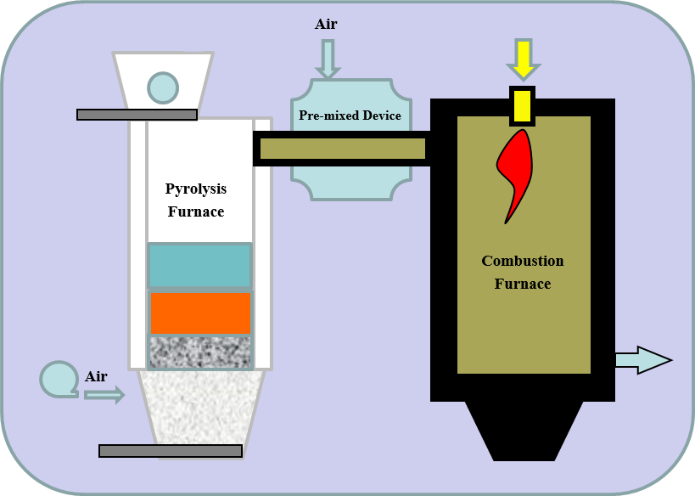
FIG. 1. Schematic diagram of pyrolysis incineration system
The waste pre-treatment system is an indispensable part of the process system to pre-treat the waste to meet the requirements for normal operation of the pyrolysis incineration system, mainly consisting of receiving, sorting, crushing, repackaging and conveying processes. Firstly, the waste receiving device is used to dump the waste in the drum into the receiving device, then the non-combustible waste is sorted out in the sorting device through the sorting process, the sorted non-combustible waste is collected in the waste drum for the next step, the combustible waste is transported to the crusher for crushing, and finally the crushed material is repacked into bales of specified sizes through the baling device and transported through the conveying device. The material is transported continuously in batches to the charging device of the pyrolysis and incineration system.
The flue gas cooling and purification system is to cool the high temperature flue gas from the combustion furnace and then remove the dust, acid gas and radionuclides from the flue gas through various purification processes to achieve the final discharge of the exhaust gas. Through the combination of several cooling methods, the flue gas from the combustion furnace is cooled from high temperature to the working range of the purification system; the cooled flue gas is initially filtered by bag filter and other filtration devices, and the acid gas absorption device is used to absorb the acid gas in the flue gas, and finally the combined filtration device is used to purify the flue gas to ensure the final emission.
After determining the process system, ZRF series pyrolysis incineration technology has established the corresponding engineering test device and conducted engineering verification tests. The core equipment pyrolysis furnace was always at low temperature during the test, and the equipment had a long service life. The cracking gas and air diffusion mixing conditions were greatly improved, the combustion reaction was completed very fast and the reaction degree was complete, and the generation of incomplete combustion products such as tar was suppressed. At the same time, radionuclides are enriched in the incineration ash, the amount of fly ash entrained in the flue gas is less, and the workload of the purification equipment is light, which greatly reduces the generation of secondary waste. The final exhaust gas was tested and the results are shown in Table 1, and all data are better than the emission standards.
TABLE 1. Exhaust gas test results
No. | Item | Result (mg/m³) | Standard limits (mg/m³)
1 | Dioxin | 0.023 | 0.5
2 | Fume and dust | 6-12 | 100
3 | CO | 16-50 | 100
4 | SO2 | <5 | 400
5 | HCl | 10-21 | 100
6 | HF | 2.63-5.3 | 9.0
7 | NOx | Not Detected | 500
8 | Hg | Not Detected | 0.1
9 | Cd | Not Detected | 0.1
10 | Pb | Not Detected | 1.0

ZKF series compact incineration technology
Some nuclear facilities generally produce only a few tons to a dozen tons of radioactive combustible waste per year, and the activity concentration generally does not exceed 10⁵Bq/kg, while the ZRF series pyrolysis incineration technology after the application of the incineration facility assumes a waste treatment capacity of 25kg/h, if the 24-hour continuous operation per day, 200 days of operation per year, the facility can treat 120 tons of combustible waste per year, far exceeds the amount of waste generated by these nuclear facilities. At the same time, the incineration facility after the application of ZRF series pyrolysis incineration technology engineering covers a large area of about 1300 m², and the construction cost is high, the plant has 4 floors with a total height of 16 m and a floor area of about 2400 m². The operation cost is high, requiring about 50 people for production, maintenance and management.
In response to the small volume and low activity of radioactive combustible waste generated in this part of the nuclear facility, CIRP has conducted targeted research and developed the ZKF series compact incineration technology with complete process flow, small footprint, low operation and construction costs, easy operation and operation, and meeting radiation protection requirements and emission requirements.
The ZKF series compact incineration technology process system is roughly the same as the ZRF series pyrolysis incineration technology, with a certain degree of optimization in process and equipment.
The waste pre-processing system eliminates the complex "Sort-Crush-Repack" process and separates the waste pre-processing from the process system by implementing waste sorting and packaging at the source of waste generation. The waste pre-processing system only requires the direct transfer of the set size bales to the incineration system via the waste charging unit. The waste charging unit is equipped with a belt partition, which can be continuously charged several times after a single feeding operation, reducing the operating intensity of laborers. The waste charging unit is mobile and can be docked or moved as needed, allowing for more efficient use of the site.
The incineration system adopts the controlled air pyrolysis incineration method, which realizes two kinds of incineration methods: pyrolysis incineration and controlled oxygen incineration in the pyrolysis furnace, replaces the pre-mixed device with a small furnace chamber, and at the same time sets up a burner at the connection between the pyrolysis furnace and the small furnace chamber and passes in combustion air, changing the incineration process from "pyrolysis-premixing-combustion" to "Pyrolysis - combustion - re-combustion". The waste is thermally cracked in the pyrolysis furnace to produce pyrolysis coke and pyrolysis gas, and the pyrolysis gas enters the small furnace chamber from the upper part of the pyrolysis furnace and mixes with combustion air for the first time, and then enters the combustion furnace for further combustion. The pyrolysis coke continues to be burned in the pyrolysis furnace, and the heat generated can be used for preheating and pyrolysis of materials. Due to the small heat capacity of the small furnace chamber, the preheating temperature rises quickly, which significantly shortens the overall preheating time of the combustion furnace and enables intermittent operation. At the same time, the pyrolysis furnace, small chamber and combustion furnace are designed as a whole module, and the height of the incineration system is generally reduced, and the floor space is only 1/2 of that of the pyrolysis incineration technology.
The flue gas cooling and purification system eliminates the rapid cooling of water injection in the cooling stage, and only cools the flue gas through a combination of indirect water-cooled heat exchange and indirect air-cooled heat exchange, and uses an optimally designed acid gas absorption process in the purification stage. The flue gas from the combustion furnace is cooled by indirect water-cooled heat exchange through water-cooled heat exchangers and indirect air-cooled heat exchange through air-cooled heat exchangers, and then enters the bag filter at the back end for preliminary dust removal, and then absorbs the acid gas in the flue gas through the acid gas absorption equipment, and finally passes through the activated carbon absorption device and high efficiency filter to achieve the final discharge of the exhaust gas to meet the standards. Compared with pyrolysis incineration technology, the flue gas cooling and purification system avoids the generation of secondary waste liquid, and at the same time reduces the number of equipment, and through the optimization of the design of purification equipment to form a purification module, reducing the footprint of the equipment.
Compared with the ZRF series pyrolysis incineration technology, the ZKF series compact incineration technology streamlines the number of equipment by optimizing the process flow on the one hand, and reduces the size of the equipment by rational equipment design on the other hand, realizing the compactness of the whole unit. The process optimization includes improving the incineration process, reducing the preheating time of the burner, increasing the effective running time, achieving intermittent operation of the equipment, thus reducing staffing and operating costs, simplifying the flue gas cooling process and the flue gas cleaning process, and reducing the amount of water used for production and the number of supporting process equipment. The optimization of the equipment design improves the utilization of space and reduces the floor space through the compact design and arrangement of the equipment structure and the integration of individual equipment into a modular device. After optimization, the process flow diagram of the ZKF series compact incineration technology is shown in Figure 2.
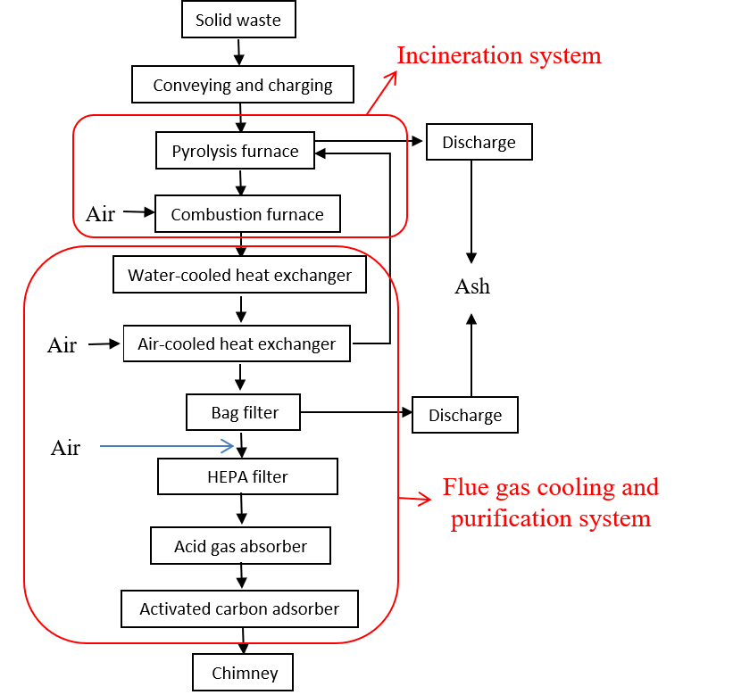
FIG. 2. ZKF compact incineration technology process flow chart
After determining the process flow of the ZKF series compact incineration technology, CIRP established an incineration unit at its affiliated waste repository, as shown in Figure 3. The facility covers an area of 86 m² and consists of an incineration hall, a waste staging room, a fan room, and a power distribution and control room. After the incineration unit was built, engineering simulation verification tests were conducted, which showed that the incineration system operated smoothly, the process of flue gas cooling and purification system was feasible, the equipment was reliable, and no process wastewater was generated.
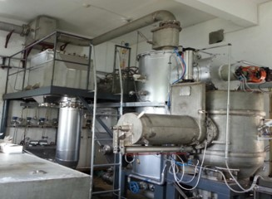
FIG.3. ZKF series compact incineration technology incinerator part of the equipment
Compared with the ZRF series pyrolysis incineration technology, the ZKF series compact incineration technology has significantly reduced the footprint, energy consumption, construction costs, and number of operating personnel, while reducing the requirements for water supply and drainage, electricity, ventilation, and other supporting conditions. The ZKF series compact incineration technology has been designed and developed according to the waste characteristics of nuclear facilities with low waste generation, resulting in a significant reduction in floor space, energy consumption, construction costs, and operating personnel, increased flexibility in operation methods while meeting the demand for treatment capacity, and reduced requirements for construction and operation support conditions to meet the treatment needs of nuclear facilities with low waste generation.

ZYF series mobile incineration technology
At present, the annual waste generation of some nuclear facilities is not even enough to support the normal operation of the ZKF series compact incineration units, and the insufficient operating time of the incineration facilities will lead to higher maintenance costs, making the incineration units less economical. In response to this situation, CIRP further optimized the process design and equipment layout on the basis of ZKF compact incineration technology by streamlining the number of equipment, compact design, and integrated layout, etc., and arranged all the process equipment in a container truck, realizing the vehicle-mobile of the incineration device, making the waste treatment method more flexible, and one device can meet the demand the waste treatment in multiple locations.
ZYF series mobile incineration technology process system in the ZKF series compact incineration technology based on the addition of the carrier part. The main process part consists of waste receiving and conveying device, incineration system, flue gas cooling and purification system, the auxiliary process part consists of the same function, the carrier part is a load-bearing vehicle, consisting of two parts: trailer and box.
The incineration system adopts the same controlled air pyrolysis incineration method as the ZKF series compact incineration process, which realizes two incineration methods, pyrolysis incineration and controlled oxygen incineration, in the pyrolysis furnace, and the generated pyrolysis gas is further burned completely in the combustion furnace. The upper, middle and lower positions of the pyrolysis furnace are equipped with combustion air inlets, and the combustion air flow rate at the upper, middle and lower three different positions can be adjusted individually according to the material components to control the incineration mode in the pyrolysis furnace. The incineration system eliminates the design of small furnace chamber, and the pyrolysis furnace is directly connected to the combustion furnace.
The waste reception conveyor is used to receive the specified size bales and transport them to the incineration system. In the same way as the ZKF compact incineration process, the waste pre-treatment process is separated from the incineration unit, and the waste is sorted and baled during the waste collection process. The double-sealed design of the waste receiving and conveying unit ensures relative isolation from the environment during feeding and refilling to avoid leakage of radioactive materials.
The cooling stage of the flue gas cooling and purification system adopts indirect water-cooled heat exchange and water jet rapid cooling, and the purification stage adopts the same process as the ZKF series compact incineration technology. The flue gas exit from the combustion furnace is first cooled down by indirect water-cooled heat exchange through a cyclone water cooler, and then the temperature is rapidly reduced by the rapid cooling effect of the water jet in the emergency cooler. The cooled flue gas is purified by the same purification process as the ZKF series compact incineration technology and then finally discharged to the standard.
The ZYF series mobile incineration technology is further optimized on the basis of the ZKF series compact incineration technology, which also features less radioactive waste liquid generation and less secondary waste generation, while further reducing the footprint of the device due to the realization of the vehicle-mobile device. At the same time, the degree of automation of the automatic control system has been improved, further reducing the number of operating personnel and lowering operating costs. The final process flow diagram of the ZYF series mobile incineration technology is shown in Figure 4.
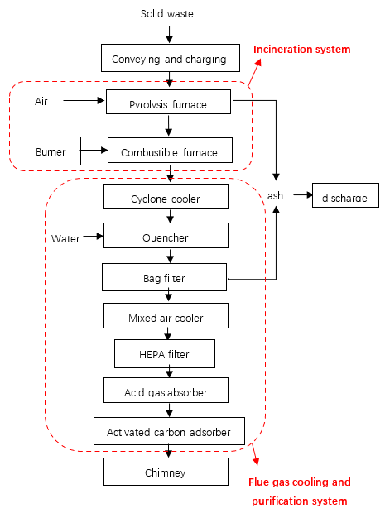
FIG. 4. ZYF series mobile incineration technology process flow chart
After determining the process flow, CIRP carried out the equipment design while taking into account the equipment layout, piping layout and transportation requirements, and arranged the equipment in a 40-foot container and built an engineering test set, as shown in Figure 5.
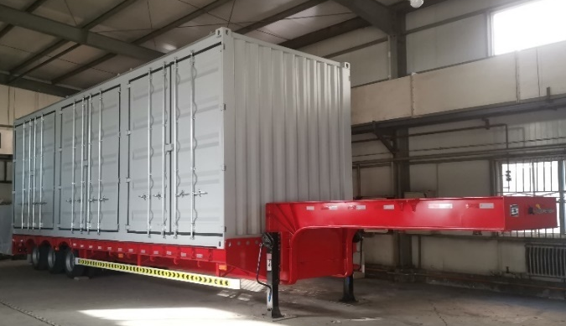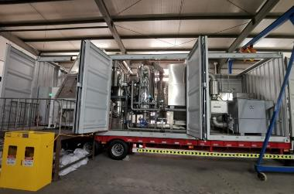
FIG. 5. ZYF series mobile incineration technology engineering device physical diagram
CIRP conducted several engineering tests on the basis of the engineering unit, using simulated materials consisting of cotton fabric, paper, plastic and rubber to determine reasonable process parameters and verify the performance of the systems and equipment. The exhaust gas was tested by a third-party testing agency during the tests and all met the emission requirements.
Through engineering tests, the engineering unit has achieved stabilization of simulated combustible waste, with technical specifications meeting design requirements and environmental standards. Compared with the ZKF series compact incineration technology, the number of operating personnel, floor space, and operating costs are further reduced, while vehicle-mobile makes the operation more flexible and meets design requirements.

Engineering Application
CIRP has implemented the ZRF series pyrolysis incineration technology, the ZKF series compact incineration technology and the ZYF series mobile incineration technology into engineering applications and has over 20 years of experience in engineering applications.
ZRF series pyrolysis incineration technology has four sets of engineering application units, the first set of engineering application units was completed in 2003, and put into operation after the completion of cold and hot commissioning, the first time to realize the engineering application of pyrolysis incineration process; the second set of engineering application units was completed in 2009, and put into operation after the subsequent completion of cold and hot testing; the third set of engineering application units was completed in 2012, and put into operation after the completion of cold and hot commissioning. After years of stable operation, more than 500 tons of combustible waste have been treated; the fourth engineering application plant is an overseas construction project, exported to Pakistan, all design work has been completed, and the equipment has been processed and manufactured, and the installation and construction work is in progress.
ZKF series compact incineration technology has built a set of engineering application units, which were constructed and completed in 2015 and successfully passed the commissioning for the treatment of radioactive combustible waste released from waste stockpiles.
ZYF series mobile incineration technology has built a set of engineering prototype, has completed the engineering test verification work, the test results show that the technology can carry out the treatment of high capacity reduction and stabilization of combustible waste.
After long-term stable operation, there are obvious differences in the operating parameters of the engineering application units corresponding to the three technologies, as shown in Table 3. The three incineration technologies complement each other in terms of technology and function, enhancing the overall scope of application of incineration technology and solving the problem of radioactive combustible waste treatment.
TABLE 2. Comparison of technical features
Item | ZRF | ZKF | ZYF
Waste acceptance requirements (Bq/kg) | β/γ≤4×10⁶  α≤2×10⁵ | β/γ≤4×10⁵ | β/γ≤4×10⁵
Processing Capacity (kg/h) | 15-80 | 15-35 | 15-30
Operation mode | 24h/d | 24h/d，8h/d | 24h/d，8h/d
Number of staff | 50 | 8（8h/d） | 3（8h/d）
Water consumption (m³/d) | 30 | 0.1 | 0.3
Installed capacity of electricity consumption (kW) | 250 | 45 | 45
Radioactive waste liquid generation (m³/d) | 3 | 0 | 0
Building area (m²) | 2400 | 120 | 60

Summary
CIRP developed ZRF series pyrolysis incineration technology, ZKF series compact incineration technology and ZYF series mobile incineration technology has different technical characteristics for different waste characteristics, the main technical indicators of the three incineration technologies are shown in Table 3.
TABLE 3. Main technical specifications
Item | ZRF | ZKF | ZYF
Processing objects | Cloth, paper, wood, plastic, rubber, waste oil and a small amount of resin
Processable plastic and rubber content | ≤70%
Solid waste treatment capacity | 15-80kg/h | 15-35kg/h | 15-30kg/h
Waste oil treatment capacity | 7-30L/h | 7-15L/h | 7-12L/h
Capacity reduction ratio | 50-120 | 50-100 | 50-100
Weight reduction ratio | 15-50 | 15-50 | 15-50
Purification factor | DF≥10⁷ | DF≥10⁶ | DF≥10⁶
Non-radioactive pollutant emissions | Comply with the requirements of GB18484-2001
The engineering application units of incineration technology developed by CIRP have been in actual operation for many years and have treated a large amount of radioactive combustible waste, proving the advancement, stability and reliability of the incineration technology process. During this period, CIRP has continued to work on improving the incineration technology and solving the problems arising in the operation process, and will continue to strengthen the exchange and cooperation with relevant units in technology development and engineering application, and promote the development of radioactive waste incineration technology together.
References
- MA Mingxie, Incineration treatment of radioactive waste [J]. Radiation Protection (1991, 11) 161-173.
- WANG Peiyi, ZHOU Lianquan, MA mingxie, et al. Technological process of a multi-purpose radswate incineration system [J]. Radiation Protection (2002, 22) 321-325.
- LI Xiaohai, ZHOU Lianquan, WANG Peiyi, et al. An overview of a nuclear waste incinerator’s erection and commissioning [J]. Radiation Protection (2004, 24) 46-50.
- ZHENG Bowen, XU Wei, CHU Haoran, et al. Designing and verification of a compact incineration device for low level radioactive solid waste [J]. Radiation Protection (2020, 9) 365-371.
- YANG Lili, WANG Peiyi, ZHENG Bowen, et al. Designing, establishing and engineering verification of compact low level solid radioactive waste incinerator [J]. Radiation Protection (2016, 36) 408-412.
- ZHENG Bowen, XU Wei, YANG Lili, et al. Improvement and its validation to the flue gas cleaning system in low-level waste incinerator [J]. Radiation Protection (2014, 7) 206-213.

