DISMANTLING AND SAFE MANAGEMENT OF IONISATION SMOKE DETECTORS AND LIGHTNING PREVENTORS CONTAINING RADIOACTIVE SOURCES IN THAILAND

C. Muanglay
Waste Technology Development Section, Radioactive Waste Management Center,
Thailand Institute of Nuclear Technology (Public Organization)
Chatuchak/Bangkok, Thailand
Email: Chalit@tint.or.th

A. Phattanasub, P. Srimork, C. Sutharom, T. Panprom, S. Sudchawa and N. Prasertchiewchan
Waste Technology Development Section, Radioactive Waste Management Center,
Thailand Institute of Nuclear Technology (Public Organization)
Chatuchak/Bangkok, Thailand

Abstract

Ionization smoke detectors as a kind of fire alarm device mounted on the building ceiling and the lightning prevention containing radioactive substances were collected from building construction companies and radioisotope users in Thailand. The most common ionization smoke detectors contain americium-241 with activities up to 0.666 MBq lightning preventers contain americium-241 or radium-226 with activities up to 695 and 432 MBq, respectively. Several thousand pieces of these devices were labeled, recorded, packed, and stored in the radioactive waste storage building for several decades. Although the activities of these devices are low however due to a large number of these devices and the long half-life of the radioisotopes, special attention was considered. In the year 2020, Radioactive Waste Management Center (RWMC), Thailand Institute of Nuclear Technology (TINT) launched the management plan to improve the safety and security of the category 3-5 disused sealed radiation source in Thailand. The management plan is conducted according to Thai’s regulation, the IAEA safety standards, and international practices. Dismantling and conditioning of these devices were planned. The relevant documents for conditioning authorization were submitted to the nuclear regulator, Office of Atoms for Peace (OAP), for approval. Ionization smoke detectors and lightning prevention using radioactive substances were dismantled. Radioactive sources were removed from the devices, encapsulated in the stainless-steel tube containers, and overpacked in the lead shielded concrete drums for future management. Source inventories were registration recorded. Successful implementation of the plan was achieved. 6,000 pieces of sources were conditioned and the volume reduction of the devices was more than a thousand times.

INTRODUCTION
The most common ionization smoke detector (ISD) are smoke detectors using radioactive substances, in most cases americium-241 (²⁴¹Am) with activities up to 0.666 MBq. The ionization lightning preventers (ILP) in Thailand, they used the main radioisotope was ²⁴¹Am in this equipment. Although radium-226 (²²⁶Ra) with activities up to 695 and 432 MBq, respectively was also used, but in a very smaller scale. Individual ISDs and ILPs, classified by the IAEA as consumer products. Although the activity of these devices is very low, due to the large number of these devices collected together and the long half-life of the sources, special attention should be paid to the safe management of these devices when become disused, should be managed as radioactive waste. In 2020, More than 3,297 pieces with difference models of ISD and 254 pieces of ILP have been collected and stored at Thailand Institute of Nuclear Technology (Public Organization) (TINT), Radioactive Waste Management Center (RWMC) is the organization responsible for radioactive waste management in the country under the supervision of the Office of Atoms for Peace (OAP). In order to improve the safety and security of the long-lived sources and minimize the volume of waste in the storage facility, it is recommended to dismantle those devices, remove and consolidate the sources and condition for long term storage [4].

Inventory of ISD and ILP in the Storage Facility
RWMC has stored and collected ISD and ILP from different institutions within the country. The information regarding the radionuclide contained in the source and the activity was unknown and lost information for some models of this devices. It is important information for safety assessment and dose rate analysis for worker. For this reason, before starting the ISD and ILP dismantling and source recovery operations. The detail inventory of ISD and ILP stored in the storage facility was revised and updated. The relevant information of ISD and ILP was updated from: (a) the information of ISD and ILP from documents licenses issued by OAP provided by the licensee, (b) the documents licenses issued by OAP of RWMC and the database of ISD and ILP in the storage facility, (c) the user manual or catalogue of product from manufacturers and distributors, (d) the label contained on ISD and ILP, (e) Some measurements (e.q., by using identiFINDER radiation detector to identify type radioactive sources) , and (f) other international references (e.g., technical guidance reference manual of IAEA) [1,3].

ISD
RMMC stored the ISD in the radioactive waste storage building amount of 3297 pieces. According to the
register of accepted ionization smoke detectors into central storage facility, the most commonly used radioactive source in Thailand ionization smoke detectors is ²⁴¹Am with activities 0.037 MBq to 0.666 MBq, which is bonded to the plastic inside and sealed. The ²⁴¹Am has a half-life is 432 years and decays by emitting alpha particles which is the nucleus of the chemical element Helium [4]. The 32 drums with 12 different models of ISD are stored in the radioactive waste storage buildings (Fig.1).

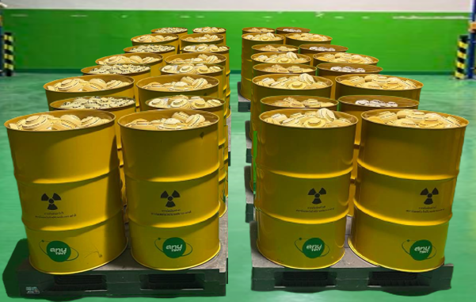

FIG. 1. ISD stored in the radioactive waste storage buildings of RWMC.

ILP
RMMC stored the ILP in the radioactive waste storage buildings amount of 254 pieces. There are two types
of radioactive sources in ILP in Thailand including ²⁴¹Am with activities 1.11 MBq to 695 MBq and ²²⁶Ra with activities 17.39 MBq to 432 MBq. The radioactive sources of the ²⁴¹Am and ²²⁶Ra are bonded to the metallic outside of the device in a different geometry but most of them have rectangular type shapes [5]. In addition, the ²²⁶Ra has a half-life is 1600 years and decays by emitting alpha particles and gamma. The 16 drums with 2 different models of ILP are stored in the radioactive waste storage buildings (Fig.2).

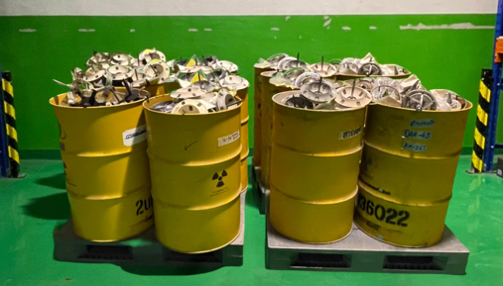

FIG. 2. ILP stored in the radioactive waste storage buildings of RWMC.

Dismantling of ISD and ILP and Recovering the Radioactive Sources
The safe management of ISD and ILP involves device dismantling, reducing the volume of radioactive waste in the storage buildings, and recovering and conditioning the associated radioactive sources for long-term storage and disposal. A technical manual has been developed with specific instructions for dismantling each model of ISD and ILP and recovering the radioactive sources [2,4]. The next step involves removing the source from the holder and performing the conditioning in the fume hood and consolidate the radioactive sources into the capsules. The rest of the non-radioactive materials after check contamination should be segregated (plastic, metal, and electronic components) for recycling.
Examples of dismantling operations for the ISD model G50602455 and TC805C1000 shown in Fig. 3 and 4. These devices contain ²⁴¹Am radioactive sources with activity 0.037 MBq.

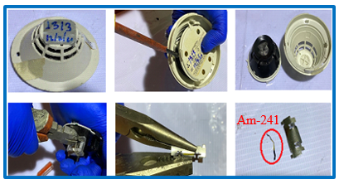

FIG. 3. ISD model: G50602455.

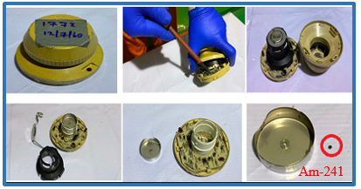

FIG. 4. ISD model: TC805C1000.

Examples of dismantling operations for the ILP model: P3 shown in Fig. 5 to 6. These devices contain ²²⁶Ra radioactive sources with activity 154.66 MBq.

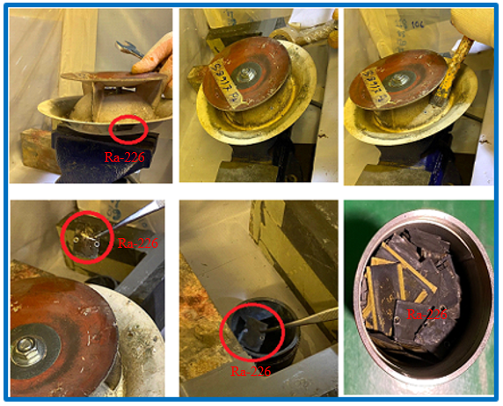

FIG. 5. The dismantling procedure of ILP model: P3.

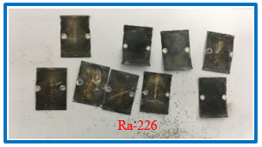

FIG. 6. ²²⁶Ra from the conditioning ILP.

Conditioning of Long Half-Life Radioactive Sources
Most ISD and ILP contain long half-life radioactive sources (²⁴¹Am and ²²⁶Ra), and. A methodology has been developed for conditioning radioactive sources and stored in the radioactive waste buildings (long-term storage).
The long half-life radioactive sources ²⁴¹Am and ²²⁶Ra are placed in stainless steel capsules (Fig. 7). Sources of the same radionuclide are placed in the same capsule. The number of radioactive sources and the total activity in the capsule are controlled and recorded in the inventory of conditioning. The activity of a radioactive source is very low. The numbers of radioactive sources placing in a capsule are depended on the radioactive source geometry and the capacity of the capsule.

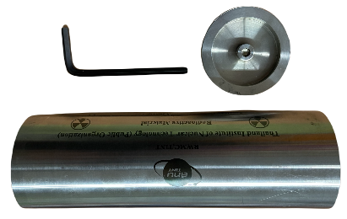

FIG. 7. The Capsule for radioactive sources after conditioned of RWMC.

For ²²⁶Ra loaded in the capsule, the capsule is sealed by the lid after that the capsules are then submitted to a contaminated test. Finally, sealed capsules are placed in a drum that is specifically designed. The drum consists of a metal outer container of 200 litters, lined concrete, and reinforced steel in the structure of concrete, 5.00 cm thick a lump of lead and high 20.00cm, and 0.50 cm thick steel pipe. Including, accessories include a lid of lead, basket for a capsule, a lid of steel with a belt for a close drum, and steel pallets for transporting drum (Fig.8). Drum with a capsule containing ²²⁶Ra is stored in the radioactive waste storage buildings (Buildings 22) (Fig.10).

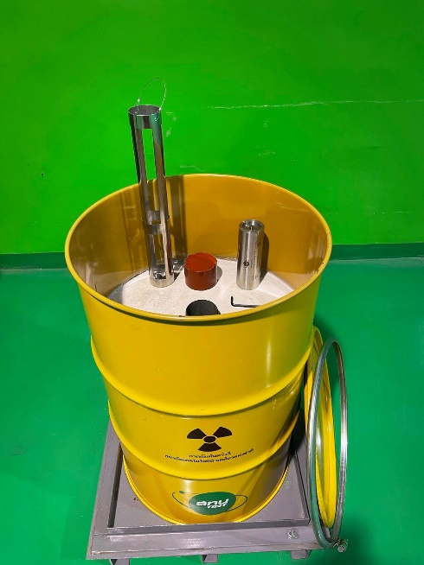

FIG. 8. A special drum and accessories for a capsule of RWMC.

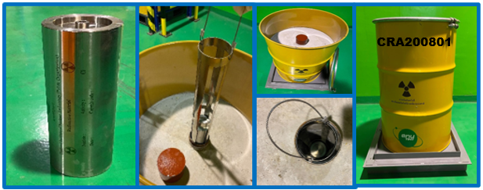

FIG. 9. The loading a capsule in the drum.

RWMC follows the compliance of waste acceptance criteria for radioactive waste storage building which is being controlled and recorded including identification of waste packaging (capsule and drum), radiation level at the surface and 1-meter, radioactive content (radioactive sources, date reference and activities), and the surface contamination. The information on waste packaging must complete with a detailed description of the drums and capsules with a radioactive source to use for traceability or to manage to use for disposal in the future.

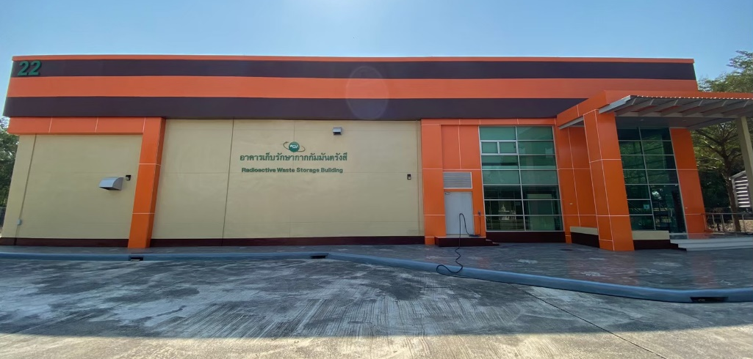

FIG. 10. The radioactive waste storage buildings (Buildings 22) of RWMC.

Results and ConclusionS
The paper aims to present dismantling and safe management of ionization smoke detectors and lightning preventors containing radioactive sources in Thailand.
RWMC has conditioned radioactive waste by dismantling 3,297 pieces of ISD and 254 pieces of ILP. The ISD and ILP have long half-life radioactive sources (²⁴¹Am and ²²⁶Ra), therefore a specific procedure was developed and implemented for the proper conditioning of the sources to guaranty safe storage (long term storage). The total radioactive sources from dismantling ISD and ILP are 6,000 pieces and the volume reduction of the devices was more than a thousand times.
In addition, the total number of capsules is 5 capsules including 4 capsules for ²⁴¹Am (3 capsules for ²⁴¹Am from ILP and a capsule for ²⁴¹Am form ISD but which can also be loaded a lot of ²⁴¹Am because size of ²⁴¹Am from ISD is a small radioactive source) and a capsule for ²²⁶Ra from ILP.
For drum contain with ²²⁶Ra capsule, the average radiation dose rate of drum at the surface about 23 µSv/hr (side of drum) and background (top of drum) and the radiation level equal to the background at 1 meter. Including drums are stored in a special room designed for high-level radioactive waste so the radiation dose rate of drums doesn't affect the radioactive waste storage building. The radiation dose rate of the radioactive waste storage building follows Thai Ministerial regulation.
A methodology has been developed and implemented for dismantling 12 different models of ISD and 2 models of ILP and recovering the associated radioactive sources.
The radiation exposure of operators has been estimated and is controlled. The average occupation dose of the workers is 0.67 mSv which doesn't exceed the dose limits for occupational exposure of workers over the age of 18 years of IAEA standard and Thai Ministerial regulation IAEA [6]. All radiation protection measures are in place and all operations are approved/ authorized by OAP. All the works have been performed under a quality management program (ISO 9001 and ISO 14001). The integrated safety management was used to ensure the health and safety of the worker and environment.
ACKNOWLEDGEMENTS
The authors would like to gratefully extend sincere thanks to the Office of Atomic Energy for Peace (OAP) for authorization dismantling ISD and ILP and we wish to thank RWMC teams for their contribution to this project.
References
- Fundamental safety principles: safety fundamentals, IAEA safety standards for protecting people and the environment series No. SF-1, IAEA, Vienna (2006).
- Paulo de Oliveira Santos, Fábio Silva, “Management of Radioactive Disused Lighting Rods”, 2013 International Nuclear Atlantic Conference - INAC 2013, ASSOCIAÇÃO BRASILEIRA DE ENERGIA NUCLEAR, Brazil (2013).
- International Catalogue of Sealed Radioactive Sources and Devices (ICSRS) (n.d.), IAEA, Vienna (2015).
- Salgado M., Benítez J.C., Castillo R.A., Berdellans A., Hemández J.M., Pirez C.J., Soto P.G., A., “Safe Management of Smoke Detectors Containing Radioactive”, IX Latin American IRPA Regional Congress on Radiation Protection and Safety - IRPA 2013, SOCIEDADE BRASILEIRA DE PROTEÇÃO RADIOLÓGICA – SBPR, Brazil (2013).
- Denise Minematsu, José Claudio Dellamano, Robson de Jesus Ferreira, “Activity Determination of the Am-241 Sources from Radioactive Lighting Rods”, 2009 International Nuclear Atlantic Conference - INAC 2009, ASSOCIAÇÃO BRASILEIRA DE ENERGIA NUCLEAR – ABEN, Brazil (2009).
- Occupational radiation protection / International Atomic Energy Agency, IAEA Safety Standards Series No. GSG-7, IAEA, Vienna (2018).

