THE STUDY of alternative encapsulants

for the treatment of intermediate level

Radioactive waste

M. HAYES
National Nuclear Laboratory
Risley, United Kingdom
Email: martin.hayes@uknnl.com

G.M. CANN, S. COCKBURN, S. RAWLINSON, D. WARD, O.C.G. TUCK
National Nuclear Laboratory
Workington, United Kingdom

D. GEDDES, S. NELSON
Department of Materials Science and Engineering
University of Sheffield
Sheffield, United Kingdom

S. FARRIS, S. MORGAN
Sellafield Ltd
Seascale, United Kingdom

Abstract

In the UK, currently the preferred method of immobilising intermediate level waste (ILW) is through the use of Portland cement (PC) based grouts. However, certain types of ILW present a challenge, with the result that PC-based matrices may not represent the optimum encapsulant. Such challenges are related to either chemical compatibility issues between the waste and encapsulant, or those related to rheology such as the infilling of wastes with tortuous pathways, or the ability to mix viscous wastes, which may all serve to restrict waste loadings or produce wasteforms with higher inherent voidage. A potential alternative is the geopolymer system which may provide product, cost and process resilience improvements over conventional PC-based matrices for the treatment of such ‘problematic’ ILW. The paper presents preliminary results from a structured research programme using statistical analysis to define suitable geopolymer formulations for subsequent waste interaction studies, in which the surrogate ion exchange resin waste, clinoptilolite, has been immobilised at ~120 L scale. The study has shown that a high fluidity geopolymer formulation developed at small scale can potentially offer a significant improvement in the ability to mix the high viscosity surrogate to produce a homogeneous wasteform, in comparison to a baseline PC-blend matrix. The resultant geopolymer/clinoptilolite matrix had significantly higher compressive strength than the PC-blend product at equivalent waste loading, whilst both products were dimensionally stable over the 90 d curing period. The geopolymer formulations developed in this study were shown to have high heats of hydration where the exotherm obtained for the Metamax®/clinoptilolite wasteform at ~120 L was 79 °C. As a result, the exotherms at full scale will need to be assessed, in conjunction with studies to assess the effects of such temperatures on the resultant geopolymer wasteform.

INTRODUCTION
Intermediate level waste (ILW) has been generated for more than 60 years at nuclear-licensed sites throughout the UK, resulting in an estimated 247,000 m³ of ILW generated from current stocks and estimated future arisings up to 2135 [1]. ILW is classified in the UK as emitting more than 4GBq per tonne of alpha activity, or 12GBq per tonne of beta/gamma activity, but is not significantly heat generating such that heating is not considered in the design of storage or disposal facilities [1]. Historically in the UK, the preferred method of immobilising ILW has been through the use of Portland cement (PC) blended with blastfurnace slag (BFS) or pulverised fuel ash (PFA), to produce a passively safe waste package. Whilst it is expected that cementitious encapsulation will continue as part of a suite of technologies for ILW treatment as the UK transitions from reprocessing to decommissioning, it is recognised that for certain types of ILW the use of a blended PC matrix may not provide the optimum immobilisation matrix, with the result that waste incorporation rates may be restricted [2]. These restrictions may relate to the rheology of the system, such as the ability to satisfactorily mix viscous wastes with the cementitious matrix or infill wastes with tortuous pathways. Conversely, waste loading restrictions may also arise due to chemical compatibility issues between the waste and encapsulant.
In order to address these issues, and identify potential enhanced encapsulation options for the treatment of ‘problematic’ ILW in the UK, the Encapsulants Integrated Research Team (EIRT) has been established as a collaboration between Sellafield Ltd (SL) and the National Nuclear Laboratory (NNL) to identify and provide data on alternative immobilisation matrices such that they may provide product, cost and process resilience improvements over conventional PC-based matrices for the treatment of such ILW. As a result, and following a review of the literature [3, 4, 5, 6, 7], four cement systems have been identified to form the basis of studies within the EIRT programme for the immobilisation of ‘problematic’ ILW, namely:

- Geopolymers;
- Calcium Sulfoaluminate (CSA) cements;
- High alumina cements (HAC);
- Magnesium phosphate cements (MPC).

Initial studies within the EIRT programme have focussed on defining, at a nominally small-scale (~160 mL), a range of highly fluid formulations for each of the above encapsulants with adequate setting characteristics (< 48 h) using statistical experimental design and subsequent analysis, in order to assess the effects of varying mix parameters for each encapsulant on typical processing properties required for the treatment of ILW; residual bleed liquor, viscosity, pH and set time. As a result of these studies, formulation ranges for each encapsulant were identified for subsequent scale-up studies, in which typical grout processing characteristics important for the treatment of ILW; fluidity, viscosity, bleed, setting time and heat of hydration, in addition to the product quality properties of compressive strength and dimensional stability up to 90 d curing will be assessed statistically with varying mix parameters. This allowed optimum formulation ranges to be identified for subsequent waste-matrix interaction studies.
These studies have recently been completed for the geopolymer system, in which microstructural analysis of the matrix has also been conducted up to 90 d curing in order to assess the evolution of the matrix with curing time and varying mix parameters. Selected formulations from this baseline study are currently being investigated for the immobilisation of surrogate waste test materials, including an ion exchange resin in the form of the natural aluminosilicate zeolite, clinoptilolite, and it is these geopolymer studies that form the focus of this paper.
Geopolymers are alkali activated materials (AAM) formed through the reaction between an alkaline ‘activating solution’, usually an alkali hydroxide or silicate (or combination of the two to maintain high pH) with an aluminosilicate pre-cursor [8], to form a 3-D amorphous aluminosilicate product [9]. Studies within the EIRT programme have focussed on the use of metakaolin, as the aluminosilicate pre-cursor in the studies undertaken to date [10]. The generic reaction between an aluminosilicate source and alkali silicate has been simply described as follows [11]:
$$\text{A}{\text{S}}_{\text{y}}\text{+R}{\text{S}}_{\text{z}}\text{(}\text{aq}\text{)+}\text{nH}\underset{→}{ }\text{RA}{\text{S}}_{\text{(y+z)}}{\text{H}}_{\text{n}}$$
Where: A = Al₂O₃, S = SiO₂, H = H₂O and R = alkali metal e.g. Na, K.
The geopolymer system holds several potential advantages for ILW treatment, including:

- Formulations can be produced with high fluidity, zero bleed and adequate strength development [3, 10];
- The 3-D amorphous aluminosilicate network of geopolymers may provide enhanced retention characteristics for heavy metals, radionuclides (e.g. Cs/Sr) and oils [12, 13];
- The systems are available commercially and can be deployed by current mixing technology [14].

The structure and mechanical properties of the geopolymer depend on the raw materials and processing conditions. It is possible to vary the properties of a geopolymer by changing the following [15]:

- Chemical composition, particle size and reactivity of the aluminosilicate source;
- Amount of activating solution used with respect to the aluminosilicate source and the relevant proportions of alkali hydroxide, alkali silicate and water within the activator solution;
- Type of alkali hydroxide/silicate (Na, K etc.);
- Processing conditions (curing temperature, relative humidity, shear rate).

Low viscosity geopolymer formulations, identifying metakaolin powders and reactant ratios, were defined for use in 3 L scale trials based on observations at ~160 mL scale. The study was conducted on geopolymer matrices produced with K-based silicate/hydroxide activator solutions, as previous work [16] indicated that Na- based activator solutions produced poorer rheological properties. Geopolymer formulations were formulated using the following molar ratio ranges based on two metakaolins:

- SiO₂:K₂O molar ratio (1.0 - 1.4);
- K₂O:Al₂O₃ molar ratio (1.0 - 1.5);
- H₂O:K₂O molar ratio (11 – 15).

This 3 L scale study aimed to assess the effects of varying the molar ratios above, on both processing characteristics and product quality of the geopolymer product. Additionally, the effect of two different shear regimes (“low” and “high” shear), on both of these matrix characteristics was also assessed, with the aim to identify formulations for subsequent clinoptilolite waste interaction studies.

2. EXPERIMENTAL

To minimise the number of trials, a factorial test matrix design was used, including axial and midpoint formulations; midpoint trials were undertaken in triplicate to assess consistency. The trial matrix for the 11 geopolymer formulations was tested for both metakaolin powders under both high and low shear regimes. A total of 44 mixes were undertaken covering the molar ranges shown above for each metakaolin powder and shear regime with all mixes carried out in a randomised order to reduce the effects of both random and systematic error. Statistical analysis of the results from this study, including linear regression modelling, was used to identify the effects of changing mix parameters on performance and to inform molar formulation ratios to take forwards.

Materials
BASF Metamax® and Argeco Developpment Argicem® metakaolins were sourced. Metamax® is a high purity metakaolin manufactured via a rotary calcination process. In contrast, Argicem® is a metakaolin containing a higher quartz fraction manufactured via a flash calcination technique. The chemical and physical properties are presented in Table 1.

TABLE 1. METAKAOLIN POWDER CHARACTERISATION DATA FOR 3 L SCALE TRIALS

Metakaolin Type | Fineness (m²/kg) | LOI (wt%) | Moisture Content (%) | Particle Size Distribution (µm)
 |  |  |  | D_{v}10 | D_{v}50 | D_{v}90
Metamax® | 3614 | 1.0 | 0.26 | 1.2 | 3.5 | 11.1
Argicem® | 706 | 2.4 | 0.34 | 5.2 | 38.5 | 127.7

Metakaolin Type | X-Ray Fluorescence Analysis (wt%) |  |  |  |  |  |  | Chloride (wt%) | Particle Density (g/cm³) | Molar SiO₂/ Al₂O₃ ratio
 | Al₂O₃ | SiO₂ | Na₂O/K₂O | TiO₂ | Fe₂O₃ | CaO | MgO
Metamax® | 44.5 | 52.6 | <0.5 | 1.7 | 0.4 | <0.05 | <0.05 | <0.01 | 2.61 | 2.0
Argicem® | 23.1 | 67.0 | <0.5 | 1.2 | 3.9 | 1.7 | 0.34 | <0.01 | 2.62 | 4.9

Activator solutions were prepared from the following:

- Potassium silicate, K120. Supplied by PQ Corporation, Warrington, UK containing 21.8 wt% K₂O, 31.4 wt% SiO₂ and 46.8 wt% H₂O;
- Potassium hydroxide extra pure flakes manufactured by Acros Organics;
- Deionised water.

Experimental Method
Activator solutions were prepared by adding potassium hydroxide to deionised water. The potassium hydroxide solution was cooled to 20 °C, and then added to the K120 potassium silicate solution, according to the SiO₂:K₂O ratio required. Once cooled, the appropriate quantity of metakaolin was added for the respective formulation in a Hobart N50 mixer, with stirring over a 5 min period at 62 r/min. After a further 5 min mixing, depending on the shear regime required, the grout was either mixed for a further 10 min on the N50 mixer (“low” shear) or was transferred to a Silverson L5 mixer and mixed for 10 min at 4,500 r/min (“high” shear).
After a total of 20 min mixing (t=0), a series of tests were carried out to assess processing properties and the mix was placed back on the Hobart N50 for up to 150 min (t=150) continued mixing with grout fluidity assessed at 30 min intervals. If a fluidity measurement of ≤500 mm was obtained during the mix hold-up period, or the mix showed visible signs of rapidly declining fluidity/gelation, the mix was aborted and all products for subsequent testing were cast at this point. This fluidity value was chosen as a grout fluidity ≤500 mm would show no enhancement over standard PC-blended grouts. The grout processing properties were assessed as follows:

- Grout fluidity was measured by the Colcrete Flow Channel test, developed by Colcrete Ltd and based on the method defined in EN 13395-2. The test uses 1137 mL of grout, placed into a pre-wetted tundish, the bung is carefully removed, and the grout falls under gravity onto a level, pre-wetted 1020 mm flow channel. The distance the grout travels along the channel after 60 s is recorded;
- Grout viscosity was assessed using a LAMY RM200 rheometer at 20 °C for samples taken at t=0 and at the termination of the mix. The rheometer used the MS-R2 measuring system. The test program applied a 120 s pre-shear at 262 s⁻¹ followed by a linear ramp of the shear-rate from 0 s⁻¹ to 262 s⁻¹ in 150 s followed by a linear ramp back down to 0 s⁻¹. The viscosity measurement at 106 s⁻¹ during the descending ramp is reported;
- Initial set and final set of grout samples were measured on samples of grout taken at the termination of the mix and tested by using Vicat apparatus according to EN 196-3. Grout samples were stored in lidded plastic Securitainers at 20 ± 1 °C between measurements;
- Bleed liquor on the surface of the grout samples taken at t=0 was monitored as vol % of the grout volume at 24 h, 2 d and 7 d on samples placed in sealed 100 mL measuring cylinders and stored at 20 ± 1 °C;
- Heat of hydration was determined on 3 g grout samples taken at t=0 using a TAM Air isothermal conduction calorimeter operated at 35 °C, representing a pessimistic encapsulation plant cell temperature.

The following product quality samples were prepared for all formulations (36 mixes excluding centre-point repeats) at the termination of mixes:

- Twelve 40 mm cubes were used to assess compressive strength development in triplicate at 2 d, 7 d, 28 d and 90 d;
- Four 26 mm x 26 mm x 286 mm prisms were cast to monitor dimensional stability at 2 d, 7 d, 28 d, 56 d, 70 d and 90 d curing in accordance with ASTM C 490;
- All products were cured under standard conditions of 20±1 °C and >90%RH.

RESULTS AND DISCUSSION

Fluidity and Viscosity
A large proportion (36 of 44) of the mixes exhibited high fluidities up to 120 min (>1020 mm) covering both metakaolins and all formulation ratios. In addition, three mixes had fluidities >500 mm at 120 min, whilst a fourth had a fluidity >500 mm up to 90 min. These four mixes covered both SiO₂/K₂O ratios of 1 and 1.4 and incorporated both metakaolins at the low H₂O/K₂O and K₂O/Al₂O₃ point of the formulation envelope (11 and 1 respectively) under both shear regimes. However, their equivalent four mixes for both metakaolins under the alternate shear regime tested, failed to reach 60 min mixing, necessary to allow sufficient time for waste infilling. Further, despite both Metamax® mixes exhibiting fluidities >800 mm at t=0, these mixes had to be aborted at 10 min and 30 min respectively, due to rapid gelation of the geopolymer with noticeable stress induced in the mixer. The Argicem® mixes at the equivalent molar ratios had to be aborted during the initial mixing process due to rapid gelation and therefore did not reach t=0.
Viscosity measurements showed that the mixes which exhibited high fluidity (>1020 mm at t=120) were characterised by low viscosities (<500 mPa∙s, typical of PC-blended encapsulation grouts) at t=0, with geopolymers incorporating Argicem® having a slightly higher viscosity than those incorporating Metamax® at equivalent molar ratios, and particularly under low shear conditions, consistent with the overall lower w/s ratio of the Argicem® mixes. Low viscosity readings of <500 mPa∙s were still maintained over the 120 min hold-up period for all except two of the 36 mixes, with the two exceptions, both incorporating Argicem®, still exhibiting viscosities of <600 mPa∙s at t=120 min. Statistical regression modelling indicated that at t=0, viscosities of the mixes significantly reduced as the H₂O/K₂O increased. In addition, as the K₂O/Al₂O₃ of the mixes increased from 1.0 to 1.5, there is a significant reduction in measured viscosity, whilst higher shear decreases viscosity at equivalent formulations. Increasing the SiO₂/K₂O ratio 1.0 to 1.4 first decreases and then increases viscosity, with the midpoint of 1.2 chosen in this study, appearing close to optimising low viscosity formulations under the shear and reactant molar ratios studied.

Set Time
All products achieved an initial set >2 h with three of the 44 mixes reaching initial set in <3 h. An initial set in ≥3 hours from t=0 is desirable so that the grout remains workable allowing infill of a 3 m³ waste container, however an initial set of >2 h is satisfactory for smaller waste containers i.e. 500 L drums.
The 3 mixes that exhibited a more rapid initial set, were all conducted under high shear conditions and featured one Metamax® and two Argicem® formulations at a Si₂O/K₂O = 1 and K₂O/Al₂O₃ = 1. Two of the mixes had a H₂O/K₂O = 11, however the other Argicem® mix, had a H₂O/K₂O = 15. This latter mix had rapid gelation after 120 min. Despite these relatively rapid initial set times, these 3 mixes still had a high fluidity at 90 min with flows ≥760 mm, showing an enhancement over standard PC-blended grouts.
In terms of final set, all but four mixes met final set in ≤48 h. These four mixes (Table 2) all incorporated Argicem® at the extreme H₂O/K₂O and K₂O/Al₂O₃ ratios tested, showing significant retardation and segregation (see section 3.6), such that products could not be demoulded until at least 5 d.

TABLE 2. GEOPOLYMER FORMULATIONS EXHIBITING DELAYED SET

Metakaolin Type | SiO₂/K₂O Molar Ratio | H₂O/K₂O Molar Ratio | K₂O/Al₂O₃ Molar Ratio | Shear Conditions
Argicem® | 1.4 | 15 | 1.5 | Low
Argicem® | 1.4 | 15 | 1.5 | High
Argicem® | 1.0 | 15 | 1.5 | Low
Argicem® | 1.0 | 15 | 1.5 | High

Heat of Hydration
Heat flow curves for formulations at the extreme and midpoints (SiO₂/K₂O = 1.2, H₂O/K₂O = 13 and K₂O/Al₂O₃ = 1.2) under low and high shear conditions at 35 °C are shown in Fig.1. Results were calculated based on the total solids in the mix, i.e. metakaolin, potassium hydroxide and solids content of the potassium silicate solution. These show that shear appears negligible on the heat output for both powders, with the high initial heat output likely arising from a combination of the dissolution of the aluminosilicate network of the metakaolin and initial phases of the geopolymer polymerisation step [16]. Results from repeat mixes show high reproducibility, and the peak rate of heat output is higher for Metamax® mixes at equivalent formulations. Statistical analysis predicts that increasing both SiO₂/K₂O and K₂O/Al₂O₃ generally decreases the cumulative heat of hydration, whilst H₂O/K₂O did not appear to have a significant effect. The mixes for both geopolymer systems show a much higher peak rate of heat output ranging from 6.8 – 18.9 mW/g compared with a typical peak rate of 2.7 mW/g for a conventional PC-blended encapsulation grout.

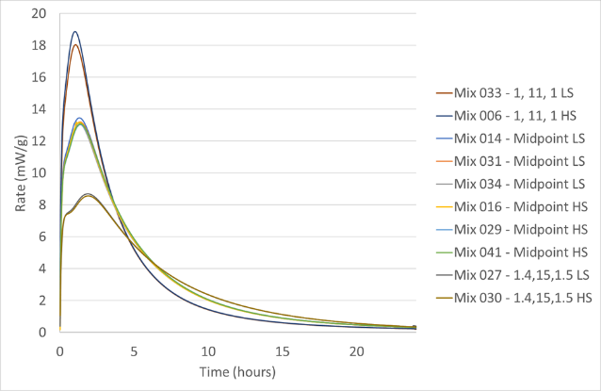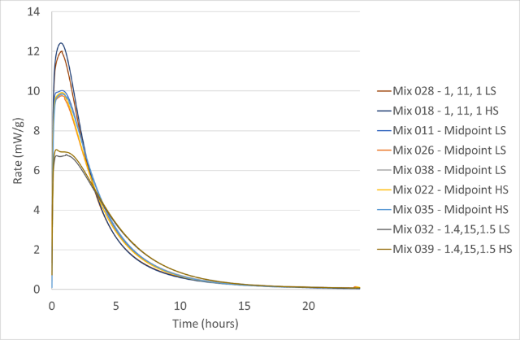
FIG. 1. Heat flow curves for Metamax® (LHS) and Argicem® (RHS) formulations at 35 °C. Formulations shown in SiO₂/K₂O :H₂O/K₂O:K₂O/Al₂O₃ format. LS = low shear, HS = high shear.
Cumulative heats of hydration at 24 h are consistent with the heat flow plots shown in Fig. 1, with all Argicem® formulations, over the range tested, producing less heat over the first 24 h than Metamax® formulations.

Bleed
Residual bleed liquor on a product should be minimal and in small scale studies (i.e. 100 mL), a result of ≤2 vol% is considered acceptable. For Argicem® mixes, the only formulations with a bleed value >2 vol% at 24 h were the four mixes which showed significant retardation at the extreme H₂O/K₂O and K₂O/Al₂O₃ ratios tested (see Table 2). Despite the geopolymerisation reaction resulting in the expulsion of water, by 7 d, only the two mixes in Table 2 at low shear exceeded 2 vol% bleed, with bleed generally decreasing from 2 d to 7 d under both shear conditions.
For Metamax® mixes, all mixes had <2 vol% bleed when tested at 24 h, but one mix at the SiO₂/K₂O = 1, H₂O/K₂O = 15 and K₂O/Al₂O₃ = 1 formulation had a bleed marginally >2 vol% bleed at up to 7 d. In addition, generally low shear mixes decreased in bleed levels from 2 – 7 d, whilst high shear mixes generally increased in bleed levels from 2 – 7 d. This increase for high shear mixes may be the result of an enhanced reaction of the fine Metamax® powder with resultant expulsion of water.

Product Quality
Results indicate that geopolymer strength development is characterised by a relatively rapid strength gain up to 7 d curing with strengths plateauing from this point up to 90 d (Fig. 2). In general, Argicem® formulations at equivalent molar ratios exhibited an increase in strength in comparison to Metamax® mixes, likely due to the reduced water content of the Argicem® mixes, a consequence of the lower Al₂O₃ content for the Argicem®, with a related reduction in the quantity of K₂O and H₂O to yield the requisite molar ratios. Statistical analysis of the results obtained up to 90 d curing identified that each mix parameter, excluding shear, had an effect on the resultant compressive strength of the products. The strengths increased with increasing SiO₂/K₂O and decreasing H₂O/K₂O and K₂O/Al₂O₃.
Microstrain results indicate that there is a general modest decreasing trend in microstrain values for both geopolymer systems up to 90 d curing, with final dimensional changes relative to 2 d products ranging from +0.01 % (expansion) to -0.08 % (shrinkage). The effect of shear appears insignificant in terms of affecting the dimensional stability of the resultant products.

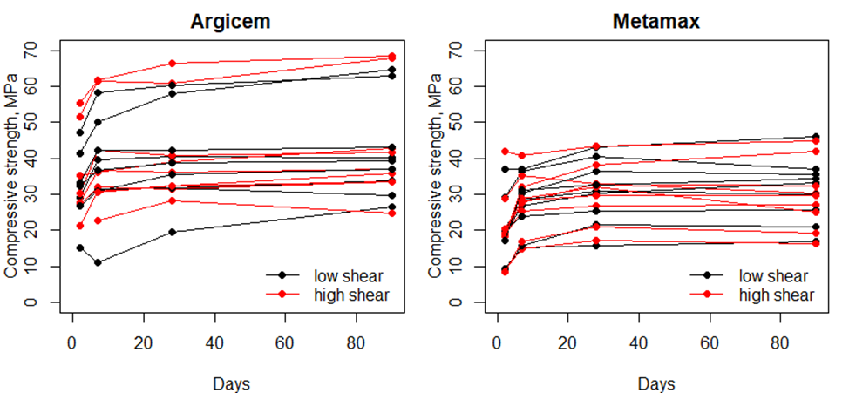
FIG. 2. Average compressive strength results to 90 d for Argicem® and Metamax® geopolymer formulations.

conclusions FROM 3 L SCALE STUDIES
The study has shown that the large majority of geopolymer formulations over the full range tested, exhibited very high fluidity (>1020 mm) up to 120 min. Satisfactory bleed performance was observed over the full range tested, and Metamax® formulations showed a lower propensity to bleed over a 7 d period. This is consistent with the higher reactivity of the finer and purer Metamax® powder, indicated by the higher heats of reaction. However, Argicem® formulations at H₂O/K₂O = 15 and K₂O/Al₂O₃ = 1.5, exhibited significant bleed, segregation and retarded set, consistent with its lower reactivity. Therefore, for Argicem® formulations, this corner of the envelope is not recommended for further study.
The geopolymer systems are characterised by rapid strength development with the Argicem® mixes generally stronger for equivalent formulations, due to the reduced water content of Argicem® mixes. All mixes were dimensionally stable with modest shrinkage to 90 d. Statistical analysis showed that shear had a significant effect on the viscosity of geopolymer mix but does not significantly affect product properties at small scale.

120 L SCALE waste encapsulation STUDIES
Spent ion exchange resin in the form of clinoptilolite is an ILW which requires treatment, arising from the clean-up of active liquid effluent (e.g. removal of dissolved Cs, Sr and residual alpha contaminated particulates). Previous studies have shown that trying to immobilise such resin via an In-Drum Mixing (IDM) process produced a limited waste loading of ~43 vol% flooded resin, using a PC-blended matrix. However, this waste loading is restricted due to the high viscosity of the flooded clinoptilolite bed when mixed with PC-based powders.
Preliminary studies have been undertaken to assess both the ease of mixing and the degree of incorporation of a low viscosity geopolymer formulation identified in the 3 L scale trials at a clinoptilolite waste loading of ~43 vol% flooded resin in comparison to a PC-blended matrix.

Materials
The following materials were used for the 120 L scale trials:

- BASF MetaMax® metakaolin. This batch had the following properties: D_{v}50 = 3.0µm, bulk fineness 3851 m²/kg, LOI of 1.61 wt%, 43.99 wt% Al₂O₃, 51.48 wt% SiO₂ (molar SiO₂/Al₂O₃ ratio = 1.99);
- Potassium silicate, K120 (PQ Corporation) containing 21.3 wt% K₂O, 30.4 wt% SiO₂ and 48.3 wt% H₂O;
- Potassium hydroxide extra pure flakes manufactured by Acros Organics;
- Deionised water;
- Clinoptilolite supplied by RS Minerals Ltd, Guisborough with 300 µm < PSD < 700 µm;
- Ribblesdale PC, CEM I 52,5N to BS EN 197-1;
- Purfleet BFS to BS EN 15167-1.

Experimental
An overhead mixer manufactured by Greaves and fitted with a 3-blade propeller type mixer head (Ø = 300 mm) was used to mix clinoptilolite-grout mixes in a 200 L drum to produce a nominally 120 L wasteform. The target waste loading for these trials was 43 vol% (~52 L of flooded clinoptilolite). The following procedure was undertaken prior to each mix. The clinoptilolite was saturated for ≥24 h and then filled to 52 L within the drum, covered to a depth of 150 mm with water for 4.5 h, after which excess water was removed back to the 52 L level. The following procedures were then undertaken for the respective mixes as described below.

PC-blended Matrix
Scoping trials indicated that a water/cement (w/c) ratio of 0.46 was required to produce a workable mix. The saturated clinoptilolite contained 34.7 L of water, however a total of 62 L was required to reach 0.46 w/c. Therefore an additional 27.3 L of water was added and this was mixed at ~200 rpm for 5 min prior to powder addition. A preblended 5:1 BFS/PC formulation was then added to the drum over 30 min. The target mass of PC-blend was 135 kg; however, it was only possible to add 80 kg of PC-blend powders due to significant problems incorporating the powders into the mix. This meant that the actual w/c ratio of the mix was 0.78. Mixing was continued for a further 20 min, after which the paddle was removed, homogeneous samples were taken for product quality testing (Section 5.2.3) and a thermocouple was inserted into the centre of the wasteform. Products were cured at 20±1 °C and >90%RH, and the wasteform was covered and cured at 20±1 °C and ambient RH.

Geopolymer Matrix
A geopolymer target formulation as follows, SiO₂/K₂O = 1.2, H₂O/K₂O = 13, K₂O/Al₂O₃ = 1.2, was selected for clinoptilolite encapsulation. The saturated clinoptilolite in this trial contained 29 L of water, therefore for a ~120 L wasteform volume, the lowest H₂O/K₂O molar ratio that could be achieved was 13.5, whilst maintaining the other molar ratios at 1.2. As a result, the activator solution was prepared by adding potassium hydroxide flakes to the potassium silicate solution, allowing it to cool to 20 °C prior to undertaking the trial.
The activator solution (70 kg) was added to the saturated clinoptilolite (52 L) containing 29 L of water, and this was mixed at ~200 rpm for 5 min prior to powder addition. The required mass of Metamax® (46.8 kg) was added to the drum over 20 min. Mixing was continued for a further 15 min, after which the paddle was removed, homogeneous samples were taken for product quality testing (Section 5.2.3) and a thermocouple was inserted into the centre of the wasteform. Products were cured at 20±1 °C and >90%RH, and the wasteform was covered and cured at 20±1 °C and ambient RH.

Product Quality Assessment of Clinoptilolite-Grout Matrices
After mixing, sub-samples of encapsulated clinoptilolite were taken, ensuring that homogeneous samples were taken. The following tests were undertaken:

- Set of the 120 L scale product was confirmed using a penetrometer;
- Bleed liquor on the surface of the 120 L scale product as vol % at 24 h, 2 d and 7 d;
- Eight 100 mm cubes to assess compressive strength to 90 d in duplicate at 2 d, 7 d, 28 d and 90 d to BS 1881-116;
- Four 26 mm x 26 mm x 286 mm prisms were cast to monitor dimensional stability at 2 d, 7 d, 28 d, 56 d, 70 d and 90 d curing in accordance with ASTM C 490;
- Exotherm was monitored at the centre of the product after sub-samples were taken;
- Visual and quantitative assessment by weight of the incorporation of clinoptilolite into the wasteform;
- All products tested were cured under standard conditions of 20±1 °C and >90%RH.

In addition, to the standard product quality tests described above, microstructural analysis and phase evolution including waste interactions, up to 90 d, are being undertaken separately and will be reported elsewhere.

Results

Product Quality Assessment of Clinoptilolite-Grout Matrices
Both wasteforms achieved final set within 24 h, with a level surface and no bleed at 24 h, or up to 7 d. As can be observed in Fig.3, the low viscosity geopolymer formulation resulted in a homogeneous product with subsequent analysis indicating that only 0.34 wt% of the total clinoptilolite added to the mix was unincorporated into the wasteform. In contrast, the PC-blend formulation had a significant quantity of clinoptilolite towards the bottom of the wasteform which had not been encapsulated (11.3 wt% of the total clinoptilolite added to the mix) this was consistent with the inability to incorporate all powders into the mix. Therefore under these shear conditions, the geopolymer formulation produced a significantly more homogeneous wasteform.

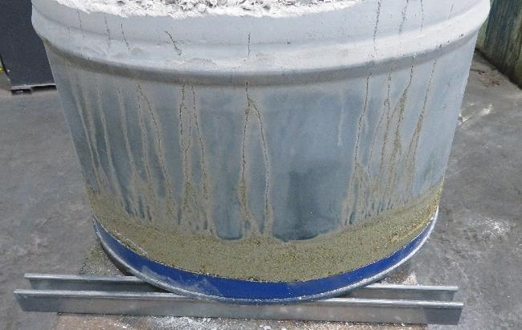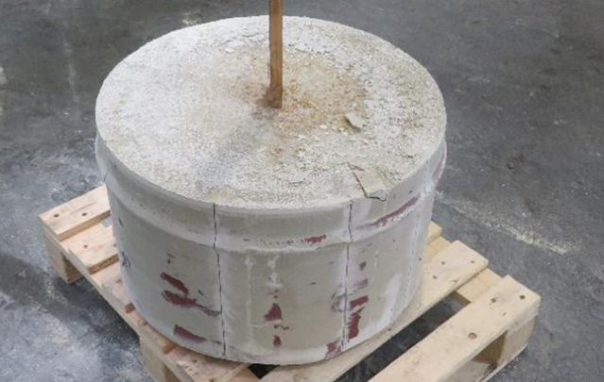
FIG. 3. PC-blend/clinoptilolite wasteform (LHS) and Metamax®/clinoptilolite wasteform (RHS).
Analysis of the exotherms measured from the centre of each product indicated that the geopolymer formulation produced a significant heat output within 11 h of 79 °C (Fig. 4), consistent with observations for the heats of hydration obtained for baseline Metamax® formulations (see Section 3.3). As a result of the exotherm observed, full scale trials (500 L) are to be undertaken to assess the heat output, whilst studies to assess the effects of these temperatures on geopolymer wasteforms will also be required. In contrast, the PC-blend exotherm peaked at only 28 °C at 20 h, consistent with the high BFS replacement in the PC-blend and the inability to incorporate all powders into the mix resulting in a high w/c ratio.
The Metamax®/clinoptilolite matrix (Fig. 5) is characterised by rapid strength development in which the major proportion of compressive strength had developed by 7 d. In contrast, compressive strengths for the PC-blend/clinoptilolite matrix were significantly lower (9 MPa at 90 d compared to 32 MPa for Metamax®/clinoptilolite), indicative of the high w/c ratio, as well as the high BFS content of the mix design. Products from both formulations were dimensionally stable with minimal shrinkage observed to 90 d with <0.1 % shrinkage for Metamax®/clinoptilolite and <0.05 % for PC-blend/clinoptilolite.

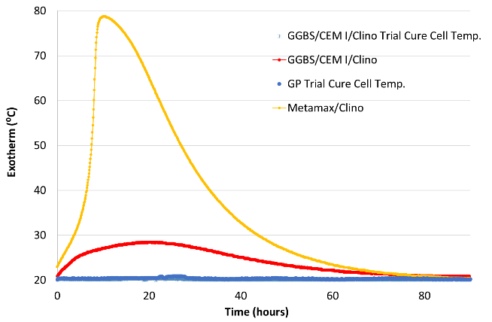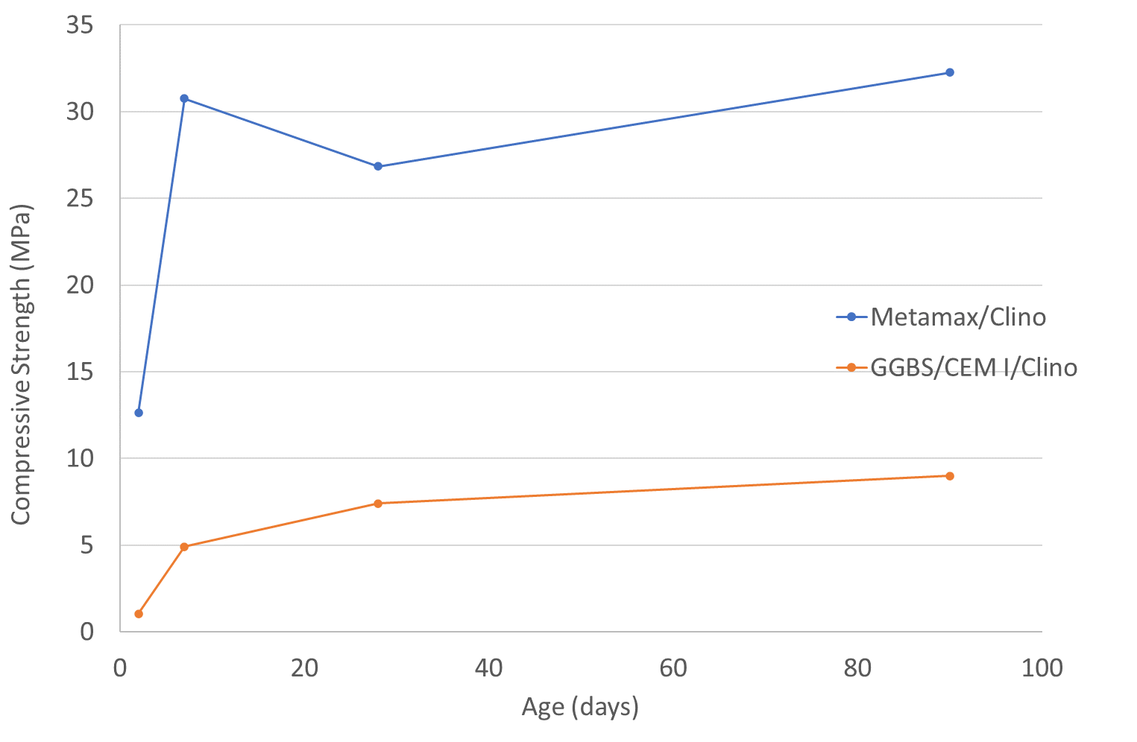
FIG. 4. Exotherms measured for wasteforms (LHS) and average compressive strength results to 90 d for Metamax®/ clinoptilolite and PC-blend/clinoptilolite formulations (RHS).

CONCLUSIONS
The study has shown that a high fluidity geopolymer formulation developed at small scale has been shown to potentially offer a significant improvement in the ability to mix a high viscosity clinoptilolite ILW surrogate to produce a homogeneous wasteform, compared a baseline PC-blend matrix. The resultant geopolymer matrix had significantly higher compressive strength than the PC-blend whilst both products were dimensionally stable over the 90 d curing period.
The geopolymer formulations developed in this study were shown to have high heats of hydration and the exotherm obtained for the Metamax®/clinoptilolite wasteform at ~120 L was 79 °C. As a result, the exotherms at full scale will need to be assessed, in conjunction with studies to assess the effects of such temperatures on the resultant geopolymer wasteform.
ACKNOWLEDGEMENTS
The funding for this work from Sellafield Ltd is gratefully acknowledged.
References
[1] NUCLEAR DECOMMISSIONING AUTHORITY, 2019 UK Radioactive Waste Inventory, 2019.
[2] NUCLEAR DECOMMISSIONING AUTHORITY, Radioactive Wastes in the UK: A Summary of the 2016 Inventory, 2016.
[3] ROOSES, A., STEIN, P., DANNOUX-PAPIN, A., LAMBERTIN, D., POULESQUEN, A., FRIZON, F., Encapsulation of Mg-Zr alloy in metakaolin-based geopolymer, Appl. Clay Sci. 73 (2012) 86-92.
[4] ZHOU, Q., MILESTONE, N.B., HAYES, M., An alternative to Portland cement for waste encapsulation - the calcium sulfoaluminate system, J. Hazard. Mater. 136 (2206) 120-129.
[5] WAGH, A.S., SINGH, D., SEUNG-YOUNG, J., “Chemically Bonded Phosphate Ceramics for Stabilisation and Solidification,” Handbook of Mixed Waste Technology, CRC Press (2000).
[6] NAVARRO-BLASCO, I., DURAN, A., SIRERA, R., FERNANDEZ, J.M., ALVAREZ, J.I., Solidification/stabilization of toxic metals in calcium aluminate cement matrices, J. Hazard. Mater. 260 (2013) 89-103.
[7] HAYES, M., GODFREY, I.H., “Development of the use of alternative cements for the treatment of intermediate level waste,” Waste Management Symposium, Tucson, (2007).
[8] PROVIS, J.L., DUXSON, P., VAN DEVENTER, J.S.J., LUKEY, G.C., The role of mathematic modelling and gel chemistry in advancing geopolymer technology, Chem. Eng. Res. Des. 83 7 (2005) 853-860.
[9] ODLER, I., “Geopolymeric cements,” Special Inorganic Cements, Taylor & Francis, Abingdon (2000).
[10] COCKBURN, S., HAYES, M., CANN, G.M, TUCK, O., FARRIS, S., MORGAN, S., DOWSON, M., “The study of alternative encapsulants for the treatment of Intermediate Level Radioactive Waste,” in 40th Cement & Concrete Science Conference, Sheffield, 2020.
[11] GARTNER, E.M., Industrially interesting approaches to "low-CO₂" cements, Cem. Concr. Res. 34 (2004) 1489-1498.
[12] KUENZEL, C., CISNEROS, J.F., NEVILLE, T.P., VANDEPERRE, L.J., SIMONS, S.J.R., BENSTED, J., CHEESEMAN, C.R., Encapsulation of Cs/Sr contaminated clinoptilolite in geopolymers produced from metakaolin, J. Nucl. Mater. 466 (2015) 94-99.
[13] CANTAREL, V., NOUAILLE, F., ROOSES, A., LAMBERTIN, D., POULESQUEN, A., FRIZON, F., Solidification/stabilisation of liquid oil waste in metakaolin-based geopolymer,” J. Nucl. Mater. 464 (2015) 16-19.
[14] AMEC NUCLEAR SLOVAKIA, “The Progressive Technology for the Removal, Retention and Fixation of the Radioactive Sludge, Sorbents and Non-Standard Radioactive Waste into the SIAL® Matrix,” in The 18th 2010 WiN Global Annual Conference, Busan, 2010.
[15] GEDDES, D., A Study of the Suitability of Metakaolin-based Geopolymers for the Immobilisation of Problematic Intermediate Level Waste, PhD Thesis, University of Sheffield, 2020.

