Lifetime of long-lived nuclear waste in accelerator-driven subcritical systems undergoes transmutation process

J.S. Novita
Limapuluh Kota, Indonesia
Email: jesy.novitajsn@gmail.com

A. WARIS
Nuclear Physics & Biophysics Research Division, Department of Physics, Faculty of Mathematics and Natural Sciences, Bandung Institute of Technology
Bandung, Indonesia
Email: awaris@fi.itb

Abstract

Nuclear waste is one of the big issues of public acceptance of nuclear energy or nuclear uses in general. Nuclear waste is classified into high level nuclear waste, transuranic waste, low level waste. High level nuclear waste can be transmuted into non-hazardous materials. Accelerator-driven system is used to transmute nuclear waste, moreover it can produce energy for generating electricity at the same time. ADS consist of two main parts: the accelerator and the subcritical reactor. In the paper, the fuel density inside the subcritical reactor depends on the concentration of U-ThO₂(NO₃)₂, PuMA(NO₃)₂, and HNO₃ (liquid phase). The reactor reaches subcritical condition for RGPuMA, WGPuMA, SGPuMA when the concentration of PuMA-Nitrate is above 62.6 kmol/m³, 65.6 kmol/m³ and 66.6 kmol/m³ respectively. The investigation is to determine time taken or lifetime of a subcritical reactor transmuting the long-lived nuclear waste to shorter-lived. Therefore, after transmutation process, the waste can be saved safely inside the nuclear waste repository.

INTRODUCTION
Based on IEA (International Energy Agency) electricity information in 2017 (FIG. 1), 39.3% of energy source come from coal and it is the highest percentage of energy source. As it known, the coal produces such a harmful gas for environment that leads to climate change and global warming/cooling.

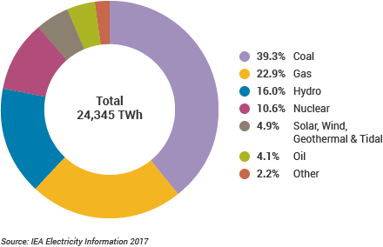
FIG. 1. Chart showing the percentage of world electricity source in 2017 [1].

That is one of the main reasons to find the alternative sources of energy, one of them is nuclear. However, most of the society against the nuclear energy due to the fear of nuclear safety, the fear of nuclear proliferation and nuclear waste management issues. The paper will focus on how to manage the nuclear waste by using ADS (Accelerator Driven Subcritical System).

ADS is using to transmute long-lived nuclear waste into the shorter-lived nuclear waste. The following figure shows the transmutation flow.
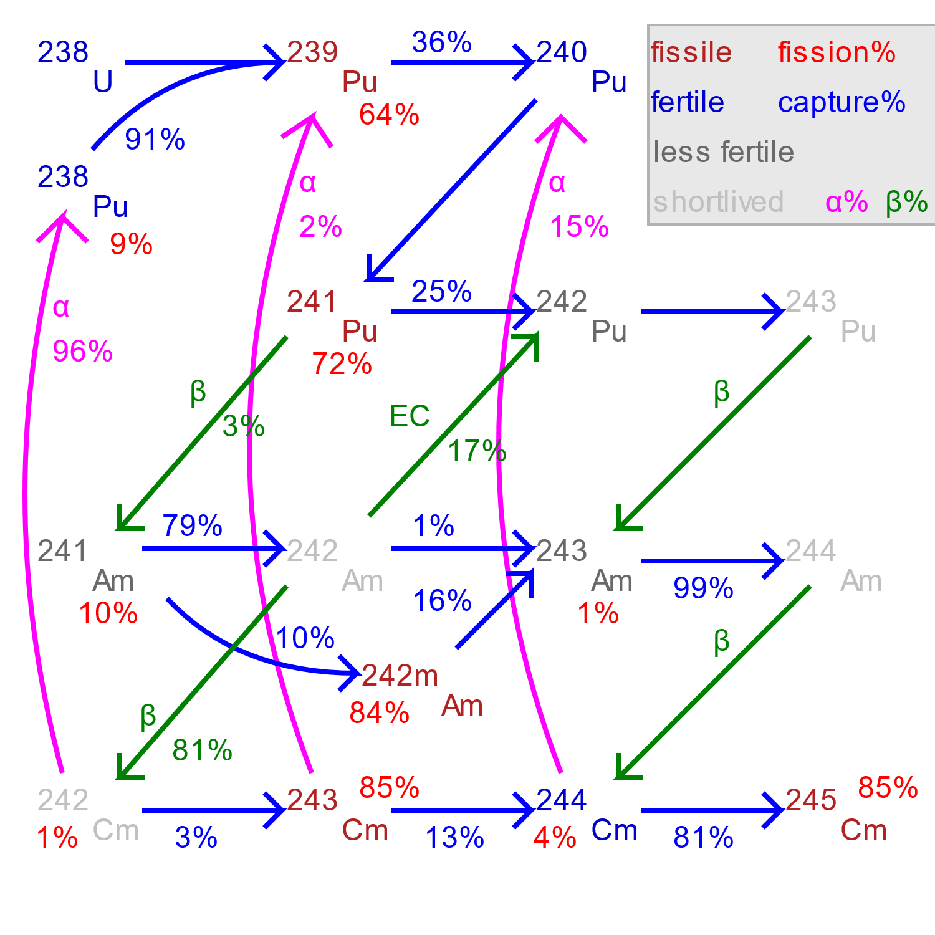
FIG. 2. Transmutation flow between Pu-238 and Cm-244 [2].

Methodology

ADS consist of two main parts: the accelerator and the subcritical reactor core. The geometry of reactor core used in the paper is a finite cylindrical shape with radius 14.7 cm and a height of 54.249 cm and a cladding is 0.3 cm thick.

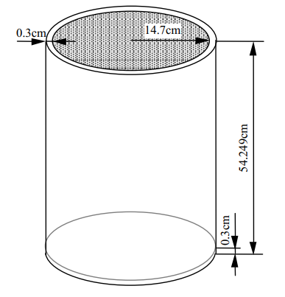
FIG. 3. Reactor Core Geometry [3].

In the paper, SRAC is used to analyze reactor systems developed by JAERI Japan. The library is integrated with 5 basic codes for neutron transportation and diffusion calculations. They are PIJ (is based on the collision probability method applies to 16 types of fuel grid models), SN ANISN (1D) and TWOTRAN (2D) transport codes, TUD (1D) and CITATION (multi-D) diffusion codes. The system also includes two additional codes: ASMBURN and COREBN. JENDL 4.0 is the nuclear data library which has 406 isotopes in total.

The initial data are needed to perform calculations consist of fuel dimensions, fuel radius and atomic fuel density. The general description of SRAC input is as follows.
- Setting libraries, energy groups, collapsing,
- General SRAC input settings,
- General PIJ input settings,
- Region and geometry specifications,
- Material specifications, and
- Burnup specifications

ADS reaches subcriticality for RGPuMA (Reactor Grade Plutonium-Minor Actinide), WGPuMA (Weapon Grade Plutonium-Minor Actinide) and SGPuMA (Super Grade Plutonium-Minor Actinide) when the concentration of PuMA-Nitrate is above 62.6 kmol/m³, 65.6 kmol/m³ and 66.6 kmol/m³ respectively [4].

result and discussion
FIG.4 shows the change of PuMA density over time for RGPuMA 100 MWth. It shows clearly that the number of Np-237, Pu-239 and Am-241 are decreasing in 660 days from its initial number of nuclides. Percentage of decrease by each nuclides are 89.9%, 70,6% and 84.7% respectively. The number of nuclides that have half-life smaller than 9000 years are increasing. They are Pu-238 (62.4%), Am-243 (63.7%), Cm-242 (1223%), Cm-343 (13160%), Cm-244 (977%), Cm-245 (5119%) and Cm-246 (5350%). Although there is a nuclide remain constant such as Pu-242.

FIG. 4. PuMA density over time (RGPuMA 100 MWth).

The following FIG. 5 shows when the output power is changed to twice larger than before. All of the nuclides number of plutonium isotopes are decreasing: Pu-238 (89.6%), Pu-239 (90.4%), Pu-240 (69.5%), Pu-241 (66.3%) and Pu-242 (40.4%). Np-237 is decreasing by 99.6% and AM-241 is decreasing by 99.5% as well.

FIG. 5. PuMA density over time (RGPuMA 200 MWth).

FIG. 6 and FIG.7 are showing PuMA Density over time for 100 MWth and 200 MWth. When both graphs are compared, it can be seen clearly that as the output power increases the time taken to decrease the number of nuclides such as neptunium-237 and Plutonium-239 are shorter.

FIG. 6. PuMA density over time (WGPuMA 100 MWth).

FIG. 7. PuMA density over time (WGPuMA 200 MWth).

The isotopes with higher half-life, such as Np-237 (half-life = ~ 2x10⁶ years) and Pu-239 (half-life = ~ 24000 years [5]) is decreasing by 92.0% and 80.7% in SGPuMA with 100 Mwth. Am-241 is decreasing by 90.5% as well. Although Pu-240 is increasing by 8 times larger than the initial number of nuclides. FIG. 8 below shows the PuMA density over time of SGPuMA 100 MWth.

FIG. 8. PuMA density over time (SGPuMA 100 MWth).

FIG. 9 shows the change in density of PuMA isotopes over tome for SGPuMA 200 MWth. In 660 days, Np-237 is already decreasing up to 99.9%. The other isotopes including Pu-239 and Am-241 are decreasing by 97.5% and 99.9%.

FIG. 9. PuMA density over time (SGPuMA 200 MWth).

conclusion
The paper has proved that by increasing the output power, the time taken to decrease the amounts of certain nuclides such as Neptunium-237, Plutonium 238 and Americium-241 are shorter. Number of nuclides of Np-237 for RGPuMA is decreasing by 89.9% (100 MWth) and 99.6% (200 MWth) within 660 days. In WGPuMA, it is decreasing by 90.8% (100 MWth) and 99.8% (200 MWth). As for SGPuMA, number of nuclides of Np-237 is decreasing by 92.0% in 100 MWth output power and 99.9% in 200 MWth output powers. However, the further research is needed to make this reactor economically possible to build.

References
- World Nuclear Association 2018 : Nuclear Power in the World Today, http://www.world-nuclear.org/information-library/current-and-future-generation/nuclear-power-in-the-world-today.aspx
- Sasahara, Akihiro., Matsumura, Tetsuo., Journal of Nuclear Science and Technology, “Neutron and Gamma Ray source evaluation of LWR High Burn-up UO2 and MOX Spent Fuels” (2004) 448-456.
- Okumura, Keisuke., Kugo, Teruhiko., Kaneko, Kunio., dan Tsuchihashi, Keichiro (2007) : SRAC2006 : A Comprehensive Neutronic Calculation Code System, Division of Nuclear Data and Reactor engineering, JAERI, Japan.
- Novita, Jesy Sry., Pramutadi AM, Asril., and Waris, Abdul., Journal of Physics: Conference Series, “Preliminary study on Transmutation of Plutonium and Minor Actinides in Accelerator Driven System” (2018), 2-4.
- EPA facts about Plutonium, https://semspub.epa.gov/work/HQ/176324.pdf first visited on July 15, 2021.

