Taking a Lifecycle View for the Management of Legacy Metallic Fuel
  - IAEA- International Conference on Radioactive Waste Management: Solutions for a Sustainable Future
N.J. Atherton
Sellafield Ltd
Seascale, Cumbria (UK)

M.J. Cairns
Radioactive Waste Management
Harwell, Oxfordshire (UK)

Abstract
Metallic uranic fuel has been used in the United Kingdom’s Magnox fleet of reactors since the 1950s, with the Magnox reprocessing plant at Sellafield forming a key part in the management of spent fuel with over 54,000 tonnes reprocessed to date. Following the retirement of the Magnox reactor fleet and planned completion of reprocessing, the UK will possess an inventory of several hundred tonnes of metallic uranic fuel that will need to be managed and permanently disposed.
Metal fuel is not passively safe; its chemical reactivity poses a challenge across the lifecycle of storage, treatment and ultimate disposal. At each stage of this lifecycle, the potential for expansive corrosion, gas generation, fission product release and uranium hydride formation must be managed to ensure ongoing human and environmental safety.
This paper describes the approach being undertaken to manage the remaining inventory of metallic uranic fuel in the UK to understand how this material should be stored, packaged and ultimately disposed of in a geological disposal facility. The paper describes how the following key questions are being considered to manage the lifecycle balance of risk for the remaining inventory:
- How do you make hundreds of tonnes of metal fuel passively safe and what is the right disposal concept for metallic fuel?
- How do you minimise the impact of dose and cost now while ensuring long-term passive safety, sustainability and intergenerational impacts?
- How do you balance the risk of near-term safety with long-term uncertainty?
The paper explains the collaborative approach that has been adopted between the material custodian, Sellafield Ltd (SL), and the geological disposal facility developer, Radioactive Waste Management Limited (RWM), to understand the risks at each stage in the waste management lifecycle. This information will then be used by the waste owner, the Nuclear Decommissioning Authority (NDA), to make risk-informed decisions on the questions set out above.

Introduction
The Magnox fleet was the first generation of nuclear reactors to be built in the UK for the supply of electricity. The Calder Hall reactors started operation in 1956 as the world’s first commercial nuclear power plant (Figure 1) [1]. A further nine Magnox Nuclear Power Plants were subsequently constructed with a progressively optimised design. The final Magnox reactor to end its operational life was Wylfa, in Wales, which stopped electricity generation in 2015 [2]. The fuel in the Magnox reactors was composed of natural (metallic) uranium, clad in a magnesium-aluminium alloy (Magnox) can, which gave the reactor design its name.
For over 50 years, the spent fuel from the Magnox reactors was brought to Sellafield for reprocessing in the Magnox Reprocessing Plant. In this time over 50,000 tonnes of spent Magnox fuel have been reprocessed to allow recovery of uranium and plutonium products. With the Magnox power plants having ceased operation and being defueled, the Magnox Reprocessing Plant is due to complete its operation in the coming year, with the aim to have reprocessed as much of the remaining spent Magnox Fuel inventory as possible in this time [3].
A range of additional metallic uranic fuel materials have been accumulated at the Sellafield site during the period of the Magnox Operating Programme. It is not possible to incorporate this inventory into the remaining period of reprocessing and therefore an alternative management plan is required to ensure that all of the remaining materials can be safely stored pending the definition of a final disposal route. These materials include uranium bits produced during decanning operations, corroded fuel and a number of experimental and aluminium-clad metallic fuels. Sellafield Ltd (SL)

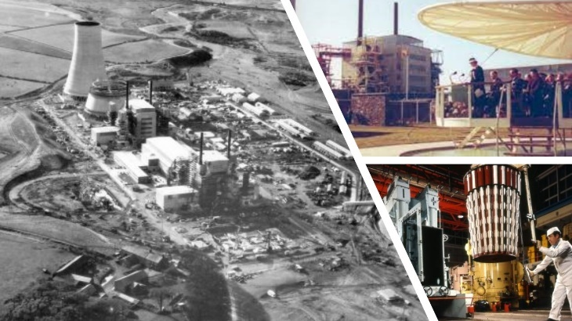
has been working with Radioactive Waste Management (RWM) to identify credible management options for this material.
Figure 1 Calder Hall Magnox Reactors seen during construction, during the opening ceremony and refuelling operations

RWM is responsible for the development of a Geological Disposal Facility (GDF) for the UK’s inventory of higher activity wastes, including spent nuclear fuel. The outline safety case for the spent fuel disposal concept is based on extended containment and isolation of the spent fuel, using high integrity containers surrounded by low permeability buffer materials in a suitable host rock setting. This concept was originally conceived for the disposal of oxide fuels, where the uranium dioxide matrix gives a passive wasteform that would dissolve very slowly once the high integrity engineered containers eventually degrade.
The baseline strategy for the management of any remaining metallic uranic material is also based on the UK spent fuel disposal concept. However, the propensity for metallic uranium to preferentially corrode to the oxide form presents novel challenges. In particular, corrosion of metallic uranium has the potential to generate significant volumes of hydrogen gas. Large volumes of such gas could adversely affect the performance of the engineered barriers. For this reason, the fuel would need to be very carefully dried prior to packaging, and the container itself would need to be a qualified pressure vessel. Failure of that container and ingress of water would nevertheless result in a resumption of corrosion and bulk gas generation. The ability to successfully dry wetted metallic uranic materials, and the consequences of bulk gas generation in the GDF post-closure phase remain as uncertainties to the viability of this as the baseline option. This is one of the drivers for exploring alternative opportunities to manage the remaining inventory of metallic uranic materials.
The conceptual design for the disposal of Magnox fuel as high-heat-generating waste is shown in Figure 2, along with an overview of the disposal container and outline of the GDF concept.

 | 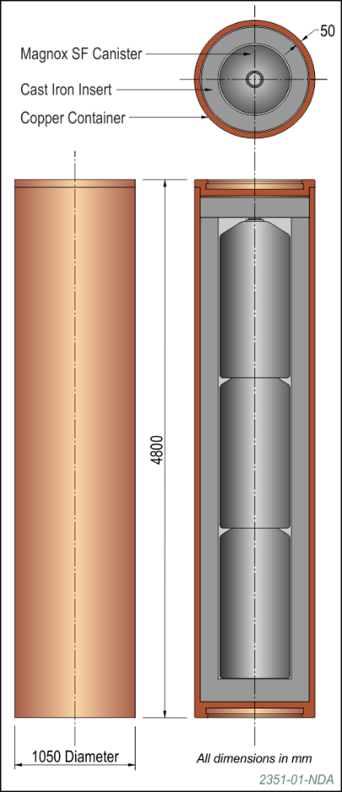 | 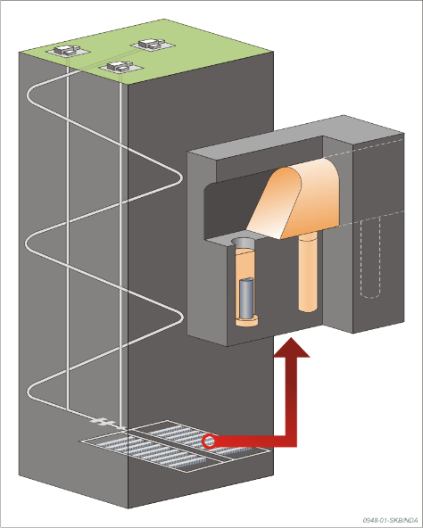
Figure 2 Baseline option for the management of remnant metallic uranic materials as high-heat-generating waste in a UK GDF showing (left to right) the dried Magnox fuel in a sealed canister, the sealed canister in a high integrity disposal container and the UK geological disposal concept for these packages

Storage of Metallic Fuel
Pond storage was an important step in the fuel cycle allowing spent fuel to be transferred from the power plants, where there was only minimal space for spent fuel storage, to Sellafield for a period of further storage prior to reprocessing. The First Generation Magnox Storage pond was built as a buffer store primarily to support the Magnox reactor fleet. Pond storage allowed cooling of the fuel prior to reprocessing. At Sellafield, the Magnox fuel was also cropped and decanned in preparation for reprocessing, with end crops and broken fuel pieces forming a part of the remaining inventory that is still stored in the pond [4].
An unintended consequence of extended storage of Magnox fuel in ponds for prolonged periods was corrosion of the Magnox alloy cladding. At times where the fleet of nuclear power plants were being heavily utilised, fuel receipts into the pond would outstrip the capacity of the reprocessing plant, resulting in fuels being wet stored for longer than intended. The loss of cladding also allowed corrosion of the metallic uranium. The extent of fuel corrosion in the pond reached the point where the fuel elements became difficult to reprocess. This ultimately resulted in accumulation of large quantities of fuel, fuel pieces and corrosion product sludge in the legacy ponds, much of which remains to this day.
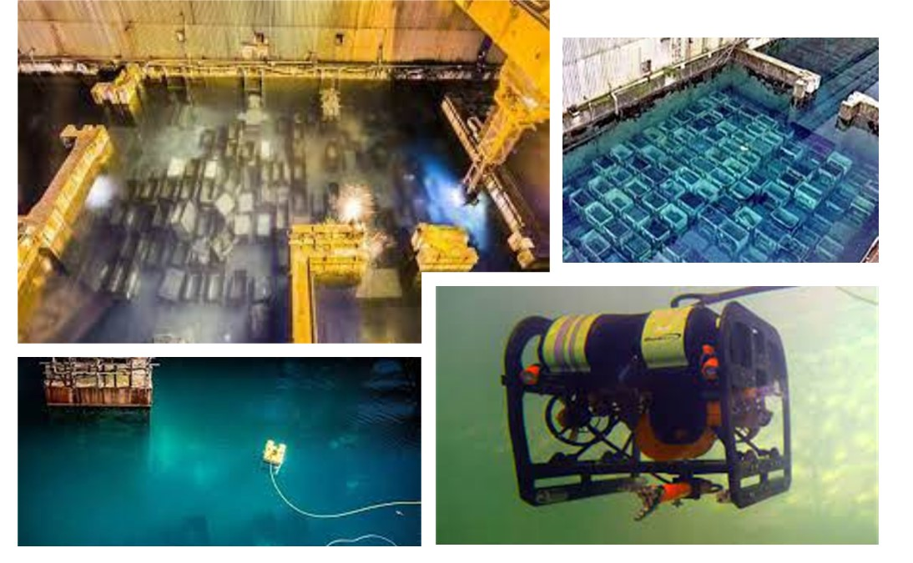
The majority of the metallic uranic fuel inventory remains in pond storage, with the First Generation Magnox Storage Pond being the most significant as this contains the greatest proportion of the inventory of legacy material that will not be reprocessed. The First Generation Magnox Storage Pond stopped fuel receipts following the commissioning of the Fuel Handling Plant. The Fuel Handling Plant continues to store fuel in a pond but is optimised to limit corrosion with the ability to locally containerise and ullage the fuel at higher pH.
Figure 3 The long term storage of metallic fuel in the legacy ponds has led to degraded conditions. The priority is to retrieve the material, an operation that is assisted by the use of remotely operated vehicles alongside skip handling machines.
The retrieval of the fuel bearing material from the First Generation Magnox Storage Pond is one of the highest priorities for Sellafield Ltd, with an alternative storage selected as the preferred option to support timely retrievals (Figure 3). Although retrieval of the metallic fuel from the Fuel Handling Plant does not have the same urgency, an alternative is still required, especially for any intact fuel where the preference is to keep wet storage to less than ten years to maintain the integrity of the cladding.
Self-Shielded Boxes have been identified as the preferred alternative to allow buffer storage of the metallic fuel pending conditioning for disposal. The boxes are ductile cast iron vented containers into which the fuel skips can be transferred [5]. During transfer, the majority of fuel types will be washed and drained to minimise sludge and water carryover. The self shielded boxes will then be stored within an interim storage facility. The vents have been designed to allow the exchange of gases while still providing containment. The gas exchange allows for hydrogen generated during corrosion to be released (ensuring it remains at a safe concentration) and oxygen to ingress to prevent the formation of uranium hydride. A dedicated storage facility has been constructed at Sellafield to store the self-shielded boxes.

Conditioning and disposal options for metallic fuel
Recognising the challenges with drying the inventory of metallic uranic materials, and uncertainty on long-term performance of these materials in a spent fuel disposal concept, a number of potential alternative approaches are being explored to enable disposal in a UK GDF.
The UK spent fuel disposal concept has been developed around the requirements for the long-term management of spent fuels with much greater heat outputs than that of the metallic uranic materials. Furthermore, as explained above, the metallic uranic materials do not fit well within the spent fuel concept due to the corrosion challenge. Consideration has therefore been given to the feasibility of alternative options that would rely on geological disposal via the UK concept for low-heat-generating wastes.
The UK disposal concept for low-heat-generating wastes has been primarily developed around cementitious wasteforms within thin-walled stainless steel containers. Unlike the spent fuel disposal concept that relies on long-term containment of radionuclides within a highly engineered container, the safety case for the low-heat concept is based on chemical conditioning in high pH backfill. In the low-heat waste concept, the waste packages are not sealed but include filtered vents to allow release of gas from corrosion and radiolysis. Because of the relatively low thermal output, low-heat waste packages would be emplaced in stacked arrays within large vaults, with the voids between adjacent packages being backfilled with a cementitious material that provides for pH buffering and high radionuclide sorption.
The UK high-heat and low-heat disposal concepts are illustrated and compared in Figure 4.
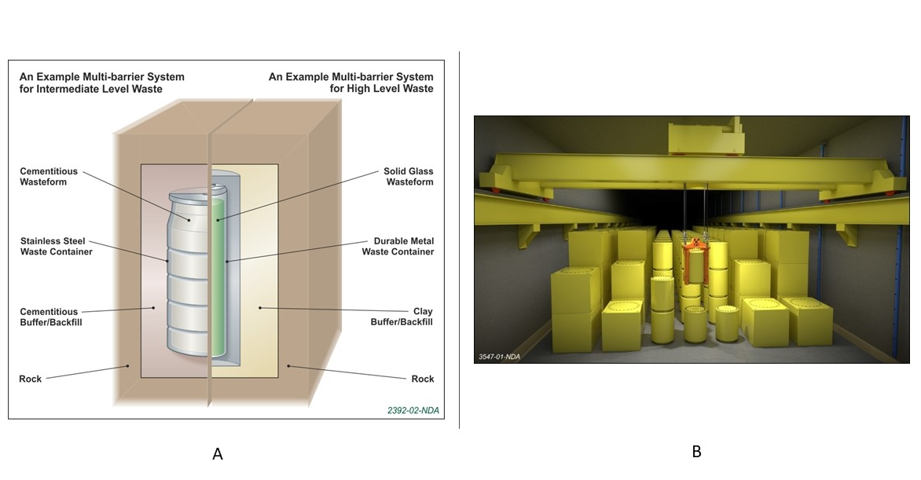
Figure 4 Geological Disposal Facility concept: A showing comparison of ILW (low heat) disposal system with the High Heat disposal system; B impression of a vault for ductile cast iron disposal packages (image is during vault filling and prior to backfilling with high pH cementitious grout)
Two opportunity options are currently being explored to enable disposal of the metallic uranic materials in the UK low-heat-generating waste concept: encapsulation within stainless steel boxes using a cementitious grout, and direct disposal of the SSBs themselves. The first of these two opportunity options is based on well-established encapsulation technology using existing waste container designs. Alternatively, direct disposal of the SSBs represents a novel approach that, if feasible, could offer significant opportunity to minimise both waste generation and near-term operator doses. A further description of both options is provided below, along with a discussion of some of the challenges and uncertainties presented by each of these opportunity options. Sellafield Ltd and RWM have been working in close collaboration to understand the full lifecycle risks of these two options.

Inorganic Encapsulation of Fuel in 3m³ Boxes
The direct encapsulation option is based on well-established cement encapsulation technology and standardised 3m³ stainless steel boxes that has been applied in the UK since the 1980s for the packaging of operational wastes across a range of UK sites. However, the proposal to apply cement encapsulation to the packaging of bulk uranic materials is novel. Some existing cement encapsulation plants do allow for the encapsulation of small quantities of uranium metal, though these tend to be in cases in reprocessing wastes where fragments are carried over from bulk fuel, and permitted masses are low.
The majority of the metallic uranic material inventory is based on irradiated uranium of natural initial enrichment, and so criticality safety is generally not a significant issue. The most significant challenge associated with cement encapsulation of bulk metallic uranium is the potential for expansive corrosion and the consequences of this on package integrity. Recognising this threat, a programme of work has been initiated to define potential package limits on bulk uranium and explore mitigations to the consequences of expansive corrosion. For example, the use of expansive/aerated cements is being considered that could accommodate any additional volume from expansive corrosion. Packages would also need to comply with limits as defined by the current UK low-heat disposal concept, including those on gas generation, heat output and, where relevant for slightly enriched materials, safe fissile mass.
Optimising the package payload for bulk metallic uranium will be the key to the feasibility of this option since very low payloads would lead to a significant proliferation of the volume of waste/numbers of packages needing to be disposed of in the UK GDF.

Direct Disposal of Fuel in Self-Shielded Boxes
As discussed in Section 2, the SSB was originally designed to provide a means for accelerating high-hazard risk reduction at Sellafield by enabling retrieval of fuel from aged ponds and was not originally intended to facilitate future disposal in a GDF. Nevertheless, the high integrity nature of the SSB is not dissimilar to other robust cast iron containers that have been approved by RWM for acceptance into the UK low-heat-generating waste concept. Furthermore, RWM recognises the potential near-term benefits that could be realised if direct disposal is be shown to be feasible. It is for this reason that SL and RWM have been collaborating to understand the full range of lifecycle opportunities, uncertainties and risks that would be presented by direct disposal of SSBs to a GDF. This will ultimately support the risk-based decision making to identify a single viable option. The work to understand the potential disposability of the SSBs containing metallic uranic materials in the low-heat concept of the UK GDF has been ongoing since 2015.
Being a novel container type, the SSB itself is not currently compatible with the outline GDF design and safety case and would therefore require changes to be implemented. Furthermore, being bulk irradiated metallic uranic material, the wasteform also presents novel challenges for the GDF safety case, and especially so when considered for disposal in vented containers via the low-heat-generating waste vaults. The key issues identified through the work completed to date are described in this paper. These issues would need to be resolved before RWM would be in a position to apply changes to the GDF design and safety case that would make these packages acceptable into a GDF.
The SSBs were originally developed to support up to 100 years of interim on-site storage at Sellafield. Accordingly, longer-term structural requirements necessary for eventual off-site transport and geological disposal have not yet been established. The need to understand how the SSB would perform on timescales beyond 100 years is important since corrosion of the cast iron walls and filtered vents could challenge the ability for the packages to be safely handled.
The radiogenic thermal output of the SSBs containing irradiated materials is significantly greater than for typical low-heat wastes and, in some cases, exceeds the guidance values for the UK concept. Work is underway to understand the consequence of elevated thermal loads on corrosion processes and the long-term performance of backfill and engineered barriers.
Recognising that there are currently no plans to actively dry the fuel, bulk quantities of water may be carried over into the SSBs. The fate of this water is uncertain and it could threaten the stability of the wasteform, promote gas generation or accelerate corrosion of both the fuel and the internals of the SSB.
Corrosion of uranium and Magnox cladding inside the SSBs has the potential to rapidly generate a significant gas (hydrogen) source term. This could threaten the limits for safe handling during transport and during GDF operations, e.g. by pressurising containers or creating flammable atmospheres. The threat presented by bulk gas is sensitive to the physical condition of the fuel at various stages in the lifecycle, that is, the degree to which the cladding and uranium will have corroded in the period prior to transport and disposal. As well as presenting conventional hazards, bulk gas generation has the potential to enhance radionuclide migration by acting as a carrier gas for gaseous radionuclides. This is a particular concern in the GDF post-closure phase, due to the release of carbon-14 (C-14) from the corroding materials.
C-14 is a key radionuclide in the post-closure safety case for the UK GDF. The inventory of metallic uranic materials would represent a large increase in the total activity of C-14 that would be consigned to the GDF. This is because the GDF safety case is currently based on the assumption that any remaining metallic uranic materials would either be reprocessed, or packaged using high-integrity spent fuel containers. The lifetime of high integrity spent fuel containers would be sufficient for C-14 activity to have decayed to a negligible amount before container failure. Being a vented container, the SSB option would not offer any such containment and, when coupled with high bulk gas generation rates, remains a significant question for the GDF safety case. The impact of post-closure C-14 therefore remains one of the key uncertainties and further work is already underway to better understand this.
As currently envisaged, the wasteform within the SSBs would comprise loose fuel elements within skips, potentially including a dispersible particulate source term as a consequence of corrosion, within a large void space. Furthermore, the conditions for uranium hydride formation exist, in the event that the vents in the SSB were to block. Uranium hydride represents a further hazard due to the potential for a high exothermic reaction on exposure to oxygen.
Although the majority of the metallic uranic material is irradiated natural uranium, very small quantities of slightly enriched material have also been used. Since it is not possible to distinguish enriched material from the bulk fuel, pessimistic assumptions have to be made when developing a transport criticality safety assessment for the packages. The deterministic nature of the IAEA Transport Regulations means that the development of a transport criticality case is challenging for this package. The ability to transport the SSBs from Sellafield site to the UK GDF has been advanced by the development of a conceptual design of Type B transport container [7]. Nevertheless, a special application may need to be made to the UK transport regulator, the Office for Nuclear Regulation, to make the criticality case for transport, which carries further risk given the long timescales before transport and disposal.
The current baseline approach to direct disposal of the SSBs assumes that there would be no encapsulant or infill media, with the uranic materials being loose within fuel skips inside the box. However, the addition of some form of infill material represents an opportunity that could address a number of the challenges referred to above, for example applying some geometric control for criticality, controlling the rate of gas generation, fixing loose particulate and also eliminating bulk voidage and free liquor. Identification of a suitable infill material is complex due to the nature of any interaction with the waste. The timing at which the infill medium is introduced into the SSB is also important since early additions could lead to wasteform instability and adverse gas generation rates during the interim storage phase at Sellafield. The requirements for infill materials and consequences of their use is one of the key tasks that is planned to be undertaken as a joint task by RWM and SL during 2022.
While RWM has developed outline designs and a generic safety case for a UK GDF, no specific site has yet been identified for its construction. Hence there are still opportunities to optimise the GDF design to address the unique nature of specific waste types that do not fit within current disposal concepts. The disposal of metallic uranic materials is one such example where a specific disposal concept maybe required to address unique challenges. In considering such design changes, RWM would ask firstly, what design changes could be made to make the technical case for safe disposal; and secondly, should these changes be made, or in other words, is there a compelling reason to make such changes from a lifecycle perspective. RWM is currently considering the could-we question by looking at elements of the GDF design to identify whether there are engineering mitigations that could be adopted to make a disposal safety case. The wider work with NDA and SL is looking at the should-we perspective to consider whether there is a compelling argument to implement such design changes when judged against the short-term risks.

Discussion
There are different drivers between the needs of SL, which are based on mitigating immediate short-term hazards, and with RWM’s needs for passively safe waste packages that comply with a safety case for a GDF that currently only exists as a concept. However, both organisations recognise the overall need of the NDA to make a judgement based on balance of lifecycle risk to establish the most credible management approach for metallic uranic materials.
The consideration of the opportunity lifecycle options for the metallic uranic fuel inventory requires a two-step process:
- Developing the technical viability of the options by identifying and investigating potential risks and identifying credible mitigations.
- Lifecycle analysis to identify and justify the preferred option
During the first step, if any of the risks identified in Section 3 are confirmed following assessment and cannot be effectively mitigated the options would be rejected as a viable option. However, in practice this requires judgement as there is uncertainty associated: with the materials and their behaviour under various conditions; with the GDF siting which will affect design and associated safety case; and with the efficacy of any proposed mitigations.
Even if the options are retained as credible there is likely to be a number of residual risks that will need to be mitigated during the development of the disposal route. Again, uncertainty in the performance of the mitigations must be considered. While decisions associated with conditioning and disposal are required now to support planning for storage, much of the residual risk will remain until the GDF site is fully characterised and designed many decades later. These risks are held across three organisations: SL (the Operator), RWM (GDF developer/operator) and the NDA (Material Owner). The balance of these risks must therefore be considered as part of step two in the progress, where the lifecycle analysis is competed.
The greatest uncertainty is associated with the GDF since RWM is still in the process of identifying a suitable site, which is based on a consent-based process. The characteristics of a GDF site are therefore not yet established, meaning it is necessary to take a precautionary approach to risk identification using limiting-case scenarios. It is anticipated that the GDF site selection process will take some decades before a suitable site and willing community is identified. Nevertheless, interim storage of the uranic metallic materials in the SSBs affords an opportunity to delay any decision that could foreclose treatment options. As the GDF siting process evolves, it is also expected that uncertainties around the final disposition options may also be reduced. Therefore, the transfer of metallic uranic materials into to SSBs decouples final decision making with the need to make final waste packages.
SL recognises the technical challenges associated with the direct disposal of metal fuel in SSBs, especially when considering the full scope of the inventory, but the benefits that could be realised from direct disposal of SSBs are potentially very significant when compared to the alternative options. Direct disposal of the SSBs would eliminate very large capital costs for new facilities and waste containers, while also reducing worker doses and secondary wastes, not least the disposal of 500 or so emptied SSBs. The cost estimate for direct disposal comes out at approximately £400m. This compares to approximately £4.1bn required to condition the material to meet the specification for the high-heat-generating waste disposal concept and £2bn for inorganic encapsulation using 3m³ boxes. Nevertheless, the full lifecycle implications need to be established to confirm the technical viability of direct disposal of SSBs and develop understanding of the residual risks that would be carried if this approach were adopted. A complex programme of work is therefore being completed to understand these risks, potential mitigations, and wider implications such as design changes and costs, as an input to future decision making.
By establishing a collaborative working relationship between SL, RWM and the NDA to investigate the opportunity options, it will be possible to understand the level of risk to the disposal system, the operational and transport safety cases and any associated uncertainty and balance this against the operational risks of continued storage and waste conditioning. The risk balance may be different for the alternative GDF concepts which will not be resolved during the current options assessment. This uncertainty will therefore need to be incorporated into the decision making.
The NDA has developed a Value Framework as a means to explore and understand the balance of risk by comparing options across a number of factors, such as safety, environmental and economic (ref). However, the value framework does not easily take into account the level of uncertainty associated with the long-term plans for the siting and design of a GDF. In these cases, the timing of future decisions on the potential mitigation approach will need to be evaluated to ensure that they do not timeout or foreclose alternative options.
In order to accommodate the metallic fuel into the low-heat waste disposal concept it is likely that a number of operational and design changes will be required to a GDF. As the encapsulation of the material into 3m³ boxes utilises an existing waste package the changes are likely to be minimal, with the main concerns being the post-closure performance of the disposal system when the additional inventory has been incorporated. The direct disposal of the SSBs will require operational changes associated with this novel waste container as well as additional risks associated with the evolving nature of the wastes on GDF closure and post-closure performance. For the direct disposal in SSB option, some of the disposal risk may be better addressed using a simplified finishing step, prior to export to the GDF; for example, a filler material could be incorporated to improve performance during accident conditions.
The impact of the range of potential changes to the cost and delivery of a GDF will also need to be understood to inform the economic aspects of the lifecycle options.
SL plans to make a strategic decision on the disposal of the metallic fuel inventory in 2024. This will either:
- select one of the opportunity options;
- select a hybrid between the available options (aligning different part of the inventory to different options); or
- Continue with the plans to condition the material for disposal in the high-heat waste part of a GDF using high integrity spent fuel containers.
The timing of the decision reflects the potential need to construct new capabilities to condition and/or repackage the materials which is expected to take 15-20 years to deliver.
If one of the opportunity options is selected, both the SL and RWM programmes will need to formally complete change control prior to progressing the selected option. It is expected that this will be followed by an implementation period where further justification and optimisation of the selected option will be required in line with regulatory expectations.

Concluding Remarks
The reactive nature of the metallic uranic fuels is a challenge when considering the lifecycle of treatment and disposal. Collaboration between SL and RWM with support from the NDA offers an opportunity to identify and select the best option across the lifecycle. The lifecycle approach to decision making will aim to justify the best overall outcome, rather than focussing on each phase individually.
The use of self-shielded boxes provides a means to buffer storage the metallic fuel while the remainder of the lifecycle is developed. The storage system aims to minimise the carryover of water and sludge thereby minimising the evolution of the waste by corrosion. The self-shielded box is robust and there is an opportunity to also adopt it as a disposal container in a GDF.
Two opportunity options that use the low-heat waste route in a GDF are currently being evaluated. The direct disposal of the material in SSBs offers the simplest approach but has the greatest challenge to the disposal system as the waste remains in a reactive form. The alternative is to encapsulate the waste in cement within an existing design of 3m³ box which presents a lower challenge to the disposal system, but the storage system must account for the evolution of the package which may limit the payload.
Making a decision on the lifecycle of metallic fuel will need to account for the uncertainty associated with the GDF due to the current conceptual status of the design. The duration of the UK GDF siting process is uncertain but may take up to 20 years and until completed there will remain uncertainties associated with the geological setting.

References
- THE ENGINEER., Calder Hall Power Station No1. Pg 464 5th October 1956.
- ROBERTS, T., CLARK, H., Nuclear Electricity in the UK.
- Magnox Fuel: Strategy Position Paper. July 2012
- Nuclear Decommissioning Authority Case Study Legacy Ponds and Silos at Sellafield
  - https://www.gov.uk/government/case-studies/ponds-and-silos-at-sellafield#:~:text=The%20Legacy%20Ponds%20and%20Silos,risk%20in%20the%20NDA%20estate.C
- WARD, R. The Strategic Benefit of Self Shielded Boxes for Storage and Disposal of Metallic Uranic Material, Waste Management 2018 (Phoenix Arizona).
- RWM, Waste Package Specification and Guidance Documentation: Specification for Waste Packages Containing Low-Heat Generating Waste: Part C – Fundamental Requirements, WPS/220/01, March 2020
- RWM, Development of a Conceptual Design for a Type B Transport Container for GNS Yellow Box® DCIC or SSB: Conceptual Design Report, 245144-09-12 Issue 2, January 2020

