# ELECTROCHEMICAL DECONTAMINATION OF

# RADIOACTIVE SOLUTIONS FROM

# PHADEC-BASED PROCESSES ENHANCED BY

# ADDITION OF CO-PRECIPITATION AGENTS

F. Galluccio, E. Macerata, E. Mossini, T. Briola, M. Mariani

Politecnico di Milano, Department of Energy

Milan, Italy

Email: francesco.galluccio@polimi.it

M. Frogheri, G. Castagnola, V. Pierantoni

Ansaldo Nucleare S.p.A.

Genova, Italy

**Abstract**

An advanced Phosphoric Acid Decontamination (PHADEC)-based process is being developed to manage the large amount of contaminated metallic materials coming from dismantling activities in nuclear decommissioning. Volume savings of the final waste, lower environmental footprint and reduction of secondary waste by declassifying scrap metals and reusing decontaminated phosphoric solution are the main goals of the process. This PHADEC-like method relies on the following steps: i) dissolution of the superficial contaminated layer of scrap metals by phosphoric acid, ii) oxidation of the pickling solution, iii) electrochemical precipitation of iron and contaminants phosphates, and iv) conditioning of the dried precipitate by vitrification.

From commercial steel pickling and oxidations steps, a simplified surrogate metal liquor was prepared by adding 500 Bq each of Co-60, Sr-85, Cs-137 and Ni-63 radiotracers, as representatives of activation and fission products contamination. The electrochemical process conducted at laboratory scale (120 mL) showed a precipitation yield of about 35% for Co-60 and Ni-63, 25% for Sr-85 and 50% for Cs-137. To reuse the phosphoric acid solution in a pilot plant, the electrochemical decontamination needs to be improved. The concentrations of the radionuclides in the dissolved metal liquor might be much too low to reach the product solubility constants of the contaminants phosphates. Research efforts are being focused on the potential role of co-precipitation agents in the electrochemical precipitation step. Notably, precipitation tests have been performed in the same configuration cell by adding stable Co, Cs, Sr and Ni ions and introducing BaSO4, Ca2P2O7 and Ca3(PO4)2 compounds in the concentration range 0.1-0.3 M. BaSO4 and Ca2P2O7 at a concentration of 0.3 M showed a slightly improved abatement of contaminants into the precipitate (both around 50% against about 30% without adding co-precipitation agents). More promising results have been found after using 0.2 M Ca3(PO4)2, that promoted an abatement of about 70-75% of initial contamination.

Focused improvement of the decontamination yields is carried out by tuning the concentration of the co-precipitation agents and investigating new experimental setups by varying the solution volume or managing more electrochemical precipitation stages. The best experimental conditions will be adopted in performing electrochemical decontamination tests, by adding the most promising co-precipitation compounds to surrogate metal liquors spiked with radioactive solutions. The outcomes of this research will encourage a large-scale implementation of the process.

## INTRODUCTION

Nowadays, large amounts of metallic materials have been already produced in nuclear decommissioning, and much more will be collected as dismantling activities progress worldwide.[1] Most of the retrieved metallic inventory is only superficially contaminated, therefore the bulk of these metallic materials could become radiologically unrestricted to be recycled and reused after implementing suitable decontamination processes. A sustainable strategy to manage metallic waste is currently one of the main goals that nuclear industry is achieving.[2][3]

Among the several promising technologies, an advanced Phosphoric Acid Decontamination (PHADEC)-based process is being developed to save final waste volumes and repository capacity, lower environmental footprint, and reduce the amount of secondary waste. To this purpose, declassification of metallic materials by

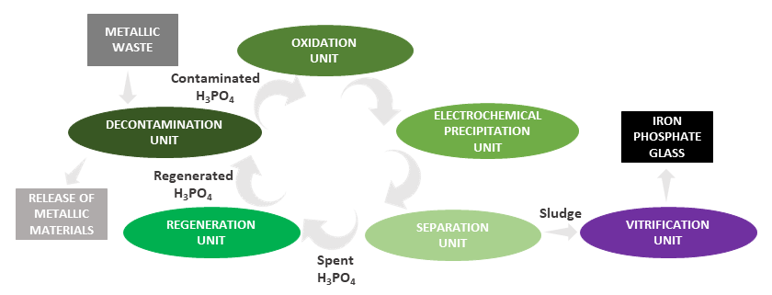

*FIG.1 The sustainable loop of the advanced PHADEC-based process for scrap metals decontamination*

pickling process and reuse of decontaminated phosphoric solution for a new metal decontamination step are being pursued.

As depicted in Fig. 1, the process encompasses a sustainable closed loop with the following units: i) dissolution of the superficial contaminated layer of scrap metals by phosphoric acid, ii) oxidation of the pickling solution, iii) electrochemical precipitation of iron and contaminants phosphates, and iv) conditioning of the dried precipitate by vitrification process at lower temperature and time than borosilicate one. [4][5]

The process is an advancement of the standard PHADEC technology already developed and currently used in decommissioning activities of Italian and German nuclear power plants. The new approach points to solve some of the main critical issues.[6] Notably, it is less energy-intensive due to the recycle and reuse of phosphoric acid without evaporation treatment, limits the production of secondary solid waste and promotes the direct conditioning of the final residue as iron polyphosphate glass without dilution in cement matrices.

Following the decontamination unit to declassify or release metallic materials, the spent phosphoric acid solution needs to be managed. To this purpose, the electrochemical precipitation step is of paramount relevance in the closed loop to produce the waste sludge for the following vitrification, and to regenerate the phosphoric acid solution for its reuse in a new metal decontamination step. Nevertheless, the recycle and reuse of phosphoric acid solution is not a straightforward process because of the not negligible amounts of contaminants that remain after the electrochemical precipitation step. Hence, it is worth investigating some co-precipitation agents to be added during the process in one or more stages to optimize and enhance the decontamination yield of the spent phosphoric acid solution.[7]

## materials and methods

### Chemicals

In the pickling process was used commercial steel Fe-52/Fe 510/S 355, containing < 1.5% Mn, 0.55% Si, 0.22% C and 0.045% P and S. Technical grade phosphoric acid (H3PO4, 40% w/w) and hydrogen peroxide (H2O2, 35% w/w) were purchased from Chimitex Italy.

Metal stock solution of stable contaminants were prepared in H3PO4 (40% w/w) by using Cobalt (Co, 99%), Nickel (Ni, 99%), Strontium (Sr, 99.5%) and Caesium (Cs, >99%) nitrates, purchased from Carlo Erba and Fluka. Stock solutions of radioactive contaminants were prepared by diluting certified standard solution (100 kBq 60CoCl2, 5.936 MBq 85SrCl2, 50 MBq 137CsCl in 3 g·L-1 HCl and 99 kBq 63NiCl2), purchased from Czech Metrology Institute. Each standard solution is prepared in 3 g·L-1 HCl, and 20 mg·L-1 of the respective stable chloride compound are present as carrier.

BaSO4, Ca3(PO4)2 and Ca2P2O7 compounds were purchased from Sigma-Aldrich (Reagent Grade). All chemicals were used as received.

Ultrapure nitric acid (purchased from Santis Analytical Italia) and ultrapure water (Millipore, Billerica, USA; 18.2 MΩ∙cm) were used to dilute samples for mass spectrometry analysis.

*FIG.2 The simplified electrochemical cell configuration (top); current and voltage profiles (red and blue curves) during one of the performed precipitation tests (bottom).*

### Procedure

#### Electrochemical precipitation

After the dissolution of commercial metal steel chips in 40% w/w phosphoric acid and subsequent oxidation of the resulting solution with hydrogen peroxide, a surrogate metal liquor was prepared by tracing it with stable and radioactive contaminants stock solutions to simulate the activation and fission products contamination in the process, notably the concentration of the contaminants ranges from 400 ppb to 100 ppm.[7]

The electrochemical process was initially conducted by loading about 120 mL of the ferric solution in a simple electrochemical cell configuration (see Fig. 2, no anion exchange membrane, electrode section 4×4 cm2 and distance 2.5 cm, applied voltage 8 V, process time 4h 30’). Current and voltages profiles are recorded to monitor the evolution of the electrochemical process (Fig. 2, *bottom*). These experimental conditions have been used for the tests with the radiotracers, and then with stable contaminants to assess some co-precipitation agents as potential candidates for the enhancement of the electrochemical precipitation step. Afterwards, some experimental activities have been conducted by increasing the volumes of ferric solutions up to 200 mL, and then to 240 mL. A multistage configuration has been tested with the best co-precipitant according to the previous experiments. This last experimental setup consists of a first stage, where the electrochemical iron phosphate precipitation occurs from a weighed amount of ferric solution, and a second stage where the previously obtained supernatant undergoes a second electrochemical process with the addition of a suitable co-precipitant to further enhance its decontamination.

#### Phase separation

The milky solution obtained from the electrochemical precipitation is quantitatively retrieved and centrifuged under previously optimized conditions (4500 rpm, for 10 minutes).[7] The wet sludge and the supernatant are weighed for evaluating the precipitation yield, that is defined as the ratio between the mass of the obtained wet sludge and the mass of the initial ferric solution.

#### Characterization

Inductively Coupled Plasma-Mass Spectrometry (ICP-MS, NexION 2000, Perkin Elmer) was used to characterize the commercial steel after acid dissolution in a microwave oven, and to measure concentrations of stable Co, Ni, Sr and Cs in the ferric solution and the supernatant obtained from the electrochemical precipitation experiments. Radioactive solutions have been detected by gamma spectrometry (2” x 2” NaI(Tl), Silena SNIP N MCA) and ultra-low background Liquid Scintillation Counting (LSC 1220 Quantulus, Perkin Elmer).

## RESULTS AND DISCUSSION

Besides electrochemical precipitation experiments with stable contaminants, a simplified surrogate metal liquor was prepared by tracing about 120 mL (192.85 g) of the ferric solution with 500 Bq each of 60Co, 85Sr, 137Cs and 63Ni radiotracers. The electrochemical process resulted in 98.86 g of supernatant and 71.69 g of wet sludge. Consistently with stable contaminants experiments, it showed a precipitation yield of about 35% for 60Co and 63Ni, 25% for 85Sr and 50% for 137Cs. Nevertheless, the electrochemical decontamination of the phosphoric acid solution is not so efficient to recycle and reuse it in a pilot plant. Hence, the improvement of the precipitation process needs to be pursued. The reason for this insufficient decontamination effect can be found on radionuclides concentrations (60Co: ~ 40 ppm, 63Ni: ~ 41 ppm, 85Sr: ~ 708 ppb, 137Cs: ~ 416 ppb) in the dissolved metal liquor that might be too low to reach the product solubility constants of the contaminants phosphates.

### The addition of a co-precipitation agent

The concern of the low contaminants concentration in the metal liquor can be overcome by investigating the potential role of some co-precipitation agents added during the electrochemical precipitation step to boost their abatement. The choice of the compounds is based on the value of their solubility product constants with respect to the insoluble phosphates of the present contaminants. Several compounds such as Al2(SO4)3, CaHPO4, BaSO4, Pb(CrO4), Ca(NO3)2, Ca3(PO4)2 and Ca2P2O7 have been preliminarily assessed in a previous work. [7] Indeed, most of them have been already discarded because of poor chemical stability over time and low abatement of contaminants (Fig. 3).

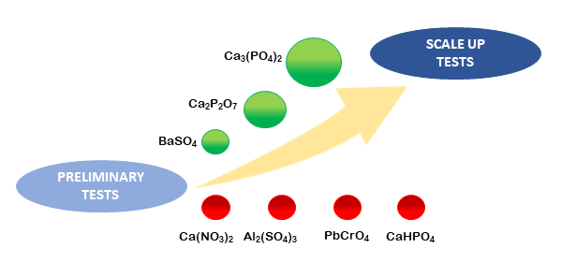

*FIG.3 The selection of the best co-precipitants for scale-up tests.*

In this work, first optimization studies of the precipitation process have been conducted in the configuration cell used for radioactive tests (120 mL) by adding stable Co, Cs, Sr and Ni ions and using BaSO4, Ca2P2O7 and Ca3(PO4)2 compounds in the concentration range 0.1 - 0.3 M (Table 1).

BaSO4 and Ca2P2O7 at a concentration of 0.3 M showed a little improvement of the contaminants abatement into the precipitate (both around 50% against about 30% without adding co-precipitation agents). Higher decontamination effects have been achieved after using 0.2 M Ca3(PO4)2, that improved the abatement up to about 70-75% of initial Ni, Co, Sr contamination; worse behaviour can be observed for Cs with respect to blank conditions.

TABLE 1. CONTAMINANTS IN THE SUPERNATANT [%]

|  |  |  |  |  |
| --- | --- | --- | --- | --- |
| Co-precipitant | Co | Ni | Cs | Sr |
| None | 64 ± 1.2 | 57 ± 1.1 | 5 ± 0.1 | 71 ± 1.9 |
| 0.1 M BaSO4 | 48 ± 1.2 | 47 ± 1.0 | 4 ± 0.1 | 49 ± 1.4 |
| 0.3 M BaSO4 | 40 ± 5.1 | 40 ± 4.9 | 4 ± 0.1 | 47 ± 1.8 |
| 0.1 M Ca3(PO4)2 | 46 ± 1.2 | 48 ± 1.9 | 23 ± 0.7 | 55 ± 1.9 |
| 0.2 M Ca3(PO4)2 | 24 ± 1.3 | 31 ± 1.0 | 12 ± 0.5 | 25 ± 1.3 |
| 0.3 M Ca2P2O7 | 42 ± 1.2 | 44 ± 1.5 | 13 ± 0.8 | 47 ± 0.9 |

### Setup changes and multistage configuration

Focused improvement of the decontamination yields is being carried out by tuning the concentration of the co-precipitation agents and investigating new experimental setups by changing the solution volume or managing more electrochemical precipitation stages. In the same cell configuration, more experiments have been recently performed by using 200 mL of ferric solution. Given the results of the first experiments, BaSO4 has been left out because of its similar decontamination efficiency with Ca2P2O7; what is more, its structure may be less suitable than phosphate compounds for the final vitrification step to produce an iron phosphate glass wasteform.[6] Besides, only the most promising Ca3(PO4)2 compound at concentration of 0.2 M has been chosen for the new experiments conducted at larger volumes. No remarkable decontamination yields have been found for Co, Ni and Sr, while better results have been obtained for Cs (~ 100% of initial contamination) as shown in Figure 4. Concerning the separated solid phase, about 135 g of wet sludge have been obtained thereby achieving a high precipitation yield of 0.5. In addition, a heavy and heterogeneous blackish residue of about 30 g has been found at the bottom of the precipitation cell and it has been partially identified as strontium phosphate by XRD spectroscopy. The volume configuration of 240 mL has shown a similar behaviour of Ca3(PO4)2 compound during the process.

Finally, the geometry adopted for 120 mL of ferric solution provides an optimal cell configuration to minimize the concentration of contaminants in the supernatant as depicted in Figure 4. Perhaps, the variation of the electrochemically active surface of the electrodes at larger solution volumes results in a lower decontamination yield. Nevertheless, the relative position of the same electrodes in the cell (distance from the walls), depth of immersion into the solution and cell geometry are being further optimized to improve the decontamination yield at larger volumes with the addition of a coprecipitation agent as well.

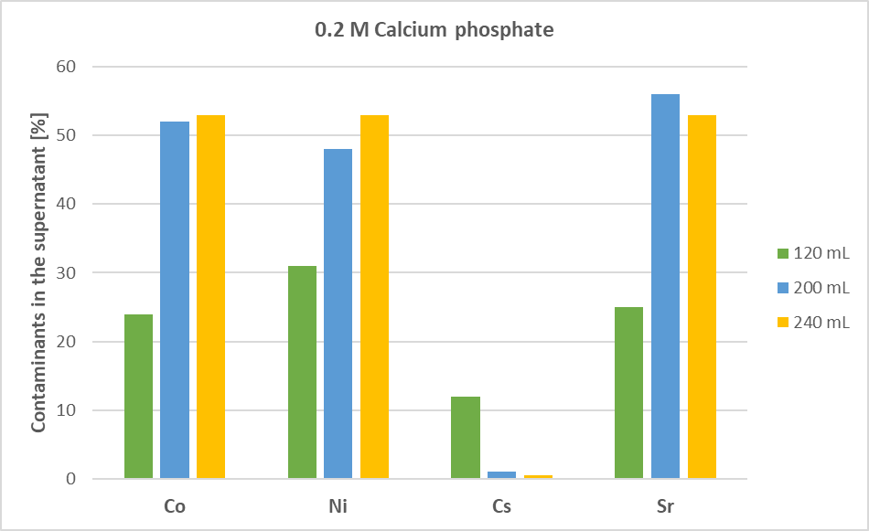

*FIG.4 Percentage of contaminants in the supernatant at different volume configurations after the addition of 0.2 M Ca3(PO4)2*

Pointing at a closed-loop of the PHADEC-based process, the phosphoric acid solution needs to be recycled and reused. To this purpose, the approach of multistage decontamination is being investigated. The process involves two stages of electrochemical precipitation on: i) ferric solution as it is and ii) resulting supernatant after adding a co-precipitation agent. The addition of a particular co-precipitant to a supernatant instead of a ferric solution might further promote contaminants precipitation and enhance the final decontamination yield of the process. One attempt has been made so far by adding to the supernatant solutions 0.2 M Ca3(PO4)2, consistently with its efficient behaviour in the single stage precipitation tests. Unfortunately, Ca3(PO4)2 compound does not promote further decontamination of the supernatant in the second stage as shown in Table 2. Despite these first results, the double stage precipitation is still being investigated by using Ca2P2O7 compound in the concentration range 0.1 – 0.3 M.

TABLE 2. CONTAMINANTS IN THE SUPERNATANT [%] FOR A MULTISTAGE CONFIGURATION

|  |  |  |  |  |  |
| --- | --- | --- | --- | --- | --- |
| Stage | Co-precipitant | Co | Ni | Cs | Sr |
| I | None | 63 ± 1.2 | 74 ± 1.8 | 0.3 ± 1.5 | 65 ± 2.5 |
| I + II | None + 0.2 M Ca3(PO4)2 | 61 ± 2.1 | 73 ± 2.1 | 0.3 ± 0.01 | 63 ± 2.6 |

## sum-up and future outlook

The addition of co-precipitation agents to the ferric solutions coming from PHADEC-based processes can improve its decontamination yield thus promoting its reuse and recycle for new pickling steps in a closed-loop plant. The high concentration of contaminants in the supernatant found in the radioactive tests has led to investigate the potential role of a co-precipitant during the electrochemical precipitation step. The first series of experiments pointed out the efficacy of BaSO4, Ca2P2O7 and especially Ca3(PO4)2 to abate contaminants into the final wet sludge. These results encouraged new electrochemical precipitation tests by varying the volume of ferric solution from 120 to 200 and 240 mL, and by using 0.2 M Ca3(PO4)2. The best volume configuration to minimize the concentration of contaminants in the supernatant currently resulted in 120 mL of ferric solution, but the relative position of the electrodes and the cell geometry are still being optimized.

Despite the promising results obtained from single stage precipitation tests, the implementation of two consecutive electrochemical precipitation stages highlighted the inefficacy of Ca3(PO4)2 to further decontaminate the supernatant coming from the first precipitation stage. However, the performance of Ca2P2O7 will be assessed in the future.

Once the best experimental conditions of the electrochemical precipitation tests have been achieved, the most promising co-precipitation compounds will be added to surrogate metal liquors spiked with radioactive contaminants.

The outcomes of these research activities will be a crucial step forward for a large-scale implementation of this PHADEC-based process.

ACKNOWLEDGEMENTS

The research activities are being developed at Politecnico di Milano in cooperation with Ansaldo Nucleare and supported by ECIR – ECO INIZIATIVA e REALIZZAZIONI S.R.L. This research project is financed by MISE (Italian Minister of Economic Development).

F. G. sincerely acknowledges the Collaborative Doctoral Partnership between Politecnico di Milano and European Commission’s Joint Research Centre – Ispra site on Nuclear Decommissioning and Waste Management.

References

1. MOSTEČAK, A., BEDEKOVIĆ, G., Metal waste management and recycle methods in the nuclear power plant decommissioning, The Mining-Geology-Petroleum Engineering Bulletin, **33** (2018) 25-33.
2. NUCLEAR ENERGY AGENCY, Recycling and Reuse of Materials Arising from the Decommissioning of Nuclear Facilities, NEA No. 7310, OECD (2017).
3. SANG-HO, L., HYUNG-WOO, S., CHANG-LAK, K., Application Review of Clearance for Metallic Waste After Decommissioning, Proceedings of the Korean Radioactive Waste Society Conference, **17** (2019) 358-359.
4. COSTA, P., P., COSTA, L., Method for the conditioning of waste coming from decommissioning of nuclear plants, PCT International Bureau WO 2012/062903 (2012)
5. MESKO, M.G., DAY, D.E., BUNKER, B.C., Immobilization of High-Level Radioactive Sludges in Iron Phosphate Glass, In: Schulz W.W., Lombardo N.J. (eds) Science and Technology for Disposal of Radioactive Tank Wastes, Springer, Boston (1998)
6. LO FRANO, R., AQUARO, D., FONTANI, E., PILO, F., Application of PHADEC method for the decontamination of radioactive steam piping components of Caorso plant, Nucl. Eng. Des., **273** (2014) 595-601.
7. GALLUCCIO, F., MACERATA, E., MOSSINI, E., CASTAGNOLA, G., PIERANTONI, V., MARIANI, M., Recycling metal waste in nuclear decommissioning by advanced phosphoric acid decontamination process, Il Nuovo Cimento **43 C** (2020)