PROMISING PRE-DISPOSAL SOLUTIONS

TO MANAGE SPENT RADIOACTIVE

ION-EXCHANGE RESINS

F. Galluccio*, E. Mossini*, L. Brambilla#, C. Castiglioni#, G. Magugliani*, E. Macerata*, M. Mariani*
* Department of Energy
# Department of Chemistry, Materials and Chemical Engineering
Politecnico di Milano, Milan, Italy
Email: francesco.galluccio@polimi.it

G. D. Gatta⁺, P. Lotti⁺, D. Vadivel, D. Dondi, G. Bilancia°, P. Peerani°
⁺ Università degli Studi di Milano, Department of Earth Sciences, Milan, Italy
University of Pavia, Department of Chemistry, Pavia, Italy
° European Commission, Joint Research Centre, Ispra (VA), Italy

Abstract

Nuclear decontamination processes generate a wide range of radioactive waste to be properly managed. Spent ion-exchange resins (IER) are a large component of radioactive low and intermediate level waste. The development of suitable treatment and conditioning processes is an urgent task to address, as the challenging waste nature (flammability, dispersivity, swelling), high radionuclides leachability (e.g.: Cs) and final waste package volumes do not comply with Waste Acceptance Criteria (WAC) of modern nuclear waste repositories.
Nowadays, advanced pre-treatment processes are preferred to direct encapsulation of spent IER, to reduce organics content and volume of the package, thus limiting corrosion and flammability troubles, and optimizing footprint and costs of the final repository. In this work, IER thermal incineration and Fenton-like wet oxidation have been studied at laboratory scale. A stepwise thermal treatment based on spent IER incineration is being optimized by slowing the gasification process to gradually convert cesium volatile species into inorganic and thermally stable compounds. A simplified surrogate waste was prepared by loading nuclear grade cationic IER with CsNO₃ solutions. Thermogravimetric analysis has allowed to optimize residence time and temperature ramp rate, to enhance the conversion of the (-SO₃-Cs⁺) functional group into less-volatile cesium sulphate. Incineration has been performed into a muffle furnace up to 800 °C. The obtained ashes have been characterized by Raman and X-Ray Diffraction (XRD) analyses, while Cs retention efficiency has been calculated by Inductively Coupled Plasma – Mass Spectrometry (ICP-MS) analysis. The wet oxidation process has been optimized by tuning temperature, catalyst and oxidant concentration. The decomposition over time of a surrogate waste containing Cs, Co, Sr and Ni, as representatives of activation and fission products contamination, has been monitored by Raman and FT-IR spectroscopy. The residue left after treatment has been investigated by XRD to prove the process efficacy. The nuclides distribution has been monitored by ICP-MS analysis. Finally, the obtained ashes and sludges will undergo encapsulation into a geopolymer matrix as promising alternative to Ordinary Portland Cement, to provide physical and chemical stability according to the WAC.
Dry and wet oxidation tests showed a promising weight reduction and good organic decomposition of the treated spent IER. For resin batches treated at 800 °C, promisingly high cesium retention into the ashes has been obtained. A homogeneous residue and a weight reduction rate of 40% turned out from optimization of wet oxidation. Ongoing activities are focused on developing and characterizing residue geopolymer encapsulation for long-term disposal.

INTRODUCTION
The final goal of reducing greenhouse gas emissions has to be met worldwide, according to 2015 Paris Agreement. All efforts are undoubtedly useless if the potential role of nuclear energy will not be considered in the future low carbon energy mix.[1] Meanwhile, nuclear industry has to tackle the waste management challenge to mitigate the environmental footprint of nuclear energy.
Spent ion-exchange resins (IER) are a large fraction of radioactive low and intermediate level waste. The challenging nature (flammability, dispersivity, swelling), high radionuclides leachability and final waste package volumes are not compliant with Waste Acceptance Criteria (WAC) of modern nuclear waste repositories. Innovative treatment and conditioning processes are being developed to minimize the potential hazard towards the environment and human health.
Nowadays, advanced pre-treatment processes are preferred to direct encapsulation of spent IER in cement or bitumen, to reduce organics content and volume of the package, thus limiting corrosion and flammability troubles, and optimizing footprint and costs of the final repository.[2] In this work, oxidative decomposition of IER like thermal incineration and Fenton-like wet oxidation have been studied at laboratory and intermediate scale.
Dry oxidation is an effective way to achieve a good waste volume reduction, but the high temperatures involved in the process (above 700 °C), besides making the process energy intensive, usually entail large production of gaseous secondary waste and potential release of the more volatile radionuclides, like Cs. A stepwise thermal treatment method is being optimized in this work by slowing down the gasification process to enhance the conversion of the (-SO₃-Cs⁺) functional group into inorganic and thermally stable compounds, always pursuing the best waste volume reduction rate.[3]
The alternative approach of wet oxidation has been developed to tackle these issues. Degradation and dissolution of IERs are performed at more moderate temperature (60-100 °C) and with a promising oxidation efficiency. Consequently, the energetic cost of the process and the issue of off-gas treatment are reduced with respect to incineration. The oxidative process is based on the production of hydroxyl and peroxide radicals (Eq. (1)(2)) that initiate along with a catalyst (FeSO₄) a series of chain reactions to decompose IERs into low molecular organics, then a complete mineralization into carbon dioxide and water occurs as shown by Eq. (3).

Fe²⁺ + H₂O₂ → Fe³⁺ + OH⁻ + OH• (1)
OH• + H₂O₂ → H₂O + HOO• (2)
C₈H₈SO₃ +20 H₂O₂ → 8 CO₂ + 23 H₂O + H₂SO₄ (3)

Besides, the use of a cheap and non-toxic catalyst, green oxidant, and moderate temperature make the wet oxidation an environmentally friendly process. In the present work, optimization studies on the process conditions of Fenton-like wet oxidation are being conducted to find out the most sustainable, efficient and economic procedure by limiting temperature, reaction time and rates.
The best formulation of geopolymeric matrix to immobilize the treated IERs by both oxidation processes is being studied, thus achieving high chemical and radiolytic stability of the final wasteform and reducing waste volumes and costs regarding transport and final waste repository.

Pre-treatment of ion exchange resins

Incineration of IERs by Dry Oxidation
Nuclear grade cationic IER (DuPont Amberlite IRN77, exchange capacity ≥ 1.8 meq/mL) has been loaded with CsNO₃ solutions to prepare a simple surrogate waste. Preliminary thermogravimetric analysis (TGA) was conducted to find the optimum thermal treatment conditions by tuning the residence time and temperature ramp rate of the process. Both batches of resin as it is and loaded resin showed a similar weight reduction rate up to 520°C, then the profile of loaded resin increases as result of -SO₃-Cs⁺ oxidation into inorganic sulfate compounds.
Afterwards, lab scale dry oxidation has been conducted into a muffle furnace up to 800 °C. Raman spectroscopy and X-Ray powder Diffraction (XRD) spectroscopy have been used to characterize the left ashes shown in Fig. 1, and to demonstrate the complete decomposition of organic matter. Both Raman spectra and XRD patterns confirmed the TGA outcomes, i.e. the destruction of organic matter and the formation of cesium sulfate compound. Thereafter, no cesium losses, within the experimental uncertainty, have been measured by Inductively Coupled Plasma – Mass Spectrometry (ICP-MS) analysis.

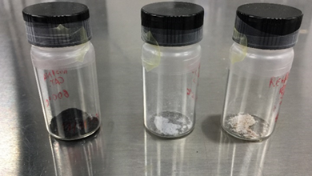
FIG. 1. Ashes obtained from resin incineration at 600 °C (left), 700 °C (middle) and 800 °C (right).

The alternative approach of Wet Oxidation
The wet oxidation is being also pursued by using a surrogate IER waste containing Cs, Co, Sr and Ni ions, as representatives of activation and fission products contamination. The first research steps have been taken to arrange the best experimental setup shown in Fig. 2:

- Four-necked round-bottom flask as glass reactor of 500 mL and 3000 mL used for lab and intermediate scale respectively;
- Stirring heating mantle to control the initial temperature and the speed of the stirrer at 200 rpm during the process;
- Glass thermometer immersed into the resin solution to measure the process temperature over time;
- Peristaltic pump to control the addition of the oxidant (H₂O₂ 30% w/w) at a constant flow rate into the glass reactor containing the resin and the catalyst (FeSO₄∙7H₂O);
- Condenser and receiving flask to condense released vapours, thus trapping potential volatile species of contaminants;
- Two bubblers with NaOH to capture CO₂ release as further check of the complete resin mineralization by sodium carbonate production.

As well, several experiments were carried out to optimize temperature, catalyst and oxidant concentration.[4] As depicted in Fig. 3, the IER can be decomposed within 180 min, even though recent experiments evidenced shorter reaction times for a complete resin dissolution.

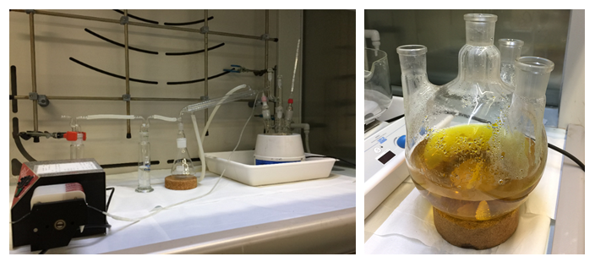

FIG. 2. Experimental setup (left) of wet oxidation process and yellow solution (right) of the mineralized cationic resin
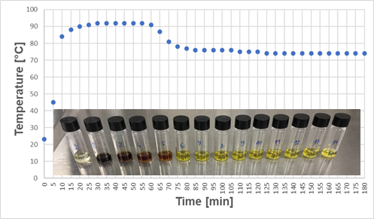

FIG. 3. Temperature profile and solution colour shift over time for a lab scale wet oxidation process

The reaction temperature reaches 90 °C at early stage and it remains constant for about 1 h, then it decreases to about 75 °C till the end of the process. The evolution of the treatment can be also monitored by the colour shift of the solution. Indeed, it gradually becomes black in correspondence with the peak at 90 °C, then it progressively fades to brown and beyond yellow colour as the organic matter degrades, that is within 1 h (Fig. 2, right). In addition, the IER mineralization efficiency has been evaluated by measuring the amount of Total Organic Carbon (TOC) as a function of time. An increase of TOC content can be observed within 1 h of reaction, where the temperature is higher and the resin decomposition occurs. Thereafter, TOC amount reaches smaller values coherently with temperature and colour of the solution.
At the end of the process, the yellow solution is retrieved from the glass reactor and filtered to collect a small amount of fine precipitate that has been identified as strontium sulphate by XRD. The clear solution undergoes evaporation process at controlled temperature for about 24 h. A reddish and wet residue has been obtained (Fig. 4). The result is a weight reduction rate of about 40%, calculated according to the following formula (w₀ – w₁)/w₀ × 100, where w₀ is the initial weight of dry resin and w₁ is the weight of residue after the evaporation process.
Raman, FT-IR and XRD techniques have contributed to confirm complete IER decomposition by detecting only inorganic sulphate compounds into the left precipitate and residue. In addition, ICP-MS analyses were conducted on the resulting solutions to ascertain cations retention, thus corroborating the process efficacy.
The best scale-up of this management approach is being developed. About 100 g of cationic resin have been successfully treated by wet oxidation.

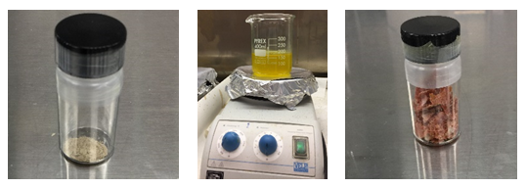

FIG. 4. Fine precipitate after filtration (left), evaporation process (middle) and resulting reddish residue (right).

conditioning of residues
Some efforts are being devoted to confinement of ashes and sludges produced by incineration and wet-oxidation treatments of surrogate IERs. A novel geopolymer matrix based on natural pozzolanic raw materials is being formulated as alternative to Ordinary Portland Cement matrix.[5] The use of highly zeolitized aluminosilicate materials might be a breakthrough since it would reduce the leaching rate of several contaminants.[6] In addition, these natural materials are highly available in nature.
Although the formulation of such geopolymer is under development, some attempts are being made by using a selected natural aluminosilicate raw material contacted with NaOH as activator. After loading of residues, curing of wasteforms will be performed. The so-obtained specimens will undergo mechanical, thermal and leaching tests to prove enough resistance and compliance with standard Waste Acceptance Criteria (WAC).

FUTURE OUTLOOK
The future work outlook points to the scale-up of both incineration and wet oxidation treatment processes. An intermediate scale will be pursued by using cationic IER containing Cs, Sr, Co, Ni and other activation, fission and corrosion products representative ions.
Dry oxidation of IER has been just demonstrated on only ~1 g cationic resin batches. Although ongoing tests are being carried out by using about 10 g of resin, the uniformity of temperature of resin particles becomes more and more crucial in a large-scale system, and it needs to be suitably considered in the future.
Next step forward for wet oxidation is to demonstrate the efficacy of the process at larger scale for the management of about 0.5 or 1 kg of cationic resin (Fig. 5).
High rate of residue loading into geopolymer matrix will be performed. In order to optimize and boost formulation and properties of the geopolymer matrix, a mix of industrial reactive materials, like blast furnace slags and fly ashes, may be added to natural aluminosilicate raw materials.

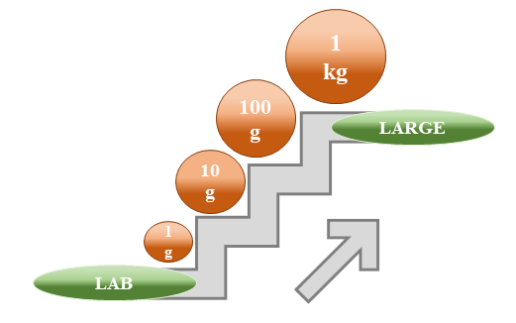

FIG. 5. Scale-up of dry and wet oxidation from lab to large scale implementation.

ACKNOWLEDGEMENTS
This project has received funding from the Euratom research and training programme 2019-2020 under grant agreement No 945098.
F. G. sincerely acknowledges the Collaborative Doctoral Partnership between Politecnico di Milano and European Commission’s Joint Research Centre – Ispra site on Nuclear Decommissioning and Waste Management.
G.D.G. and P.L. acknowledge the support of the Italian Ministry of Education (MIUR) through the projects ‘‘PRIN2017 - Mineral reactivity, a key to understand large-scale processes” (2017L83S77).
References
- INTERNATIONAL ATOMIC ENERGY AGENCY, Climate Change and Nuclear Power 2020, IAEA, Vienna (2020).
- WANG, J., WAN, Z., Treatment and disposal of spent radioactive ion-exchange resins produced in the nuclear industry, Prog. Nucl. Energy 78 (2015) 47-55
- YANG, HC., LEE, SY., CHOI, YC., YANG, IH., CHANG, IY., Thermokinetic analysis of spent ion-exchange resins for the optimization of carbonization reactor condition, J Therm Anal Calorim 127 (2017) 587–595
- XU, L., MENG, X., LI, M., LI, W., SUI, Z., WANG, J., YANG, J., Dissolution and degradation of nuclear grade cationic exchange resin by Fenton oxidation combining experimental results and DFT calculations, Chem. Eng. J. 361 (2019) 1511-1523
- TIAN, L., HE, D., ZHAO, J., WANG, H., Durability of geopolymers and geopolymer concretes: A review, Rev. Adv. Mater. Sci. 60 (2021) 1-14
- BAEK, W., HA, S., HONG, S., KIM, S., KIM, Y., Cation exchange of cesium and cation selectivity of natural zeolites: Chabazite, stilbite, and heulandite, Microporous Mesoporous Mater 264 (2018) 159-166

