**CN-294; EVT2001735 ||| International Conference on Radioactive Waste Management: Solutions for a Sustainable Future**

**Title: Monte Carlo forecast for 241Am/Be DSRS management optimization**

GUEMBOU SHOUOP CEBASTIEN JOEL; BEYALA ATEBA JEAN FELIX; SIMO AUGUSTIN

National Radiation Protection Agency of Cameroon, PO Box 33732, Yaounde Cameroon

**Abstract:**

The present research provided an optimal option for Disused Sealed Radioactive Sources (DSRS) management based on Monte Carlo simulation. The objective was to design the appropriate means for radioactive waste conditioning to avoid material and economic losses based on trials during the sources' dismantling and to find the best optimizing DSRS geometry package. The Particle and Heavy Ion Transport code System (PHITS) was used to design waste containers with appropriate DSRS to get the ALARA principle of dose limitation in the boundary of the waste package. The investigated radioactive waste was made of several disused 241Am/Be neutron sources previously used in well-logging and petroleum exploration in the Gulf of Guinea (CAMEROON). From the obtained result, disk and cylinder were found to be the most appropriate geometries while the parallelepiped geometry was the worst case. The obtained results were stored for the upcoming IAEA expert mission to dismantle and store the DSRS in Cameroon.

**Introduction**

Several developing countries in Africa use sealed radioactive sources (SRSs) with weak or no regulatory infrastructure, and when the SRSs become disused, their management becomes a challenging task. For this reason, the International Atomic Energy Agency (IAEA) has put in place a Regional Technical Cooperation Project “Strengthening Cradle-to-Grave Control of Radioactive Sources” and these member states are dealing with the issue of disused sealed radioactive sources (DSRSs) [1, 2]. As their lifetime starts with production and ends with decommissioning, storage, and disposal, DSRSs are most vulnerable at their end of use as being spent or otherwise since the strict administrative controls implemented when under use are not well planned.

Because of the technical aspect of the management of DSRSs, the inventory including the current status of 241Am/Be neutron sources was developed, their collection was done to safely et securely store them. One most important task to be achieved in the future is to dismantle such inventoried and collected DSRSs for long-term storage or disposal. This delicate work should be planned through technical cooperation with the IAEA, US-DOE assistance, or Expert mission [1, 3–10]. But before such complex operations are undertaken, national experts can use one of the most powerful computer tools to assess the safety of the DSRS geometry and materials used for disposal. This work aims to develop a Monte Carlo-based method that will set the appropriate geometry for 241Am/Be neutron source package into the appropriate capsule and concrete-filled drum.

**Material and Methods**

The Particle and Heavy Ion Transport code System (PHITS), a Monte Carlo tool will be used to investigate the most optimizing source geometry for the DSRS package. The appropriately designed waste drum is given in the following pictures (Figure 1 and 2). The inventoried spontaneous neutron sources are listed in Table 1. A computed geometry of the system is shown in Figure 3 where details on the capsule position in the concrete-filled drum can be seen. The detail on the implementation of the source in the PHITS code was provided by references [11–20] and the description of the appropriate Monte Carlo method was developed by Guembou [2, 5, 8, 10, 21].

The principle consists of modeling the real situation by simulating the encasement of the neutron sources into an Am1 P60 Capsule, in turn, encased into a concrete-filled drum prepared for long-term storage or disposal purpose. Then the neutron and gamma fluxes are calculated. Based on the neutron and gamma fluxes and their energy, the kerma and the dose rate are computed to determine the conditions the will be present during the dismantling operation to be undertaken. The effective dose rate is determined at the contact of the DSRS package and 1 m away. The best optimizing source geometry is then determined among the 5 types investigated (point, disk, sphere (03 dimensions), cylinder (02 dimensions), and parallelepiped type source (02 dimensions)).

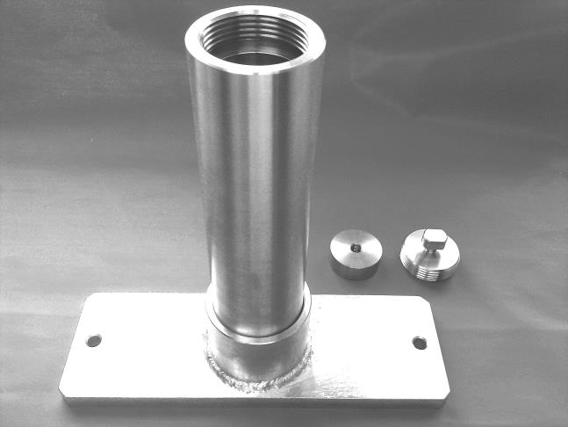 

Figure 1. The image of an Am1.P60 Capsule used to store the 241Am/Be spontaneous neutron DSRS and the five investigated geometry types of the source

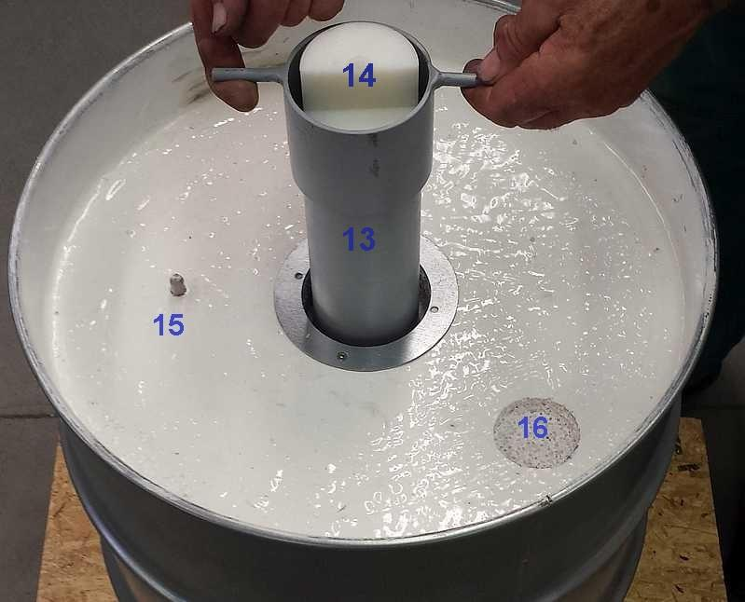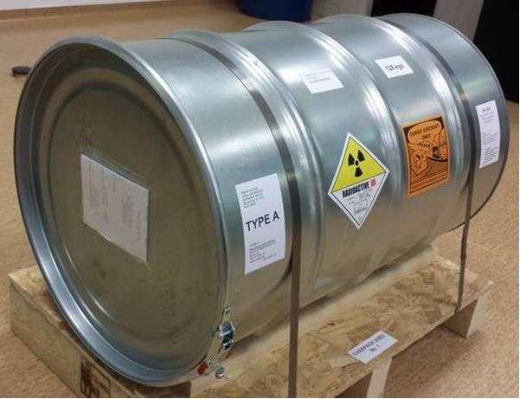

Figure 2. Pictures of the Drum to contain Am1 P60 or LB 100W container with X. P60. The nest (13), Plastic plug (14), Center container pin (15), and the Hole filled with borate concrete (16)

Table 1: Inventoried disused sealed radioactive sources of 241Am/be considered for one P60 capsule

|  |  |  |  |  |
| --- | --- | --- | --- | --- |
| **Manufacturer** | **Radionuclide** | **Activity (mCi)** | **Date of Activity** | **Activity on 8/16/2021 12:00:00 (mCi)** |
| TROXLER | Am-241/Be | 40 | 16-08-1982 | 37.5731118827636 |
| TROXLER | Am-241/Be | 40 | 16-08-1982 | 37.5731118827636 |
| HUMBOLT | Am-241/Be | 40 | 09-13-1989 | 38.0023065103134 |
| HUMBOLT | Am-241/Be | 40 | 09-13-1989 | 38.0023065103134 |
| HUMBOLT | Am-241/Be | 40 | 09-13-1989 | 38.0023065103134 |
| HUMBOLT | Am-241/Be | 40 | 09-13-1989 | 38.0023065103134 |
| SEDITECH | Am-241/Be | 50 | 06-15-1987 | 47.3318312526414 |
| SEDITECH | Am-241/Be | 50 | 06-15-1987 | 47.3318312526414 |
| **Total** |  | **340.00** |  | **321.819112312064** |

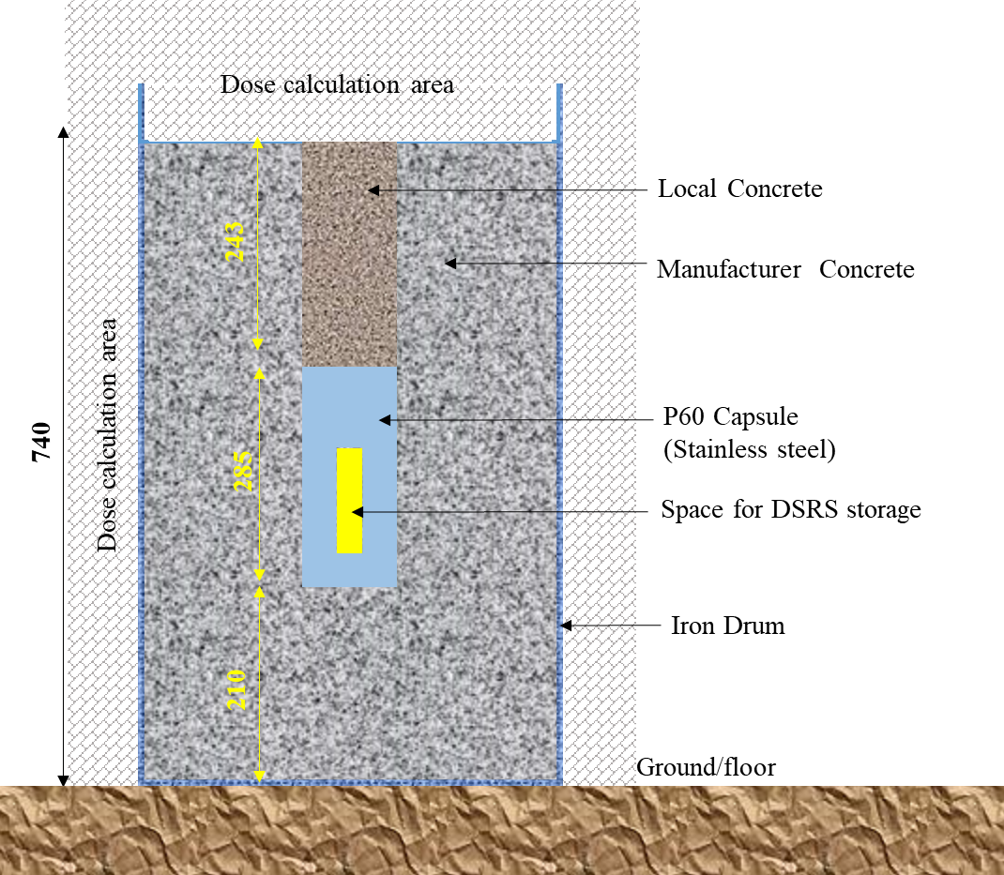

Figure **3**. Geometry of the simulation designed for DSRSs waste management optimization.

**Results and discussions**

The neutron and photon-generated fluxes for the five investigated DSRS geometry types are given in Figure 4 to Figure 12. It can be seen that the flux is concentrated at the source position and for volume sources, it is more dispersed than that of the point source of the surface source. This shows that the surface source is the most appropriate DSRS geometry to be used while preparing for dismantling, long-term storage, and/or disposal operations. The Disk form was found to be the most optimizing among the investigated geometries while the parallelepiped geometry was found to be the worst case.

The 08 DSRS used for the simulation totaled an effective activity of 450 mCi on June 1st, 2021, which is less than the recommended value of 2 TBq as recommended by the P-60 capsule manufacturer. In addition, the simulation using the source activity limit as recommended by Eckler & Zekler company demonstrate an agreement with the targeted result of less than 1 mSv in the adjacent public area to the interim storage facility. Further investigations are under development regarding gamma sources in Cameroon. The obtained results are stored for the upcoming IAEA expert mission to dismantle and store the DSRS in Cameroon.

Table 2: Effective dose rate for decision-making process based on Monte Carlo simulation

|  |  |  |  |
| --- | --- | --- | --- |
| **Geometry** | **Effective dose at different position (μSv/h)** | | |
| **At contact (x-axis)** | **1 m away** |
| **Point-like** | 3.04E+01 | 1.72E+00 |
| **Disk source** | 3.03E+01 | 1.70E+00 |
| **Sphere 1** | 3.24E+01 | 1.81E+00 |
| **Sphere 2** | 3.41E+01 | 1.87E+00 |
| **Sphere 3** | 3.44E+01 | 1.88E+00 |
| **Cylindrical 1** | 3.37E+01 | 1.84E+00 |
| **Cylindrical 2** | 3.42E+01 | 1.85E+00 |
| **Rectangle 1** | 3.42E+01 | 1.86E+00 |
| **Rectangle 2** | 3.48E+01 | 1.89E+00 |

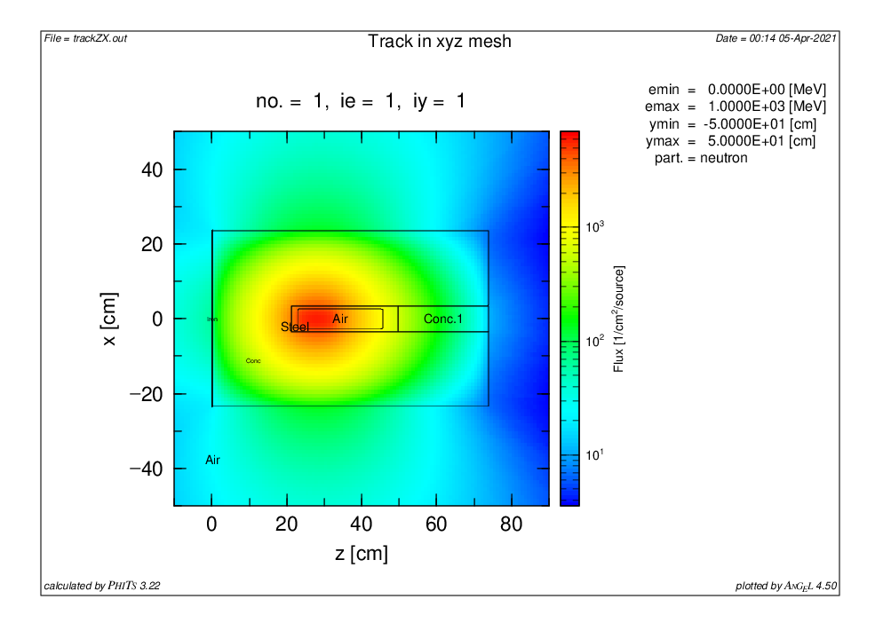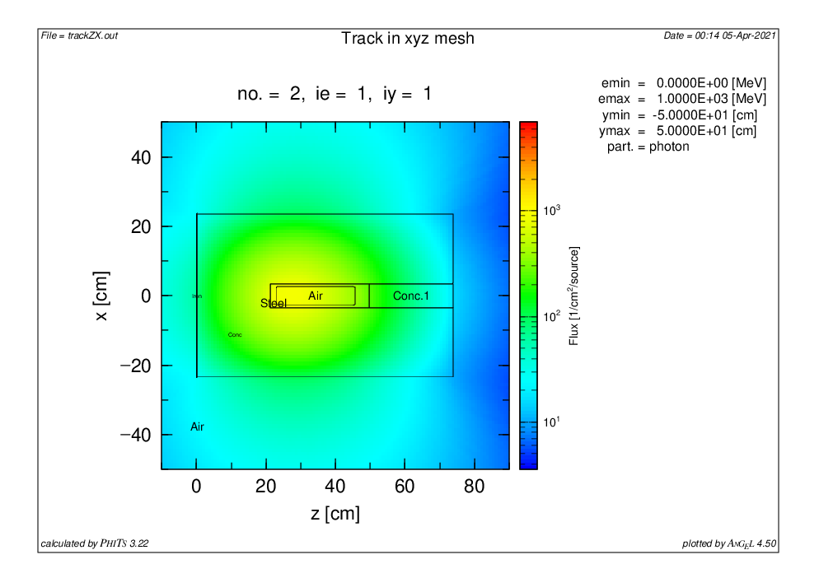

Figure 4. Neutron and gamma fluxes from Am-241/Be source in the disk geometry: Cylindrical 10

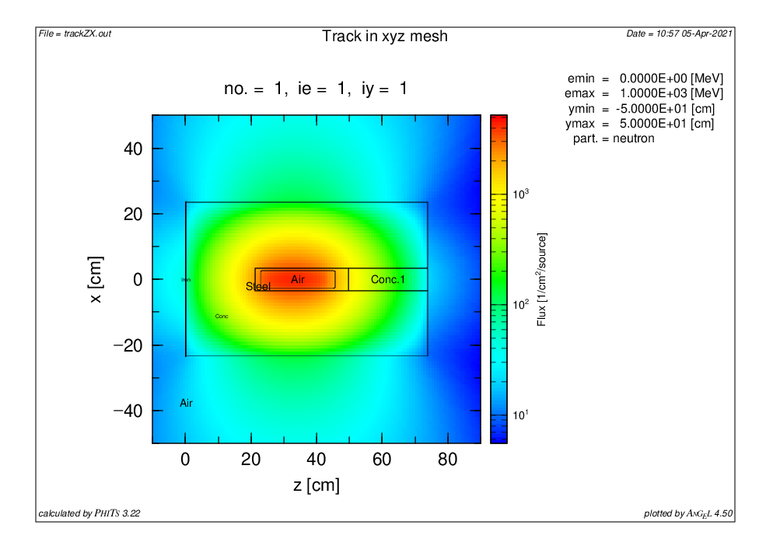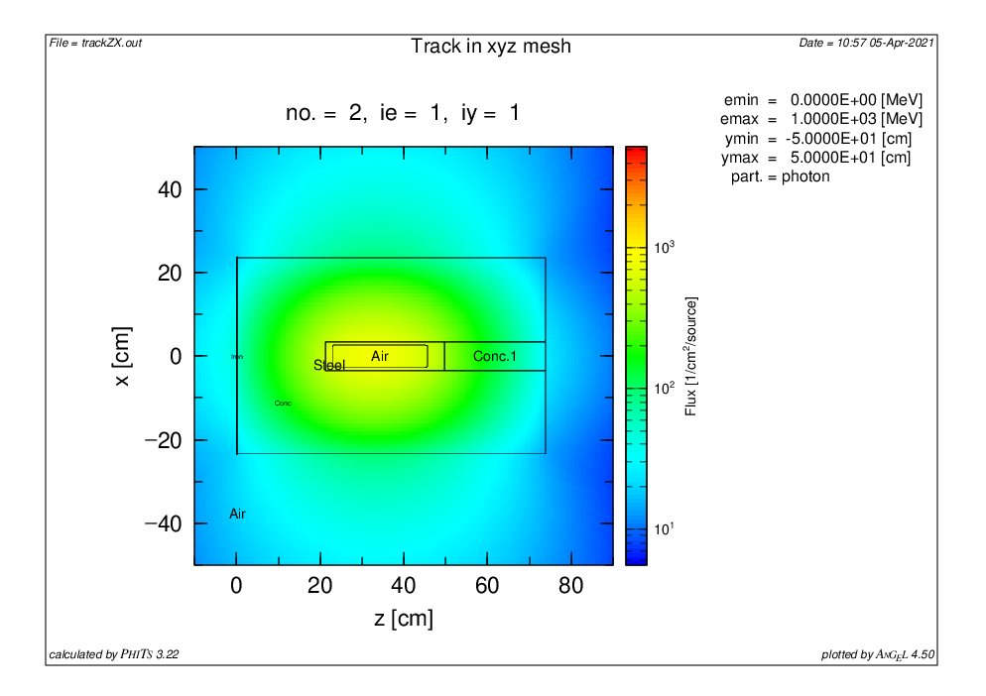

Figure 5. Neutron and gamma fluxes from Am-241/Be source in the disk geometry: Cylindrical 20

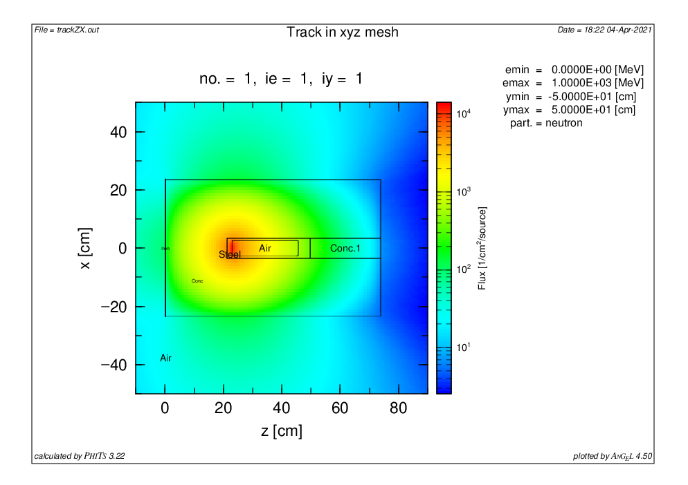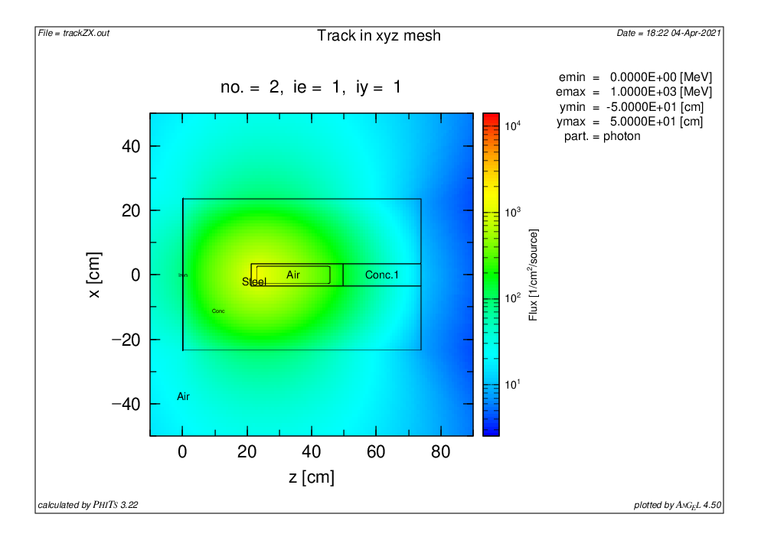

Figure 6. Neutron and gamma fluxes from Am-241/Be source in the disk geometry: Disk source

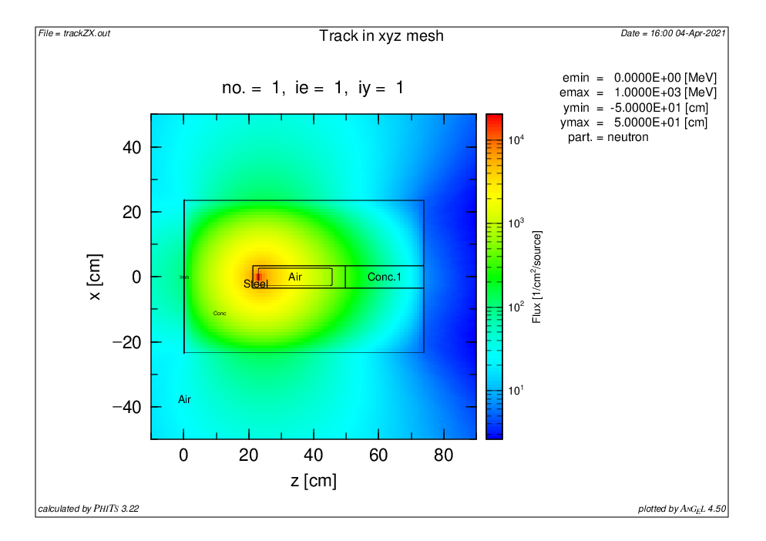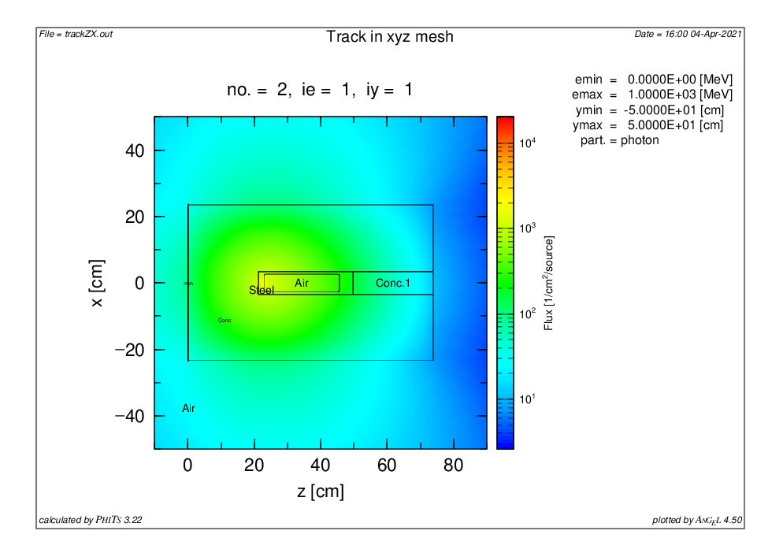

Figure 7. Neutron and gamma fluxes from Am-241/Be source in the disk geometry: Point-like source

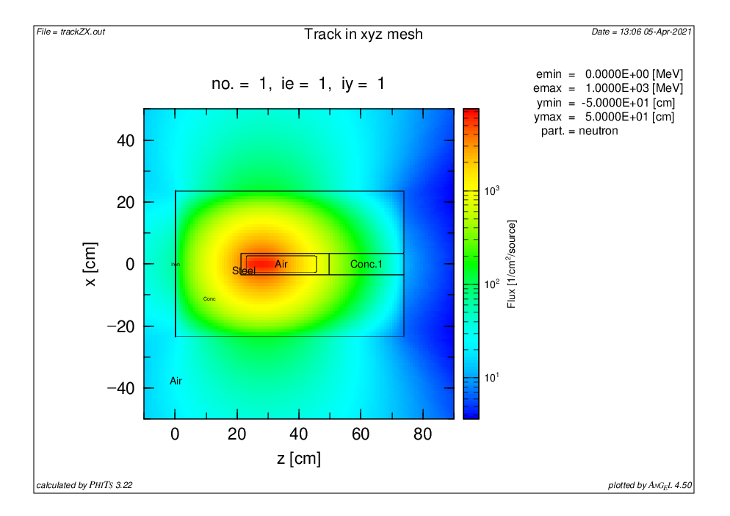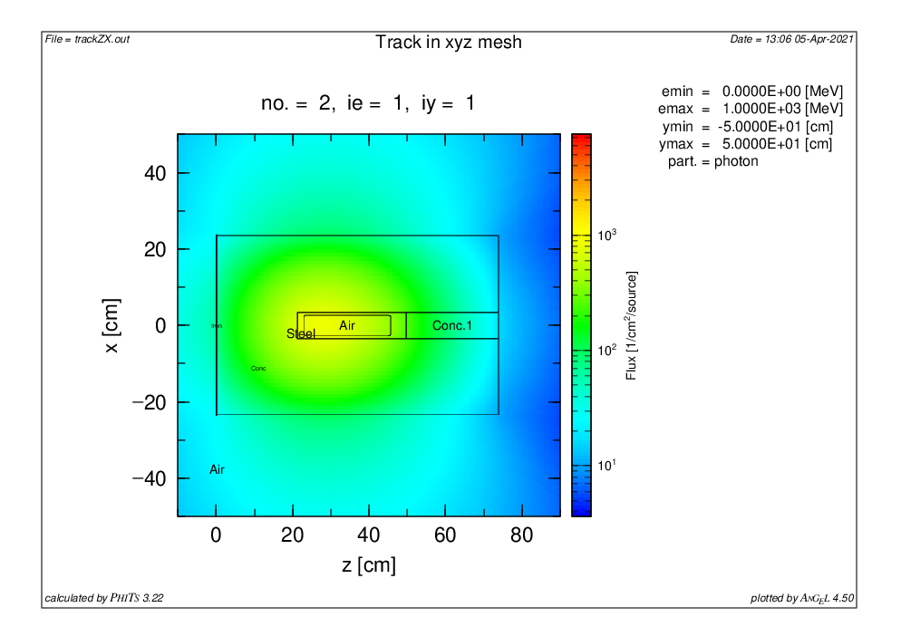

Figure 8. Neutron and gamma fluxes from Am-241/Be source in the disk geometry: Rectangle 1

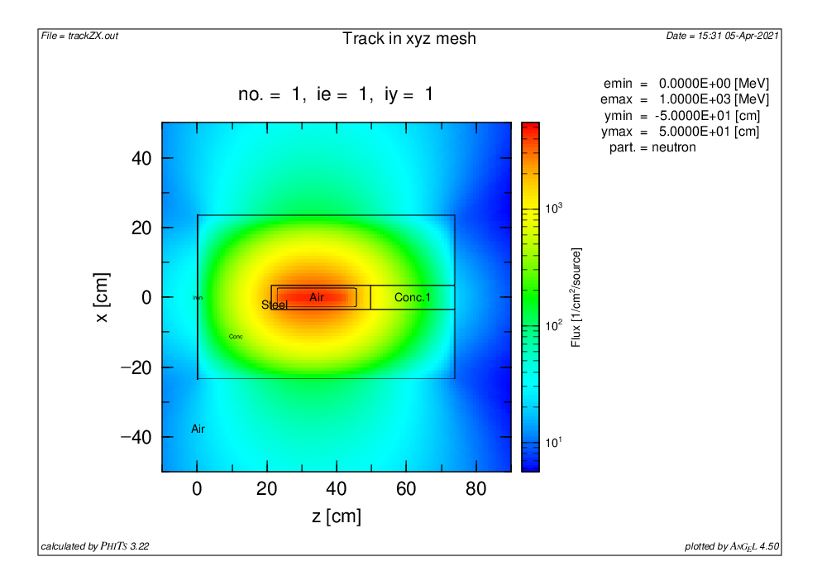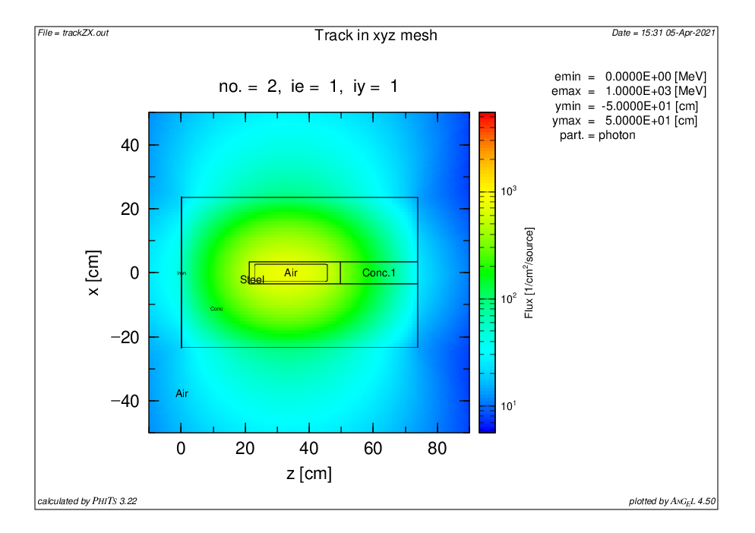

Figure 9. Neutron and gamma fluxes from Am-241/Be source in the disk geometry: Rectangle 2

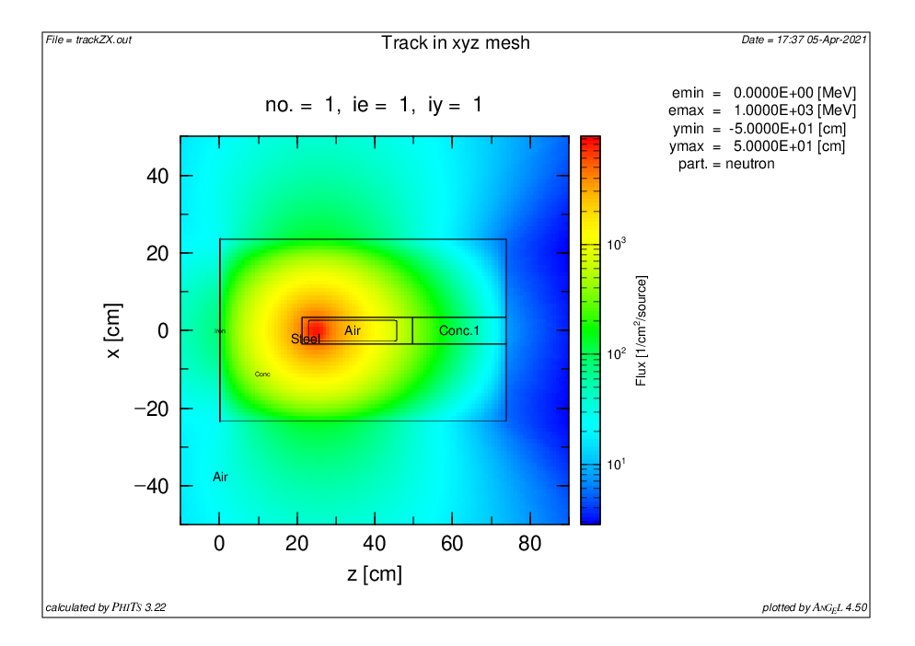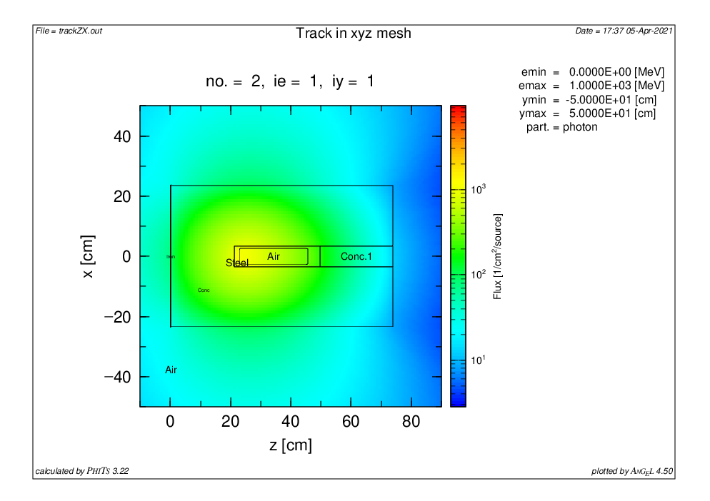

Figure 10. Neutron and gamma fluxes from Am-241/Be source in the disk geometry: Sphere 1

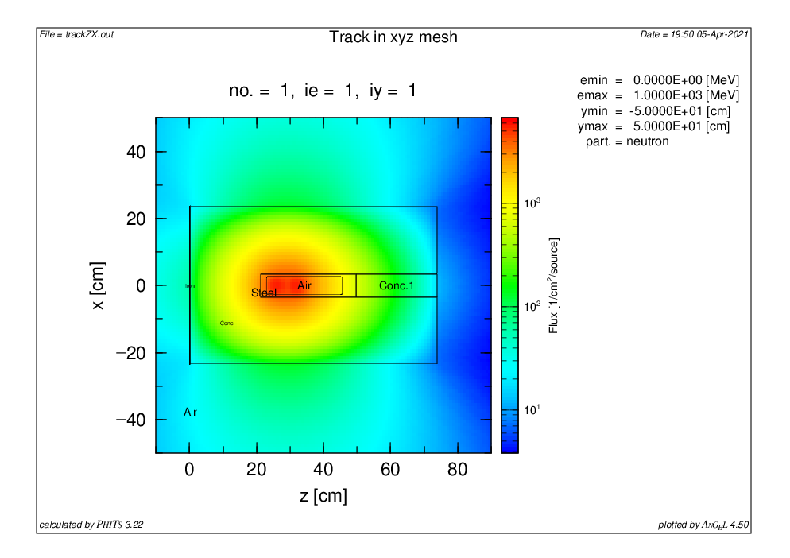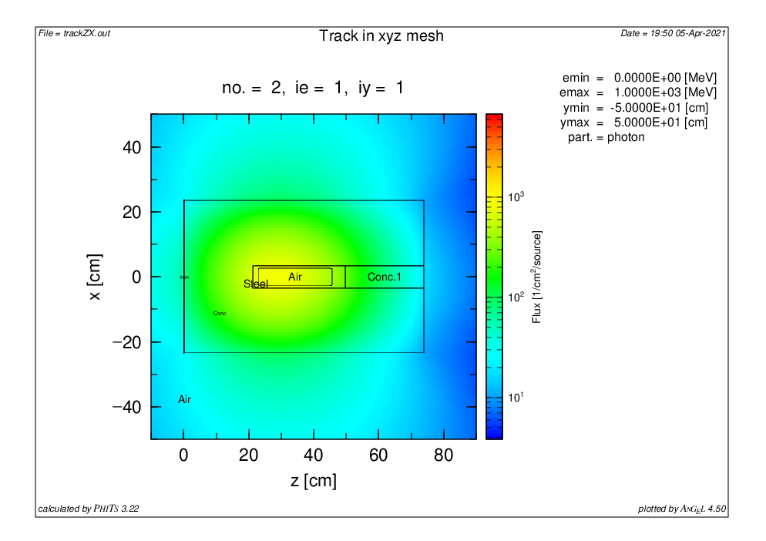

Figure 11. Neutron and gamma fluxes from Am-241/Be source in the disk geometry: Sphere 2

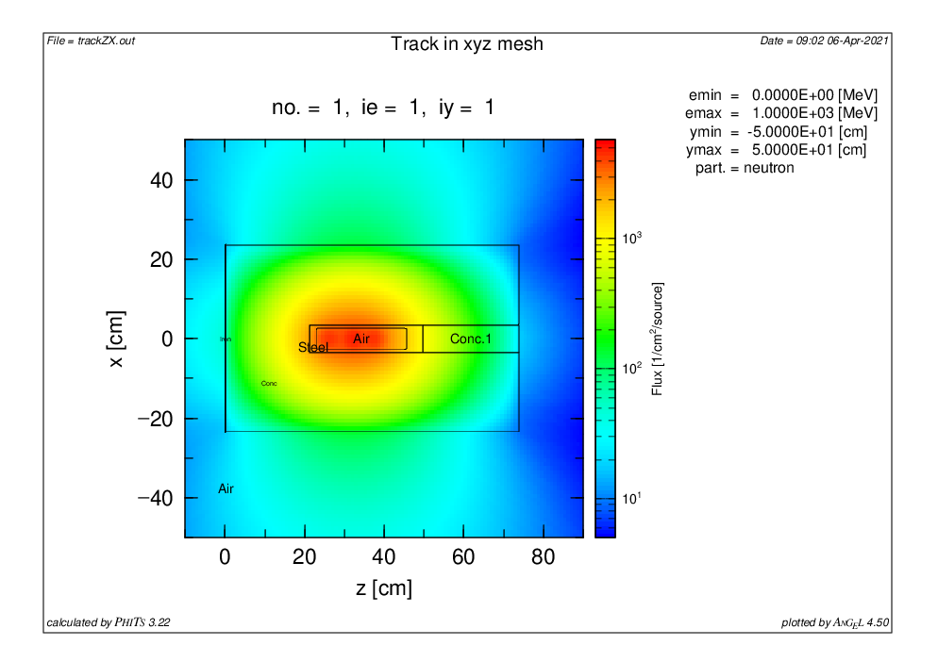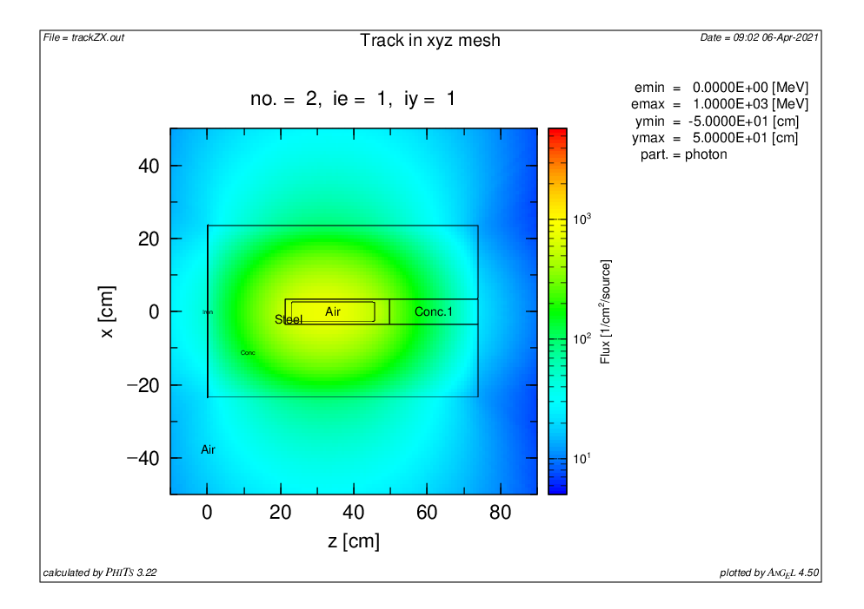

Figure 12. Neutron and gamma fluxes from Am-241/Be source in the disk geometry: Sphere 3

**Conclusions**

The optimum geometry of the 241Am/Be disused sources based on PHITS Monte Carlo simulations for the disposal of DSRSs as a waste package was performed. Disk and cylinder were found to be the most optimizing geometries for DSRS long-term storage. The determination of the most radiological optimizing source form will allow the dismantling and disposal of DSRSs in a safe and secured way worldwide. The obtained results also allow the evaluation of the DSRS storage capacity as the effective dose rate calculated for the 321.82 Bq of 241Am/Be neutron spontaneous source shows lower values than the permissible ALARA principle.

In conclusion, one can say that Monte Carlo methods are effective computational tools that can be used to enhance the “cradle to grave” management of disused radioactive sources. As the issue of nuclear waste management is an up-to-date topic, the future perspective will consist of looking at a Monte Carlo-based method (with statistic) to validate the most optimizing complex source geometry and the function of gamma, beta, and alpha sources (Cebastien SHOUOP GUEMBOU et al., 2021).

**Acknowledgment:** The authors are grateful to PHITS Collaboration (T. Sato, S. Hashimoto, K. Niita, et al.) for PHITS development. They want to extend their gratitude to the National Radiation protection Agency of Cameroon – NRPA for promoting Monte Carlo development in the research institute and to the IAEA for promoting this research through the conference.

**References**

1. AGENCY IAE (1999) Radiation Protection and Safety in Industrial Radiography (IAEA 1999) Safety Reports Series No. 13. VIENNA

2. Shouop G, Joel C, Maurice NM, et al (2018) Monte Carlo method for gamma spectrometry based on GEANT4 toolkit: Efficiency calibration of BE6530 detector. J Environ Radioact 189:109–119. https://doi.org/10.1016/j.jenvrad.2018.03.015

3. IAEA (2014) IAEA Nuclear Energy Series International Safeguards in the Design of Nuclear Reactors. IAEA Nucl Energy Ser No NP-T-29

4. International Atomic Energy Agency, IAEA (2014) Radiation Protection and Safety of Radiation Sources: International Basic Safety Standards (GSR Part 3). Int At Energy Agency Vienna 3:471. https://doi.org/STI/PUB/1578

5. Guembou Shouop CJ (2020) SHIELDING DESIGN AND SAFETY MEASURES AROUND 60Co, 192Ir, AND 252Cf SOURCES IN INDUSTRIAL RADIOGRAPHY FACILITIES BASED ON PHITS MONTE CARLO SIMULATIONS. KAIST - Korea Advanced Institute of Science and Technology

6. IAEA (2005) Categorization of Radioactive Sources. IAEA Saf Stand Ser No. RS-G-1:70

7. Guembou Shouop CJ (2020) Radioactive Waste Management option for Cameroon: Current Practices towards an optimized management strategy in the future. In: ICTP (ed) International School on Radioactive Waste Cementation. ICTP, Trieste, pp 16–22

8. Guembou Shouop CJ (2020) RADIATION PROTECTION OPTIMIZATION IN FIXED INDUSTRIAL RADIOGRAPHY-BASED PHITS MONTE CARLO CODE SIMULATION. In: IAEA International Conference on Radiation Safety: Improving Radiation Protection in Practice

9. Guembou Shouop CJ, BAK S-I, NDONTCHUENG MOYO M, et al (2020) Barite concrete for 252Cf spontaneous neutron shielding based on Monte Carlo computation. In: NuMat2020: The Nuclear Materials Conference

10. Guembou Shouop CJ, Bak SI, Ndontchueng Moyo M, et al (2020) New Cf-252 neutron source shielding design based Monte Carlo simulation using material combination. AIP Adv. https://doi.org/10.1063/1.5144923

11. Sato T, Niita K, Matsuda N, et al (2013) Particle and heavy ion transport code system, PHITS, version 2.52. J Nucl Sci Technol. https://doi.org/10.1080/00223131.2013.814553

12. Niita K, Matsuda N, Iwamoto Y, et al (2010) PHITS : Particle and Heavy Ion Transport code System , Version 2 . 23. JAEA-Data/Code

13. Sato T, Niita K, Matsuda N, et al (2014) Overview of the PHITS code and its application to medical physics. Prog Nucl Sci Technol. https://doi.org/10.15669/pnst.4.879

14. Sato T, Niita K, Matsuda N, et al (2015) Overview of particle and heavy ion transport code system PHITS. Ann Nucl Energy. https://doi.org/10.1016/j.anucene.2014.08.023

15. Sato T, Niita K, Iwamoto Y, et al (2017) Recent Improvements of Particle and Heavy Ion Transport code System: PHITS. In: EPJ Web of Conferences

16. Niita K, Matsuda N, Iwamoto Y, et al (2007) PHITS overview. In: AIP Conference Proceedings

17. Iwamoto Y, Sato T, Hashimoto S, et al (2017) Benchmark study of the recent version of the PHITS code. J Nucl Sci Technol. https://doi.org/10.1080/00223131.2017.1297742

18. Sihver L, Sato T, Gustafsson K, et al (2010) An update about recent developments of the PHITS code. Adv Sp Res. https://doi.org/10.1016/j.asr.2010.01.002

19. Niita K, Sato T, Iwase H, et al (2006) PHITS-a particle and heavy ion transport code system. Radiat Meas. https://doi.org/10.1016/j.radmeas.2006.07.013

20. NIITA K, IWASE H, SATO T, et al (2011) Recent Developments of the PHITS code. Prog Nucl Sci Technol. https://doi.org/10.15669/pnst.1.1

21. Guembou Shouop CJ, Sang-In B (2020) Shielding design for high-intensity Co-60 and Ir-192 gamma sources used in industrial radiography based on PHITS Monte Carlo simulations. Eur Phys J Plus. https://doi.org/10.1140/epjp/s13360-020-00797-8