Hardness behavior of U₃O₈ pellets: An option for

the management of research reactor spent fuel

A.A. CHAVEZ
National Atomic Energy Commission (CNEA)
San Carlos de Bariloche, Rio Negro, Argentina
Email: ariel.chavez@cab.cnea.gov.ar

A. MAGNONE and others
National Atomic Energy Commission (CNEA)
San Carlos de Bariloche, Rio Negro, Argentina

Abstract

The paper continued the research work on the CERUS (Ceramization of radioactive elements in sintered Uranium) project of the Argentinean National Atomic Energy Commission (CNEA) carried out in the laboratories of the Bariloche Atomic Centre (CAB). Microhardness measurements were made on U₃O₈ pellets sintered at different temperatures, using Vickers and Knoop indenters. An analysis and comparison of the obtained values with the two techniques were carried out and the HV / HK value was obtained for comparing it with the values from other ceramics materials. Finally, micrographs obtained by Scanning Electron Microscopy are presented to assess the interaction of the material with the indenters.

INTRODUCTION
The CERUS project was developed by the Argentinean National Atomic Energy Commission (CNEA) in the framework of the strategies for research reactor spent fuel management policy stated at the National report for the Joint convention on the Safety of Spent Fuel Management and on the Safety of Radioactive Waste Management [1], in order to achieve a predisposal treatment for conditioning aluminium cladded and dispersed U₃Si₂ spent fuel. Research Reactor Spent Fuel (RRSF) management is challenging due to the enrichment at discharge higher than 11% of ²³⁵U [2]. Due to criticality considerations and susceptibility to materials degradation, direct disposal is not considered a viable option for U₃Si₂-Al RRSF management [3]. The main idea of the process consists of the use of natural (or depleted) uranium oxide to achieve the ²³⁵U isotope dilution down to 1 wt.% and seeking for a monolithic ceramic wasteform with triuranium octoxide (U₃O₈) as immobilization matrix.
Previous research works carried out at the Bariloche Atomic Centre (CAB) focused on the characterization of a mixture of natural U₃O₈ and a chopped, calcined and milled aluminium cladded and dispersed natural uranium silicide plate [4]. This study proposes the continuity of the research of U₃O₈ precursor powders that began with the study of densification behaviour by Chavez et.al. [5-6]. Several 4 grams, 9 mm diameter and 10 mm height, cold-pressed and sintered uranium oxide pellets were obtained by two routes of powder synthesis: AUTC-ammonium uranyl tri-carbonate (UO₂ industrial process of Argentina), and ADU-ammonium diuranate. Finally, they were characterized by Archimedes method of immersion to obtain the porosity as well as ceramography, optical and electronic microscopy techniques to assess the shape and morphology of the ceramic matrix.
This work addresses the response of micro-indentations on the sintered pellets. Vickers and Knoop indentation measurements were done to obtain the hardness value with each method. Then a comparison was made between both values to know the hardness of the material, and to infer the mechanical strength of the triuranium octoxide (U₃O₈) matrix. Lastly, samples were observed in a Scanning Electron Microscope (SEM) to characterise the interaction between the indentations and the ceramic matrix.
Future works will begin with the treatment, thermal and mechanical grounding of simulated U₃Si₂-Al mixed with the triuranium octoxide matrix (U₃O₈) obtained and analysed in this work, in order to create a waste form of Uranium oxide and treated simulated SFE.

EXPERIMENTAL PROCEDURE

Pellets fabrication and first characterizations
The pellets were obtained by two different routes, by calcination of UO₂ from AUTC, and by the dissolution of UO₂, precipitation and calcination of ADU. Finally, they were cold pressed and sintered at different temperatures (1100, 1200, 1300 and 1400°C). Then, immersion in water and mercury were performed to obtain the density and porosity of the samples.

Embedding and ceramography
The pellet samples were cut in the axial direction by the use of a metallographic saw, then they were embedded in an epoxy resin and finally grinded and polished to analyse the porosity at the surface.

Microindentation measures and Electron microscopy
The micro-hardness test was carried out in a Mitutoyo MVK-H0 hardness machine in the Nuclear Materials Department (CAB, CNEA). The loads used were 500 g and 300 g, with a loading time of 15 seconds. The samples were measured in 3 zones: centre, top, and diameter. Figure 1 shows the measured areas in the sample.
These hardness measurements are based on the ratio of applied load/area of indentation [7]. For the Vickers test, the resulting area is square and hardness is determined by:
$$HV=\frac{F}{A}≈\frac{1.8544∙F}{d^{2}}\left[{kgf}/{{mm}^{2}}\right] (1)$$
Where F is the load in Newton (N), and d is the mean diagonal length in millimetres (mm).
For the Knoop test, the resulting area is an elongated diamond pyramid, and the hardness is determined by:
$$HK=\frac{load (kgf)}{A ({mm}^{2})}=\frac{F}{C_{p}L^{2}}\left[{kgf}/{{mm}^{2}}\right] (2)$$
Where F is the load in N, L is long axis indentation length in mm.
Despite the fact that the hardness of the material is an intrinsic property, these hardness tests do not result in the same Hardness values due to the intrinsic characteristics of the measurement methods, the indenter geometries, the indentation impressions and the elastic response of the material.
The scanning electron microscopy was done in the Zeiss Crossbeam 340 from Applied Research Area, CAB, CNEA, and the Energy Disperse Spectroscopy (EDS) analysis was done with a Fei Inspect S60 in the Materials Characterization Department of CAB, CNEA.
- Pellet indentation scheme. Green: axial line; Blue elongated diamond: Knoop indentations; Red diamond: Vickers indentations.

RESULTS AND DISCUSSIONS

Microhardness tests
The Vickers and Knoop hardness were calculated using equations (1) and (2). Each test was carried out leaving considerable spacing between points to avoid hardening effects by the deformation of the surrounding material. Figure 2 summarizes the results of these measurements in the U₃O₈ matrix.
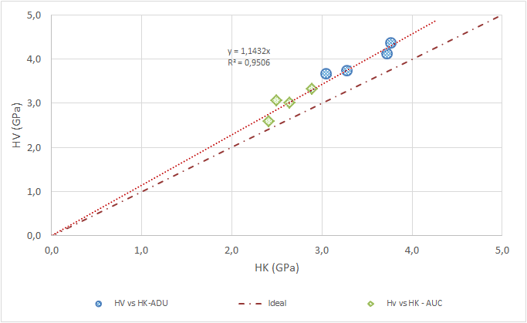
- Comparison between HV and HK for both types of oxide precursor powders.
The results show higher HV than HK values for both types of pellets. Moreover, the pellets obtained by the ADU route showed higher values of HV and HK, with a 500 g load. The green diamonds represent values from pellets obtained through the AUTC route. Blue circles represent values obtained for pellets from the ADU route, and both results can be adjusted by a linear equation with a slope of 1.1432. Ben Ghorbal et.al [8] presented a revision of different authors about the relationship between Vickers and Knoop hardness for different ceramic materials and showed the same relation of HV vs HK. The authors also reported an HV/HK ratio that varies from 1.05 to 1.15 for hard materials. Table 1 shows the average values from HV and HK for each temperature point, the ratio HV/HK and the average ratio HV/HK by powder precursor. It is interesting to observe that the average ratio HV/HK for both materials is closely similar.
- Average values for HV, HK and ratio HV/HK of samples
 | T(°C) | HV av (GPa) | HK av (GPa) | HV/HK | HV/HK av (mat) | σ(HV/HK av)
ADU route | 1100 | 4.1 | 3.7 | 1.10 | 1.15 | 0.04
 | 1200 | 4.4 | 3.8 | 1.15
 | 1300 | 3.7 | 3.3 | 1.13
 | 1400 | 3.6 | 3.1 | 1.19
AUTC route | 1100 | 3.1 | 2.5 | 1.23 | 1.15 | 0.06
 | 1200 | 3.3 | 2.9 | 1.15
 | 1300 | 3.0 | 2.6 | 1.10
 | 1400 | 2.6 | 2.4 | 1.11

Finally, the hardness tests were carried out with a load of 300 g in the pellets obtained by the ADU route and compared with the results of the 500 g load tests. The comparative values ​​are shown in Figure 3.
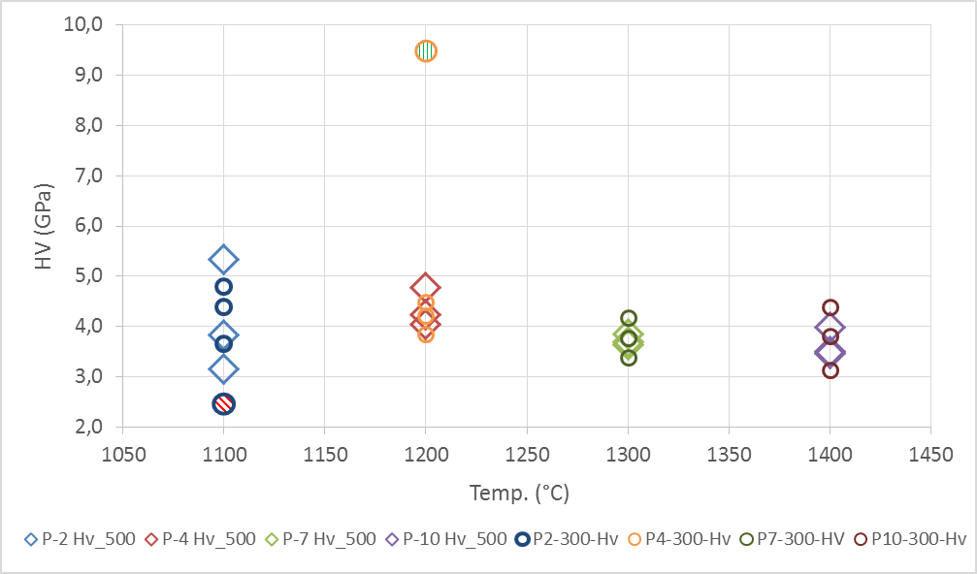
- Comparative results from HV test for different loads: 300 g (Circle) y 500 g (Diamond). Samples P2, P4, P7 and P10 from ADU route were measured at both loads.
Those results showed correlation values from both loads and for both types of precursors. In pellet #2 (1100°C) a zone with high porosity (dark blue – diagonal red lines circle) was found which showed the lowest hardness value, and for pellet #4 (1200°C) an inclusion contaminant in the ceramic matrix (vertical green lines – orange big circle) showed the highest hardness value. Dispersion on the values from the measurements in the pellets at 1100°C and 1400°C can be observed.
The average HV value for U₃O₈ by ADU route is close to 4.0 GPa. For the pellets from the AUTC route, the average value is close to 3.0 GPa. Due to the different crystal structures of the different oxides, lower hardness values are expected in U₃O₈ than UO₂. Sivov et. al. [8] showed hardness values for HV1000 of 5.52, 5.73, and 5.80 GPa for UO₂ pellets with different grain sizes: 13, 26, and 33 µm for VVER type reactor.
A grain size analysis was not performed, in future steps, an etching of the pellets in order to reveal and delineate the grain boundaries will be carried out.

Electron microscopy and energy disperse analyses
From the sample sintered at 1200 °C, in which the higher hardness value was obtained, the energy dispersive x-ray spectroscopy showed Silicon, which could possibly be contaminations from the agate mill, composed of silicon dioxide (SiO₂). Figure 4 shows the area analysed and the results.
- Up: contaminant inclusion in the matrix, EDS zones. Down: Analyses EDS for the inclusion.
Figure 5 shows Knoop indentation on pellet #9 from the AUC route. The damage in the material due to the indenter can be observed, in the vicinity of the indentation, some cracks are present wich could be intergranular cracks through grain boundary. Figure 6 shows Vickers indentation on pellet #7 from the ADU route. The average size of the indentations is small due to the 300 g load applied, the cracks on the perimeter look more chaotic than the cracks in the AUTC U₃O₈. The cracks are possibly transgranular through the grains.
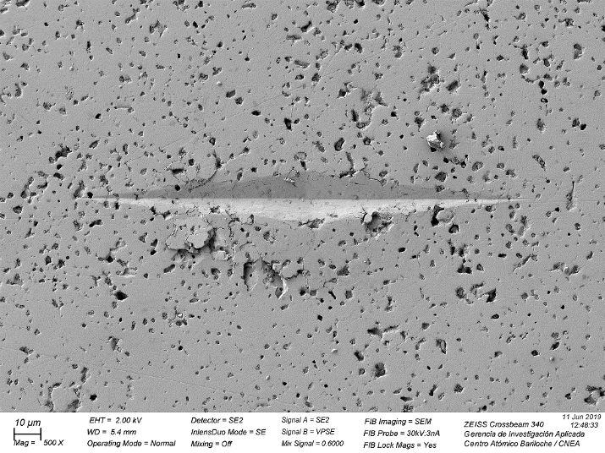
- Knoop indentation on pellet #9 from the AUC route, sintered at 1300 °C.
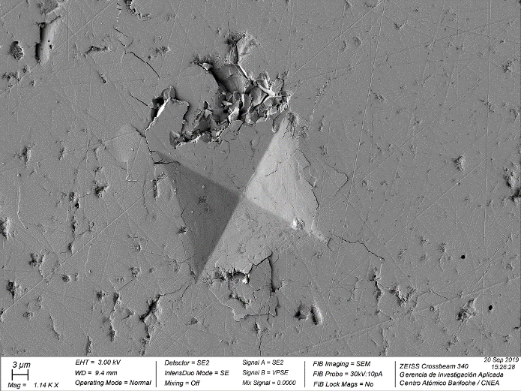
- Vickers indentation of pellet #7 from the ADU route, sintered at 1300 °C.
Figure 7 shows the high porosity zone in pellet #2 from the ADU route at 1200 °C that was shown in Figure 3 with the lowest hardness value. Small grains close to 1 µm in size can be observed.
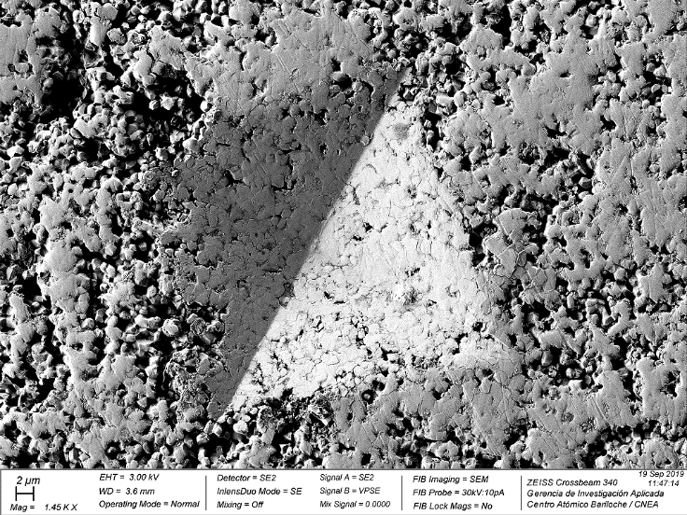
- Vickers microhardness indentation in high porosity zone in pellet #2 from ADU route.
The study of mechanical properties of these uranium oxides for future waste forms allows us to estimate the long term behaviour of these matrices. To complete the feasibility studies of the material, fracture toughness, chemical durability (leaching) and radiation damage (ion irradiation and self-irradiation) tests will be required.

Conclusions AND OUTLOOK
- Microhardness tests by Vickers and Knoop indenters were performed in order to characterize the hardness of the material.
- The global HV/HK ratio for both types of samples was 1.14 and for each oxide synthesis route was 1.15; these results are consistent with the reported value [8] for hard materials.
- In the pellets sintered at 1100 °C, areas of high porosity and smaller grain size were found. As expected, in these areas the hardness was considerably lower than in the rest of the matrix.
- The silicon contaminant found in the matrix by EDS analysis could come from the agate mill. The hardness of that area was considerably higher than the matrix of uranium oxide.
- For future analysis, we are going to obtain the hardness to modulus ratio (H/E) of elastic-plastic materials, and the Fracture toughness analysis from the crack formation generated in the corner of the Vickers indentation.
- In the future the chemical durability of the uranium oxide matrix will be studied, in addition, it will start with the treatment by mechanical (chopping), thermal (calcination) and grinding/milling of a natural U₃Si₂-Al fuel plate to add to the uranium oxide matrix.
Acknowledgment
To the co-authors of this research work, Abel Magnone, Carolina Ayala, Fernando Becker, Michele Sanfilippo and Diego Russo from the National Atomic Energy Commission (CNEA). The National Radioactive Waste Management Program (PNGRR), and the Nuclear Materials Department (DMN-CAB-CNEA). To Mr Bernardo Pentke from Materials Physicochemistry Department (CAB-CNEA) for the SEM images.
References
- SEVENTH NATIONAL REPORT. Joint Convention on the safety of spent fuel management and on the safety of radioactive waste management. (2020). https://www.argentina.gob.ar/sites/default/files/7_seventh-national-report.pdf.
- AUDERO M.A., BEVILACQUA A.M., MEHLICH A.M. and NOVARA O. “Research reactor Spent Fuel Management in Argentina”. International Meeting on Reduced Enrichment for Research and Test Reactors. (2002). Bariloche, Argentina.
- IAEA-TECDOC-1508, Vienna. (2006).
- RUSSO D. O., RODRIGUEZ D. S., MATEOS P., HEREDIA A., SANFILIPPO M., STERBA M. “Acondicionamiento de combustibles gastados de reactores nucleares de investigación en matrices cerámicas”. Conamet/SAM- Simposio Materia. (2002). Santiago, Chile.
- CHAVEZ, A.A., MAGNONE A., GANA WATKINS I.A. and RUSSO D.O. “Óxidos de Uranio como matriz de inmovilización de CGRI: Estudio de propiedades de U3O8”. XLIV Reunión anual de AATN. (2017). Buenos Aires, Argentina.
- CHAVEZ, A.A., MAGNONE A., GANA WATKINS I.A. and RUSSO D.O. “Sintering behavior of Uranium octoxide matrix for MTR spent fuel immobilization treatments”. International Youth Nuclear Congress-Women in Nuclear 18. (2018). San Carlos de Bariloche, Argentina.
- ASTM E384-17. Standard Test Method for Microindentation Hardness of Materials.
- GHORBAL, G.B., TRICOTEAUX, A., THUAULT, A., LOUIS, G., CHICOT, D. “Comparison of conventional Knoop and Vickers hardness of ceramic materials”. J. Eur. Ceram. Soc., 37 (2017), pp. 2531-2535.
- SIVOV, R., NOVIKOV, V., MIKHEEV, E., & FEDOTOV, A. “Fracture toughness of WWER Uranium dioxide fuel pellets with various grain size”. In Mitev, M. (Ed.). 11 International conference on WWER fuel performance, modelling and experimental support Proceedings, (2015). Bulgaria: Institute for Nuclear Research and Nuclear Energy.

