PILOT-INDUSTRIAL CONDITIONING
OF SPENT ION EXCHANGE RESINS

E.E. OSTASHKINA
RADON FSUE
Moscow, Russia
e-mail: EEOstashkina@radon.ru

A.E. SAVKIN, PhD
RADON FSUE
Moscow, Russia
e-mail: AESavkin@radon.ru

YU.T. SLASTENNIKOV
RADON FSUE
Moscow, Russia
e-mail: YTSlastennicov@radon.ru

ABSTRACT

In order to solve the problem of handling the accumulated ion exchange resins of Russian NPPs, the FSUE "RADON" carried out a comparative study of various methods of their processing. Based on the results of laboratory tests and assessment according to regulatory and technological criteria, a choice was made in favor of including ion exchange resins in a polymer binder. Pilot-industrial tests of this method have shown the efficiency of the technology and compliance of the resulting product with regulatory requirements.

- INTRODUCTION

During processing of liquid radioactive waste (LRW) at the nuclear engineering objects, concentrates (high salt LRW) and spent filter materials are generated, the main of which are ion exchange resins (IER). Free volumes for their storage at all facilities in Russia are practically exhausted. As a result of operation, about 30 thousand m³ of IER were accumulated at Russian NPPs with a total volume of accumulated LRW of 90 thousand m³. Large quantities of IER have also been accumulated at the enterprises of Atomflot FSUE.
Significant part of IER in the total amount of accumulated LRW excludes the possibility of their joint processing. For processing of IER, it is necessary to create specialized plants. There are currently no industrial plants for IER processing in Russia.
Rosenergoatom Concern JSC made a decision to use three IER conditioning technologies for Russian NPPs. It is proposed to use pyrolysis at the Kursk NPP for conditioning of accumulated IER, at the Balakovo and Beloyarsk NPP - drying, at the Kalinin NPP - dehydration and inclusion in a polymer binder.
Tests of various methods of processing and conditioning of radioactive spent IER, used in global practice, were carried out at RADON FSUE [1]. Among them, destructive methods (pyrolysis, peroxide oxidation, supercritical water oxidation) and non-destructive methods (drying, dehydration, inclusion in matrix materials) have been tested. Comparison of various technologies was carried out according to the following criteria: compliance with the requirements of regulatory documents, specific activity of IER and an availability of certified packaging, plant capacity.
The IER handling cost was estimated according to the technologies corresponding to the selected evaluation criteria. Minimum handling costs are common to dehydration and inclusion in the polymer binder [2, 3]. Therefore, further work was aimed at testing this IER conditioning technology on an experimental and industrial scale.

- EXPERIMENTAL PART

At the initial stage, experiments were carried out in laboratory conditions using three IER conditioning technologies:
- drying;
- pyrolysis
- dehydration and inclusion in the polymer binder.
In order to study the drying process, a column-type dryer with an inner diameter of 50 mm and a height of 350 mm was used, equipped with technical holes for the input and output of the drying agent (air), as well as for pressure differential control.
IER pyrolysis was carried out in a muffle furnace at 600 °C, heating time - 0.5 hour, holding time - 1 hour. An IER sample weighing about 60 g was placed in a crucible and covered with a lid. Crucible with the IER sample was placed in a cold furnace and heat treated. The IER of the Kursk NPP was used in the experiments.
In order to dehydrate the IER, a vacuum treatment method was used. Dehydrated IER (wet, without free liquid) was loaded into a column with a diameter of 20 - 50 mm and a height of up to 1.1 m. The column was equipped with two partitions at the top and bottom. The partitions were permeable to water, air and polymer binder and impermeable to IER. Experiments on impregnation of dehydrated IER were carried out with the help of the plant, including a polymer binder tank, a pump, a pressure gauge, a column filled with IER, a receiving tank and pipelines. A mixture of epoxy resin and hardener was used as a polymer binder.
As a result of the IER conditioning by the methods listed above, the following final products were obtained:
- uncured samples (IER after drying, product of IER pyrolysis);
- cured samples (polymer compound based on IER).
Conducted experiments indicate the following disadvantages of the drying process:
- low productivity;
- low water resistance of dry resin; the leach rate of ¹³⁷Cs from dry IER of the Kursk NPP in sodium chloride solution (5 g / l) simulating groundwater on the 28th day amounted to - 2.6 ∙ 10⁻² g / cm² ∙ day,
- if water gets into a package with a dried IER through leaks, swelling of the IER and integrity failure of the package integrity is possible, which contradicts the requirements of normative documents. For IER with a moisture content of 20 wt. %, the swelling pressure amounted to 0.57 MPa, and for IER with a moisture content of 7 wt. % - 1.56 MPa. None of the known containers can withstand such swelling pressure.
Conducted experiments indicate the following disadvantages of the pyrolysis process:
- increase in the volume of the final product;
- the need to process the final product in order to reduce the volume;
- carryover of radionuclides; carryover of ¹³⁷Cs ranged from 3 to 5%;
- low water resistance of the IER pyrolysis product; the leach rate of ¹³⁷Cs in a sodium chloride solution simulating groundwater on the 28th day amounted to - 1.2 ∙ 10⁻² g / cm² ∙ day;
- generation of the secondary liquid radioactive waste;
- high specific activity of the IER pyrolysis product, which imposes additional requirements on the disposal container.
Conducted studies have shown that dehydration and inclusion of IER into a polymer binder has a number of advantages over drying and pyrolysis of IER:
- lack of swelling of the final product in contact with water;
- high water resistance; the leach rate of ¹³⁷Cs in a sodium chloride solution simulating groundwater on the 28th day was - 1.2 ∙ 10⁻⁴ g / cm² ∙ day.
- absence of secondary liquid radioactive waste;
- the need for additional operations for the IER conditioning is eliminated;
- possibility of creating a plant with a higher capacity in comparison with the thermal processes;
- compliance of the final product with all the requirements of NP-019-15 [4].
Therefore, the technology of dehydration and incorporation of IER into a polymer binder was chosen for the experimental and industrial tests.
In 2019, RADON FSUE developed and manufactured a pilot-industrial plant for IER conditioning directly in the container for disposal by the method of dehydration and inclusion in a polymer binder.
This project is aimed at creating a mobile plant for the IER processing and conditioning at various nuclear power facilities with a capacity up to 800 m³ / year.
Plant in the form of separate units is transported by special transport to the Customer's facilities, assembled at the site, connected to the utility networks, the IER are conditioned, and the containers for temporary storage are placed with subsequent transfer to the National Operator.
The pilot-industrial plant is designed for IER conditioning with obtainment of packages based on containers of the KMZ type, which are used at the IER specific activity up to 10⁷ Bq / kg, and NZK-150-1.5P containers with a metal insert, which are used at the IER specific activity up to 10⁸ Bq / kg.
Design of the insert for NZK-150-1.5P differs from the design of the KMZ-type container only by overall dimensions and is characterized by presence of a pipe mixer of a polymer binder and two mesh partitions in the bottom and top, permeable to air and water and impermeable to IER.
External appearance of the plant, its main components and systems are presented below.

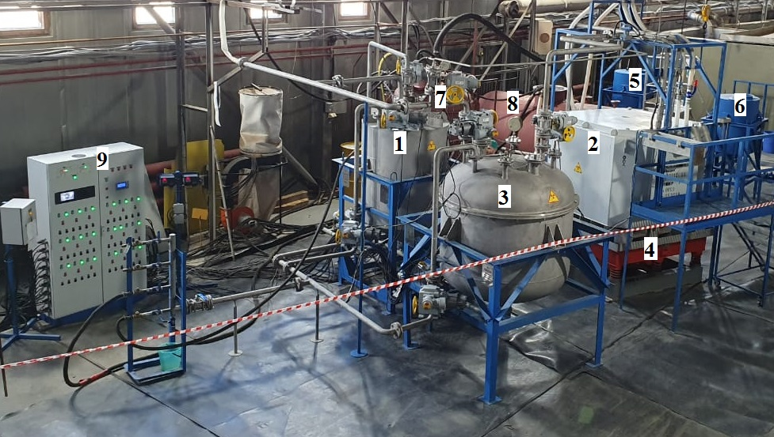 | 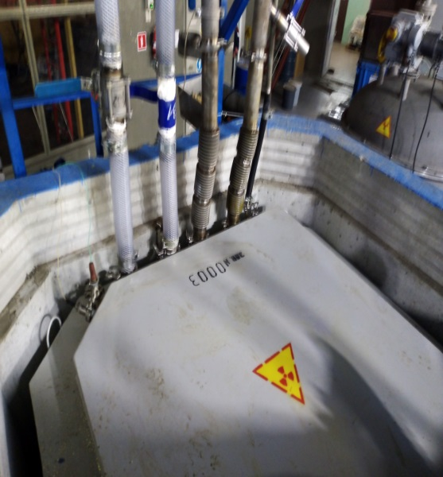
a) | b)
FIG. 1. a - general view of the pilot-industrial plant
1 - batcher, 2 - container, 3 - air lift, 4 - vibrating table, 5 - container for epoxy resin, 6 - container for hardener, 7 - air lift, 8 - receiving container for IER, 9 - control desk
b - NZK container with an insert

Control system allows to monitor the process and determine levels and pressures in the machines, visual monitoring of the pulp thickening and the absence of the container's leaks using tv cameras, remote opening / closing of valves, switching on of pumps and regulating their performance.
Presence of interlocks excludes overfilling of machines of the plant, as well as overpressure in them.
Each piece of equipment is provided with a supply of technical water and a disinfectant solution for decontamination of internal surfaces, as well as removal of the spent solutions into a radioactive drain system. All emission sources are connected to a dirty blow-off.
Tests of the plant were carried out on a spent IER from the radioactive water treatment system of RADON FSUE. Specific activity of the IER amounted to 2∙10⁶ Bq / kg, the main radionuclides: ¹³⁷Cs and ⁶⁰Со.
After completion of the commissioning work, the IER were processed using a pilot-industrial plant. During processing, 7.5 m³ of IER were conditioned in one container of the KMZ type and two NZK-150-1.5P containers with an insert. Capacity of the plant for dewatering amounted to 1 m³ / hour, and for dewatering and impregnation - 0.5 m³ / hour.
Upon completion of conditioning, samples of the polymer compound were taken from containers in order to determine quality indicators in accordance with NP-019-15 [4].
Calculated content of IER in the polymer compound for three containers ranged from 58 to 65 wt. %.
Content of free liquid in the IER samples from containers was less than 1 wt. %. In accordance with the requirements of NP-093-14 [5], this indicator shall not exceed 3% of the weight of radioactive content of the RW package.
Water resistance (leach rate) of the polymer compound samples for ¹³⁷Cs radionuclide on the 28th day amounted to 4.21 ∙ 10⁻⁵ g / cm² ∙ day. NP-019-15 requirements for this parameter are in the range from 1 ⋅ 10⁻² to 1 ⋅ 10⁻³ g / cm² ∙ day.
Tests of polymer compound samples for heat resistance showed that after holding at a temperature of 100 ° C for three days, their structure does not change, and the leach rate on the 28th day amounted to 2.21 10⁻⁵ g / cm² day. NP-019-15 requirements for heat resistance - no changes in structure and water resistance as a result of storage at the temperatures from 0° C to 100°C.
Average value of the compressive strength for five samples amounted to 22 MPa. There are no requirements of NP-019-15 for strength of the polymer compound. In comparison with the cement compound, the strength requirements for which are 4.9 MPa, this indicator for the polymer compound significantly exceeds normative values.
In order to determine radiation resistance, the samples were exposed to gamma irradiation at a dose of 10⁴ and 10⁶ Gy, after which the leach rate of the ¹³⁷Cs radionuclide from them was determined. The leach rate on day 28 in both cases ranged from 1 ∙ 10⁻⁵ to 1 ∙ 10⁻⁶ g / cm² ∙ day.

CONCLUSIONS

Based on the results of laboratory experiments on conditioning IER using drying, pyrolysis, dehydration and inclusion into a polymer binder, conclusions were drawn about the advantage of the latter method. Pilot tests of this method using of the pilot-industrial plant for IER by RADON FSUE showed that as a result of conditioning, a product was obtained that meets all requirements of NP-019-15.
After certification of containers and licensing, the plant may be recommended for use at the enterprises of Rosatom State Corporation for conditioning of the accumulated spent IER.

REFERENCES

- Application of ion exchange processes for the treatment of radioactive waste and management of spent ion exchangers: Technical reports series no. 408, IAEA, Vienna, 2002.- P. 115.
- SAVKIN A.E., OSTASHKINA E.E., PAVLOVA G.YU., KARLINA O.K. Experimental processing of spent ion-exchange resins // VANT, series: Materials science and new materials - 2016. - No. 3 (86). -pp. 40 - 49.
- A.E. SAVKIN, O.K. KARLINA. Development of conditioning technology for spent ion-exchange resins // "Radioactive waste". Scientific and technical magazine, No. 1 (2), 2018, pp. 54 - 61.
- Federal norms and rules in the area of atomic energy use “Collection, processing, storage and conditioning of liquid radioactive waste. Safety requirements": NP-019-15: approved by Federal Environmental, Industrial and Nuclear Supervision Service on 25.06.2015.
- Federal norms and rules in the area of atomic energy use "Criteria for Accepting Radioactive Waste for Disposal": NP-093-14: approved by Federal Environmental, Industrial and Nuclear Supervision Service on 15.12.2014.

