STRATEGIES FOR THE MANAGEMENT OF

GRAPHITE WASTE ARISING FROM THE

DECOMMISSIONING OF UNGG REACTORS

M.J. TAYLOR & P.LEFEVRE
Cyclife SAS & EDF S.A
Lyon, France
Email: michael.taylor@cyclife-edf.fr

N. VIDARD & C. ANDRES
Graphitech
Lyon, France

Abstract

The decommissioning of UNGG (“Uranium Naturel Graphite Gaz” or “Natural Uranium Gas Graphite” in English) reactors inevitably creates the issue of managing the arising irradiated graphite, both from the reactor pile and from the sleeves surrounding the fuel elements. The irradiated graphite is considered as a long lived low level waste in France and is not contact handle able. In France, EDF (Electricité de France) is responsible for the decommissioning of six UNGG reactors and as such EDF, along with its subsidiaries of Cyclife and Graphitech are developing innovative ways of managing the irradiated graphite that has arisen and will arise in the future from the decommissioning programme. EDF currently has three major projects underway relating to the management of graphite waste:
- The retrieval of graphite sleeves currently stored in a silo at the Saint Laurent des Eaux A UNGG site using remote handling techniques to retrieve, package and transfer graphite sleeves from an inaccessible area;
- The optimisation of the scenario for the graphite structures retrieval in line with the waste transfer route for graphite arising from the dismantling of the reactor pile of the Chinon A2 UNGG reactor. This has been done using digital tools developed specifically for the nuclear decommissioning industry. This has demonstrated a possible net increase in the number of packages that could be able to be evacuated from the work face each day, and which could become necessary as a result of the scenario optimisation and to face better production rates;
- EDF is constructing a Graphite Reactor Dismantling demonstrator that will be used to de-risk the UNGG decommissioning programme. A part of this will be dedicated to the cutting and removal of graphite bricks and keys from the reactor pile and how to size the resulting waste to optimise waste packing factors.

The paper will summarise each of the projects and highlight the principal strategic approaches to managing the graphite arising from UNGG reactor decommissioning and how these approaches may be implemented by graphite reactor decommissioning projects outside of France.

INTRODUCTION
Through more than fifteen years of experience, Electricité de France (EDF), along with its subsidiaries Cyclife and Graphitech, has developed innovative and efficient strategies to manage existing and future graphite waste arising from its decommissioning programme. EDF is responsible for the decommissioning of six Uranium Naturel Graphite Gaz (UNGG) reactors in France which can be seen on the map below in Fig 1. In addition to these sites already in the process of decommissioning, EDF’s UK subsidiary, EDF in the UK, is currently responsible for operating fourteen Advanced Gas Cooled Reactors (AGR) which are due to be progressively brought offline and enter into decommissioning between 2023 and 2032. For this reason the subject of managing the graphite waste arising from decommissioning is of upmost importance to EDF.
Chinon
St Laurent
Bugey
UNGG Reactor Unit
FIG. 1. Map showing the EDF UNGG units under decommissioning in France

Currently, in conjunction with its dedicated decommissioning and waste management subsidiaries Cyclife and Graphitech, EDF is managing three key projects which, combined, will determine the strategy for the management of graphite arising from the UNGG decommissioning programme. The first is the retrieval of graphite sleeves from the silos at the Saint Laurent des Eaux site. Graphitech is developing bespoke remote handling tools to remove the sleeves for storage in a future purpose built facility. The development of these tools is closely linked to the development underway for the dismantling of the reactor vessel at the Chinon site. The Chinon A2 reactor will be the lead and learn site for the UNGG reactor vessel dismantling programme and Graphitech are leading the way on developing the tools and scenario for this project.

Along with the development of technologies and tools deployment systems for the dismantling of the Chinon A2 reactor vessel, Graphitech and Cyclife Digital Solutions are optimising the dismantling scenario to align the scenario with the optimal waste route for the retrieved graphite waste. By employing innovative digital tools and previous company experience from smaller reactor decommissioning projects (such as WAGR in the UK and Brookhaven in the USA), the team has identified optimisations resulting in the reduction of the risks of delays due to breaks, blocking of tools or due to other unforeseen events. The optimisations have also led to net efficiency gains by increasing the number of packages that can be evacuated from the workface per day.

Finally, in order to de-risk the Chinon A2 reactor vessel dismantling project, and to qualify the tools and test the scenarios developed by Graphitech and Cyclife, EDF is constructing the Graphite Reactor Dismantling Demonstrator. The building, which will be commissioned in early 2022, will house mock ups of various reactor components to be able to test the tools developed by Graphitech and the scenarios envisaged for the reactor core dismantling at Chinon A2. The demonstrator will also allow EDF and Graphitech to test and qualify tools for other projects such as the removal of the graphite sleeves from the silos at the Saint Laurent des Eaux A site.

These three key projects, taken in combination, demonstrate EDF’s innovative approach to the management of graphite waste arising from their decommissioning programme. The methods and tools developed will also be transferable to other nuclear operators who have graphite moderated reactors to dismantle.

Retrieval of graphite sleeves from the saint laurent des eaux silos
Within the boundaries of the Saint Laurent des Eaux A UNGG site are two silos constructed in the early 1970’s. The silos have been used to temporarily store operational waste from the two Saint Laurent A reactors, mostly graphite sleeves which formed part of the fuel assemblies used during the operation of the plant and some graphite logs. Other waste stored in the silos include some steel drums containing stainless steel saddle wires, which were originally attached to the graphite sleeves, and small quantities of miscellaneous secondary operational wastes (gloves, …). Overall, the silos were operated from 1971 to 1994, at which date EDF proceeded to the last operational waste loading. The silos have since been under surveillance.

Since the silos have been filled, the regulatory requirements have evolved (seismic qualification etc.). In the absence of a suitable repository for the graphite, EDF has therefore decided to construct a new dedicated interim store for the graphite sleeves and to retrieve the sleeves from their current location. The retrieval presents several challenges:

- The installation of the retrieval facility should not impair the structural integrity of the silos;
- Access into the silos is limited;
- The graphite sleeves are not uniformly stored in the silos;
- The sleeves are not contact handle able;
- Space on site for the construction of the new store is limited and the sleeves therefore need to be size-reduced to improve waste packaging.

In order to overcome these challenges, Graphitech is designing

- Remote tooling that will be able to enter into the silos and retrieve the sleeves;
- A retrieval facility, that will enable the deployment of the remote tooling into the silos and its maintenance as shown in Fig 2 below;
- A waste processing facility, for the size reduction of the graphite sleeves and packaging of the waste into suitable storage containers;
- Remote tooling that will enable the segregation of steel drums and secondary wastes from the mainstream graphite.

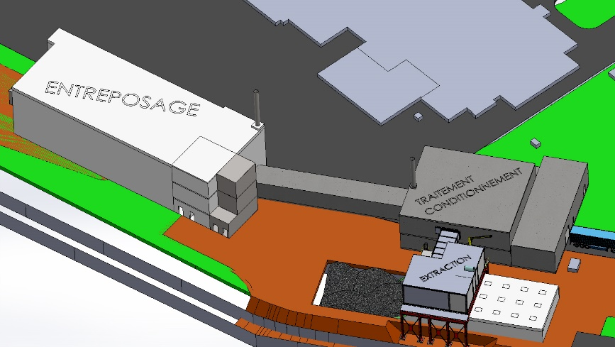
Conditioning & Treatment
Storage
FIG. 2. Representation of the facilities required for extracting the graphite sleeves from the silos

In a similar way to the de-risking strategy implemented by EDF for the dismantling of the Chinon A2 reactor, the intention is that Graphitech will be qualifying and testing the remote tooling and key plant items in the Graphite Reactor Dismantling Demonstrator being built at Chinon.

Optimisation of the Chinon A2 dismantling scenario
EDF’s decommissioning strategy for its UNGG reactor fleet is prompt dismantling, using Chinon A2 as the lead and learn site. The lessons learned and the experience gained from decommissioning the Chinon A2 reactor will be integrated into the decommissioning programme for the five remaining units in France and will also help other operators with a need to dismantle graphite reactors elsewhere in the world.

An original scenario was developed for the Chinon A2 reactor between 2013 and 2015, however, since then Graphitech has proposed different optimisations related to the dismantling tools deployment systems, the above reactor concrete slab opening and related to the dismantling tools themselves. Graphitech is currently designing the tools deployment system, the first mock-up including graphite bricks and keys and the first dismantling tools. Graphitech along with Cyclife Digital Solutions have been developing optimisations using innovative methods such as the DEMplus® for nuclear software.

DEMplus® for nuclear, a 3D digital software developed by Cyclife Digital Solutions, has been applied by different companies in France and around the world over the last few years. It is a decision-making support tool which responds to working challenges in the nuclear environment and assists leading engineering companies to define operational strategies. [1]

The software is based on a global approach (it considers a large set of parameters to compute duration, costs, dose uptake and waste in a global method) that permits the development of an as low as reasonably achievable / practicable (ALARA/ALARP) methodology. This all-in-one feature enables improved safety, waste management, reduced doses for workers, shorter interventions, and lower overall costs. [1]

It appears that the use of 3D digital tools gives rise to a better management of data, the detection of discrepancies, and helps the stakeholders to design scenarios precisely thanks to accurate output data. All of these benefits lead to better assumptions that improve, in the first instance, the risks and safety management; then finally result in reduced costs and more accurate schedules. [1]
For the Chinon A2 project, Graphitech must provide a detailed reactor dismantling scenario and the design of specific tools and equipment that will be tested in EDF’s reactor dismantling demonstrator facility near the Chinon site. Moreover, digital methods will allow the implementation of dismantling tools inside the reactor’s environment.

The dismantling of the Chinon A2 reactor is divided into 8 phases presented in Fig 3 below.

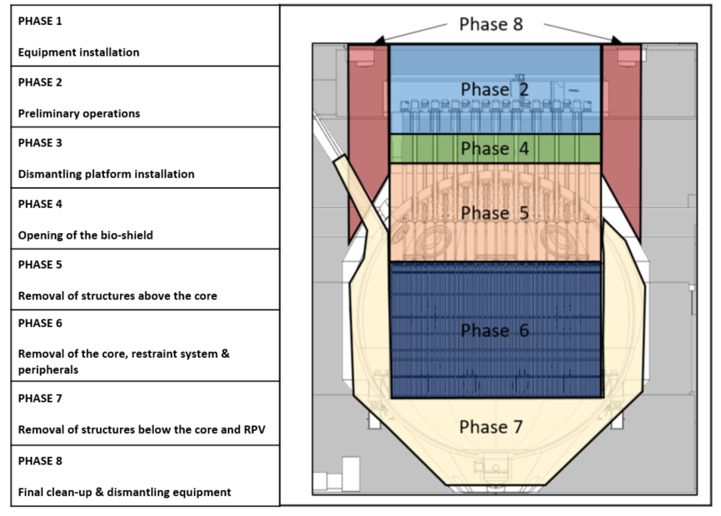
FIG. 3. Chinon A2 Decommissioning Project Phasing [1]

As described previously, to develop an optimised dismantling scenario, Graphitech has decided to use DEMplus® for nuclear software. The Chinon A2 Reactor Pressure Vessel digital mock-ups imported into DEMplus® enables the modelling of the baseline scenario (as shown in Fig 4 below) and later will allow the analysis and comparison of alternative dismantling scenarios.

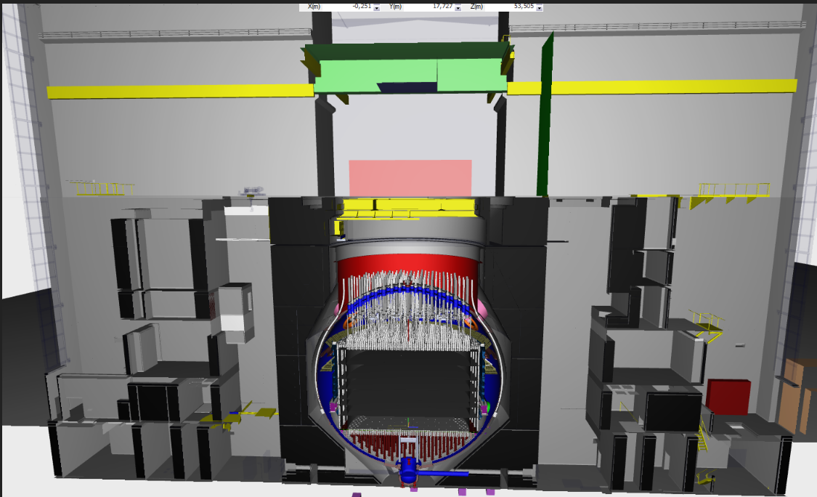
FIG. 4. Chinon A2 and Dismantling Equipment BIM in DEMplus® [1]

In 2019 the first test was carried out using DEMplus® for a relevant case study. To validate the test, different critical parts of the Chinon A2 baseline dismantling scenario had been modelled. The main objective was to obtain a feedback of DEMplus® to have enough elements to validate this tool for the next steps of the project as well as for the future decommissioning projects.

At the present time, several tasks are being carried out to develop the entire reactor dismantling scenario for Chinon A2 using DEMplus®:

- Digital mock-ups of the building, reactor and dismantling systems have been imported and modified to obtain the digital mock-up presented in Fig 3;
- From this digital mock-up, the inventory has been linked to all of the Chinon A2 reactor parts which are dismantled during the Chinon A2 decommissioning project (Fig 3). The missing data are clearly identified on the Chinon A2 BIM inventory and later, investigations should be done to determine these data;
- Operational conditions have been defined for all of the decommissioning project phases (Fig 3), as teams involved in the tasks, work organisation, work suits, dose rates at the working position, etc.;
- Duration calculation models (dismantling systems installation, operational time, equipment withdrawal) and maintenance;
- Operators’ radiation exposure models during every operation and tools/robot’s maintenance;
- Radioactive waste management routes have been modelled for all operations and the exposure after conditioning.

Thanks to these tasks, the baseline scenario is being modelled by both teams involved.

One recent optimisation, which was developed and verified through the use of numerical tools, was to improve the efficiency of the waste transfer route for graphite and other metallic structures arising from the decommissioning of the Chinon A2 reactor core. A simulation, modelled using Flexsim, of the waste kinematics from this operation can be seen in Fig 5 below.

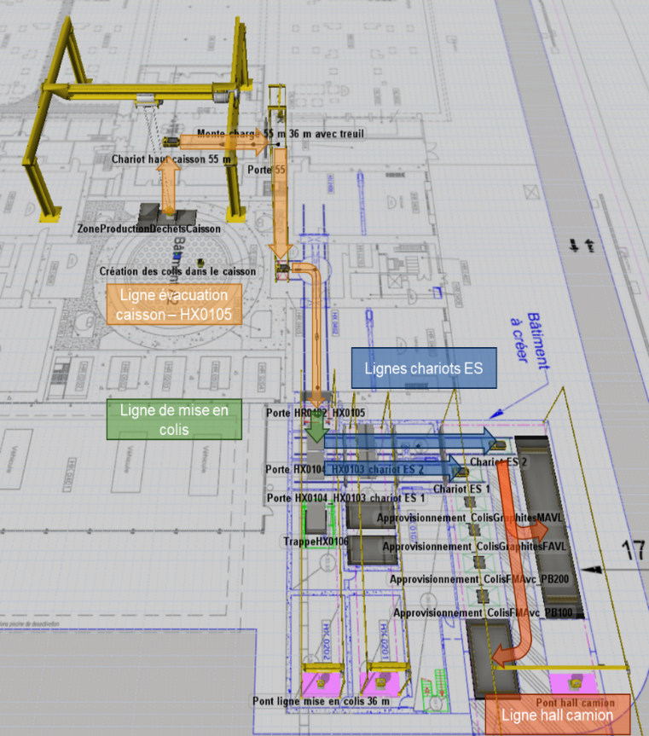
FIG. 5. Simulation of the waste kinematics from the Chinon A2 reactor core dismantling

The aim of this simulation was to:

- Simulate the waste logistics from the reactor vessel up to the transport bay;
- Estimate the evacuation time of the waste packages and baskets according to the planned kinematics;
- Propose improvement paths (technical and organisational) to optimise the evacuation rate;
- Indicate complementary investigations that could be performed for the consolidation of results and data.

This kind of simulation tool is essential because all of the interactions between the human resources and the assets and the physical environment makes standard tools impossible to use.

For example, the containment rule in the nuclear industry which places constraints on the opening and closing of doors. Due to ventilation capabilities and air contamination confinement, doors cannot be opened simultaneously along the waste path.

These rules and constrains can be simulated and take into account the opening and closing time of these doors. The simulation model is then composed of all of these rules of interaction with the performance of the tools and the processing capacities of each workstation (cutting, transport and measurement and verification time), and so on. From this model, the simulation of waste flows can be carried out and the first results will give a global view of the real facility processing capacity in an ideal case.

By modifying specific values, such as the travel speed of an overhead crane, the simulation software can assess and quantify the impact this would have on the plant's throughput.

For this project, by changing working assumptions on tool performance rates etc. the waste evacuation rate capacity was optimised by more than double from two packages evacuated per day to five packages per day.

On the other hand, by running perturbations (e.g. non-conforming waste packages) the impact on the optimised scenario was to half the waste evacuation rate capacity from five packages evacuated per day to two packages per day.
These results are useful because they allow the estimated evacuation time of the waste packages and baskets, according to the planned kinematics, to be validated

It is also possible to simulate another degraded operating mode, i.e. consider a crane failure and see the impact as well. This type of result allows for the definition of maintenance strategies (e.g. preventative versus curative).

development of the Graphite reactor Dismantling demonstrator
In order to qualify the new and innovative tooling in development by Graphitech, and to test and de-risk the dismantling scenario for the Chinon A2 reactor, EDF is in the final stages of constructing and commissioning a Graphite Reactor Dismantling Demonstrator near the Chinon site.

The numerous risks listed in the dismantling safety case associated with the complexity of the decommissioning processes for Graphite reactors are mainly due to their dimensions, the compactness and presence of graphite

The Graphite Reactor Dismantling Demonstrator has been designed in order to demonstrate and optimise the tooling and methodologies for this reactor technology. A design drawing for the demonstrator can be seen in Fig 6 below.
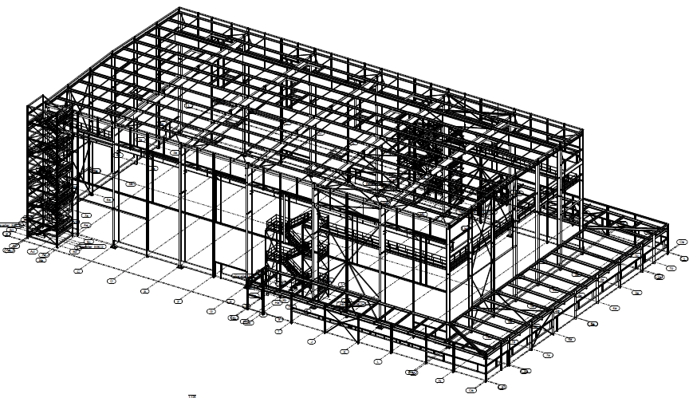
FIG. 6. Design Drawing of the Graphite Reactor Dismantling Demonstrator

The facility is mainly composed of a large test hall which is 70m long, 35m wide and 20m high. This facility will allow physical tests on mock-ups: remote cutting and handling of thick metallic structures, graphite blocks, concrete, etc.

To feed the needs in digital simulation, 3D scenario design and digital calculations, the facility also hosts a digital room and offices.

The Demonstrator will participate in:
- Demonstrating the dismantling scenario feasibility (normal configuration, degraded modes);
- Qualifying the dismantling processes and optimising their performance and limits;
- Optimising the dismantling scenario by testing alternative (and innovative) technologies;
- Optimising the design and the performance of the main dismantling tool which is the dismantling platform;
- Accumulating data in order to increase and validate the numerical 3D models;
- Personnel Training, as close as possible to dismantling activities;
- Back up operations in the event of a hazard during operations (rear base).

Fig 7 below shows the evolution of the construction project for the Graphite Reactor Dismantling Demonstrator from the beginnings through to May 2021.

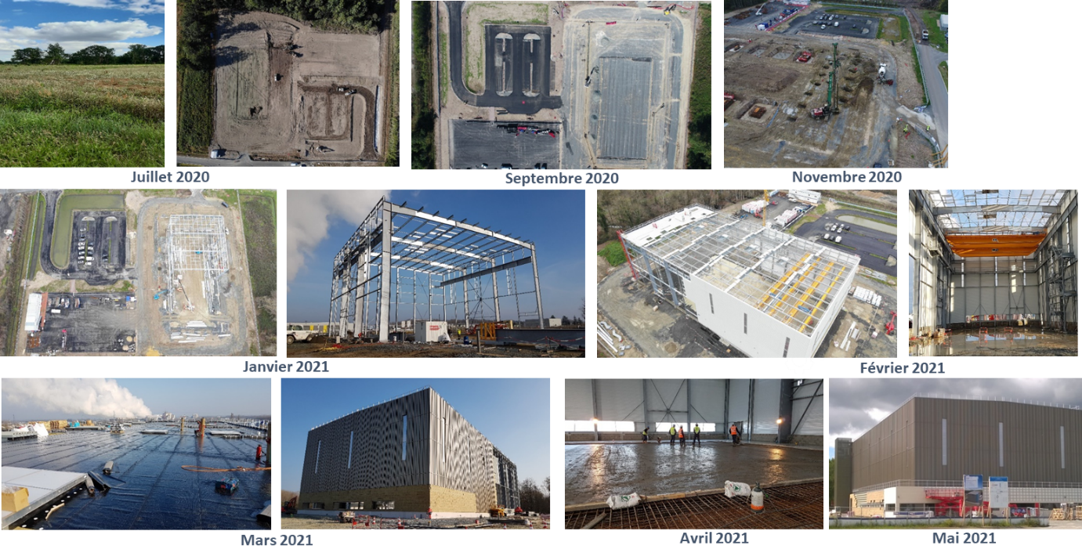
FIG. 7. Evolution of the construction of the Graphite Reactor Dismantling Demonstrator

The Demonstrator will be commissioned in early 2022, and the first tests on mock-ups will take place by mid-2022.

Conclusion
EDF is developing various innovations to allow it to confront the challenge of prompt dismantling its UNGG reactor fleet. The tools, processes, scenarios and optimisations being developed and tested in 2021, and in the following years, will also be of service to the international community. There are many graphite reactors in continental Europe, particularly in the United Kingdom, which bear several similarities to the EDF UNGG fleet. By investing in significant engineering and expertise, through dedicated companies such as Graphitech, EDF is paving the way for Graphite operators worldwide to optimise their strategy for the management of graphite arising from the decommissioning of gas cooled graphite moderated reactors.

ACKNOWLEDGEMENTS
The authors would like to thank their respective organisations for their cooperation in producing this paper and for the use of the information and images contained herein.

Particular thanks go to Mathieu Noe from Cyclife Digital Solutions who contributed heavily to the creation of this paper.
References
- L. Ardellier et al., 3D Simulation of complex D&D Projects Use Case: Chinon A2 dismantling project, 2021

