One step low temperature thermochemical

process in air at atmospheric pressure

to denitrate a simulated HLLW without or

with addition of an aluminoborosilicate

glass powder

A. FERNANDEZ ZUVICH
Comisión Nacional de Energía Atómica
San Carlos de Bariloche, Río Negro, Argentina
Email: afz@cab.cnea.gov.ar

S.G. PÉREZ FORNELLS
Comisión Nacional de Energía Atómica
San Carlos de Bariloche, Río Negro, Argentina

A.M. BEVILACQUA
Comisión Nacional de Energía Atómica
San Carlos de Bariloche, Río Negro, Argentina

Abstract

A novel method published as patent WO2021019319, was applied to denitrate a 3 M nitric acid stream of uranium, lanthanides, metals and non-metals which simulates the high level liquid waste (sHLLW) arising from heavy water reactor (HWR) spent fuel reprocessing. The tests were performed adding 50 wt.% of the German SG7 aluminoborosilicate glass powder to the sHLLW in order to denitrate the mixture for obtaining the simulated high level waste (sHLW) form material. Denitration takes place in just one step by thermally treating the nitric steam without or with added glass powder in air at atmospheric pressure and temperatures between 185°C and 230°C to obtain a nanoparticulated loose dry ash which presents a homogeneous elemental distribution of simulated high level waste and aluminoborosilicate glass components. Results to be reported include scanning and transmission electron microscopy, energy dispersive spectroscopy and X-ray diffraction.

INTRODUCTION
Radioactive waste streams from the reprocessing of spent fuel from nuclear reactors must be conditioned prior to storage and disposal. In the literature, actinide conversion routes can be categorised into three mayor families: precipitations, sol-gel and denitration routes. Precipitation processes have filterability difficulties and produce effluents that are difficult to manage [1-6]. Denitration processes are generally used to obtain actinide oxides from nitrates so as to prepared nuclear fuel pellets and also to treat radioactive waste streams from spent fuel reprocessing. One of the most common denitration method consists of drying the solution followed by cooling at temperatures above 500°C for several hours to produce a solid material [2, 7]. The drying step can be carried out in an oven, microwave oven, freeze drying system, etc. followed by a heat treatment usually carried out in muffles, rotary kilns, microwave ovens [8, 9], by pyrolysis [10] or flame [11], in sealed containers [12], etc. These thermal treatments, however, may cause volatilization of low vapour pressure radioactive species carrying technetium and ruthenium, among others. Also, when uranium is denitrated from uranyl nitrate, it is converted to the U₃O₈ or UO₃ phase, which must be converted to the UO₂ phase (required to manufacture fuel pellets) by a subsequent reduction treatment [2]. Other denitration processes to prepare nuclear fuels use fluidized bed systems [13-15].
Also, methods called “radiation chemical synthesis” produce the reduction of U(VI) to U(IV) with the consequent coalescence and precipitation of uranium dioxide nanoparticles, from reducing or oxidizing agents obtained by exposing a precursor solvent to ionizing radiation [16]. Depleted UO₂ nanoparticles were obtained through gamma irradiation for at least 7 days from an acidic uranyl nitrate solution with a ⁶⁰Co source. The reported product still contains a mixture of nanoparticles of uranium dioxide and uranyl nitrate remaining in solution [17].
Alternatively, partial chemical denitrations with formaldehyde, formic acid and sugar at around 100°C, followed by calcination above 400°C to decompose residual nitrates, have been implemented to treat simulated and actual high level waste streams on a laboratory and industrial scale since 1980 [18-22].
The paper presents a novel method of synthesis [23], in which the process temperature does not exceed 230°C and the treatment time is shorter than 2 hours. The process features not only prevent the volatilization of
radioactive species but also reduce operation costs. Furthermore, the method does not require a radiation source or a subsequent calcination because all compounds are denitrated in a single step. In addition, the desired nanoparticulated crystalline phases are obtained in a controlled manner by tuning certain process parameters, without the need for post treatments.
The novel low temperature one step thermochemical process was simultaneously developed for producing uranium and thorium oxides and mixed oxides and or mixtures of these actinides with burnable poisons such as gadolinium, samarium, erbium among others (U₃O₈, UO₂, ThO₂, (U, Th)O₂, (U, Gd)O₂, (U, Er)O₂, (Th, Gd)O₂, (Th, Sm)O₂ and (U, Th, Gd)O₂) and to fully denitrate a simulated HWR high level liquid waste (sHLLW) stream as well as the incorporation of the aluminoborosilicate glass SG7 in a 50:50 wt.% oxide ratio for its subsequent immobilization by sintering [3, 4, 23-29].

Experimental methods
2.1 Sample preparation
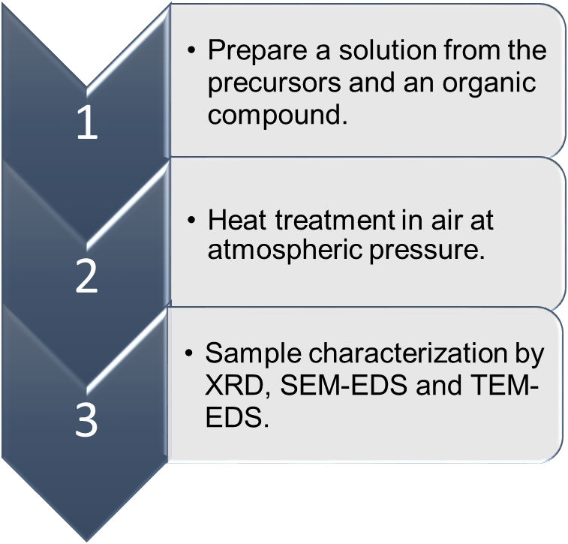
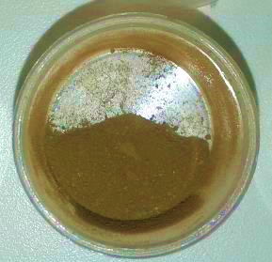
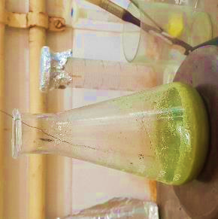
The materials were prepared following these steps: a simulated HLLW stream corresponding to the reprocessing of spent fuel from HWR was generated by preparing a suspension in 3 M HNO₃ with nitrates (Rb, Sr, Y, Ag, Cd, Cs, Ba, Ce, U, Fe), oxides (Zr, Ni, Sn, La, Pr, Nd, Sm, Eu, Gd, Cr, P, Se, U), and metals (Te, Rh, Ru, Mo) as indicated by Bevilacqua PhD Thesis [20], then a monomer or polymer with acrylonitrile functional groups was added and finally the nitric solution or suspension was thermally treated in air atmosphere at atmospheric pressure from room temperature to temperatures between 185-230°C with a constant heating rate of 2°C/min to obtain nanoparticles of actinide and lanthanide oxides [23]. Two samples were obtained after the one step thermal treatment called “simulated high level wastes (sHLW)” and “simulated high level wastes with 50 wt.% of the German SG7 aluminoborosilicate glass powder added (sHLW + 50%SG7) (Fig. 1).
(c)
(b)
(a)
FIG. 1. (a) Sample preparation layout (a) Nitric suspension. (b) Nanoparticulate ash.

2.2 X-ray diffraction (XRD)
X-ray diffraction patterns of the powdered samples were measured at room temperature in a Bruker D8 Advance diffractometer mounted in a Bragg-Brentano configuration and using Cu K𝜶 radiation (λ= 1.54184Å), in the 15°-90° 2θ range with a step of 0.02° and an acquisition time of 200 s/step. The present phases were identified with the PANalytical X’pert High Score Plus 2011® software [30]. The average crystallite size was determined using the Scherrer equation from de XRD data based on the full width at half maximum of the 32° (2θ).

2.3 Electron Scanning Microscope (SEM-EDS)
The morphological characterisation of the powders was performed by scanning electron microscopy (SEM-FIB, Zeiss, Crossbeam 340) with an energy dispersive X-ray spectroscope (EDS, Oxford Instruments). The sample was deposited on the carbon adhesive and covered with gold to avoid charge effects. SEM micrographs were obtained at 5 keV to obtain high quality images.

2.3 Transmission Electron Microscopic (TEM)
The Philips 200UT Transmission microscope with LaB₆ filament operated at 200 keV was used for the samples analysis. TEM images were acquired using CCD cameras. For this characterization a homogeneous suspension of some milligrams of powdered material in 1 ml isopropyl alcohol was prepared by ultrasonication during 5 minutes. A drop of the obtained suspension was transferred to a gold TEM grid (ultra-thin carbon film type A, 300M, Ted Pella®) and then allowed to dry in air.

Results and discussion

Crystal phases and crystallinity
The morphology and structural composition of the samples were studied by X-ray diffraction. The samples synthesized at 185-230°C were analysed by X-Ray Powder Diffraction (Fig. 2). The patterns were analysed with X’pert software [30] and confirmed the formation of uranium dioxide, corresponding to a cubic crystal phase with Fm3m spatial group (Powder Diffraction Card N 01-075-0421, International Centre for Diffraction Data, ICDD). This crystallographic phase is similar to simulated high level waste without and with 50 wt.% SG7 added. This is an important result because the current trend for increasing the waste loading in the waste form for storage and disposal. The crystallite sizes calculated by Scherrer equation resulted in 6 nm for sHLW and 5 nm for sHLW+50%SG7. The crystallite sizes calculated demonstrate that average crystallite size of sHLW is the same order of magnitude than sHLW+50%SG7, both synthesised by the novel method.
FIG. 2. Normalized XRD diffractograms of uranium dioxide, sHLW, sHLW+50%SG7 and SG7 glass.

Nano/Microstructural characterisation
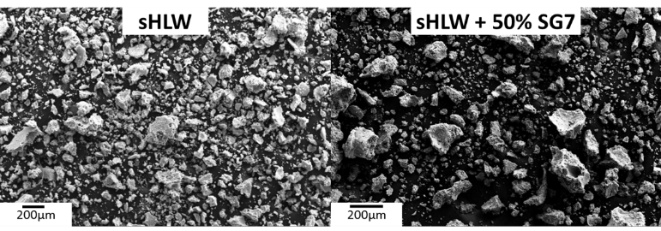
The SEM micrograph obtained with secondary electrons for the samples can be seen in Fig. 3. The samples consist of agglomerates ranging in size from less than 1 µm to approximately 300 µm.
FIG. 3. SEM micrograph for the material obtained by one step thermal treatment.
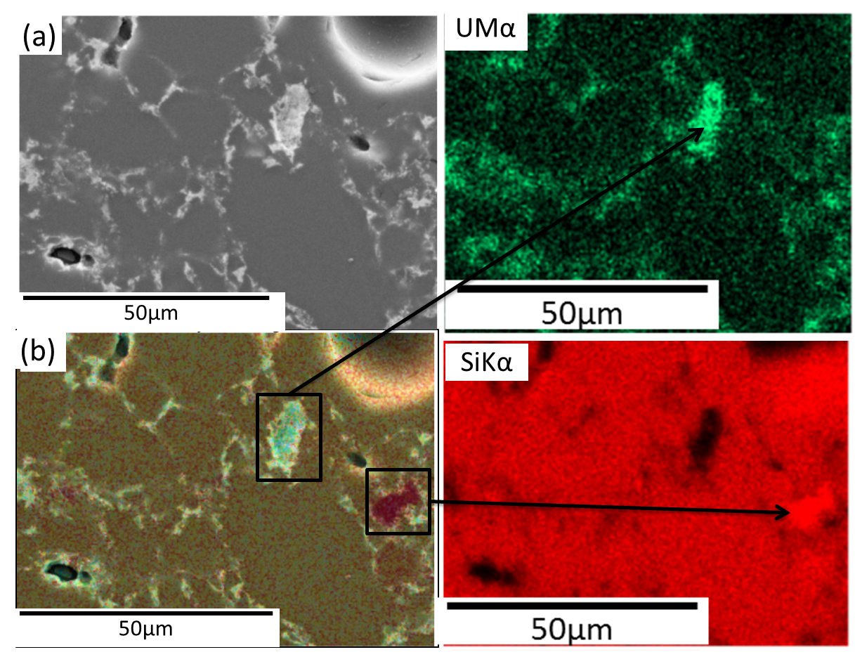
The EDS spectra were integrated during 200 s, on the 30 keV energy. The M𝜶 and K𝜶 X-ray emissions were used for quantification (SiKα = 1.74 keV and UMα = 3.16 keV, respectively). With the EDS mappings the distribution of the materials in the samples can be observed (Fig. 4(b)). sHLW is totally homogeneous at the resolution of the equipment, however, when SG7 glass is added (sHLW+50%SG7) different zones appear in the samples: a rich uranium zone and a rich silicon zone, which are the major components of the simulated waste and glass, respectively. For better mapping process and results interpretation a disc obtained from a cold pressed (54 MPa) and sintered (778 ºC, 190 min) pellet sample was grinded and polished.
FIG. 3. (a)SEM micrographs (b) Area mapping of sHLW+50%SG7pressed and polished pellet. Light zone show a high uranium content.
Finally, samples were characterized by Transmission Electron Microscopy (TEM). After TEM measurements it was found that the agglomerates are formed by nanoparticles. The crystallite sizes were characterized by TEM using their longest dimension (i.e. the diameter in case of a quasi spherical morphology). The result is in agreement with the RX measurements (TABLE 1).

TABLE 1. SAMPLES CRYSTALLITE SIZES DETERMINED BY XRD AND TEM

Sample | XRD particle size (nm) | TEM particle size (nm)
sHLW | 6.1 | 5.9 ± 2.8
sHLW+50%SG7 | 5.2 | 5.6 ± 1.2

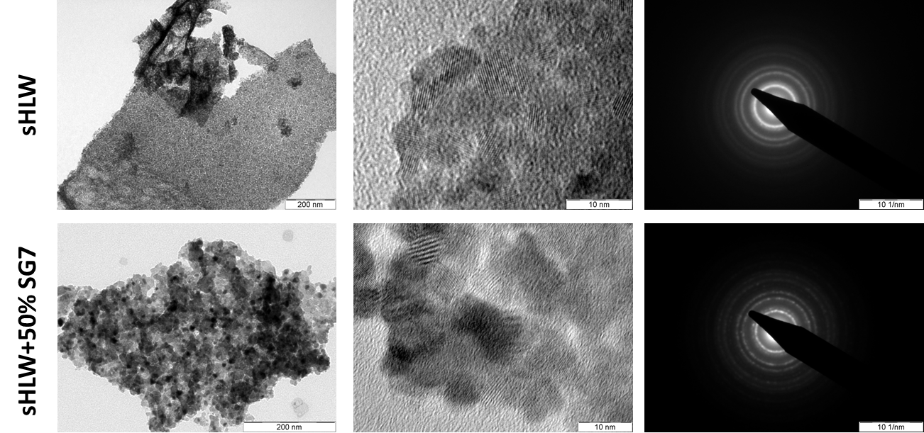
The sHLW sample shows a higher crystallite size, however, crystallite size differences between samples without and with SG7 are small. Bright Field images and the corresponding selected area electron diffraction pattern are observed in Fig. 5 [26]. This sample shows polygonal morphologies and average grain sizes of 5.9 ± 2.8 nm. The minimum/maximum crystallite sizes observed correspond to 3 nm and 11 nm, respectively. The electron diffraction pattern corresponds to a polycrystalline sample, as expected for a nanometric material.
FIG. 5. (a)SEM micrographs (b) Area mapping of sHLW+50%SG7pressed and polished pellet. Light zone show a high uranium content.
The results obtained for the materials synthesized by this one step low temperature method agree with those of other authors who use synthetic methods assisted by organic compounds such as Poppa et al., Balice et al. and De bona et al.[31-33], among others. The present one step process substantially improves any other method because no secondary waste streams are generated [21, 22].

Conclusion
This novel synthesis method produces nanoparticles after fully denitrate a simulated HWR high level liquid waste (sHLLW) stream without (sHLW) and with 50 wt.% aluminoborosilicate glass SG7 (sHLW+50%SG7).
X-ray and electron diffraction showed the cubic crystalline fluorite pattern of UO₂ fluorite in the samples without and with 50 wt.% SG7.
The thermochemical process which was developed at inactive laboratory scale and merges in a low temperature single step in air at atmospheric pressure all steps encompassing concentration, denitration, glass mixing, grinding, milling and drying and, in this way, reduces the formation of radioactive volatile compounds as well as the generation of secondary waste streams.
Summarizing, the novel method reduces I) Synthesis steps, II) Operating time, III) Operating temperature, IV) Operating costs, V) Formation of radioactive volatile compounds and VI) Generation of secondary waste streams.
ACKNOWLEDGEMENTS
The authors thank to Bernardo Pentke from Departamento Fisicoquímica de Materiales for the SEM micrographs, and Analía Soldati and Departamento Física de Metales for the TEM micrographs.
References
[1] Martin Leblanc , G.L., Eleonore Welcomme, Xavier Deschanels,Thibaud Delahaye, Actinide mixed oxide conversion by advanced thermal denitration route. Journal of Nuclear Materials, 2019. 519 p. 157-165.
[2] Weber, W.G., et al, Preparation of Uranium Dioxide, in Uranium Dioxide: Properties and Nuclear Applications, in Naval Reactors, Division of Reactor Development, J. Belle, Editor. 1921: USA Energy Commission: Washington. p. 35-64.
[3] Soldati, A.L., et al., Synthesis and characterization of Gd2O3 doped UO2 nanoparticles. Journal of Nuclear Materials, 2016. 479: p. 436-446.
[4] Jonás S. Narváez Arrúa, A.M.B., A. Fernandez Zuvich, S. Perez Fornells, A.L. Soldati, ESTUDIO DE FORMADORES DE POROS PARA PASTILLAS COMBUSTIBLES DE (U; Gd)O2 NANOPARTICULADO OBTENIDO POR COPRECIPITACIÓN INVERSA, in 19° Congreso Internacional de Metalurgia y Materiales CONAMET-SAM
2019: Valdivia-Chile.
[5] Durazzo, M., et al., Phase studies in the UO2-Gd2O3 system. Journal of Nuclear Materials, 2010. 400(3): p. 183-188.
[6] Durazzo, M.R., H. G., Technological aspects concerning the production procedures of UO 2-Gd2O3 nuclear fuel, in Materials Science Forum. 2008. p. 673-678.
[7] Harrington, C.D.a.A.E.R., Uranium Production Technology. 1959, New York.
[8] al., Z.G.e., Method for producing uranium trioxide by heating uranyl nitrate solution in microwave manner. 2017: China.
[9] al., Z.G.e., Semicontinuous automatic microwave denitrification facility. 2017.
[10] al., G.L.e., Process for preparing UO3 through uranyl nitrate air-blast atomization dry pyrolysis denitration. 2017: China.
[11] Hedley, W.H., R.J. Roehrs, and C.M. Henderson,, Flame denitration and reduction of uranium nitrate to uranium dioxide 1962: USA.
[12] Yoshimura, T., Denitration-roasting equipment. 2001: Japan.
[13] Fane, A., B. Charlton, and P. Alfredson, , The Thermal denitration of uranyl nitrate in a fluidised bed reactor., ANSTO, Editor. 1974.
[14] Onoshita, S., Method of processing massive particles produced in the fluidized bed denitration. . 1999: Japan.
[15] al., R.F.e., Uranyl nitrate hexahydrate feeding device for fluidized bed denitration technology. 2017: China.
[16] Roth, O., H. Hasselberg, and M. Jonsson, Radiation chemical synthesis and characterization of UO2 nanoparticles. Journal of Nuclear Materials, 2009. 383(3): p. p. 231-236.
[17] Nenoff, T.M., et al., Synthesis and low temperature in situ sintering of uranium oxide nanoparticles. Chemistry of Materials, 2011. 23(23): p. p. 5185-5190.
[18] Ondracek, G.a.K.S., Powder Technological Vitrification of High Level Nuclear Waste by In-Can Hot Pressing Including a Sol-Gel Mixing. 1984: Primärbericht Kernforschungszentrum Karlsruhe. p. p. 1-5.
[19] Bauer, C.a.G.O., Treatment of Nuclear Waste - an Engineering Material Problem. Part III: Materials Technology for Producing Nuclear Waste Packages, U.C. Institut für Material und Festkörperforschung Kernforschungszentrum Karlsruhe. Instituto Balseiro, Editor. 1985: Germany.
[20] Bevilacqua, A.M., Inmovilización de residuos líquidos de alta actividad simulados en vidrios sinterizados, in Nuclear Engineering. 1992, Instituto Balseiro. Universidad de Cuyo: San Carlos de Bariloche, Argentina.
[21] A. M. Bevilacqua, N.B.M.d.B., D. O. Russo, M. A. Audero, M. E. Sterba, A. D. Heredia, Immobilization of simulated high-level liquid wastes in sintered borosilicate, aluminosilicate and aluminoborosilicate glasses. Journal of Nuclear Materials 1996. 229 p. 187-193.
[22] M. A. Audero, A.M.B., N. B.M. de Bernasconi, and M.E.S. D. 0. Russo, Immobilization of simulated high-level waste in sintered glasses. Journalof NuclearMaterials, 1995. 223: p. 151-156.
[23] BEVILACQUA, A.M.F.Z., A.; SOLDATI VALENTE, A. L.; PÉREZ FORNELLS, S. G.; ZOLOTUCHO, H. A.; GONZÁLEZ OLIVER, C. J. R.; SILIN, N. , Method for Obtaining Nanoparticulated Ashes of Actinide, Lanthanide, Metal and Non-Metal Oxides from a Nitrate Solution or from a Nitrate, Oxide, Metal and Non-Metal Suspension. , W.I.P. Organization, Editor. 2021: Switzerland
[24] Soldati A., F.Z.A., Gana Watkins I., Zolotucho H. and Prado M., Characterization of (U,Gd)O2 nanoparticles synthesized by a low temperature method, in The Nuclear Materials Conference. 2016: France.
[25] A. Fernandez Zuvich, A.M.B., N. Silin, H. A. Zolotucho, C. González Oliver, A. Soldati. CARACTERIZACIÓN DE PASTILLAS COMBUSTIBLES SINTERIZADAS A PARTIR DE NANOPARTÍCULAS DE (U,Gd)O2. in 18º Congreso Internacional de Metalurgia y Materiales SAM-CONAMET. 2018. Argentina.
[26] A. Fernandez Zuvich, A.M.B., N. Silin, S. Pérez Fornells, H. A. Zolotucho, C González Oliver, A. Soldati. ACONDICIONAMIENTO DE RESIDUOS LÍQUIDOS DE ALTA ACTIVIDAD SIMULADOS. in 18º Congreso Internacional de Metalurgia y Materiales SAM-CONAMET 2018. 2018. Argentina.
[27] A. Fernandez Zuvich, A.B., S. Pérez Fornells, A. Soldati, C. González Oliver, F. J. Castro, Soluciones sólidas ThO2 - Sm2O3, in XV Reunión Anual de la AACr. 2019: Argentina.
[28] A. Fernandez Zuvich, A.M.B., S. Pérez Fornells, C. González Oliver, A.L. Soldati, Caracterización de (U,Gd)O2 nanoparticulado dopado con Gd como veneno quemable en diferentes concentraciones in 19° Congreso Internacional de Metalurgia y Materiales CONAMET-SAM. 2019.
[29] A. Fernandez Zuvich, A.M.B., S. Pérez Fornells, C. González Oliver, F.J. Castro, A.L. Soldati., Caracterización morfológica y estructural de combustibles nucleares de torio con samario como veneno quemable, in 19° Congreso Internacional de Metalurgia y Materiales CONAMET-SAM. 2019: Valdivia-Chile
[30] PANalytical, Xpert HighScore Plus. 2011.
[31] K. Popa, O.W., O. Dieste Blanco, A. Guiot, D. Bouëxière, J.-Yves Colle, L. Martel, M. Naji and D. Manara, A low-temperature synthesis method for AnO2 nanocrystals (An = Th, U, Np, and Pu) and associate solid solutions. The Royal Society of Chemistry, 2018.
[32] Balice, L., et al., Nano and micro U1-xThxO2 solid solutions: From powders to pellets. Journal of Nuclear Materials, 2018. 498: p. 307-313.
[33] De Bona, E., et al., Synthesis of nanostructured ThO 2 pellets. Journal of the American Ceramic Society, 2019. 102(7): p. 3814-3818.

