Improvement of accuracy in waste characterisation by applying innovative techniques (ASGS)

M. Fritzsche
Mirion Technologies (Canberra) GmbH
Rüsselsheim, Germany
Email: mfritzsche@mirion.com

M. Dürr
Aachen Institut für Nuclear Training (AiNT) GmbH
Stolberg, Germany

Abstract

The safety consideration in the management of radioactive waste is largely related to its radionuclide inventory due to the harm of ionizing radiation. Depending on the origin and the purpose (free-release or disposal), different pre-conditions such as activity levels or waste container properties need to be applied. The most effective and accurate method to determine the nuclide inventory of a waste drum is Gamma-Spectrometry using High Purity Germanium Detectors (HPGe). These detectors allow the direct measurement of decay-radiation from the nuclear waste and, due to the high energy resolution, the determination of activity for each gamma-emitting nuclide.
In the last decades, several measurement approaches based on HPGe detectors have been developed and all approaches are using the principle that the detector “views” the drum from the outside. The advantage is that the waste drum does not need to be opened, but since the waste matrix has some shielding effects for the gamma-radiation, detailed knowledge about the drum content needs to be obtained in order to be able to calculate the nuclide activities. The less information that is available, the higher the uncertainties of the results are, which needs to be mitigated by adding some additional activity as a safety margin - so called virtual activity - to the best estimate of the activity obtained from the measurement. A large fraction of radioactive waste may deviate from calibration conditions applied in spectrometric radiation measurement, assuming a uniform activity distribution in their analysis model. This deviation results in a bias of the measurement result which needs to be accounted for as a so-called model-uncertainty of the measurement.
Mirion Technologies (Canberra) developed and validated in cooperation with Aachen Institute for Nuclear Training (AiNT) an innovative measurement approach which allows more accurate results and therefore applying lower uncertainties. This new measurement approach extends the concept of a standard Segmented Gamma Scan (SGS) by performing sectorial measurements of single drum sectors in addition to segments, hereby gaining information on the spatial distribution of the activity within the drum. The goal is to perform gamma scans with high throughput and an accurate analysis based on the reconstruction of activities for each sector. The new approach has been developed, tested and validated with a measurement system and calibration drums. The comparison with SGS shows, that the novel method increases the measurement accuracy for non-uniform activity distribution hereby allowing the reduction of model uncertainties by a factor two to three, depending on the density of the waste matrix.

INTRODUCTION
The safe management of radioactive waste involves adequate characterization measures to determine the waste properties, in particular, the content of radionuclide activity. Among the non-destructive methods for radioactive waste characterization, gamma spectrometric measurement methods based on HPGe-detectors, so called Gamma Scanning, represent a well-known and established tool which allows the determination of radionuclide activities in waste drums. The measurement results are the basis for the verify the compliance with regulatory safety requirements for storage and disposal of radioactive waste packages. Adherence to national and international standards for radiation measurements is a required by licensing authorities and the applied characterization methods are subject to an assessment by technical safety organizations. The decommissioning of nuclear reactors and facilities and efforts to address legacy waste results in waste streams where the waste producers often opt for the treatment and packaging of the waste for final disposal. To this end, the waste characterization plays a pivotal role in qualifying waste packages with regard to the waste acceptance criteria of repositories for radioactive waste.
To obtain accurate results from Gamma Scanning, knowledge about the waste matrix material and density and the spatial distribution of the gamma-emitting nuclides is required for the analysis to correctly account for the self-absorption of gamma rays. In standard Gamma Scanning such as Segmented Gamma Scanning (SGS) developed in the late 70’s [1], the homogeneity of the waste matrix and activity is assumed. However, during campaigns for qualification of radioactive waste, if this assumption is not underpinned by any further evidence, a rigid and quantitative consideration of all measurement uncertainties mandates the assumption of the worst-case. In Gamma Scanning, the worst-case activity distribution is represented by a point source in the radial center of the drum. The analysis under the worst-case assumption leads to additional safety margins which are added on top of the measured nuclide activities, so called virtual activities, which cover the worst-case scenario for the activity distribution. Eventually, virtual activities result in higher storage and handling costs since the safety margin comes from inadequate waste characterization and is thus higher than necessary.
Advanced non-destructive measurement methods have been developed which offer detailed and powerful imaging capabilities for a full analysis of the waste drum content with spatial resolution ([2], [3]). However, these methods come at the expense of long measurement times per measured drum. SGS, on the other hand, offers economical operation to routinely perform drum measurement in a robust manner at high throughput, yet with the caveat of relying on a simplifying assumption and, in consequence, overly large safety margins for the measurement result. In order to address the unmet need for a robust, automated and high-throughput drum measurement device for the radiological characterization of waste, Mirion Technologies (Canberra) developed a Gamma Scanning device and analysis method – Advanced Sectorial Gamma Scanning (ASGS) – in a joint cooperation with AiNT. In conjunction with the newly developed software module called ECIAD (“Efficiency Calculation for Inhomogeneous Activity Distributions”), ASGS drum measurement offer following features:
• Unattended operation of the drum measurement
• Automated analysis without a need for additional human intervention
• Throughput of several drums per 8-hour shift
• High flexibility with respect to activity content within the drum
• Analysis and consideration of non-uniform activity distributions for higher measurement accuracy
• Consistent and robust uncertainty calculation in accordance with international norms
This paper presents the measurement approach, the analysis procedure and the experimental validation using an ASGS demo-system specifically designed towards the features listed above. Using the ASGS system, measurements could be performed in the standard SGS mode which allows a direct comparison of the methods with regard to the measurement uncertainty and the cost saving potential by the increased accuracy of the ASGS method..

MEASUREMENT APPROACH
The concept of this method is to perform a sectorial scan of the drum with a stepwise rotation between each acquisition of a gamma spectrum. The sectorial scan is repeated for each segment of the drum as in segmented gamma scanning. Each sector is measured individually with an acquisition time ranging from 15 seconds to several minutes depending on the gamma dose rate level of the drum. At the end, a multitude of spectra have been recorded and the peak-intensity of individual nuclides are evaluated. The measurement sequence provides a surface-profile of the gamma radiation field determined for individual lines in the gamma spectrum (see Fig. 1 - right). The spatial activity distribution of the nuclides within the drum is reconstructed based on a discretized model of the drum matrix volume consisting of source partitions as shown schematically in see Fig. 1 (left). By virtue of the discretized partition source model, a suitable efficiency calibration reflecting the spatial distribution of the activity within the waste matrix is acquired. This approach is called Advanced Sectorial Gamma Scanning (ASGS).
ASGS follows a new approach for the efficiency calibration by calculating the efficiencies of each individual source partition for a waste drum model based on volume partitions of the active matrix. In the model it is assumed that the activity distribution within each volume partition is homogeneous. To this end, a dedicated software called ECIAD (Efficiency Calculation for Inhomogeneous Activity Distributions) was developed with an efficiency calculation based on Monte-Carlo Sampling of gamma ray interactions and a validated detector model. ECIAD uses input data such as matrix information and drum parameters like wall-thickness, matrix fill-height and material composition to calculate the photopeak efficiency at each measurement angle and height position and for each volume partition.
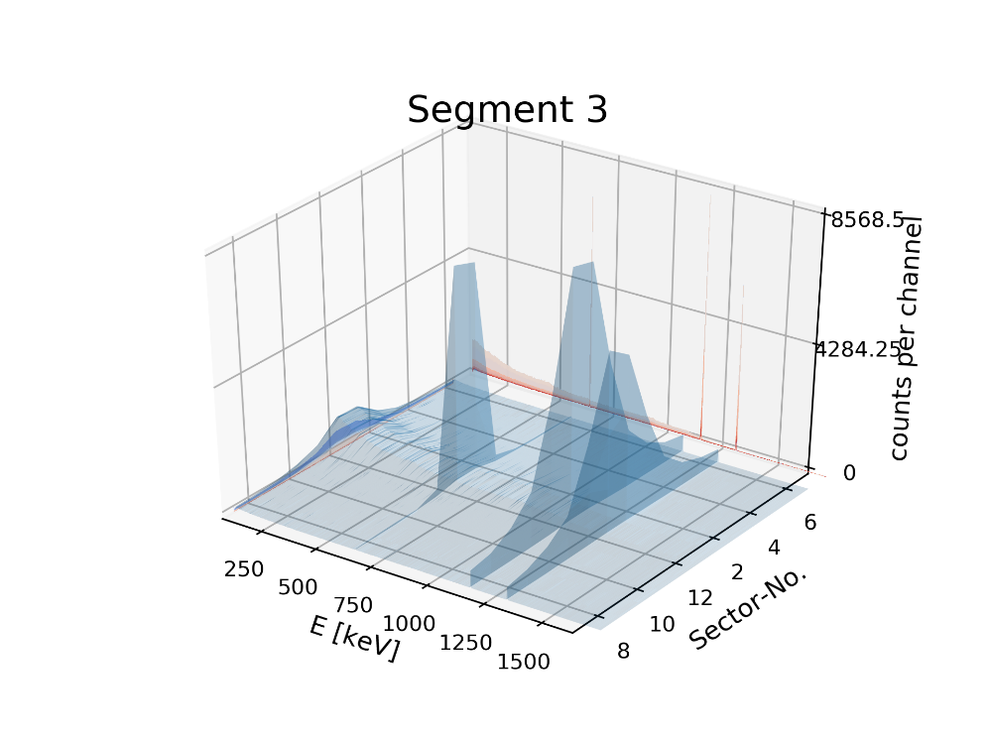
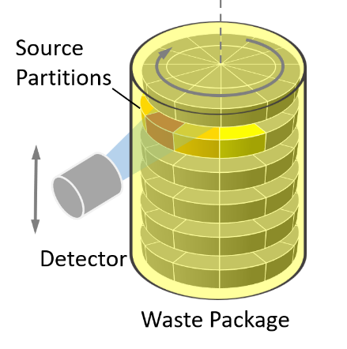
The calculation of photopeak-efficiencies in ECIAD was validated using point-source measurements. In addition, the calculation of photopeak-efficiencies (‘partial efficiencies’) for modelled volume sources were benchmarked with other efficiency calculation methods like MCNP and ISOCS. The results show the good agreement between the results obtained from the ECIAD calculation and MCNP indicating that the ECIAD software provides true photopeak-efficiencies for the volume partition sources.
Fig. 1: Left: Measurement geometry of the ASGS Gamma Scan of the drum. The discrete model of the waste matrix consists of ‘virtual’ volume source partitions. Right: Graph of measured spectra for 12 sectors recorded for a full rotation of a drum with Cs-137 and Co-60 activity with ASGS.
The photopeak efficiencies calculated for all partitions and detector measurement positions are used to reconstruct the nuclide activities in each volume partition using an algorithm to find the activity distribution

RECONSTRUCTION BASED ON THE PARTITION MODEL
In the development of ASGS, simulated data obtained from modeling the gamma scanning measurement of waste drums was used as a test bed for various reconstruction methods. The question at hand was how a source could be handled which is localized close to the center of the drum, serving as a demanding test case with a high absorption by the active matrix. First tests indicated the need for a fine radial subdivision of the radial matrix by increasing the number of source partitions. To cover this, additional radial sectors have been introduced. The increase of source partitions, however, comes with a trade-off with the computation time for calculation of the photopeak-efficiencies for the individual partitions. In addition, a larger number of source partitions increases the degree of freedom for the reconstruction algorithm, whereas the number of measurements is kept fix in order not to prolong the time for the gamma scanning any further. To test this approach, a 200-l waste drum filled with a cement matrix and a single point source was modeled and simulated net peak areas were generated assuming an Eu-152 source. The generated peak areas were used as input for the ECIAD algorithm. This procedure allows testing a large range of configurations of radial subdivisions of the partition model. Moreover, we could evaluate how the choice of gamma lines of a given nuclide affects the result of the reconstruction algorithm by performing the reconstruction for varying choices of gamma lines considered for the Eu-152 nuclide.
At the beginning, an analysis was performed using a model without radial segmentation. For point sources located in the radial center of the drum, the reconstruction led to an underestimation of the activity. This underpins the statement made above, that a sectorial source is a poor representation of a point source located in the radial drum center as it cannot correctly account for the attenuation by the matrix. Taking this result, additional subdivisions of the sectorial source were considered, and the sectors further divided with different fashions of subdivision as shown in Fig. 2.

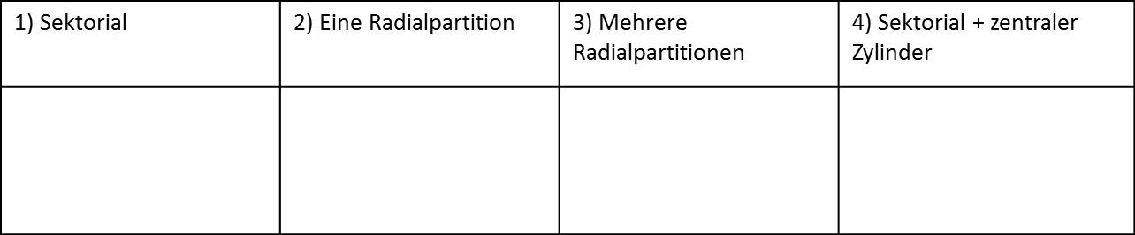
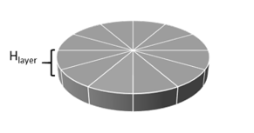
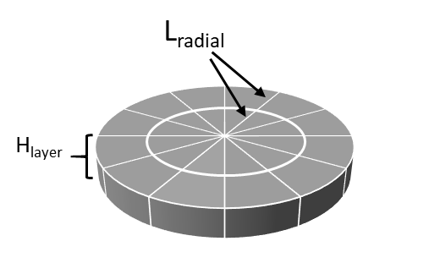
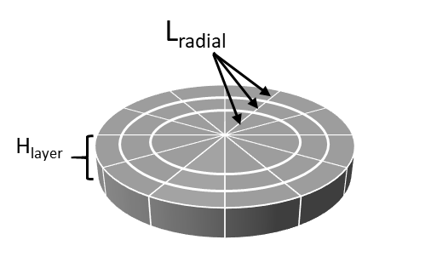
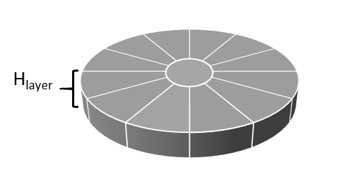
Sectorial
One radial partition
Several radial partitions
Sectorial + cylinder
Fig. 2: Various options of the partition model evaluated during the development of the reconstruction of activity distributions.
Testing each of these models demonstrated that the best results can be obtained with 6 radial sectors. With such a model, the waste drum matrix is represented by a total 432 volume partitions (6 segments x 12 sectors x 6 radials).
All these calculations were made assuming an Eu-152 source, which has a high number of gamma lines. The reconstruction of the nuclide activity can be performed taking multiple lines of a single nuclide into account which significantly increases the reconstruction results. This is attributed to the fact, that the relative peak intensity between the lines of the same nuclide evaluated obtained in the profile of the sectorial scan has the source location encoded due to the energy dependent self-absorption in the active matrix. The reconstruction using multiple lines resulted in an accuracy in the range of 20 %. However, source locations in the drum center result in a reconstructed activity with a significant underestimation of larger than 50% of the true value if only a single line is analyzed. This is caused by an ambiguity of the radially centered source configuration which causes a rotational symmetric count rate profile.
Many users, especially those who are decommissioning their nuclear sites, are interested in characterizing the Cs-137 content. This nuclide has only one detectable Gamma energy at 661.7 keV. It was necessary to look for ways how this could be solved. The idea is to mechanically move the detector and collimator ca. 20 cm from the center of the drum and perform an ASGS scan in the off-axis configuration. Since the gamma photons have a different way to pass through the drum matrix the difference of the count-rates relative to the on-axis gamma scan provides additional information where the source is located. We call this measurement approach the “Tomo-Light Mode”. Using this mode, a Cs-activity could be reconstructed and located inside the drum.
In summary, the ASGS allows the characterization of waste drums in a more precise way with more accurate activity results than a standard SGS. The reconstruction of activities is implemented in the ECIAD software which reconstructs the nuclide activities for the partition model using 432 volume partitions by partitioning the active matrix into six layers, twelve sectors and six radial subdivision. This allows an ample localization of the activity hereby significantly reducing the safety margin to cover the worst-case scenario. The technique requires only modest upgrade of the measurement system compared to a normal SGS as it uses most of the same hardware and therefore offers a convenient upgrade path for existing drum measurement devices. It can be used effectively in cases where the drum matrix is relatively uniform but with possibly localized activity within the matrix. The ASGS method allows for an automated operation and analysis without requiring human intervention or specially trained personnel for analysis of the data. It is anticipated to perform ASGS scanning measurements in ca. 1.5 h (including the scan in Tomo-Light Mode) significantly surpassing the throughput of the more expensive and time-consuming tomographic technique.

EXPERIMENTAL VALIDATION
Purpose of the experimental validation of ECIAD and ASGS is to test and assess the accuracy of the newly developed measurement approach and to benchmark it with already established analysis used in SGS. Furthermore, the possibility to present the real system to customers as well as the development of the user software with performance tests was possible with a real validation system. For this, a drum measurement system was designed, built and set up at the technical center of AiNT in Stolberg, Germany (Fig. 3 - left). The whole system contains a turntable which includes weight scale and a detector stand with adjustable collimator. The detector can be moved to different heights and off-axis which allows maximum flexibility.
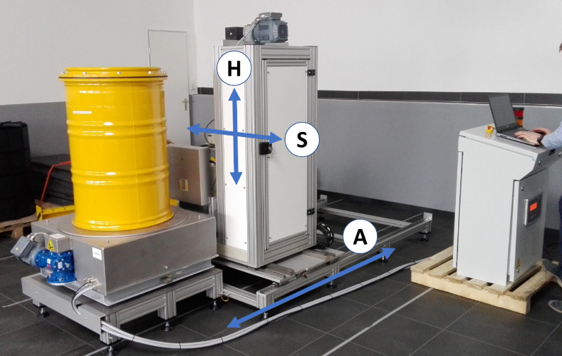
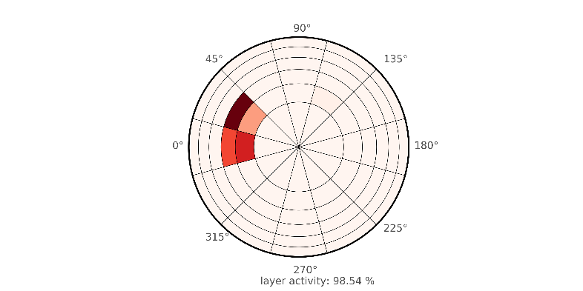
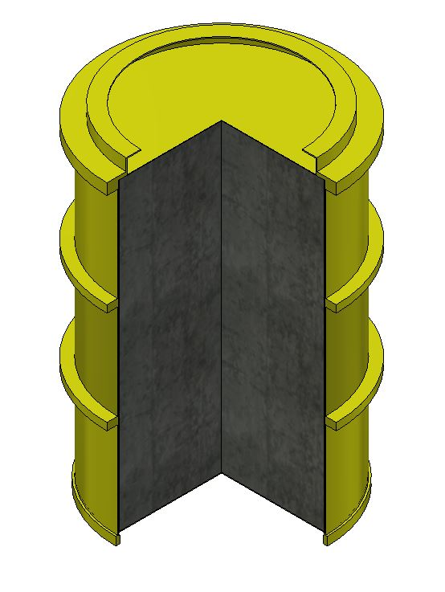
Fig. 3: Left: ASGS gamma scanner used for validation with the translation options of the detector assembly indicated by ‘H’, ‘S’ and ‘A’. Right: Example of the reconstructed activity distribution of a Co-60 source measured with the ASGS gamma scanner.
Eu-152
Co-60
Cs-137
reconstructed
Co-60 activity distribution

To test the ASGS and ECIAD approach and validate the complete system, reference waste drums were prepared with well-defined matrix properties and with calibration sources of known activity placed in various locations within the drum (Fig. 4). The matrix materials were chosen to cover a range of waste matrix densities:
- MDF (medium density fiber) with a density of 0.7g/cm³
- PE (polyethylene) with a density of 0.9g/cm³
- GMI (garnet sand) with a density of 2.1 g/cm³
For all matrix types the density and material properties have been validated by checking the gamma absorption in transmission measurements undertaken by placing a source in front of the matrix and checking the reduction of count rates. In addition, the accuracy of modeling the detection system and the measurement geometry including the attenuation by the matrix was checked systematically by measurements of calibration sources in various positions. The experimentally measured line intensities in the recorded spectra were compared with the calculated photopeak-efficiency obtained from modelling a point source in the ECIAD software in order to verify that the efficiency modelling is appropriate. To this end, the ECIAD software provides a dedicated function call intended for calibration checks with a point source at a known location for quality assurance purposes. Considering all checks and matrix configurations, the deviation of uncertainty modelling was below 5%.
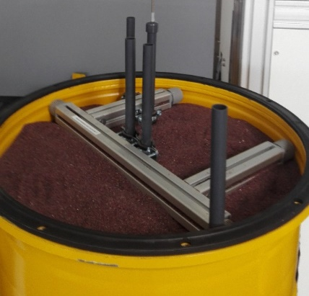
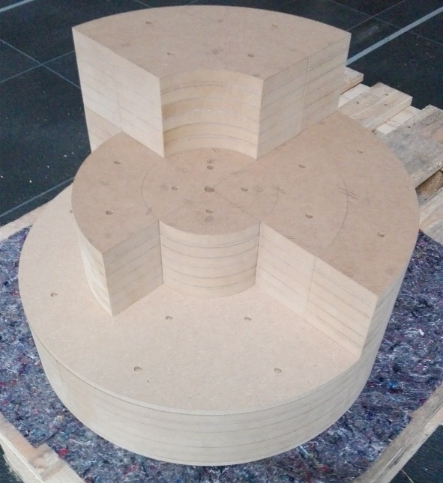
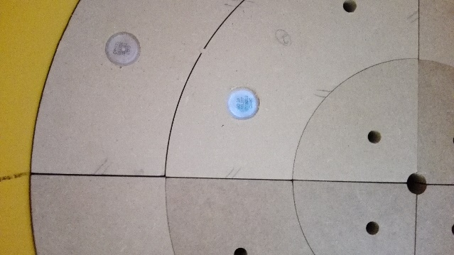
Fig. 4: Left: Reference drum with garnet sand matrix and tubes for placement of a calibration source. Center: Medium density fiber board matrix (MDF) made of modular building blocks. Right: Calibration Sources located in an inset within MDF.

With regard to the performance of the reconstruction algorithm, an Eu-152 point source was placed in different positions inside the waste drum (see Fig. 5). The ASGS gamma scan was performed automatically, and the spectra analyzed. In the ideal case of an accurate measurement, the reconstruction yields a measurement result which is close to the true value. For the purpose of the validation the true value of the measured activity is known which allows us to assess the accuracy of reconstruction.
The analysis was performed by calculating the activities for each Eu-152 gamma line and comparing the reconstructed with the true activity of each line. The first results showed that for the MDF matrix a reconstruction of activity with a deviation less than 25% is possible for all measured positions except for source positions on the top of the drum, which are the worst-case positions for sources. Similar results are obtained for the PE matrix, where the reconstruction deviation below 600 keV is larger than 25%. Also, here a clear deviation is seen for the source positions at the top of the drum. A test was performed with an 8 MBq Eu-152 and performing a gamma scan in the target measurement time of 1.5 h. For the high matrix densities GMI the gamma spectra show low counting statistics for source position in the radial drum center. In this case, the accuracy of reconstruction is 50% or even worse which is caused by the failure to localize the source exactly in the radial center due to the Poisson noise of the counting measurement. In consequence, the activity is underestimated for this kind of source locations. This uncertainty contribution is considered in the ECIAD software reconstruction which performs an estimation of the uncertainty caused by limited resolution of the reconstruction by a Monte-Carlo sampling approach.
Taking these intermediate results, ways have been identified to improve the model for activity reconstruction in such a way that for the worst-case positions the activity reconstruction leads to more accurate results. This model modification led to large improvements of the activity reconstruction. The reconstructed activity with the improved model is shown in Fig. 6. The plots show the primary results without error bars and without consideration of the critical limits. The data in Fig. 6 for the polyethylene matrix show a large spread for the reconstruction of the activity for the 121 keV Line, which reflects the fact, that the signal intensity of the peak is in proximity to the background level for source positions in the radial center of the drum (Positions SX_R0 and SX_R1, X= 3, 5, 6) The full treatment of uncertainties and the characteristic limits according to ISO 11929 will be presented elsewhere.
To benchmark the ASGS versus the SGS model, the same measurements have been performed by positioning the sources in one layer and varying the radial position of the source. During the measurement, the drum rotated in 2° steps and data were acquired during the whole rotation. SGS scans were performed with the same reference drums and by placing the source in different radial locations within the drum. Since a point source deviates from the homogeneity assumption, SGS measurements lead to a significant negative bias when the source is in the drum center in particular for highly absorbing matrices.
To relate the results to practical measurements the line energies of Co-60 and Cs-137 have been considered. The ASGS and SGS gamma scanning measurements were performed with Eu-152 and we took credit from the wide span of line energies emitted during its decay. In order to assess the performance in terms of measurement accuracy, the SGS and ASGS analysis of Eu-152 decay lines with energies close to the emission lines of Co-60 and Cs-137 was used as a proxy in order to assess the measurement accuracy for these particular nuclides of interest in radioactive waste characterization. For Co-60 we assumed the reconstruction using two different lines which improves the reconstruction of the activity distribution. The accuracy is quantified in terms of the maximum observed deviation of the measured activity relative to the true value for the respective lines (Tab. 1).
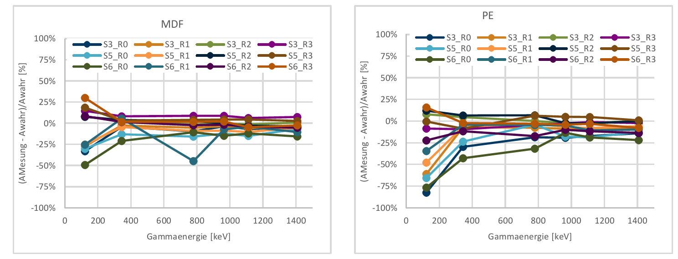
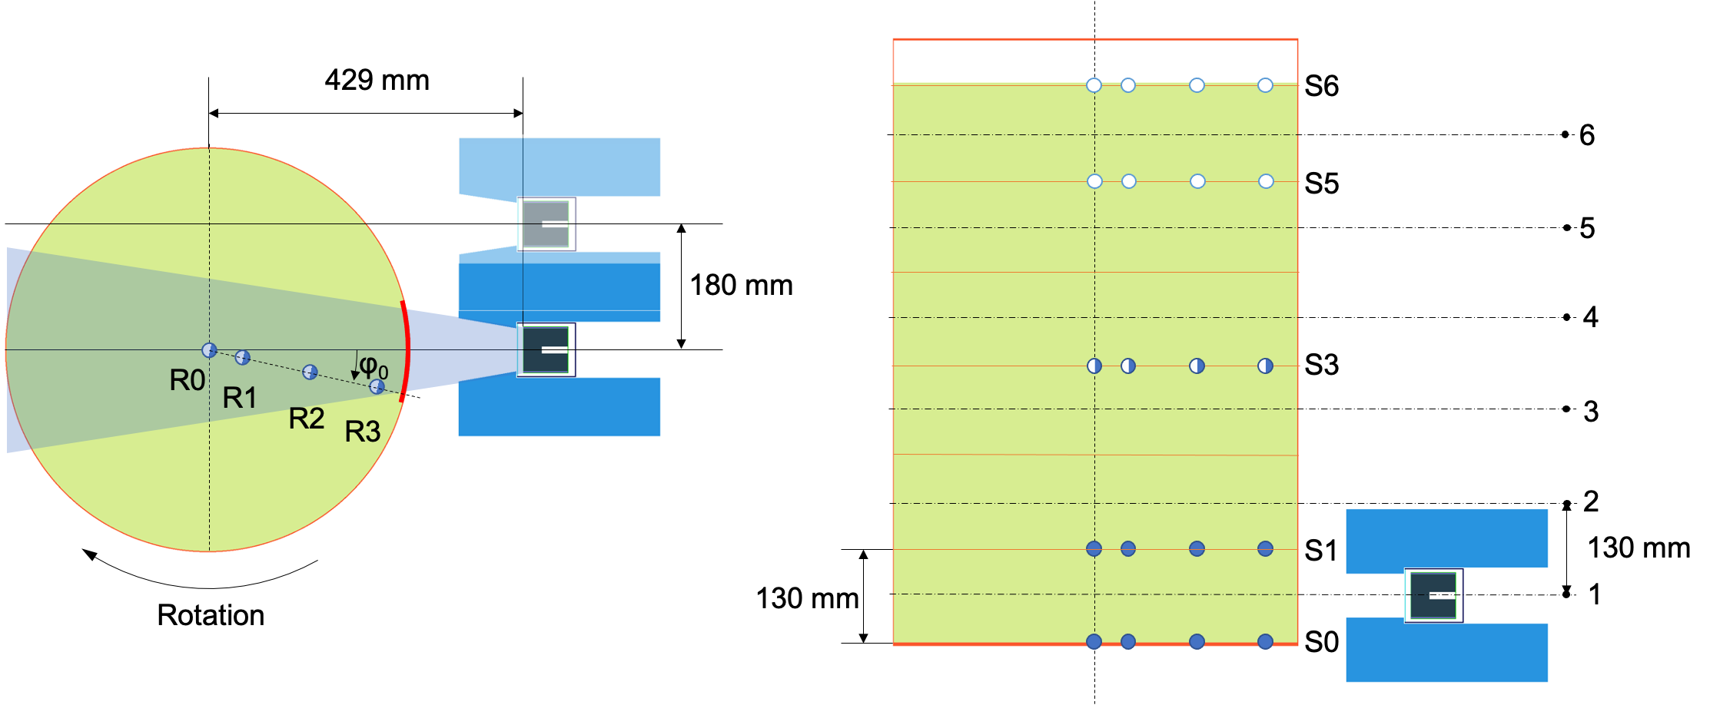
It is clearly visible, that ASGS outperforms standard SGS by a factor of two, the improvement of ASGS being even higher for matrix material with high densities. In practice this means that user can declare their nuclear inventory in waste drums more accurate which allows saving costs.
FIG. 6: Reconstruction of Eu-152 line activities for MDF (left) and PE (right): in both cases a reconstruction of the source activities below 50% at energies above 200keV could be observed for all source positions in the drum.
Gamma energy [keV]
Gamma energy [keV]
Fig. 5: Source positioning in waste matrix (green) within the drum, lateral displacement during the Tomo-Light Mode (left), and the vertical measurement positions or the gamma scan (right). The source positions are given as dots. Filled dots represent the positions of the sources in the GMI matrix. Empty dots represent the positions for the sources in MDF and PE matrix and half-filled dots represent the positions of the sources in all matrices. The radial and vertical source position is labeled with R0-R3 and S0-S6, respectively.

TABLE 1. Model uncertainties for reconstruction of Cs-137 and Co-60 activities with ASGS and SGS

Matrix | ASGS |  | SGS
 | Cs-137 | Co-60 | Cs-137 | Co-60
MDF | 9% | 8% | 13% | 10%
PE | 13% | 8% | 40% | 17%
GMI | 52% | 30% | 90% | 64%

SUMMARY
The development of the new Advanced Sectorial Gamma Scanner (ASGS) concept and the Efficiency Calculation for Inhomogeneous Activity Distribution (ECIAD) Algorithm allows one to obtain the spatial activity distribution within waste drums therefore more accurate results and lower uncertainties compared with traditional methods. The concept has been designed and tested using simulations.
To test and validate the concept of ASGS a validation system was set up at technical center of AiNT. The validation tests confirm the capability of ASGS in terms of measuring the source activity accurately irrespective of the source position within the drum. In comparison with to the established Segmented Gamma Scanning, which assumes a homogeneous model for the source distribution, ASGS reaches by a factor two to three lower uncertainties by approximating the source distribution with a partitioned model. This reduction is reached by accurately accounting for the activity localization in the drum as demonstrated with ASGS measurements with point sources in waste matrices with a density between 0.7 – 2.1 g/cm³.
During the validation campaign the performance of the computer hardware was also tested and validated. For all the 432 source partition volumes the photopeak efficiencies can be calculated by the ECIAD software within an hour using a normal desktop computer (3.2 GHz Quad-Core CPU with 16 GB RAM). The automated spectrum analysis of multiple lines for in total 144 spectra obtained for a single ASGS measurement in the Tomo-Light Mode proved to be successful for the measurements performed during the validation campaign. The ECIAD software performs reconstruction of the activity distribution and th calculation of characteristic limits (decision threshold, detection limit, limits of the confidence interval) according to ISO 11929 for nuclides identified in the measured spectra and for nuclides of interest as specified by the user. With a measurement time of 1.5 h and an automated operation a Eu-152 source with an activity of 8 MBq was measured and line energies above 1000 keV could easily be reconstructed for all studied matrices and all source positions. Waste matrices with higher densities than 1 g/cm³ and measurement of nuclides with line energies below 1000 keV, such as Cs-137, will require higher measurement time to increase the sensitivity of the measurement.
In conclusion, the experimental validation demonstrates the capability of the novel gamma scanning method ASGS to perform waste characterization measurements with a throughput matching currently used standard of SGS with a significant increase of measurement accuracy. For waste producers ASGS thus provides a means to significantly reduce the cost by significantly reducing overly conservative safety margins caused by current limitations of non-destructive characterization methods.

References
- E. R. Martin, D. F. Jones, and J. L. Parker, “Gamma-Ray Measurements with the Segmented Gamma Scan.”, Report LA-7059-M, Los Alamos National Laboratory, Dec. 1977.AUTHOR, A., Internal Report Title in Title Case, internal report, Organization, Location, Year.
- R. Venkataraman et al., “The Next Generation Tomographic Gamma Scanner,” Annual Symposium on Safeguards and Nuclear Material Management, London, UK, 2005, pp. 249–280.RESEARCHER, A., Organization, unpublished data.
- R. Venkataraman, S. Croft, M. Villani, R. D. McElroy, and R. J. Estep, “Total Measurement Uncertainty Estimation For Tomographic Gamma Scanner,” 46th Annual Meeting of the INMM, Phoenix, USA, Jul. 2005.AUTHOR, A., AUTHOR, B., AUTHOR, C., Journal article title in sentence case, Abb. J. Title 1 2 (Year) 120–123.

