Processing design for a pyrochemical-distillative recovery alternative in nuclear waste recycling
Distillation-based concepts for making nuclear energy more sustainable

D. BOEHM^{1,2}
¹Institute for Solid-State Nuclear Physics gGmbH
Berlin, Germany
Email: boehm@festkoerper-kernphysik.de
²University of Szczecin
Szczecin, Poland

J-C. LEWITZ^{1,3}
¹Institute for Solid-State Nuclear Physics gGmbH
Berlin, Germany
³LTZ-Consulting GmbH
Dresden, Germany

K. CZERSKI^{1,2}
¹Institute for Solid-State Nuclear Physics gGmbH
Berlin, Germany
Email: czerski@festkoerper-kernphysik.de
²University of Szczecin
Szczecin, Poland

Abstract

A conceptual design of a chloride distillation-based processing plant for spent nuclear fuel, also known as used nuclear fuel (UNF), processing, including recycling of the zirconium cladding material, was developed and fully simulated. First, the fuel is separated from zirconium cladding material. Cladding material and fuel are chlorinated and the components, mainly as chlorides, are separated by fractional distillation, respectively: for the fuel at ambient pressure and the cladding material at pressures above 23 bar. Simulation results have shown that neptunium tetrachloride and uranium tetrachloride as light boilers and plutonium trichloride with lanthanum, cerium and praseodymium trichloride impurities can be separated excellently within a distillation column with a minimum height of 1.22 m, applying the fractional distillation. The separation of these impurities can be carried out by a fractional distillation. If higher separation effort of maximum separable chlorides is required, the minimum column height increases to 4.25 m. Pre-fractionation of the chlorinated fuel material by, among others, single-stage distillation processes with crystallization at 625 K - 1135 K serves to separate volatile components and solids from the remaining chlorides. Fundamental goal of the present study was to propose entirely new options in nuclear waste management leading to reduction and closing fuel cycles to avoid final disposal. Furthermore, combination of the distillation process with reactors utilizing fast neutrons and operating at high temperatures of order 1200 K, proposed within the Dual Fluid principle, makes it even possible to burn out UNF material, and the remaining waste would only need to be stored for a few hundred years. Consequently, only 6 distillation-based separation units of 1000 t/a capacity each, working together with liquid fuel reactors for about 60 years, could completely consume the nuclear waste collected by the reactors of the second generation.

INTRODUCTION
Reprocessing of nuclear fuel by means of suitable separation processes is becoming enormously important due to the development of reactors of the so-called fourth reactor generation, which apply liquid fuel. The idea of closing the fuel cycle by using a pyroprocessing separation unit to recycle the fuel and the better utilization of the liquid fuel at higher temperatures, allows a significant reduction of used nuclear fuel. According to the 2007 IAEA report (Table 5), spent fuel inventory sizes reached 176,419 t worldwide [1] (Tables 5,8 and 9). This amount has been increased until 2018 according to the IAEA report [2] to approx. 370,000 t worldwide, consisting of about 250,000 t of spent fuel and 120,000 t of reprocessed spent fuel. For comparison, the German inventory alone amounts to 19,000 t [3].
One of the most promising method of reprocessing and recovery of nuclear waste is the fractionated distillation of chloride compounds on an industrial scale of 1000 t/a [3-4]. Compared to liquid-liquid extraction techniques, such as the PUREX (Plutonium Uranium Reduction EXtraction) separation process, no solvents or extraction agents are required and the separation is performed by fractionation via exploiting the different volatility of the substances, mainly chlorides, involved [3], [5-6].
Significant reduction of used nuclear fuel can be achieved by repeated combination of use of liquid fuel reactors and subsequent separation of the different volatile substances by distillation. The novel reactor concept, so-called Dual Fluid Reactor, a fast-neutron, high-temperature reactor, in which the liquid fuel cycle of an undiluted molten salt or a eutectic uranium-chromium mixture, and molten lead as the coolant [7-9] could be very helpful here. Within this concept, the pyroprocessing separation unit, based on the distillation process, has been proposed. This unit can separate most of the substance components of UNF and fuel at a very high purity level [3-4,7]. Furthermore, the cyclic use of UNF is so effective that only short-lived radioactive material is produced, which only needs to be stored for decay of for about 400 years [4,7]. Even simple application of the distillation-based separation unit alone allows for significant reduction of waste [3-4]. The idea of using distillation of chloride compounds goes back to the Kroll process, where in the 1940s a pilot unit for distillation of titanium tetrachloride was successfully built and operated [10].
Separation of other chlorides by distillation was also successfully realized, and the experimental results were presented in different publications [11-16], mainly involving purification of lithium, sodium, potassium chloride mixtures and eutectics. The separation of uranium fluorides from nuclear fuel mixtures was also experimentally investigated in the 1960s and 1970s [17]. In the present work, the chloride-based separation concept is presented, including subsequent options and strategy changes for the future handling of used nuclear fuel worldwide.

Model development required for Simulations
For the simulation, every single-step separation unit consists of a set of non-linear equation systems from mass, energy, and thermal equilibrium condition, in which the equation system should be solved numerically. These systems of equations were usually solved with the Newton-Raphson method, as described in more detail in [18]. Interval bisection methods were also used only for equations with one variable. Details in simulation procedure are described in [3]. For single-stage distillation and flash evaporation, the equations required for this purpose were used from [19] (Section 13.25-26).
For distillation columns, equilibrium stage models were used, which were applied to reduced triagonal matrix methods of the MESH equations given by [19] (Section 13). Continuously operated total-reflux columns are columns where the entire distillate is continuously fed back to the column under steady-state conditions. Simplified, those types of columns are also used for the simulation. For thermal equilibrium, the ideal condition is used as follows:

$x_{i,j}{γ_{i,j }p}_{i,j}^{LV}=y_{i,j}p$ (1)

Here x/y is the mass fraction of the liquid/vapor phase per substance component i and column stage j. $p_{i,j}^{LV}$ is the vapor pressure of the pure component and p is the simplified constant assumed total column pressure. Ideally, the activity coefficients $γ_{i ,j}$ from equation (1) are neglected. Both phases are ideally mixed. All required data and substance property data, including pure substance data such as vapor pressures, heat capacities, densities, viscosities, and many other property data can be found in the secondary literature references of [3-4].
In this publication, the simulation results for distillation are presented as total reflux distillation columns in order to be able to represent the separation of the substance components in the most ideal case to prevent connection between substance property deviation and process complexity. For simulation simplifications in this publication view, each simulation system is considered as repeating total-reflux operations with equilibrium separation stages under separated distillation and product removal operation in time after each repetition. The unenriched substance components left in the column, are added to the column with the same column stage number and product placement as before for the simulation strategy. As many repetitions of total reflux columns are done until the last two to three substance components depending on a selected separation accuracy limit are removed.

design of the main preprocessing unit
The developed separation process is shown in Fig. (1) as a simplified block flow diagram. Analogous to the application of distillation by the Kroll process according to [10], the separation of the mixture into fractions as pure as possible is obtained by discontinuous distillation. For this purpose, it is necessary to divide the feed mixture into four different separation groups, see: Fig. (1): Section-Distillation. The separation process consists of three separation sections, in which the fuel and the zirconium-alloy cladding material are processed in parallel after mechanical separation. These sections are:

- Section mechanical Separation & Chlorination: For general production of distillable mixtures;
- Section prefractionation: Separation of all non-chloride and volatile chlorides with higher volatilities above that from neptunium and uranium tetrachloride, as well as separation of non-chlorinated material and prefractionation into distillation groups of all chlorine vapors;
- Section distillation: The separation of chlorides or solids into fractions of the individual (chlorides or solids) or into groups of components of similar boiling points and volatilities that are as pure as possible. This includes separation of precious metals, remaining unchlorinated oxide material and waste gas treatment to recover the noble gases as far as possible.

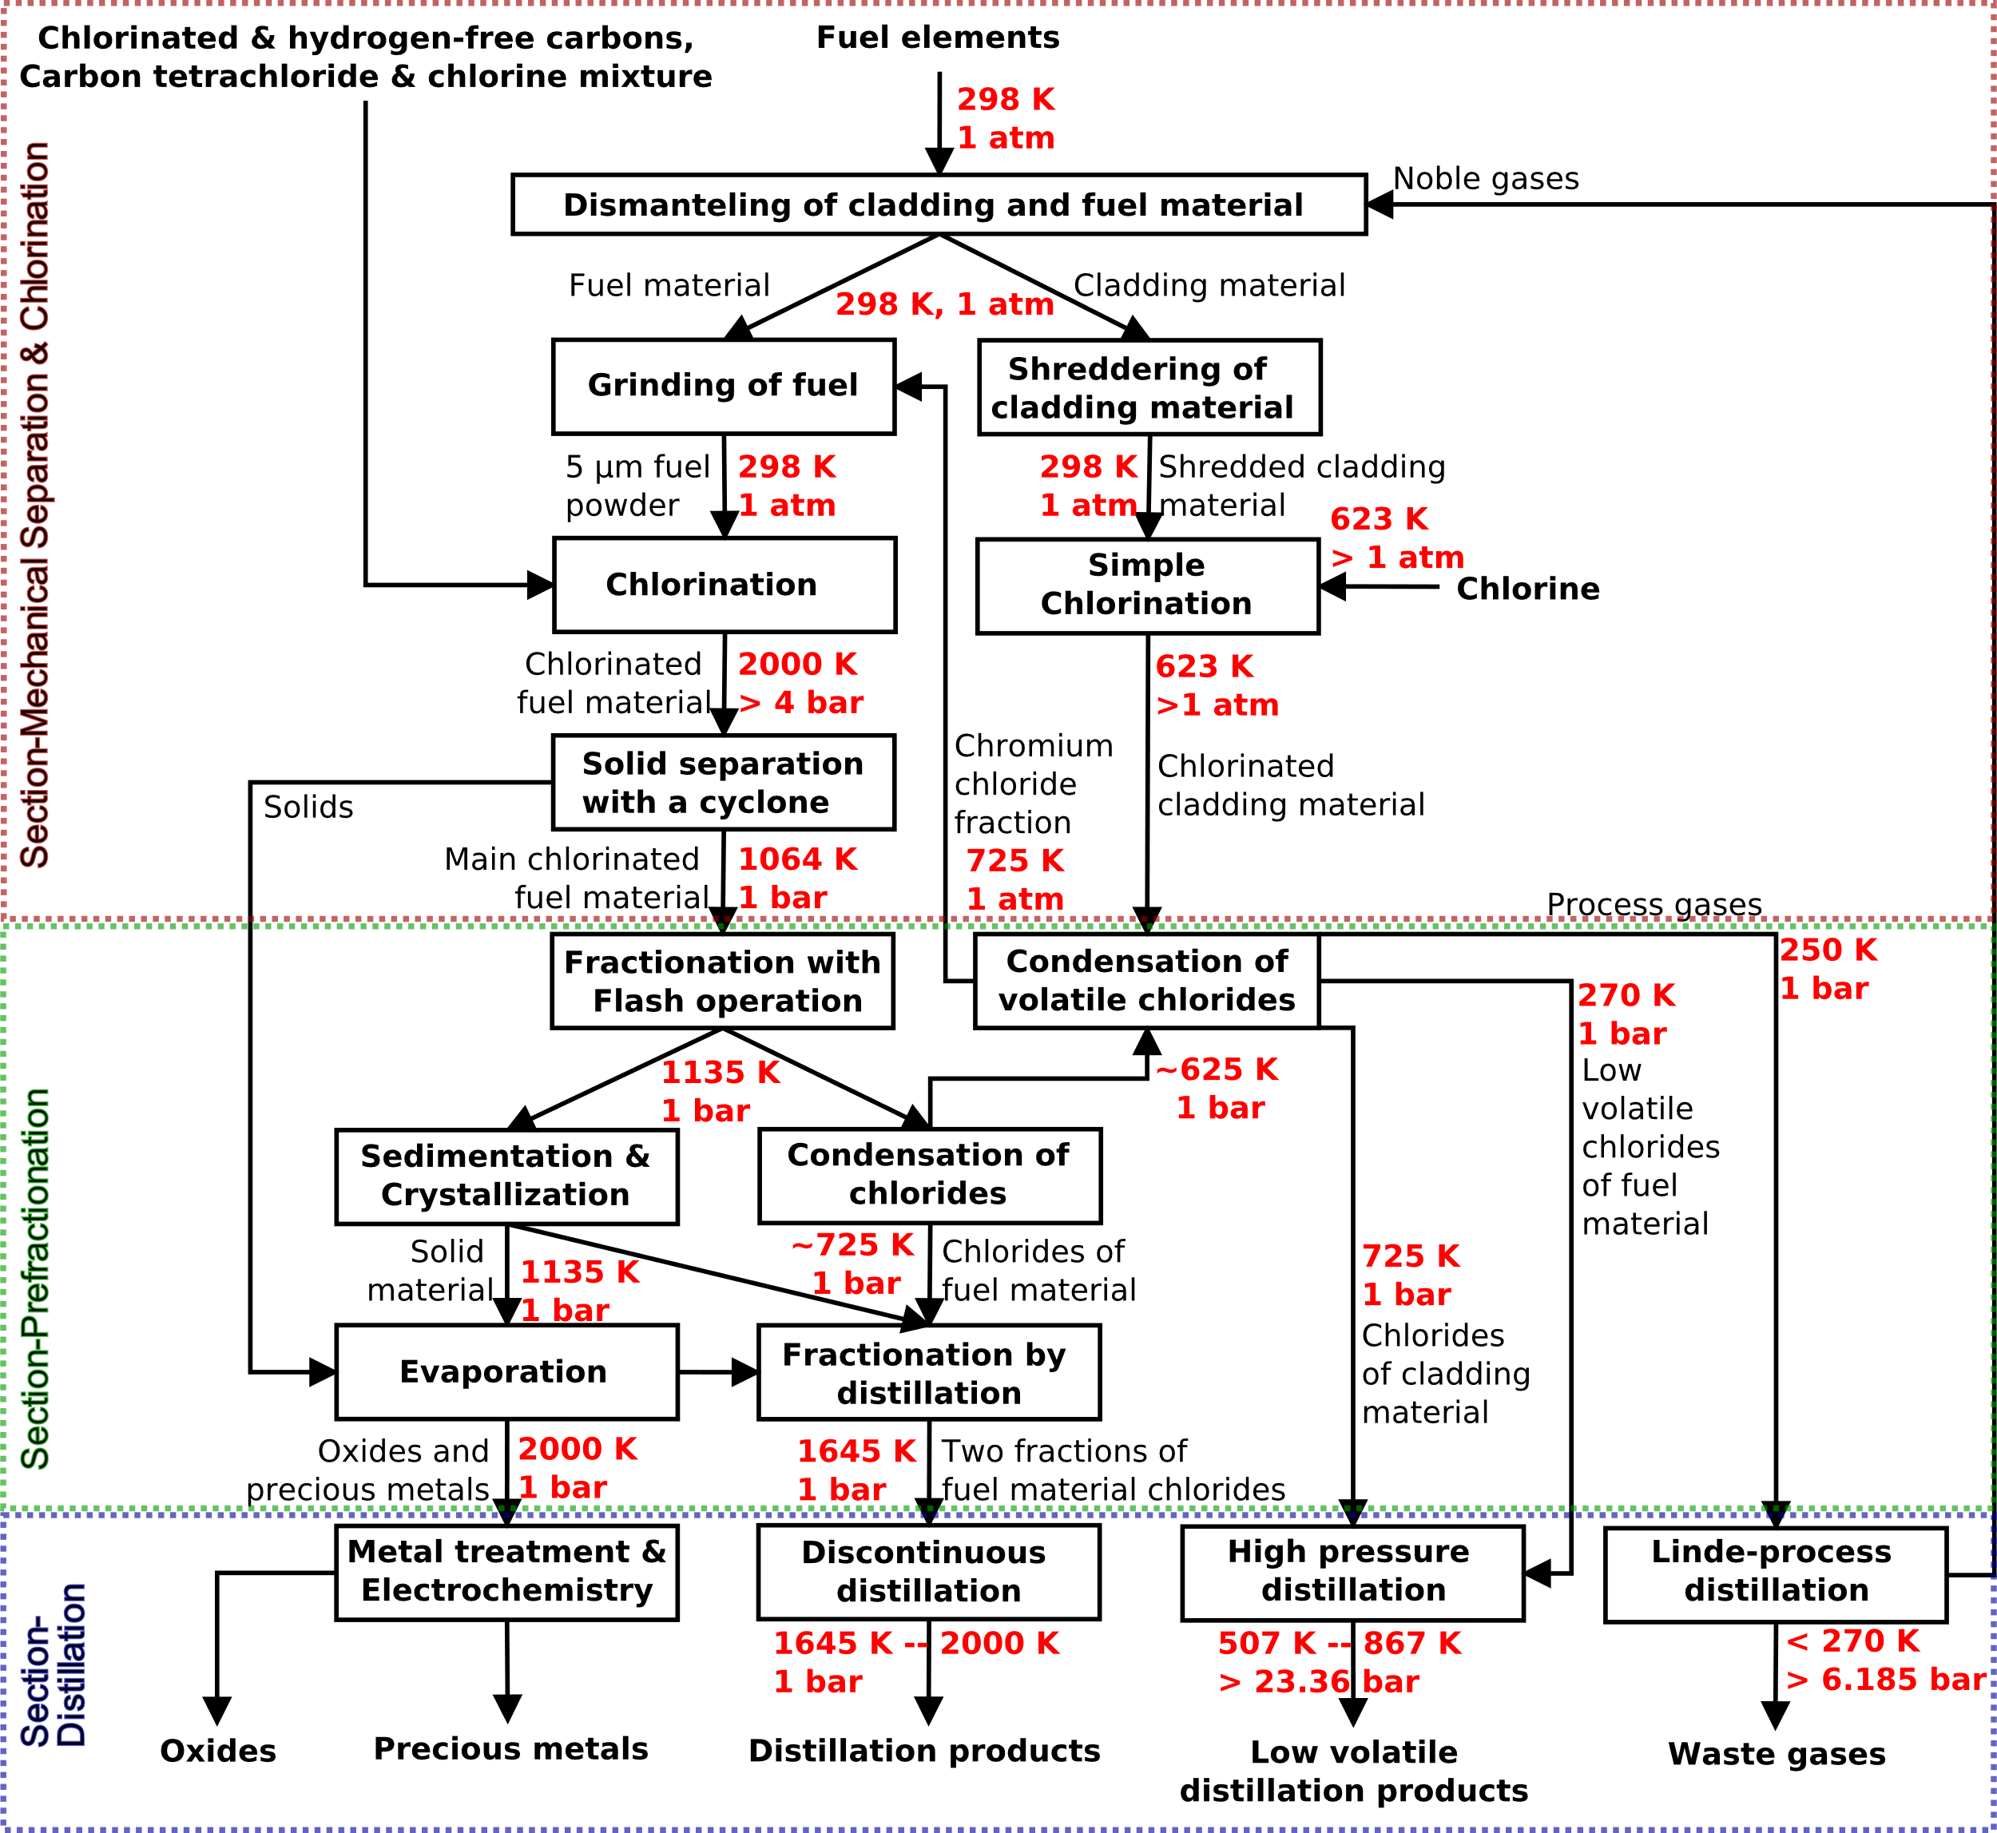
FIG. 1. Overview of the developed separation concept as Pyrochemical Processing Unit (PPU)

Processes on the left refer to the hot side of the process, while the right describes the cold side. The cold side of the process includes condensation (in Fig. (1) Condensation of chlorides and Condensation of volatile chlorides), high pressure distillation and off-gas Linde process distillation at temperatures below 0°C in some cases. All process steps from Fig (1) are operated at 1 bar pressure, except for the chlorination of the fuel material at a pressure of at least 4 bar, the high-pressure distillation and the Linde process distillation. For both distillation units, higher pressures are required to produce a liquid phase for some components. For high pressure distillation these are zirconium tetrachloride at pressures above 23.36 bar and in the Linde Process distillation process to liquefy carbon dioxide at pressures above 6.185 bar. Besides that, the continuous fractionation unit shown in Fig. (1) in the section of Prefractionation is used for the main chlorides to first obtain the easily separable ternary mixture of neptunium tetrachloride, uranium tetrachloride and cadmium dichloride as the largest starting fraction of at least 95-mol% starting from the original UNF feed material.

Mechanical Separation and Chlorination
A mechanical pre-separation unit according to Fig. (1) (Dismantling of cladding material) is necessary to separate the fuel material from the cladding zirconium alloy of the fuel element, as described in [3]. This pre-separation unit can be operated at standard conditions of 298 K and 1 atm. Furthermore, after dismantling of the cladding material, grinding of the fuel material to 5 µm is performed within a ball mill [3]. The zirconium cladding material is shredded in a parallel separated processing route, as shown in Fig. (1). Detailed information on the design and description of the mechanical separation unit is available in [3]. Because the fuel material consists mainly of oxide with at least 95-mol% of uranium oxide, chlorination is performed by mixtures of chlorine and hydrogen-free chlorinated carbon compounds, preferably carbon tetrachloride. For uranium, the following chemical reaction equation applies

UO₂(s) + CCl₄ → UCl₄(g) + CO₂(g) (2)

It should be noted that measures for electrostatic charging and explosion protection regarding dusts in general must be taken in general in all chlorination steps. The chlorination of the fuel material occurs at 2000 K and pressures above 4 bar in a type of plasma torch or fluidized bed, as described in more detail in [4].
Simplifying calculations for chlorination have been done assuming equilibrium reactions in a shrinking core model in [4]. Unchlorinated material in the form of dust and agglomerated solids must also be separated. For this purpose, the larger agglomerated particles according to [22] with an average diameter > 10 µm can be mechanically separated in a simple cyclone (solid separation with a cyclone, Fig. (1)). The unchlorinated fine dust (< 10 µm) should be separated in a kind of wet scrubber at low temperatures. However, it is assumed in a simplified manner that after cooling to 1064 K and by means of spray devices in a pressure relief in "Fractionation with flash Operation" Fig. (1), including settling tank, the dust material is transferred in the melt by 95-mol%. For this purpose, it must be urgent ensured for the dust residual amount not to leave the separation plant.
For the zirconium cladding material, simple chlorination at 623 K and 1 atm is sufficient, as shown by equilibrium calculations and data from [23] for the ingredients zirconium and tin. Even under the pessimistic assumption that adherent fuel material impurities are present on the cladding material, they are not co-chlorinated under these process temperature and pressures conditions with chlorine and can be condensed out together with chromium as chromium dichloride in the unit Condensation of volatile chlorides as shown in Fig. (1) (Section-Prefractionation) at 725 K. The separated amount of residual fuel material can be fed to the chlorination step to the fuel material separation route. All calculations for chlorination of the cladding material were also handled under simplifying assumptions of chemical reaction equilibria (simple chlorination Fig. (1)).

Required pre-fractionation for the applicability of distillation
The main purpose of fractionation in single-flash operation, including pressure reduction, is not only to transfer the dust into the liquid phase, but also to ensure a separation cut between volatile substances below the boiling point of uranium tetrachloride, and as well as solids with very high boiling points, into one single distillation apparatus which additionally divides the mixture as equimolar as possible. This is also shown by the extract of the melting and boiling points of some important substance compounds according to Fig. (2). Here, the volatile chlorides are the tetrachlorides of tin, selenium, tellurium and zirconium. The solids involved are substance components with very high boiling points, such as precious metals, like palladium, rhodium, ruthenium, technetium and molybdenum, but also unchlorinated material, such as uranium dioxide. Those solids are sieved out in the sedimentation & crystallization unit. Adherent chlorides are removed by the evaporator and returned to the main fractionated distillation unit. The defined volatile chlorides are separated from the process gases and the and the other chlorides into a single two-stage condensation process. For this purpose, all non-volatile substances are condensed out at 725 K from the vapor stream. Subsequently, the volatile chlorides of the fuel material are condensed out at temperatures below 0°C. However, for the zirconium cladding material, the non-volatile components with boiling points above zirconium tetrachloride, such as chromium in a chromium chloride fraction at 725 K and 1 bar, are fed into the fuel material grinding unit of the hot fuel processing side .

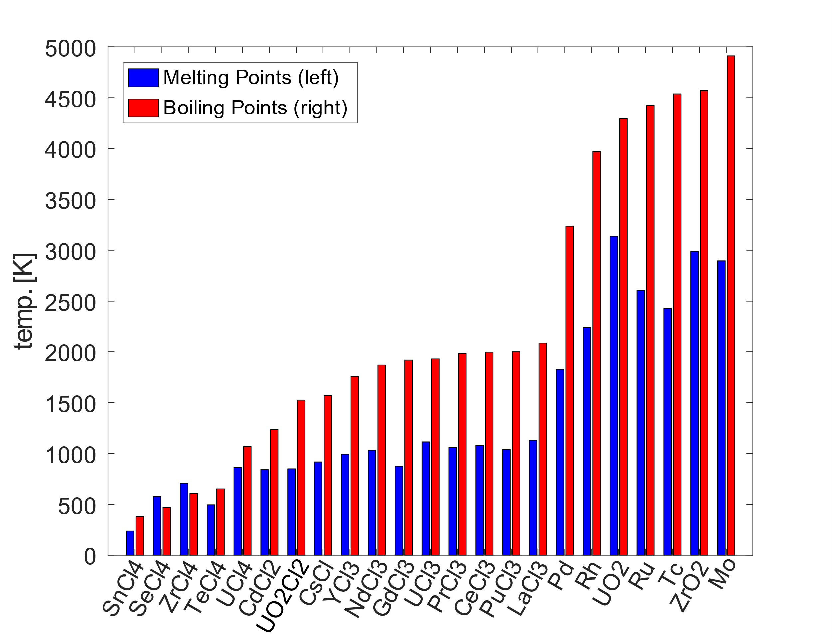
FIG. 2. Example overview of some representative melting and boiling points of the most important involved chlorinated fission product compounds of U-235; Source of the data:[20] and from secondary references in [3],[4].

For all following simulations of the flow chart from Fig. (1), a feed mixture from fission product mixtures of 98-mol% U-235, 1-mol% Pu-239 and 1-mol% of actinides from [21] was used. The separated chloride compounds from the simulation results of the Section-Prefractionation from Fig. (1) are summarized in Table (1). The separation accuracy was set to 2.5E-06 of mole fraction value.
It can be seen from Table (1) of the simulation result summary that the fractionation into four groups of section distillation can be successfully implemented in the pre-fractionation and the given separation accuracy:
- All solids are obtained in the evaporation step according to Table (1);
- The main chlorides are completely collected from the units of evaporation, sedimentation & crystallization and main condensation of chlorides compared to Fig. (1) and Table (1) and enter the unit of fractionation by distillation;
- The volatile zirconium-containing chlorides of the separation unit from condensation of volatile chlorides and condensation of chlorides, are obtained according to Table (1) from the volatile chloride separation of the liquid phase and the cladding material residual fuel amount separation of the vapor phase.
The separation of the precious metals, such as rhodium is done by a metal separation processes and/or by electrochemical separation methods. This separation step is the only one which was not yet detailly investigated.

TABLE 1. SUMMARY OF SIMULATION RESULTS OF THE PREFRACTIONATION UNIT.

Separation Unit | Vapor  (only) | Vapor & Liquid  (Vapor dominated) | Liquid & Vapor  (Liquid dominated) | Liquid  (only)
Fractionation with Flash operation | Ne, Xe, Ar, CO₂, SnCl_{2/4}, SbCl_{3/5}, SeCl_{2/4}, MoCl₅ | TeCl₂, TeCl₄, ZrCl₄, NpCl₄, UCl₄ | CdCl₂, CmCl₃, SmCl_{2/3}, AmCl₃, CsCl, YCl₃, NdCl₃, CeCl₃, PuCl_{3/4} | SrCl₂, BaCl₂, GdCl₃, PrCl₃, LaCl₃, Pd, Rh, Tc, Mo, UO₂, ZrO₂
Condensation of chlorides | Ne, Ar, Xe, CO2, SnCl2/4, SbCl3/5, MoCl5, TeCl2/4, ZrCl4 |  | UCl₄ (first column) | NpCl₄, UCl₄ (second column), CdCl₂, CmCl₃, SmCl_{2/3}, AmCl₃, CsCl, YCl₃, NdCl₃, CeCl₃, PuCl_{3/4}
Volatile chloride Separation | Ne, Ar, Xe, CO₂ |  | SnCl_{2/4} | SbCl_{3/5}, MoCl₅, TeCl_{2/4}, ZrCl₄
Cladding material residual fuel amount separation | SnCl_{2/4}, NbCl₅, FeCl_{2/3}, Fe₂Cl₆, ZrCl₄ |  |  | CrCl_{2/3}, UO₂
Separation Unit | Liquid  (only) | Liquid & Solid  (Liquid dominated) | Solid & Liquid  (Solid dominated) | Solid  (only)
Sedimentation & Crystallization | CdCl₂, UCl₄, GdCl₃, CsCl, SmCl_{2/3}, CmCl₃, SrCl₂, AmCl₃, YCl₃, NdCl₃, PuCl_{3/4}, PrCl₃, CeCl₃, LaCl₃ |  | BaCl2, Pd | Rh, Tc, Ru, Mo, UO₂, ZrO₂
Separation Unit | Vapor  (only) | Vapor & Solid  (Vapor dominated) | Solid & Liquid  (Solid dominated) | Solid  (only)
Evaporation | BaCl₂ |  |  | Pd, Ru, Rh, Tc, UO₂

Distillation procedure and simulation
For all distillation systems, total reflux distillation columns were used for all simulations of distillation columns. According to Fig. (1), the following distillation systems were summarized to be simulated with serial used total reflux distillation columns:
- The main distillation as fractional distillation at 1645 K and the discontinuous distillation at 1645 K - 2000 K at 1 bar with constant assumed column pressure;
- The high-pressure zirconium fractional distillation at 507 - 867 K and pressures of 23 bar;
- Linde process noble gas recycling plant at temperatures below 270 K and pressures above 7 bar to recover argon.
Fig. (3) shows an excerpt of the simulation results for the first distillation column, where all fewer volatile components have been combined to form the uranium trichloride fraction and the initial feed composition is set on the third distillation stage. The summary of the results on enriched top (first separation stage) and bottom (last separation stage) distillation product, as well as the complete simulation results are given in table (2). Here, the separation accuracy of the separated fraction is set very high with a molar fraction impurity limit of 1E-07. Fig. (3) clearly shows that uranium tetrachloride can be enriched to high purity in the ppm range with as few as seven separation stages. The mole fraction value is no longer recognizable for uranium tetrachloride in the seventh separation stage, despite logarithmic axis plotting. Cadmium dichloride and cesium chloride are the medium boiling components which circulate within the distillation column due to condensation and evaporation. After separation of the enriched fractions, the separation of the remaining chlorides or the distillate products is repeatable within the same number of stages, of the same column. The results for a simple series connection in the same feed template examples from the previous section are given in Table (2), including the stage height. Per stage height, it can be approximated as a heuristic that the distillation per separation stage should be similar to those of titanium tetrachloride distillation according to [10]. From [10], the so-called HETP (Height Equivalent to Theoretical Plate) is used as the height value of a separation stage, in which to estimate the total column height $H = \text{HETP}⋅n_{th}$ as an estimation equation with $n_{th}$ as the total number of stages. This HETP value ranges from 0.203 m to 0.630 m.
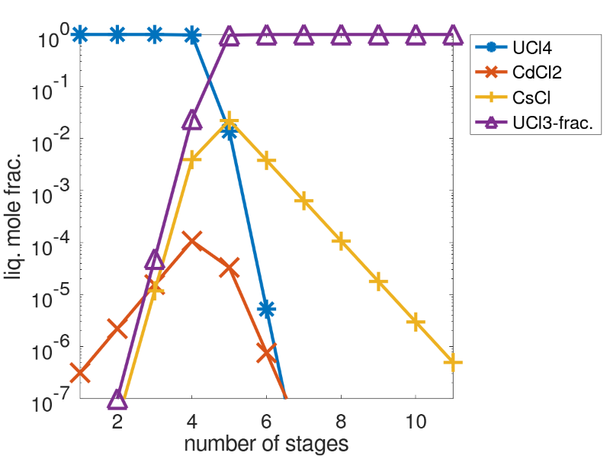
FIG. 3. Summarized simulation result of the first total reflux column for the discontinuous distillation unit
From the results of the first simulation series according to Table (2), uranium tetrachloride can be separated together with neptunium tetrachloride. First, a mixture of neptunium tetrachloride is separated in the discontinuous distillation, followed quickly by uranium tetrachloride of high purity due to the small amounts of neptunium tetrachloride. Cadmium dichloride is also separable with high purity. Plutonium trichloride is also very separable, but in combination with lanthanum, cerium, and praseodymium trichloride. Cerium and praseodymium trichloride also form other separation fractions by selecting the indicated number of stages according to Table (2) in column repetition VI together with more volatile gadolinium and neodymium trichloride. Caesium chloride contaminated with another very small fraction of strontium dichloride can be easily separated with high purity without the presence of americium, samarium, and curium trichloride. With the presence, however, separation fractions III and IV are formed, with fraction IV containing only minor amounts of cesium chloride.

TABLE 2. FIRST SERIES: DISTILLATION SIMULATION RESULTS OF MAIN CHLORIDES

Column  repetition | Separated Chlorides: (mole fraction value range): Separation accuracy: 1E-07 | Number  stages | Column  height [m] | TOP Temperature  (Top distillate) [K]
I | UCl₄ (10⁻¹-10⁰), NpCl₄ (10⁻¹-10⁰) | ~6-8 | 1.22 – 5.04 | ~1051 – 1068
II | CdCl₂ (high pure) | ~15-16 | 3.05 – 10.08 | ~1236.0
III | CsCl (10⁻¹-10⁰), CmCl₃ (10⁻¹-10⁰),  SmCl₃ (~10⁻⁵) | ~18 | 3.65 – 11.34 | ~1409 – 1464
IV | SrCl₂ (10⁻¹-10⁰), AmCl₃ (10⁻¹-10⁰),  CsCl (~3x10⁻⁴) | 16-21 | 3.25 – 13.23 | ~1463 – 1569
V | NdCl₃ (8x10⁻¹-10⁰), BaCl₂ (~10⁻⁴),  YCl₃ (10⁻⁴) | ~16 | 3.25 – 10.08 | ~1756 – 1898
VI | CeCl₃ (9x10⁻¹-10⁰), PrCl₃ (5x10⁻²-10⁰),  GdCl₃ (10⁻⁴-10⁻³), NdCl₃ (10⁻⁶-10⁻⁵) | ~16 | 3.25 – 10.08 | ~1981 – 2000
VII | LaCl₃ (10⁻¹-10⁰), PuCl₃ (10⁻¹-10⁰),  CeCl₃ (10⁻²-10⁻¹), PrCl3 (5x10⁻³-10⁻²), GdCl3 (<10⁻⁵) | 13-16 | 2.64 – 10.08 | ~2060

Discussion of management strategies in dealing with UNF material
Based on the simulation results, four options for handling UNF were established. Already from the simulation results of the section Prefractionation according to table (1) of the flow diagram Fig. (1), a rough separation of the active elements like plutonium is possible. Other separable components are ⁹⁰SrCl₂, ¹³⁷CsCl, ²⁴¹AmCl₃, ²⁴⁴CmCl₃ and ²³⁸PuCl₃. However, this allows only a small reduction of maximum 15-mol% in the storage volume. With the application of section distillation, three further options are available:

- 50-vol% reduction of a final repository for UNF can be achieved by applying distillation through the separation into single fractions, mostly by element.
- Processing of waste is only related to high purity uranium tetrachloride separation and refeeding of actinides into a liquid fuel reactor. After separation only small amounts of fission products remain, which reduces the neutron absorption in the fuel. The residual 1 – 5 -vol% of material can be stored. For this, a fractionation of Pu as plutonium trichloride together with lanthanum, cerium, praseodymium trichloride is required.
- Almost complete recycling of UNF and reusing of all material in a liquid fuel reactor until all long-lived radioactive isotopes have been transmuted and no final repository is needed.

Option (a) can only be fully utilized if the distillation is completely carried out based on the simulation results from table (2). In option (b), variations of the distillation separation accuracy are available. In the case where only uranium tetrachloride is removed along with possible small amounts of neptunium tetrachloride, only 5-vol% of repositories are needed. But with final increasing of distillation application intensity, the final repository volume can be reduced to only 1-vol%.
For options (b) and (c), the processing by conversion of radioactive waste, mainly from UNF material, including its full-scale cladding material recycling, will result in a fundamental change in the strategy of radioactive waste management. For a worldwide inventory of 370,000 t of such waste material, it is possible to operate with 6 plants of distillation separation unit together with a feeding of a fuel reactor, such as the Dual Fluid Reactor, each with a possible industrial reprocessing scale capacity of 1000 t/a for about 60 to 65 years, to highly reduce the waste by the above amounts of the options in (b) and (c). In this case, the reprocessing of the spent fuel can be done continuously. For Germany alone, with an inventory of 19,000 tons, a single unit can be operated for twenty years to completely reduce the waste.

Conclusion and future aspects
The simulation results of this work have shown that distillation-based separation processes have great potential to sustainably recover undiluted UNF material including zirconium cladding material directly without the addition of solvents or extractants. For this purpose, the pre-fractionation, which is also distillation and crystallization based, can be converted into four separation mixtures of, i) solids of unchlorinated material and precious metals, ii) major components of nuclear chlorinatable materials in the fuel material, iii) cladding components and volatile chlorides from fuel material, and vi) off-gas cleaning for noble gas recovery without having to use further additives apart from the chlorination material. With the combination of liquid fuel reactors, such as the Dual Fluid Reactor, allowing the complete consumption of nuclear fuel waste, it is possible to open numerous new strategic fields in the management of radioactive waste. In the future it is even possible to use this separation technology completely and to avoid final disposal for the most part. Also mixed forms in disposal reduction and material separation are also possible alone or together with further utilization in liquid fuel reactors. The separation process is also flexible enough to be used for varying fuel element compositions.

References
- Estimation of Global Inventories of Radioactive Waste and Other Radioactive Materials, IAEA-TECDOC-1591, IAEA, Vienna 2008, ISBN: 978–92–0–105608–5
- Status and Trends in Spent Fuel and Radioactive Waste Management, No. NW-T-1.14 (IAEA Nuclear Energy Series), IAEA, Vienna 2018, ISBN: 978–92–0–108417–0
- BÖHM, D. et al., Partitioning of nuclear waste by fractionated distillation, 150153 Report of NuDest Reactor Safety Research-Project, Institute for Solid-State Nuclear Physics gGmbH, 2019
- BÖHM, D. et al., New methods for nuclear waste treatment of the Dual Fluid Reactor concept, Acta Physica Polonica B, 51 (2020), 893–898
- BAISDEN, P. A., CHOPPIN, G. R., A., Nuclear waste management and the nuclear fuel cycle, Radiochemistry and nuclear chemistry, 2007
- PAIVA, A. P., MALIK, P., Recent advances on the chemistry of solvent extraction applied to the reprocessing of spent nuclear fuels and radioactive wastes, Journal of Radioanalytical and Nuclear Chemistry, Springer Nature, 261 (2004), 485-496
- HUKE, A., el al., The Dual Fluid Reactor - A novel concept for a fast nuclear reactor of high efficiency, Annals of Nuclear Energy, Elsevier BV, 80 (2015), 225-235
- HUKE, A., el al., Dual-Fluid Reactor, Molten Salt Reactors and Thorium Energy, Elsevier, (2017), 619-633
- SIERCHUŁA, J. S., Determination of the liquid eutectic metal fuel Dual Fluid Reactor (DFRm) design – steady state calculations, International Journal of Energy Research, Wiley-VCH, 43 (2019), 3692-3701
- STODDARD, C. K., Pietz, E., Pilot-plant distillation and purification of titanium tetrachloride, Report of investigations, United States Bureau of Mines. (1947)
- KIM, I.S., et al., Evaporation of CsCl, BaCl2, and SrCl2 from the LiCl–Li2O molten salt of the electrolytic reduction process, Journal of Radioanalytical and Nuclear Chemistry 303, 1 (2014), 223—227
- LEE, J.-H., et al., Electrodeposition Characteristics of Uranium in Molten LiCl-KCl Eutectic and its Salt Distillation Behaviour, Journal of Nuclear Science and Technology 43, 3 (2006), 263—269
- PARK, S. B., et al., Investigation of the evaporation of rare earth chlorides in a LiCl–KCl molten salt, Journal of Radioanalytical and Nuclear Chemistry 287, 2 (2010), 603—608
- EUN, H. C., et al., Study on a separation method of radionuclides (Ba, Sr) from LiCl salt wastes generated from the electroreduction process […], Journal of Radioanalytical and Nuclear Chemistry 292, 2 (2011), 531--535.
- EUN, H. C., et al., An improvement study on the closed chamber distillation system for recovery of renewable salts from salt wastes containing radi […], Journal of Radioanalytical and Nuclear Chemistry 295, 1 (2012), 345—350
- YANG, H.-C., et al., Closed Chamber Salt Distillation System for an Enhanced Recovery of Evaporated Pure Salt, Journal of Nuclear Science and Technology 47, 11 (2010), 973--976.
- CARTER, W., LINDAUER, R., MC NEESE, L., Design on an engineering-scale, vacuum distillation experiment for molten-salt reactor fuel, Report of investigations, Oak Ridge National Laboratory, (1968)
- PRESS, W., et al., Numerical recipes in C++: The art of scientific computing, Cambridge University Press, (2002),
ISBN: 978-0521750332
- PERRY, R., GREEN, D., Perry's Chemical Engineers Handbook 7th, Section 13 : Distillation; Distillation perry's chemical engineering, McGraw-Hill, New York, (1997)
- RUMBLE, J., CRC Handbook of Chemistry and Physics, 99th Edition, CRC Press, (2018), ISBN: 978-1138561632
- NICHOLS, A. L., ALDAMA, D. L., VERPELLI, M., Handbook of nuclear data for safeguards: Database extensions, August 2008, IAEA: INDC(NDS)-0534 (Distr. SQ), International Nuclear Data Committee, Vienna (2008)
- BANK, M., Basiswissen Umwelttechnik Wasser, Luft, Abfall, Lärm und Umweltrecht,Vogel, Wuerzburg (2007), ISBN: 978-3834330604
- Collins, E., et al., Process Development Studies for Zirconium Recovery/Recycle from used Nuclear Fuel Cladding, Procedia Chemistry, Elsevier BV, 7 (2005), 72-76, DOI: 10.1016/j.proche.2012.10.013

