THE IMPACT OF RADIATION LOADS ON THE STRUCTURE AND PROPERTIES OF THE CEMENT COMPOUND AS A PROMISING MATRIX FOR THE IMMOBILIZATION OF HIGH-LEVEL WASTE
A.P. Varlakov
JSC «High-technology scientific research institute of inorganic materials named after A. A. Bochvar» Moscow, Russia
Email: varlakov_a@mail.ru

A.V. Germanov
JSC «High-technology scientific research institute of inorganic materials named after A. A. Bochvar» Moscow, Russia

A.A. Zherebtsov
JSC «Proryv»
Moscow, Russia

Abstract

The paper presents of evaluation of the effect of high doses of ionizing radiation on cement compounds based on Portland cement and granulated blast furnace slag with included imitators of high-level liquid and solid waste of various morphologies synthesized by hot isostatic pressing. For this purpose, the parameters of physical and chemical properties, phase composition, and morphology of the samples were measured. The measurements were carried out before and after irradiation of electrons and alpha particles up to the absorbed dose of 10⁹ Gy and 10¹⁹ decay/g. It is shown that cement compounds retain strength properties, chemical resistance, composition, and microstructure. They are also resistant to ionizing radiation doses equivalent to high-level waste.

INTRODUCTION
The development of a unified technology for turning waste of various levels of activity (including high-level waste (HLW)) into a safe state is a promising task. The implementation of this task will significantly increase the efficiency of radioactive waste (RW) conditioning within one enterprise. The proposed method should allow to obtain the product with reliable RW fixation in the matrix. The matrix should satisfy the regulated requirements of the acceptance criteria, resist to ionizing radiation during storage, and have low cost.
The widespread use of cement materials in constructions at nuclear and radiation-hazardous facilities gives reason to talk about the potential possibility of using a cement matrix for HLW immobilization.
A comprehensive assessment of the effect of radiation load equivalent to a dose of ionizing radiation of HLW during their storage on the properties, phase composition, and microstructure of cement compounds based on Portland cement was held. The results of previous studies [1-4] confirmed the stability of a cement matrix, including a waste simulator, to irradiation up to a dose of 100 MGy.
So far, an important task is to expand the range of mineral binders as matrix materials for the immobilization of RW with improved technical and physical properties and low cost. Granulated blast furnace slag can be considered as such type of cement [5, 6].
The purpose of this study was to evaluate the regulated properties, composition, and structure of cement matrices based on Portland cement and blast furnace slag after irradiation with electrons and alpha particles to a dose of 1 GGy and 10¹⁹ decay/g.

SUBJECTS AND RESEARCH METHODS
The subjects of the study were cement compounds based on Portland cement (PC) with or without bentonite clay powder (DB) and blast furnace slag (BS). Compounds were prepared with simulator of liquid and solid RW. A water-cement ratio (W/C) was a 0.2. The addition of bentonite clay was taken into account in the total weight of the binder in the amount of 5% by weight.
The composition of the radioactive waste simulator corresponded to the composition of HLW on the PA Mayak [7], g/l: NaNO₃ 318.8; CsCl 27.6; KCl 4.3; Al(OH)₃ 20.8; HNO₃ 50.4. The solution was acidified to pH=2 with the solution of nitric acid. A simulator of highly active LRW with an alkali solution was added to the slag. In order to prepare simulators of solid waste of various morphologies (fuel element shells, gas purification filter materials, laboratory tools, and plastic), mixture of a crushed metal, glass, plastic, and fabric was prepared and placed in capsules in an amount of 20 vol.%.
Hot isostatic pressing (HIP) was used for the synthesis of cement matrices with HLW in a hermetic container. HIP makes it possible to obtain materials with a high density and a uniform structure than when compacting by other method.
The outcome of the HIP process is the change of the initial volume of material to take a more compact form. This happens due to reduction of the voids in the material as well as the plastic deformation of the particles. The desired values of pressure, exposure period, and temperature are selected based on the required density of the final product.
The combined application of cementing technology and HIP for radioactive waste has a serious potential for realization and should be scientifically studied.
The matrices were synthesized in sealed cylindrical stainless steel capsules by the HIP method under 200-300 °С and with a pressure of 50-100 MPa (Table 1).

TABLE 1. SYNTHESIS OF THE CEMENT COMPOUNDS WITH W/C=0.2 BY THE HIP METOD

Composition | Bonding agent | Additive | Grouting fluid | Synthesis conditions by HIP
1 | PC | ― | Simulator | 50 MPa, 200 °С
2 | PC | ― | Simulator | 100 MPa, 300 °С
3 | PC | DB | Simulator | 50 MPa, 200 °С
4 | PC | DB | Simulator | 100 MPa, 300 °С
5 | BS | ― | Simulator with alkali | 50 MPa, 200 °С
6 | BS | ― | Simulator with alkali | 100 MPa, 300 °С
Simulator, g/l: NaNO₃ 318.8; CsCl 27.6; KCl 4.3; Al(OH)₃ 20.8; HNO₃ 50.4

Parameters of a special capsule for matrix synthesis: height – 200 mm, outside diameter – 65 mm, wall thickness-4 mm. The appearance of the capsule before and after the treatment of the HIP is shown in Fig. 1.

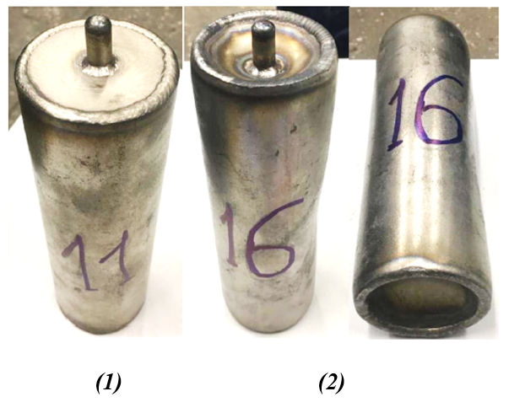
FIG. 1. Deformation of the capsule with mixtures based on cement or slag after HIP at a temperature of 300 °C and a pressure of 100 MPa: 1 –the capsule before HIP, 1 –the capsule after HIP.

The capsules were opened 7 days after pressing. They were sawed, the cement compound was extracted and samples were given the form of cubes (10x10x10 mm) and plates (10x10x3 mm) by cutting.
The mechanical strength, frost resistance, and resistance of matrices to thermal loads, chemical, and radiation resistance were measured using standard methods.
Compressive strength was determined on the Testing Cybertronic testing machine (Germany), frost resistance was evaluated by periodic freezing-thawing of samples using the REOCAM TC-64 heat-cold test chamber (Russia), followed by determination of compressive strength. The leaching rate was used as a parameter for assessing chemical resistance. An atomic absorption spectrometer «KVANT-2A» (Russia) was used to analyze the content of cesium ions in leaching water. The effect of thermal loads on the stability of cement matrices was evaluated by holding samples at a temperature of 120 °С, followed by determining the compressive strength.
The samples were exposed to electron irradiation on the PTM-55 microtron (Russia) by alpha-particles on the HVEE cascade accelerator (Holland) until reaching the values of the absorbed doses of 10⁹ Gy and 10¹⁹ decay/g.
The phase composition of the samples was determined by X-ray phase analysis on a Bruker D8 Advance diffractometer (Germany). The morphological characterization of the samples was carried out using a scanning electron microscope JSM 6480 LV (Japan) at an accelerating voltage of 3-20 kV in the secondary electron mode.

RESULTS AND DISCUSSION
Table 2 presents the tests results obtained during the tests of cement compounds samples of compressive strength, frost resistance, and resistance to thermal loads. The strength of all samples increases within the period of 28 days. There is no effect of bentonite clay powder addition, simulator composition, synthesis mode on the strength characteristics. The strength of the samples did not depend on temperature.
Samples after the tests of frost resistance and resistance to thermal loads were compared to the control samples (samples which were hardened under air-wet conditions with equal hardening age). The loss of strength was 10 and 8% on average, respectively.

TABLE 2. COMPRESSIVE STRENGTH (AVERAGE MEASUREMENT) OF CEMENT COMPOUNDS OBTAINED BY THE HIP AND AFTER FROST RESISTANCE TEST AND RESISTANCE TO THERMAL LOADS

Composition | Hardening age, MPa |  |  | During the frost resistance test, MPa |  | During the thermal loads resistance test, MPa
 | Day 7 | Day 14 | Day 28 | Control compound with equal hardening age | After the test |  | Control compound with equal hardening age | After the test
1 | 8.4±0.7 | 10.8±1.1 | 15.4±1.5 | 15.5±1.5 | 14.0±1.5 |  | 15.4±1.5 | 13.8±1.4
2 | 8.9±0.9 | 11.1±1.1 | 15.6±1.5 | 15.6±1.5 | 14.2±1.5 |  | 15.6±1.5 | 14.0±1.4
3 | 7.8±0.7 | 9.5±0.9 | 13.6±1.3 | 13.8±1.3 | 12.3±1.3 |  | 13.6±1.3 | 12.4±1.2
4 | 7.9±0.7 | 9.6±0.9 | 13.9±1.4 | 14.0±1.4 | 12.5±1.4 |  | 13.9±1.4 | 12.3±1.2
5 | 8.9±0.9 | 9.8±0.9 | 14.4±1.4 | 14.5±1.4 | 13.0±1.4 |  | 14.4±1.4 | 13.5±1.3
6 | 9.2±1.0 | 10.0±1.0 | 14.6±1.5 | 14.6±1.5 | 13.0±1.5 |  | 14.6±1.5 | 13.6±1.4

A comprehensive assessment shows that the cement samples with HLW simulators of various morphologies meets the regulated requirements [8]. Their compressive strength is higher than the regulated value – at least 10 MPa and losses during the testing are not more than 20%.
Table 3 lists the results of testing cement mixtures of chemical resistance. In general, leaching rate of Cs⁺ for cement compositions with the addition of bentonite clay (3, 4) is lower than leaching rate for cement compositions without the addition (1, 2) by two orders of magnitude. Temperature and pressure increase during the synthesis by the HIP method provides no negative effect on chemical resistance.

TABLE 3. Cs⁺ LEACHING RATE FROM CEMENT COMPOUNDS OBTAINED BY THE HIP

Composition | Days
 | 1 | 3 | 7 | 10 | 14 | 21 | 28
 | Leaching rate, g/(cm²·day)
1 | 9.2·10⁻² | 5.8·10⁻³ | 3.3·10⁻³ | 1.7·10⁻⁴ | 9.7·10⁻⁵ | 5.9·10⁻⁵ | 2.1·10⁻⁵
2 | 8.6·10⁻² | 5.5·10⁻³ | 3.0·10⁻³ | 1.4·10⁻⁴ | 9.2·10⁻⁵ | 5.5·10⁻⁵ | 1.8·10⁻⁵
3 | 4.2·10⁻³ | 2.5·10⁻⁴ | 1.5·10⁻⁴ | 7.0·10⁻⁵ | 4.2·10⁻⁶ | 2.2·10⁻⁶ | 7.2·10⁻⁷
4 | 3.7·10⁻³ | 2.2·10⁻⁴ | 1.2·10⁻⁴ | 6.8·10⁻⁵ | 3.5·10⁻⁶ | 1.9·10⁻⁶ | 5.0·10⁻⁷
5 | 7.7·10⁻³ | 4.2·10⁻⁴ | 2.4·10⁻⁴ | 1.1·10⁻⁵ | 6.4·10⁻⁶ | 3.0·10⁻⁶ | 8.8·10⁻⁷
6 | 7.3·10⁻³ | 4.0·10⁻⁴ | 2.2·10⁻⁴ | 1.0·10⁻⁵ | 6.0·10⁻⁶ | 2.8·10⁻⁶ | 6.6·10⁻⁷

Studies of the samples were carried out before and after electron irradiation to an absorbed dose of 10⁸, 5·10⁸, 10⁹ Gy and alpha-particles to an absorbed dose equivalent to 10¹⁸, 5·10¹⁸, 10¹⁹ decay/g. There were no damages, cracks after a visual assessment of compounds. The parameters of compressive strength (Table 4) and leaching rate of cesium ions (Table 5) were identified as criteria for evaluating properties.

TABLE 4. COMPRESSIVE STRENGTH (AVERAGE MEASUREMENT) OF CEMENT COMPOUNDS SUBJECTED TO RADIATION WITH ELECTRONS UP TO A DOSE OF 10⁹ Gy

Composition | Compressive strength of the compound, MPa
 | Electrons, Gy |  |  |  | After 30 freezing/thawing cycles
 | 0 | 10⁸ | 5·10⁸ | 10⁹
1 | 15.5±1.5 | 15.1±2.3 | 14.0±1.5 | 13.5±2.0 | 12.9±1.9
2 | 15.6±1.5 | 15.2±2.3 | 14.2±1.5 | 13.7±2.1 | 13.2±2.0
3 | 13.8±1.3 | 13.5±2.0 | 12.3±1.3 | 12.1±1.8 | 11.7±1.8
4 | 14.0±1.4 | 13.7±2.1 | 12.5±1.4 | 10.2±1.8 | 10.8±1.8
5 | 14.5±1.4 | 14.2±2.1 | 17.0±1.4 | 25.5±1.9 | 24.0±1.8
6 | 14.6±1.5 | 14.3±2.1 | 16.5±1.5 | 22.6±1.9 | 22.1±1.8

The samples meet the regulated requirements [9] – their compressive strength is more than 10 MPa. The radiation loads did not lead to a loss of compressive strength below the 20%. Thus, cement compounds with liquid and solid HLW simulators retain their strength characteristics at a radiation load of up to 10⁹ Gy (electrons).

TABLE 5. LEACHING RATE OF Cs⁺ FROM IRRADIATED SAMPLES ON THE 28TH DAY
Composition | Leaching rate, g/(cm²·day)
 | No exposure | Electrons, Gy |  | Alpha-particles, decay/g
 |  | 10⁸ | 10⁹ | 10¹⁸ | 10¹⁹
1 | 2.1·10⁻⁵ | 6.7·10⁻⁵ | 9.5·10⁻⁵ | 2.5·10⁻⁵ | 3.5·10⁻⁵
2 | 1.8·10⁻⁵ | 4.4·10⁻⁵ | 6.3·10⁻⁵ | 2.3·10⁻⁴ | 2.6·10⁻⁵
3 | 7.2·10⁻⁷ | 7.6·10⁻⁷ | 2.3·10⁻⁷ | 6.3·10⁻⁷ | 4.4·10⁻⁷
4 | 5.0·10⁻⁷ | 6.0·10⁻⁷ | 8.5·10⁻⁷ | 5.9·10⁻⁷ | 6.2·10⁻⁷
5 | 8.8·10⁻⁷ | 7.2·10⁻⁷ | 8.3·10⁻⁷ | 8.1·10⁻⁷ | 7.8·10⁻⁷
6 | 6.6·10⁻⁷ | 7.8·10⁻⁷ | 8.1·10⁻⁷ | 4.3·10⁻⁷ | 1.2·10⁻⁶

The leaching rate of cesium ions from samples based on PC and BS meets the regulatory requirements for cemented HLW [8]. No dependence between the irradiation type and the leaching rate of cesium ions from the cement compounds could be identified. For samples without the addition of DB the leaching rate meets the regulatory requirements for cemented form [9].
The comparison of the phase composition of the samples before and after irradiation at different values of the absorbed dose (Fig. 2) shows that no changes in the phase composition were appeared even at high radiation loads. This indicates the resistance of the crystalline phases of the early stages of hydration to the effects of radiation.

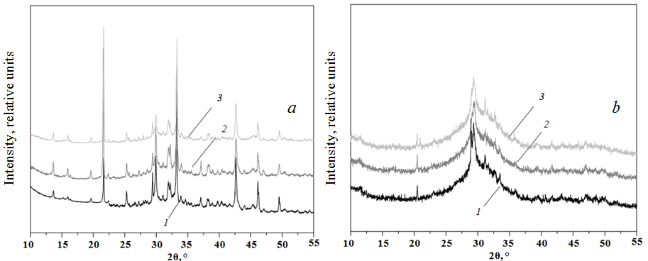
FIG. 2. X-ray images of samples based on PC (a) and BS (b): before irradiation (1), after irradiation with electrons up to an absorbed dose of 10⁹ Gy (2), and alpha-particles up to 10¹⁹ decay/g (3).

Fig. 3 shows the microstructures of samples based on PC (a, b) and BS (c, d) before and after irradiation, gained by scanning electron microscopy (SEM).
The microstructure of cement samples based on Portland cement contains large aggregates and individual lamellar crystallites. Pores up to 3 microns in size are observed between the crystal formations. The microstructure of cement samples based on slag contains large inclusions with a size of 5-30 microns of a lamellar shape. The size and shape of the inclusions are similar.

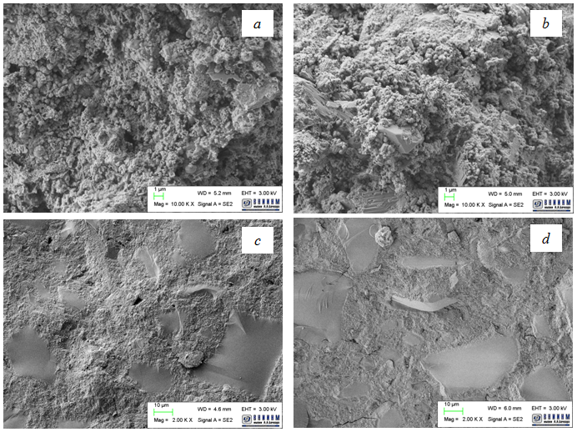
FIG. 3. SEM images of cement samples: based on Portland cement before (a) and after electron irradiation to an absorbed dose of 10⁹ Gy (b) and blast furnace slag before (c) and after electron irradiation to an absorbed dose of 10⁹ Gy (d).

In comparison with the original sample there are no new formations, defects in the form of microcracks, and channels.

CONCLUSIONS
As a result, tests of compounds based on Portland cement and blast furnace slag including waste simulators of various morphologies give implementations to view them as promising matrices for high-activity RW. The compounds meet the requirements [8, 9]. At the same time, it was found that the influence of radiation loads has a greater effect on the strength of cement matrices based on Portland cement than on the strength of matrices prepared based on granulated blast furnace slag. The use of slag, i.e., waste from metallurgical production, can be considered as a cheaper analog of Portland cement.
REFERENCES
- Varlakov, A, Kapustin V., Varlakova G. [et al.] The effect of radiation doses typical for high-level waste on the properties of the cement matrix. Radioactive waste, no 1(2), 2018, 89 – 96 (In Russian).
- Zherebtsov, A, Kapustin V., Varlakova G. [et al.] Chemical resistance and structural characteristics of cement compounds containing imitators of radioactive waste after the influence of ionizing radiation. Atomic energy, v. 127, no 6, 2019, 328 – 331 (In Russian).
- Varlakov, A., Petrov, V., Zherebtsov, A. [et al.] «Effects of Irradiation up to Doses Typical for High-Level Waste on Characteristics of Cement Matrices», 43rd Annual Symposium on the Scientific Basis for Nuclear Waste Management (SBNWM 2019). Vienna, Austria, 21–24 October 2019.
- Varlakov, A., Zherebtsov, A., Petrov, V. [et al.] Assessment of radiation and temperature loads on cement compound containing simulated radioactive waste. Radioactive waste, no 1(10), 2020, 53 – 58 (In English)
- Ojovan, M., Samanta S. «Recent IAEA activities to support the utilization of cementitious materials in radioactive waste management», NUWCEM 2014, 1st Int. Symposium on Cement-based Materials for Nuclear Wastes. Avignon, France, 3 – 5 June 2014.
- Rakhimova, N., Rakhimov, R., Stoyanov, O. Alkali-activated slag cement as an effective mineral matrix for solidification of borate salt solution. Bulletin of the Technological university (Kazan national research technological university), v. 22, no 4, 2019, 91 – 94 (In Russian).
- Vinokurov, S., Kulyako, Yu.M., Slyuntchev, O., [et al.] Low-temperature immobilization of actinides and other components of high-level waste in magnesium potassium phosphate matrices. J. Nuclear Materials, V. 385, no 1, 189―192, 2009.
- State Standard GOST R 50926-96 High solidified waste. General technical requirements, 1996.
- State Standard GOST R 51883-2002 Cemented radioactive waste. General technical requirements, 2002.

