# Non-destructive material characterization of radioactive waste packages with QUANTOM®

LAURENT COQUARD

Framatome GmbH

Erlangen, Germany

Email: Laurent.coquard@framatome.com

ANDREAS HAVENITH, THEO KOEBLE*

Aachen Institute for Nuclear Training (AiNT) GmbH

*Fraunhofer Institute for Technological Trend Analysis INT

Stolberg, Germany,   
*Euskirchen, Germany

**Abstract**

During the last decades, the nuclear and non-nuclear industry has produced a considerable amount of low (LLW) and intermediate level (ILW) radioactive waste. Though the waste form and streams might be different, such radioactive waste must be safely disposed in a final repository under the same strict waste acceptance requirements (e.g. the radiological and material characterization) defined by national licensing and supervisory authorities. Material characterization remains an indispensable criterion to prevent pollution of the ground water with toxic materials. Nowadays material description stays very challenging for waste producers, especially for legacy waste. It can be performed on the basis of existing documentation or, if the documentation is insufficient (e.g. legacy waste), on further destructive or non-destructive analysis. Destructive analysis is not favored as operating personal is exposed to radiation, the waste volume is increased, it is very time-consuming and generates high costs. Therefore, non-destructive methods are to be preferred.

In this paper, an innovative non-destructive technology called QUANTOM® (QUantitative ANalysis of TOxic and non-toxic Materials) based on Prompt and Delayed Gamma Neutron Activation Analysis (P&DGNAA) is presented. This technology is able to identify, verify and quantify the amount of hazardous and non-hazardous substances in waste packages such as 200-l radioactive drums. The technology can also be applied for larger volumes. The first prototype of QUANTOM® is already in operation. The main benefits of QUANTOM® are summarized below:

* Non-destructive multi-element analysis with high sensitivity (ppm-range) of the entire matrix
* Fast measurement process (2h-4h per waste drum) with high measurement precision
* No repackaging and no increase of waste volume
* Reduction of costs (min. 50% per waste drum) compared to destructive analysis processes
* Minimizing the transportation of radioactive waste drums and radiation exposure of the operation.

## INTRODUCTION

Low and intermediate level radioactive wastes are currently stored on surface in intermediate storages. Due to the phasing-out of the German nuclear power plants and dismantling activities, a considerable increase in low and intermediate level radioactive wastes is expected. Such wastes will be finally disposed underground in the geological repository Konrad, which is planned to go into operation in 2027. In Germany the federal company for radioactive waste disposal BGE (Bundesgesellschaft fuer Endlagerung) is responsible for the approval of conditioning procedures and the qualification of radioactive packages for the disposal in Konrad. Strict waste acceptance requirements [1] were defined on the basis of the results of a site-specific safety assessment. They include requirements on waste forms, waste containers, activity limitations as well as mass limitations of non-radioactive harmful substances. The latter is required in order to preserve the groundwater according to the water law [2]. Thus, the masses of several non-radioactive toxic substances are limited in the repository Konrad. The mass of these hazardous substances needs to be tracked and quantified in the repository inventory (e.g. mercury, cadmium, copper, arsenic, aluminium, antimony, lead, cyanide etc). This requires each waste producer to quantify the amount of those materials if they exceed a specified value, usually 1% of the whole container mass (drum + material content). For old legacy waste the threshold is typically 5%. Waste producers declare their wastes based on material vectors (e.g. 76% concrete and 24% cast iron). Only qualified packages regarding the radiological inventory and the material composition can be delivered and subsequently disposed in Konrad. Waste producers from the nuclear industry have the possibility to transfer their qualified wastes to the BGZ (Gesellschaft fuer Zwischenlagerung, engl.: company for interim storage) already from January 2020 until Konrad goes into operation. Material characterization means that the materials in the drums need to be categorized into groups of substances (material vectors) and the mass fraction of these substances need to be quantified [1]. Currently, about 500 such material vectors have been approved by BGE. Legacy wastes are usually problematic: the existing documentation is poor and not sufficient to satisfy the requirements regarding the material characterization. Besides, the documented material vector may not coincide with the true material vector of the drum.

Until today, the material characterization of legacy wastes is performed based on documentation and by using destructive methods. Such methods are time-consuming and expensive. Additionally, they will lead to a repackaging of the wastes, which will increase the waste’s total volume. Furthermore, repackaged wastes are subject to even more restrictive requirements. To overcome limitations of the current state of the art approaches for material characterization, we propose a non-destructive technology: a fully automated mobile measurement device based on prompt and delayed gamma neutron activation analysis called QUANTOM®.

## INNOVATIVE SOLUTION: QUANTOM®

* + 1. **Measuring technology: P&DGNAA**

The QUANTOM® measuring system uses prompt and delayed gamma neutron activation analysis (P&DGNAA) as an innovative analysis method. The prompt gamma neutron activation analysis (PGNAA) is based on the detection of the prompt gamma radiation emitted quasi-simultaneously after the capture of a neutron by a nucleus [3]. In this respect, in contrast to the DGNAA, the PGNAA does not depend on the half-life of the activation products formed. These two core processes are shown schematically in Fig. 1 (PGNAA in orange and DGNAA in blue).

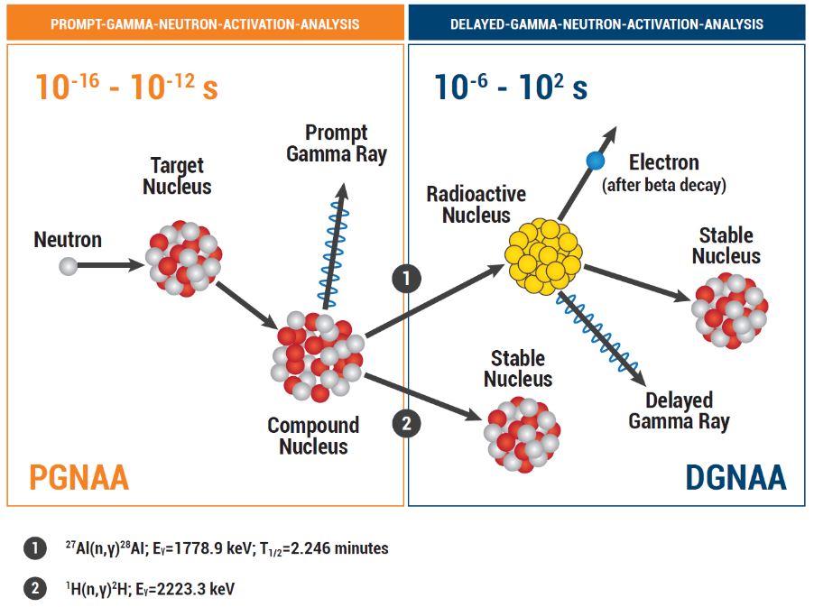

*FIG. 1 Principle of the P&DGNAA. The time windows (orange and blue) indicate the average duration for the respective core processes. After activation by a neutron, prompt gamma radiation is emitted, the resulting atomic nucleus is either a radionuclide, which emits delayed gamma radiation (1), or a stable nucleus (2).Two real examples are given with 27Al and 1H.*

* + 1. **Measurement device: QUANTOM®**

The QUANTOM® measuring system uses a Deuterium-Deuterium neutron generator as a neutron source, which isotropically emits neutrons with an energy of 2.5 MeV and a maximum source strength of 4x109 neutrons per second. Inside the neutron generator, deuterium gas is ionized as a fuel and the ionized deuterons are accelerated to a target by a high voltage of 130 kV. The neutron generator can be operated either continuously or pulsed. The neutrons generated irradiate a 200-liter waste drum, which is located inside a moderation chamber made of ultra-pure graphite. The graphite moderates and reflects the neutrons and thus maximizes the thermal neutron flux inside the waste drum. The contents of the drum are activated and the induced gamma radiation is measured by means of two N-type HPGe detectors with a relative photopeak efficiency of 60% each. The germanium detectors are electrically cooled. An additional cooling with liquid nitrogen is not necessary. The two HPGe detectors are located in the moderation chamber surrounded by collimators. Both detectors can be removed from the measuring position with little effort. The neutron flux is measured simultaneously with the gamma radiation. The neutron flux surrounding the drum is monitored online by thirty-two He-3 proportional counters with a low gas pressure of 0.5 bar of He-3 and 1.0 bar of Argon. The number and the positions of the neutron detectors have been optimized thanks to Monte Carlo simulations [4].

As part of the analysis process, collimated sectoral measurements are carried out. The drum to be measured is divided into 48 sectors, as shown in Fig. 2.

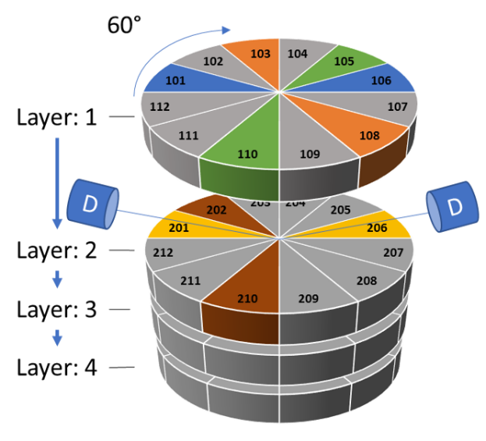

*FIG. 2. Schematic representation of a segmented drum measurement. The drum is divided into four horizontal segments (layers), which are partitioned further into 12 angular sectors. Two detector systems (D) enable the simultaneous measurement of two sectors. After two sectors with the same color are measured in parallel, the drum is automatically rotated (60°) and the next two sectors are measured.*

The gamma spectra are recorded individually for each sector. For this purpose, the drum is rotated and lifted so that only two sectors are located and measured in front of the collimated field of view of the HPGe detectors. By discretely rotating the drum in steps of 60°, each segment can be fully measured within six rotations only. The entire drum can be scanned within 24 single “sector”-measurement positions.

These sectors are further subdivided radially in the data analysis. The corresponding data analysis enables the elemental composition to be quantified individually for each sector and thus reduces the uncertainty that results from the inhomogeneous composition of the waste drum.

By using two HPGe detectors, which are arranged symmetrically to the neutron generator, two sectors are always measured at the same time, avoiding double measurements of the same sector. The use of two detectors reduces the measuring time by a factor of two and increases the overall sensitivity of the measuring system. The moderation chamber is surrounded by a neutron and gamma shield. These shields consist of borated polyethylene plates and lead-steel composite plates. The QUANTOM® measuring system has been completely set up and is currently being operated in Stolberg in the AiNT technical center. A general overview of the measuring system is shown in Fig. 3.

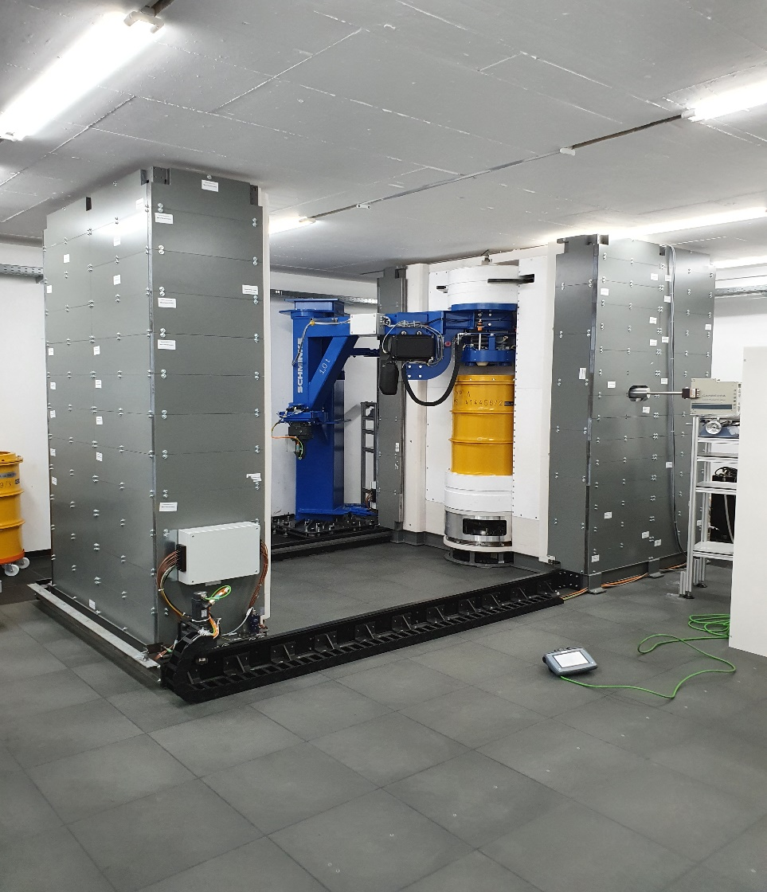

*FIG. 3. Overview of the QUANTOM® measuring system installed at the technical center of AiNT GmbH in Stolberg (Germany).*

The measuring system shown in Fig. 3 has been put into operation in 2020 after having been licensed according to § 12 Para. 1 No. 1 of the German Radiation Protection Act (StrlSchG). In addition, this license was extended in accordance with § 12 Para. 1 No. 3 (StrlSchG) for handling unsealed radioactive materials up to 3x109 times the exemption limit and for handling sealed radioactive materials up to 106 times the exemption limit. The commissioning of the QUANTOM® measuring system was authorized by a technical expert in 2020. Non-destructive measurements of radioactive waste drums using QUANTOM® at the current installation site are possible.

Regular operation and the validation phase started by the end of 2020. To test and validate the measurement technology, ten reference drums were filled with various reference materials (e.g. zircon sand, melamine, stucco plaster, asilicos etc.). The reference materials were selected as a function of their neutron affinity and gamma absorption properties. Diverse drum and cap types were used to simulate the real diversity of the waste drums used in the past. A universal adapter has been developed for handling all 200 l drum types with different drum caps. This adapter has been successfully tested and used so that all drum and cap types can be safely handled.

The content of radioactive waste drums is in most cases not homogeneous. In order to depict the heterogeneity of a real waste drum, an instrumentation drum was designed and manufactured. The drum is shown in Fig. 4. The drum consists of 48 sectors. Each sector has a volume of approx. 4 l and can be filled with any reference material.

Samples of the reference materials used for the validation campaign were analysed at the research reactor in Budapest using the same technique (P&DGNAA) and standardized processes. The results are available and will be compared with the results from the QUANTOM® measuring system. The integral measurement of a drum takes about 2 to 4 hours. The achieved sensitivity (detection limits) depends on the element. For metals such as Al, Cr, Fe, Cu, Ni, Mn, Mo etc., a detection limit of approx. 100 ppm can be achieved for a measurement time of 4 hours. For other toxic elements such as B or Hg, an even lower detection limit of approx. 10 ppm can be achieved for a measurement time of 4 hours. These low detection limits can be further reduced if, for example, the measurement time is increased.

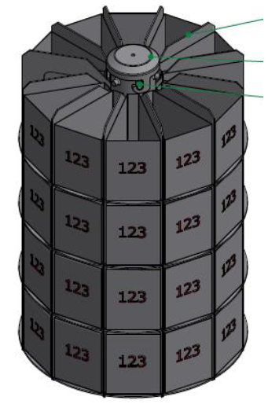

*FIG. 4. Instrumentation drum to simulate the heterogeneity of a real waste drum. The drum consists of 48 sectors that can be filled with any material.*

After the validation phase has been successfully achieved, the QUANTOM® measuring system will be integrated in a 25-foot container. This mobile unit (see Fig. 5) can be brought directly on site where the drums are stored or to the conditioner. In this case, the operation of the system only requires a notification notice according to § 17 of the German Radiation Protection Act (StrlSchG), since the local dose rate at a distance of 0.1 meter from the surface of the container lies under 10 microsievert/h. This significantly reduces the licensing efforts for commissioning the measuring system.

The entire system is fully automated. The final design of the mobile measurement device is shown in Fig. 5 including the automatic drum conveyor belt and the container. QUANTOM® can be loaded with at least up to 10 drums, so that approximately only one loading per day is necessary. The system automatically and autonomously transports one drum after the next into the final drop-off position for measurement, where it will be weighed by a high-precision scale (± 0.03%). The drum is then automatically taken off by a rotating crane and transported into the irradiation chamber on the lifting turntable.

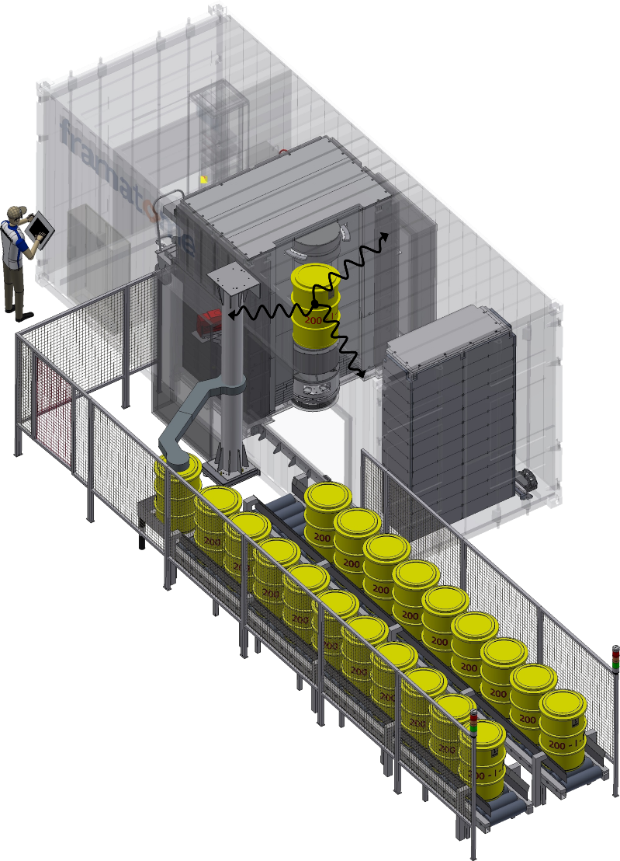

*FIG. 5. Overview of the mobile and automated measuring system QUANTOM®. The neutron-induced gamma radiation is symbolically represented as a black wave from the drum in the center of the measuring system.*

* + 1. **Methods and Software development**

The count rate distributions of the various elements are determined on the basis of the recorded gamma spectra and the fitting of the corresponding gamma lines (peaks). The analysis of these peaks is the basis for the quantification of the elements contained in a 200 l drum. The gamma spectra are analysed individually for each of the 48 sectors (see section 2.2). This enables a spatial resolution for the element quantification. Thus inhomogeneity can be taken into account within the drum. The evaluation of the 48 measurements of all sectors enables the determination of the masses of the existing elements for the whole drum.

The mathematical algorithm for spatial-dependent mass quantification is based on partitioning the drum into four axial segments (layers) and twelve radial sectors per axial segment. In the data analysis the sectors are additionally subdivided radially. The quantification algorithm takes into account the attenuation of the gamma radiation and absorption of the neutron flux within the waste matrix and the drum wall. The data analysis takes place after the measurement has been performed. It must be carried out iteratively since the measurement parameters depend on the material composition itself. The method for mass quantification is carried out iteratively with regard to the elemental composition of the drum until the computed composition of the partitions no longer changes or changes within a range smaller than a predefined threshold value. The neutron flux within a respective partition is calculated deterministically based on a diffusion approximation of the space and energy dependent linear Boltzmann equation. This is done for each individual iteration step by considering the physical boundary conditions. The design of the measuring system and the data analysis algorithm have been successfully patented [5].

## MATERIAL CHARACTERIZATION AND PLAUSIBILITY CHECK

**3.1 Material databank**

Due to the underground storage of chemo toxic substances in Konrad and its possible release in the groundwater, the plan approval authority carried out an examination of the possible changes in the groundwater as part of the plan approval procedure [2] for the Konrad repository. The Appendix 4 of the plan approval procedure [2] describes the allowed limits for the radioactive and non-radioactive substances in the final repository. The masses of 94 non-radioactive chemo-toxic substances are limited to preserve the groundwater. The national authority for final disposal (Bundesgesellschaft fuer Endlagerung mbH, i.e. BGE) is responsible for meeting these requirements. This includes the mandatory recording, monitoring and balancing of radioactive waste to be stored with regard to non-radioactive toxic substances for water. The material description and declaration are carried out using material vectors. The applicability of these material vectors is checked for a respective waste batch on behalf of the BGE (material product control). These material vectors are listed in a specific database managed centrally by the BGE, the so-called “material list”. Waste producers have online access to this database. The material list currently contains 552 entries (without deleted / blocked entries), of which 333 have been released, 52 have been notified and 132 substance list entries are in preparation (as of May 28, 2021).

**3.2 Material characterization using a destructive process**

The qualification of a conditioning process is based on a working schedule and its process descriptions, work instructions, test regulations, manuals and protocol templates. With regard to the material description, these working schedules list all working and test steps that regulate the collection of waste-specific data by the person responsible as well as the associated controls by the technical expert. The working steps which are involved in the material description have to be listed, such as for example the collection and sorting of raw waste with regard to the allocation to a substance list entry or the sampling procedure to analyse and characterize the sorted raw waste or waste products.

The material characterization has to be carried out by the waste producer and can be performed on the basis of existing waste documentation. In the case of problematic waste (e.g. legacy waste: waste that was already conditioned at the time of the validity of the water law permit), such a plausibility analysis is not always feasible depending on the documentation situation. The documentation of legacy waste is often not sufficient to rule out the presence of water-polluting substances above the description threshold or to assess a plausible material description. The current product control measures, such as visual inspection or mass determination by weighting, are not practicable for conditioned cemented waste. In the case that the material description is insufficient or not reliable, additional waste data must be collected or verified by means of analysis procedures. So far, this outstanding data collection and review for the material description of old waste can only be carried out by opening the drums, breaking down the waste matrix and then analysing its content. This cost-intensive procedure always requires complex laboratory analysis, repackaging of the waste and, in particular, causes additional radiation exposure of the operating personnel as well as secondary waste. These complex processes as well as the radiation exposure of the operating personnel are considerably reduced or even completely avoided with the use of QUANTOM®.

**3.3 Material characterization using a non-destructive process: QUANTOM**®

The data analysis of the measurement provides a full elementary composition of the individual partitions inside the drum as well as for the entire drum. Such an element signature of a waste can also be derived from the material description documentation via the material list. The measurement with QUANTOM® enables a comparison with the already declared values of the material list. Thus, a plausibility check of the element signature derived from the material description can be performed. According to the principle of exclusion, it is also possible to deduce the absence of elements or material vectors.

QUANTOM® makes it possible for the first time to verify non-destructively material descriptions of waste products (200 l drums) and to adapt or complement an existing material description using additional material vectors. The plausibility of a generic material vector for an inspection lot of drums can be verified through a random or full measurement of drums within this inspection lot. In the case of a re-qualification campaign for which there is no approved material vector entry, the waste products can randomly be measured with QUANTOM®. In such a case, the measurement data are used retrospectively to prove the plausibility of the material description after the material vector entry has been approved by the authority (BGE).

## CONCLUSION

The qualitative and quantitative determination of elements (and in some cases the ruling out of some materials) in waste drums is possible with P&DGNAA. A full-automated drum measuring system called QUANTOM® has been developed and makes it possible for the first time to verify non-destructively the material content of waste packages. The QUANTOM® measuring system was completely set up and successfully put into operation in 2020. The validation phase of the measurement process is still ongoing. After its completion QUANTOM® will be ready as a mobile unit and will be used directly in the places where (legacy) wastes are stored or conditioned. A synergetic coupling with the radiological characterization of the waste drums might also be possible.

This unique service of non-destructive characterization of radioactive waste using QUANTOM® expands the already extensive portfolio of Framatome GmbH in the field of waste management and waste treatment, which already includes services such as transport, radiochemical analysis and the documentation of waste products.

**ACKNOWLEDGEMENTS**

The joint project QUANTOM is funded by the German Federal Ministry of Education and Research under grant number 15S9406A / B / C. The project partners are Framatome GmbH, AINT GmbH and Fraunhofer Institute for Technological Trend Analysis INT (FINT). They are responsible for the content of this publication. We thank Theo Köble and Olaf Schumann (FINT) for actively contributing to this project and for their useful expertise in the field of neutrons detection and simulation.

References

1. P. BRENNECKE, “Anforderungen an endzulagernde radioaktive Abfälle (Endlagerungsbedingungen Stand: Dezember 2014) – Endlager Konrad -, SE-IB-29/08-REV-2, BGE, Salzgitter, 2014.
2. Niedersächsisches Umweltministerium, “Planfeststellungsbeschluss fuer die Errichtung und den Betrieb des Bergwerkes Konrad in Salzgitter als Anlage zur Endlagerung fester oder verfestigter radioaktiver Abfälle mit vernachlässigbarer Wärmeentwicklung”, Hannover, 2002.
3. Database of prompt gamma rays from slow neutron capture for elemental analysis, International Atomic Energy Agency, Vienna, ISBN 92-0-101306-X, 2007.
4. C.J. WERNER (editor), "MCNP Users Manual - Code Version 6.2", Los Alamos National Laboratory, report LA-UR-17-29981, 2017.
5. Europäische Patentschrift EP 3 410 104 B1, Anmeldenummer 17401060.3, „Verfahren und Vorrichtung zur Multielementanalyse basierend auf Neutronenaktivierung sowie Verwendung“, 05.12.2018.