Liquid radioactive waste treatment – Volume reduction in solution containing uranyl nitrate

MARCELO MENDOZA
Chilean Nuclear Energy Commission
Santiago, Chile
Email: marcelo.mendoza@cchen.com

VIVIAN PEREIRA
Chilean Nuclear Energy Commission
Santiago, Chile

Abstract

The purpose of this work is to develop a concentration and precipitation process of uranium contained in radioactive nitric liquid waste, in order to improve conditioning and storage features of these wastes.
Lab trials were performed using radioactive nitric liquid waste samples that contain natural uranium, with a concentration of 2 [g/L], which were concentrated in a solid phase by ions precipitation of metal method, using as reactive the ammonium hydroxide. This precipitation, filtration and drying reduces the volume until 85%, and also it transforms the liquid waste in a solid material that will be stored in physical and radiological protection conditions. On the other hand, the treated liquid is radioactively decontaminated, with an efficiency over than 99%. The lab trials results are the basis for taking this process into bigger volume treatment of radioactive liquid waste.

INTRODUCTION
In Chile, over than 10 [m³] of radioactive waste are managed for all generators in the country, and it is the Chilean Nuclear Energy Commission (hereinafter referred to as the “commission”), through the Radioactive Waste Management Section, which operates the national facility that carries out this management, due to the investigation and development of methods for conditioning of the radioactive waste and to reduce its original volume, it is a fundamental stage to optimize the waste storage.

Different radioactive wastes are received by the commission, for example the radioactive liquids, coming from different activities of universities and the commission itself. The storage stage of these is carried out based on safety and security conditions according to their matrix, these include, organic or inorganic solution, types of radioisotopes and activity levels. One of the biggest stored volumes (2 [m³]) in the commission was a nitric solution that contained uranium as uranyl nitrate, and these characterizations are described in the Table N° 1.

Table N ° 1. Characterization of the waste solution
U  [ppm] | Cl  [ppm] | NO₃  [ppm] | PO₄  [ppm] | SO₄  [ppm] | Ni  [ppm] | Al  [ppm] | pH
2.069 | 2.062 | 27.730 | 0,5 | 10.252 | 1.009 | 1.015 | 1,1

The method for the volume reduction of this waste was the precipitation of uranyl nitrate using ammonium hydroxide, adding a barium and iron as chemical carrier, which precipitates in barium sulfate and iron hydroxide co-precipitating with the ammonium diuranate (ADU) [1]. Then, from the contaminated stream (radioactive liquid waste) a decontaminated liquid stream and a solid concentrated in uranium (ADU) are obtained, which precipitates and then is filtered.

2. METHOD AND MATERIALS

2.1 Reactions of the Process

Despite of the smaller concentration of uranium in the liquid waste, the other components (see TABLE N° 1) were a convenient option for this process. The reactions in this process are the following:

(1)
(2)

Final reaction [2]:
(3)

2.2 Process Development

In the lab trials, the uranyl nitrate solution was treated in a stirred reactor of approximately 2 liters, which it was heated to 50 [° C]. The barium chloride is added, which reacts with the sulfates in the solution. Later, ferric chloride and ammonium hydroxide are added simultaneously increasing the pH from 1.0 to 7.0, the pH control is shown in Figure 1.

FIG. 1. pH adjustment using ammonium hydroxide.

The ferric chloride also allows to obtain uranium in oxidation state (+6) and the ammonium hydroxide generates the uranium precipitation, as ammonium diuranate (ADU). The reagents addition is shown in the following chart.

TABLE N° 2: Reagents
Reagents | Addition
BaCl2 | 2,4 [mL/ L of waste solution]
FeCl3 | 2,6 [mL/ L of waste solution]
NH4OH | 70,5 [mL/ L of waste solution]

The sludge (see Figure 3a) goes to a vacuum filtration stage and then it is dried in an oven at 105 [ºC], until a constant weight is obtained. The efficiency of uranium abatement in the lab results was over 99% in the decontaminated liquid, and the concentrated uranium in the filter is between 15% and 20% by weight.

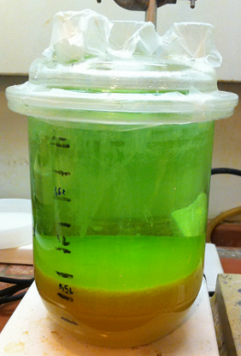 | 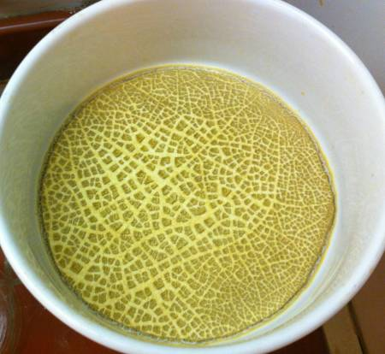
a) | b)
FIG. 3. a) Uranium precipitation, sludge formation; b) Filtration.

3. RESULTS AND CONCLUSIONS

The lab trials results are the basis to increase the treatment volume to 1,7 [m³] of radioactive liquid waste. The next table shows the initial volume, the streams of decontaminated solution and sludge, and its concentrations of uranium.

Table N° 3: Volume and concentration of the treatment
Processed | Generated
Uranyl Nitrate Solution | Decontaminated Solution | Precipitate
1.736,5 [L] | 1.640 [L] | 307 [L]
2055,5 [ppm] | < 1 [ppm] | 15 % [U]

The uranium concentration in the decontaminated solution is less than 1 [ppm], parts per million or [mg / L], which is the uranium quantification limit by the “molecular absorption spectrophotometric” chemical laboratory analysis in the commission. This result represents a removal efficiency of 99.9%.

3.1 Decontamination factor

The decontamination factor is the ratio between the initial activity (A₀) and the final one (A_{f}) (post- treatment). Also, the Table N° 3 results, the volume reduction can be determined as the percentage of final volume reduction over the initial one, based on the contained radioactive material. This means that the radioactive material is concentrated in a volume of 17.7% from the initial volume waste (or 307 [L] of sludge).

3.2 Results analysis

The specific activity of natural uranium is 26,229.373 [Bq/g], and the uranium concentration (post-treatment) is less than 1 [mg/L] in a solution of 1,640 [L]. The liquid volume calculations can be authorized to start the management of this solution as industrial waste.

a) Activity concentration for material exempt from control:

With the specific activity of natural uranium, its concentration in the solution (less than 1 [mg/L]) and the total treated volume (1,640 [L]), also it can calculate the decontaminated solution total activity:

$$\text{Total Activity = }26.229,373[Bq/g]·1.640[L]·1[mg/L]=43.016,17[Bq]$$ | (4)

The specific activity:

$$A_{U}=\frac{\text{Activity}}{\text{Solution's Volume x Solution's Density }}$$  $=\frac{43.016,17[Bq]}{1.640[L]}·\frac{1}{1.000[g/L]}=0,0262[Bq/g]$ | (5)

Therefore, the uranium concentration in the decontaminated solution is less than the GRS-Part 3 recommendations.

Decontaminated solution = $0,0262\left[\frac{\text{Bq}}{g}\right]<\text{10}\left[\frac{\text{Bq}}{g}\right]$ = GRS Part 3 recommendations | (6)

    - Management of decontaminated liquid: Clearance Authorization.

In addition, using the moderate amounts of material levels according to GRS Part 3-Table I-1, the uranium total activity is 1x10⁴ [Bq] per year.

Decontaminated solution = $43.016,17\left[\text{Bq}\right]≥\text{10.000}\left[\text{Bq}\right]$ = GRS Part 3 recommendation | (7)

Finally, this solution clearance is in 4,3 years, and its volume to manage is:

$\text{Clearance Volume per Year}=\frac{1.640[L]}{4,3[y]}=381,4[L/y]$ | (8)

3.3. Conclusions

This experimental study on the uranium precipitation in a nitric solution demonstrates one possibility to decontaminate a liquid stream, to reduce the waste volume and to obtain a solid waste for future conditioning in the chilean facility storage. This process allows to improve storage capacities and the safety and security conditions in the facility.

ACKNOWLEDGEMENTS
I would like to thank to the Chilean Nuclear Energy Commission, especially the Radioactive Waste Management Section and their members for trying to do the best job day by day. And my english teacher for his patience and support.
References
[1] Lozano, J. C., Fernández, F., Gómez, J. M. “Preparation of alpha-spectrometric Sources by Coprecipitation with Fe(OH)₃: application to uranium. Applied Radiation and Isotopes”, pp.50, 475-477 (1999).
[2] Harrington, C. D., Ruehle, A.E. “Uranium Production Technology”, pp.210 (1959).

BIBLIOGRAPHY
IAEA
Safety Standars, “Radiation Protection and Safety of Radiation Sources: International Basic Safety Standards” INTERIM EDITION, No. GSR Part 3 (Interim) General Safety Requirements Part 3, (2011)

Ministerio Secretaría General de la Presidencia de la República,
Norma Chilena de Emisión D.S.46/02: Descarga de Riles a Aguas Subterráneas, (2002).

Ministerio de Obras Públicas,
Norma Chilena de Emisión D.S.609/98: Descarga de Residuos Industriales Líquidos a Sistemas de Alcantarillado, (1998).

