Treatment of liquid radioactive waste containing organic substances

A. MISKIEWICZ
Institute of Nuclear Chemistry and Technology
Warsaw, Poland
Email: a.miskiewicz@ichtj.waw.pl

K. KIEGIEL, I. HERDZIK-KONIECKO, L. FUKS, G. ZAKRZEWSKA-KOŁTUNIEWICZ
Institute of Nuclear Chemistry and Technology
Warsaw, Poland

Abstract

Polish research laboratories and hospitals produce liquid organic waste among which are organic solvent waste and aqueous waste contaminated with organic pollutants (waste with high COD), sometimes containing long-lived alpha emitters that require different treatment pathways. The presence of organic substances affects further stages of radioactive waste processing and the safety of its final disposal. Therefore, it is advisable to render this admixtures harmless in an appropriate manner before the next stages of the treatment. The removal of organic compounds could be achieved by various methods, including sorption or advanced oxidation process. In the paper three methods of removing organic compounds from the low-level liquid radioactive waste were considered i) physical separation of organic compounds by adsorption; ii) chemical decomposition of organic compounds by ozonation process and iii) separation of organic substances from inorganic compounds (including radioisotopes) using a electromembrane process – electrodialysis (ED). The research on the treatment of liquid radioactive waste was accompanied by development of analytical methods necessary for process control and characterization of the waste at each stage of processing. The main techniques of characterization of liquid waste streams was the Gamma spectrometry and Total Organic Carbon (TOC) analysis.

INTRODUCTION
Low-level radioactive liquid wastes (LLWs) from industrial and medical applications typically contain short-lived radionuclides and sometimes trace concentrations of long-lived radionuclides. Such wastes may also include some amounts of organic substances: spent acids and bases, analytical solutions, scintillation cocktails, decontamination and cleaning solutions or waste oils [1]. Generally, LLWs are very complex solutions and therefore require appropriate, sometimes specific, treatment. The presence of organic substances affects later stages of radioactive waste processing and the general safety of its final disposal. Therefore, it is advisable to separate such compounds before the next treatment stages.
Various methods have been employed for the treatment of organic contaminated radioactive waste, e.g. evaporation, adsorption, wet or advanced chemical oxidation, electrochemical methods etc. [2]. Advanced oxidation processes are a class of treatment methods that include the use of ultraviolet light and such oxidants as H₂O₂ or O₃ to destroy organic compounds, producing carbon dioxide and water. These techniques can be applied industrially to wastewaters containing small amounts of organic species [3]. Physical separation of organic compounds by adsorption is usually used for decontamination of radioactive liquid waste [4].. Many other methods are considered as potential techniques for separation of organic compounds form liquid radioactive waste, among others electrodialysis - one of the electrochemical membrane processes. There are reports that describe the application of ED in the nuclear field—namely, the separation of molybdenum, carbonate, and bicarbonate ions from liquid waste containing uranium in the uranium ore leaching process [5]. The results of these studies confirmed the high retention of carbonate ions and selective separation of molybdenum from uranium. Electrodialysis combined with diffusion dialysis was tested for the separation of ¹³⁷Cs and ⁹⁰Sr from concentrated nitric acid solutions [6].
In the paper the possibility of the organic compounds removal from the low-level liquid radioactive waste was evaluated. For this purpose three different methods were considered: adsorption, ozonation and electrodialysis (ED).

materials and methods
In the experimental work, model solutions prepared on the basis of the composition of typical liquid low-level waste collected and processed by the RWMP (Świerk, Poland) were used (Table 1). The main radioactive components of this waste were: ¹³⁷Cs, ¹³⁴Cs and ⁶⁰Co. Furthermore, they contain a certain amount of ⁵¹Cr, ¹⁰⁶Ru, ¹²⁵Sb and ²³⁵U. This waste was quite saline as was shown by the TDS value of 2 to 4.3 g/L. The content of organic compounds in the waste, measured as Total Organic Carbon (TOC) concentration, ranged from 15 to 75 mg/L.

TABLE 1. GENERAL CHARACTERISTICS OF THE SAMPLES SUBJECTED TO TREATMENT.

 | Sample No 1 | Sample No 2 | Sample No 3
TOC, mg/L | 15 | 55 | 75
TDS, g/L | 3.9 | 4.3 | 2.1
Sum of gamma radioactivity, Bq/L | 1190 | 1210 | 500

In the adsorption studies, commercially available activated carbon: Impex BAK 40 was used. The activated carbon was placed in a chromatography column with a frit (Fig. 1a) and treatment of radioactive wastewater samples was carried out on the bed prepared in this way. In the ozonation process a DST 30 ozone generator was used. The source of oxygen was the oxygen concentrator. The flow rate of gas during the process was equal to 2 dm³/min. The ozonation system is shown in Fig. 1b.

a) | b)
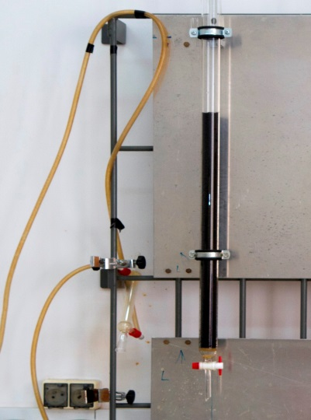 | 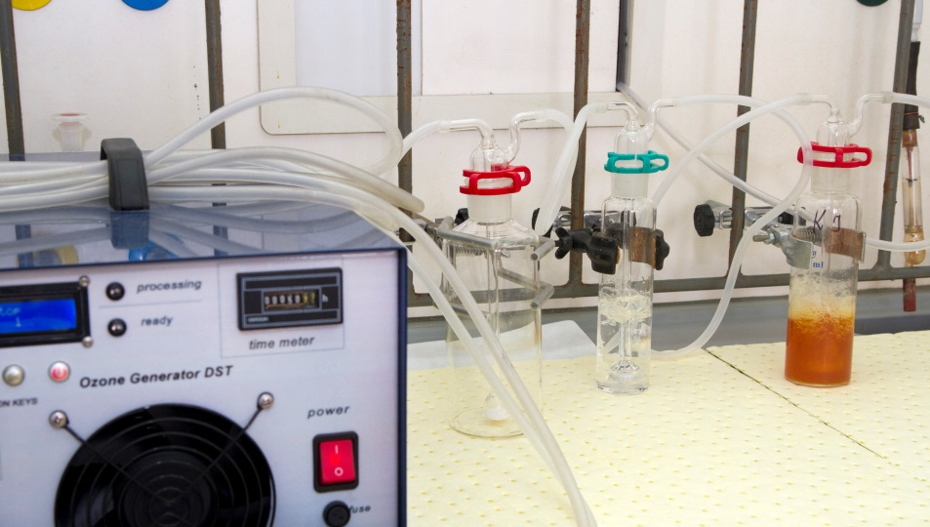
FIG. 1. The pictures of the systems for adsorption and ozonation used in experiments.

The experiments with electrodialysis process were conducted with the ED installation, BED 1-2 Compact (PCCell GmbH, Germany) equipped with an electrodialysis cell (Fig. 2).
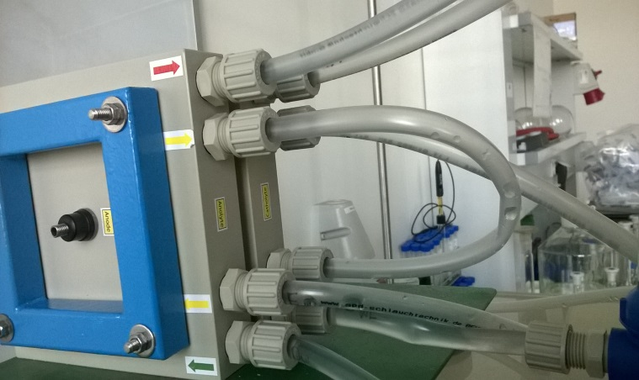
FIG. 2. The electrodialysis cell used in experiments.

TOC analysis was performed by using the Analytik Jena AG multi N/C 3100 apparatus. The TOC content was determined using a carbon analyzer equipped with a Nondispersive Infrared Sensor – NDIR detector. Based on these measurements, the removal of organic substances (R) was calculated according to equation:
$$R=\frac{C_{0}-C_{f}}{C_{0}}×100\%$$

where C₀ and C_{f} are the initial and final concentrations of organic substances in the sample, respectively.
The conductivity of each sample was measured using a benchtop conductivity meter (Oakton pH/Con 510 Series, EUTECH Instruments). The total concentrations of radionuclides in the samples were determined using a gamma counter (LG-1b type, INCT, Warsaw, Poland), while the concentrations of specific radionuclides were measured with an automatic gamma counter (PerkinElmer 2480 Wizard2©).

results and discussion
When adsorption process with activated carbon was used as a method for organic compounds removal, a very promising results were achieved. As shown in Fig. 3. for samples of TOC content in the range from 15 to 75 mg/L, about 70% removal of organic compounds was achieved. The highest efficiency of the process was observed for the sample with the highest initial content of organic compounds (R=73%), while for the other two samples, the removal was at a similar level (66% - 68%). However, in the ozonation process, the satisfactory results of organic compounds removal were not obtained. Especially in the case of model wastewater samples with lower content of organic compounds. In this case, R was only 12% and 22% for samples with TOC concentrations of 15 mg/L and 55 mg/L, respectively. Only for the sample containing the highest concentration of organic compounds a satisfactory removal of 60% was achieved. This can be explained by the difference in the salinity of these samples, namely samples with lower content of organic admixtures contained much higher concentration of dissolved salts measured as TDS than a sample with the highest TOC content (see Tab. 1.). Salinity may hinder the removal of organic compounds in the ozonation process due to the consumption of oxidants. In order to improve the efficiency of the ozonation in such a case, an extension of the process duration can be considered.

FIG. 3. A comparison of the organics removal by application of two processes: ozonation and adsorption on activated carbon.
The results of the separation of organic compounds using the electrodialysis process (ED) are presented in Fig. 4. In this case only one sample of model radioactive wastewater solution was tested. The TOC content of this sample was 55 mg/L. At the beginning of the ED experiments, the feed solution was placed in the diluate tank while a concentrate tank contained a solution of 10- fold lower concentration and no organic compounds. A solution of 0.1 M Na₂SO₄ was used as the electrolyte, and the concentrate and diluate solutions were circulated through the ED installation. During the ED experiments, samples of both circulated solutions were drawn at the same time intervals. Then conductivity, TOC content and total activity were measured in all collected samples.

a) | b)
c)
FIG. 4. Results from electrodialysis process.
As can be observed, in the final product of the process, concentrate, a separation of organic compounds from other components of the initial solution, was achieved. All components of the initial solution from the diluate stream, except the organic compounds, were transferred from diluate into the concentrate stream (Fig 4b and 4c). The organic compounds remained in the diluate. Only a small amount passed into the concentrate as evidenced by a slight increase in the TOC content in the concentrate with a simultaneous decrease of TOC in the diluate (Fig 4a).

conclusions
The paper describes attempts to remove organic compounds from liquid radioactive waste by using three different methods: adsorption using activated carbon, ozonation process and electrodialysis process. The obtained results showed a greater efficiency in the removal of organic components from selected model samples of liquid radioactive waste by the use of the adsorption process than ozonation. Whereas, the use of the electrodialysis process enables the selective separation of organic compounds from other components of the treated wastewater. As a result, valuable components, if any, can be recovered from the stream with the organic phase, while the aqueous phase, which is a concentrate of inorganic components, including radioactive components, can be further concentrated to ensure safe disposal of waste.

Additional information
The authors state that there is no conflict of interest in presented work.

ACKNOWLEDGEMENTS
This research was funded by the International Atomic Energy Agency for Coordinated Research Project on the Management of Wastes Containing Long lived Alpha Emitters (T13017).
References
- Classification of Radioactive Waste, General Safety Guide No. GSG-1, IAEA, Vienna (2009).
- Predisposal Management of Organic Radioactive Waste, Technical Reports Series No. 427, IAEA, Vienna (2004).
- SE-MOON P., et al., “Feasibility of UV-Photo degradation technology for detergent removal from laundry radioactive waste” (Proc. Int. LLW EPRI Conf. San Antonio, 2000), Rep. EPRI 1000671, Electric Power Research Institute, Palo Alto, CA (2000).
- AHMED, I.M., AGLAN, R.F., HAMED, M.M., Removal of Arsenazo-III and Thorin from radioactive waste solutions by adsorption onto low-cost adsorbent, J. Radioanal. Nucl. Chem. 314 (2017) 2253–2262.
- LOUNIS, A., GAVACH, C., Treatment of uranium leach solutions by electrodialysis for anion impurities removal, Hydrometallurgy 44 (1997) 83–96.
- MATHUR, J.N., MURALI, M.S., BALARAMA KRISHNA, M.V., RAMAHANDHRAN, V., HANRA, M.S., MISRA, B.M., Diffusion dialysis aided electrodialysis process for concentration of radionuclides in acid medium. J. Radioanal. Nucl. Chem. 232 (1998) 237–240.
- MIŚKIEWICZ, A., NOWAK, A., PAŁKA, J., ZAKRZEWSKA-KOŁTUNIEWICZ, G., Liquid Low-Level Radioactive Waste Treatment Using an Electrodialysis Process, Membranes 11(5) (2021) 324.

