Development of Mid and Long term Strategies

for TRR Spent Fuels Dry Storage

E. ABEDI

Nuclear Science and Technology research Institute

Tehran, Iran

Email: eabedi@aeoi.org.ir

Z. GHOLAMZADEH

Nuclear Science and Technology research Institute

Tehran, Iran

A.J. VAZIRI

Nuclear Science and Technology research Institute

Tehran, Iran

**Abstract**

There are significant numbers of produced Spent Nuclear Fuels (SNFs) eligible to take out from storage pool and transfer to store in dry condition due to more than 50 years operation of Tehran Research Reactor. A multi-phase plan was conceived, designed and has implemented to prepare an infrastructure and required equipment for converting the wet storage to dry for the first try in the country for TRR spent fuels. The plan is initiated with an in-site dry storage of sample SNFs in lead-steel casks since 2014. Then, the design and fabrication of a DPC basket type made of alloy steel at 2018. The TRR SF-DPC is a B(U) type of radioactive container which could load 16 standard fuel elements (SFE) and is adopted for both transport and storage purposes. The loading examinations and pre-send preparations are accomplished successfully. The cask surface dosimetry shows acceptable dose values and the desiccation and leak tests are done well. The safety mechanical experiments are planned base on SSR-6 standard to get the exploitation license. A low and medium waste storage site is considered to retrofit and licensing for final destination of DPC cask. A mid-term inside cask storage and a long-term in concrete modules storage is upcoming stages of the SNFs waste management plan.

## INTRODUCTION

The spent fuels of nuclear reactors are categorized as high level wastes and shall be treated in highly safe and rigorous manner for their storage and transport. Usually, spent fuels get stored and remain under water, instantly after their discharge of reactor core. The spent fuels stay at the spent fuel pool for a certain time to get cooled and their activity be reduced. Additional storage options are available such as dry storage using the designed casks to store the nuclear spent fuel (SNF) for long term. Dual-purpose metal casks have proven a current technical, safe and flexible solution, adaptable to any long and short-term SNF storage strategy [1].

Tehran Research Reactor (TRR) is a MTR pool type reactor that has been operated since 1967. Via more than 50 years of operation, the spent fuels of the reactor have got stored in a Spent Fuel Pool (SFP) located in the reactor site. Regarding both the SFP capacity limits and also technical and safety issues of spent fuels storage under water for couple of decades, it’s necessary to convert the wet storage to dry storage for the significant numbers of spent fuels which are eligible for dry storage. So, a multi-step project was planned to provide the infrastructure and devices that are required to transport and dry storage of TRR spent fuels for mid and long terms. The Nuclear Science and Technology Research institute (NSTRI) as the operator of TRR initiated the project since 2019.

The TRR spent fuel dry storage project includes 3 major steps or phases. The first phase is design and development of a dual purpose cask (DPC) for both transport and dry storage of the fuel. The second phase is construction of a building for loading fuel into DPC and to do preparation and examination of cask and fuel before dispatching. And finally, the third phase is upgrading and licensing of Talmesi nuclear waste disposal site to receive and storage of DPC casks. At the section the development

## TRR Dual-purpose cask development

To design and licensing of a DPC container many technical and safety parameters must be included. The IAEA safety standard No. SSR-6 [2] has been the main reference for design of the TRR DPC container and all nuclear and engineering requirements which point out by SSR-6 has been included in design and fabrication of the cask. According to SSR-6 classification the TRR DPC would be a B(U) type of radioactive content package. The design requirements for TRR DPC are categorized as below base on the SSR-6:

* Genral engineering provisions;
* Radioative material contents requirements;
* Transport quality assurance tests and controls.

The radioactive material content requirements consists of the effective multiplication of the cask, the dose rates of the cask surfaces and the dissipation of SNF decay heat. In the case of effective multiplication coefficient or keff for the batch of the spent fuels loaded into cask in particular circumstances, and probable situations, which include the followings, should be investigated and ensure that the contents of the fuel remain intact:

* Leakage or penetration of water into the cask;
* Decrease or damage of the neutron absorber material used in the cask structure (if any);
* Changes of the fuel assemblies gap because of an accident;
* Temperature changes.

In overall, the effective multiplication coefficient of cask for all types of fuels with a percentage of the enrichment and different fuel burn-up, and various materials available in the cask in normal conditions as well as the worst incident conditions should not be greater than 0.95 [3].

The maximum dose value on the outer surface of the cask, except for casks designed to carry in special arrangements by rail, sea transport or road transport, at no point in the outer surface of the cask shall not exceed 2 mSv/h [2].

Hence, computational investigation of the gamma and neutron dose rate around a designed dual-purpose cask as well as investigation of the effective multiplication factor of the cask in different conditions are calculated in the nest sections.

## TRR Spent Fuels

There are two types of fuel elements in TRR core include Standard Fuel Element (SFE) and Control Fuel Element (CFE). The main differences between this two types of fuel elements are their height, number of fuel plates (fissile material content) and their weights. Because of this differences especially the height, two models of TRR DPC must be developed that called SF-DPC and CF-DPC for Standard and Control fuels respectively. The number of SFEs in TRR SFP are very more than CFEs and so for the development project the design of SF-DPC are implemented. Hereinaftrer, in this text the TRR DPC stands for SF-DPC and all figures and data belong to this type of DPC. Fig. 1 shows a SFE shape and their overall dimensions. It must be noted the eligible fuel elements for dry storage have a maximum burn-up of 55% U235 and at least 5 years cooling in water in SFP.

## TRR DPC cask General description

The TRR DPC is a canister base cask and so contains of two main part. The internal part are used as a spent fuel confiner and so called Canister. The canister located inside a double end opened cylindrical thick low alloy steel made shield that called Cask Body. Fig. 2 shows a section view of the cask body while the canister loaded inside it and cask lids are closed and tightened.

The canister and its lid made by stainless steel alloy ASTM A182 F304, anyway the holding parts of fuel elements which are in touch with fuels are made by Aluminum Alloy 6061. Each canister can load 16 fuel elements, so the cask capacity is 16 fuel element.

The cask body and its both ends lids are made of low alloy steel ASTM A29 (AISI 4140). The cask body outside diameter is 972 mm and its height is equal to 1320 mm. The cask is displaced using 4 trunions which installed on the cask side surfaces (Fig. 2). The main technical specifications of TRR DPC are listed in Table 1.



*FIG. 1. Overall dimension of TRR Standard Fuel Element (SFE) [4].*

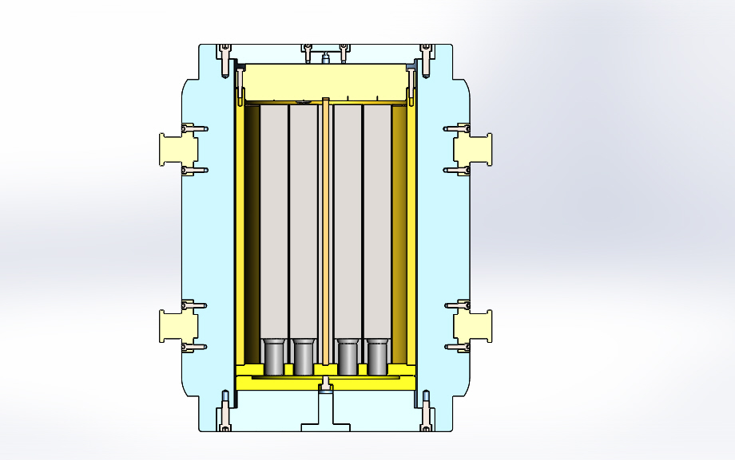

*FIG. 2. Section view of TRR DPC Assembly and loaded SFEs.*

Bottom Closure

Canister Body

Fuel elements

Cask Body

Canister Lid

Trunnion

Cask Upper Closure

Canister Drain

## TRR DPC design

The design steps starts with simulation of the designed cask to estimate the gamma and neutron dose rates on the cask surface. In fact, the calculation of required sheilding thickness is the main issue from nuclear design point of veiw. Then, using specified body thickness the mechanical design proceed to meet the safety parameters of design.

TABLE 1. MAIN SPECIFICATIONS OF TRR SPENT FUEL DUAL PURPOSE CASK

|  |  |
| --- | --- |
| Cask Type | DPC B(u) – Canister Base |
| Capacity | 16 SFE |
| Canister Material | Stainless Steel ASTM A182 F304 |
| Body Material | Low Alloy Steel 1.7225 (ASTM A29-AISI 4140) |
| Weight (Empty) | 6.25 MT |
| Total Height (with Shock Absorber) | 1960 mm |
| Outside Diameter (cask body) | 972 mm |
| Outside Diameter (With shock Absorber) | 1440 mm |

### Calculation of required sheilding thickness

The ORIGEN code is applied for radioactive source terms calculations. The code uses fuel burn-up data during exploitation in core of the reactor, the cooling time of the fuel element after discharge from reactor core, the received power of the fuel assembly in MWh, and the type of fuel materials and compounds to solve Batman's equations [5]. So, the code calculates fraction of the various radioisotopes content of fuel and then determines the gamma spectra of the spent fuel in eighteen groups of energy. This code is also able to calculate and provide the number of neutrons per second of fission products.

The gamma sources is extracted from ORIGEN code and is used in MCNPX code [6] to calculate the cask dose rates.According to the cask design criteria, the dose rate of all surfaces on the cask should be restricted less than 2 mSv/h. Hence, the cask body thickness was calculated so that fulfills this criteria.

The geometry of simulated cask in MCNPX and the Geiger detectors location to calculate the dose rate have illustrated in Fig. 3. The cask body thickness be was placed on top of the cask door (Fig. 3). In this case, the gamma dose rate on the lid surface (above cask) is about 516 µSv/h for the thickness of 15 cm and about 75 µSv/h for the thickness of 20 cm. The cask wall surface receives a gamma dose rate of 20 µSv/h for the thickness of 20 cm and 410 µSv/h for the thickness of 15 cm.

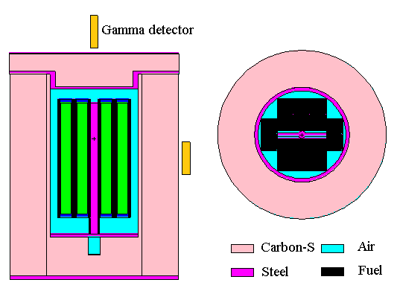

*FIG. 3. Simulation of TRR DPC and locations of Geiger detectors in MCNPX code*

### Decay heat calculations

The other important factor that must be calculated is the decay (or deposit) heat of loaded fuel inside the cask. This parameter also calculated in MCNPX code [7] and Fig.4 illustrates distribution of heat in cask section area. Calculation shows the total heat generation inside the cask is 41 W and the heat distribution is also shown, the deposited heat of the fuel assembly is less than 0.0002 W/cm3. So, it could be concluded the generated heat inside cask space is so neglible and it doesn’t need special cooling mechanisms like cooling fins.

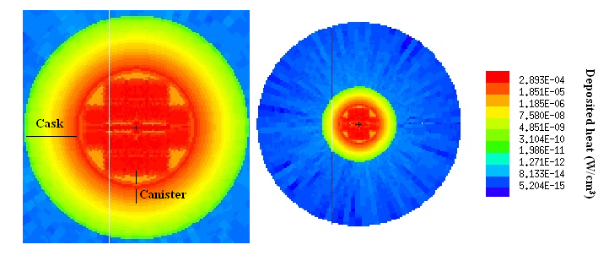

*FIG. 4. The contours of the deposited heat inside the DPC Cask area*

### Calculation of neutron dose rates for TRR DPC

Fig. 5 shows the neutron flux (consequence of (N, Alpha) and spontaneous fission) distribution within the cask. It should be noted that the leakage of these neutrons out of the cask would cause the neutron dose rates, which is also necessary to calculate. The neutron dose rate on the cask surface was calculated using LB6411 neutron detector locating on cask surface.

*FIG. 5. Contour of neutron flux distribution inside the DPC Cask area*

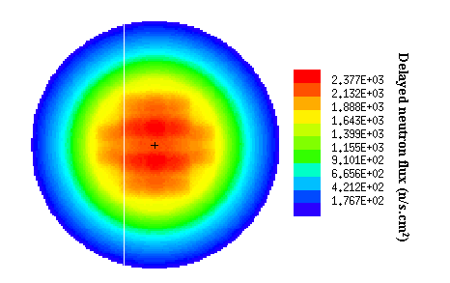

If the detector is located exactly in front of the fuels center, the neutron dose rate is about 0.582 µSv/h when the cask is filled with water while the neutron dose rate is 4.33 µSv/h for dry state (air) space of cask inside.

## Safety Standard tests requirements

Transport of radioactive waste material in any form are involved to safety regulation to prevent the public exposure with radioactive releases. The concerns escalate for high level waste like SNF which contain fissile material. Usually, DPC packages equipped with screwed or welded locking systems, are provided with shock-absorbing parts. In case of a possible accident, the shock absorbing parts reduce the mechanical stress on the other transport cask components in that a large part of the kinetic energy is absorbed by the shock absorber, which, compared to the cask and the impact body, is more resilient.

A distinction is made between the following transportation conditions in the described regulatory work regarding the definition of the stresses that the package must withstand. The transportation conditions include the proper and expert handling for both serious and routine accident scenarios [8]:

* Routine transportation conditions (no incidents);
* Normal transportation conditions (minor incidents);
* Transportation accident conditions (accidents).

Uneventful shipment is considered to take place under routine transportation conditions. The cask components are stressed only, for example, by bumps resulting from rough spots on the road surface or planned handling, such as, for example, during transloading. Normal transportation conditions include minor incidents, such as, for example, rough deposit during transloading. Transportation accident conditions are treated by a serious transportation accident. This covers combinations of different stresses such as impact and fire.

According to SSR-6 standard, 8 safety test should be implemented on TRR DPC. Any way considering the high costs of destructive tests on DPC the designer get agreed with regulatory body for implementation of 3 safety test and other test will accepeted by validated mechanical simulation of test. The plan is consecutive processing of the following 3 main tests:

1. Water immersion test
2. Free Drop test;
3. Thermal test;

The data supporting the accident safety of TRR DPC comprise the following tests, specifically:

* Water immersion test
  + - * A water depth of 15 m for at least 8 hours (as there are no sea shipping transport the 200m depth immersion test omitted)
* Free Drop test
  + - * 9 m drop on a no resilient foundation;
* Thermal test
  + - * Enveloping fire at 800ºC for 30 minutes.

## Safety tests simulation

As it mentioned before, all test scenarios are simulated to demonstrate the results of accident scenario. All the mechanical accidents scenarios are modelled and simulated in Abaqus/CAE [9] software and also the thermal test scenario (fire accident) is simulated using Ansys Fluent [10]. Fig. 6 shows the stress values of loaded fuel elements inside TRR DPC in one of the simulated scenarios. The thermal scenario also simulated an the result are illustrated in Fig. 7.

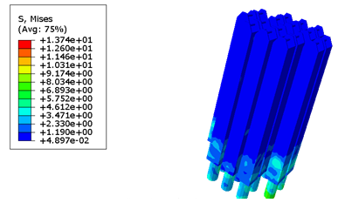

*FIG. 6. Von misses stress contours for loaded fuel elements in TRR DPC in vertical drop test scenario by Abaqus*

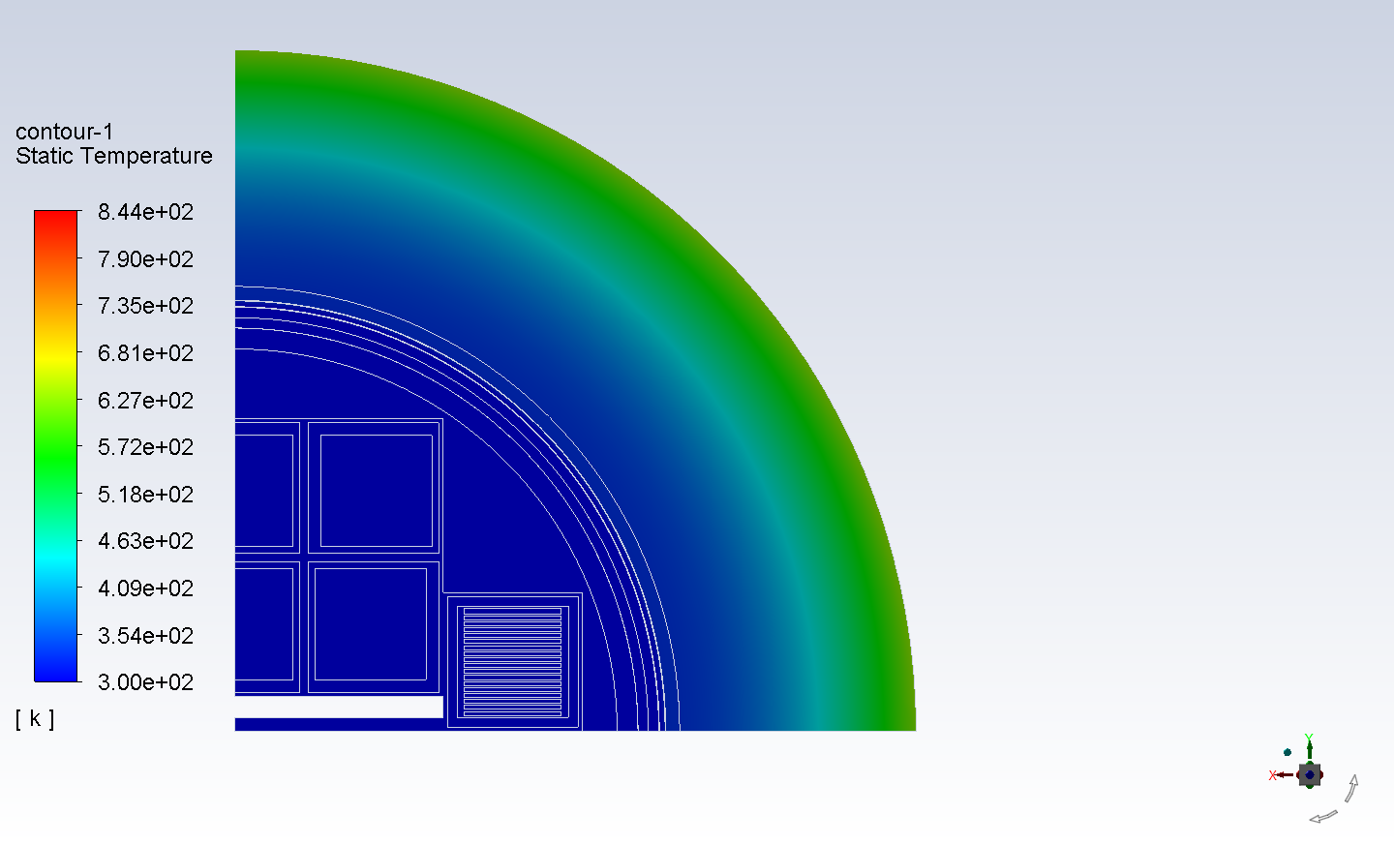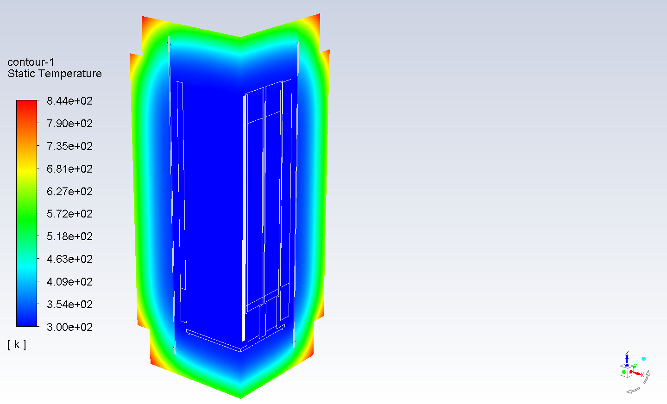

*FIG. 7. Temperature contours whithin the casl volume and section area in fire accident scenarion simulation using Ansys Fluent*

## CASK FUEL LOADING AND PRE-TRASPORT EXAMINATIONS

The fuel loading process is done under water surface as it has illustrated in Fig. 8. There is a drain hole at the bottom of the canister (Fig. 2) to drain water after fuel loading accomplishment and pull put the canister of pool water. It also used in desiccation process for hot gas circulation inside the canister. This hole get closed and sealed after preparation stages. The canister is loaded in cask body as the Fig. 9 shows, before water drainage, and its lid installed after hook released. Then, the cask body lid also is installed and water content of cansirter is drained. The desiccation process is initiated in the next step when the desiccationn and gas injection system is connected to the cask up and bottom penetration holes. Fig. 10 shows the desiccation system circulation circuit in open loop mode. It could also work in closed loop and measure the humidity of inside cask air.

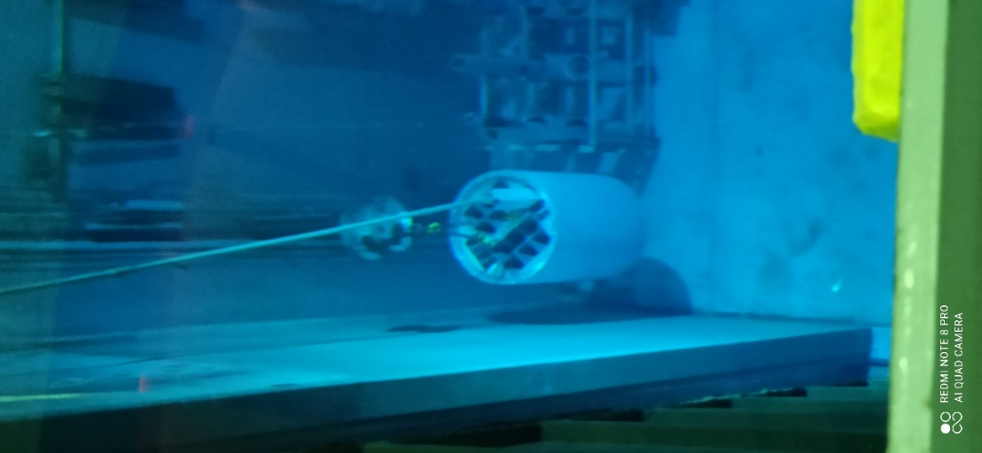

*FIG. 8. Fuel loading process into canister under water*

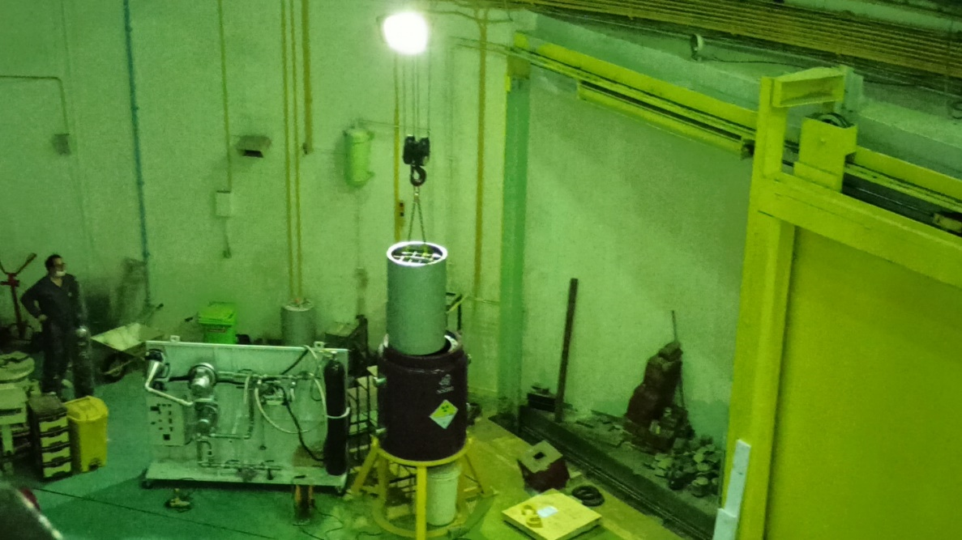

*FIG. 9. Canister loading into cask main body*

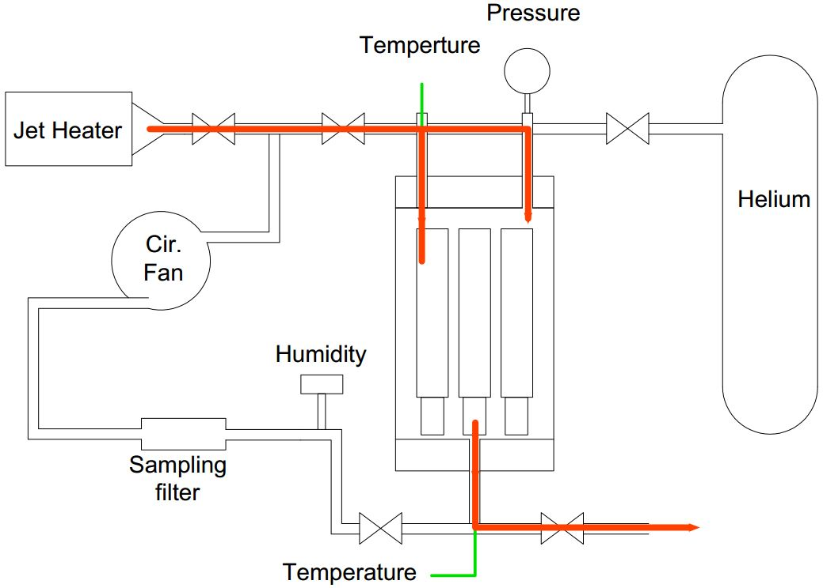

*FIG. 10. The schematic of desiccation circuit to remove the humidity of inside cask*

After desiccation completion, the hellium gas injected into the canister space and leak test is done to ensure the proper sealing of the canister penetration. The leak test then also is done for cask body as same as canister. Finally, the cask get equipped with two shock absorbers and get ready for transport.

## MID AND LONG TERM DRY STORAGE SITE

The Talmesi waste disposal site has been sugessted as the permanent dry storage site for TRR SNF. The site is operated by Iran Radioactive Waste management company (IRWA). IRWA is an exclusive governmental administrator of long term management of nationwide radioactive wastes in Iran [11]. The company was created in 2007 within the Atomic Energy Organization of Iran and established to conduct radioactive waste management activities in a high level of safety. The IRWA approach is to protect people, the environment and future generations against the hazardous and harmful effects of exposure to radiation originated from radioactive wastes under the national legal framework.

The Talmesi site has been constructed and licensed essentially fore low and medium level of radioactive wastes, anyway regarding the site potential and feasibilty studies it’s also eligible for high level waste storage after license upgrading and some development on its infrastructures.

Currently, the site has two option for TRR DPC storage in mid term. The storage building A is a ground floor storage while the building B equiped with under ground concerte cells that is proper for higher level of wastes. Fig. 11 and Fig. 12 shows the building A ans Building spaces, respectively.

The assessments show storage of TRR DPC in both site buildings is possible technically and dose concerning point of view, anyway, the building B has the capability of storage TRR SNF in containing canisters out of cask body. At the latter scenario canister unloading from cask body will be an issue and requires specific equipment and devices. So, considering the limit number of casks, dry storage in DPC complex be reasonable for mid terms up to 20 years.

For long term storage of course the special concerete cells that horizontal loading and also inspection of canisters could be possible are necessary.

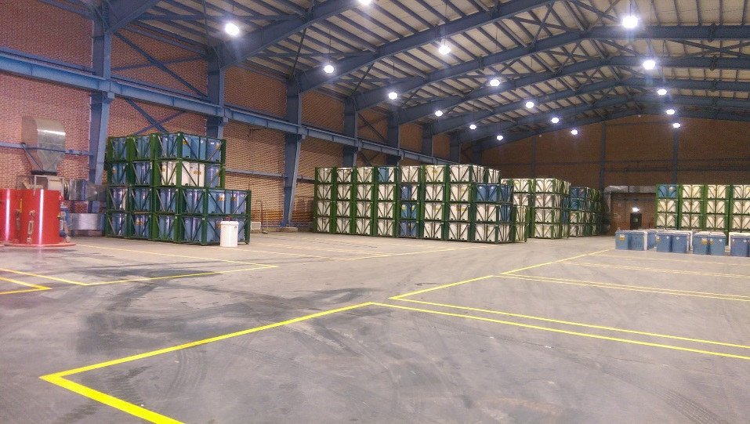

*FIG. 11. The building A is ground floor waste storage in Talmesi disposal site*

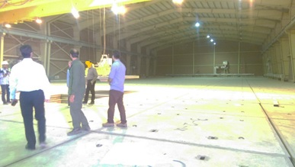

*FIG. 12. The radioactive waste storage building B in Talmesi disposal site with under ground concerete cells*

ACKNOWLEDGEMENTS

Here, the authors declare this project was supported by Nuclear Science and technology Research Institute of Iran (NSTRI) and so we reveal our gratitude to the NSTRI administration, TRR staff and reactor research department. The authors also appreciate of the IRWA head and staff for their collaboration and consultant in completeness of this project.

References

1. PALACIO, A., GARRIDO, D., CASTRILLÓN, D., GÓMEZ, V., MUÑOZ R., AND CALLEJA, G., High radioactive spent fuel management dual purpose metal casks as a current optimal solution.
2. IAEA, Regulations for the Safe Transport of Radioactive Material, Specific Safety Requirements, IAEA, Vienna, 2018.
3. MENNERDAHL D. Review of the nuclear criticality safety of SKB’s licensing application for a spent nuclear fuel repository in Sweden. Technical Note-2012. 2012; 65.
4. AEOI, Tehran research reactor final safety design, Atomic Energy Organization of Iran, 2007.
5. CROFF, A.G., A user’s manual for the ORIGEN2 computer code, ORNL/TM-7175 Oak ridge natinal laboratory, United States, 1980.
6. D.B. Pelowitz, MCNPXTM user’s manual. Los Alamos National Laboratory, Los Alamos. 2005.
7. M.L. Fensin, Development of the MCNPX depletion capability: A Monte Carlo linked depletion method that automates the coupling between MCNPX and CINDER90 for high fidelity burnup calculations. University of Florida. 2008
8. IAEA, Multi-purpose container technologies for spent fuel management, International Atomic Energy Agency, Vienna, 2000.
9. DASSAULT SYSTÈMES, Abaqus/CAE 6.14 User's Guide, online documentation help, (2016).
10. ANSYS INC., Ansys fluent 19.0 user’s guide, (2018).
11. IRWA, Iran Radioactive Waste Management Co./ homepage,

https://aeoi.org.ir/irwa-en/portal/home/?287163/homepage