SORPTION OF SELECTED RADIONUCLIDES FROM LIQUID RADIOACTIVE WASTES BY SORBDENTS OF THE BIOLOGICAL ORIGIN.

L. FUKS
Institute of Nuclear Chemistry and Technology
Warszawa, Poland
Email: leon.ichtj@gmail.com; l.fuks@ichtj.waw.pl

I. HERDZIK-KONIECKO
Institute of Nuclear Chemistry and Technology
Warszawa, Poland

Abstract

Expansion of novel radiochemical separation methods must take into account using ecologically-friendly solvents and reagents. One method to fulfil this new trend is to use chemicals from natural resources. In the paper, we present in brief the obtained in our group results for removal of the radionuclides from aqueous solutions with the composite alginic sorbent used in an unconventional method. We have also tested possible at home to be used method of removal the radionuclides from aqueous solutions using carrot roots.

INTRODUCTION
Radioactively contaminated liquid solutions arise in the nuclear industry and research centres, as a fallout from military weapon tests that contaminates water and is produced by users of radioactive materials, including medicine, research laboratories and industrial application of the devices equipped with the radiation sources. The treatment of radioactively contaminated aqueous solutions can be carried out by several methods, including thermal evaporation, distillation, chemical precipitation, sedimentation, ion exchange, and different membrane processes. The choice of purification method must consider several features, not forgetting the economic aspects. So, demand to improve the low-cost and low investment decontamination methods has resulted in development of new treatment processes for liquid radioactive waste. Among such methods, sorption seems to be preferred, as it does not produce big amounts of the secondary waste.
Sorbing materials can be accounted into one from three main classes: inorganic minerals, organic synthetic materials, and natural organic products [1,2]. Mineral materials that may be used as sorbents are e.g., vermiculite, clays, perlite, and diatomite [2,3]. These materials show great radiation and mechanical stability, but not large buoyancy and middle (as a rule) sorption capacity [2]. Among organic synthetic products that are used at nuclear power plants and the radioactive waste, one should mention primarily organic ion exchangers based on conventional poly(styrene-divinylbenzene) resins with sulfonic acid (−SO₃⁻) and quaternary ammonium (−N(CH₃)₃⁺) functional groups for cations and anions, respectively. Nuclear grade resins, however, due to their possible radiation activation have to meet best quality requirements than those used in most other industries. As compared with the natural organic products, in turn, synthetic organic materials degrade slowly. Number of the organic natural products, mainly obtained from plants, is extremely great and it is impossible to name all tested materials. Their moderate sorption capacity, as compared with the synthetic materials, may be compensated by their extremely low price and great availability. In addition to that, natural organic materials may be relatively easy destroyed thermally, so mass of the contaminated solid residue is significantly smaller, and the storage cost is lower.
Among major advantages of sorption over conventional treatment are the high availability of the biosorbents, their low cost, and easy regeneration combined with the possibility of radionuclide re-usage [4,5]. It is generally accepted, that sorption is one the most effective methods for removal metals present in the solution in concentration lower than 100 mgˑdm⁻³, while another methods work hardly or are too costly [6,7].

MATERIALS USED

2.1. Radionuclides
Carrier-free radionuclides of Cs-137, Sr-85 and Am-241 were supplied from POLATOM Świerk (Poland). NaTcO₄(Tc-99m) in 0.9% saline (ca 100 MBqˑcm⁻³) was eluted from a Mo-99/Tc-99m commercial generator (GE Healthcare, supplied by Biker, Warsaw, Poland).
Radionuclides Sr-85 and Tc-99m, were used instead of Sr-90 and Tc-99 because of their easier detection.

2.2. Studies on the alginates
Alginic acid sodium salt (purum), as well as all other inorganic chemicals (p.a.), used in this work were purchased from Sigma-Aldrich Inc. (Poland). Water used was deionized.
Iron carbonyl was offered by courtesy from the Institute of Electronic Materials Technology, Warszawa (Poland). Fine greyish grains had magnetic permeability μ_{max} ∼7 kGsˑOe⁻¹ and this value may be increased even 30 times by heating in the hydrogen flux.
The one step magnetic calcium alginate formation and the radionuclide sorption was performed as following: homogenous sodium-alginate solution containing the carbonyl iron was dropped using a peristaltic pump into the continuously stirred aqueous solution of the radionuclides after addition of the calcium chloride (CaCl₂). Then, after an additional stirring, magnetic sorbent loaded with the radionuclides was removed by using an external magnet.
The results of radionuclides’ sorption throughout the work were presented as the Removal Efficiency (E):

$$E_{radionuclide}=\frac{Radiation activity of the feed-Radiation activity of the permeate}{Radiation activity of the feed}∙100\%=(1-\frac{Radiation activity of the permeate}{Radiation activity of the feed})∙100\%$$

2.3. Studies on the carrot roots
Carrot roots were bought at the local food market. Before used, they were washed in water and dried in room temperature.

RESULTS AND DISCUSSION

Novel procedure for removal of the radioactive metals from aqueous wastes by the magnetic calcium alginate
Among the most widely used natural adsorbents of the biological origin are alginates: biopolymers extracted from different types of algae. Carboxylic groups of alginates ionically cross-link (gelling) their polymer chains in presence of the multivalent cations [8,9]. The most popular gelling cation is divalent calcium ion, which in a preferred way binds the guluronic units in the polymer chain [10]. Literature proving that calcium alginate sorbent formed in spherical beads removes effectively polyvalent heavy metal ions is enormously reach (about 600 items in the INIS database) and in the presented work we will not review them.
Normal procedure of metal sorption by calcium alginates consists of two stages. In the first one, sodium alginate, dissolved in water is dropped into the aqueous sodium alginate solution with aim for cross-linking. In the second stage of metals are sorbed either in the batch process or in the columns. In the case of batch process realized as an industrial process, separation of metal-loaded sorbent from the purified solution may be, however, difficult. So, using of the highly stable sorbent with the magnetic properties, alginate/magnetite (mixed iron(II)/iron(III) oxide Fe₃O₄) or alginate/ hematite (iron(III) oxide, Fe₂O₃) composites, has been proposed for industrial treating of aqueous waste or heavily salted water [11].
The ambition of our investigations was to check the applicability of the one-step procedure proposed by Jang et al [12] and adopt it to the management of liquid, radioactively contaminated, solutions. It seemed difficult for us to believe that over the next dozen years no one was tempted to develop this idea.
The first novelty of the proposed by us in situ gelation the magnetic alginate in wastewater solutions poor in the polyvalent metal cations was using the iron carbonyl. This material is widely used in electronics (for production of the magnetic high-frequency coils), metallurgy and in treatment of the iron deficiency as an food supplement. So, if bought in bulk, its price is extremely low.
Some results of our studies on the acidic dependence of sorption [13] are presented in Figure 1A. It can be observed that trends of the uptake of metals fairly depend on pH and are about 100 %, 80 % and 30 % for Am(III), Sr(II) and Cs(I), respectively. If the trivalent Am-241 and divalent Sr-85 are removed with the satisfactory efficiency, the monovalent Cs-137 is removed unsatisfactorily. So, in the following, we decided to replace the carbonyl iron with another magnetic material - hexacyanoferrate, environmentally friendly ion-exchanger in water treatment. It has been found that such increased uptake of Cs(I) from about 30 % to about 100 %, while removal of Sr(II) ions remained on the level of 80 % [14].
It was also interesting to find, if chlorides of other metals than calcium may affect the decontamination efficiency. It is well known that some metal salts, e.g. Ni(II), Cu(II), Zn(II) or Cd(II) chlorides, are present in certain industrial liquid waste solutions in the concentration sufficient for gelling sodium alginate. In such cases, the addition of calcium chloride may be unnecessary. Figure 1B shows results obtained for several metal chlorides added separately as the gelling agents. It has been found that removal of the radionuclides does not depend significantly on the metal used. So, only if the waste solution does not contain significant amount of heavy metals, calcium chloride of the lowest price should be used for the gelation step.

(A) | (B)
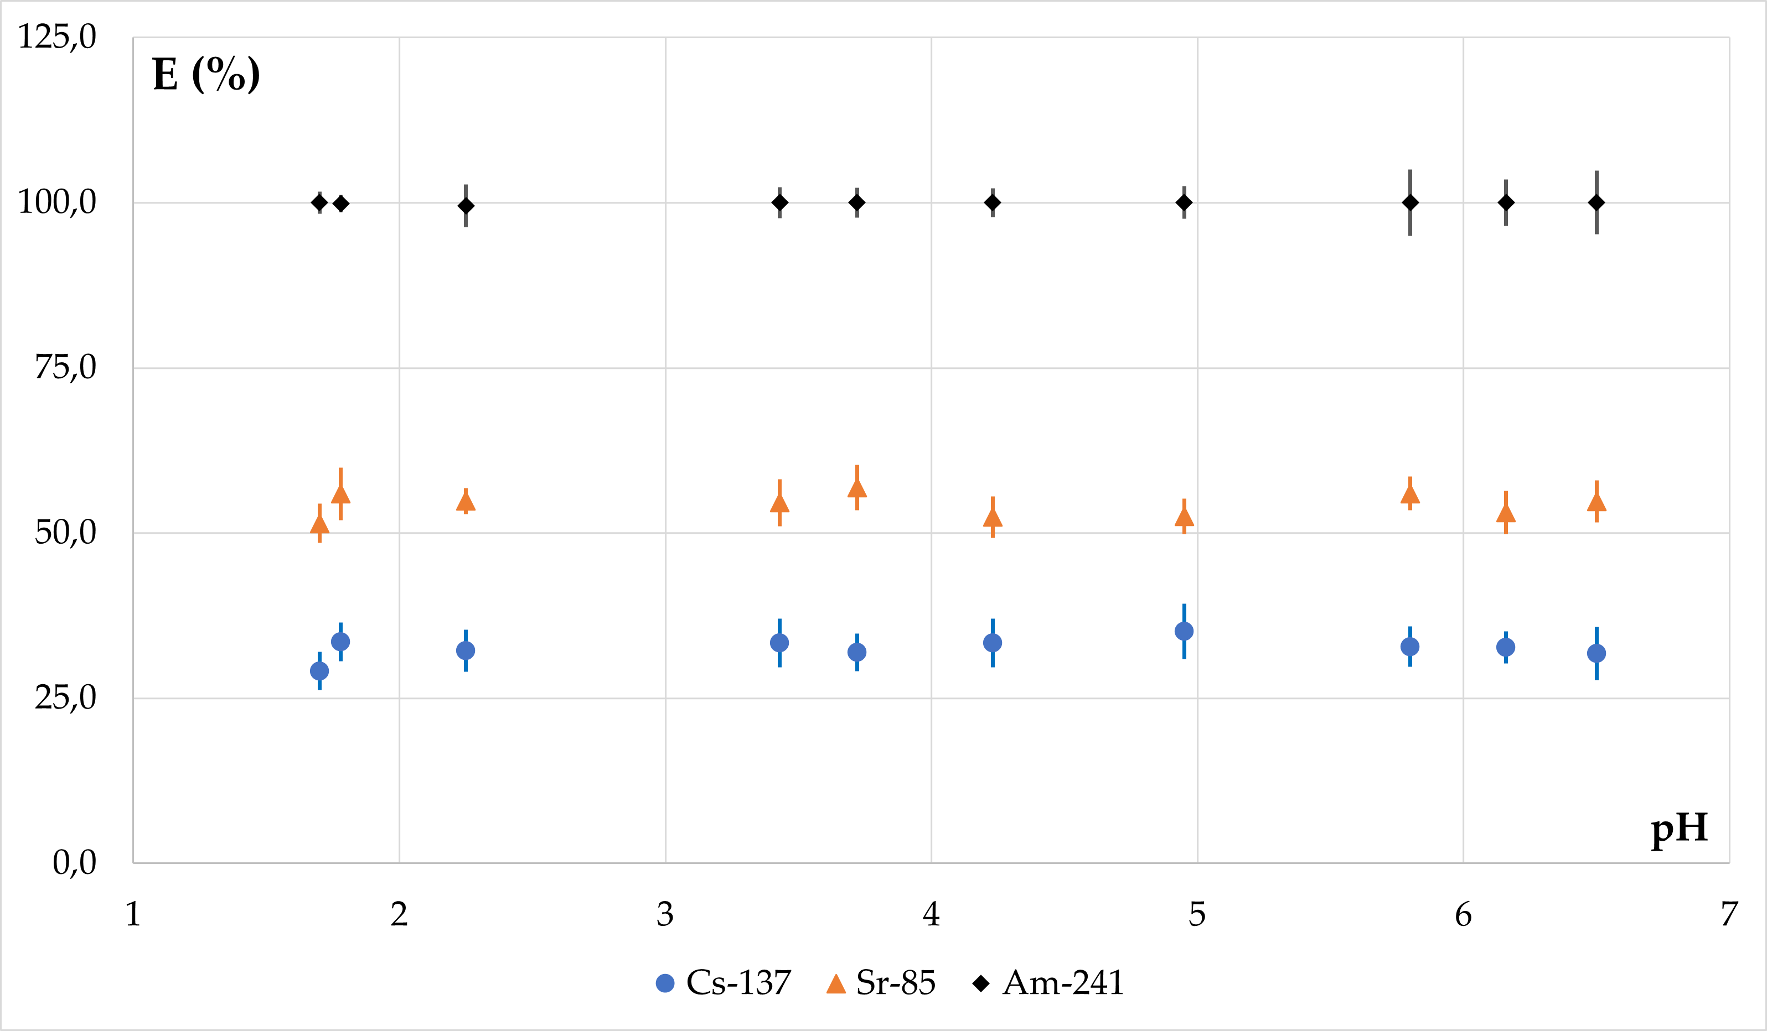 | 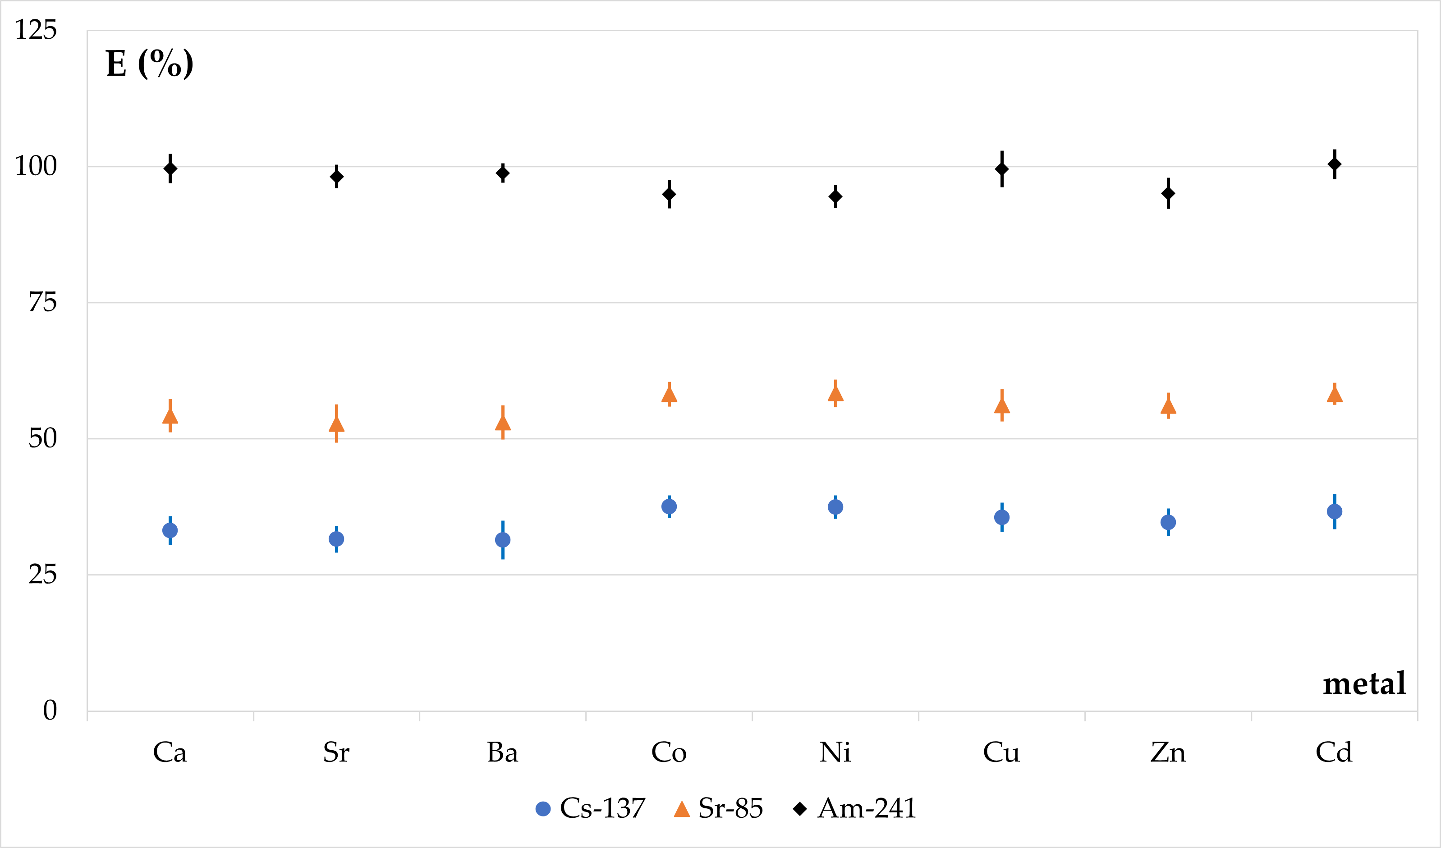
FIG. 1. (A): Effect of pH on the radionuclides’ removal by the composite alginate spheres (iron carbonyl magnetic core); (B): Effect of different gelling metals on sorption (the same sorbent).

It can be seen that only Am-241 is completely withdrew within the entire pH range and regardless of the type of gelling metal used. Both Cs-137 and Sr-85 are removed incompletely (about 30% and 60% respectively). With the aim to improve cesium(I) radionuclide sorption we have tested also the composite sorbent containing the examined already in our Laboratory core formed of potassium-cobalt hexacyanoferrate (CoHCFe) [15]. Hexacyanoferrates, the Prussian Blue derivatives, are used as “green” sorbents [16] since about sixty years [17]. The result is shown in Figure 2.

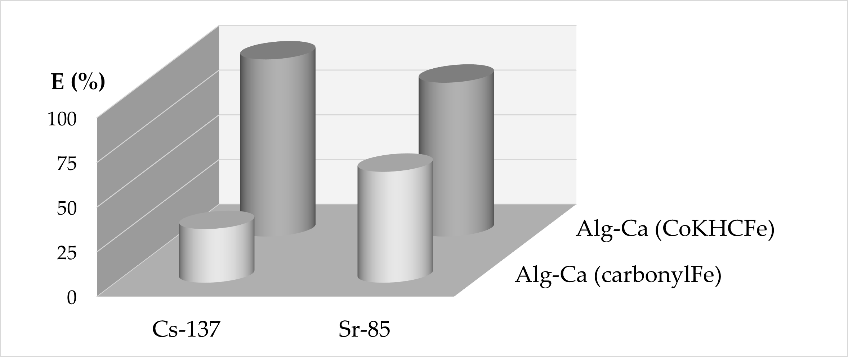
FIG. 2. Sorption of Cs(I)-137 and Sr(II)-85 by both composite alginate sorbents studied in the work.

As can be seen, using the CoHCFe core instead of iron carbonyl enhances uptake of both radionuclides to about 90%.

A crucial problem for the ecology may also form the Tc-99 radionuclide. So, in our work, we have also checked the applicability of the proposed procedure for immobilization of Tc ions. As they normally exist in the solution as the anionic species, the proposed process should include their reduction to the cationic form. Results on sorption of the pertechnetate-(Tc-99m) anion and its reduced forms are presented in Figure 3. As can be seen, uptake of the pertechnetate is not complete and only about 45 % was removed. However, it is known from the nuclear medicine, that technetium kits are formulated with addition of stannous chloride (SnCl₂) as a reducing agent. So, to improve sorption effectiveness of technetium, we have also prepared a mixture of calcium and stannous chlorides for the gelling process. Obtained results for such mixture are also presented in Figure 3 and it can be seen that addition of this reducing agent results in the significant increase of the technetium sorption up to the value about 98 %.

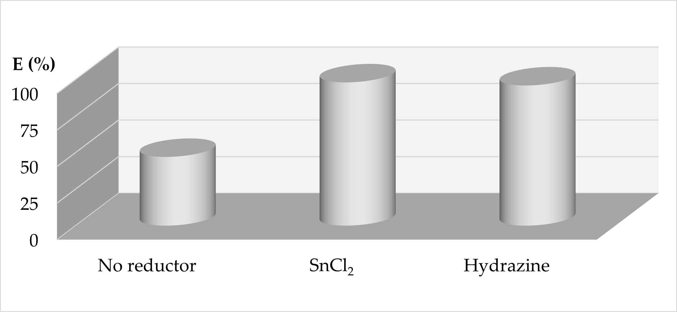
FIG. 3. Sorption of pertechnetate-Tc-99m by the composite calcium alginate/CA-CoHCFe sorbent: raw solution and in presence of the reducing agents.

Since nuclear medicine also knows kits containing hydrazine (instead of stannous chloride), we have also checked the applicability of this green reducing agent. It has been found that using of hydrazine also increases the technetium removal to about 95 %, both in the acidic and basic solutions.

Coming to an end, we tried to purify the decontaminated already solution from an excess of the unreacted calcium chloride. The membrane process, nanofiltration, has been applied and the initial experiments have shown that from the solutions of the CaCl₂ concentration lower than 0.75 gˑL⁻¹ about 70 % of the salt may be removed in the one-stage installation. By using carefully chosen type of membrane, in the optimum process conditions this value may be increased. So, the nanofiltration desalination of the saline solution resulting from the alginate water decontamination, needs more systematic studies.

Carrot roots
Carrot roots (CR) are easily available in different regions of the world. They contain mainly of pectin, cellulose, and lignin - a mixture of carbohydrates and their uronic acids. So, it may be expected that they may bind metal cations by the ether, ester, carbonyl, carboxyl, phenolic and aliphatic hydroxyl functional groups in the polyuronides [18,19]. So, it seemed reasonable to us to check carrot roots as a potential sorbent of the radionuclides.
Very few publications containing the results of the determination of Cs-137 and Sr-90 content in root vegetables grown in areas contaminated after the Chernobyl NPP accident in 1986 seem to support this hypothesis. Contamination of carrot roots by both radionuclides was found to be on the detectable level and was comparable to this of cabbage, tomatoes, potatoes, beetroots, or cucumbers [20,21].
Performed in our group the detailed studies on the sorption of Cs-137, Sr-85 and Am-241 by the carrot roots are coming to an end and the report will be published soon. Nevertheless, we would like to present now two interesting results.

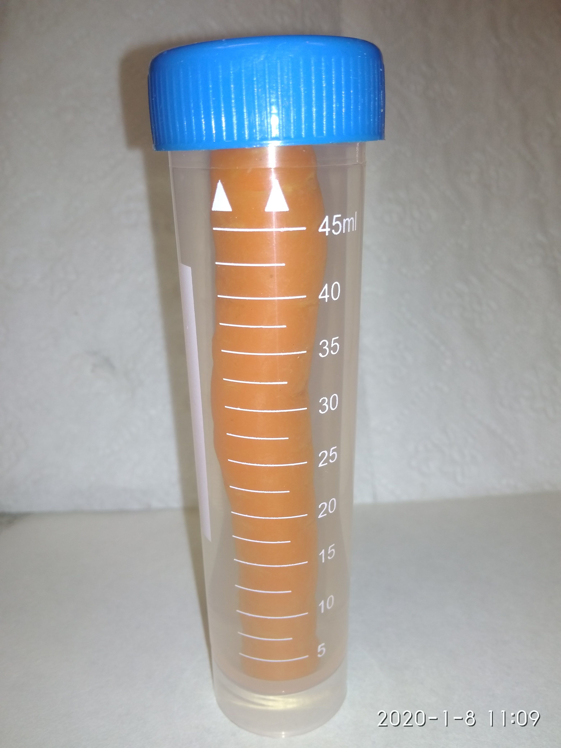
Five pieces of CR, each of about 20 g, were placed for one month into 50 mL of water containing known amounts of Cs-137 and Am-241 radionuclide. After this time, the carrots were removed, and the water was analysed for the radionuclide content. After that, we have found, that about 95 % of Am-241 and 50 % of Cs-137 were absorbed by the CR causing a significant decrease of the radioactive contamination of the aqueous solutions.

An independent experiment investigated the thermal behaviour of radionuclide-contaminated aqueous solutions in the presence of CR. For this purpose, five independent samples of aqueous solutions containing CR (25 cm³ / 20 g, each) were refluxed for three hours. The result is shown in Figure 4.

(A) | (B)
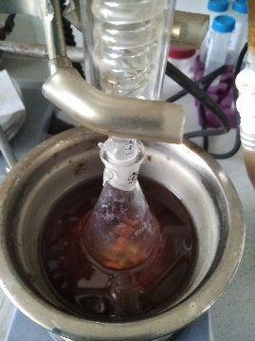 | 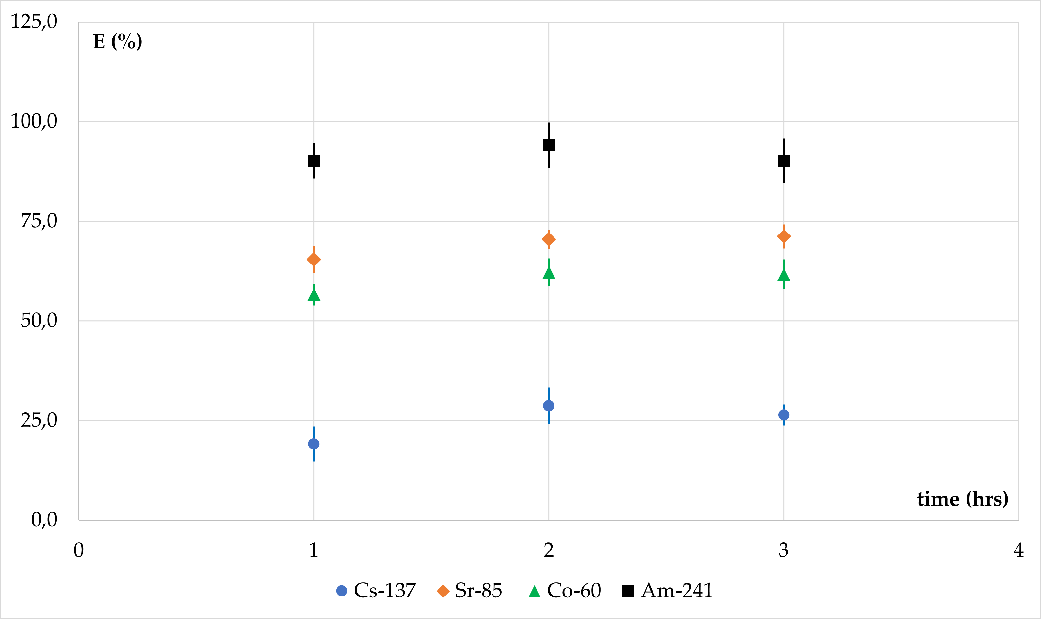
FIG. 4. Thermal removal of radionuclides from the contaminated water by boiling in the presence of CR.

It means, that culinary water processing in the presence of CR, i.e., boiling up to 3 hours and separation it from the CR material, can significantly reduce the content of Am-241 (by about 95 %) and Co-60 (about 75 %), moderate amount of Sr-85 (ca. 60 %), but only 20 % of Cs-137.

SHORT SUMMARY
In this note we present two unconventional methods, examined in our Laboratory, for the removal of radionuclides from the contaminated aqueous solutions.
In the first, we propose the use of calcium alginate, and in the second we used the roots of carrots. We believe that both methods have the potential to quickly remove Cs-137, Sr-90, Am-241 and Tc-99m radionuclides.

ADDITIONAL INFORMATION
The studies were carried out as statutory studies of the Institute of Nuclear Chemistry and Technology.
The authors state that there is no conflict of interest in presented work.

REFERENCES
[1] The International Tanker Owner Pollution Federation Limited. Measures to Combat Oil Pollution; Graham & Trotman Limited: London, 1980.
[2] SCHATZBERG, P., U.S. Coast Guard Report No. 724110.1/2/1; U.S. Coast Guard Headquarters, Washington, DC, 1971.
[3] MELVOLD, R.W., GIBSON, S.C., SCARBERRY, R., Sorbents for Liquid Hazardous Substance Cleanup and Control, Noyes Data Corp., Park Ridge, NJ (1988).
[4] NAJA, G.M., VOLESKY, B., Treatment of metal-bearing effluents: removal and recovery, Taylor & Francis and CRC Press, Boca Raton, FL (2009).
[5] AHMAD, W.A., JAAPAR, J., MIOR AHMAD, K.M.Z Removal of heavy metals from wastewater, in: PADNEY. A. (ed): Concise encyclopedia of bioresource technology, The Haworth Press Inc., New York, (2004) pp 152-157.
[6] CHEREMISINOFF, P.N. Handbook of Water and Wastewater Treatment Technology, Marcel Dekker, INC., New York (1995).
[7] SCHIEWER S., VOLESKY B Modeling of the proton-metal ion exchange in biosorption, Environ. Sci. Technol. 29 (1995) 3049-305.
[8] FUKS, L., FILIPIUK, D., LEWANDOWSKI, W., Lanthanide ions complexation by uronic acids, J. Mol. Struct. 563-564 (2001) 587-593.
[9] PAPAGEORGIOU, S.K., KOUVELOS, E.P., FAVVAS, E.P., SAPALIDIS, A.A., ROMANOS, G.E., KATSAROS, F.K., Metal-carboxylate interactions in metal-alginate complexes studied with FTIR spectroscopy. Carbohydr. Res. 34 (2010) 469-473
[10] LEE, K.Y., MOONEY, D.J., Alginate: properties and biomedical applications, Progr. Polymer. Sci. 37 (2012) 106-126.
[11] HONG, H.J., JEONG, H.S., KIM, B.-G., HONG, J., PARK, I.-S., RYU, T., CHUNG, K.-S., KIM, H., RYU, J., Highly stable and magnetically separable alginate/Fe₃O₄ composite for the removal of strontium (Sr) from seawater, Chemosphere 165 (2016) 231-238.
[12] JANG, L.K., GEESEY, G.G., LOPEZ, S.L., EASTMAN, S..L, WICHLACZ, P.L., Use of gel-forming biopolymer directly dispensed into a loop fluidized bed reactor to recover dissolved copper, Wat. Res. 24 (1990) 889-897.
[13] FUKS, L., HERDZIK-KONIECKO, I., POLKOWSKA-MOTRENKO, H., OSZCZAK, A., Novel procedure for removal of the radioactive metals from aqueous wastes by the magnetic calcium alginate, Int. J. Environm. Sci. Technol. 15 (2018) 2657-2668.
[14] FUKS, L., Improvement of the procedure for removal of the radioactive metals from aqueous wastes, Environ. Technol. and Innovation, 12 (2018) 286-292.
[15] FUKS, L., WAWSZCZAK, D., SMOLINSKI, T., HERDZIK-KONIECKO, I., CHMIELEWSKI, A.-G., Novel magnetic cobalt cyanoferrate nanoparticles as potential sorbent for solid phase extraction of the radionuclides from aqueous samples, Radiochemistry. 60 (2018) 400-408.
[16] LEE, Y., CHO, M., KIM, J.Y., YOON, J., Chemistry of ferrate (Fe(VI)) in aqueous solution and its applications as a green chemical, J. Industrial Eng. Chem. 10 (2004) 161-171.
[17] BARTON, G.B., HEPWORTH, J.L., MCCLANAHAN, E.D., MOOR,E R.L., VAN TUYL, H.H., Chemical processing wastes: recovering fission products, Ind. Eng. Chem. 50 (1958) 212-216.
[18] GUZEL, F., YAKUT, H., TOPAL, G., Determination of kinetic and equilibrium parameters of the batch adsorption of Mn(II), Co(II), Ni(II) and Cu(II) from aqueous solution by black carrot (Daucus carota L.) residues, J. Hazard. Mater. 153, 2008 1275–1287.
[19] NASERNEJAD, B., ESSLAM ZADEH, T., BONAKDAR POUR, B., ESMAAIL BYGI, M., ZAMANI, A., Camparison for biosorption modeling of heavy metals (Cr (III), Cu (II), Zn (II)) adsorption from wastewater by carrot residues, Process Biochem. 40, 2005 1319-1322.
[20] RANTAVAARA, A., Radioactivity of vegetables and mushrooms in Finland after the Chernobyl accident in 1986, Report STUK-A-59, Finnish Centre for Radiation and Nuclear Safety, Finland (1987).
[21] ASLANOGLOU, X., ASSIMAKOPOULOS, P.A., KARAMANIS, D.T., STAMOULIS, K., AVERIN, V., HOWARD, B.J., HOWARD, D.C., Impact of the Chernobyl accident on a rural population in Belarus, in: Proceedings of the first international conference 'The radiological consequences of the Chernobyl accident', Minsk (Belarus); 18-22 Mar 1996, Luxembourg; (1996), pages 363-378.

