SORPTION ON INORGANIC SORBENTS SUPPORTED BY ULTRAFILTRATION - HYBRID METHOD FOR TREATMENT OF RADIOACTIVE LIQUID WASTE

L. FUKS
Institute of Nuclear Chemistry and Technology
Warszawa, Poland
Email: leon.ichtj@gmail.com; l.fuks@ichtj.waw.pl

A. MISKIEWICZ, G. ZAKRZEWSKA-KOLTUNIEWICZ
Institute of Nuclear Chemistry and Technology
Warszawa, Poland

L. MASKALCHUK
Belarusian State Technological University
Minsk, Belarus

Abstract

In the paper, a sorption assisted ultrafiltration (SAUF) hybrid method is proposed for treatment of the radioactive wastewater. Removal efficiency (E), function of the specific activities of the permeate and feed, have been determined and discussed. It shows, that SAUF technique is promising for the radionuclide’s effective removal from aqueous solutions.

INTRODUCTION
Currently various methods for processing liquid radioactive waste, e.g. chemical precipitation, ion exchange, flotation, sedimentation, thermal evaporation or distillation, sorption, or biological methods, are used [1]. Membrane methods, such as: microfiltration, ultrafiltration, nanofiltration, reverse osmosis, electrolysis, dialysis and electrodialysis have also found their place in nuclear applications [2]. Many methods allow not only for isolation of radionuclides, but also for their purification for re-use.
The principal advantages of the industrial installations based on membrane processes are:
simplicity of operation, compactness (less space is needed than for conventional methods), energy savings and no additives and chemicals needed. In addition, membrane methods can be easily coupled with other processes and operations. The main drawbacks of membrane processes are possible fouling (i.e. the accumulation of unwanted material on solid surfaces), and resulting production of secondary waste from membrane washing, generally observed low selectivity towards metals and relatively short membrane life-time requiring their periodic replacement,. Therefore, there is a constant necessity for improvement to obtain maximum efficiency.
In recent times, many novel variants or advancements of the existing membrane methods have been proposed. In terms of too low selectivity, and in certain cases, complete purification of the permeate, so that it can be safely discharged into the environment, no single-step membrane process can fully overcome these shortcomings. Fortunately, to reach the best results, most of processes can be used in a multistage form or as a combined (hybrid) technology. Between the available membrane methods, ultrafiltration has recently received great interest to treat the wastewater and the contaminated aqueous streams, because it has more compact installations and uses less energy than another methods. In combination with complexation of the radionuclides, a resulting hybrid technique (complexation assisted ultrafiltration, CAUF) seems to be a powerful procedure. Different metal-binding polymers have been already proposed to bind the cationic heavy metals, to increase the molecular weight of separated complexes that cannot pass through the pores of the ultrafiltration membrane. Schematic presentation of the CAUF method is shown in Fig. 1.

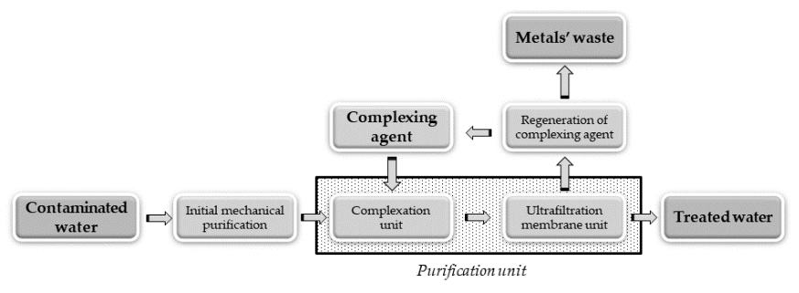
FIG. 1. Schematic presentation of the CAUF method.

This work fits into the current line of searching for new solutions in the sorption assisted ultrafiltration (SAUF) hybrid method. The number of available literature publications on application of membranes in radioactive waste treatment is rather limited. Thus, the design and selection of the best process conditions proposed for removal of the radionuclides must be based on an analysis of the information on the membrane separation of heavy metals from aqueous solutions and on laboratory studies of theses processes. Below, we will present the results of preliminary studies on the SAUF carried out at INCT’s Laboratory. A purified aluminosilicate sorbent obtained from the clay-salt slimes (CSS), industrial waste of the Joint Stock Company "Belaruskali", has been tested as a low-cost, eco-friendly sorbent. It has been already characterized as a promising sorbent and described in [3,4]. Schematic presentation of mechanism of metal sorption by the CSS is shown in Fig. 2.

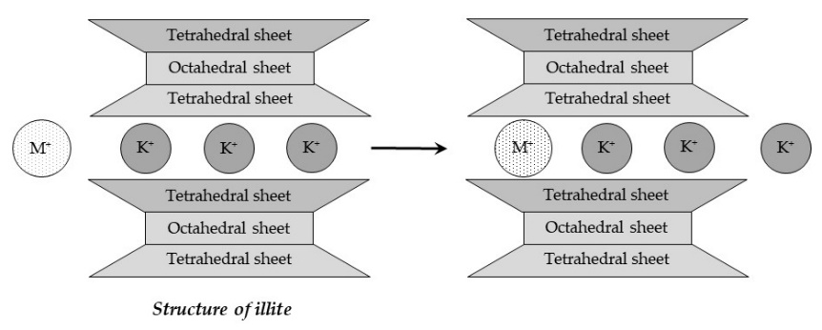
FIG. 2. Sorption of metals by illite, main component of the CSS.

MATERIALS,
The crude sorbing material had been brought from the storehouse No.1 of the Joint Stock Company JSC ‘‘Belaruskali’’ (Soligorsk, Belarus). The content of water-soluble salts (mainly, KCl, NaCl) in the raw material, determined by the atomic adsorption spectroscopy (AAS), was 13.1 wt% and of the water insoluble residue - 69.4 wt%. Raw material was repeatedly washed with distilled water to remove the water-soluble salts, and finally dried at 50 °C to the constant mass.
Carrier-free radionuclides of Cs-137, Co-60 and Am-241 were supplied by POLATOM Świerk (Poland) as standard solutions, gravimetrically diluted with deionised water and adjusted to pH 4 (HNO₃) to obtain working solutions of the desired concentration of the radionuclides.
Technetium-99m radioisotope was used to simulate Tc-99 because its favourable radiometric properties. The radionuclide, in 0.9% saline (ca 100 MBq⋅cm⁻³), was eluted from a Mo-99/Tc-99m commercially available medical generator (GE Healthcare, supplied by Biker, Warsaw, Poland).
Acids, bases and the reducing agents (p.a. grade) were delivered by Sigma-Aldrich (Poznan, Poland) and were used as obtained. Deionised water was used to prepare all experimental solutions.

EXPERIMENTAL UNIT
Ultrafiltration equipment used in the experiments included an AMICON 8400 stirred membrane cell (Merck Millipore, Merck Sp. z o.o., Poland) with volume of 350 mL. The filtration cell was equipped with a polyethersulfone (PES) ultrafiltration membrane with molecular weight cut-off of 10 kDa and diameter of 0.067 m (an effective active area of 4.18·10⁻³ m²) provided by Merck Millipore (Merck Sp. z o.o., Poland). Compressed nitrogen as a pressure source was applied.
Schematic presentation of the experimental installation and photograph of the membrane cell are presented in Fig. 3.
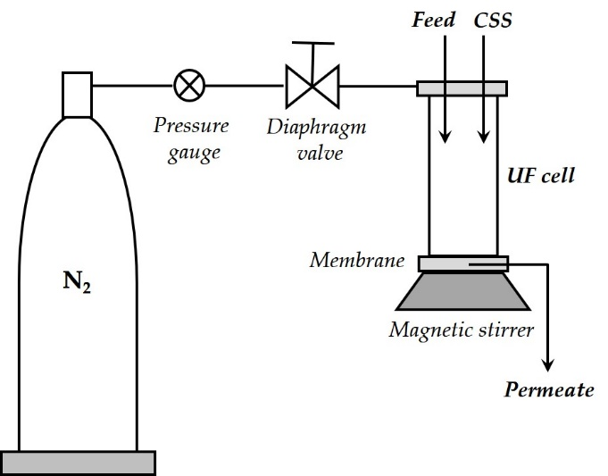 | 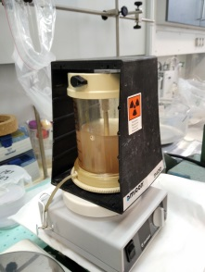
FIG. 3. Schematic presentation of the experimental installation (left) and photograph of the membrane cell (right).

RESULTS AND DISCUSSION

Clay salt slimes, sorbent (complexing agent)
Clay-salt slimes (CSS) are an industrial waste existing in the form of a suspension of clay in a saturated solution of the NaCl and KCl salts. About 120 million tons of CSS are stored on the factory premises; there is currently no idea of using it as a raw material for industrial applications. Therefore, any usage of this material is well perceived. According to the results of the mineralogical analysis, chemical composition of the material shows the predominant content of illite (about 42 wt%), dolomite (25 wt%) and the microcline potassium feldspars (16.5 wt%) [5]. The mineral composition of the water insoluble material obtained by purification of the raw material and proposed in this work as a sorbent remains similar to this in raw material.
The particle size of the water insoluble aluminosilicate material ranges from 0.25 to 2.5 mm, and the size of the main fraction (59 wt.%) is 0.25-1.5 mm.
The specific surface area (S_{a}), determined by the BET method, is 41.8 m²⋅g⁻¹ [6].
Decontamination of liquid radioactive wastes with the use of the CSS has been already studied in batch experiments [3]. It was found that the sorbent is effective for purification of the solutions containing Cs(I), Sr(II), Eu(III) and Am(III) radionuclides. It has also appeared to be sufficiently stable for practical application in the treatment of wastewater.
Zeta potential (ζn), which refers to the surface charge of solid, is accounted among the crucial factors in the sorption process. The values determined for the sorbent are - 20.1 and - 31 mV for pH = 4 and pH = 11, respectively. The potential was measured also for the material contacted with a solution containing an excess amount of the natural (non-radioactive) SrCl₂. It was found that values of the potentials are about 3-4 mV higher than in the raw materials [3]. This observation supports an idea of the chemical mechanism of sorption (chemisorption), which depends on the chemical bonding of metals with the acidic sorbing groups present in the CSS.

Caesium-137, cobalt-60, americium-241
It was already shown that conventional ultrafiltration (UF) often does not show considerable removal capacity for gross alpha, gross beta and consequently uranium activities from water [7]. To explore possibility of improving the UF treatment efficiency of water containing metal radionuclides, we have studied a LRW simulating solution that contained three cationic radionuclides: monovalent Cs-137, divalent Co-60 and trivalent Am-241. Radiochemical purity of the solution containing all these radionuclides was checked by the gamma ray spectrometry and no significant amounts of other radionuclides have been found (Fig. 4).

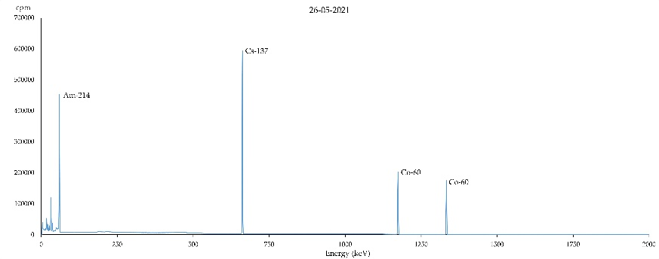
FIG. 4. Gamma ray spectrum of the working solution.

Effectiveness of removal of the radionuclides was determined by calculating the Removal efficiency (E_{radionuclide}) which considers ratio of the radiation activity concentration of the radionuclide in the permeate (i.e., in the solution coming out of the installation) and the activity concentration of the feed solution.

$$E_{radionuclide}=\frac{Radiation activity of the feed-Radiation activity of the permeate}{Radiation activity of the feed}∙100\%=(1-\frac{Radiation activity of the permeate}{Radiation activity of the feed})∙100\%$$

The content of all the radionuclides was determined simultaneously in each sample using a well type counter with automatic sample changer (Wizzard 2000®). The proper operation of the counter was periodically checked by measuring the reference solutions.

Some experimental results on water purification can be seen in Fig. 5. Content of the sorbent in the feed was 1 gˑdm⁻³ and flow-rate of this solution varied in the range 0.8-1.4 mLˑmin⁻¹ when a pressure of 2 bar was used.
These results show that independently on the valence state, radionuclides present in the solution in the cationic form may be removed by SAUF almost completely. This observation is valid both for the acidic and basic solutions.
A separate series of experiments tested dependence of the PAR values on the amount of sorbent suspended in the feed. It was observed that, in the range of the CSS added from 500 mgˑdm⁻³ to 5 gˑdm⁻³, these values within the error limits remain the same. Because of the observed membrane fouling (a process by which particles are deposited on a membrane surface or in the pores), the lower amount of the sorbent is strongly recommended.
pH 2
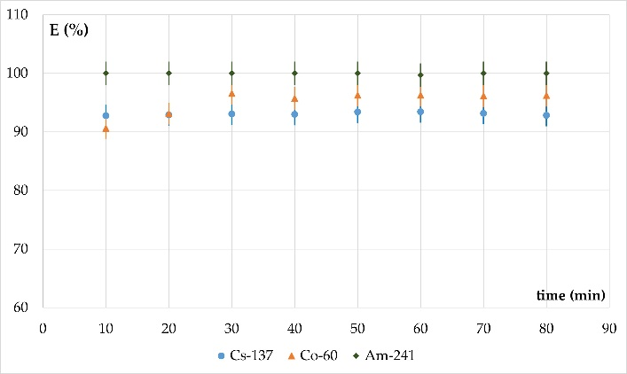
pH 10
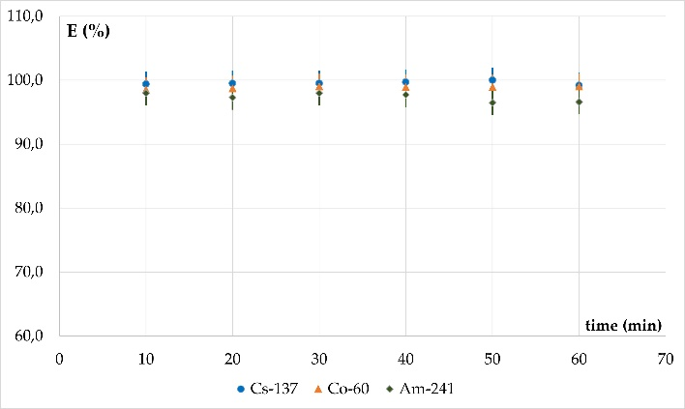
FIG. 5. Removal of Cs(I), Co(II) and Am(III) radionuclides from wastewater.

Technetium-99m
Technetium has nine oxidation states, from -1 to +7, and the most stable are +4 (in the cationic form), +5 and especially +7 (both anions). The stability of the different oxidation states depends on the nature of coordinating atoms and the medium used. Naturally, technetium exists in the form of the pertechnetate (oxyanion, chemically like the permanganate), and to a lesser extent, as a tetravalent product of the pertechnetate reduction (in the absence of strong complexing ligands, with the formation of TcO₂ hydrate [8]). Lower known oxidation states, i.e., -1, +1, +2 and +3, do not exist in a natural manner and, if formed, should be stabilized by complex formation with certain ligands.
As it is known from the literature, the relatively large pertechnetate anion can not compete successfully for the internal vacancies in the aluminosilicate structure with the smaller OH⁻, NO₃⁻, SO₄²⁻ or Cl⁻ anions usually present in solution. This makes sorption of the pertechnetate to be unsuitable for removal of this ion from water [9]. It was expected that without addition of a reductor, Tc-99m removal from wastewater using SAUF method would be unable.

(a)
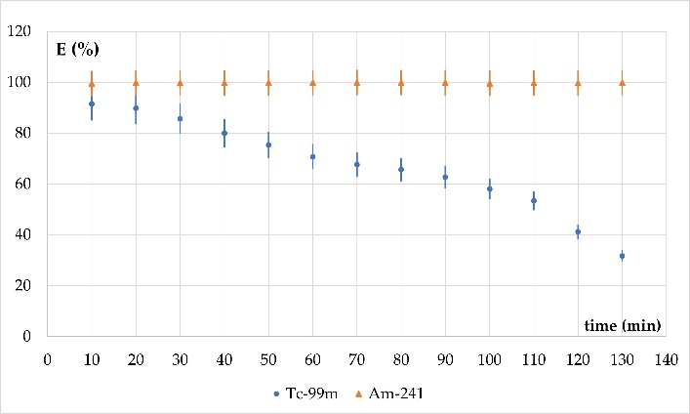
(b)
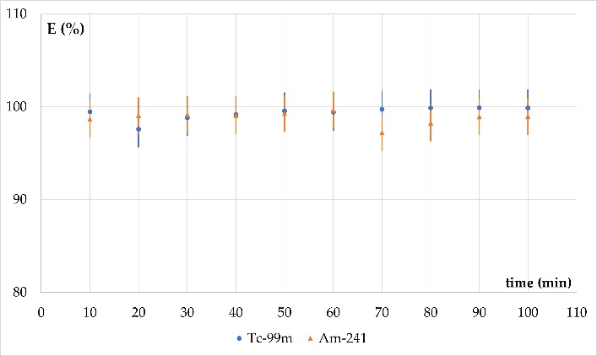
(c)
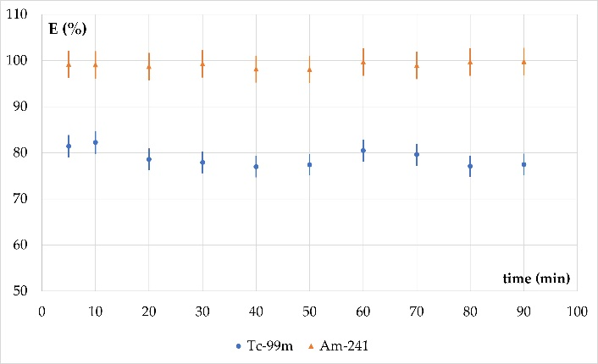
FIG. 6. Removal of Tc-99m from wastewater: (a) natural form of Tc-99m, (b) SnCl₂ added, (c) hydrazine added.

The examples of experimental results of purifying aqueous solutions from two radioactive ions can be seen in Fig. 6. The upper part of this Figure presents values of the PAR as a function of process time for natural form of Tc-99m, together with the data obtained for Am-241 added as a reference. The observed decrease in process efficiency can probably be associated with changes in the ratio of technetium oxidation forms in the solution. Over time, technetium in the lower oxidation forms is oxidized in the air and the pertechnetate content increases. The latter, because they do not bind to aluminosilicate, penetrate through the pores of the membrane as smaller than the particles of the technetium-saturated sorbent. As can be seen in the other parts of the Figure, the addition of a reducing agent to the purified solution increases efficiency of the process due to the formation of cationic technetium forms. The addition of stannous chloride results in a higher decontamination efficiency than the addition of hydrazine.

CONCLUSION
The paper demonstrates the possibility of using CSS to remove radionuclides in various forms from aqueous solutions. Large radiation stability of the CSS material permits treatment even highly active solutions. The work will be continued however, even these preliminary results demonstrate the suitability of the SAUF method for decontamination of radioactively contaminated water.

ACKNOWLEDGEMENTS
The work was done within the IAEA Coordinated Research Project Management of Wastes Containing Long-lived Alpha Emitters: Characterization, Processing and Storage (Project Code: T13017).
The authors acknowledge Mr. Miroslaw BUTA (Institute of Nuclear Chemistry and Technology), for help in the SAUF experiments.

Additional information
The authors state that there is no conflict of interest in presented work.

REFERENCES
- ABDEL RAHMAN, R.O., IBRAHIM, H., HUNG, Y.-T., Liquid radioactive wastes treatment: A review, Water 3 (2011) 551-565.
- ZAKRZEWSKA-TRZNADEL, G., HARASIMOWICZ, M., CHMIELEWSKI, A.G., Membrane processes in nuclear technology - application for liquid radioactive waste treatment. Sep. Purificat. Technol. 2 (2001) 617-625.
- FUKS, L., HERDZIK-KONIECKO, I., MASKALCHUK, L., LEONTIEVA, T., Clay-salt slimes of the JSC ‘‘Belaruskali’’ as potential engineering barriers in the radioactive waste repositories: sorption of Cs(I), Sr(II), Eu(III) and Am(III), Int. J. Environm. Sci. Technol. 15 (2018) 2047-2058.
- FUKS, L., MASKALCHUK, L., HERDZIK-KONIECKO, I., LEONTIEVA, T., Clay‑salt slimes of the “Belaruskali” ‑ novel sorbents for management of liquid radioactive wastes and decontamination of environmental water streams, J. Radioanal. Nucl. Chem. 320 (2019) 87-100.
- MASKALCHUK, L.N., MILYUTIN, V.V., NEKRASOVA, N.A., LEONTIEVA, T.G., BAKLAY, A.A., BELOUSOV, P.E., KRUPSKAYA, V.V, Aluminosilicate sorbents based on clay-salt slimes from JSC “Belaruskali” for sorption of cesium and strontium radionuclides. Radiochem. 62, (2020) 381–386.
- MASKALCHUK, L., BAKLAY, A., LEONTIEVA, T., Chemical and mineralogical aspects of clay-salt slimes of “Belaruskali”. Using for the preparation of nanostructured sorbents of radionuclides. Procedia Chemistry 21 (2016) 394-400.
- MONTAÑA, M., CAMACHO, A., SERRANO, I., DEVESA, R., MATIA, L., VALLÉS, I., Removal of radionuclides in drinking water by membrane treatment using ultrafiltration, reverse osmosis and electrodialysis reversal, J. Environm. Radioactivity 125 (2013) 86-92.
- SCHWOCHAU, K., Technetium radiopharmaceuticals - fundamentals, synthesis, structure, and development, Angew. Chem. Int. Ed. Engl. 33 (1994) 2258-2267.
- LITTLEWOOD, J., SHAW, S., BOTS, P., PEACOCK, C., TRIVEDI, D., BURKE, I., Effect of solution composition on the recrystallization of kaolinite to feldspathoids in hyperalkaline conditions: Limitations of pertechnetate incorporation by ion competition effects. Mineralogical Magazine 79 (2015) 1379-1388.

