SEGREGATION AND DISPOSAL OF

LEGACY MIXED ORGANIC LIQUID WASTE

IN MALAYSIA

A.K. ZAHARI
Malaysian Nuclear Agency
Bangi, Malaysia
Email: khairulikram@nuclearmalaysia.gov.my

N. ZAKARIA
Malaysian Nuclear Agency
Bangi, Malaysia

R. SALIHUDDIN
Malaysian Nuclear Agency
Bangi, Malaysia

N. HARUN
Malaysian Nuclear Agency
Bangi, Malaysia

Abstract

Waste Technology Development Centre (WasTeC) of the Malaysian Nuclear Agency has been managing various forms of radioactive wastes since 1984. Among liquid wastes managed at the centre, the most challenging type is the mixed organic liquid waste. These consist of a multitude of scintillation liquids, mineral processing solvents, and medical radiotherapy fluids. The hazardous-radioactive combination of this waste type requires both associated regulations to be fulfilled when it comes to disposal. The radioactivity of the waste must be reduced to safe levels by means of reprocessing, radionuclide extraction or decay storage before it can be disposed according to hazardous waste procedures. In the Malaysian Nuclear Agency, there were about 3900, 2.5-litre bottles of mixed organic waste of various types that has been stored for over 30 years. The degrading conditions of the waste bottles posed a threat to the overall safety of the workplace should the bottles fail, while records and labels we also found dilapidated. For the purpose of identification, two characterization methods were used: the determination of activity concentration using Geiger-Mueller Ludlum 185-8 and the detection rate information using ThermoScientific RadEye B20-ER. Among 3900 bottles of waste, 55 bottles were randomly selected to establish the correlation between these methods. As a result, an expeditious characterization protocol was developed to segregate the radioactive waste from the decayed wastes. The protocol was also supported by the decay information of radioisotopes (where available) and observations of the would-be physical attributes of the waste. The protocol successfully identified less than 100 bottles from the estimated 3900 bottles of waste to be of higher activity and continued to be stored for decay.

INTRODUCTION
Ever since its inception, it is the responsibility of the Malaysian Nuclear Agency through the Waste Technology Development Centre (WasTeC) to manage radioactive wastes within the Malaysian borders. Because of this, the Malaysian Nuclear Agency was christened as the National Radioactive Waste Management Centre. Radioactive wastes from the industry, mining activity, oil and gas exploration, hospitals and research centres have been collected, treated, conditioned, and stored within the premise since 1982. Different form of waste requires different management strategy. While most of the waste received be it disused sealed radioactive sources (DSRS), solid, and aqueous wastes can be treated to reduce the volume, such is not the case for mixed organic liquid waste. The mixed organic liquid waste has two types of hazards namely radioactive and chemical hazards. Disposal of radioactive waste in Malaysia follows Schedule 2 of the Atomic Energy Licensing (Radioactive Waste Management) Regulations 2011 which specifies the allowable activity and activity concentration of a radionuclide contained in a waste before the waste can be disposed safely. [1] Incineration, distillation, and absorption are some of the methods which can be used to treat long lived and high activity radioisotopes. [2] For short lived and low-level waste, decay storage is the most economical option.
The Low-Level Effluent Treatment Plant (LLETP) is a facility in the Malaysian Nuclear Agency for the treatment of aqueous radioactive waste. It is also the site where more than 3900 bottles of mixed organic waste were stored for decay. Initially, the mixed organic waste collected over several years were stored and arranged on 3-tier plywood racks which were susceptible to termite attack. Furthermore, the bottle caps which were mostly made of plastic were found deteriorated due to extended exposure to corrosive vapour. This could potentially exposing workers to hazardous organic compounds. Also, some of the liquids were found contained in HDPE bottles which were not suitable for long term storage. Due to these factors, some of the waste were consolidated and had their bottles changed into used chemical glass bottles while all waste bottles were then rearranged inside storage barrels. The condition of the storage pit before the waste segregation is shown in Fig. 1. There were 60 storage barrels altogether in the mixed organic waste storage pit and each barrel contained around 70, 2.5-litre amber chemical bottles.

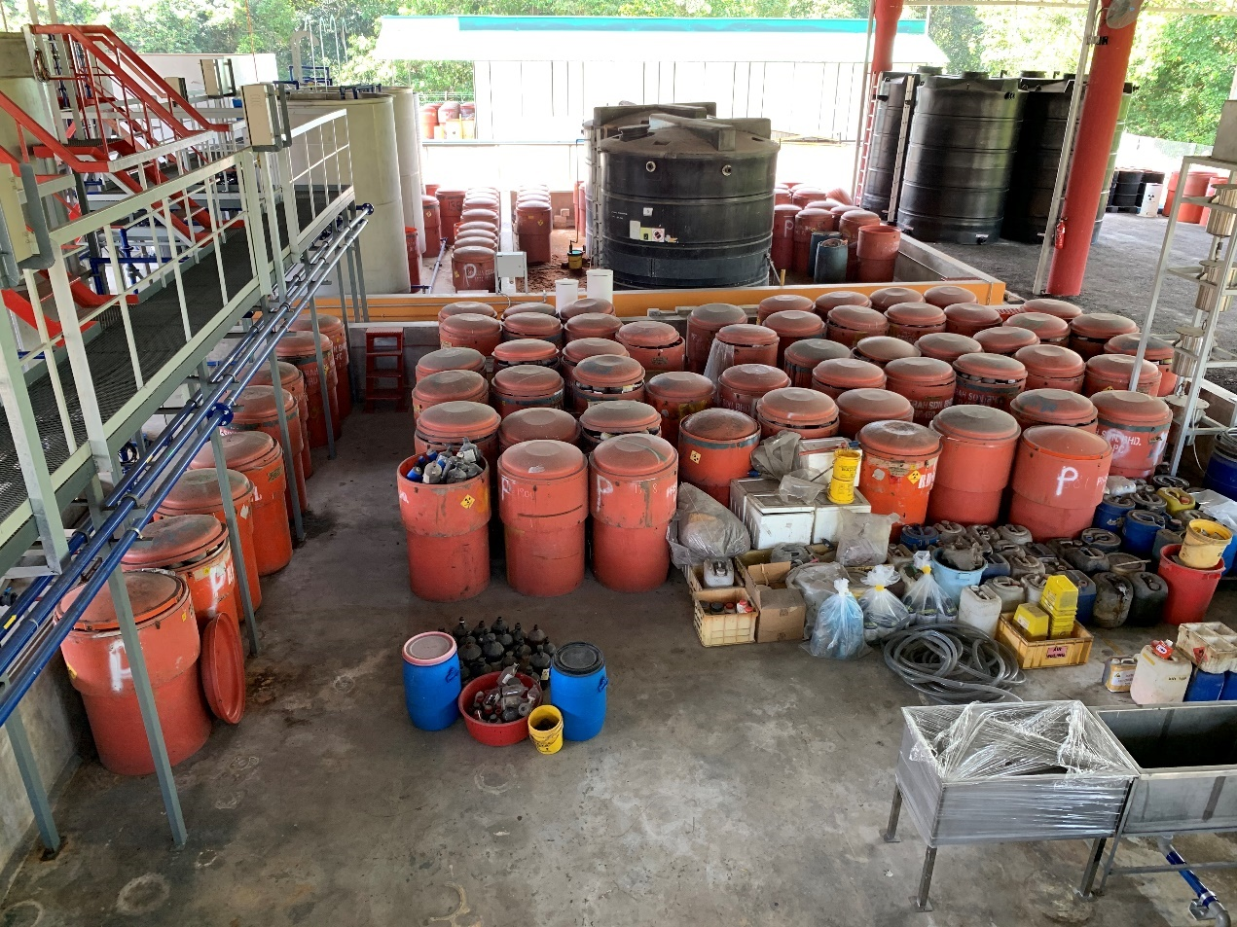
Fig. 1. The condition of the mixed organic storage pit with 60 storage barrels containing on average 60 amber glass bottles.
The presence of the waste has taken much of the space needed to receive new waste and for other radioactive waste management activities to be done particularly on liquid waste treatment and development of its conditioning technology. Therefore, WasTeC has decided to segregate and dispose the mixed organic waste by first identifying the decayed waste from the waste that are still radioactive.

waste CHARACTERIZATION
Due to the unavailability of the waste inventory and the fact that the bottle contents had been consolidated before, the composition of wastes and its associated radioisotopes stored in each of every barrel were assumed to be of random. To get some insights about the types of waste being stored, one waste bottle was randomly selected from each of the storage barrels. However, only 55 barrels contain such waste bottles and the remaining five were either empty or filled with waste that is not of mixed organic liquid. The contents of the waste bottles were visually checked in terms of colour and consistency. The waste bottles were also inspected for any presence of labels or identification. Table 1 summarizes the physical attributes of the sampled bottles.
The visual observation was proved to be inconclusive in categorizing the types of wastes. The labels were found unreliable because used chemical bottles were reutilized to store some of the waste without proper reidentification. Inspection towards the bottle contents were also inconsistent with the labels. However, some trends can be established; for example, most bottles which had been identified to contain various hydrocarbons including Toluene were mostly present in two-phases. This proves that these bottles indeed contained hydrocarbon by the different density of the contents. During the sampling too, it was found that the waste bottles were in poor condition that many of the plastic caps crumbled when screwed open. This could give rise to occupational hazards if the waste is to be kept for longer. This fact was used as a justification to expedite the segregation and disposal of these wastes.

TABLE 1. VISUAL OBSERVATION OF RANDOMLY SAMPLED WASTE BOTTLES.

Attributes | Quantity | Remarks
Labelled with date | 15 | Mostly between 1983 and 1994. One bottle labelled 2003.
Labelled with type of radionuclide | 9 | ³H = 5, ¹²⁵I = 1, ¹³¹I = 1, ²²Na = 1, ThO₄ = 1
Labelled with initial activity | 5 | Between 0.17 – 62 μCi. One labelled as 1.6 Bq/g
Presence of content label  - Toluene/scintillant  - Other hydrocarbons  - Various acids  - ‘Organic waste’  - Others | 52  9  26  5  7  5 | Many labels were found incoherent with its content.
Present in two or more phases | 14 | Present in bottles labelled as hydrocarbons, scintillant, or toluene

As mentioned earlier, chances were that different types radioisotopes had been consolidated together in one bottle, adding to the fact that only 9 out of 55 samples were labelled with the radioisotope type, it was difficult to correctly characterize the radionuclide contained in each bottle. Hence the way forward was to develop a fast segregation protocol to decide whether the waste can be safely disposed as normal chemical waste. For this, bottle contents were sampled by using swabs. Detection reading using ThermoScientific RadEye B20-ER were immediately taken after each swab. Background reading of the area was determined to be at 62 cpm before the detection reading were performed on the swab samples. Swab samples were also taken to the radiological safety lab for analysis using Geiger-Mueller Ludlum 185-8 to determine their activity levels. Here, readings were taken five times with 1-minute measuring time for each sample. The results were then calculated on different calibration sheets; Am²⁴¹ for alpha emitters, Sr⁹⁰ for beta emitter and Co⁶⁰ for gamma emitters. The results calibrated against the background reading is as shown in Fig. 2.

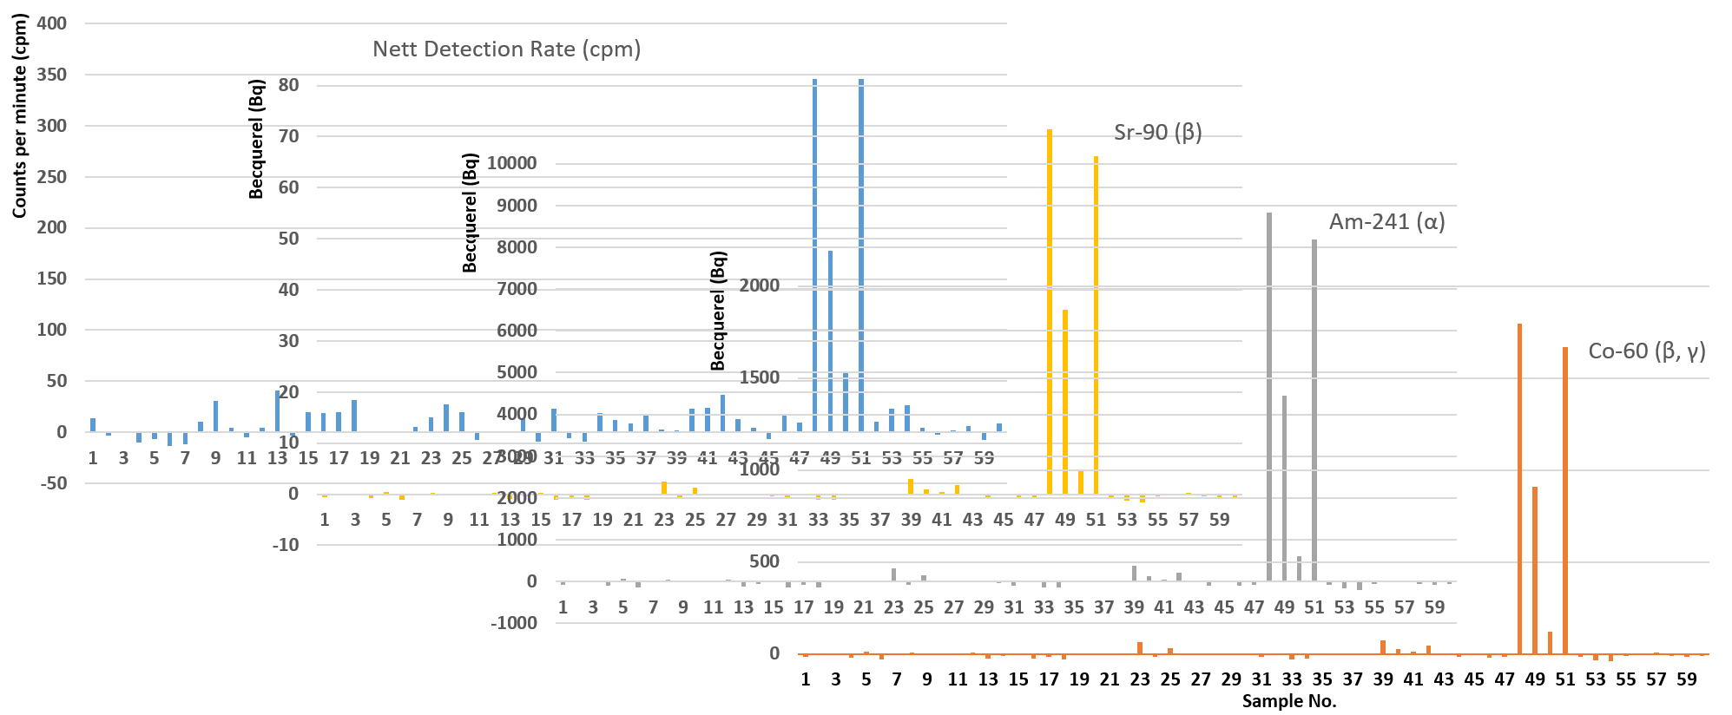
Fig. 2. Comparison of net detection rate (cpm) and activity (Bq) for samples numbered 1-60.

It can be seen from Fig. 2 that detection rate and activity of sample number 48 through 51 were prominent and consistent throughout. A checkback to the visual observation records revealed that sample 48, 49 and 51 were somewhat similar. Sample 48 was labelled to contain thorium, kerosene, tributyl phosphate, nitric acid and carbon tetrachloride. These are the chemicals known for use in thorium extraction processes. [3, 4] Sample 48, 49 and 51 were also yellowish in colour suggesting that they were indeed of the same chemical type, even though there were no label to explicitly support the claim. As for sample 50, the only information gathered from the label was that the sample was received in 2003, more than a decade later than most other samples received for decay storage in the Malaysian Nuclear Agency. The high and consistent activity level for the sample could mean that the sample has not gone enough decay cycle as other samples, regardless of its initial activity. A second probability is that the sample could contain thorium as with sample 48, 49 and 51 due to the fact that in 2003, the decommissioning and decontamination of the Long Term Storage Facility (LTSF) of the Asian Rare Earth Corporation which contained 87,000 waste drums was started where some of the waste drums were sent to the Malaysian Nuclear Agency for research purposes. [5]
Apart from these four samples, others did not show any significant pattern. Detection rate for all other samples were generally below 50 cpm. Inconsistencies in detection at low levels were likely caused by the limitations of the equipment as pancake type G-M are sensitive to natural background radiation. [6] Activity analysis on all three calibrations also show almost negligible activity levels for these samples. By comparing the highs and lows of the detection rate and activity, a correlation between these two methods can be established and were to be the basis for the rapid segregation method.

WASTE SEGREGATION
Since it has been established that the reading of detection rate using ThermoScientific RadEye B20-ER and activity level using Geiger-Mueller Ludlum 185-8 contamination were in great agreement, a rapid segregation method was established by using only the former equipment. ThermoScientific RadEye B20-ER offers faster detection and stabilization time compared to conventional analogue survey meters. Threshold limit was set at 120 cpm, taking twice the background reading of the area. This means that any sample bottle exceeding this value will be continued to be stored. During the segregation exercise, each bottle was first scanned externally. Bottles exceeding 120 cpm at this stage was immediately stored without having to undergo further identification steps. Then, using white cotton buds, the bottle content was sampled and scanned using ThermoScientific RadEye B20-ER to determine its detection rate.
The sample were also observed for its colour and consistency. Samples determined to be below the threshold level were then sorted according to their observed physical attributes as it was assumed that similar attributes were of similar chemical type. It was found in some that there was no clear cut between different attributes. For example, some workers might perceive a sample as being only slightly fluorescent as opposed to others, therefore the chemicals could be of the same type with slight variations in colour. Regardless, the segregation process was important as it is a requirement to dispose the chemical wastes according to hazardous waste disposal procedures. Fig. 3 shows the segregated waste bottles.

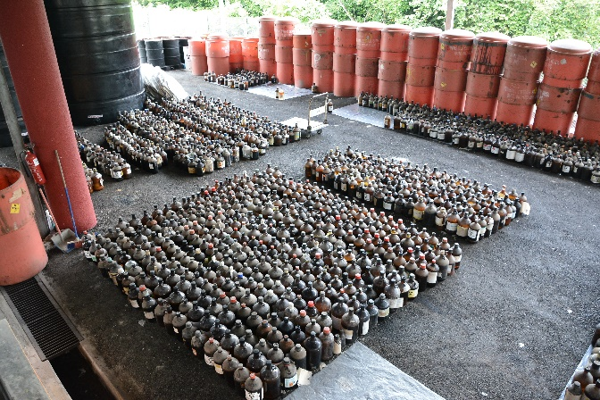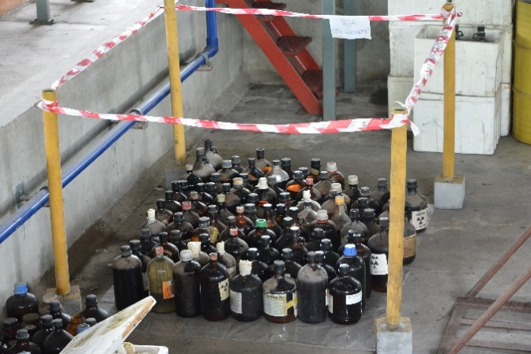
Fig. 3: On left: decayed mixed organic liquid waste segregated according to physical attributes and on the right: waste which are not cleared for disposal and requiring further action were grouped and barricaded.

DISCUSSIONS
The purpose of characterization in this regard was to collate required data and to inspect the physical conditions of the mixed liquid radioactive waste. The characterization protocol entails segregation, swab sample, contamination check, and surface dose reading. Apart from the disposal requirement, segregating the chemicals according to their attributes provides some idea on the types of mixed organic waste that has been sent to the Malaysian Nuclear Agency for storage since 1984. Table 2 explains the different attributes found among cleared mixed organic waste during the segregation exercise and the quantity of each type. Group A (colourless waste liquid) represents most of the cleared waste. Physical observation on available labels and presence of two-phase liquid in some bottles found that group A was consistent to the finding during the characterization stage that these liquids were indeed organic scintillant. Liquid scintillation counting (LSC) uses liquid chemical medium which can convert kinetic energy into light energy upon contact with radioisotopes. [7] Toluene, xylene, and benzene are classical organic solvents normally used as LSC cocktails. However, due to health and safety reasons, these organic solvents are no longer popular for LSC applications and now replaced with safer types of scintillant cocktails which have higher flashpoint, less toxic, and much lower vapour pressure that reduces strong odour. [8] There are no information on LSC usage in Malaysia but this could be the reason that dates recorded on labels where available for group A are between 1980s to 1990s only.

TABLE 2. PHYSICAL ATTRIBUTES AND QUANTITIES OF CLEARED WASTE.

Group | Physical Attribute | Quantity (bottles)
A | Colourless | 3,018 (est.)
B | Turbid | 207
C | Brick red/brown | 111
D | Black (oil) | 34
E | Viscous | 81
F | Yellowish | 215
G | Purple | 46
H | Acid sizzle | 42
I | White | 26
J | Green | 9
K | Blue | 17
Total |  | 3,806

Radionuclide types found written on the label denotes the radionuclide that has been mixed with the LSC cocktail for detection. During the segregation exercise, more types of radioisotopes were discovered on the labels which are ³²P and ¹⁵¹Sm. Table 3 shows the list of radioisotopes found during segregation and its associated halflife. Types of radioisotopes were also considered when deciding if a waste can be disposed or should be kept for longer. As explained earlier, bottles with obvious high activity are continued to be kept, such as thorium waste. However, some bottles were found at the borderline of the threshold value. An example being bottles containing ¹⁵¹Sm which were read around 110-130 cpm. Considering the halflife of ¹⁵¹Sm which is 88.8 years, bottles identified with ¹⁵¹Sm were continued to be stored. As for other radioisotopes, the longest of half-lives would be ³H at 12.3 years. As the waste in general has been kept for up to 36 years by the year 2020, ³H could have easily undergone 2 or 3 decay cycles, much more so for other radioisotopes with far shorter half-lives while also noting the fact that the initial activity was already very low (0.17 – 62 μCi).
Disposal of radioactive substances in Malaysia are bound by Schedule 2 of the Atomic Energy Licensing (Radioactive Waste Management) Regulations 2011. Schedule 2 enlists all radioisotopes and their activity and activity concentration clearance levels. Clearance levels for radioisotopes found during segregation are listed in Table 3. In principal, to satisfy the regulation, for every waste bottle to be disposed, the radioisotope contained in the waste and activity levels must be determined. Characterization works was previously done on the same waste; gross alpha/beta counting was done using Canberra Tennelec LB5100 gas flow proportional counter, while for gamma, Ortec GEM25-76-XLB-C gamma spectroscopy was used. These methods were very time consuming from sample preparation to scanning. Hence, the characterization study was done to find correlation with a faster counting system, the Geiger-Mueller Ludlum 185-8. The study found that the methods compared were conclusive and Geiger-Mueller Ludlum 185-8 can be used to quantify the samples quickly to expedite disposal. [9] However, in practice, to sample and characterize 3900 bottles of waste for the purpose of disposal is still very time consuming and exposes the workers to various hazards. Hence, the current characterization protocol was developed. The current practice did not identify the radioisotope as required by the regulation but to justify it, a generalized worst-case scenario is considered.

TABLE 3. RADIOACTIVE WASTE CLEARANCE LEVEL AS STIPULATED IN THE REGULATION [1]

Radionuclide | Half-life | Activity Concentration (Bq/g) | Activity (Bq)
Tritium (³H) | 12.3 years | 1 x 10⁶ | 1 x 10⁹
Sodium-22 (²²Na) | 2.6 years | 1 x 10¹ | 1 x 10⁶
Iodine-131 (¹³¹I) | 8 days | 1 x 10² | 1 x 10⁶
Iodine-125 (¹²⁵I) | 60 days | 1 x 10³ | 1 x 10⁶
Phosphorus-32 (³²P) | 14.3 days | 1 x 10³ | 1 x 10⁵
Samarium-151 (¹⁵¹Sm) | 88.8 years | 1 x 10⁴ | 1 x 10⁸
Thorium-232 (²³²Th) | 14 x 10⁹ years | 1 x 10⁰ | 1 x 10³

The worst-case scenario assumes that for each bottle, there could be two or more radioisotopes present but only bound to the ones that has been found on labels. Consider that among all waste bottles that are lower than 120 cpm threshold value after segregation, ³H is the radioisotope with the longest half-life found. Also, the highest initial activity found and recorded among all the cleared waste is 62 μCi (2.29 MBq). After a minimum of 2 decay cycles, the activity for ³H has reduced to 0.57 MBq. The clearance level for ³H disposal in Schedule 2 is at 1 TBq. This justifies the segregation methodology.

WAY FORWARD
The legacy mixed organic waste stored in the Malaysian Nuclear Agency was left unsolved for decades due lack of records and proper storage system. A record keeping system was probably not in place and even if they were, rudimentary record keeping do not last long. Records could be lost, destroyed, or misplaced when the person in charge retires from service. Developing from this issue, the Malaysian Nuclear Agency continues to improve the management practices pertaining radioactive waste especially in terms of record keeping and traceability of the inventory. Adopting a digitized inventory system that has been successful for the inventory of DSRS on mixed organic liquid waste system needs to be in place to avoid the issue of legacy wastes from repeating. It is also suggested that decay storage should be only applicable to the waste in which the half-life is in a foreseeable future. For longer lived radioisotopes, treatment and conditioning process should be taken shortly after receiving the waste. This could avoid the discovery of unidentified waste decades in the future.

CONCLUSION
Segregation of legacy mixed organic liquid waste was performed successfully using ThermoScientific RadEye B20-ER surveymeter after its correlation with Geiger-Mueller Ludlum 185-8 has been established. Disposal of radioactive waste must abide to the clearance limitations stipulated in the regulation while at the same time performed safely and quickly considering the derelict condition of the waste packages, limited availability of records, and hazards in handling the waste.
ACKNOWLEDGEMENTS
The author would like to thank all officers and staff of the Waste Technology Development Centre (WasTeC) who are willing to contribute their time and effort in this momentous and labour-intensive segregation exercise. Special appreciation goes to Dr. Norasalwa Zakaria, manager of WasTeC who are very supportive towards suggestions and new ideas.
References
- ATOMIC ENERGY LICENSING BOARD, Atomic Energy Licensing (Radioactive Waste Management) Regulations 2011, Federal Government Gazette. Malaysia (2011)
- INTERNATIONAL ATOMIC ENERGY AGENCY, Treatment and Conditioning of Radioactive Organic Liquids, IAEA, Vienna (1992)
- MAIOROV, V.G., NIKOLAEV, A.I., ADKINA, O.P., MAZUNINA, G.B., Extraction of thorium with tributyl phosphate from chloride solutions, Radiochemistry 48 (2006) 576-579.
- TANABE, T., KONDO, Y., Solvent extraction of thorium nitrate and nitric acid by tributyl phosphate – carbon tetrachloride solution, Trans. Jpn. Inst. Met. (Online) 17 6 (1976) 360-369
- AZMI, S.A.N., KENOH, H., AB. MAJID, A., Evaluation on radiation protection aspect and radiological risk at Mukim Belanja repository, AIP Conference Proceedings 1704 (2016)
- GREENHOUSE, N.A., “Practical instrumentation considerations when planning a radiation monitoring program for the field and the laboratory”, New Techniques for the Detection of Nuclear and Radioactive Agents, Springer, Dordrecht (2009)
- MOBIUS, S., MOBIUS, T.L., Handbook of Liquid Scintillation Spectroscopy, KIT, Karlsruhe (2012)
- EDLER, R., Cocktails for Liquid Scintillation Counting, PerkinElmer Product Note. (2015)
- ZAKARIA, N., WAFA, S.A., YII, M.W., MAHAT, S., ASSADAR HUSAIN, M.A., Development of characterization protocol for mixed liquid radioactive waste classification, Jurnal Sains Nuklear Malaysia 29 1 (2017) 18-27

