Investigating the Feasibility to Characterise

Nuclear Waste from the Asse II Mine

using Cosmic-ray Muon Tomography

R.B. Kaiser
Lynkeos Technology Ltd.
Glasgow, United Kingdom
Email: ralf.kaiser@lynkeos.co.uk

C. Vieh, K. Föhl, M. Dauke
Bundesgesellschaft für Endlagerung mbH
Salzgitter, Germany

G. Yang, S. Gardner
Lynkeos Technology Ltd.
Glasgow, United Kingdom

Abstract

Waste packages that in the future will be retrieved from the Asse II mine in Germany will have to be characterised before they can be treated and stored again. Cosmic-ray muon tomography has been established as an effective way to image the contents of shielded nuclear waste containers. A feasibility study into the use of cosmic-ray muon tomography for waste packages, in particular concrete shielded 200 l drums has been carried out by BGE and Lynkeos Technology. The results of this study are the subject of the paper.

INTRODUCTION
The Bundesgesellschaft für Endlagerung (BGE) is mandated by the German government to perform tasks in the final disposal of radioactive waste. This federally owned company, founded in July 2016 by merging predecessor companies, became the responsible operator for the Asse II mine. According to § 57b (the so-called ”Lex Asse”)[1] enacted in April 2013 as an amendment to the German Atomic Energy Act, the Asse II mine is to be closed without delay after retrieving the emplaced nuclear waste.
The Asse II mine is located in Lower Saxony, Germany, and was originally used for commercial production of potash from 1909 to 1924 and rock salt from 1916 to 1964. Subsequently used as a research mine for the final disposal of radioactive waste in a deep geological repository, from 1967 to 1978 some 47,000 m³ of low and intermediate-level waste (LLW/ILW) in about 126,000 drums and packages were emplaced in the Asse II mine on behalf of the German Federal Government (see Figure 1). While the emplacement chamber for ILW is located at 511 metres depth, LLW and somewhat ILW is stored in 12 chambers at 725 and 750 metres depth, with ten of these chambers at 750 metres depth forming a pearl string in the Na3 Leine rock salt of the southwest flank of the Asse salt dome.
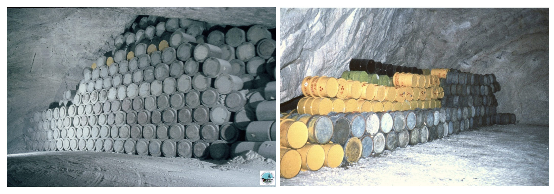
Figure 1: Waste drums stored in the Asse II mine. The left image shows mostly concrete shielded drums (In German called “Verlorene Betonabschirmung (VBA)”).

There was strong convergence with translation rates of up to 18 cm/year in parts of the mine, due to about 5 million cubic metres of rock salt (extraction ratio 60%) mined from the southwest flank between 490 and 750 metres depth. The extraction cavities have been left open for several decades before backfilling started, initially using pneumatic stowing with salt grit. Residual volumes caused by the setting of the compressible salt grit have since been filled with sorel cement injections. Since most of the rock salt extraction chambers have been filled to structurally stabilise the mine building, the translation rates are now reduced to 7 cm/year or less. In structurally deficient mine parts the stabilising injections continue to this day.
Since 1988 there is a permanent brine inflow from the overburden. Currently about 12 to 13 m³/day of saturated brine enter on the southwest flank, and most of it is collected at 658 metres depth before any contact with radioactive inventory has been possible. After temporarily being stored underground, and samples being chemically and radiologically analysed, the brine is brought above ground and correctly disposed of as per regulations.
Given the risk of an increasing brine inflow due to a progressive deformation and degradation of the overburden rock, preparations need to be made for the case of emergency that at some point the inflow becomes no longer technically manageable. Precautionary measures consist of continued stabilisation and the erection of flow barriers to guide the liquid, emergency measures are being prepared for the time of such a potential situation where it would be necessary to prematurely retreat from the mine.
For the retrieval it is planned to build new mine parts located in fresh rock including a new shaft, Schacht 5, which will be used for both the transport of the retrieved waste above ground and the exhaust air.
Upon retrieval, the drums and packages with radioactive waste and some of the encasing salt material will be packaged into temporary containers for further characterisation. It is possible that the original drums are no longer intact, and this must be taken into account. Characterisation and conditioning must have happened before the final disposal at a future geological repository.
The waste classification and conditioning as LLW happened according to the technical standards of the emplacement period. Significant fractions of drums have been encased in shielding concrete (VBA, Verlorene Betonabschirmung) to reduce the outside radioactivity level. The documentation of the inventory is sparse and often gives only upper limits for radioactive sources, nuclear material and small quantities of individual waste. Some types of radioactive waste may contain small volumes of high specific activity (i.e. radioactive sources) despite the drum having been classified as LLW at the time.
As a result, non-invasive techniques are required for the characterisation. This might allow to suitably characterise the contents into the given categories depending on radioactive and nuclear material content, without the need to open and penetrate into the content of all drums. Given the inherent risk of direct contact with radioactivity when opening the retrieval container this should be avoided.
Cosmic-ray muon tomography utilises muons created by high-energy cosmic-rays in the atmosphere for the imaging of shielded structures, e.g nuclear waste containers. Muons are highly penetrating, natural, ubiquitous and health-and-safety neutral. Muon tomography for nuclear waste containers has been developed by the University of Glasgow and the UK National Nuclear Laboratory since 2009. It has been commercialised through the award-winning start-up company Lynkeos Technology. The worldwide first muon tomography system for nuclear waste containers, the Lynkeos MIS, is operating on the Sellafield site since 2018 [2,3].
This paper presents a Monte Carlo simulation study that investigates the capabilities of muon tomography to non-destructively characterise radioactive waste from the Asse II mine. The aim is to identify on the one hand the waste structure including voids and free liquids, and on the other hand nuclear material, either in compact metallic form, or in a homogenously diluted concentration.

GEANT4 Monte Carlo Simulation of ASSE II Waste containers
GEANT4 is a toolkit for simulating the passage of particles through matter [4]. In nuclear and particle physics it is widely used to study the anticipated performance of new detector systems. It can be adapted to a wide variety of different experimental scenarios and the use of cosmic-ray muons for muon tomography is one of them. The Glasgow Nuclear Physics Group has used GEANT4 to study muon tomography since 2009. Through repeated comparison with experimental data this tool has been iteratively refined and it is now possible to produce simulated data that are in excellent agreement with actual data.
For this feasibility study cosmic-ray muons with the typical angular and momentum distribution at sea level have been simulated, together with a detector arrangement that is similar to the Lynkeos Muon Imaging System (MIS). Two double-layers of scintillating fibres in x- and y-direction form one detector module that produces one space point. Two such modules above the waste container and two below the waste container form the muon tomography system, that allows to reconstruct the track on the incoming and outgoing muons. This input information is then used by a likelihood algorithm to reconstruct the distribution of the scattering density λ for each 3D volume element (voxel) in the active detector volume, i.e. between the top and bottom detectors.
The scattering density λ is proportional to the density ρ, but also dependent on the atomic number Z. In fact, λ is the inverse of the radiation length X₀ and can be expressed as [5]:

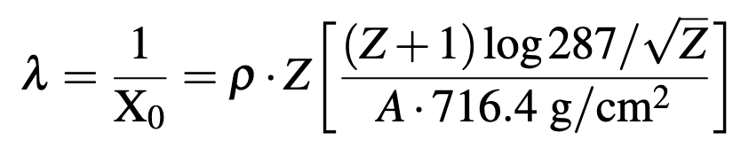

The detector configuration used in this feasibility study is shown in Figure 2. It basically corresponds to the design parameters of the Lynkeos MIS [2], albeit with a larger detector area and active volume. The scintillating fibres have a diameter of 3 mm, the detector modules consist of 1280 fibres in double layers, i.e. the size of the detector area is 192 cm x 192 cm. The distance between the two top (bottom) detectors is 30 cm and the distance between the top and bottom detector sets is 180 cm. Therefore, the active volume between the detectors is 6.6 m³.
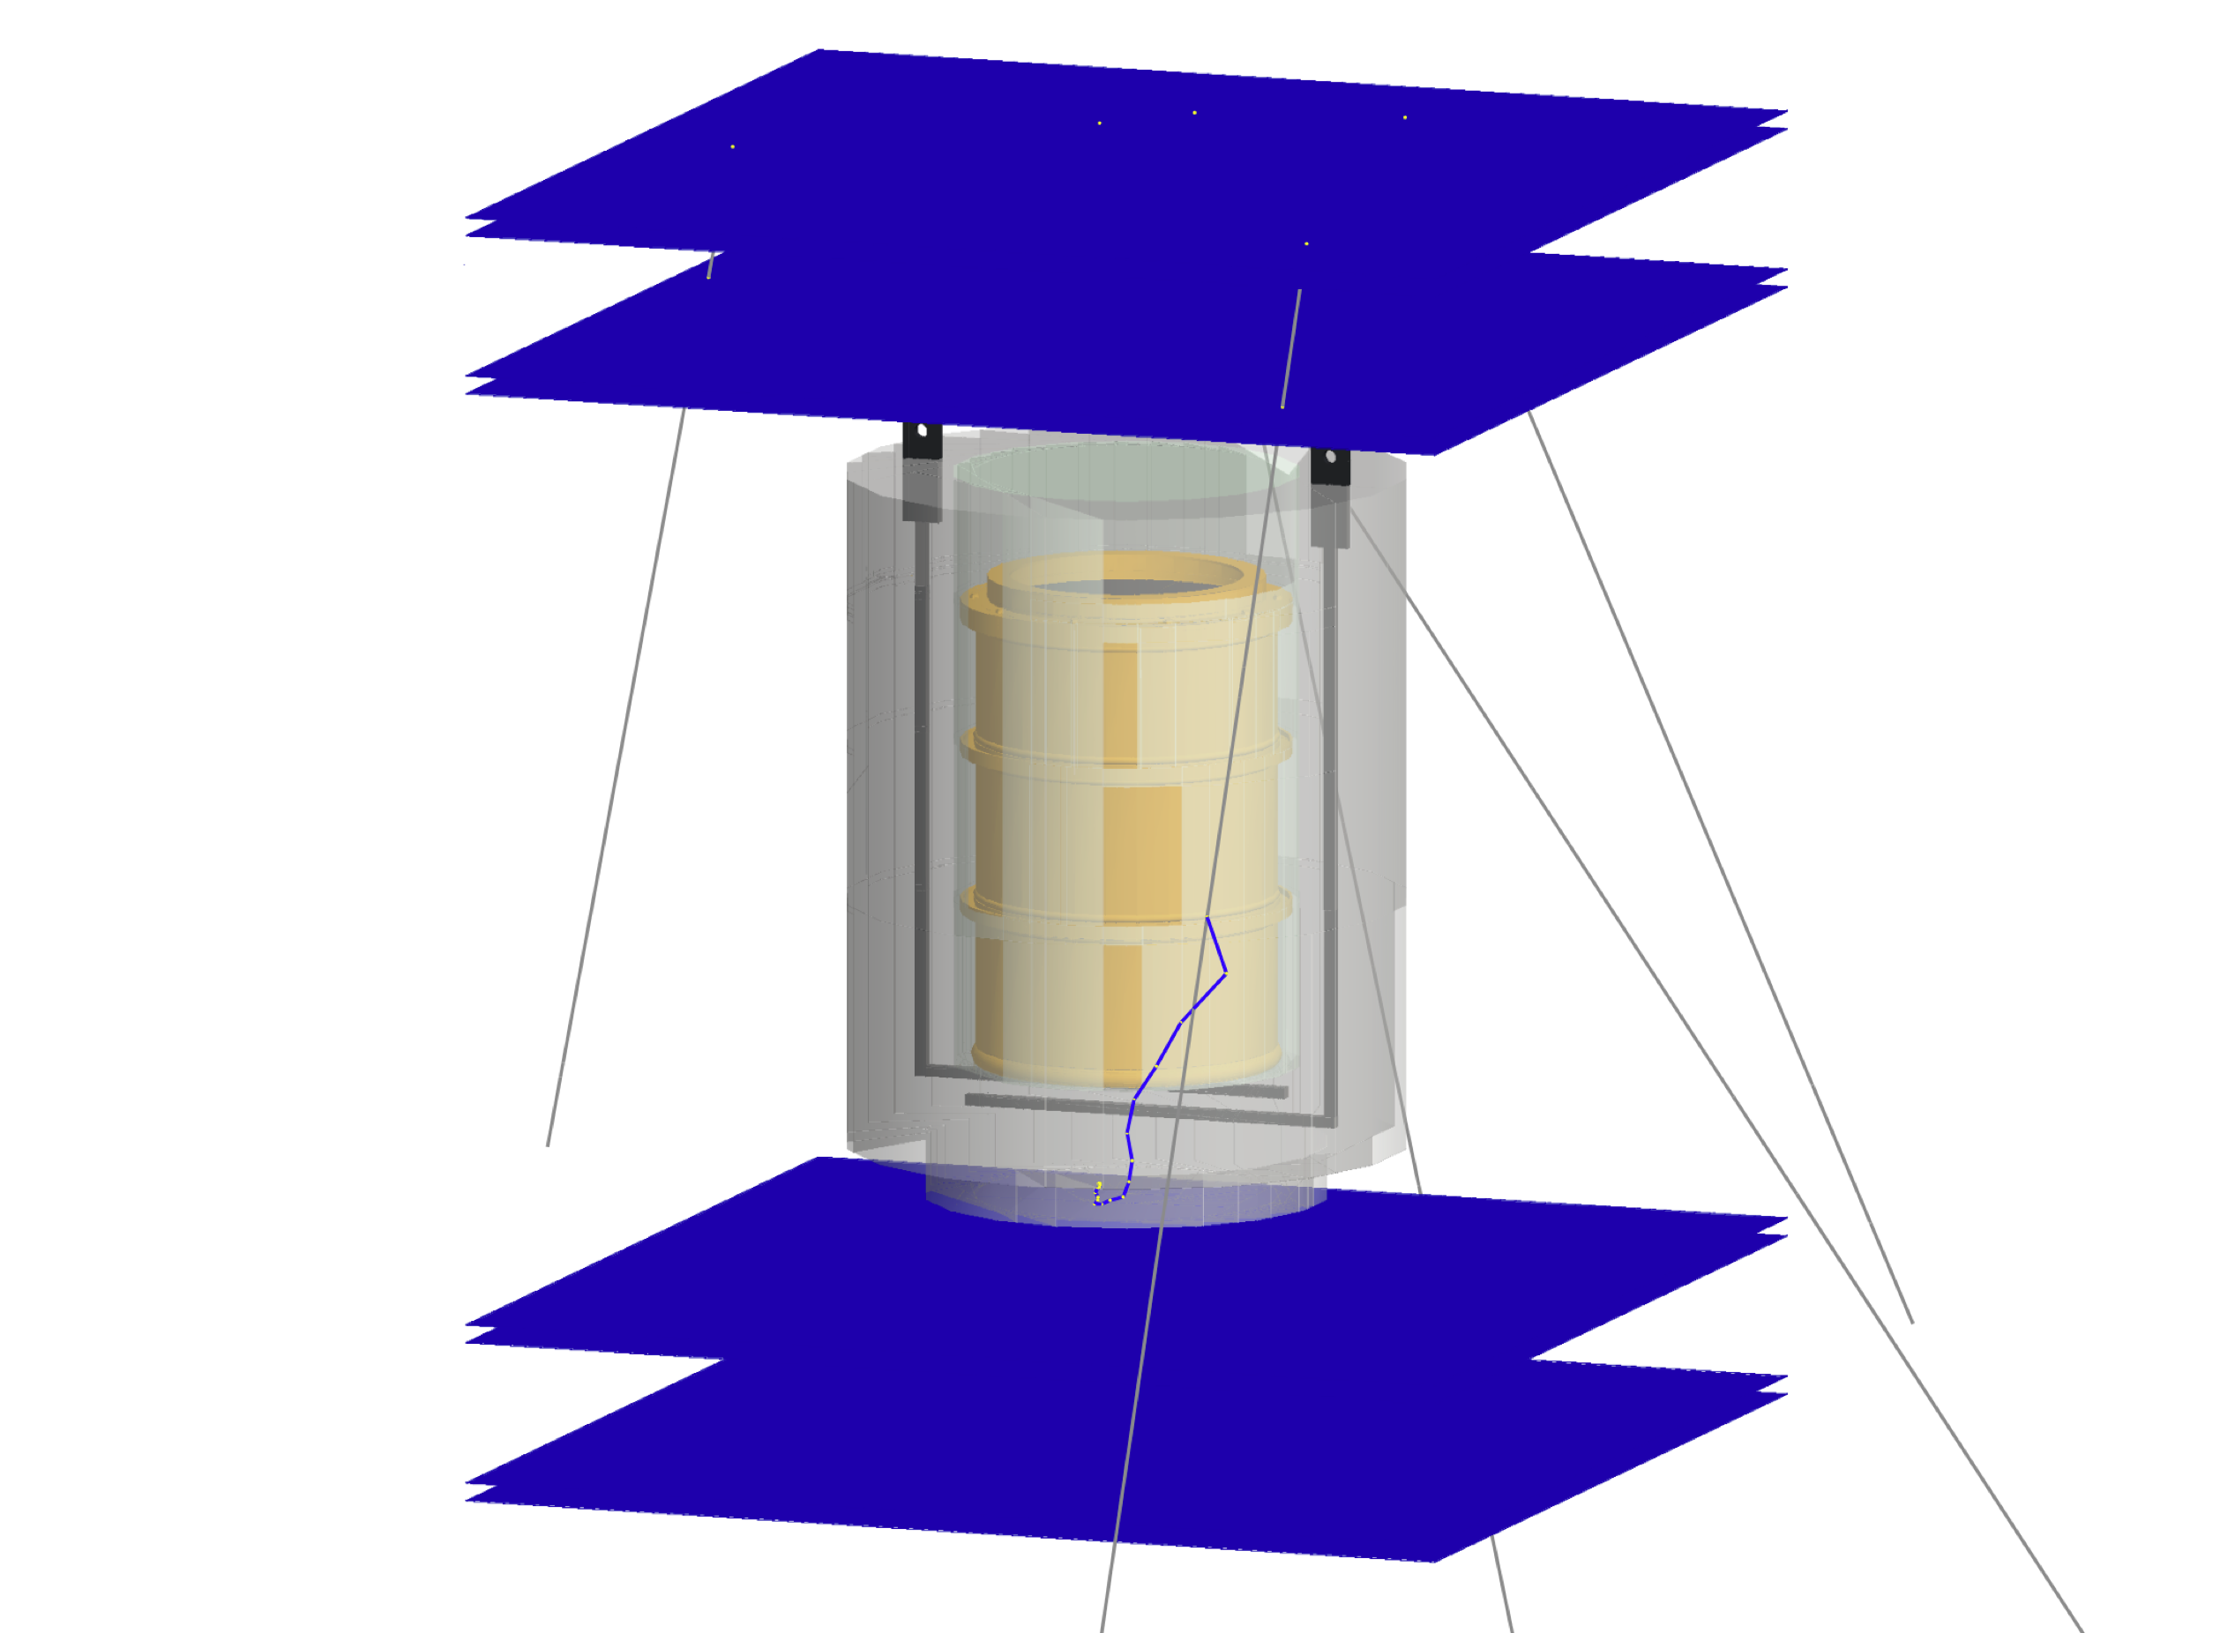
Figure 2: GEANT4 model of a VBA (Verlorene Betonabschirmung) container with muon tracking detectors above and below the container. The model clearly shows the steel drum inside the concrete shielding, together with the embedded steel holding structures and the reinforcement rings around the drum.

A detailed simulation plan for this study has been agreed between BGE and Lynkeos Technology. This involves the creation of a detailed model of VBA containers in GEANT4, for four different material configurations, as shown in Figure 3. The first studies that were carried out concern the optimum orientation of the VBA containers inside the muon tomography detector (vertical or horizontal), density measurements, fill and shielding material determination and the detection of voids inside the VBA. Further studies will concern the detection of phase boundaries, the detection of radioactive sources, the identification of different materials and the detection of nuclear fuel. However, some of these studies are not yet completed and therefore not included in this paper.
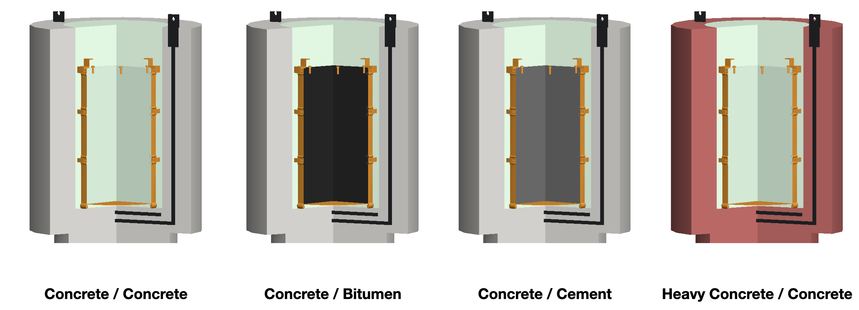
Figure 3: Four different VBA configurations that were simulated for the feasibility study. Light grey and green represent concrete, black bitumen, dark grey cement and red heavy concrete.

Results of the Feasibility study

Horizontal and Vertical Container Orientation
To study which orientation inside the detector system, horizontal or vertical, would be better, 10 cm cubes of air, steel and uranium were introduced into a GEANT4 model of a VBA as shown in Figure 4. This model was imaged with 4 weeks of simulated cosmic-ray muon data in horizontal and vertical orientation.

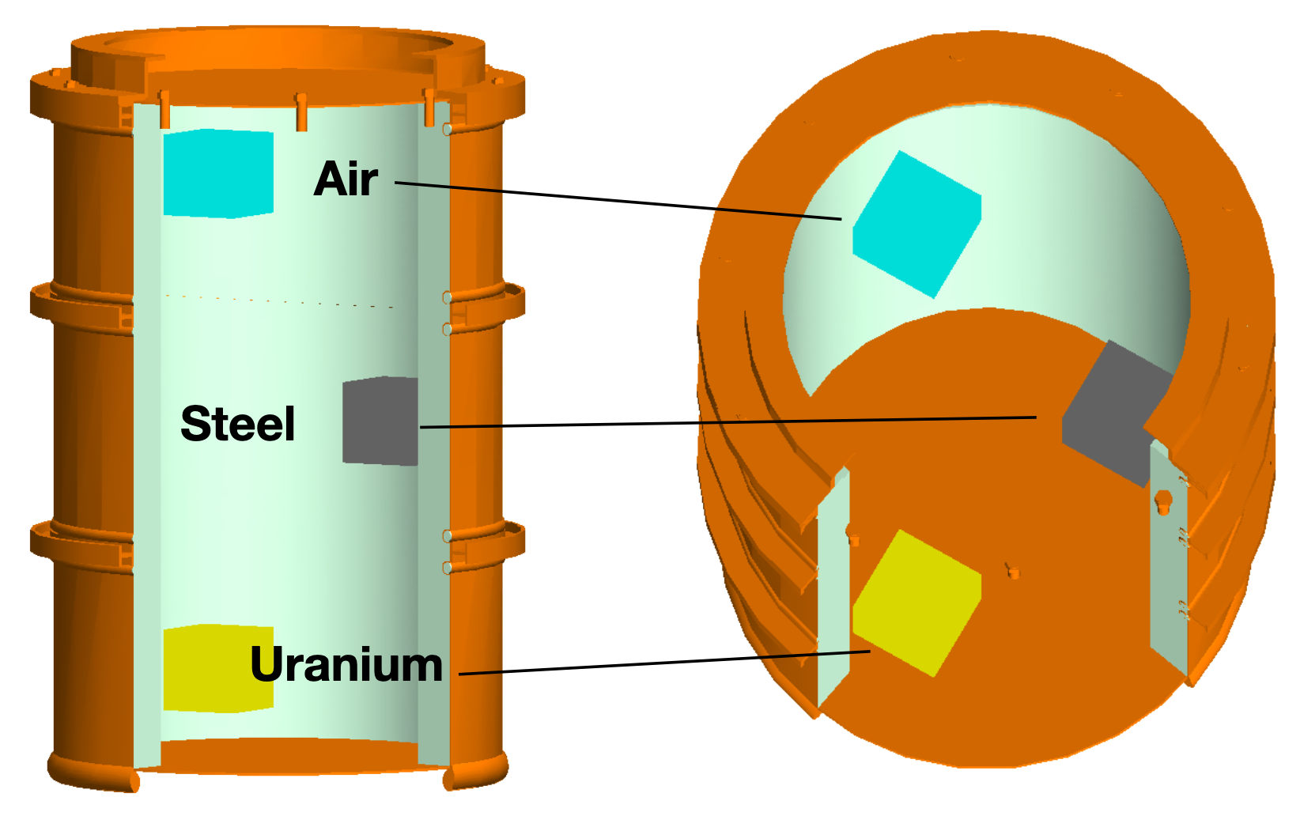
Figure 4: GEANT4 VBA model to study the optimum orientation of the container, with 10 cm cubes of air, steel and uranium embedded in concrete.

Figure 5 shows horizontal slices of 10 cm thickness at the respective vertical positions of the three different material cubes. The color scale for λ is in each case optimised for the best possible resolution.
For uranium embedded in concrete (top of Figure 4) the vertical orientation of the VBA (top right) delivers the better result – the cube is clearly imaged at the right size with few mm resolution. This had previously already been shown with actual data for a similar geometry [2]. However, in vertical orientation and with this contrast all other features are almost invisible. There is only a small hint of the steel holding structures visible. In horizontal orientation (Figure 5, top left) the inner steel drum can clearly be seen, together with the reinforcement rings, and there is also a shadow of the steel cube. The resolution of the uranium cube itself is not as good as in vertical orientation.
The steel cube (Figure 5, middle) is imaged about equally well in horizontal and in vertical VBA orientation. In vertical orientation (middle right) also the steel holding structures are visible, as well as an indication of the inner steel drum. In horizontal orientation (middle left) the inner steel drum, but also a shadow of the uranium cube and the air cube can be seen.

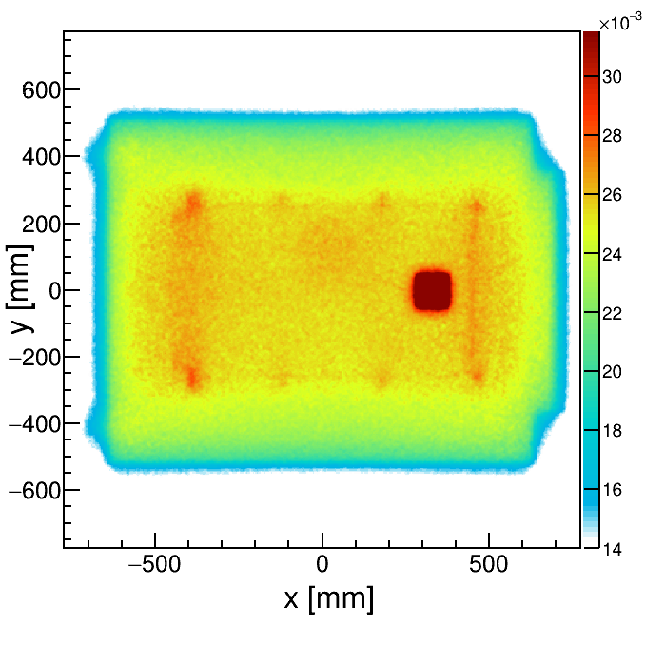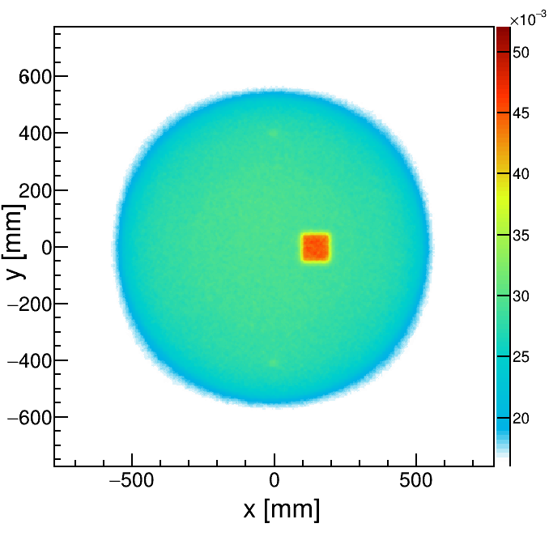
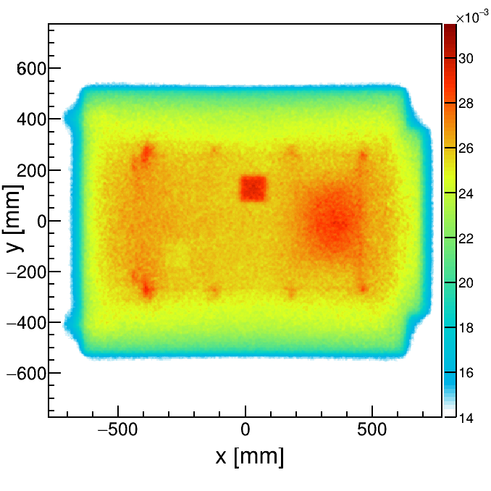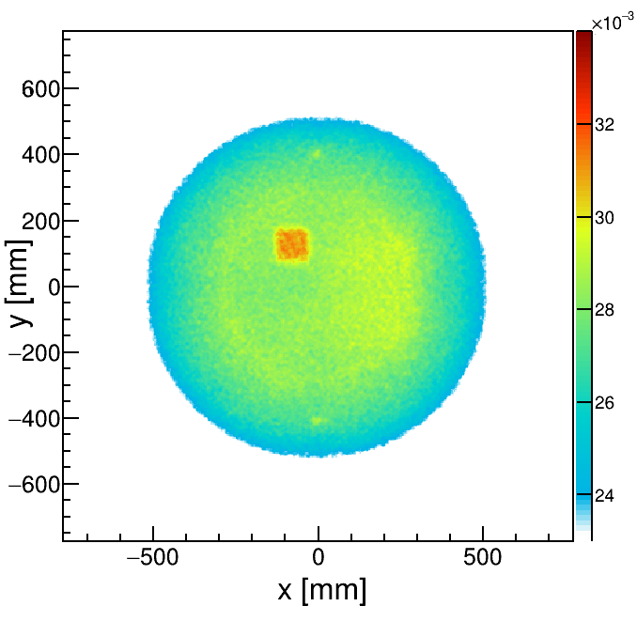
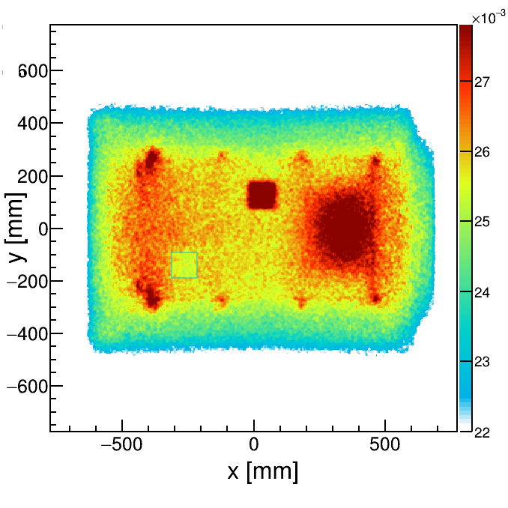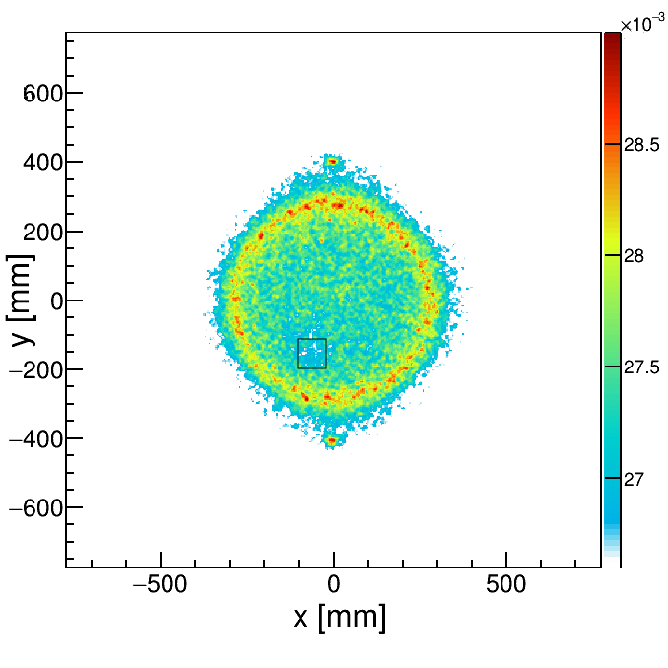
Figure 5: Muon tomography images of the model from Figure 3, 10 cm thick horizontal slices, 4 weeks of data taking. Left: horizontal orientation, Right: vertical orientation. Horizontal slices centered on uranium (top), steel (middle) and air (bottom) objects.

If the image is optimised for the air cube (Figure 5, bottom), it is clearly visible and imaged with the correct dimensions in the horizontal orientation (bottom left), but in vertical VBA orientation (bottom right), the air cube is only indicated, but not imaged correctly. Instead the inner steel drum and the steel holding structures are clearly visible. The overall size of the horizontal slice through the VBA (Figure 5, bottom right) is now only a bit larger than the size of the inner steel drum. This is an artefact of the color scale for λ that is used here – values between 20 and 26 are simply colored white in this image.
Overall, it appears that the horizontal VBA orientation shows more details, while in particular the image of high-Z material (uranium) in concrete has a better resolution in vertical VBA orientation. The main difference between both orientation geometries is that there is less material thickness for horizontal orientation, but more homogenous material thickness for vertical orientation. Both seem to have advantages and disadvantages.

Density Measurements and Material Determination
VBA containers from Asse II can have four different material combinations, as shown in Figure 3: Concrete shielding with concrete fill material, concrete shielding with bitumen fill material, concrete shielding with cement fill material and heavy concrete (hematite enriched) with concrete fill material. The GEANT4 simulation of all four configurations in vertical orientation shows that the determination of these different material combinations is very obvious in muon tomography. The results for horizontal slices through all four VBA material combinations are shown in Figure 6.

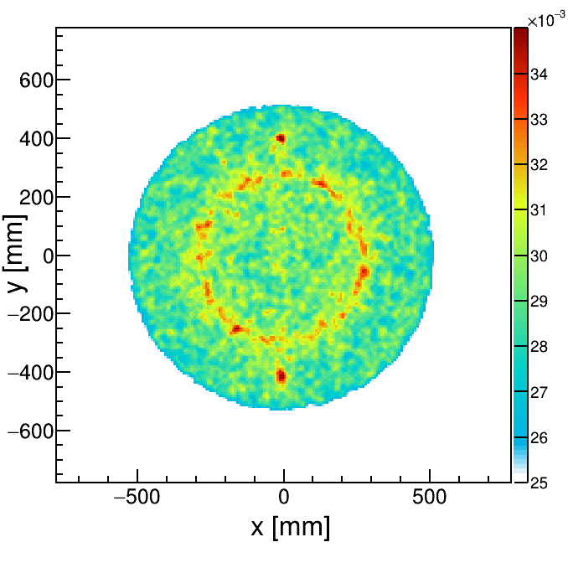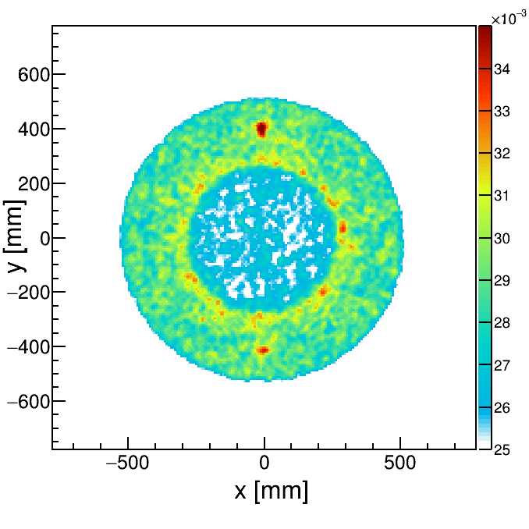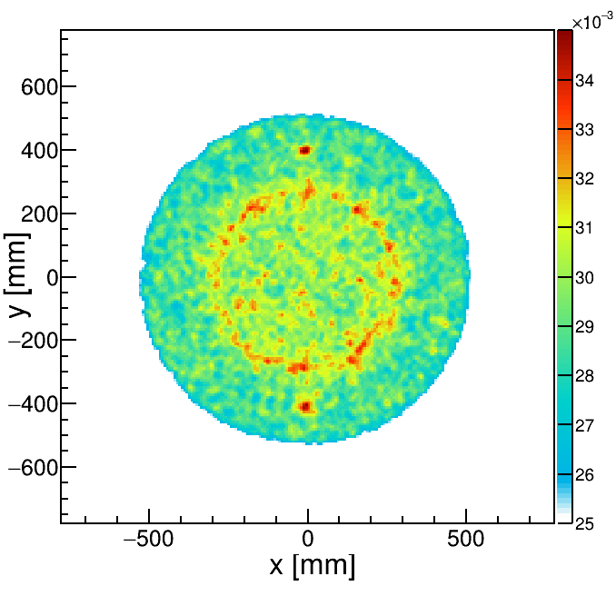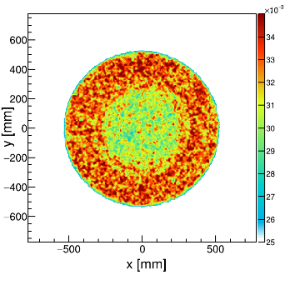
Concrete / Concrete Concrete / Bitumen Concrete / Cement Heavy Concrete / Concrete

Figure 6: Horizontal slices of 40 cm thickness through VBA in vertical orientation for four different material combinations. The different configurations correspond directly to those shown in Fig.3.

This result leads directly to the question if the density of the material can also be quantified, i.e. measured directly by muon tomography. A plot of the reconstructed average λ value versus material density shows that the relationship is not monotonic as in previous investigations, i.e. although concrete has a higher density than cement, it has a lower average λ (Figure 7, left). This is easily understood by considering that the scattering density λ is the inverse of the radiation length as already introduced in Section 2.
A plot of the reconstructed λ versus the calculated inverse of the radiation length of the material is plotted on the right side of Figure 7 and it shows the expected monotonically increasing behaviour.
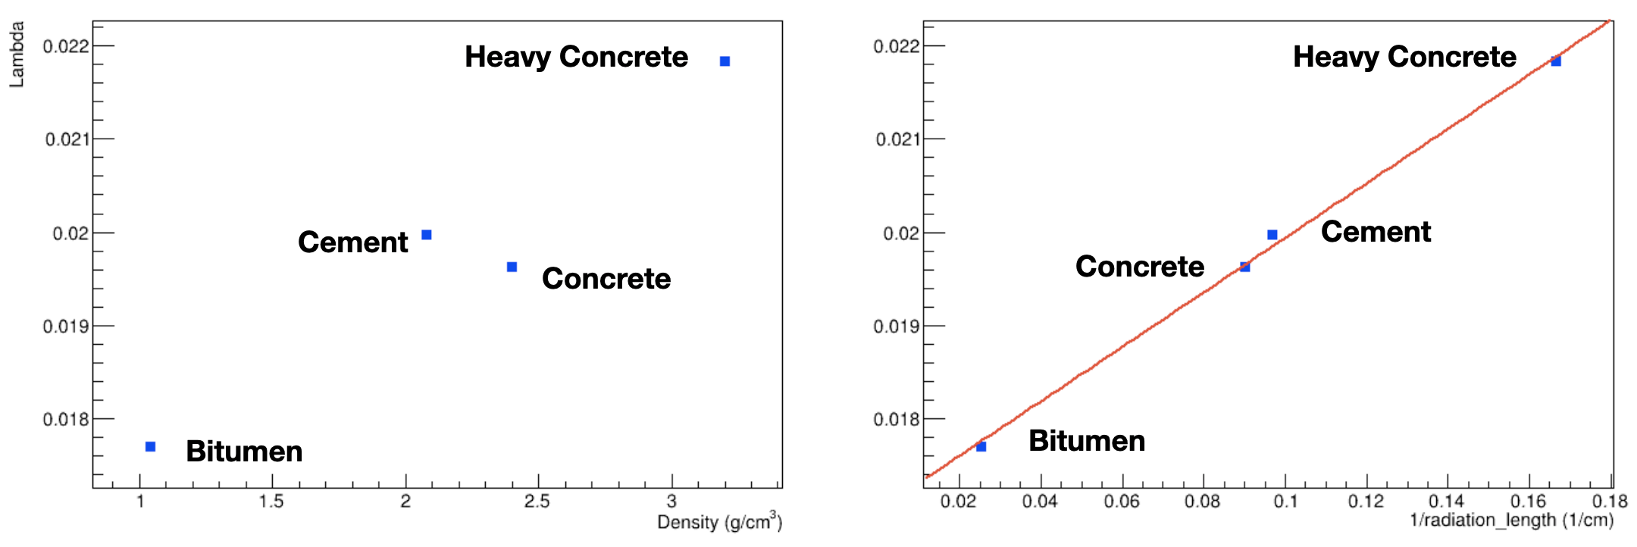
Figure 7: Reconstructed value λ for different fill and shielding materials plotted vs material density (left) and 1/radiation length (right).

Void Detection
For the study of the detection of voids inside VBA containers, different sizes of ‘air cubes’, from 2 cm to 30 cm, were introduced into the GEANT4 VBA model and the simulated data were split into data sets corresponding to different lengths of time from 2 days to 32 weeks. This study was carried out for both horizontal and vertical orientation of the VBA. The better homogeneity of material thickness of the VBA in the vertical orientation appears to make the detection of smaller voids more easily possible. Voids down to 5 cm diameter were detected, but the required detection time for these voids was about 17 days. Figure 8 shows the time development of a horizontal slice through a VBA in horizontal orientation from 2 days of data taking to 32 weeks. All key features, including a 20 cm void, are present after 4 weeks, but the images continues to improve all the way up to 32 weeks. Figure 9 shows two small voids, 5 cm and 10 cm, that are clearly imaged in a vertical VBA after 17 days.
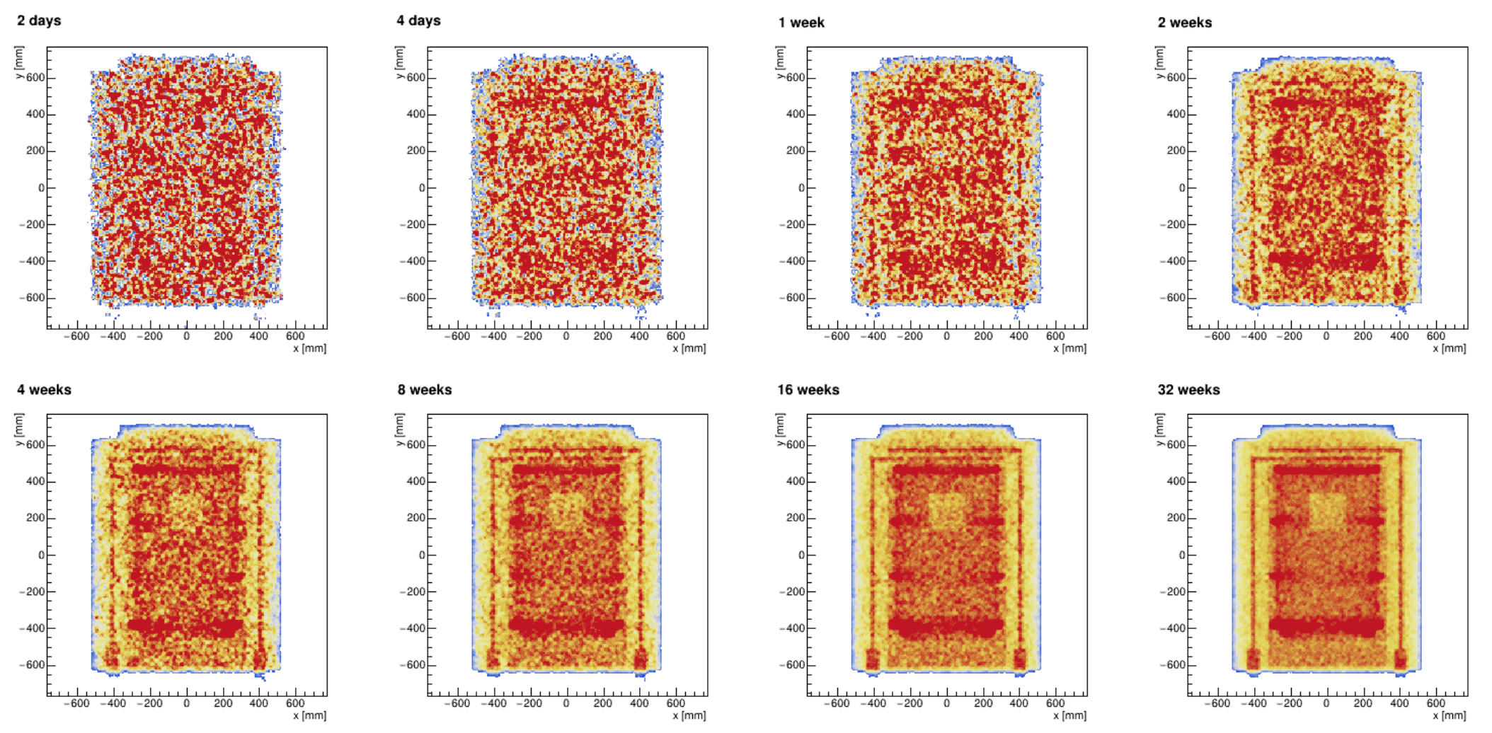
Figure 8: Horizontal slice through VBA in horizontal orientation, fill material concrete, 20 cm void, after different lengths of data taking.
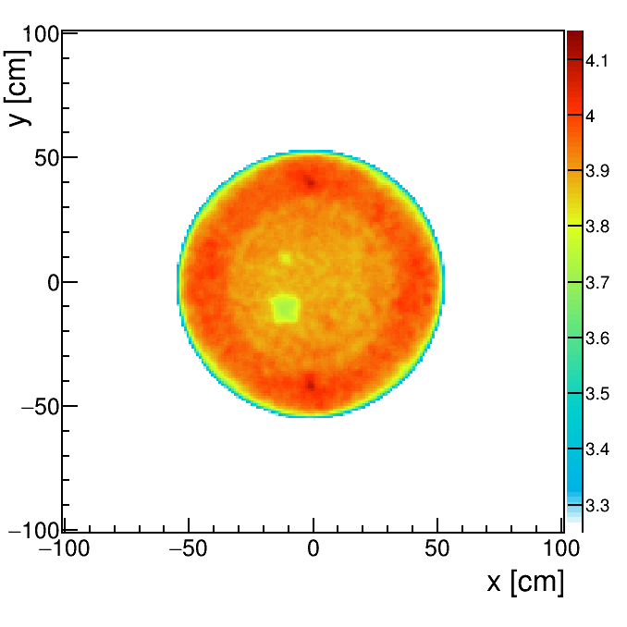
10 cm
5 cm
Figure 9: Horizontal slice through VBA in vertical orientation, with 5 cm and 10 cm void, for 17 days of data taking.

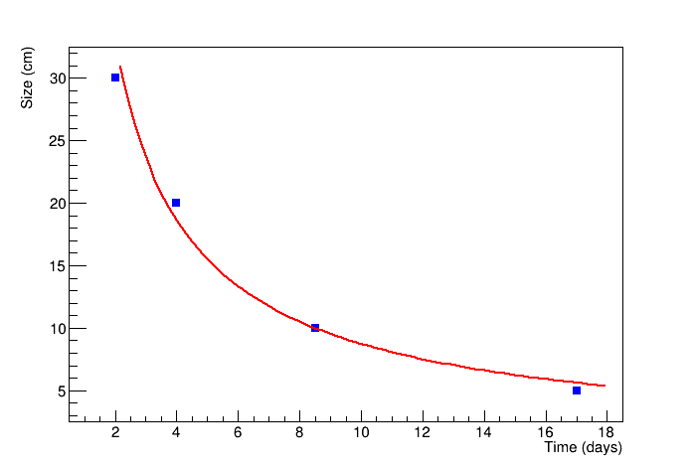
Figure 10: Identifiable void size vs data taking time with exponential fit function.
The time dependence of the void reconstruction in a vertical oriented VBA is shown in Figure 10. It follows roughly a 1/t behaviour, the fit function in red is y= 59/t^{0.83}.

conclusions
The present study on the feasibility to use cosmic-ray muon tomography for waste containers from the Asse II mine has been carried out using GEANT4. The results on the first scenarios and geometries that have been completed show that different materials can be identified, both with regard to the shielding and the fill material, and with regard to objects inside the inner steel drum. High-Z material objects can be detected and with few mm resolution, steel structures including the inner steel drum itself and the embedded steel holding structure can be imaged. The detection of voids in concrete fill material is possible down to about 5 cm diameter with measurement times of 2 ½ weeks. The optimum orientation of the VBA depends on the measurements that are carried out. This investigation will be completed with a set of additional studies that are still being carried out. However, the intermediate results show that cosmic-ray muon tomography may be a valuable non-destructive method for the characterisation of waste containers retrieved from Asse II.

ACKNOWLEDGEMENTS
The research described in this paper was funded by the State-owned Federal Company of Radioactive Waste Management in Germany (BGE).

References
- Lex Asse, Gesetz zur Beschleunigung der Rückholung radioaktiver Abfälle und der Stilllegung der Schachtanlage Asse II, https://www.bmu.de/gesetz/gesetz-zur-beschleunigung-der-rueckholung-radioaktiver-abfaelle-und-der-stilllegung-der-schachtanlage/
- D. Mahon et al., First-of-a-kind muography for nuclear waste characterisation, Philosophical Transactions of the Royal Society A 377 (2137), 20180048
- A. Simpson et al., Muon tomography for the analysis of in-container vitrified products, Applied Radiation and Isotopes 157, 109033
- S. Agostinelli et al., GEANT4 – A simulation toolkit, Nucl. Inst. Meth. A, Vol 506, Issue 3, 1 July 2003, Pages 250-303
- G. Bonomi, Progress in muon tomography, Proceedings of the EPS Conference on High Energy Physics, Venice, 2017

