Progress on the Management of DSRS at China Institute for Radiation Protection

Gao Chao
China Institute for Radiation Protection
Taiyuan, China
Email: cau-227@163.com

An Hong-xiang
China Institute for Radiation Protection
Taiyuan, China

Liu Jian-qin
China Institute for Radiation Protection
Taiyuan, China

Abstract

This document has suggested a conceptual design for an infrastructure to recover, handle and condition SHARS for long-term storage.The stumbling block on the international level was the management of Spent High Activity Radioactive Sources (SHARS) because of its high potential radiological risk. Based on the design concept of IAEA and the practice of NECSA, with slightly different design requirements but with basically the same concept, IAEA cooperated with China to develop a Mobile Hot Cell specifically to deal with SHARS from irradiators. The development has provided an opportunity to develop for the first time the required infrastructure in an Asian country and to test some new features of the infrastructure. A pilot conditioning operation with an activity of an around 1000 Ci Co-60 irradiator sources had been carried out in September, 2010 that the sources were handled and conditioned very successfully. The new features have provided for a more efficient source conditioning operations and increased the potential SHARS activity acceptance capacity of the hot cell. In 2017, the same MHC hasl been used to realize the cold conditioning of Co-60 medical source. The performance testes conducted by the team from China Institute for Radiation Protection (CIRP) showed that the mobile hot cell meets all performance requirements. Further work for the licensing of the unit in China is underway.

INTRODUCTION
SHARS are usually Cobalt-60, Cesium-137 sources arising from teletherapy devices, irradiators or Thermo Electrical Generators. Because of many reasons, e.g. no fitable transport containers, no return money or no return contracts, SHARS are usually interim stored in the user’s premises rather than returned to the producers. The handling and conditioning of high activity sources in developing countries had always been a problem since there was no available infrastructure (national or multinational) to allow for the safe and secure handling of bare SHARS. Even if the hot cell producing the new high activity sources can be used for the SHARS conditioning, it is impossible because of the lack of the fitable transport containers for the SHARS. This has been made possible with the introduction of the Mobile Hot Cell (MHC) capable of handling such high activity sources. Following the pilot operation and the international peer review of the MHC, the conduction of the first two operations in Sudan and Tanzania have paved the way to further utilization of the concept by Member States as well as the initiation of further development for the design to be safer, more efficient and conduction of operations in a smoother manner.
With the prevailing situation over the last few years emphasizing a strong need for the security of radioactive sources some Member States (Brazil, China India, Malaysia, and Uzbekistan) have expressed interest in having more information on the know-how and possibly develop their own mobile hot cell to conduct operations within their boarders. From the initial discussions it was identified that other design requirements that were not considered for the first mobile hot cell had to be considered. And according to the experience from the development of the first mobile hot cell other improvements were necessary to be introduced (See Fig.1). The detailed design for the second MHC was developed by CIRP in 2009. Based on the detailed design the mobile hot cell has been manufactured by CIRP (See Fig.2). The permit for the pilot operation was given by the regulatory body of China but operational license is still pending further provision of documentation.The basic design of the first MHC and justification for its use can be found in reference.
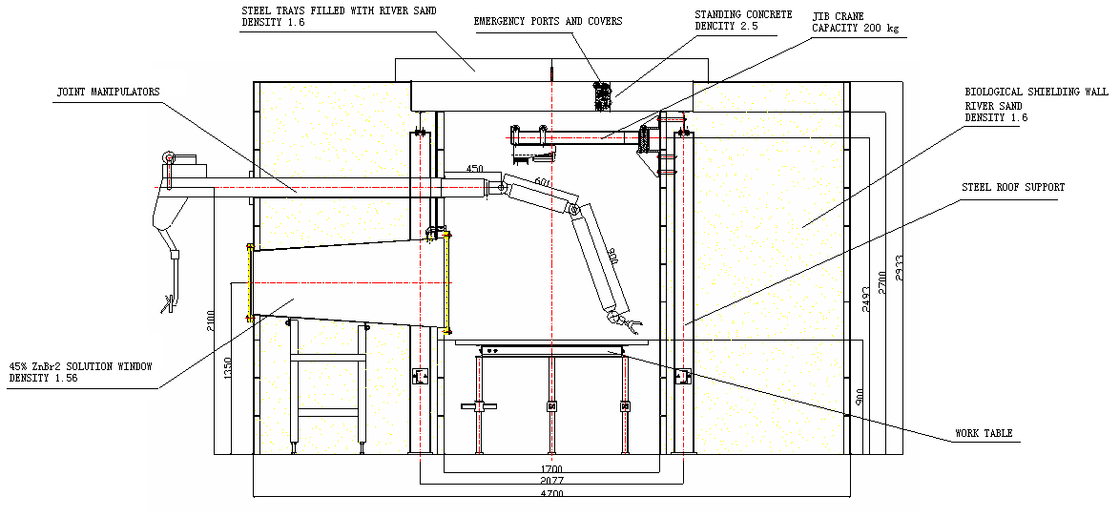
FIG.1 SHARS conditioning facility general arrangement and subsystems based on the first MHC
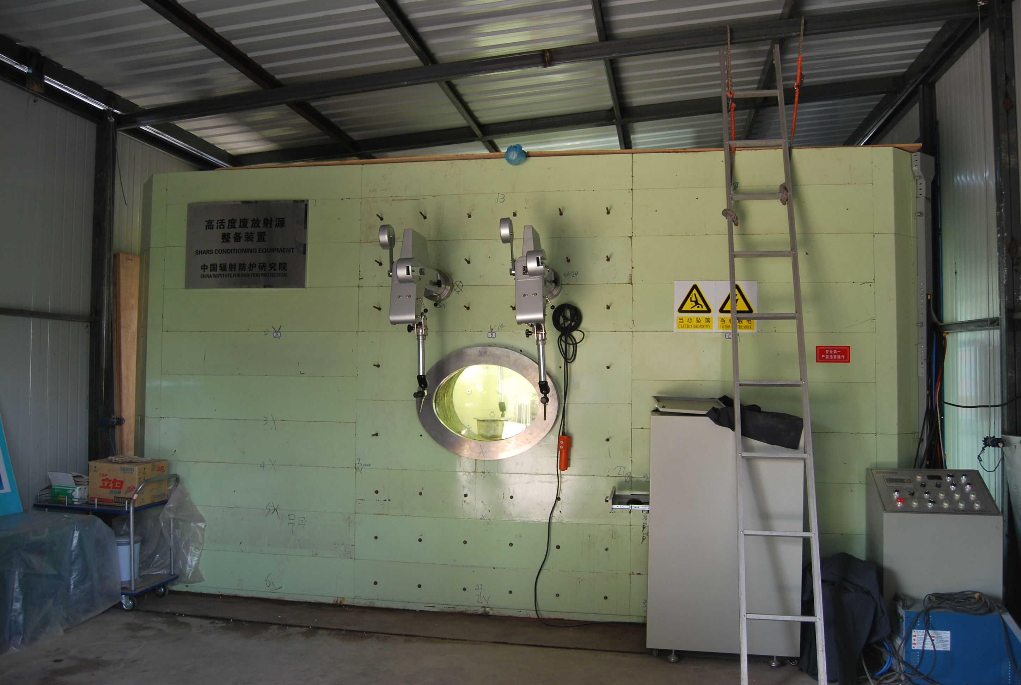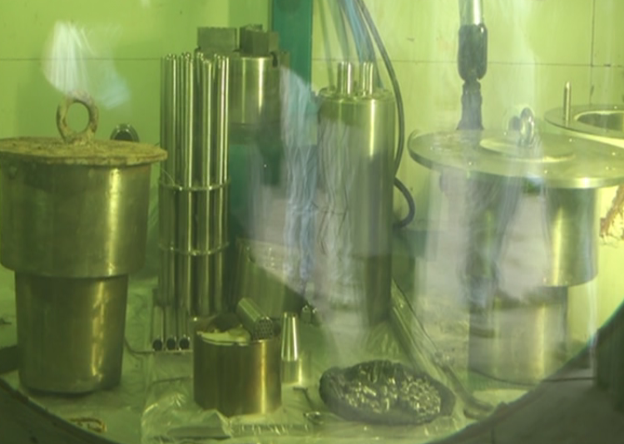
FIG.2 The 2nd MHC and the inner layout of the pilot opration throuth window

Variations in the MHC second generation
As it was briefly mentioned due to different design requirements and according to the experience with the first unit several changes have been considered and introduced. They are as follows:

Source Transfer Port
The design of this unit varies from the first unit based on the experience and the user requirements stated at the beginning of this project. From the experience it was concluded that the space available within the hot cell provide ample space to eliminate the need for the source transfer channel. While it has proven that radiation dose rate spike during the source transfer does not provide any significant dose to worker or the general public this possibility has been totally eliminated by having both the long-term storage shield and the old working shield within the MHC cavity (See Fig.3). For this requirement the work table has been totally redesigned to allow for the housing of both shields. A skirt has also been introduced to prevent the presence of any space between the table and the shields which may led to a source or a small tool to drop under the table. In this respect, further development for the Long-Term Storage Shield (See Fig.4) designed earlier to work with the transfer channel can be modified to accommodate for this version. The modification can also meet other requirements which can make SHARS management easier and more flexible. It is worth mentioning here that the next obstacle to be tackled is certified source package for ease of transportation world wide.
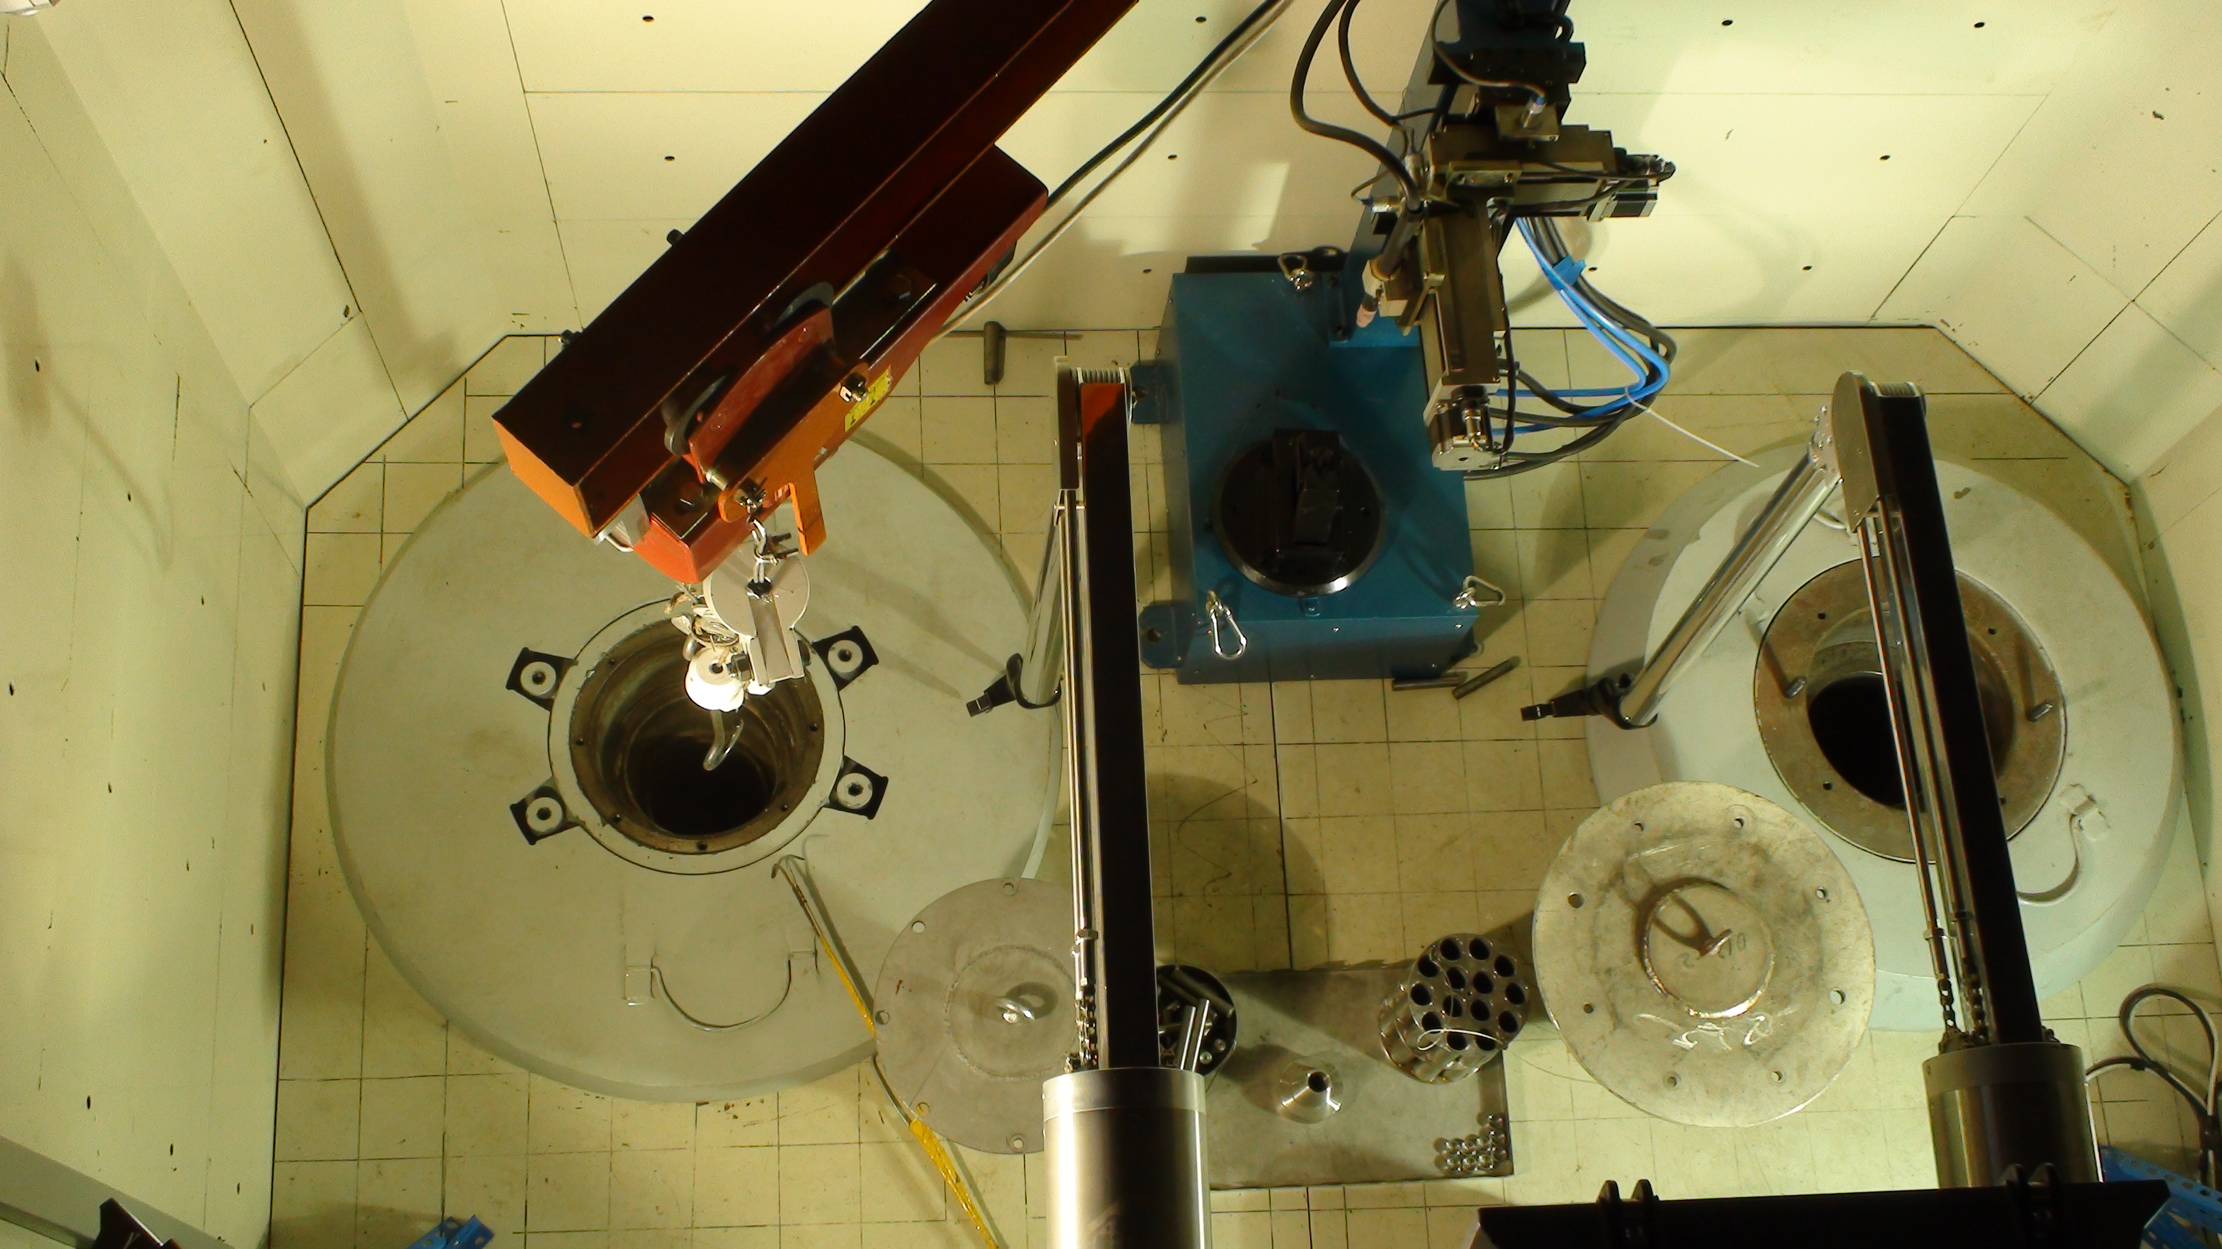
Fig.3 Layout of the inner work table of the 2nd MHC
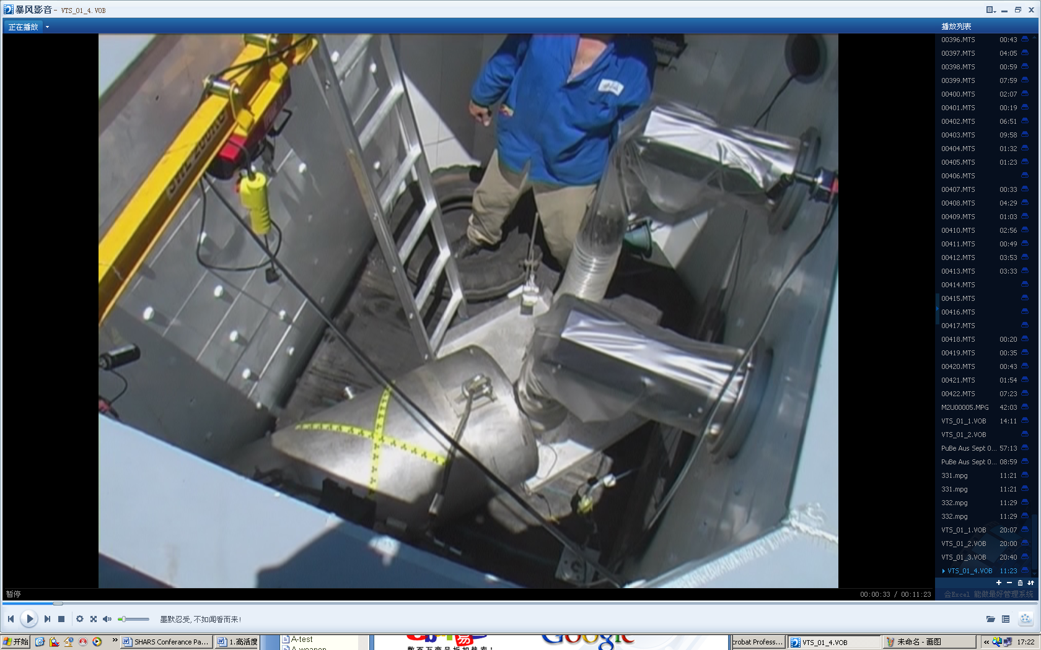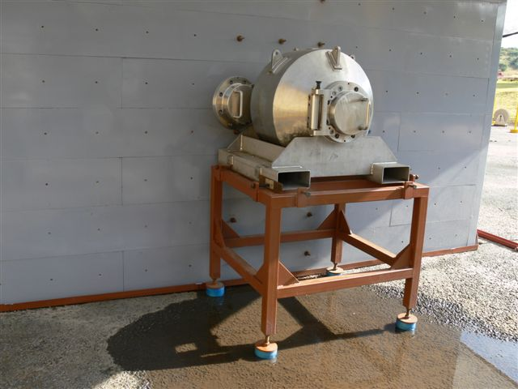
Fig.4 Layout of the inner work table and the outside Long-term Storage Shield of the 1st MHC

Filtration System
From the original design it has been noticed that a pre-filter within the hot cell would be necessary to prevent any significant activity to pass to the main HEPA filtration system outside the MHC. This filter is fitted to the ventilation duct(see Fig.5). The ventilation system (outside the hot cell) has also been simplified to meet the same requirement but with substantially less complicated and compact system size as well as performance has been enhanced to allow for a better performance as well as easier transportability. The pre-filter, HEPA and the fanner are emplaced in the same stainless steel box with 400 mm ×400 mm ×600 mm. The air flux of the fanner is 200 m3/h which can ensure that nearly 17 air changes per hour of the MHC can be met and the transducer is used to control the air flux. The efficiency of the HEPA can ensure that the penetration of the 0.3 μm particulate less than 0.05%.

Emergency Ports
From the experience in the previous operations and exhausting possibilities of mode of failures access ports to the concrete slabs for the MHC shielding were introduced (See Fig.6). Usually the emergency ports are covered with steel caps. In the case of any scenario of equipment failure (e.g. the jib crane breaks and the hook cannot up and down ) the ports provide access point where SHARS can be safely emplaced into the long-term storage shield or the working shield with the lead cap be covered by outside crane then manipulation of equipment within the MHC cavity can be carried out with the maintainers get into the MHC freely. This opens the door for revisiting the emergency procedures and development of new ones that address more design based accidents. This will fortify the concept and provide more confidence in its utilization in a wider context. These access ports also allow for the handling of weights that cannot be handled by the internal crane.
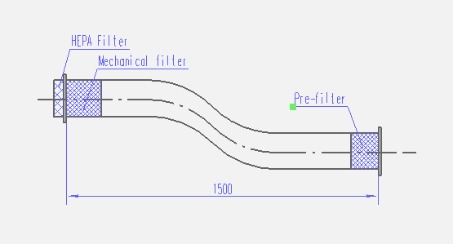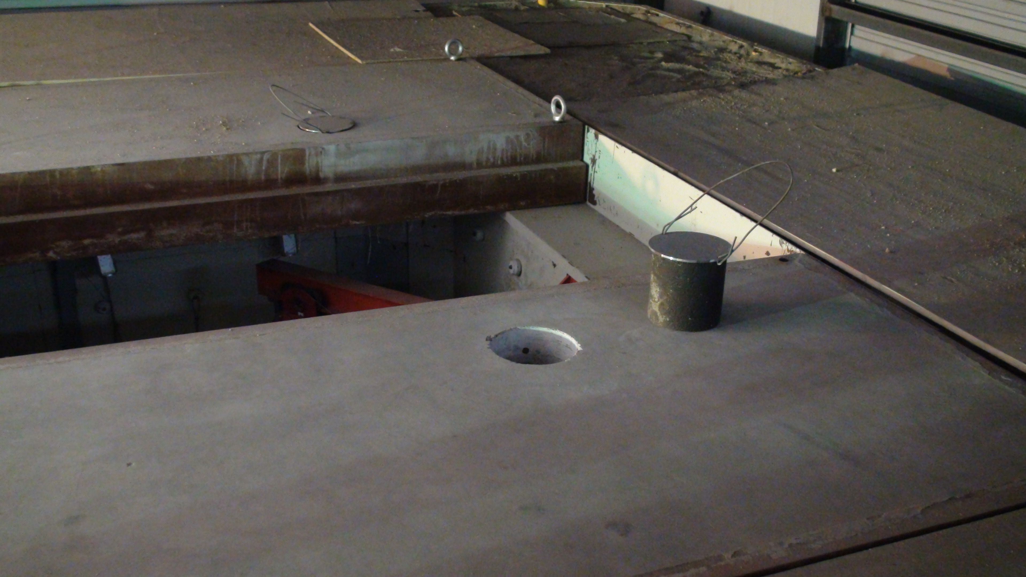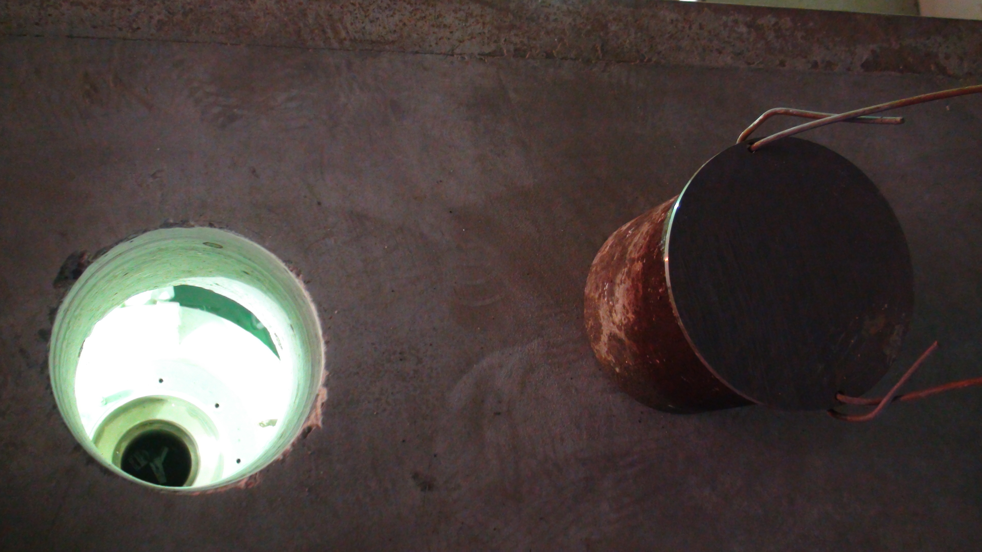
Fig.5 Ventilation duct with filters Fig.6 Concrete slabs with emergency ports

Eliminating the hot points of higher MHC surface dose rate
It has been also noticed that area under the window would need special attention when compacting the sand in order to eliminate a slightly higher dose. This has been completely eliminated by introducing a semicircular lead shield (See Fig.7) to eliminate that effect by design and not through operational procedures. The second MHC development has shown that the issue of higher dose rate in some points is generally relevant to the nature of access points to the cavity. This has lead to a special approach to address the design of all access points which will be utilized in any further development of other MHC that may be developed for the same or similar applications.

Thin Stainless Steel Sources Holder
Since the new MHC was primarily for recovery and conditioning of sources from irradiators, considering both the existing storage facility in China and the volume minimization of conditioned SHARS, a new approach for the long term storage and a different concept for the source holder have been suggested. This option allow for the thin stainless steel sources holder with the capsuled sources can be put into the long term storage shields for long-term storage. On the other hand, the option allow for the sources holder can be remotely placed into below ground storage tube, each several meters deep. The stainless steel sources holder are stacked vertically in the storage tubes below ground level with special security features, using a shielding remote handling machine. In principle, many sources can be stored in each stainless steel sources holder, This would allow for substantial saving with respect to both the storage volume and money because both the long term storage shield and the old working shield can be reused. The sources holder has been designed in several geometries (See Fig.8) that fit for different types of irradiator sources, e.g. ö15mm×90mm, ö26mm×27mm andö11.1mm×451mm.
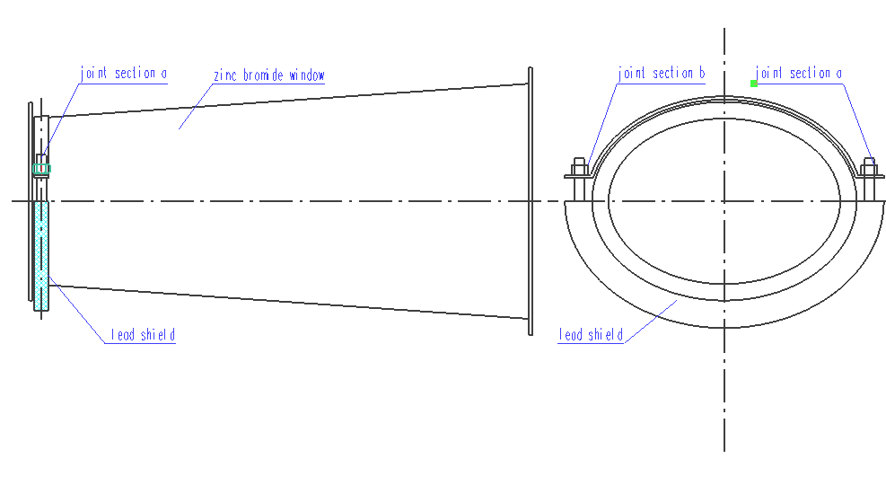
Fig.7 A semicircular lead shield beneath ZnBr₂ window
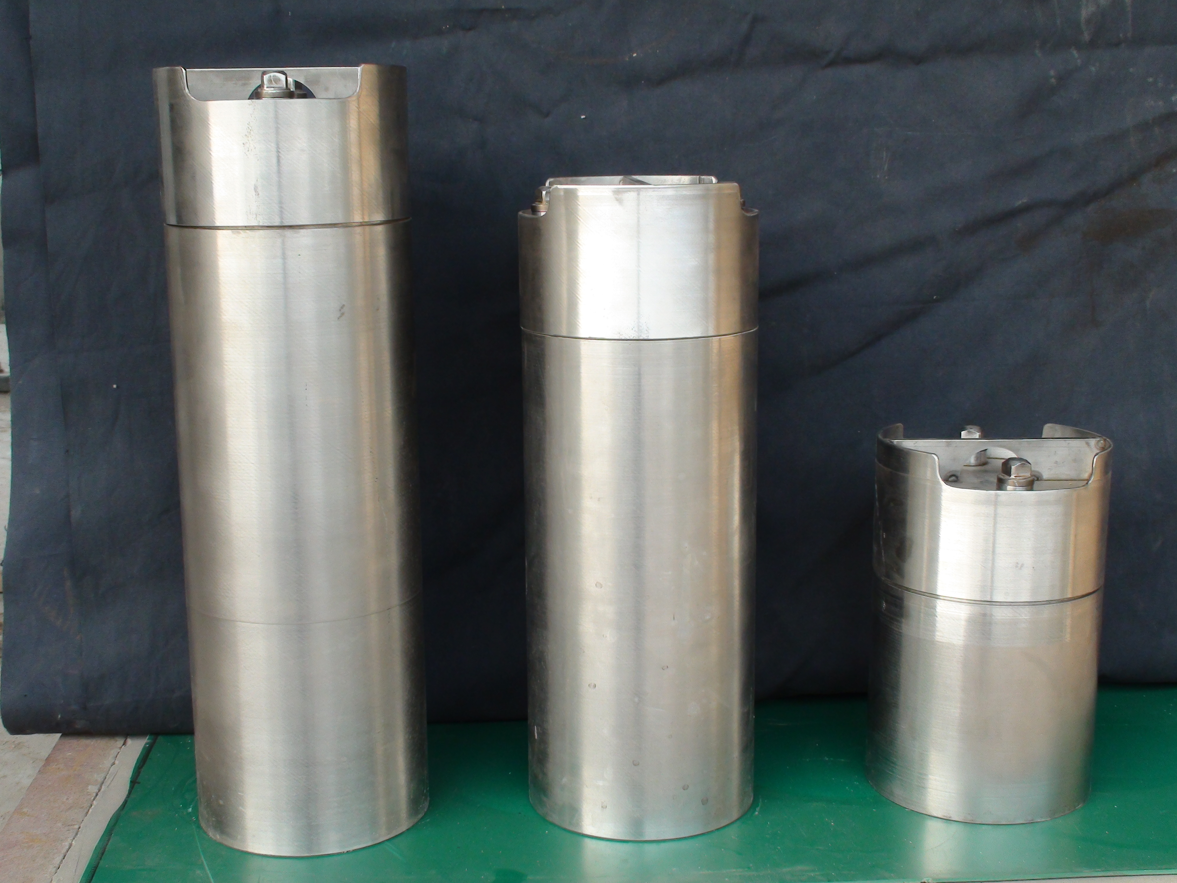
Fig.8 A series of stainless steel sources hold

Sources beyond design bases
From the previous operations it has been verified that sources with beyond basic design activity (i.e. > 1000 Ci Co-60) can be recovered and handled in a limited number. A design feature of the second Mobile Hot Cell will allow such work to be carried out routinely with no limitation. Steel trays Fig.9 Using the pictures that you had are designed to be filled with sand and deployed where necessary. Since the basic design requirements of these trays can be met by any steel welding facility they only need to be produced where needed.

Long-term storage shield
The long-term storage shield is a container based on and compatible to the design of the IRS-I and IRS-II source transport container licensed by National Nuclear Safety Agency (NNSA). The container was designed to the requirements of a Type B transport container but was not licensed as such since it is essentially a storage container not a transport container.
It is very important that source re-encapsulation is carried out with the possibility of the issuance of a Special Form Certificate (SFC). This is an important requirement for easier and efficient source management in the future. This has been developed for the Necsa and has been realized by CIRP in the case of the Chinese infrastructure. It will be very useful to cooperate on these issues to improve sources management now and later on.
The long term storage container is shown on Fig.10 and it can be placed into the inner accordingly hole of the MHC covered with the skirt (See Fig.3). For ease of transport, the dose rate on the outer surface of the shield should not exceed 2,0 mSv/h.
Fig.9 Steel trays filled with sand Fig.10 The long term storage shielding

Conclusion
The second MHC is operational and functional according to the set design requirements. Preliminary safety assessment demonstrated the safety of the infrastructure. The new design features proved to be useful and addresses the requirements to allow for safer and more efficient operations.
ACKNOWLEDGEMENTS
The authors wish to thank all those involved in the SHARS project at CIRP, especially Mr. Muhammad. Al-Mughrabi from IAEA, Mr. Juan Carlos Benitez-Navarro from IAEA, Mr. Gert Liebenberg from IAEA, Mr. John P. Hageman from Southwest Research Institute of USA.

References
- IAEA. Conditioning and Interim Storage of Spent Radium Sources. IAEA-TECDOC-886. Vienna (1996).
- IAEA. Reference Design for a Centralized Spent Sealed Sources Facility. IAEA-TECDOC-806. Vienna (1995).
- IAEA. Handling, Conditioning and Storage of Spent Sealed Radioactive Sources. IAEA-TECDOC-1145. Vienna (2000).
- Del J. Gonzalez, Strengthing the Safety of Radiation Sources and the Security of Radioactive Materials. IAEA Bulletin 41/3/1999.
- M. J. Angus, C. Crumpton, G. Mchugh, etc. Management and Disposal of Disused Sealed Radioactive Sources in the European Union. 2001.
- National Nuclear Security Administration，The Off-site Source Recovery Project News. LALP-03-022. January 2003.
- IAEA. Handling, Conditioning and Storage of Spent Sealed Radioactive Sources. IAEA-TEDDOC-1145. Vienna, 2000
- IAEA. Code of Conduct on the Safety and Security of Radioactive Sources. IAEA-CODEOC-2004-Rev.1 Vienna, 2004：3～11
- Council Directive 2003/122/EurAtom of 22 December 2003 on the Control of High-Activity Sealed Radioactive Sources and Orphan Sources. Official Journal of the European Union, L346: 57～64.

