# US-Mexico Cooperation on Source repatriation

The Off-Site Source Recovery Program-OSRP and

The National Institute for Nuclear Research-ININ

Charles Streeper

Los Alamos National Laboratory

Off-Site Source Recovery Program

Los Alamos, NM USA

Email: streeper@lanl.gov

Dr. Huemantzin Balan Ortiz Olivero

Instituto Nacional de Investigaciones Nucleares

La Marquesa, Ocoyoacac Mexico

**Abstract**

In cooperation with the National Institute for Nuclear Research of Mexico, the Off-Site Source Recovery Program at Los Alamos National Laboratory repatriated to the United States an inventory of low-activity sources located at the Radioactive Waste Treatment Plant and the Radioactive Waste Storage Center. The Off-Site Source Recovery Program and National Institute for Nuclear Research completed the source packaging into compliant Type A containers in January 2020. Despite a rapidly changing and increasingly restrictive environment due to the spread of Covid-19, the US and Mexico teams were able to repatriate the sources to an interim storage facility in the US in April 2020.

## INTRODUCTION-Establishing Cooperation

Ensuring that there is a viable pathway for characterizing, transporting, and disposing of disused radioactive sealed sources (sources) is essential to any end-of-life management strategy. The Off-Site Source Recovery Program (OSRP), which is sponsored by the Department of Energy National Nuclear Security Administration’s Office of Radiological Security (ORS), provides permanent and sustained threat reduction through the secure removal and repatriation of disused sources of US origin from international locations. Since 2006, the OSRP has recovered over 3.477 sources from 28 countries. Each country’s repatriation effort is unique, creating planning challenges, but the processes employed from characterizing the sources to their packaging for disposal are procedural and mostly uniform. In most cases, navigating the shipping and customs logistics are the least predictable variables and pose the highest potential for unforeseen challenges. With over two decades of operations, the OSRP has developed source removal processes and techniques to ensure the compliant, effective, and timely permanent disposition of the material.

In September 2019, on the sidelines of the International Atomic Energy Agency (IAEA) General Conference, the Department of Energy-National Nuclear Security Administration (DOE-NNSA) Undersecretary for Nuclear Security, Lisa Gordon-Hagerty, and the director of the National Institute for Nuclear Research[1] (ININ) of the United Mexican States, Dr. Javier Cuitláhuac Palacios Hernández, signed a Memorandum of Understanding (MOU) for the consolidation and removal of disused radioactive sources of US origin from Mexico. Annex II of the memorandum specified an inventory of low-activity sources in Mexico to be repatriated to the United States by the OSRP, part of the Los Alamos National Laboratory (LANL).

## Project preparation

ININ assists private source users in Mexico to consolidate and securely store disused radioactive sealed sources. These sources are of varying isotopes and activities. This consolidation effort is in itself is a measure of threat reduction. The sources/devices are checked for contamination, photographed, and documented prior to secure storage. The OSRP and ININ worked together to identify US origin sources and to characterize the majority of them prior to OSRP arriving at the secure source storage facility.

The OSRP’s core mission is a national security mandate to remove excess US origin radioactive sources that have the potential to be used for malicious purposes such as in a radiological dispersion device (RDD). As there are many types of radioactive sealed sources used in a variety of applications the OSRP has prioritized the removal of the following ten isotopes located in the table below all of which are stored at ININ[2]:

|  |  |
| --- | --- |
| 238Pu | 90Sr |
| 239Pu | 137Cs |
| 241Am | 60Co |
| 252Cf | 192Ir |
| 244Cm | 226Ra |

*Table 1: OSRP Prioritized Isotopes*

Due to shielding concerns associated with a large quantity of beta-gamma sources and a limited timeframe, the team elected not to attempt to package these sources without a hot cell. The OSRP focused solely on the transuranic inventory. Because the two source/device storage facilities in Mexico are distant from one another, ININ worked with the facilities to consolidate the devices and sources at one location. This enabled the OSRP to conduct source identification and packaging operations more efficiently.

As is commonly the case, most of the sources remained within devices. The OSRP contracted with an experienced industry partner, Qal-Tek, to disassemble the devices and remove the sources for efficient packaging. Qal-Tek is one of several companies in the US qualified for device disassembly.[3] ININ also had experience removing sources from devices, resulting in a mixed inventory of gauges with sources intact and bare sources stored in shielded containers. The OSRP and Qal-Tek conducted their work in parallel, but with separate work areas and in constant communication.

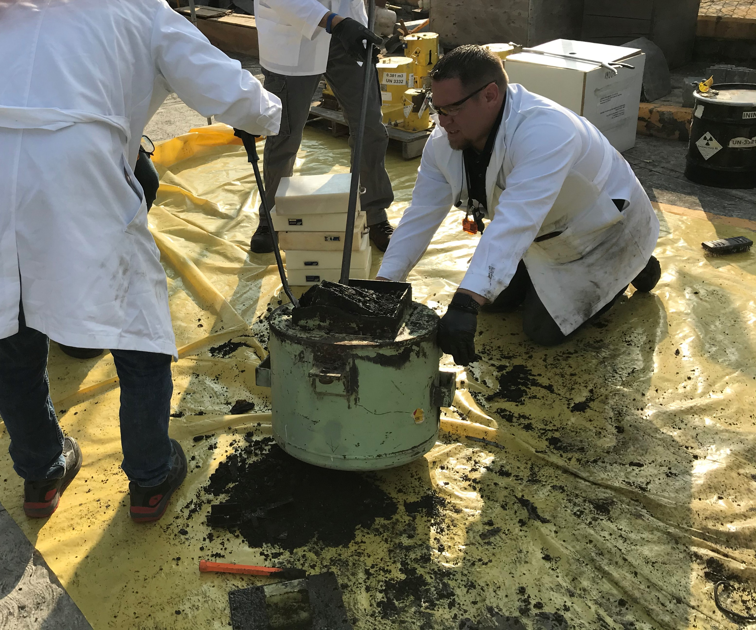

*Photo 1: Qal-Tek technicians extracting a source from an old Kay-Ray Device*

The OSRP reviews each source to determine its pedigree and the country of manufacture of its radioactive contents prior to each mission. This is to ensure the eligibility of the sources for eventual disposal at a secure DOE-operated disposal facility. Qal-Tek also reviews multiple variations of available device drawings and verifies that they are familiar with and prepared for the device disassembly and source extraction. The manufacturer, the IAEA’s Waste Technology Section, and the Nuclear Regulatory Commission’s Sealed Source Device Registry are secure repositories of device information where device drawings can sometimes be obtained. By reviewing the source and device inventory in detail prior to the mission, the teams were able to ensure that adequate resources and any specialized materials would be available onsite prior to arrival. Checking on resources and personnel that the facility has on hand often helps supplement tool availability and simplifies logistical planning. ININ provided personnel in addition to material support to OSRP and Qal-Tek.

The OSRP maintains a suite of special form capsules and Type A containers of different sizes and shielding configurations to ensure flexibility in available options for packaging sources of varying dimensions and activities. The OSRP special form capsules are IAEA Certificates of Competent Authority field-sealable stainless-steel capsules that can be used to encapsulate normal form sources to meet special form requirements. Special form is a term that generally allows a greater activity of a radionuclide to be transported in a Type A container and means that in a hypothetical accident scenario the radioactive contents will not be dispersible.

International source repatriations are uniquely challenging in that there is only one opportunity to get all the necessary supplies to the location, package the sources, and repatriate them. Repeat trips are not economical and there is no possibility to quickly obtain additional or replacement equipment from the point of origin.[4]

In preparation for the source packaging and repatriation, Type A containers, special form capsules, radiation detection equipment, and auxiliary support supplies were sent to the source consolidation facility in Mexico in late 2019. A brokerage company and freight forwarder were used to support the equipment shipment to Mexico and the hazardous return shipment of sources back to the US. ININ consulted and obtained approvals from the Mexican regulatory authority and the National Commission on Nuclear Security and Safety (CNSNS) for both the incoming and outgoing shipments.

Even though an exact packaging configuration is not available until after packaging is completed, it is important to begin to line up export arrangements simultaneously with the import. The key in making all import and export arrangements is finding freight forwarders and in-country customs brokers, preferably with experience handling international shipments of radioactive materials. In this case, for the export, OSRP chose a trusted freight forwarder, Kinetix International Logistics (Kinetix), with extensive background shipping radioactive materials and a Mexican customs broker, Corporative de Ingenieria y Diseño de Equipos de Instrumentos (CIDEI), that ININ identified as having regular experience importing and exporting radioactive materials to and from Mexico.

Extensive preparation is more time intensive but is far less costly and time consuming than having goods stuck in transit and requiring special assistance and measures to mitigate the situation.

## project implementation

In January 2020, the OSRP and Qal-Tek teams arrived at the source consolidation facility in Mexico to implement the removal mission. Prior to initiating work, the teams verified that the site conditions were conducive to the planned operations and prepared and staged the equipment, tools, and containers.[5]

Once visual examination of sources commenced it was noted that there were some sources that had been cemented (conditioned) in concrete, which could not be retrieved and had to be left out of the packaging effort. These and any other sources deemed ineligible for repatriation (e.g. not US origin) were left at the site.

All sources that were packaged by OSRP were swiped to check for contamination, visually examined and recorded (photographed or logged in a field notebook), and encapsulated/packaged compliantly into Type A containers for transport to the US. The majority of the Am241Be sources came from the oil well logging industry and were still inside their original pressure vessels. Such pressure vessels are large, often grimy and scraped up from the conditions of their use in boreholes. These and other sources/devices may be over 40 years old and heavily used, showing limited visible markings making their identification a challenge. The high neutron dose rate from the Cf252 sources also posed challenges, which ININ helped resolve by providing additional poly shielding.

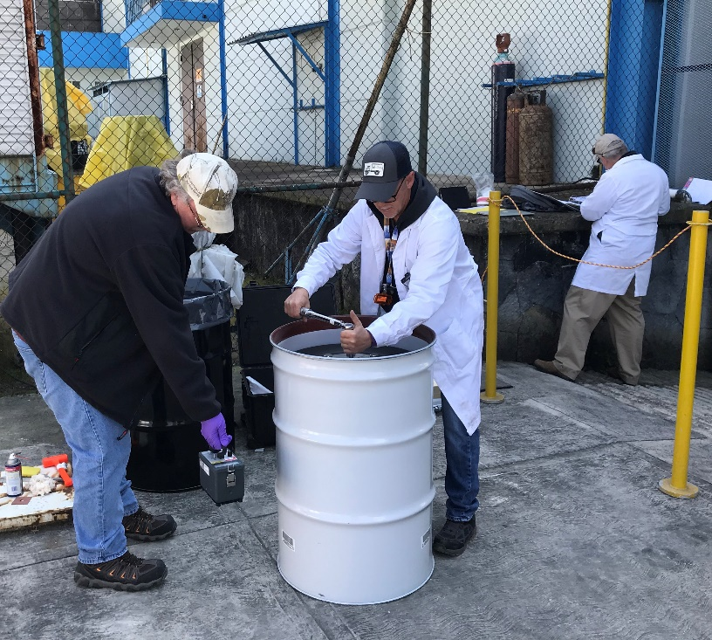

*Photo 2: Type A Drum Closure*

International shipments of radioactive materials are costly and complex, so it is highly desirable to reduce dose rates and package with the intent to export just one consignment rather than split it up into multiple shipments.

While onsite, the OSRP had a unique opportunity to interact directly with site personnel consolidating sources and to observe their available supplies and radiological equipment first-hand. Based on these observations, the ORS in consultation with OSRP and the site determined that it made sense to support the provision of some equipment to locations with limited resources. A very specific set of equipment routinely utilized by LANL-OSRP was determined to be useful to the source storage facility and is in the process of being sent to Mexico.

## Source Repatriation

At the conclusion of the disassembly and packaging mission, very few devices remained of the original transuranic inventory. The consolidation effort alone resulted in the complete removal of the low activity device inventory at one facility and a significant reduction in device and source volume taking up storage space at the consolidation site.

The OSRP and ININ achieved permanent risk reduction by eliminating more than 4.44 TBq of Americium-241/Beryllium (well above the IAEA threshold for Category 2 of 592 GBq), as well as packaging a significant quantity of Californium-252. A total of 158 sources were packed and repatriated to an interim storage facility in the US. The shipment of the sources had to be prioritized due to the increasingly restrictive environment caused by the Covid-19 pandemic that occurred just after the packaging and prior to the export of the sources from Mexico to the US.

With the receipt of the sources in the US, the OSRP, DOE-NNSA and ININ completed their commitment to Annex II and improved global radiological security. The partnership of OSRP, Qal-Tek, and ININ demonstrates an effective method for continued source repatriations that are underway worldwide. Source repatriation is essential to global security and the process undertaken in this example can be emulated worldwide.

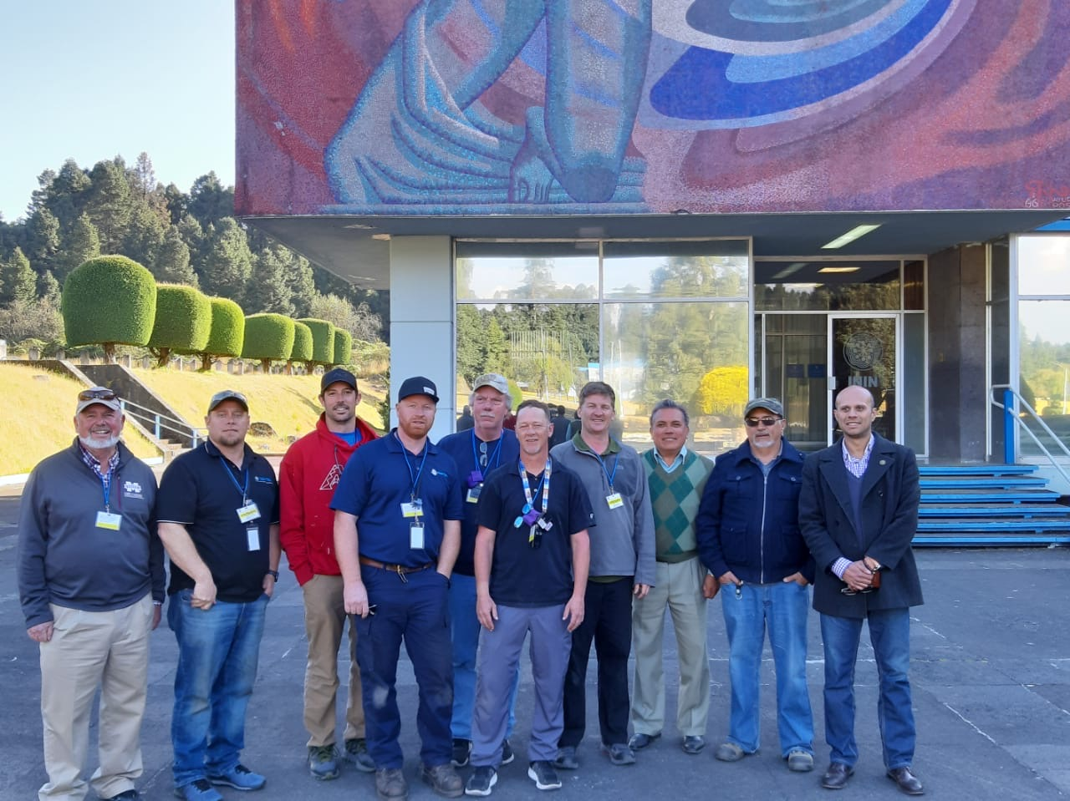

*Photo 3: ININ-OSRP-Qal-Tek Teams*

ACKNOWLEDGEMENTS

The OSRP and ININ would like to acknowledge Evan Thompson from the US Department of Energy-National Nuclear Security Administration Office of Radiological Security for sponsoring and supporting this effort as well as the efficient and compliant support of the US Freight Forwarder Kinetix and the broker in Mexico CIDEI.

1. Instituto Nacional de Investigaciones Nucleares
2. Recoveries are not limited to this list of isotopes.
3. **Disclaimer of Endorsement:** Reference herein to any specific commercial products, process, or service by trade name, trademark, manufacturer, or otherwise, does not necessarily constitute or imply its endorsement, recommendation, or favoring by the United States Government or the Los Alamos National Security, LLC. The views and opinions of authors expressed herein do not necessarily state or reflect those of the United States Government or the Los Alamos National Security, LLC., and shall not be used for advertising or product endorsement purposes.
4. Calibrated radiological survey and counting equipment are an example of non-replenishable supplies needed while working abroad. Duplicate calibrated equipment is sent to mitigate the potential for a single point of failure.
5. Materials (particularly sensitive electronics) can be damaged during shipment.