EFFECTS OF THERMAL LOAD ON BEHAVIOR OF CHERKASY BENTONITE AS A BUFFER MATERIAL

B.P. Zlobenko,
State Institution "Institute of Environmental Geochemistry of National Academy of Sciences” of Ukraine
Kyiv, Ukraine
Email: borys.zl@gmail.com

Yu.G. Fedorenko, S.P. Buhera, A.N. Rozko
State Institution "Institute of Environmental Geochemistry of National Academy of Sciences” of Ukraine
Kyiv, Ukraine

Abstract

Ukrainian a DGR concept considers crystalline rock environments. The most common buffer material for engineered barrier system (EBS) is compacted bentonite, which features low permeability and high retardation of radionuclide transport [1-3]. Establishing the thermal limit for bentonite in a nuclear waste repository is a potentially important, as the thermal limit plays on a major financial challenge requiring long-term strategic planning for used fuel management. Characterization of long-term mineralogical changes for EBS concerning the long-term geological evolution is needed for safety assessment purposes. To test the suitability and predicted functions of bentonite-based buffers under simulated repository conditions and to assess geochemical changes in minerals and porosity variations, thermal dehydration studies of bentonite were carried out at the temperature 150°C in “dry” and “wet” conditions. Commercial calcium bentonite (PBA-22 «Extra») was chosen as clay component of the buffer materials as less sensitive for saline rock water. The expected porosity enhancement and reduction as a result of mineral dissolution and precipitation, respectively, have been evaluated in experiments with elevate temperature in autoclave. Total surface area measurements show decreases with increasing of treatment temperature for this range. The decrease in cation exchange capacity also displays with increasing temperature. The connection between structural peculiarities of bentonite, and processes of heat treated is considered. The montmorilonite shows changes induced by dehydration with temperature, there are change and a decrease of the XRD profile intensity with heating to 150°C. The predicting evolution of bentonite behaviour so as the degree of montmorilonite hydration is a very important parameter for cation behaviour as a function of the thermal load. Further studies will be focused on heat effects on hydrothermal alteration of bentonites on permeability and swelling pressure.

INTRODUCTION

Bentonite clays are candidate materials for engineered barriers for disposal of high-level radioactive wastes due to its unique set of natural properties, such as high swelling pressure, low permeability relatively high mechanical and thermal stability. In the HLW repository, the EBS must function under complex disposal conditions due to the radioactive decay heat from spent fuel, the inﬁltration of ground water from the surrounding rock, the thermal loading and the swelling pressure of the barrier. The effects of continuous heating on swelling, ion exchange, mineralogical and other properties of bentonite barrier are important issues for application in geological repository.
A review of the literature performed within EURAD project of the WP7 “Influence of Temperature on Clay-based Material Behaviour” suggested that some aspects of usage bentonite as buffer materials in the engineered barrier systems require further investigations. The study of the effect of temperature on bentonite properties by analysing the change of properties of preheated material. The properties of these preheated materials are usually tested at laboratory temperature and compared with those obtained in non-heated material to assess the changes during operation [4].
Montmorillonite mineralogical stability at high temperatures has been studied in Leupin et al. [5]. The report contains literature review of montmorillonite stability in high temperature and reviews several different kinds of high-temperature experiments:
- experiments on thermal stability of montmorillonite at 90-150°C, showing montmorillonite dissolving and releasing silica, altering the montmorillonite towards beidellite;
- experiments on the effect of steam on the swelling capacity of bentonite at temperatures up to 200°C showing that high-temperature water vapour and unsaturated conditions do not cause significant reduction of the water uptake capacity of montmorillonite.
The tests by Valter [6] with MX-80 bentonite with different degrees of saturation stored at different temperatures in a closed system, showed a high mineralogical stability but considerable changes in physicochemical properties, particularly above the critical temperature of 120°C. The cation exchange capacity decreased during heating at 150°C by approximately 10%. The specific surface area dropped by more than 50%. The water vapour adsorption ability dropped by 25% already within three months at 120°C. These changes were mostly related to the variations in the interlayer cation composition and to smectite aggregation processes [7].
According to the review performed in [4]: within the PEBS project (Long-term Performance of the Engineered Barrier System, 7th European FP 2007-2011) the conclusion was reached that the characterisation of bentonite performance and THM properties below 100°C was largely established [8]. Overall, the observed effects of temperature on the hydro-mechanical properties (decrease of swelling pressure, increase of permeability, decrease of water retention capacity) can be qualitatively explained by considering the transfer of high-density interlayer water to the macropores that is triggered by the increase in temperature. The different behaviour of smectites exchanged with monovalent versus divalent ions can be explained by taking into account the different interlayer/diffuse-double-layer water ratio in both. The study performed by Dueck with fully saturated samples, are exposed to short-term laboratory heating as high as 150°C and swelling pressure and hydraulic conductivity are measured after cool-down, property changes are small compared to reference untreated samples [9]. Furthermore no significant changes were found after the six-year duration LOT study, performed at Äspö, in which the bentonite experienced temperatures up to 130°C [10]. The treatment tests performed by R. Pusch some impact of vapour on bentonite properties under repository relevant conditions (120-150°C) can be expected and should be clarified taking into account repository vapour regimes. This impact might be due to minor surface cementation effects, although this needs further confirmation. The possible scale dependence of the vapour movement is also to be assessed [11].
The purpose of study was to investigate thermal load on Ca-bentonite at the temperature 150°C in “dry” and “wet” conditions. Analytical techniques that were used to characterize the bentonite: IR spectroscopy, XRD analysis, SEM, swelling pressure measurement, surface area BET analysis, cation exchange capacity and chemical analysis, TGA analysis, permeability testing.

2. Materials and methods

2.1 Materials
The object of studies was bentonite of the Cherkaske deposit. The Cherkaske deposit is one of the largest in Ukraine. The main rock-forming mineral of the second clay layer of the deposit is montmorillonite; in some samples from the lower part of the layer there is a negligible admixture of palygorskite. The clay is sage-green, homogeneous, and solid with wax glitter on the fracture. It intakes water and swells well. Bentonite PBA-22 «Extra» is industrially milled, powder. The mineralogical composition of the Cherkasy bentonite has been analysed by X-ray diffraction (XRD) using DRON-4-07 diffractometers with a Cu anticathode.

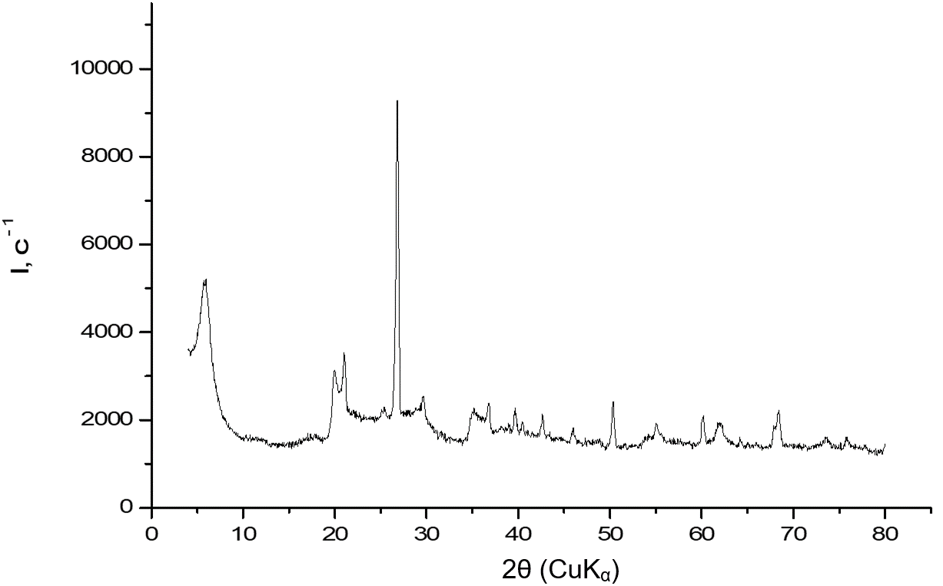
Fig. 1. The X-ray diffractogram of Cherkaske bentonite used in this study

The content of montmorillonite is higher than 90%, besides, the bentonite contains variable quantities of quartz (3-5 %), calcite (carbonate) (2-5 %). The heavy fraction of the clays is presented variable quantities accessory minerals (zircon, rutile). The light fraction contains quartz, feldspar. A spherule’s with size of 4÷5 µm were found in a highly dispersed part of bentonite. Taking into consideration morphological characteristics, their chemical composition the spherules’ can be identified as opal particles. Result of chemical analysis of Cherkasy bentonite sample received by wet chemical method are given in Table 1.

TABLE 1. CHEMICAL COMPOSITION OF CHERKASKE DEPOSIT BENTONITE PBA-22 SAMPLE (WET CHEMICAL ANALYSES).
Elements | Content in bentonite, %
SiO2 | 54,7
Al2O3 | 16,3
Fe2O3 | 5,7
FeO | 0,3
MgO | 3,2
CaO | 2,1
Na2O | 0,1
K2O | 0,7
H2O+ | 5,7
H2O− | 11,4

TABLE 2. PHYSICAL-CHEMICAL PROPERTIES OF CHERKASY BENTONITE PBA-22.

Cherkaske bentonite | Sand fraction, | Colloidal properties | Free-swelling | Water absorption, * | Specific surface, m²/g**
Content, % | up to 10,0 | 25÷40 | 1,3÷2,0 | up to 160 | 90÷120
*The free swelling capacity of liquid water was determined using Enslin-Neff device (DIN 18132, 1995).

The cation exchange capacity (CEC) of Cherkaske bentonite samples had been measured by ammonium acetate method at pH 8, is of 92,6 meq/100 g of dry clay, that apparently dissolved calcite.
**The methods applied for the determination of specific surface are gas adsorption method by nitrogen adsorption.
The methods used for determination of grain size distribution and amount of clay and silt fraction were dry/wet sieve analysis and sedimentograf for particle analysis (Mastersaizer-2000).
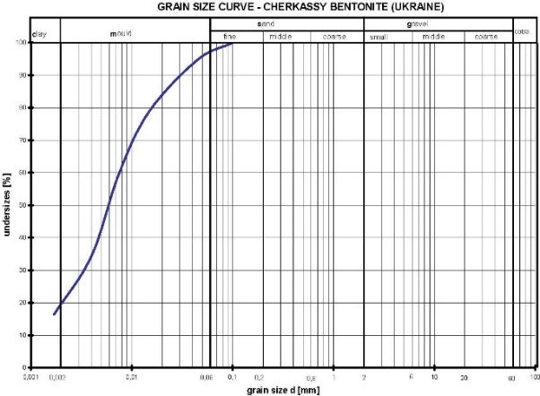
Fig. 2. Bentonite PBA-22 grain size curve.

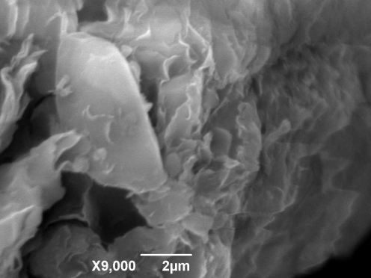 | 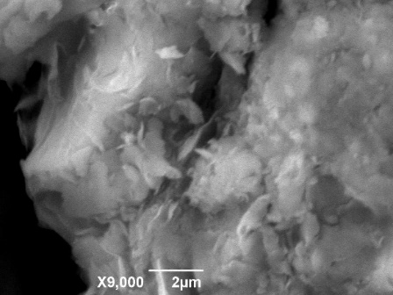

Fig. 3. SEM image initial sample bentonite PBA-22 and after treatment

The initial water content, liquid limit and plastic limit of the bentonite were determined by following the procedures laid out in the standards [12]

TABLE 3. PLASTICITY OF CHERKASKE BENTONITE PBA-2 «EXTRA».

Specific gravity, ρs (kg/m³) | 2705
Water content (%) | 12
Liquid limit (%) | 119
Plasticity limit (%) | 42
Plasticity index (%) | 80

TABLE 4. THERMOPHYSICAL PROPERTIES (NATURAL, POWDER)

Samples | ρ_{d} (kg/m³) | Ks (ms⁻¹)
Initial | 1480 | 2,6 E-13
 | 1535 | 4,7 E-13
 | 1680 | 3,4 E-14

2.2 Experimental program for material treatment (wet and dry at 150°C)

The main objectives of the investigation was to study in detail the influence of high temperature on the thermal and hydraulic behaviour of compacted bentonites. Material was used laboratory treated (initial and after treatment) were characterization (mineralogy, chemical composition, chemical and mechanical properties). Bentonite clay minerals can adsorbed/desorbed water from their interlayer, which is connected with changes in d_{00l} spacing. Two types of treatment were used:
- ”Dry“ - powder material will be placed into 150 °C (drying allowed)
- “Wet“ - bentonite water suspension will be placed into 150 °C (drying prevented). It was thought that heating in conjunction with wetting, i.e. conditions that prevail in a HLW repository, can generate thermal stresses and help to disintegrate them, and this possibility was investigated in [8]. Test duration were 3, 6 and 12 months (e.g. 3 campaigns were planned). Wet samples were dried and milled after treatment as part of test preparation.

Dry test program
Powder samples were heated in a muffle furnace at 150°C with a heating rate of 5°C/min and kept for 3 and 6 mounts at temperature. Three independent tests were carried out on bentonite specimens using the heating cells. After tests completions, the bentonite specimens were taken out from the cells to conduct analysis. After dehydration of the samples it was recorded TGA analysis under laboratory conditions.

Wet test program
The present study the bentonite prepared from Cherkaske bentonite PBA-22 «Extra» exposed to saturated water vapor a temperature of 150 ⁰C.

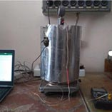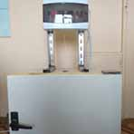
Fig. 4. Wet test program, autoclave treatment and dry program heat cell
The experiments comprised autoclave treatment for 3 and 6 months at 150⁰C of ordinary bentonite suspension was placed. The bentonite had an initial water content of 12%. Distilled water was contained in cups placed in the hydrothermal cells, the amount being theoretically sufficient for water vapor a temperature of 150⁰C (Fig.5). The temperature readings were monitored within the ±1.0 °C range given by the manufacturer. Once 150⁰C is reached, temperature is automatically regulated by a program, to maintain a constant temperature of 150⁰C at the heater/bentonite interface.
Microscopy and XRD was made on bentonite after opening the autoclave, and the samples used for testing the expandability in ‘‘free’’ swell experiments and for determining the swelling pressure and hydraulic conductivity using oedometers. Permeability (K m/s) and swelling pressure (σ_{sw}, MPa) were measured in constant volume cells (D=50 mm, H=20mm). At first permeability is measured followed by swelling pressure determination. Permeability was measured using constant pressure gradient permeameter. Samples are compacted directly into constant volume cells then water gradient is applied, water inflow and total pressure development measured. Once stable flow (total pressure) has been obtained permeability is calculated. Pressure gradient is then released and swelling pressure measurement begins.
Swelling pressure is determined on fully saturated sample from permeability test. The pressure gradient is no longer applied and once the total pressure stabilizes it equals to swelling pressure (no pore pressure in sample).

Test results and discussion

The powder from each samples was subjected to x-ray diffractometer analysis to determine any possible mineralogical changes that have occurred in tests. The basal spacing’s of Ca-montmorillonite changed at times (3 and 6 moths). The d₍₀₀₁₎ value of Ca-montmorillonite decreased with increasing times treatment.
The profile intensity decreased together with a shift of the maximum. Based on XRD spectra of the first basal diffraction (001) of Ca montmorillonite, significant changes induced by dehydration were observed (see Fig. 5) and shows the evolution of the position, shape and intensity of the 001 reflection as a function of times for 150⁰ C heating temperature. The profile intensity decreased together with a shift of the maximum from 15,36 Å to 12,5 Å during the 6 month exposure.

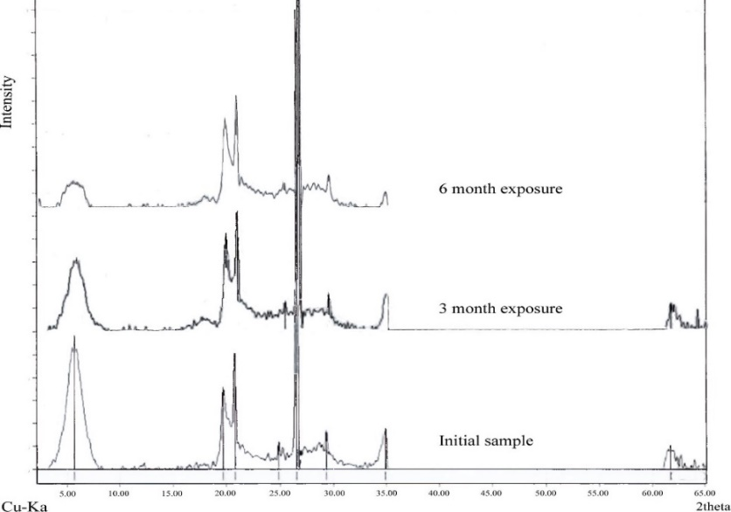

Fig. 5. XRD patterns of samples after dry thermal tests conducted at 150⁰C

With increasing time treatment to 3 months, evolution is observed in peak shape although there is a slight shift to 14.9 Å. The 001 peak decreases in intensity, shifts and broadens, developing a tail toward the high-angle side. After 6 months heating, the 001 peak near 12.5 Å decreases in intensity, broadens and becomes asymmetric and diffuse.

Table 5. PHYSICAL-CHEMICAL PROPERTIES AFTER TREATMENT BENTONITE PBA-22.

Treatment | CEC(meq/100 g of dry clay) | Free-swelling | Specific surface (m²/g)
Initial | 92.6 | 1,3-2,0 | 90-120
3 month | 79,2 | 1,3 | 90-100
6 month | 72,6 | 0,8 | 75-80
The values of ion exchange capacity the lover values of the initial bentonite material. The swell index test procedure is used to determine the general swelling characteristics and swell index is considered by most to be an indicator of bentonite quality. The specific surface area S_{BET} was determined according to the BET method from the N₂ adsorption isotherm at 77 K.
An overlap of bands produced by the O−H stretching vibrations of H₂O (O–H_{w}) and structural OH (O−H_{s}) in bentonite hampers the study by infrared spectroscopy (IR) of both their layer and interlayer structure [13].
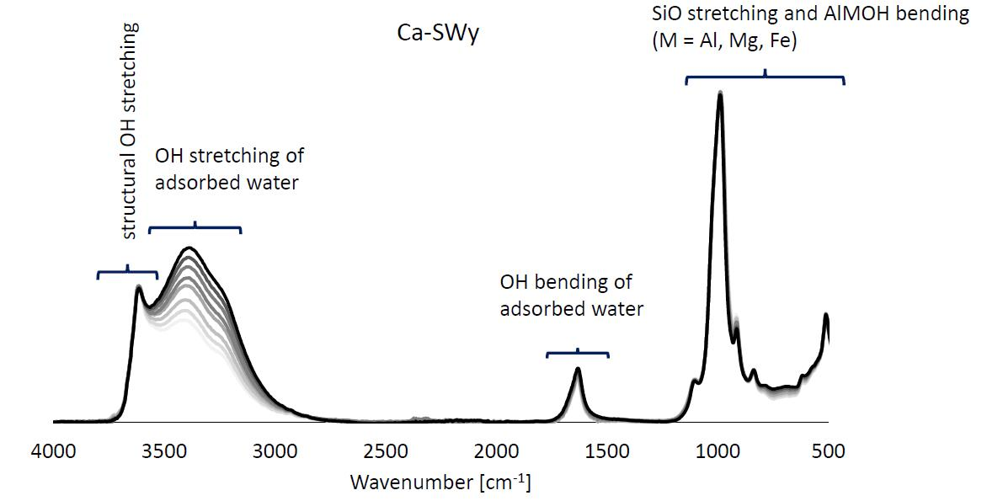

Fig. 6. IR spectra of water sorption on bentonite –IR experiments [13]

Analysis of the IR spectra of the samples in the region of stretching and bending oscillations of OH groups associated with octahedral cations, as well as in associated water molecules, indicates a clearly defined band for Al-Al-OH at 3622 cm⁻¹. At the same time, the band at 913-915 cm⁻¹ is most pronounced in the form of a bend. The band at 875 cm⁻¹ corresponds to the bending oscillations of the OH-group in the structural fragment Al-Fe-OH and is most pronounced for bentonite treated for 6 months.
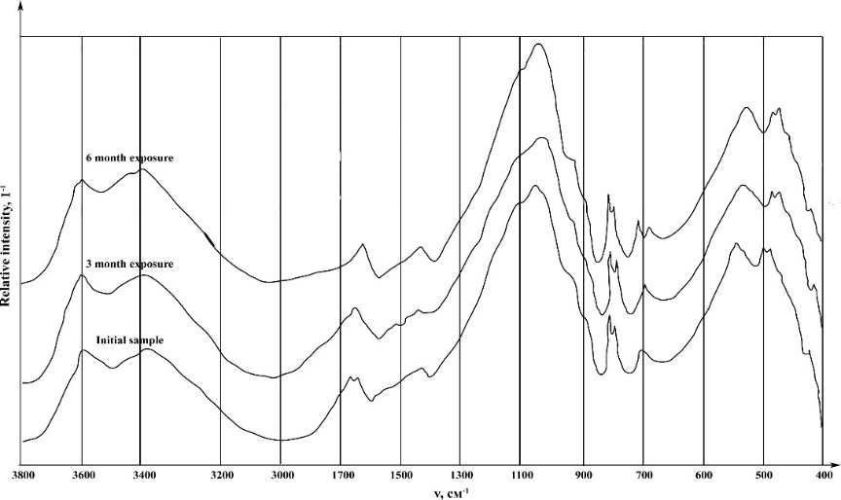

Fig. 7. IR spectra of the samples after dry thermal tests conducted at 150⁰C

TABLE 6. WAVENUMBERS (ν, cm⁻¹) OF ABSORPTION MAXIMA IN IR SPECTRA OF BENTONITE

Structural groups | М-ОН | Аl-Аl-ОН | Аl-Fе-ОН | Н₂О | Si-O-Si
Stretching oscillations | 3692 | 3622 | - | 3426 | 1164, 1095, 1039
Deformation oscillations | - | 913 | 875 | 1634 | 798; 779;  694; 519; 467
The stretching oscillations bands of OH groups of water molecules for three samples have the same shape, but differ in the values of the wave numbers at the maximum point. This band is the most intense, and the maximum, in comparison with the other two samples, is shifted to the low-frequency region: (3426 cm⁻¹) <(3430 cm⁻¹) <(3435 cm⁻¹). Obviously, one can speak of a weakening of the energy of hydrogen bonds in the indicated series. At the same time, in the region of deformation vibrations of water molecules, an intense band with symmetrical shape appears at 1632-1634 cm⁻¹.

Most studies relating to the influence of temperature on bentonite dehydration have been performed using thermogravimetric or differential thermal analysis. Thermogravimetric analyses (TGA) were performed using a Thermal instrument Q-1500, curves were recorded simultaneously in a static air atmosphere at a heating rate of 5°C/min. For Ca-bentonite there is a first dehydration start near 60–90 °C, usually attributed to water loosely bonded, and another part at 110–150 °C, attributed to strongly held water (see Fig 8).

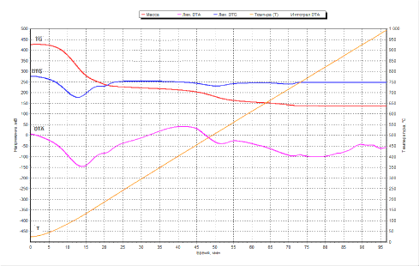 | 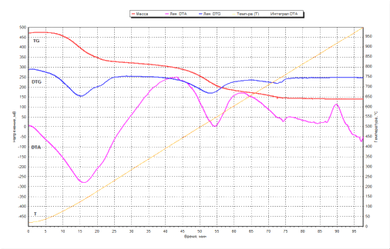 | 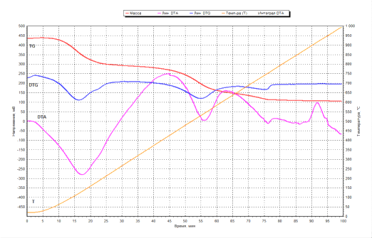
Initial | 3 moths thermal load | 6 moths thermal load

Fig. 8. TGA analysis of Cherkasy bentonite PBA-22 after dry thermal tests conducted at 150 ⁰C

The dry density of the compacted specimens was kept same for ensuring reproducibility of the test results. The specimens were prepared by statically compacting bentonite powder (water content = 12.0 %) to a targeted dry density of 1520, 1580 and 1650 kg/m³. Compaction of bentonite powder was carried out using a high-capacity compression testing machine.
The hydraulic conductivities were then computed by applying Darcy’s law from the slopes of linear relationships, and the results are listed in Table 7. In the table, the values of hydraulic conductivity at different dry density after trated.
Experiments with bentonite exposed to hot water vapor showed that the swelling pressure and hydraulic conductivity were not significantly changed for the investigated temperature 150⁰ C. A slight increase in conductivity that was recorded.
The method is based on ASTM standard D 5084-03 [14]. The permeameter has diameter of 50 mm, while the diameter of the sample can vary between 50 mm. The height of the sample is 50 - 250 mm.
The test results showed that thermal treatment (see Table 7.), the hydraulic conductivities for all compacted bentonites with the dry densities of 1520, 1580 and 1650 kg/m3 are very low Ks (ms⁻¹) ≈ E-13. The hydraulic conductivities decrease with increasing dry density of bentonite. The hydraulic conductivities decrease faster with increasing dry density at higher porosity. The change of hydraulic conductivities in the bentonites at elevated temperatures is attributable to the change of the permeability factor and the density factor. At an elevated temperature, the adsorbed water may be degenerated into bulk pore water Pusch, [11], and this degeneration may lead to a higher amount of bulk pore water resulting in an increase of permeability due to an increase in flow channel volume.

TABLE 7. THERMOPHYSICAL PROPERTIES OF BENTONITE AFTER TREATED

Samples | ρ_{d}(kg/m³) | K_{s} (ms⁻¹)
Initial | 1480 | 2,6 E-13
 | 1535 | 4,7 E-13
 | 1680 | 3,4 E-14
Treated | 1520 | 3,3 E-13
 | 1580 | 4.0 E-13
 | 1650 | 4.9 E-13
A consequence of heating experiments, a continual decrease in ion exchange ability of the bentonite and S_{BET} values decreased due to the temperature treatment. Heat treatment has changed the structure of clays and their physico-chemical properties.
ACKNOWLEDGEMENTS
The project has received funding from the European Union’s Horizon 2020 research and innovation programme under grant agreement No 847593. The comments on this paper by Ms B. ALTENHOFER acknowledged.

References
- ZLOBENKO, B.P.; MOVCHAN, N.P.; VOVK, I.F.; LITOVCHENKO, A.S.; PLASTININA, M.A. Studies of clays from deposits in Ukraine as barrier material for radioactive waste repositories (1995) 857-859.
- INTERNATIONAL ATOMIC ENERGY AGENCY, Characterization of Swelling Clays as Components of the Engineered Barrier System for Geological Repositories, IAEA-TECDOC-1718, IAEA, Vienna (2014).
- ZLOBENKO, B.P., FEDORENKO YU.G. Ukrainian programme on characterization and evaluation of swelling clays for use in engineered barrier system of geological repository, International Meeting “Clays in natural and engineered barriers for radioactive waste confinement”. Tours , France (2005).
- VILLAR, M.V., ARMAND, G., CONIL, N., DE LESQUEN, CH., HEROLD, PH., SIMO, E., MAYOR, J.C., DIZIER, A., LI, X., CHEN, G., LEUPIN, O., NISKANEN, M., BAILEY, M., THOMPSON, S., SVENSSON, D., SELLIN, P., HAUSMANNOVA, L. D7.1 HITEC. Initial State-of-the-Art on THM behaviour of i) Buffer clay materials and of ii) Host clay materials. Deliverable D7.1 HITEC. EURAD Project, Horizon 2020 No 847593. (2020).
- LEUPIN OX (ED), BIRGERSSON M, KARNLAND O, KORKEAKOSKI P, SELLIN P, MÄDER U, WERSIN P, Montmorillonite Stability Under Near-Field Conditions. NAGRA TR14-12. Wettingen, (2014)
- VALTER, M. PLÖTZE, M. Characteristics of variably saturated granular bentonite after long-term storage at near-field relevant temperatures. Clay Minerals 48(2) (2013) 343-361
- TSURUMI, S. & IIZUKA, A. Characteristics of variably saturated granular bentonite after long-term storage at near-field relevant temperatures. Clay Minerals. 48. 10.1180 (2013).
- JOHNSON LAWRENCE, GAUS IRINA, WIECZOREK KLAUS, MAYOR J. C., SELLIN P., VILLAR M.V., SAMPER J., CUEVAS J., GENS ANTONIO, VELASCO M., TURRERO M. J., MONTENEGRO L., MARTÍN P.L., ARMAND G. Integration of the short-term evolution of the engineered barrier system (EBS) with the long-term safety perspective (Deliverable D4.1 of the PEBS project). NAGRA Arbeitsbericht NAB 14-079 (2014).
- DUECK, A. Laboratory studies on stress-strain behavior. PEBS Deliverable D2.2-12 (2014).
- KARNLAND O., OLSSON S., SANDÉN, T., FÄLTH, B., JANSSON, M., ERIKSEN T.-E., SVÄRDSTRÖM, K., ROSBORG B., MUURINEN, A. Long-term test of buffer material at the Äspö Hard Rock Laboratory, LOT project. Final Report on The A0 Test Parcel. SKB report TR-09-31, Svensk Kärnbränslehantering AB. Stockholm (2009).
- PUSCH, R. Permanent crystal lattice contraction—a primary mechanism in thermally induced alternation of Na-bentonite. Scientific Basis for Nuclear Waste Management, Material Research Society, (1986) 791-802.
- ISO/TS 17892-5:200, GOST 12248 – 2010 Geotechnical investigation and testing - Laboratory testing of soil (2010).
- KULIGIEWICZ, A., DERKOWSKI, A., SZCZERBA, M. ET AL. Revisiting the infrared spectrum of the water—smectite interface. Clays Clay Miner. 63, (2015) 15–29/
- 13. ASTM standard D 5084-03. Standard Test Methods for Measurement of Hydraulic Conductivity of Saturated Porous Materials Using a Flexible Wall Permeameter

