Novel electrical, electronics, and

instrumentation systems for fast

reactor fuel reprocessing plants

GEO MATHEWS M., BHANU PRAKASH, SAYED IMRAN ALI, JOHN SWAMIDOSS, K.P. DESHEEB, S. MANICKAM, R. RAGHUNATH, R.V. SATHEESH KUMAR, PADI SRINIVAS REDDY, AVIK KUMAR SAHA, SWATILEKHA BHATTACHERJEE, REUBEN DANIEL J.W., AMUDHU RAMESH KUMAR, M.S. GOPIKRISHNA, K.ANANTHASIVAN.

Reprocessing Group, Indira Gandhi Centre for Atomic Research, Kalpakkam, Tamil Nadu, India.

Email contact of corresponding author: geo@igcar.gov.in

Abstract

Fast Reactor Fuel Reprocessing Plants require specialized Electrical, Electronics, and Instrumentation systems to meet the requirements process operation and safety. The radiation fields in the hot cells are particularly high due to the large burnup of the spent fuel. The high fissile material content of the spent fuel poses a significant risk of accidental criticality at all stages of the process. Many of these systems operate in the harsh radiological and chemical ambience of the hot cells. The operation and maintenance of the systems pose unique challenges. The paper describes the novel electrical, electronics, and instrumentation systems developed and deployed in the fast reactor fuel reprocessing plants. The novel systems include the heat pipe based LED Light, Passive neutron assay based waste drum assay system for fissile material, Averaging Pitot Tube based stack flowmeter, Dual phosphor scintillator based radiation monitors, Plant Data Acquisition System based on VME bus, Soft Dissolver Temperature Sensor based on Artificial Neural Network, Control System with wireless signal transmission, Control System for vacuum based liquid transfer, Speed sensing system for Centrifuge, and VFD based Control System for Centrifugal Extractor Motor Bank. The experience of the operation the Electrical, Electronics, and Instrumentation systems in the Plant is also provided in the paper.

INTRODUCTION
Fast Reactor Fuel Reprocessing Plants reprocess the spent fuel from fast nuclear reactors. The spent fuel from fast reactors is characterized by high burnup of up to 155 GWday/T and high fissile material content of up to 70%. These specialities of the spent fuel pose a challenge not only to the process design and operation but also for the electrical, electronics, and instrumentation systems. The radiation fields in the hot cells are particularly high due to the large burnup of the spent fuel. The high fissile material content of the spent fuel poses a significant risk of accidental criticality at all stages of the process. Many of these electrical, electronics, and instrumentation systems operate in the harsh radiation and chemical ambience of the hot cells. The operation and maintenance of the systems pose unique challenges.

Novel Electrical and Instrumentation systems Developed and deployed
The novel Electrical, Electronics, and Instrumentation systems developed for the Fast Reactor Reprocessing Plants include the Heat Pipe based LED Light, Passive Neutron based Waste Drum Assay System For Fissile Material, Averaging Pitot Tube based stack flowmeter, Dual phosphor scintillator based radiation monitors, Plant Data Acquisition System based on VME bus, Soft Dissolver Temperature Sensor based on Artificial Neural Network, Control System with wireless signal transmission, Control System for Vacuum based Liquid Transfer, Speed sensing system for Centrifuge, and VFD based Control System for Centrifugal Extractor Motor Bank.The details of these systems are as follows.

Heat Pipe based LED Light
The Plant required the development of a special lighting system for the lead wall shielded hot cells. The design of this lighting system was a challenging task because of the confined opening (90 mm diameter) for the entry of light fixtures, limited provision for cooling and high illumination requirement.
A unique heat pipe based 50W LED light fixture was developed for this application. Heat pipes employ phase change to transfer thermal energy from one point to another by the vaporization and condensation of a working fluid. In this design, a cylindrical heat pipe and de-ionized water as the working fluid is used. Copper fins are provided on the heat pipe for further heat dissipation into the ambient air. The LED used is the Chip On Board (COB) type and has a relatively high luminous efficacy 140 lm/W. The high efficacy provides high light output with reduced heat generation. The average illumination was over 2000 Lux in the hot cell as viewed for the Radiation Shielding Window. Various components of the Heat pipe based LED light fixture was tested in gamma radiation chamber and found to perform satisfactorily in terms of long time operation and easy maintainability.

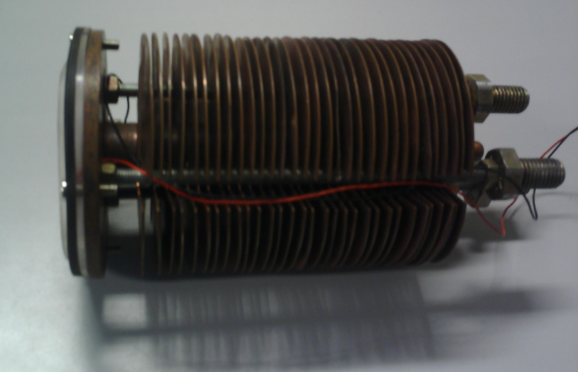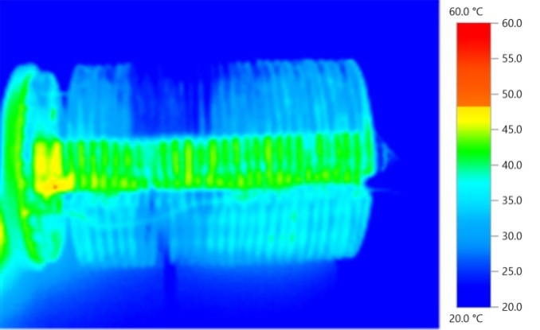
Fig. 1. Optical and Thermal image of 50 W Heat Pipe based COB LED lamp with copper fins

Passive Neutron Based Waste Drum Assay System for Fissile Material
It is essential to quantify the plutonium in the alpha-active solid wastes generated during the reprocessing of fast reactor spent fuel. Neutron waste assay systems measure the uranium or plutonium content of waste containers or objects. They can be either PASSIVE (measuring spontaneous fission neutrons) or ACTIVE (measuring induced fission neutrons). In the passive system, the inherent emission of neutrons by the even-even isotopes of plutonium is utilized and this is suitable for assaying the plutonium in the waste drums. The sensitivity is dependent on the isotopic composition. A complete system based on passive neutron counting technique using He3 detector has been designed and fabricated indigenously. The system consists of eight He³based neutron detectors embedded in High-Density Polyethylene (HDPE) moderating medium and configured in a semi-circular shape which encircles half of the drum containing the waste to be assayed. Each detector has a sensitivity of 130 cps/nv. Gamma tolerance of 20 mSv/h is achieved using lead shielding.
Studies were carried out to determine the effect of the matrix on the counts obtained using a 1g plutonium source of standard isotopic composition. Extensive calibration is carried out with different known quantities of Pu distributed in a heterogeneous manner simulating different gamma field as background. The system can be used for the drum having up to 2 R/h surface dose. Based on previous operating experience, a new system using BF3 detectors and enclosing the waste drum in a full circle has been designed and fabricated.
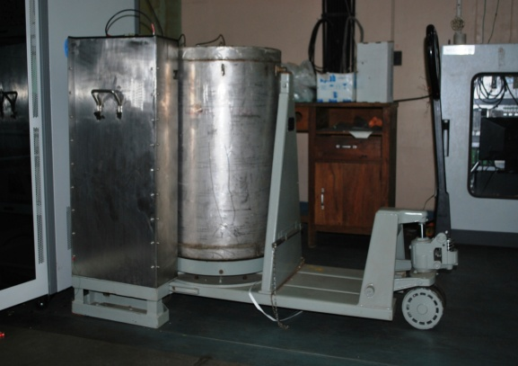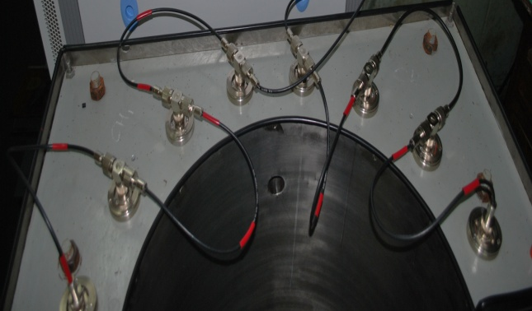
Fig.2. Waste Drum Monitoring System Fig. 3. Arrangement of He3 detectors

Averaging Pitot Tube based Stack Effluent Flowmeter with wireless communication
The stack is essential for the ventilation system of every Nuclear Plant. Measurement of the flow rate of effluent air through the stack provides confidence regarding the health of the ventilation system. However, this measurement is challenging due to site conditions. For the stack duct, its cross-sectional dimensions are very large, the straight length available is low and its location makes the access by personnel difficult. The averaging pitot tube (APT) was selected as the flow sensor as they are rugged, accurate, and are easy to maintain. To sense the flowrate, the pressure difference between the stagnation pressure and static pressure is measured. The stagnation pressure is averaged across the length of the duct by the APT using several taps. As the availability of the straight lengths of the duct is less, three APTs are installed to obtain a more accurate measurement.
In order to overcome the difficulties in installing the long signal and power cabling, wireless signal transmission technology and in-built battery power were employed. The wireless field devices communicate with the field wireless access point through the industrial automation wireless communication standard ISA 100.11a.
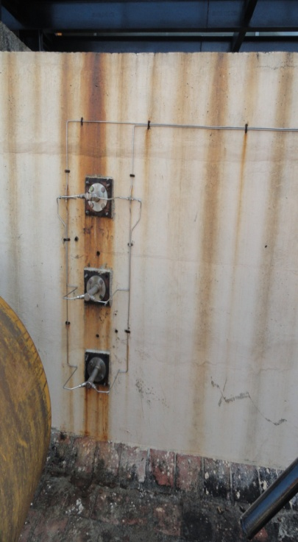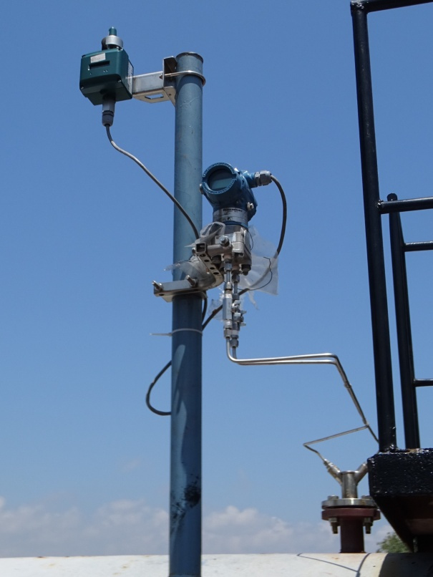
Fig.4. Three APTs in the exhaust duct Fig. 5. DP transmitter with battery powered wireless transmitter

Plant Data Acquisition System based on VME bus
The Data Acquisition System for the CORAL Fast Reactor Fuel Reprocessing Facility is a Nuclear Reactor grade system. The hardware architecture is a two-tier system. The bottom layer consists of VME bus based system for the input modules. The top layer is dual hot redundant Ethernet communication connected to the Display Station computers for the operators. The M68020 processor based CPU card is connected to both the layers. The hardware is qualified for reactor grade specifications for environmental, EMI/EMC conditions.
The application software is developed using ‘C’ language and compiled using tasking cross compiler. It is fused into EPROM and running at one second scan rate. The Graphical User Interface application software for the Display Station computers is developed using open source Qt kit on Linux OS platform. Database for signals and historian data logging is designed using MySQL, which is also an open source database software. Plant information can be viewed by the operators in various formats and reports can also be printed for archival.
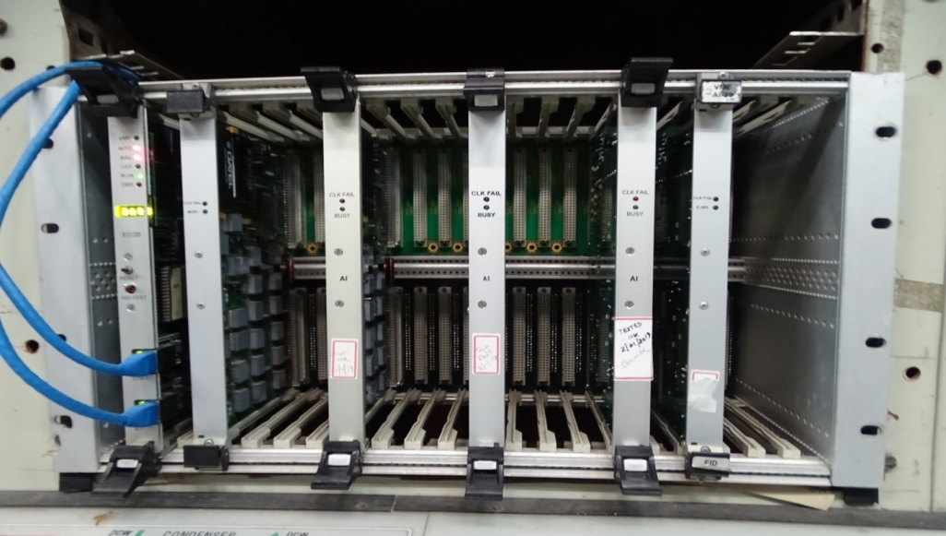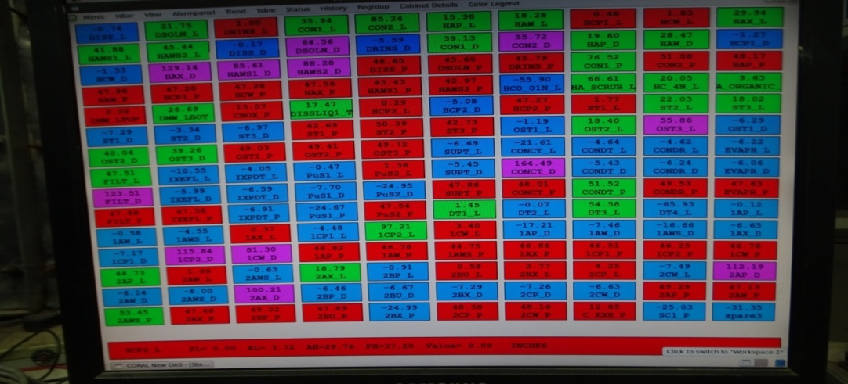
Fig.6. VME based Data Acquisition System hardware Fig. 7. Graphical Display Station Computer Screen

Wireless Communication based Remote Measurement and Control
Monitoring the level of water in the remotely located sump used for the fire hydrants of the Plant is an important requirement of safety. Laying of signal cables for conventional communication presented significant logistical challenges. There was also a requirement of automatic control of the pump to the overhead tanks based on the water levels in both the sump and the overhead tanks. Here too, providing the signal and control cables were prohibitive due to site conditions. For both these requirements, wireless communication technology was deployed to meet the requirements effectively and reliably which has provided much ease of installation and maintenance. This has also led to a lot of saving of time and cost.
Zigbee Pro wireless protocol was used for these systems which communicated reliably for around 500 Metres of Line-Of-Sight distance. Solar powered wireless system was also deployed to avoid power supply cabling.
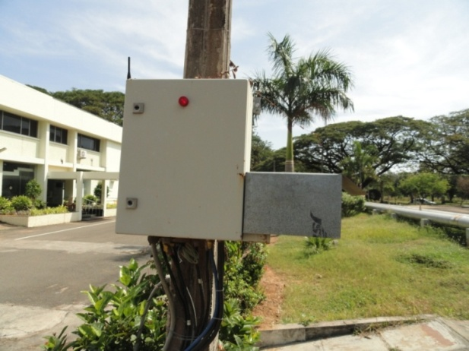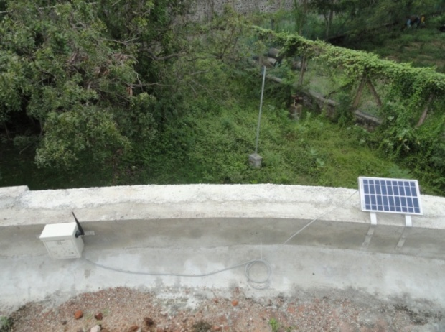
Fig.8. Wireless Receiver near the water sump Fig. 9. Solar powered Wireless Router

Soft Dissolver Temperature Sensor based on Artificial Neural Network
The dissolver has more than one thermocouple for temperature measurement that are located at various points of the equipment. The thermocouple has a risk of failure and it is difficult to replace them. As an experiment, modelling of the main thermocouple (in the liquid) of the dissolver was carried out using the recorded data from the actual operation of the system. The data of the readings of the thermocouple in the liquid and the thermocouple in the vapour was logged (Fig.10). The modelling was done using Artificial Neural Network (ANN). In ANN, the model used was Nonlinear Autoregressive Exogenous (NARX). This is a time series modelling which uses the current and past values of the parameter to estimate the required value. The estimate of the liquid temperature based on the vapour temperature showed excellent relationship with the actual liquid temperature and the error were minimal (Fig.11). Using this ANN based model of the thermocouple, in eventuality of the failure of the thermocouple in the liquid, the thermocouple in the vapour will be used to estimate the temperature of the liquid in the dissolver which will then be used to control the dissolution process.

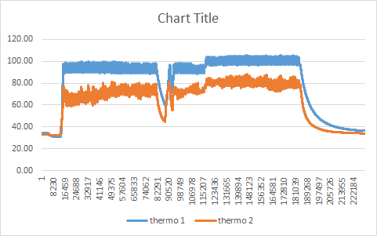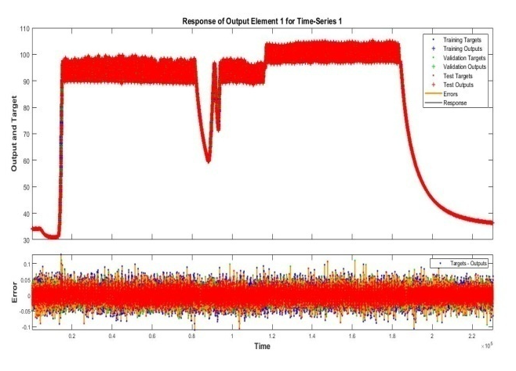
Liquid Vs Vapour Temperature (in °C)
Fig.10. Time series graph of Liquid and Vapour temperature Fig. 11. Estimated and actual liquid temperature and error

Dual Phosphor Scintillator based Radiation Monitors
A Dual phosphor scintillator is sensitive to both alpha and beta radiation and the two types of radiation can be individually measured using pulse shape discriminating electronics. This two-in-one sensor provides significant savings of space and cost as compared to the conventional radiation monitors which could detect only one type of radiation. This system also leads to saving of time when checking for radioactive contamination, measuring the radioactivity in samples etc. The developmental activity carried out in-house included the optimizing of specifications like the thickness of the dual phosphor and the shape discriminating parameters of the electronic circuit in order to obtaining maximum efficiency, minimum noise and minimum cross-talk. Various types of radiation monitors were developed, qualified and deployed in the Plant including hand & clothing contamination monitors, continuous air monitor, alpha & beta counting systems and contamination survey meters.
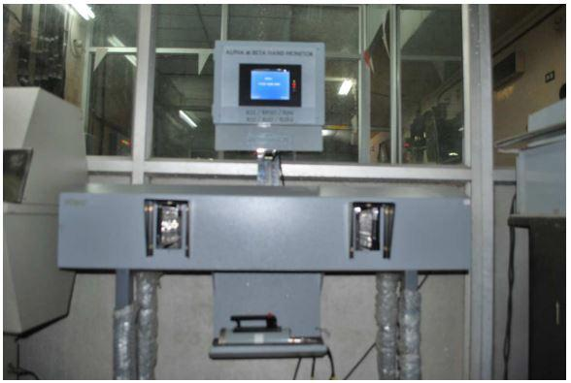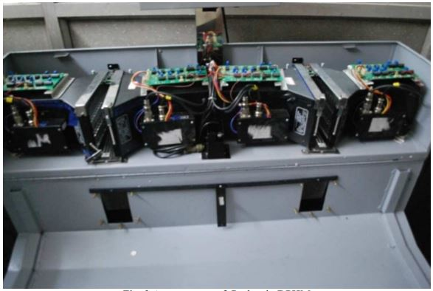
Fig.12. Dual phosphor scintillator based hand & clothing contamination monitor and its internals.

Control System for Vacuum based Liquid Transfer
In the Reconversion laboratory, vacuum transfers (VT) are used to carry out the transfer of liquids form one tank to another. In a typical VT operation, vacuum is created in the destination tank with the help of an air ejector. The motive air pressure supplied to the air ejector is set by the Pressure Reducing Valve (PRV). The motive air supply for the ejector is controlled by a Solenoid Valve (SV).When the transfer is stopped by de-energizing the SV, due to the sudden loss of vacuum, liquid rushes into the air purge pipes for level and density measurement of the destination tank. This is problematic and significant time is also taken for this entrained liquid to flow back to the tank and the resumption of normal air purge into the liquid.
In order to overcome this problem, a control system has been developed which is implemented by using a Programmable-logic Controller (PLC). The conventional PRV installed in the main air header is replaced by an electronic PRV to control the motive air pressure. The analog output of the PLC is connected to the electronic PRV. After the start of the transfer, a ramp output logic is initiated in the PLC to reduce the header pressure at a steady rate, till the target value of the negative pressure in destination tank is reached. All the pressures and timings are set by field trials.
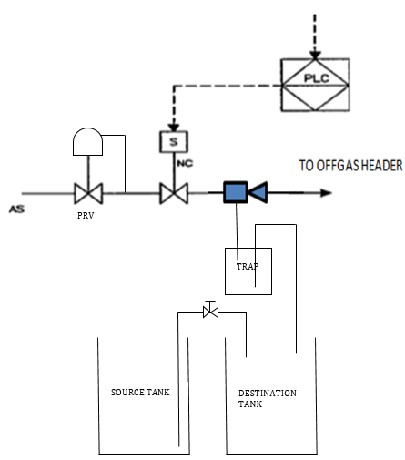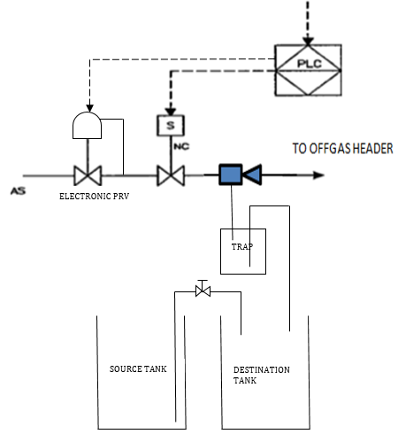
Fig.13. Conventional vacuum based liquid transfer Fig. 14. New scheme for vacuum based liquid transfer

Speed Sensing System for Rotary Equipment
Various rotary systems are used in the hot cells of Fast Reactor Fuel Reprocessing Plants. A ferromagnetic metal target on the collet of the rotor shaft is used for speed sensing. The operating speed of the centrigfuge is a critical parameter that needs to be monitored to ensure its proper functioning and safe operation.
A customized non-contact sensor was developed in-house, which meets the following special requirements;The sensor should withstand high radiation, be compatible with the acid and organic fumes prevailing inside the containment box, and also be maintainableby Master-Slave manipulators. It shouldalso work reliably at a distance of up to 8mm from the metal target. The electronic systems for signal conditioning, speed indication, digital communication and alarm outputs were also developed in-house.
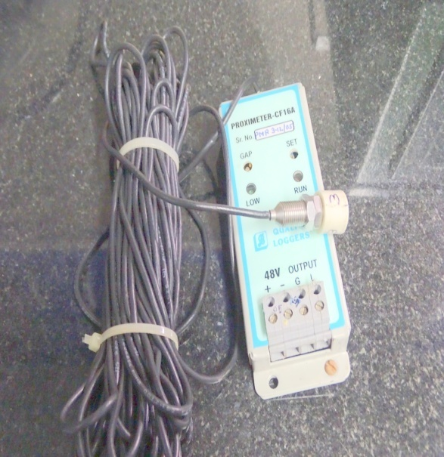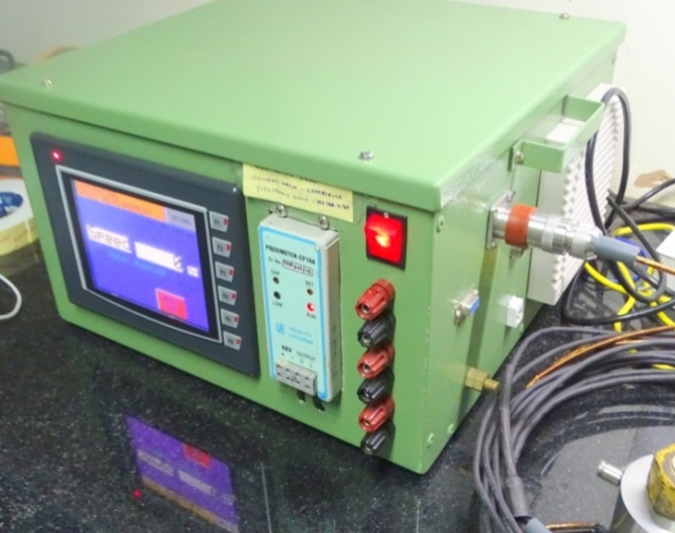
Fig.15. Rotary speed sensor with signal conditioner Fig. 16. Speed Display Unit

VFD based Control System for Centrifugal Extractor Motor Bank
Centrifugal Extractors (CE) are used especially in fast reactor fuel reprocessing as the contactor for solvent extraction, stripping and partitioning. It consists of a series of stages of centrifuge bowls that are driven by electrical three-phase squirrel cage motors. The speeds of the electrical motors have to be controlled and monitored. For this requirement, a system using Variable Frequency Drives (VFD) was developed and deployed.
Besides controlling the motor speed, the VFD is also does the sensorless measurement of the motor speed. Each VFD also generates a trip signal in case of motor stalling, overload, short circuit, earth fault, single phase failure, etc. The trip signal from the VFD trips the entrire CE bank and also the liquid feeds. The VFD also provides a soft start for the motor. The VFD is also capable of digital communication by multidrop RS-485. The HMI of the system communicates with the Control Room SCADA for indication of all VFD parameters and remote start / stop.

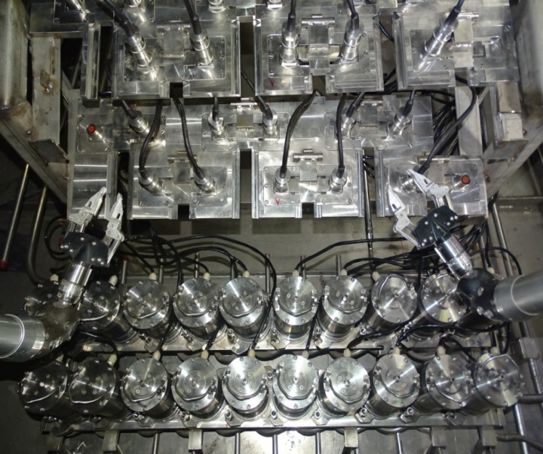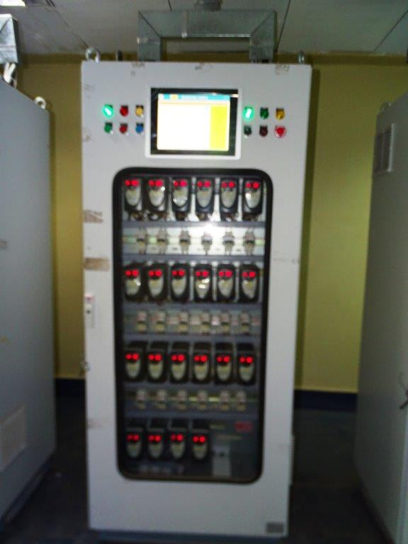
Fig.17. A Centrifugal Extractor bank with connector bed Fig. 18. VFD Panel for a Centrifugal Extractor bank

Conclusion
Several types of Electrical, Electronic, and Instrumentation systems have been designed and developed in-house for the special requirements of Fast Reactor Reprocessing Plants. They have been implemented and tested to meet their challenging environmental requirements. All the systems have been successfully deployed in the Reprocessing Plants and are operating continuously and reliably.
ACKNOWLEDGEMENTS
The authors acknowledge the invaluable technical contributions and support of the officials the Electrical and Instrumentation Sections of the Reprocessing Maintenance Division for the development and implementation these novel systems. The authors thankfully acknowledge the contributions and support of the officials of all Divisions in Reprocessing Group for the implementation and operation of these systems in the Plant. Thanks are also due to the Health Physicists working at Reprocessing Group for the development and testing of the Radiation Instruments described in the preceding sections. The authors acknowledge the technical contributions of Computer Division, IGCAR for the development and testing of the wireless systems.
References
- JUSTIN T. LONG, Engineering for Nuclear Fuel Reprocessing, Office of Technical Information, U.S. Department of Energy, 1978.

