Uranium and mixed uranium-plutonium nitrides thermal stability
M.P. KRIVOV¹, A.V. TENISHEV², G.A. KIREEV¹, A.V. DAVYDOV¹

¹Stock Company "A.A. Bochvar High-technology Research Institute of Inorganic Materials" (SC "VNIINM"), Moscow, Russian Federation
²National Research Nuclear University MEPhI (Moscow Engineering Physics Institute), Moscow, Russian Federation

Email contact of corresponding author: MPKrivov@mail.ru

Abstract

The thermogravimetric method was used to study the behavior of uranium nitride and mixed uranium-plutonium nitride (MNIT) in a helium flow and a helium with nitrogen gas mixture at temperatures up to 1900 °С. When heated in helium in the low-temperature range (˂1500 °С), a mass loss was found, which amounts to hundredths of a percent. In this case, mass loss occurs in 2 stages, accompanied by the release of nitrogen. It has been shown that sintered nitride fuel pellets may contain several percent of uranium sesquinitride U₂N₃, which decomposes in this range. Nitride fuel pellets were heated in a gas mixture of helium with nitrogen to study the formation of higher nitrides.

INTRODUCTION
Since the 1950s, nitride fuel has been considered as an alternative to oxides for use in fast reactors [1]. The use of high-density and thermally conductive mixed uranium-plutonium nitride (MNIT) fuel in fast reactors makes it possible to provide the desired neutron-physical and thermal-hydraulic properties of a reactor based on the principles of natural safety. Due to the high density (more than 12 g/cm3), breeding ratio in the reactor core ≈ 1.06 is provided, allowing for the rejection of the uranium blanket use and the possibility of operating in an equilibrium mode with a minimum reactivity margin, excluding the production of weapons-grade plutonium. The low temperature of the fuel helps to prevent overheating and destruction of the claddings in case of an emergency failure of cooling system and introduction of reactivity. However, despite the 15-year experience of operating the BR-10 reactor with nitride fuel [2], as well as the practice in the USA, Western Europe and Japan [3-5], there is no production of nitride fuel on an industrial scale, and its use in nuclear power plants is limited.
One of the significant drawbacks of mixed nitride fuel is the high vapor pressure of uranium and plutonium nitrides and their components at temperatures above 2100-2300 K. This can lead to the transfer of nitrides from the regions with a maximum temperature into the regions with a minimum temperature within the fuel element, i.e., migration of uranium/plutonium from the centre of the fuel rod to the cladding.
It should also be noted that in the uranium-nitrogen system there are four phases of uranium nitrides, which are unstable when heated in vacuum and dissociate before reaching the melting point. In the manufacture of mononitride fuel based on uranium or a uranium-plutonium mixture, the final product may contain the nonstoichiometric nitrogen excess [6–7]. Since uranium and plutonium mononitrides are stoichiometric compounds at room temperature, excess nitrogen will be in the nitride fuel pellet in the form of separate phases of higher uranium nitrides, which are insoluble in the mixed uranium-plutonium nitride fuel. The operation of nitride fuel containing an excess amount of nitrogen can lead to the integrity breach of the fuel pellet and nitriding of the fuel cladding.
When fuel elements with nitride fuel are used in fast neutron reactors, it is necessary to have reliable data on the thermochemical stability of nitride fuel in the initial state and during irradiation in a wide temperature range. It is necessary to know the temperature limit, above which the processes of dissociation of fuel nitrides, intensive changes in their structure and properties are possible. The problem of thermochemical stability of nitride nuclear fuel has been little studied, especially for mixed uranium-plutonium nitride fuel.

EXPERIMENTAL PART

Sample production
Samples nitride fuel were produced from a uranium and plutonium mononitrides obtained from the initial dioxides by carbothermic synthesis. Sample manufacturing operations were performed in an atmosphere of dry nitrogen.
The vortex layer device, laboratory mill, automatic press, and pit-type furnaces for synthesis and sintering were used for their production. The synthesis of the nitride and the manufacture of discs were performed according to the procedure used in [8-9]. Below are the main stages of producing the final samples. The raw materials, uranium and plutonium dioxide, carbon black grade were mixed in the specified proportions in the vortex layer device. Before the carbothermic synthesis of nitrides, the mixture of the initial reagents was pre-compressed into pellets in order to provide maximum possible reaction passage and to reduce dust losses. Furthermore, they were subjected to heat treatment with isothermal exposure at about 1800 K sequentially in a nitrogen flow and a mixture of nitrogen with hydrogen. In the nitrogen medium, a mixture of uranium and plutonium dioxides was carbothermically reduced to form a mixed mononitride, and in the mixed medium of nitrogen and hydrogen, residual carbon was removed from it. The heat-treated nitride pellets were then crushed in a hammer mill and ground in the vortex layer device. Dry lubricant (zinc stearate) was added to the nitride powder and the mixture was blended in a turbulent mixer. Green pellets were obtained by compressing the obtained powder. The compressed pellets were heat treated in a flow of a nitrogen and hydrogen mixture with isothermal exposure at about 2100 K. The pellets were further heated up and cooled down to room temperature in an argon media to prevent the formation of the nitrogen-rich nitrides of uranium [10].
The level of carbon impurity in nitride fuel samples was determined by the infrared absorption method using a МЕТАВАК CS-30 carbon and sulphur analyser, based on the mass of the sample to be burned, the concentration of carbon dioxide produced in the oxygen flow, and the volume of oxygen passed through the infrared detector. The level of oxygen impurity was defined by an infrared absorption method using the МЕТАВАК АК analyser. The measurement method is based on the decomposition of a sample under reductive melting in a graphite crucible in a flow of a helium inert gas carrier. The amount of oxygen in the sample is calculated based on the mass of the decomposed sample, the concentration of carbon dioxide formed, and the volume of helium passed through the infrared detector. The impurity composition of the obtained samples is oxygen 0.04 – 0.06 wt.%, carbon 0.09 - 0.11 wt.%. The uranium and plutonium content in the sintered nitride fuel tablets corresponded to the ratio in the initial mixture of uranium and plutonium dioxides. The content of uranium and plutonium in the nitride fuel was controlled using an optical emission spectrometer with inductively coupled plasma (ICP) "Prodigy".

Thermogravimetric study
Thermogravimetric studies were carried out in a flow of high-purity helium and mixture of helium with nitrogen using the NETZSCH STA 449 F1 thermal analyser combined with a quadrupole mass spectrometer to analyse the gas atmosphere in the furnace. The STA was placed in a glove box with an inert atmosphere and a gas cleaning system.
In the course of the experiment, the following parameters were recorded: the change in the sample mass (TG), temperature, the ion current registered by the quadrupole mass spectrometer suitable for mass number 28, which could be associated with the release of nitrogen, and the temperature time-dependence of the sample using a W-Re thermocouple. The experimental procedure involved heating the sample in a tungsten furnace at a constant rate to a predetermined temperature, holding at this temperature, and then controlled cooling.
Before each experiment the following steps were carried out:
- furnace annealing with the holder and crucible in a vacuum,
- correction according to the sample temperature programme for the empty system.
The tests were conducted on a samples of uranium nitride UN and MNIT (U_{0,902}Pu_{0,098})N fuel composition. In the investigations of the thermochemical stability, mass loss was found in all samples in the low temperature range (<1500 °C). Figure 1 shows the results of one of the thermogravimetric studies of mixed uranium-plutonium nitride. The mass loss occurs in two stages, which is reflected by steps in the thermogravimetry curve, as well as by two nitrogen release peaks (Fig. 1). It is known that the mass loss in this region is not associated with the decomposition of uranium or plutonium mononitride.
Since plutonium forms only one compound with nitrogen, namely PuN, the mass losses in the low-temperature part (<1500 °C) could be associated only with the decomposition of higher uranium nitrides. It is well-known that four phases of uranium nitrides have been found in the uranium-nitrogen system: mononitride UN, cubic α-U₂N₃ and hexagonal β- U₂N₃ sesquinitride, and uranium dinitride UN₂. Upon heating in vacuum, all of them are unstable and dissociate before reaching the melting temperature. In addition, the cubic and hexagonal U₂N₃ are not polymorphic modifications of the same compound, but ordinarily they are designated as α-U₂N₃ and β-U₂N₃. The α-phase possesses a wide composition range UN_{1.54}–UN_{1.75}, the β-phase possesses the substoichiometric composition UN_{1.45}–UN_{1.49}. The α–β phase transition occurs above 800 °С. The nitride phase has the ratio N/U > 1.75, but it could not be obtained in the form of a stoichiometric compound [7]. The mass loss at low temperatures corresponds to the decay of uranium sesquinitride to mononitride.

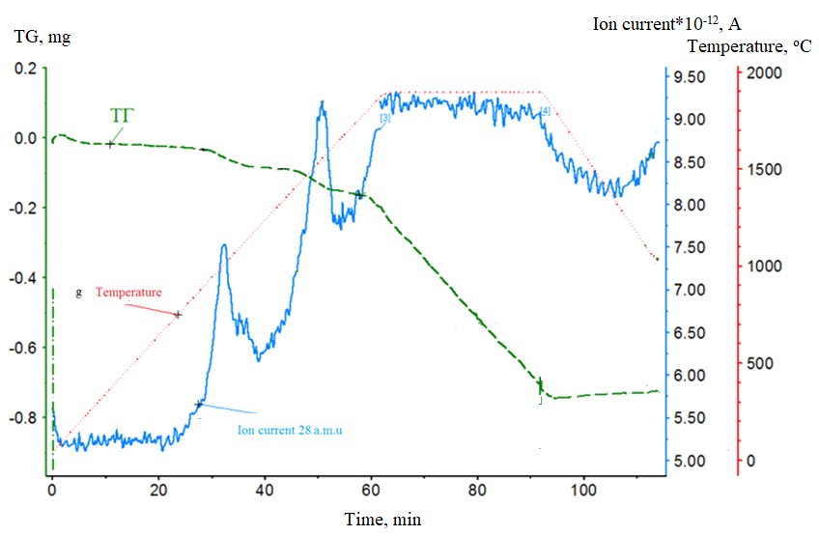
FIG. 1. Thermogravimetric studies of MNIT fuel (U_{0,902}Pu_{0,098})N, at an isothermal exposure temperature of 1900 °C in a flow of pure helium (adapted from [11]).

To study the interaction of nitride fuel with nitrogen, pellets of uranium mononitride and mixed nitride fuel were heated in a helium gas mixture with nitrogen added (Fig. 2). The helium flow was set at 95 ml/min, the nitrogen flow at 5 ml/min. As shown in Fig. 2a, the tablet of uranium mononitride weighing 223.8 mg during the first heating in a flow of a helium gas mixture with a nitrogen addition of 5 vol.% practically did not react. At temperatures of 400–500°C, the sample began to gain weight and this continued up to a temperature of ~1000°C. During this step, the sample gained 0.18 mg. After the sample began to lose weight at temperature of ~1200 °C, the sample returned to its original weight. Further heating lead to a barely noticeable drift of the TG curve towards negative values up to the isothermal holding temperature (1900 °C), where the sample lost 0.13 mg of mass. This mass loss can be attributed to a change in the uranium nitride stoichiometry, because during the heating, uranium nitride enters a certain region of homogeneity and is able to lose nitrogen without forming new phases. Afterwards, no changes in the mass of the sample were observed on the isotherm during the cooling down to 1000 °C. At temperatures of ~900 °C, the process of intensive weight gain began.
Upon cooling down to 300°C, the sample gained mass. The mass gain amounts to 5.84 mg. If the absorption of nitrogen occurs according to the reaction 2UN + 0.5N₂ = U₂N₃ (with complete conversion to sesquinitride), then the sample should have gained a mass of 6.2 mg. In our experiment, almost complete transformation took place, because the sample gained 5.84 mg. The greater mass gain during the cooling can be explained by the changes that occurred with the sample during heating. During heating, uranium nitride only partially reacted with nitrogen, probably only in the surface layer, making impossible for nitrogen to penetrate deep into the sintered pellet. Upon further heating above 1000 °C, the resulting sesquinitride decomposed. The formation of uranium sesquinitride on the sample surface and the subsequent decomposition of uranium sesquinitride could change the surface and create conditions for the penetration of nitrogen into the depth of the sample and the reaction to proceed throughout the volume. According to the calculations, the sample after testing consists of 96.5 wt.% of sesquinitride and 3.5 wt.% of uranium nitride.

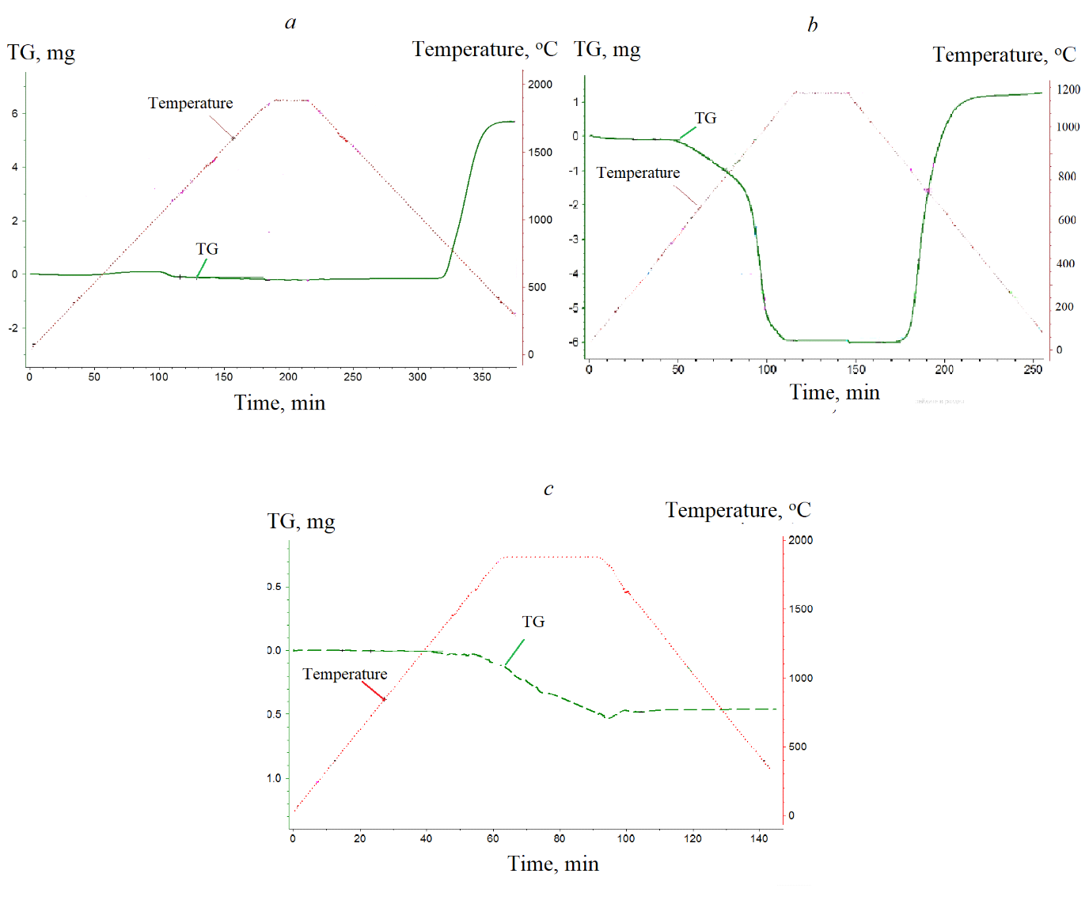
FIG. 2. The results of thermogravimetric studies: a - UN in a helium atmosphere with the addition of nitrogen 5 vol.%; b - one and a half nitride in an atmosphere of pure helium and helium with nitrogen in the cooling segment; c – (U_{0.79}Pu_{0.}21)N in a helium atmosphere with an addition of nitrogen of 5 vol.%.
The product of the uranium nitride interaction with nitrogen was subjected to repeated heat treatment in a flow of pure helium (Figure 2b). At a temperature of ~400°C, the sample began to lose weight. The weight loss was accompanied by the release of nitrogen, which was recorded by the mass spectrometer. Weight loss occurred in 2 stages up to an isothermal holding temperature of 1200°C. On the isotherm, 5 vol.% nitrogen was supplied to the helium flow. During the further controlled cooling of the sample, the weight gain was observed. After complete decomposition, the sample gained 7.17 mg of nitrogen, which is almost 1 mg more than is necessary for the formation of sesquinitride. This fact may indicate not only the formation of α and β phases of uranium sesquinitride, but also the appearance of another phase - uranium dinitride UN_{2-x}. In contrast to the first experiment (Fig. 2a), when the sample reabsorbed nitrogen, the reaction proceeded at a faster rate. This can be explained by the increase in the surface area of ​​the sample due to the cracking after successive reactions of the formation and decomposition of sesquinitride in the tablet.
Similar experiments were conducted on the MNIT fuel in a flow of helium-nitrogen mixture. When tablet of mixed nitride with the composition (U_{0.79}Pu_{0.21})N (Fig.2c) was heated in a helium-nitrogen flow, no mass gain was observed even after several repeated heating-cooling cycles. On the contrary, the figure shows the loss of mass in the isothermal holding segment at 1900 °C.
Plutonium nitride PuN is not known to react with nitrogen and there is only one compound in the plutonium-nitrogen system. Probably, the introduction of plutonium nitride into uranium mononitride stabilizes the latter, i.e. prevents the formation of higher uranium nitrides in the mixed fuel.
The addition of 5 vol.% nitrogen to the helium flow significantly exceeds the equilibrium partial pressure of nitrogen over the samples of uranium nitride and MNIT fuel in the entire temperature range (20-1900 °C) of the thermogravimetric experiments. This addition is sufficient to suppress the decomposition of uranium nitride up to a temperature of 1900 °C (Fig. 2a), which is consistent with the literature data [12]. However, in the case of MNIT fuel (Fig. 2c), decomposition occurs at 1900°C even in the atmosphere containing nitrogen. Probably, this happens due to the high partial pressure of plutonium, the mass loss of the MNIT fuel is possible under dynamic conditions (in a gas flow) even in the presence of nitrogen. This indicates a lower thermochemical stability of the mixed nitride fuel over uranium mononitride.

CONCLUSION
The thermogravimetric tests of mixed nitride uranium-plutonium fuel and uranium nitride have shown mass loss in the low-temperature region, accompanied by nitrogen release. The mass loss amounts to hundredths of a percent of the initial sample mass and occurs in 2 stages. The mass loss occurs due to the decomposition of uranium sesquinitride in the nitride fuel.
The interaction between uranium nitride, MNIT fuel and the nitrogen gas has been studied in the temperature range up to 1900 °C. It is shown that uranium nitride interacts with nitrogen at temperatures above 400 °C by forming higher uranium nitrides, which decompose to uranium mononitride at temperatures below 1100 °C. Uranium mononitride is stable up to 1900 °C in an environment containing nitrogen.
Also, it is shown that the addition of plutonium nitride to uranium mononitride prevents the interaction of uranium nitride with nitrogen. MNIT fuel with (U_{0.79}Pu_{0.21})N composition does not react with nitrogen even after several cycles of heating and cooling. Unlike uranium nitride, MNIT fuel loses mass at a temperature of 1900 °C even under dynamic conditions (in a gas flow) and even in the presence of nitrogen. The nitrogen content in the gas mixture was 5 vol.%, which is several orders of magnitude higher than the partial pressure of nitrogen over plutonium nitride in the temperature range under study.
References
- Matzke H., Science of advanced LMFBR fuels: a monograph on solid state physics, chemistry and technology of carbides, nitrides and carbonitrides of uranium and plutonium, JRC/ITU Karlsruhe-North-Holland. 1986.
- Rogozkin B.D. et al., Mononitride U-Pu Mixed Fuel and its Electrochemical Reprocessing in Molten Salts, IAEA Advisory Group Meeting, RDIPE, Moscow, October 2000.
- Bauer A.A., Storhok V.W., Irradiation Studies of (U,Pu)N, in Proc. 4th Int. Conf. Plutonium and Other Actinides, p. 532, New Mexico, 1970.
- Blank H., Fabrication of Carbide and Nitride Pellets and the Nitride Irradiations Niloc 1 and Niloc 2, EUR-13220 EN, European Commission, 1991. 498.
- Arai Y. Experimental research on nitride fuel cycle in JAERI //Proc. Int. Conf. GLOBAL'99, Jackson Hole, WY, Aug. 29-Sept. 3. – 1999.
- Wang X., Long Z., Bin R., et al., Study of the decomposition and phase transition of uranium nitride under UHV conditions via TDS, XRD, SEM, and XPS, Inorg. Chem. 55, No. 21 (2016)10835–10838.
- Hiroaki T., Phase relations and thermodynamic properties of the uranium-nitrogen system, J. Nucl. Mater. 51 (1974) 78–89.
- Arai Y., Fukushima S., Shiozawa K., Handa M. Fabrication of (U,Pu)N fuel pellets, J. Nucl. Mater. 168 (1989) 280-289.
- Ganguly C., Hegde P.V., Sengupta A.K. Preparation, characterisation and out-of-pile property evaluation of (U,Pu)N fuel pellets. J. Nucl. Mater. 178 (1991) 234-241.
- Silva G.W.C., et al. Reaction sequence and kinetics of uranium nitride decomposition. Inorп. Chem. 48(22) (2009) 10635-10642.
- Krivov M.P., Kireev G.A., Tenishev A.V. The influence of the structural-phase state of nitride nuclear fuel on the fuel rod resource, Atomic energy. 127, No. 1 (7) (2019) 25-29.
- Uno М., Tsuyoshi N., Masahide T., Thermodynamic and thermophysical properties of the actinide nitrides (2020) 202-231.

