Versatile Test Reactor (VTR) Experimental Capabilities

K. D. WEAVER T. SALEH
Idaho National Laboratory Los Alamos National Laboratory
Idaho Falls, ID, USA Los Alamos, NM, USA
Email: kevan.weaver@inl.gov Email: tsaleh@lanl.gov

M. FARMER D. WOOTAN
Argonne National Laboratory Pacific Northwest National Laboratory
Lemont, IL, USA Richland, WA, USA
Email: farmer@anl.gov Email: david.wootan@pnnl.gov

J. MCDUFFEE C. RITTER
Oak Ridge National Laboratory Idaho National Laboratory
Oak Ridge, TN, USA Idaho Falls, ID, USA
Email: mcduffeej@ornl.gov Email: christopher.ritter@inl.gov

C. UNAL S. CETINER
Los Alamos National Laboratory Oak Ridge National Laboratory
Los Alamos, NM, USA Oak Ridge, TN, USA
Email: cu@lanl.gov Email: cetinerms@ornl.gov

P. SABHARWALL D. WACHS
Idaho National Laboratory Idaho National Laboratory
Idaho Falls, ID, USA Idaho Falls, ID, USA
Email: piyush.sabharwall@inl.gov Email: daniel.wachs@inl.gov

INTRODUCTION
The Versatile Test Reactor (VTR) is a proposed fast neutron spectrum test facility that will provide irradiation capabilities not currently available within the U.S. The Idaho National Laboratory (INL), in conjunction with five other U.S. national laboratories, 18 universities and 8 industry partners, is working to develop the VTR to provide an irradiation-testing facility capable of performing a wide range of tests to meet current and future experimental needs. The VTR will allow many research institutions to have access to fast neutrons that will support the development of advanced nuclear technologies. The VTR is envisioned to be a 300 MWth sodium-cooled, pool-type fast neutron spectrum (fission spectrum) reactor for neutron irradiation testing and research, and is anticipated to perform multiple irradiation test campaigns during its operational lifespan of up to 60 years. The proposed configuration of the VTR core comprises 66 driver-fuel assemblies, up to six dedicated/fixed test locations for instrumented vehicles, cartridge loop tests, and rapid transfer (rabbit) test vehicles, and the ability to replace a specific number of the 66 driver-fuel assemblies with open test assemblies.
The ultimate goal of the experimental capabilities of the VTR is to provide a platform and test capability that will help increase the technology readiness level of advanced reactor fuels, materials, instrumentation, and sensors. In addition, it will provide the ongoing test capabilities that will support and sustain current and future nuclear reactor continuous technology improvements. This paper describes the different experiment vehicles being developed, and the different lab, university, and industry teams that are leading the design and development of each of the experiment vehicles.

VTR Experimental OrganIzation
The Experiments Organization within the VTR program is supported by five national laboratories, 18 universities, and 8 industry partners who collaborate on the development of experiment vehicles, advanced components, and advanced simulation tools to support development of advanced nuclear energy systems through the use of testing in the VTR. These key R&D activities will enhance the irradiation testing capability and/or resolve critical technology gaps for VTR experiments.
The VTR experiment partners are aligned within nine “functional” areas that are performing R&D to support irradiation tests planned for the VTR using four experiment vehicle types. Each functional area is led by a national laboratory technical expert and is supported by other national laboratories, university partners, and industry partners. These vehicle types and functional areas are described in more detail in the sections below.

experiment vehicles for the VTR

Dismountable Test Assembly (DTA)
The dismountable test assembly (DTA) is a modified fuel assembly design for VTR. Its external mechanical interfaces and hydraulic characteristics will enable it to be irradiated in standard fuel assembly positions and be manipulated with fuel handling equipment as part of typical cycle/core-load management. The DTA will offer unique capabilities for accelerating irradiation-to-data cycles for specimen materials by enabling an “insert” to be extracted from the surrounding fuel pins while in the reactor pool. A positively latching mechanism assures that the insert is retained during irradiation. The DTA will be elevated to a handling fixture so that its upper fittings protrude just above the sodium level where the latching mechanism will be disengaged and the insert removed by a special cask/gripper. Inner hex ducts provide a separate hydraulic path for adjusting insert thermal conditions in the insert while protecting the insert and surrounding pins from damaging each other during insert/removal. These inner ducts displace a small amount of the total fuel pins, compared to a normal fuel assembly, so that DTA assemblies retain most of the reactivity worth thus enabling multiple DTA’s to be irradiated concurrently. See Figure 1 for DTA design renderings.
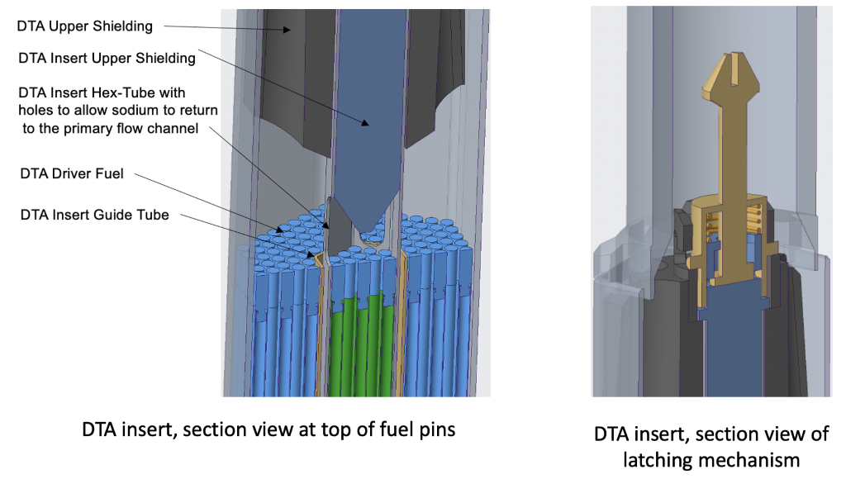
Figure 1: DTA Design Renderings.
The insert can house up to 19 fuel pins or other test materials which fit into this geometry. When extracted, the insert represents a sizeable reduction in decay heat and radiation source terms compared to a full fuel assembly in order to greatly accelerate logistics for mid-irradiation surveillance in collocated shielded cells (with the option to return to irradiation) and comprehensive post irradiation examinations in other hot cell facilities. Combined with VTR’s high flux and optimized operational tempo, especially noting that the DTA will retain most of the fuel inventory and resulting high flux, this irradiation device will offer the most expedited option for fast neutron irradiation data. While self-contained loops and live-lead instrumented devices in VTR will offer specialized environments and unique data opportunities, the DTA is expected to be VTR’s workhorse device both in terms of volume and acceleration potential.
This research is currently being supported by the Idaho National Laboratory and does not have any university or industry partners.

Normal Test Assembly (NTA)
These are standard non-instrumented or passively instrumented open test assemblies that are the same size, flat-to-flat and length, as VTR driver fuel assemblies. They will be used to conduct fuels and materials irradiation testing within the core at predetermined locations (for low fissile content or materials tests).
One variation of the NTA is the NTA-PC (Normal Test Assembly–Pin Carrier). It will contain a Pin Carrier insert (similar to the DTA insert) that houses material or fuel tests, but the remainder of the assembly would be dummy rods/blocks (material) or sodium. The Pin Carrier will be capable of being removed and replaced (like the DTA insert), but this would occur in the shielded cell rather than in the primary sodium.

Extended Length Test Assembly (ELTA)
ELTAs extend through the reactor head, and typically have various instrumentation leads, etc., that run to the Non-Radiation and/or Radiation Experiment Rooms that are adjacent to the Head Access Area (HAA) of the VTR. ELTAs include fuel, materials, and cartridge loop experiments. They will contain various sensors and instruments to continuously monitor and control the physical conditions of the test. As a reference, these will be similar to the designs for the Fuels Open Test Assembly (FOTA) and Materials Open Test Assembly (MOTA) used in FFTF, the EBR-II In-Core Test Facility (INCOT and INSAT), and the Advanced Gas Reactor (AGR) test train used in the Advanced Test Reactor (ATR).

Gas-Cooled Cartridge Loop ELTA - Lead Laboratory: Idaho National Laboratory (INL), Industry Partner: General Atomics (GA), University Partners: Texas A&M University (TAMU), University of Michigan (UM) (co-PI Oregon State University (OSU), University of Houston (UH), University of Idaho (UofI) and Texas A&M University (TAMU))
The primary objective of the Gas-Cooled Cartridge Loops (GCL) will be to produce irradiation data for Gas-cooled Fast Reactor (GFR) fuels and materials. Secondary objectives are to demonstrate fuel integrity and support qualification of the fuel design and fabrication process for GFR operating conditions. The reference GFR that is selected to develop these design requirements is the Energy Multiplier Module (EM2), a 500-MWth helium (He)-cooled reactor being developed by GA [1]. Though He is the reference coolant material, the thermal/mechanical design should consider another potential gas coolant, such as supercritical carbon dioxide (sCO2) [2].
The university partner TAMU supports the design of GCL by investigating the thermal-hydraulic transport of fission gases in a GFR fission product venting system (FPVS). In addition, the other university partners, led by UM, are working on a multifunctional GCL test bed to investigate instrumentation and controls, thermal-mechanical properties, surface emissivity, and helium impurity for fuel-failure detection.
A preliminary double-wall GCL design was proposed for the out-of-pile testing. A schematic of the GCL design is depicted in Figure 2, and a cross-sectional view of the simulated core (GFR fuel testing region) is shown in Figure 3. Alloy 617, recently codified in the ASME BPVC, is chosen as the candidate material of construction for the GFR cartridge pressure vessel due to its relatively higher allowable stress at high temperatures. The annular gap between the outer and inner vessel walls is filled with argon gas at 3.5 MPa, which can help reduce the potential of GCL He-diffusion leakage into the VTR sodium coolant. The He gas in the inner vessel is pressurized to 7.0 MPa. The two-stage pressurization strategy helps reduce the required thickness of the vessel.
An electrical heater, installed near the bottom of the GCL, heats the He flow during out-of-pile testing. Above the electrical heater is the simulated core, or GFR fuel-testing region. Tentatively, seven fuel rods can be installed for irradiation. During testing, the He, driven by a circulator, flows downward in the narrow gap between the inner vessel and the simulated barrel. The He flow direction reverses to go upward in the lower plenum and then flow through the electrical heater. A compact heat exchanger is installed as a cooler near the GCL top on the gap side to cool the He. To avoid engineering challenges for the circulator shaft seal, the electrical motor is to be sealed in a cavity that is above the top flange. The detailed dimensions of the preliminary GCL design are being developed.
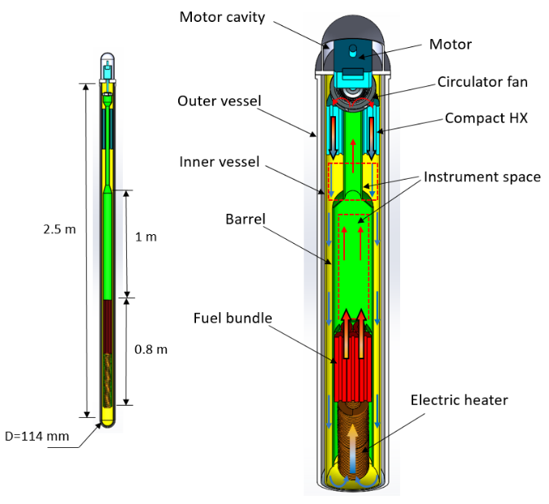
Figure 2. Schematic of GCL design core.
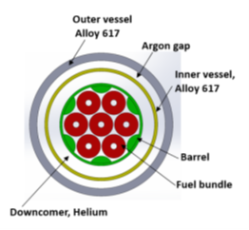
Figure 3. Cross-sectional view of GCL.

Lead/Lead-Bismuth Reactor Cartridge Loop ELTA–Lead Laboratory: Los Alamos National Laboratory (LANL), Industry Partner: Westinghouse (WE), University Partner: University of New Mexico (UNM)
One of the advanced nuclear reactor concepts that has been considered previously is the Lead-cooled-Fast Reactor (LFR). LFR is cooled by either liquid lead or lead-bismuth eutectic (LBE), and features favourable attributes primarily stemming from the characteristics of these coolants.
The primary objective of the Lead/Lead-Bismuth Reactor Cartridge Loop (LCL) is to support testing to advance the technical readiness level (TRL) of nuclear fuels and materials for use in Lead-cooled-Fast Reactors (LFR). LCL designs have provisions for instrumentation to characterize experimental environments and experimental performance and ability to reject heat to the reactor primary sodium coolant at a temperature of 350 to 500˚C. With this temperature constraint, LCL design will include thermal management features as required to deliver the desired environmental conditions.
The high flux environment in VTR, combined with the design requirements for the LCL cartridge, provide a difficult challenge for cartridge designers in heat removal. The usage of lead as a coolant and the associated cartridge structural materials under consideration result in high power deposition, primarily from the high gamma flux present in the VTR. To aid thermal design decisions, an extremely accurate MCNP model of the VTR core and the LCL was developed. Evaluation of this model revealed that not only was the external flux, applied to the cartridge by the surrounding VTR driver fuel assemblies, an important component of the total cartridge heating, it was actually the dominant contributor. Accurate modeling of the core-driven heating in the cartridge was crucially important in its thermal design to ensure limits are met. Accordingly, this particle physics model was used in multiple design iterations to inform thermal-hydraulic models and design decisions. The close collaboration between particle physics modeling and thermal-hydraulic modeling has resulted in an accelerated design path for the LCL, informing critical decisions on dimensions and material selection along the way.
After several scoping studies and design iterations in the pre-conceptual stage, a conceptual LCL baseline design has been developed to accommodate the following technical challenges:
- Minimizing gamma heating
- Maximizing heat transfer from Pb loop to Na channel
- Thermal requirements to avoid lead corrosion
- Operating requirements for material testing (500ºC and 2m/s for initial requirement).
One of the key design challenges was thermal management in the experimental vehicle. Heating is mainly created from two sources: fission heating from the fuel rods, and gamma heating in the coolant and structure. The total heating should be effectively dissipated by the VTR coolant to maintain the maximum lead temperature in the loop below a target value, as lead becomes very corrosive/erosive above a certain temperature and velocity. To reduce the gamma heating, a helium pocket in riser wall is employed in the conceptual design, which effectively decreases the gamma heating by minimizing the lead and structural volume in the active core zone. In addition, the interior volume between the double walls of the downcomer is now filled with high thermal conductance material (i.e., Na) to improve the heat transfer between the lead loop and the sodium channel, which helps to maintain the lead temperature below the target value.
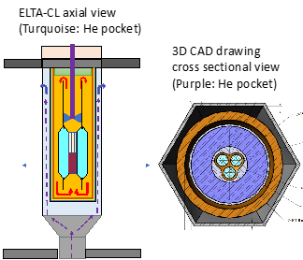
Figure 4. Conceptual design of LCL with He pocket.

Instrumented Materials Test Assembly ELTA-Lead Laboratory: Los Alamos National Laboratory, Industry Partner: EPRI, University Partner: Oregon State University and Purdue University
The instrumented materials test assembly for the VTR is using the Materials Open Test Assembly (MOTA) design used in the Fast Flux Test Facility (FFTF) as its basis. The MOTA was highly instrumented, and was able to manipulate the thermal-hydraulic conditions of specific test capsules within the assembly. For the VTR instrumented materials test assembly, current work is focused on specialized instrumentation that can measure (in real time) the mechanical conditions of the test samples (e.g., creep).
The primary objective of the Materials team is to help advance the knowledge base of the changes in mechanical properties in materials for structural and fuel cladding applications to inform development of advanced materials with improved radiation tolerance. This will be accomplished through the following approach:
- Identify critical materials properties needed to support materials selection and implementation for advanced reactors.
- Identify current status of knowledge/material property data for critical materials with respect to reactor applications’ requirements.
- Identify materials data gaps and testing needed to validate materials for structural applications in GEN IV reactors.
- Identify key requirements of experimental vehicles for VTR to support validation of materials for GEN IV reactors.
- Provide design concepts for flexible experimental vehicles for VTR.

Molten Salt Reactor Cartridge Loop ELTA – Lead Laboratory: Oak Ridge National Laboratory (ORNL), Industry Partner: TerraPower, University Partners: University of Utah (UofU) (co-PI: University of Michigan (UM) and Virginia Commonwealth (VCU)) and University of Idaho (UofI)
The goal of the VTR Molten Salt Reactor Cartridge Loop (MCL) is to support irradiation testing of molten salts for use in Molten Salt Reactors (MSR). Partners in this area are collaborating to mature the MCL design and maximize its potential as a testing platform by ensuring these tests will fit within the standard fuel assembly dimensions of the VTR.
The MCL presents several unique design challenges.
- First, most molten salt candidates of interest freeze at temperatures greater than the sodium coolant outlet temperature within the VTR, so control is required to prevent overcooling of the salt while rejecting its heat to the sodium coolant.
- The second challenge is that the primary coolant is also fuel. Thermal management is a key concern with the design, since additional coolant cannot simply be added without also increasing the thermal load within the vehicle. Molten salts also do not have great heat transfer properties (relative to liquid metals), and need to be carefully controlled to avoid overcooling and accidental freezing of the salt. A large focus of the design efforts to date have been focused on these constraints to maximize both fuel salt volumes as well as targeted fission power levels.
- The final design challenge to discuss is the overall concern about fabricability since each design includes a double wall between salt and sodium to provide a gas gap to regulate the temperature of the salt by changing composition, as well as provide additional protection against leaks to the VTR coolant. Due to the low thermal conductivity of gases these gaps are extremely small, and tight tolerances must be maintained over the entire length of the heat exchange surface.
Preliminary efforts to assess fabricability and instrumentation have identified gaps in knowledge base for the MCL. The instrumentation being developed, including the redox probe, corrosion sensor, and flux meter, have been notionally placed within the limited area of the MCL; however, additional analyses are needed to verify the adequacy of the positioning. The designs and methods of the advanced instrumentation, PIE analysis, and salt synthesis continue to evolve.
Reference design concepts for the MCL included static capsule, natural circulation tube and shell, and natural circulation annular (J. Jordan, et. al. 2017 [4]). The final design has been narrowed down to two leading concepts: the loop (Figure 5) and the annular design (Figure 6). Both designs offer trade-offs, with neither fully able to meet the original target heat generation rates, while maintaining adequate volumes of salt to support the full suite of instrumentation and salt sampling being developed. The two parallel MCL design concepts will continue to mature until sufficient design information and data is provided to down select to one design.
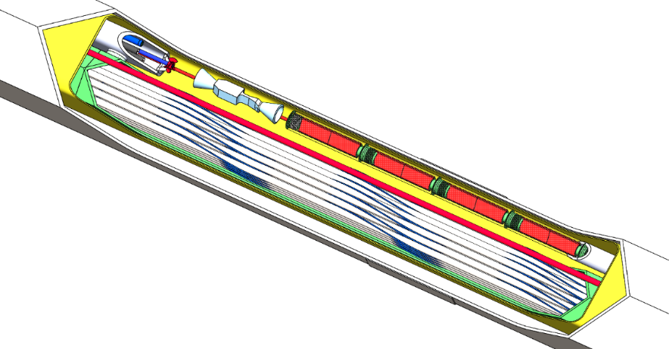
Figure 5. MCL Loop design.
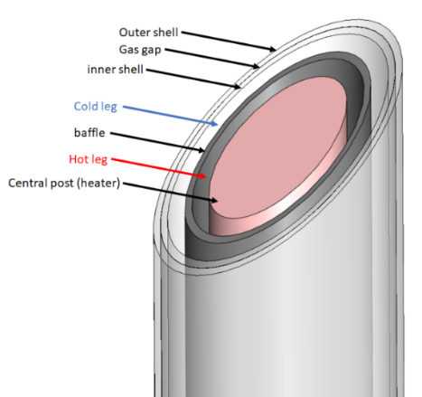
Figure 6. MCL Annular Design.

Sodium Reactor Cartridge Loop ELTA – Lead Laboratory: Argonne National Laboratory (ANL), Industry Partner: Framatome, University Partners: University of Michigan (UM) and Purdue University
In order to help satisfy critical irradiation needs for sodium fast reactor applications, a cartridge loop testing capability is also being developed for the sodium coolant applications in which it is desirable to maintain the test coolant separate from the reactor coolant. A specific application in this area is testing of vented fuel. In this case, the cartridge would perform the important function of retaining volatile fission products (e.g., noble gases, Cs, I) within the cartridge itself, as opposed to venting the fission products directly to the reactor sodium. Venting directly into the primary sodium would increase dose to workers in the vicinity of the reactor, as well as increasing the requirements for the reactor sodium cleanup system. This would be obviated by using a cartridge loop.
The team developing the sodium coolant cartridge loop testing capability consists of Argonne National Laboratory as the laboratory partner, Framatome Inc. as the industrial partner, and Purdue University along with the University of Wisconsin-Madison as university partners. Design development is being carried out as an evolution of the Independent Lead Channel (ILC) cartridge loop that was originally developed in Russia and tested in the BOR60 reactor [5]. An illustration depicting overall contributions to the cartridge development process is provided in Figure 7.
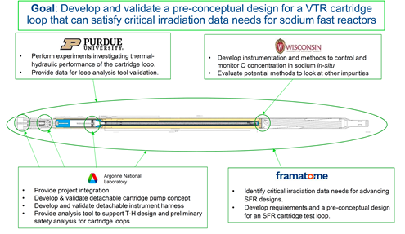
Figure 7. Team contributions to sodium cartridge test loop development for the VTR.
Specific elements of the current work include overall cartridge loop design and preliminary thermal/hydraulic performance analysis that is being led by Framatome, Inc. Initial efforts have focused on developing a 7 pin SFR test assembly that is integrated into a cartridge loop. The test coolant loop includes the 7 pin test assembly, a multi-stage centrifugal pump that draws suction at the outlet of the test assembly and then drives the flow down through an annular heat exchanger where the fission heat is dumped to the reactor coolant. From the outlet of the heat exchanger, the test coolant then flows back to the inlet plenum located at the bottom of the test assembly. Framatome has also led efforts to develop a list of critical irradiation data needs for sodium fast reactor applications as a basis for the cartridge loop development process.
Purdue University is developing a scaling methodology and, on that basis, a thermal-hydraulics testing capability to validate fluid flow and heat transfer models that will be used to support cartridge loop design, performance analysis and safety analysis. For any test vehicle inserted into VTR, it will be required to demonstrate that the cartridge can perform adequately under both normal and anticipated off normal operating conditions. The test data that will emerge from this work will help satisfy model validation needs for this critical application.
Coolant chemistry monitoring and control are key elements of any high pedigree irradiation testing capability; the University of Wisconsin is leading this effort by developing and experimentally verifying methods for achieving this capability in-pile. University of Wisconsin has looked at several potential technologies for accomplishing this, and are currently developing and testing a hot trapping technique for chemistry control, and are also reestablishing the vanadium wire method for assessing overall chemistry control during an irradiation cycle. The advantage of these technologies is that they can be fully integrated into the cartridge design and achieve the chemistry monitoring and control objectives without removing sodium from the test vehicle over the irradiation cycle. This significantly simplifies loop operations.
Laboratory partner Argonne has focused on developing and testing cross-cutting technologies specifically targeted at simplifying VTR operations. In particular, an in-cartridge centrifugal pump design with a magnetic coupler has been developed and is currently undergoing testing. This system will allow the pump shaft drive to be detached at the top of the core and retracted during refueling operations. A detachable instrument coupler concept has also been developed and is being tested. This device is based on the concept of a diving bell; i.e., electrical connections are kept free from highly conductive sodium by using a slight argon overpressure within covering chambers where the connections are made. With these technologies, it may be possible to leave the SFR cartridge in the core during refueling operations by detaching and retracting the pump drive and instrumentation leads, and reattaching them after refueling is completed. This approach would allow the cartridge to be irradiated over multiple cycles while retaining a full set of instrumentation. Moreover, the cartridge could be inserted and removed through the normal fuel handling pathway. These methods would streamline VTR sodium loop operations, and some of these techniques are being considered for other cartridge types. Finally, a software package denoted CARLITA [6] is being developed, validated, and utilized in support of cartridge loop design development and safety performance.

Rabbit Test Assembly (RTA) Lead Laboratory: Pacific Northwest National Laboratory (PNNL), University Partner: Texas A&M University (TAMU)
The RTA is a rapid shuttle system, or “rabbit,” that uses a hydraulic or pneumatic-actuated means of inserting and removing small capsules with test samples inside the reactor core during operation. The use of the RTA allows both fast data collection and insertion or extraction of samples both intra-cycle or inter-cycle.
Among the target capabilities for the VTR program is a desire for a rabbit system loop which serves as a “rabbit hole” for in-core neutron irradiation experiments to enable testing behavior of new fuel materials, or investigating the byproducts or radiation hardness of a specific material. The RTA team focuses on two fundamental thermal hydraulic designs of the secondary rabbit loop: u-tube and concentric tube. The rabbit required functions (insertion, removal, and sample cooling) are being analyzed for both designs along with their advantages and disadvantages. Although both designs are feasible from a performance standpoint, the concentric tube carries the benefit of an extra pressure boundary that provides additional safety considerations. Because of this, design guidelines are developed for the thermal-hydraulic metrics of interest.
The initial focus of this project has been threefold:
- Construction of an assembly-scale experiment vehicle to enable parametric variable assessment and mechanical system development,
- Thermal hydraulic simulations to assist in the design of the assembly-scale system and definition of instrumentation and experiments for the system, and
- Computational system analyses to assess reactivity perturbations, irradiation conditions, and experiment simulations, and advance the design of the rabbit capsule and the insertion/extraction methods.
The mechanical demonstration of the VTR rabbit system was inserted into TAMUs Nuclear Engineering and Science Center’s (NESC) TRIGA reactor pool during July, 2020. The assembly is a full-scale representation of a VTR rabbit assembly consisting of a hexagonal aluminum supporting base section which is plumbed for water to enter at the bottom of the test section. The hexagonal shape will partially stabilize the water flow before it enters a clear hexagonal PVC section. The clear PVC test section is eight feet long and houses the rabbit capsule catch section, the helium driving lines, support structure, and sensors. Figure 8 shows a schematic of the assembly with blowout details for the upper and lower sections. The primary fluid flowing through the assembly is water from the reactor pool, which acts as a surrogate for molten sodium. The secondary fluid inside of the rabbit tubes is helium, which will drive the capsule into and away from the catch section.
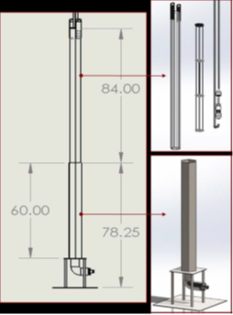
Figure 8. Schematic of the experiment-scale rabbit assembly (left) with blowout details for the upper (top right) and lower (bottom right) components.

Experiment Vehicle Support Teams

Instrumentation and Controls - Lead Laboratory: Oak Ridge National Laboratory (ORNL), Industry Partner: CosyLab, University Partners: Georgia Institute of Technology (GTI), Abilene Christian University (ACU), and Massachusetts Institute of Technology (MIT)
VTR Experiments Instrumentation and Controls (I&C) area is tasked with initiating, leading and coordinating the sensing, measurement and controls activities for the VTR Experiments. These research and development activities are being pursued to deliver the needed measurement capabilities for various reactor technology areas.

Digital Engineering, Virtual Design & Construction + Modeling and Simulation - Lead Laboratory: Idaho National Laboratory (INL), Industry Partner: TerraPower, University Partners: Virginia Commonwealth University (VCU) and North Carolina State University (NCU)
The Versatile Test Reactor (VTR) Program will utilize digital engineering principles for design, construction, and operations to reduce risk and improve efficiencies. Digital engineering is an integrated, model-based approach which connects proven digital tools such as building information management (BIM) and systems engineering software tools into a cohesive capability. INL will manage the authoritative source of truth for the VTR program with contractors and university partners interfacing with this data source.
The design of advanced nuclear reactors has become increasingly challenging with geo-dispersed teams and complex innovative designs. Currently, engineering teams operate in siloed tools and disparate teams where connections across design, procurement, and construction systems are translated manually or over brittle point-to-point integrations. The manual nature of data exchange increases the risk of silent errors in the reactor design, with each silent error cascading across the design. These cascading errors lead to uncontrollable risk during construction, resulting in significant delays and cost overruns.
Construction delays and cost overruns are not unique to the nuclear domain. For example, the defense and aerospace industry have found a solution to this challenge through the concepts of digital twins and digital engineering. The aerospace industry has demonstrated a 40% improvement in first-time quality using digital twin asset models. The United States Department of Defense (DoD) has published a digital engineering strategy for the creation, integration, and curation of design models throughout the lifecycle. The capture of current and prior states of the design defines an authoritative source of technical truth. This authoritative source of technical truth and digital transformation is expected to enhance communication, increase confidence, and inform decision making with greater transparency. Mortenson realized 600 days in direct schedule reductions and 25% productivity increases across a total of 416 VDC projects.
Since the integrated BIM and systems tools are not integrated presently, the VTR proposes to utilize a phased approach (see Figure 2). North Carolina State (NCSU) is leading integration of building information management software to automate brittle connections across engineering codes. Virginia Commonwealth University (VCU) and Texas A&M (TAMU) is leading integration of requirements management and traceability analysis codes into the digital architecture. TerraPower, an industry partner is leading experiment physics code integration.
The VTR project expects to significantly reduce project risk, realize schedule improvements, and increase project performance. The project currently expects the digital engineering team for facility design and construction to reduce project cost by 3%.

Crosscutting Technologies - Lead Laboratory: Idaho National Laboratory (INL), University Partner: Oregon State University (OSU)
This Crosscutting Technologies team focuses on designing an ex-pile thermal-hydraulic facility that will provide a mechanical and operational interface representative of that which will be utilized in the VTR with sodium as the working fluid. Associated with this effort, another aspect of the project is to develop safety culture and curriculum to support education and training of those involved in VTR operations.
Although the unique features of VTR would facilitate a wide variety of operational capabilities, such complex design does not come without any technical and operational challenges as well as uncertainty; uncertainty as it relates to sodium safety and operations; uncertainty in in-pile materials and instrument performance; uncertainty in system compatibility and operations between reactor primary and in-pile loops.
To reduce these uncertainties, it has been proposed to design a scaled down ex-pile thermal hydraulic test loop that could reproduce the operating condition and geometry of VTR and in which the loop cartridges could be fully shaken down. This approach would not only allow answering whether the technical challenges were met but also help develop the operational procedures and the necessary safety culture associated with these operations. A conceptual rendering of the test facility layout is presented in Figure 9.
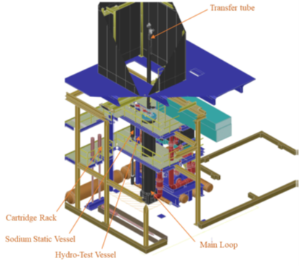
Figure 9. Three-dimensional CAD rendering of the ex-pile thermal-hydraulic facility layout.

References
- H. Choi, R. W. Schleicher, “The Energy Multiplier Module (EM2): Status of Conceptual Design.” Nuclear Technology, vol. 200, pp. 106–124, 2017. https://doi.org/10.1080/00295450.2017.1364064
- S.A. Wright, et al., “Super critical CO2 direct cycle Gas Fast Reactor (SC-GFR) concept,” SAND2011- 2525, Sandia National Laboratories, 2011. https://doi.org/10.2172/1013226
- J. Zhang, N. Li, Y. Chen, A.E. Rusanov, "Corrosion behaviors of US steels in flowing lead–bismuth eutectic (LBE)," Journal of Nuclear Materials, vol. 336, pp. 1-10, 2005. https://doi.org/10.1016/j.jnucmat.2004.08.002
- J. Jordan, M. Martin, J. Choi, J. Vollmer, "MSR VTR- EV Conceptual Design," VTREV-ENG-STDY-0001, 2019.
- V. N. Leonov et. al., “Pre- and In-Pile Tests of Fuel Element Mock-ups for the BREST-OD-300 in the Independent Lead-Cooled Channel of the BOR-60 Reactor,” ICONE11-36409, 11th International Conference on Nuclear Engineering, Tokyo, Japan, April 20-23, 2003.
- A. Dix, D. O'Grady, A. Brunett, M. Farmer, “CARLITA Code Benchmarking with SAM for LBE Natural Circulation Flow,” 2020 American Nuclear Society Virtual Winter Meeting, Chicago, IL US, November 16-19, 2020.

