ELECTROLYTIC REDUCTION OF A SIMULATED OXIDE SPENT NUCLEAR FUEL

A.V. SHISHKIN
Institute of High Temperature Electrochemistry
Yekaterinburg, Russia
Email: a.shishkin@ihte.uran.ru

V.Y. SHISHKIN
Institute of High Temperature Electrochemistry
Ekaterinburg, Russian Federation

V.A. KESIKOPULOS
Institute of High Temperature Electrochemistry
Ekaterinburg, Russian Federation

A.E. DEDYUKHIN
Institute of High Temperature Electrochemistry
Ekaterinburg, Russian Federation

Y.P. ZAYKOV
Institute of High Temperature Electrochemistry
Ural Federal University
Ekaterinburg, Russian Federation

WEIQUN SHI
Institute of High Energy Physics
Chinese Academy of Sciences
Beijing, People's Republic of China

Abstract

A pyrochemical technology for processing of spent nuclear fuel (SNF) from fast neutron reactors is developed within the framework of the “Breakthrough” (“Proryv”) project. The electrochemical reduction of uranium dioxide or oxides of other actinides by lithium in the LiCl - Li₂O (1-2 wt. %) melt at 650°C is one of the steps of this pyrochemical technology. The obtained data allows us to suggest that a specific algorithm the electrochemical lithium extraction in molten salts provides a selective reduction of actinides oxides to metals, in particular uranium oxide to melt, and to preserve rare-earth metals (REM) oxides in the oxide state. Therefore, prerequisites are created for successful separation of actinides and lanthanides in further steps of the emerging pyrochemical technology.
- INTRODUCTION
The voloxidation process and the following reduction of oxides by metallic lithium or lithium formed during the electrolysis of the molten LiCl-Li2O (1-2 wt. %) mixture, are one of the possible technological solutions for the pyrochemical processing of mixed nitride uranium plutonium (MNUP) SNF from fast neutron reactors. These processes have been actively studied in many countries for the last 15-20 years [1-8]. The main focus is usually given to uranium oxides (UO₂, U₃O₈) [2-4], in some cases oxides mixtures (UO2+PuO2) [1], (U-40Pu-5Np)O₂ [5] or light water reactor (LWR) spent fuel [6-7]. Park et al studied the metallization of the oxide mixtures simulating spent nuclear fuel (SIMfuel) [8]. The values of the REM oxides degrees of conversion to metals are provided up to tenth of percent in the above papers and in some other works on the electrochemical reduction of real SNF, as well as SIMfuel. However, the thermodynamic analysis of the corresponding reactions does not support the conclusions drawn in the above mentioned papers.
$$\frac{1}{3}La_{2}O_{3 (s)} + 2{Li}_{(l)} =\frac{2}{3}La_{\left(s\right)}+ L{i_{2}O}_{\left(s\right)}; ΔG_{650 C}= +34.47 kJ.$$ | (1)

$$\frac{1}{3}Ce_{2}O_{3 \left(s\right)}+ 2{Li}_{\left(l\right)}=\frac{2}{3}Ce_{(s)} + Li_{2}O_{(s)}; ΔG_{650 C} = + 40.022 kJ.$$ | (2)

$$\frac{1}{3}Nd_{2}O_{3 \left(s\right)}+ 2Li_{\left(l\right)}=\frac{2}{3}Nd_{(s)} + L{i_{2}O}_{(s)}; ΔG_{650 C}= +39.70 kJ$$ | (3)

After multiple experiments we established an algorithm of the electrochemical lithium extraction in the molten salt at the electrochemical reduction of porous SIMfuel pellets by lithium using an indifferent cathode. This process provides a high degree of uranium oxides reduction (98-99%) and allows preserving REM oxides unchanged. In addition, the summarized amount of the electricity used for one cycle of SIMfuel reduction did not exceed 160-180% of the theoretical value required for the electrolytic production of lithium used for reduction of uranium dioxide and REM oxides. The cathode loads of porous SIMfuel pellets varied from 2 to 200 g.
To determine the degree of the cathode product reduction to metals we suggest a hybrid approach that allows determining the metallic phase in the reduced product. This approach combines two methods: “bromine method” and reduction melting. The bromine method involves dissolution of the reduced product in the solution of bromine in ethyl acetate; metallic uranium transfers to the liquid phase and uranium oxide remains in the solid deposit. This method is commonly used to determine the uranium dioxide conversion to metal [9-10]. Thus, it is possible to determine precisely the quantity of metallic uranium and its dioxide, and therefore, the quantity of oxygen bound to uranium in the studied sample. The second method is the reduction melting of metals and oxides in a graphite crucible in a molten metal bath at high temperatures [11-12] using a Metavak-AK device (Eksan Ltd, Russia). This method allows determining a total concentration of oxygen in the sample. The combination of these methods with general chemical elemental analysis allowed determining the amount of oxygen per each atom of rare-earth element (lanthanide) after the reduction.

- EXPERIMENTAL

  - Preparation of samples
To optimize the technological regimes of the reduction process we used SIMfuel composed of the mixture of uranium dioxide and REM oxides. The preliminary prepared UO₂ + 5-10 wt. % (La₂O₃, CeO₂, Nd₂O₃ ratio 1:1:1) pellets were used. The UO₂ pellets containing REM oxides were made of commercial powders of uranium dioxide (UO₂, 2-5 µm fraction, 99.9%), cerium dioxide (ultra-high purity CeO₂), neodymium and lanthanum oxides (ultra-high purity Nd₂O₃ and La₂O₃). Prior to the preparation, REM powders were dried at 200 °С for 2 hours and then were put into a glove box with an argon atmosphere, the oxygen concentration was below 10 ppm and water content was below 0.1 ppm. The powders were annealed in a furnace heated up to 700 °C for 2 hours. They were kept in a glove box before usage and after the tests. The powder mixtures were prepared using zirconium dioxide milling pots with screw caps and zirconium dioxide balls. The powders agitation was performed by a Retsch MM 400 vibrational mill (Retsch, Germany) for several hours at different frequencies. The pellets were pressed from the prepared mixture by an Atlas 25T press (Specac, GB) into the round cross-section forms of a standard 10 mm caliber. The prepared pellets were annealed in reducing atmosphere of the Ar +5 vol. % of H₂ gas mixture at 1100 °С and then were exposed for 2 h. The porosity of the obtained pellets was 45-50%, the diameter was 10.3 -10.6 mm and the height was 2-5 mm (Fig.1). Sakamura and Omori [13] illustrated that the porous UO₂ pellets have a great advantage in the electrolytic reduction process [13].

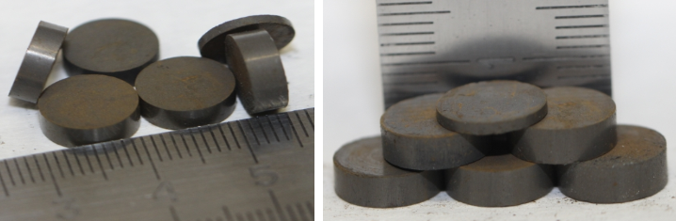
FIG.1. Photos of the uranium dioxide pellets with 10 wt. % addition of La₂O₃, CeO₂, Nd₂O₃ in the ratio 1:1:1.
  - Materials, chemicals, and apparatus
The experiments were performed in the electrolytic cell with a quartz body of the diameter up to 125 mm and height of 500 mm. The electrolytic cell cover was cut from the unitary fluoroplastic block and had necessary technological openings and noses for free and hermetic location of all electrodes. Heat screens made of nickel or molybdenum sheets were fixed to the cover, which was firmly adjusted to the electrolytic cell body. A container welded from a nickel sheet served as an electrolyte crucible and was placed on the bottom of the electrolytic cell.
Parallelepiped bars made of lithium oxide doped nickel oxide (II) ceramics (Fig. 2) were used as anodes [14]. When more than 20 g of SIMfuel pellets were loaded, two anodes were placed on different sides of the cathode basket. During the experiment the electrolytic cell was continuously supplied with argon, which was withdrawn through the anode cover and which provided an effective removal of anode gases. These gases from the glove box were transported through the system of mechanical filters and flexible pipes to the electrochemical sensor to determine the output oxygen concentration.

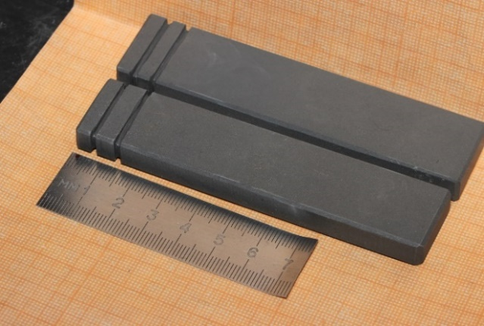
FIG. 2. Photo of the inert ceramic anodes.

Ceramic MgO containers with openings in the walls or parallelepiped X18H10T wire baskets with molybdenum wire current leads (the diameter of 1-1.5 mm) were used as cathode baskets (Fig. 3).
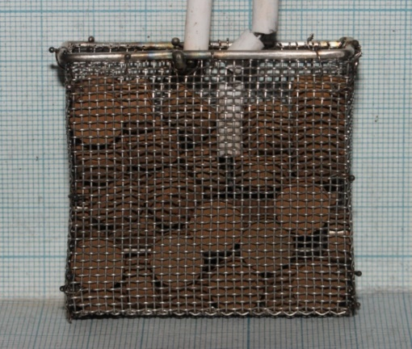
FIG. 3. Photo of the stainless steel cathode basket with 150 g load of SIMfuel pellets.

The Bi-Li (∼60 mol %) alloy, placed into the MgO ceramic cover with a molybdenum wire current lead (1.5 mm in diameter) served as a reference electrode. An auxiliary molybdenum wire electrode (1.5 mm in diameter) was used to determine and to monitor intermittently the values of the reference electrode during the cyclic voltammograms recording.
Commercial anhydrous lithium chloride (99.3%, «FMS», GB) and lithium oxide (99.5%, Alfa Aesar, USA) were used as initial reagents for the electrolyte preparation. Lithium chloride was preliminary melted in vacuum and purified by the zone recrystallization [15].
All procedures on the electrolytic cell installation and manipulations with lithium chloride and its oxide, as well as the electrolysis process were performed in a glove box in an argon atmosphere with the oxygen concentration not exceeding 10 ppm and water content not exceeding 0.1 ppm. All parameters were controlled during the measurements.
The electrolysis was performed at 650+/-5°C in LiCl - Li₂O (1-2 wt.%) under the galvanostatic regime. The necessary process parameters were set and controlled using an Autolab PGSTAT302N device with a current amplifier BSTR 20A, the anode potential was recorded by a digital voltmeter GW Instek GDM-78351.
- RESULTS AND DISCUSSION
The electrolysis was performed under the galvanostatic conditions, the cathode and anode voltages were constantly monitored and the cathode potential was measured during short current interruptions. The cathode potential was by 150-30 mV more positive than that of the metallic lithium liquid phase formation; this value of the potential was maintained during the electrolysis. Only at the final steps of the process the cathode potential was equal to that of the liquid lithium formation.
As the amount of the passed electricity increases the cathode potential (at the moment of the current switch off) approaches the potential corresponding to the liquid lithium phase formation. Fig. 4 illustrates the dependencies of one of the electrolysis cycles of UO₂ + 5 wt.% REM oxides pellets (150 g) under the galvanostatic regime, the current load of 7 A was supplied in cycles: the current was supplied for 600 seconds and the current was switched off for 60 seconds. The measurements performed during the current interruptions illustrate that during the electrolysis the cathode potential approaches continuously the potential of lithium extraction in the form of a separate phase, whereas the rate of lithium consumption for SIMfuel reduction decreases. This is testified by the characteristic potential shift to the positive side after the current switch off (the upper curves). This fact suggests that the electrolysis current may be decreased and the cathode potential should be maintained within the interval of +100 to 10 mV relative to Li⁺/Li. During the reduction of one batch of pellets such operations of the electrolysis current reduction were performed 5-6 times. Figs. 5 and 6 illustrate the dependence of the cathode potential change at the moment of current interruption during the reduction of 33 g of UO₂ + 5 wt.% REM oxides pellets and UO₂ + 10 wt.% REM oxides pellets, respectively. In addition, it is seen that as the concentration of REM oxides in SIMfuel increases and the cathode potential shifts faster to the region of lithium formation potentials, whereas the electrolysis current and cathode loads remain the same.

FIG. 4. Time dependence of the cathode potential change relative to the Bi-Li reference electrode (the potential is relative to Li⁺/Li⁰, 0.655V).

FIG. 5. Time dependence of the cathode potential change at the current interruption during the electrolysis with the cathode load of UO₂ + 5 wt.% REM oxides pellets (33 g).

FIG. 6. Time dependence of the cathode potential change at the current interruption during the electrolysis with the cathode load of UO₂ + 10 wt.% REM oxides pellets (33 g).

Fig. 7 demonstrates the cathode basket with the UO₂ + 5 wt.% REM oxides pellets (130 g) after the electrolysis at the 170% current load of the calculated value. A part of the cathode basket presented in Fig. 7a was mechanically separated and Fig. 7b illustrates the pellets from this basket. The pellets from different parts of the basket were sampled for the primary visual examination. These samples were cut into two parts to determine the uranium oxide residues.

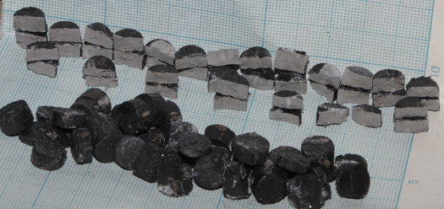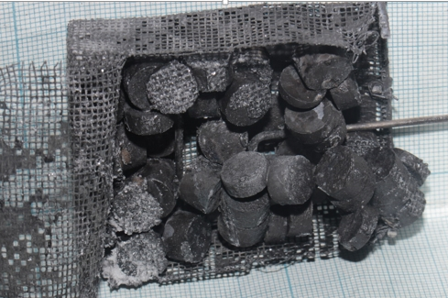
a
b
FIG. 7. (a) Cathode basket with 130 g of UO₂ + 5 wt.% REM oxides pellets after the electrolysis at the current load of 170% of the calculated theoretical value and partial separation of the wire net wall; (b) UO₂ + 5 wt.% REM oxides pellets divided into two parts.
Residues of uranium dioxide were not detected in the divided pellets after the performed experiments at the 160 – 180% current load of the theoretical value, which is required for the electrolytic formation of lithium to be used for the reduction of uranium dioxide and REM oxides. All pellets had a uniform grey color of the breaking area (Fig. 8a), the pellets treated with a file had a bright metallic shining (Fig. 8b).
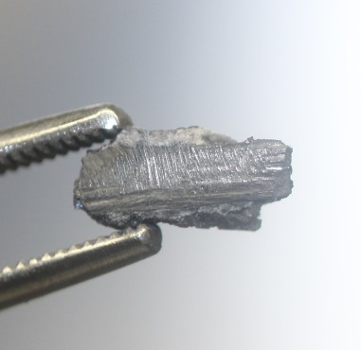
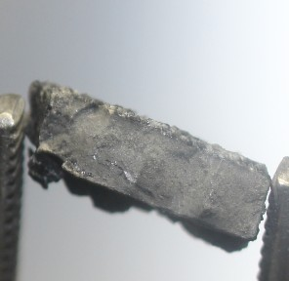
b
a
FIG. 8. (a) Photo of the divided SNFfuel pellet (UO₂ + 5 wt.% REM oxides) after 166% current load of the theoretical value; (b) analogous SIMfuel pellet treated with a file.

The X-ray diffraction analysis performed using a Rigaku MINIFLEX 600 diffractometer (Rigaku, Japan) demonstrated that in all studied samples oxygen transferred from the UO₂ lattice and the main phase α-U with the orthorhombic lattice was formed. The presence of the lithium chloride, (La/Nd/Ce)₂O₃ phases and in some samples UO₂ traces were determined. The absence of pure REM phases allowed us to assume that REM oxides were not reduced and their amount was negligible. Only CeO₂ was found to reduce to Ce₂O₃.
A part of the obtained SIMfuel samples after the reduction was subjected to high temperature vacuum electrolyte distillation [16] and further analysis by the scanning electron microscope. The micro-X-ray study of these and analogous samples performed by an auto emission electron microscope TESCAN MIRA 3 LMU (TESCAN, Czech Republic), which allows analyzing separate parts of the sample at different magnification, demonstrates that lanthanum, cerium and neodymium are surrounded by a significant amount of oxygen. The regions with the composition similar to REM oxide-chlorides were detected in some samples.
The arbitrary chosen SIMfuel pellets from the cathode baskets and those after the electrolyte distillation were analyzed according to the transformed “bromine method” suggested by Park et al [8]. Table 1 illustrates the obtained data for UO₂ + (5-10 wt.%) REM oxides pellets.

TABLE 1. UO₂ REDUCTION DEGREE IN THE UO₂ + 5-10 WT.% REM OXIDES (CeO₂, Nd₂O₃ AND La₂O₃) PELLETS AFTER THE ELECTROLYTIC REFINING AND THE ELECTROLYTE DISTILLATION ACCORDING TO THE “BROMINE METHOD”

UO₂ reduction degree before the electrolyte distillation, % | UO₂ reduction degree after the electrolyte distillation, % | REM oxide reduction degree after the electrolyte distillation, %
97.8 – 99. 9 | 97.2 – 98.3 | 10-30

Table 1 illustrates that the reduction degree in the samples after the electrolyte distillation decreases by 0.6-1.6 % depending on the pellets porosity, which correlates with the previously obtained data and which is explained by the reverse reaction of the reduced uranium with lithium oxide remaining in the electrolyte residues in the pellet pores. The change in this value was considered in the further analysis. The data obtained for the REM oxides reduction were widely scattered and were not verified either by micro-X-ray or X-ray diffraction analyses. That is why the further sample analysis aimed at the determination of the metallic phase in the reduced product was performed using the hybrid approach.
The uranium dioxide reduction degree is accurately determined in the distilled samples of SIMfuel pellets during the first step of this method according to the previously mentioned “bromine method”. The method of reduction melting in the graphite crucible was used to determine the concentration of remaining oxygen. Knowing the amount of oxygen bound to uranium, the remaining quantity was considered to be oxygen bound to REM oxides. The oxygen concentration in the electrolyte residue in the pellet pores, determined according to the Li₂O wt. % concentration in the melt sample, as well as the transformation of cerium dioxide to Ce₂O₃ were also considered when calculating the total oxygen concentration. The statistical data obtained for multiple SIMfuel samples of UO₂ + (5 and 10 wt. %) REM oxides are provided in Table 2. According to the obtained results the maximum reduction degree of REM oxides may reach 5 %.

TABLE 2. DETERMINED VALUES OF THE OXIDES REDUCTION DEGREE IN THE SIMfuel OF UO₂ + 5-10 WT.% REM OXIDES (CeO₂, Nd₂O₃ AND La₂O₃) PELLETS ACCORDING TO THE HYBRID APPROACH

SIMfuel | UO₂ reduction degree after the electrolyte distillation, % | Oxygen concentration in the samples, determined by the reduction melting, % | REM oxides reduction degree after the electrolyte distillation, calculated using the hybrid approach, %
UO2 + 5 wt.% of REM oxides | 97.2 – 98.3 | 1.0-1.2 | 0±5
UO2 + 10 wt.% of REM oxides | 97.2 – 98.3 | 1.7-2.0 | 0±5

Combining the results obtained by the mentioned methods of the SIMfuel UO₂ + (5-10 wt.%) REM oxides (CeO₂, Nd₂O₃ and La₂O₃) pellets analysis we may conclude that REM oxides do not reduce to REM metals under the studied conditions. The performed studies demonstrate that the oxygen concentration in the REM oxide may be determined in the presence of significant amount of metallic uranium by a Metavak -AK device and this procedure may be suggested for determination of the reduction degree of REM and actinide oxides in SIMfuel.
It was experimentally demonstrated that when the process of the UO₂ + (5-10 wt.%) REM oxides reduction is performed according to the aforesaid requirements it is possible to obtain the product containing up to 98-99% of reduced metallic uranium, but lanthanum, cerium, neodymium are as oxides and insignificant amounts of their oxide- chlorides.

ACKNOWLEDGEMENTS
This work is supported by the State Atomic Energy Corporation ROSATOM (State Contract No. Н.4o.241.19.21.1070, dated April 16, 2021).

REFERENCES
- USAMI, T., KURATA, M., INOUE, T., SIMS, H.E., BEETHAM, S.A., JENKINS, J.A., Pyrochemical reduction of uranium dioxide and plutonium dioxide by lithium metal, J. Nucl. Mater. 300 (2002) 15 – 26.
- HUR, J.M., JEONG, S.M., LEE, H., Underpotential deposition of Li in a molten LiCl-Li₂O electrolyte for the electrochemical reduction of U from uranium oxides. Electrochemistry Communications 12 (2010) 706 – 709.
- CHOI, E.Y., KIM, J.K., IM, H.S., CHOI, I.K., NA, S.H., LEE, J.W., JEONG, S.M., HUR, J.M., Effect of the UO₂ form on the electrochemical reduction rate in a LiCl–Li₂O molten salt. J. Nucl. Mater. 437 (2013) 178–187.
- SHISHKIN, A.V., SHISHKIN, V.Y., SALYUEV, A.B., KESIKOPULOS, V.A., KHOLKINA, A.S., ZAIKOV, Yu.P Eltctrolytic reduction of UO₂ in LiCl-Li₂O melts. Atomic Energy 131 (2021) 79-84.
- IIZUKA, M, Y. SAKAMURA, T. INOUE. Electrochemical reduction of (U–40Pu–5Np)O₂ in molten LiCl electrolyte. J. Nucl. Mater. 359.1-2 (2006): 102-113
- HERRMANN, S.D., LI, S.X., Separation and Recovery of Uranium Metal from Spent Light Water Reactor Fuel Via Electrolytic Reduction and Electrorefining, Nuclear Technology. 171 (2010) 247-265.
- BYCHKOV A. V., ISHUNIN V. S., KORMILITSYN M. V. Reduction of the spent nuclear fuel of a VVER-1000 reactor by lithium in a lithium chloride melt. Russian Metallurgy (Metally). (2010) Т. 2010. №. 8. 712-717.
- PARK, T.H., CHO, Y.H., KANG, B., KIM, J.G., SUH, K., KIM, J., BAE, S.E., KIM, J.Y., GIGLIO J.J., JONES, M.M., Constituent analysis of metal and metal oxide in reduced SIMFuel using bromine-ethyl acetate. Journal of Radioanalytical and Nuclear Chemistry 316 (2018) 1253–1259.
- BRUNZIE, G.F., JOHNSON, T.R., STEUNENBERG, R.K., Selective dissolution of uranium from uranium oxide mixtures by bromine-ethyl acetate. Anal. Chem. 33 (1961) 1005–1006.
- LARSEN, R.P., Dissolution of uranium metal and its alloys, Anal. Chem. 31 (1959) 545 – 549.
- GRIGOROVICH, K.V., New possibilities of contemporary methods of determination of gas forming admixtures in metals. Zavodskaya laboratoriya. 73 (2007) 23-34.
- VASSERMAN, A.M., KUNIN, L.L., SUROVOY, Yu.N., Determination of gases in metals. Method of Reduction Melting in Gas Carrier Atmosphere, Nauka, Moscow (1976). (in Russian)
- SAKAMURA, YOSHIHARU, and TAKASHI OMORI. "Electrolytic reduction and electrorefining of uranium to develop pyrochemical reprocessing of oxide fuels. Nuclear Technology 171 (3) (2010) 266-275.
- MULLABAEV, A.R., KOVROV, V.A., KHOLKINA, A.S., ZAIKOV, Y.P. Anode processes on Pt and ceramic anodes in chloride and oxide-chloride melts. Nuclear Engineering and Technology. 54 (3) (2022) 965-974.
- SHISHKIN, V.Yu., MITYAYEV, V.S., Purification of alkali halides by zone melting, Izvestiya ANSSSR. Neorganicheskiye materialy 18 (1982) 1917-1918. (in Russian)
- SALYLEV, A.B., SHISHKIN, A.V., SHISHKIN, V.Y., ZAIKOV, Yu.P. Distillation of lithium chloride from the uranium metallization products. Atomic Energy 126 (2019) 199-203.

