INVESTIGATION of THE anodic processes on THE ceramic electrode for electrochemical reduction of spent oxide nuclear fuel in THE oxide-chloride melts

A. MULLABAEV
Institute of High Temperature Electrochemistry
Ekaterinburg, Russian Federation
Email: albert_06@mail.ru

V. KOVROV
Institute of High Temperature Electrochemistry
Ekaterinburg, Russian Federation

A. KHOLKINA
Institute of High Temperature Electrochemistry
Ural Federal University
Ekaterinburg, Russian Federation

A. DEDYUKHIN
Institute of High Temperature Electrochemistry
Ekaterinburg, Russian Federation

Y. ZAIKOV
Institute of High Temperature Electrochemistry
Ural Federal University
Ekaterinburg, Russian Federation

Y. MOCHALOV
Joint stock company «Proryv»
Moscow, Russian Federation

WEIQUN SHI
Institute of High Energy Physics, Chinese Academy of Sciences
Beijing, People's Republic of China

Abstract

The paper is devoted to study of anodic processes on a ceramic anode NiO-(2.5 wt.%)Li₂O in LiCl-KCl-Li₂O melts for the electrochemical reduction of oxide spent nuclear fuel and the reduction of uranium dioxide using the ceramic electrode. Voltammetric studies have shown that two electrode processes can occur on the NiO-Li₂O anode: i) oxidation of oxide ions with the formation of gaseous oxygen up to the potentials of 2.8÷2.9 V vs Li⁺/Li couple and ii) electrochemical decomposition of the anode material at potentials more positive than 3.0 V vs Li⁺/Li. The anode tests during galvanostatic electrolysis at an anode current density of 0.25 A·cm⁻² testified its stable operation during the entire test period (35 h). The current efficiency of oxygen at the studied anode is close to 100%. The reduction of uranium dioxide pellets by electrolysis using the ceramic anode resulted in a product containing 99.8 wt.% uranium metal.

INTRODUCTION
Alkaline halide melts and alkaline earth metals are used for the electrochemical reduction of metal oxides to their metallic forms. In practice, fluoride, chloride, and mixed chloride-fluoride melts of alkali and alkaline earth metals are used most often. Graphite is usually applied as an inert anode material in these media. However, during the electrolysis of oxide-halide melts, carbon is not an inert anode [1-3]. In recent years, metals and their alloys, metal oxides and metal-oxide composites have been considered as candidate inert anode materials for the electrolysis of oxide-halide melts. Studies of anodic processes on metallic electrodes in oxide-halide melts performed by various groups of researchers have shown that at high temperatures metallic electrodes are oxidized by oxygen, which causes the formation of metal oxide films. These films do not have protective properties and, therefore, do not protect the metal from further oxidation [1, 4-5].
At present, oxide-chloride melts based on LiCl are used for the electrolytic reduction of uranium and plutonium oxides with lithium formed at the cathode [6]:
${MeO}_{2}+4{Li}^{+}+4e→Me+{2Li}_{2}O$, (1)
where $Me$ is uranium or plutonium.
The formed lithium oxide dissolves in the chloride melt and oxidizes at the anode with the evolve of gaseous oxygen:
${2Li}_{2}O-4e→O_{2}+4{Li}^{+}$. (2)
The process of electrochemical reduction is one of the main stages of many pyrochemical schemes for the processing of oxide nuclear fuel. The cathodic reduction process of actinide oxides has been well studied, while anodic processes and anodic materials have been given insufficient attention.
Platinum is usually used as the anode material for oxygen evolution in these melts [7-9]. However, platinum is highly susceptible to corrosion in these melts, and therefore it is not the inert anode material. In addition, platinum is expensive metal, which is an obstacle for its industrial implementation.
We have thoroughly studied anodic processes and preformed electrolysis tests on the NiO-Li₂O ceramic anode in LiCl-KCl-Li₂O melts. The NiO-Li₂O ceramic anode was selected because it showed good corrosion-electrochemical properties during the electrolysis of CaCl₂-CaO melts [10]. The addition of 20 mol.% KCl to the LiCl melt lowers the liquidus temperature by almost 100 ºC [11-12], while the solubility of lithium oxide in the melt at 550 ºC is 3.4 mol.% [13].

EXPERIMENTAL
Voltammetric studies and electrolysis tests were performed in an argon glove box with a controlled atmosphere (O₂ <10 ppm, H₂O <1 ppm). The experiments were carried out in (80 mol.%)LiCl-(20 mol.%)KCl melts with the addition of Li₂O. The following reagents were used for the study: (i) anhydrous lithium chloride (≥99.5 wt.%, FMC, UK), (ii) potassium chloride (≥99.8 wt.% "Mikhailovsky Chemical Reagents Plant" Ltd, RF) and (iii) lithium oxide (99.5 wt.%, Alfa Aesar, USA). Lithium chloride was previously dried under vacuum at the temperature of 400 °C for 24 h. Dry LiCl was remelted in a glassy carbon crucible and then it was purified by the method of zone recrystallization. Pre-melted KCl was also purified from impurities by zone recrystallization. The reagents prepared for research were stored in the glove box.
The study of anodic processes was carried out using the cyclic voltammetry (CV) in an electrochemical cell assembled according to a three-electrode scheme. Thе cell was fabricated from a quartz tube with a side gas outlet, a fluoroplastic cover with heat-reflecting shields, a magnesium oxide crucible, electrodes and a Pt-Pt(10 wt.% Rh) thermocouple. The potentials were measured relative to a lead reference electrode. The electrode was assembled from a MgO porous cover, metallic lead (99.99 wt.% purity), the (LiCl-KCl)_{eut.}-(30 mol.%)PbCl₂ melt layer, and a molybdenum (wire ø 1.0 mm, ≥99.96 wt.% purity) current lead shielded by a MgO tube. The potential of the Pb reference electrode was calibrated against the potential of metallic lithium using the cathodic cyclic voltammogram on the molybdenum electrode. Metallic Pb (99.99 wt.% purity) placed in the drilled MgO cover served as a counter electrode. A molybdenum wire (ø 1.0 mm, ≥99.96 wt.% purity) in the MgO protective tube was used as a current lead to molten Pb. A homogeneous NiO-Li₂O powder was pressed into cylindrical electrodes, which were sintered at 1350 °C for 5 h. The synthesized anodes had an average diameter of 9 mm and a height of 40 mm. The prepared anodes NiO-Li₂O were analyzed for the Li content by the emission spectral analysis with inductively coupled plasma using an Optima 4300 DV Perkin Elmer instrument. The Li concentration in the synthesized samples calculated as Li₂O was within 2.45÷2.55 wt.%. The current lead to the ceramic anode was made of platinum wire (ø 1.0 mm, 99.99 wt.% purity). A photograph of the NiO-(2.5 wt.%)Li₂O anode with the Pt current lead is shown in Fig. 1.

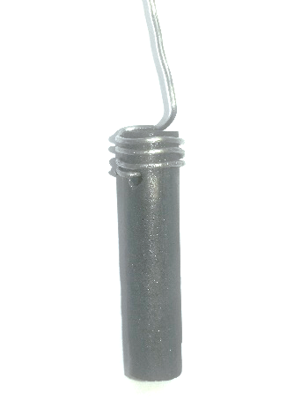

FIG. 1. Ceramic anode NiO-(2.5 wt.%)Li₂O with platinum current lead

Electrolysis tests on the NiO-Li₂O anode were carried out in the (80 mol.%)LiCl-(20 mol.%)KCl+(2.0 wt.%)Li₂O melt at 650 °C in the electrochemical cell assembled as described above. Lead (300 g) was used as a liquid cathode. The Li-Pb alloy was formed on the cathode. The electrolysis was carried out in a galvanostatic mode at an anode current density of 0.25 A·cm⁻². The concentration of lithium oxide in the melt was constantly renewed to 2 wt.% by lithium oxide additions. Oxygen formed during the electrolysis test was removed from the electrochemical cell by continuous purging of the cell volume with argon gas.
Electrolysis tests of the NiO-Li₂O anode during electrochemical reduction of uranium dioxide were performed in a standard cell for the oxide electrochemical reduction. The tests were carried out in the LiCl-(1 wt.%)Li₂O melt at 650 °C. The UO₂ pellets with a total weight of 7.20 g were placed in the Ni cathode assembly, and were reduced; the potential of the cathode basket was maintained more positive than the potential of metallic Li by about 100 mV. The electrode potential during the electrochemical reduction without an ohmic potential drop (IR) was determined by short-term interruption of the cell current.
Voltammetric measurements and electrolysis tests were performed using a potentiostate-galvanostate Autolab PGSTAT-302N (Metrohm, Netherlands). The concentration of lithium oxide in the melts was determined by the acid-base titration.

RESULTS AND DISCUSSION

Cyclic voltammetry
Cyclic voltammograms recorded on the ceramic anode NiO-(2.5 wt.%)Li₂O in the (80 mol.%)LiCl-(20 mol.%)KCl+(0.4 wt.%)Li₂O melt at a potential scan rate of 500 mV/s and temperatures of 550 and 650 °C are shown in Fig. 2. The oxidation wave (1) of oxide ions to gaseous oxygen is observed at about 2.9 V at 550 °C and about 2.8 V vs Li⁺/Li couple at 650 °C. The potential of oxide ions oxidation wave is shifted to the positive region by about 100 mV due to a decrease in the melt temperature by 100 °C.
This potential shift correlates with the Nernst equation for the equilibrium potential and the wave potential, which is related to the standard potential. The peak current density for melts of the same composition increases with increasing temperature, as can be seen in Fig. 2. Therefore, an increase in the electrolyte temperature makes it possible to increase the oxidation rate of oxide ions. From the point of view of spent nuclear fuel reprocessing, this is an advantage, since the rate of the electrochemical reduction process is mainly limited by the anode current density.
At potentials more positive than the oxidation of oxide ions, wave (2), which is associated with the electrochemical decomposition of the NiO-Li₂O anode, is observed. The electrochemical decomposition of the ceramics occurs at potentials more positive than 3.0 V vs Li⁺/Li couple. Lithium oxide present in ceramics is electrochemically decomposed to oxygen. The process of electrochemical dissolution of the NiO-Li₂O anode is clearly visible in the cyclic voltammograms shown in Fig. 3. At potentials more positive than 2.9 V, the current sharply rises, which is explained by the electrochemical decomposition of the anode material. This process produces non-conductive nickel oxide. Therefore, during the electrolysis of LiCl melts, the anode potential should not exceed 2.9÷3.0 V vs Li⁺/Li couple.
At the reverse scanning wave (3), which is associated with the oxidation of molecular oxygen to oxide ions, appears. The oxygen reduction wave (3) shifts to the positive side as the electrolyte temperature decreases by 100 ° C.
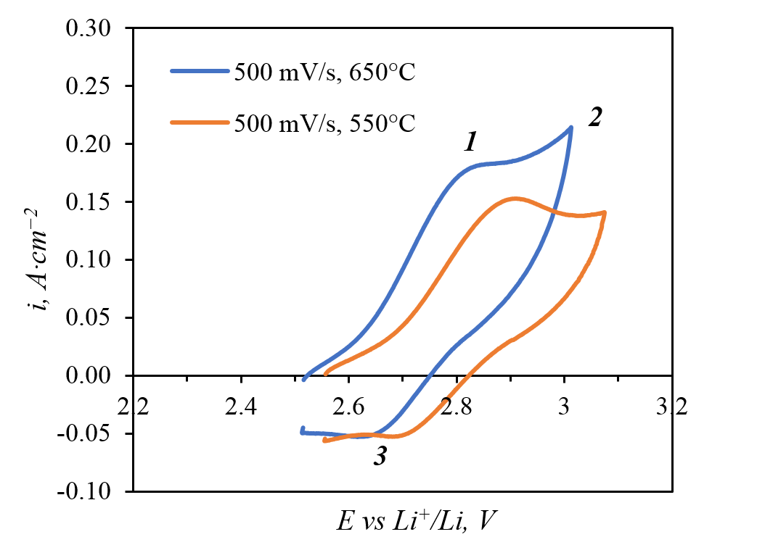
FIG. 2. Cyclic voltammograms recorded on the NiO-(2.5 wt.%)Li₂O ceramic anode in the (80 mol.%)LiCl-(20 mol.%)KCl+(0.4 wt.%)Li₂O melt. Potential scan rate and temperatures are indicated in the graph legend.

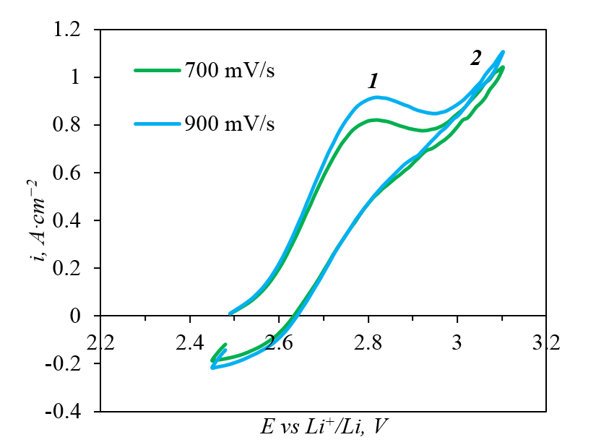
FIG. 3. Cyclic voltammograms recorded on the NiO-(2.5 wt.%)Li₂O ceramic anode in the (80 mol.%)LiCl-(20 mol.%)KCl+(0.8 wt.%)Li₂O melt at 650 °C. Potential scan rates are indicated in the graph legend.

Electrolysis tests of the NiO-Li₂O anode during galvanostatic electrolysis using a lead cathode
The electrolysis tests of the anode were performed in the (80 mol.%)LiCl-(20 mol.%)KCl+ (2.0 wt.%)Li₂O melt at 650 °C and anode current density of 0.25 A·cm⁻². Since molten Pb served as the cathode, the concentration of Li₂O decreased during the electrolysis. The electrolysis was carried out until the concentration of Li₂O in the melt reached 1.3 wt.%. The current was interrupted every 5 hours and lithium oxide was added to renew the its concentration to 2 wt%.
As can be seen from Table 1, the potential of the anode during electrolysis is in the range of 2.6÷2.7 V vs Li⁺/Li couple. This potential, according to voltammetric measurements, corresponds to the oxidation of oxide ions to oxygen gas. The value of the Li₂O concentration in the melt calculated from the amount of electricity and the value determined by the analysis of samples practically coincide. The oxygen current efficiency calculated from the change in the concentration of Li₂O in the melt is more than 98.0%. The deviation from 100% may be due to the analysis error and the error in the Li₂O addition to the melt. The nickel concentration in the melt, determined by atomic emission analysis, was about 0.0004 wt% during the experiment. As a result of 35 h electrolysis experiments, the diameter and length of the anode sample did not decrease. Therefore, the NiO-(2.5 wt.%)Li₂O ceramic anode is an inert anode for the electrolysis of LiCl-KCl-Li₂O melts.

TABLE 1. RESULTS OF THE NiO-Li₂O ANODE ELECTROLYSIS TESTS

Electrolysis interval time, h | E_{anode} – IR, V | Initial concentration of Li₂O, wt.% |  |  | Final concentration of Li₂O, wt.% |  |  | Oxygen current efficiency,%
 |  | Calculation | Analysis |  | Calculation | Analysis
0÷5 | 2.67÷2.64 | 2.00 |  | 2.10 | 1.30 |  | 1.32 | 98.57
5÷10 | 2.67÷2.64 | 2.00 |  | 2.08 | 1.30 |  | 1.39 | 98.57
10÷15 | 2.68÷2.62 | 2.00 |  | 1.94 | 1.30 |  | 1.25 | 99.14
15÷20 | 2.65÷2.63 | 2.00 |  | 2.09 | 1.30 |  | 1.39 | 99.43
20÷25 | 2.65÷2.62 | 2.00 |  | 1.98 | 1.30 |  | 1.33 | 92.29
25÷30 | 2.67÷2.64 | 2.00 |  | 1.97 | 1.30 |  | 1.27 | 99.71
30÷35 | 2.66÷2.67 | 2.00 |  | 1.94 | 1.30 |  | 1.24 | 99.57

Electrolysis tests of the NiO-Li₂O anode during the electrochemical reduction of uranium dioxide
Electrolysis tests of the anode were carried out in the LiCl-(1.1 wt.%)Li₂O melt during the electrochemical reduction of uranium dioxide, as described in the Experimental Section. During the reduction, the potential of the anode was monitored. Fig. 4 shows the time dependences of the anode potential under current (taking into account the IR value) and the anode current density. The potential of the NiO-Li₂O ceramic anode weakly depends on the anode current density and its value is in the range of 2.5÷2.6 V relative to Li⁺/Li couple. This potential range corresponds to the discharge of oxide ions to oxygen. The concentration of Li₂O in the LiCl melt was 1.10 wt.% at the beginning of the process and 1.08 at the end, that is, the electrolysis proceeded at the constant concentration of Li₂O.

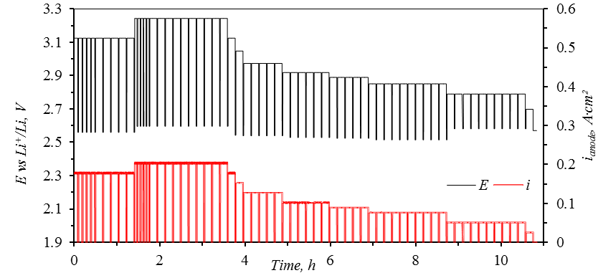
FIG. 4. Time dependence of the NiO-(2.5 wt.%)Li₂O anode potential and the anode current density during the electrochemical reduction of uranium dioxide in the LiCl-Li₂O melt at 650 ° C.

Fig. 5 shows a sample of the reduced pellet before and after the electrolyte removal. The reduction of uranium dioxide pellets by electrolysis using a ceramic anode resulted in a product containing 99.8 wt.% uranium metal. Thus, the NiO-Li₂O anode can be used for the electrochemical reduction of actinide oxides contained in spent nuclear fuel.

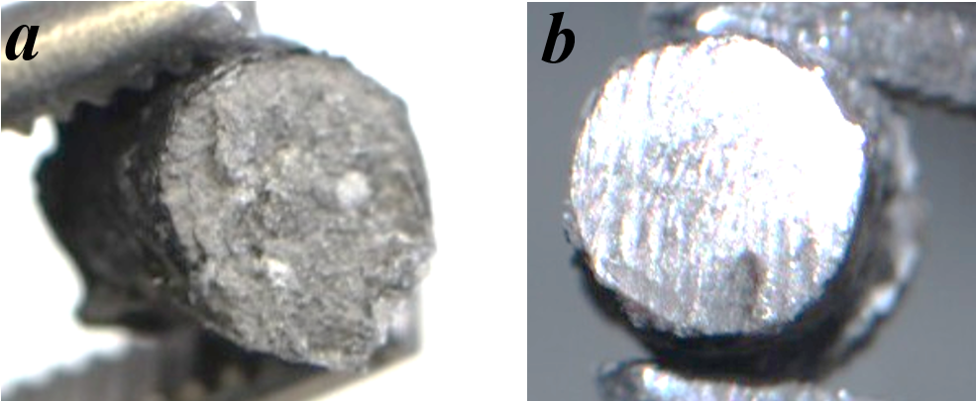
FIG. 5. Photo of a reconstituted uranium dioxide tablet before the electrolyte removal (a) and after the electrolyte removal and surface treatment (b)

CONCLUSION
The present study demonstrates that the NiO-Li₂O ceramics is the inert anode material for the electrolysis of LiCl-KCl-Li₂O melts at the temperatures of 550-650˚C. The voltammetric measurements have shown that two electrode processes can occur on the NiO-Li₂O anode: i) oxidation of oxide ions with the formation of gaseous oxygen up to potentials of 2.8÷2.9 V vs Li⁺/Li couple and ii) chlorination of the anode material at potentials more positive than 3.0 V vs Li⁺/Li couple. Experiments carried out during the electrolytic reduction of UO₂ testify that NiO-Li₂O is the inert anode material. The anode current efficiency of oxygen evolution at this anode is close to 100%. After the 35 h electrolysis experiments the diameter and length of the anode sample did not decrease. The reduction of uranium dioxide pellets by electrolysis using a ceramic anode resulted in a product containing 99.8 wt.% uranium metal. Thus, the NiO-Li₂O anode can be used for the spent nuclear fuel reprocessing in molten salts based on LiCl-Li₂O.

ACKNOWLEDGEMENTS
This work is supported by the State Atomic Energy Corporation ROSATOM (State Contract No. Н.4o.241.19.21.1070, dated April 16, 2021).

References
- Frederic, L., Groult, H., Molten Salts Chemistry From Lab to Applications, Elsevier (2013).
- Hur, J.-M., Cha, J.-S., Choi, E.-Y., Can Carbon Be an Anode for Electrochemical Reduction in a LiCl-Li₂O Molten Salt, ECS Electrochemistry Letters, Vol. 3, No. 10 (2014) E5-E7.
- Kim, S.-W., Jeon, M.K., Kang, H.W., Lee, S.-K., Choi, E.-Y., Park, W., Hong, S.-S., Oh, S.-Ch., Hur, J.-M., Carbon anode with repeatable use of LiCl molten salt for electrolytic reduction in pyroprocessing, J. Radioanal. Nucl. Chem., Vol. 310, Issue 1 (2016) 463-467.
- Yin, H., Gao, L., Zhu, H., Mao, X., Gan, F., Wang, D., On the development of metallic inert anode for molten CaCl₂–CaO System, Electrochimica Acta, Vol. 56 (2011) 3296–3302.
- Chapman, V., Welch, B.J., Skyllas-Kazacos, M., Anodic behaviour of oxidized NiFe alloys in cryolite-alumina melts, Electrochimica Acta, Vol. 56 (2011) 1227-1238.
- Choi, E.-Y., Jeong, S.M., Electrochemical processing of spent nuclear fuels: An overview of oxide reduction in pyroprocessing technology, Progress in Natural Science: Materials International, Vol. 25, Issue 6 (2015) 572-582.
- Sakamura, Y., Kurata, M., Inoue, T., Electrochemical Reduction of UO₂ in Molten CaCl₂ or LiCl, J. of the Electrochemical Society, Vol. 153, No. 3 (2006) D31-D39.
- Park, B.H., Lee, I.W., Seo, C.-S., Electrolytic reduction behavior of U₃O₈ in a molten LiCl-Li₂O salt, Chemical Engineering Science, Vol. 63 (2008) 3485-3492.
- Sakamura, Y., Effect of alkali and alkaline-earth chloride addition on electrolytic reduction of UO₂ in LiCl salt bath, J. of Nuclear Materials vol. 412, Issue 1 (2011) 177–183.
- Zajkov, Yu.P., Dubovtsev, A.B., Batukhtin, V.P., Khramov, A.P., Ivanovskij, L.E., Electrolysis with oxide anodes in chloride-oxide melt, Rasplavy, Issue 2 (1995) 41-46.
- Kovrov, V.A., Mullabaev, A.R., Shishkin, V.Y., Zaikov, Y.P., Solubility of Li₂O in an LiCl–KCl Melt, Russian Metallurgy (Metally), Vol. 2018, Issue 2 (2018) 169-173.
- Mullabaev, A., Tkacheva, O., Shishkin, V., Kovrov, V., Zaikov, Y., Sukhanov, L., Mochalov, Y., Properties of the LiCl-KCl-Li₂O system as operating medium for pyrochemical reprocessing of spent nuclear fuel, J. of Nuclear Materials, Volume 500 (2018) 235-241.
- Sakamura, Y., Solubility of Li₂O in molten LiCl-MClx (M = Na, K, Cs, Ca, Sr, or Ba) binary systems, J. of the Electrochemical Society Vol. 157, # 9 (2010) E135-E139.

