THERMODYNAMIC SIMULATION OF OXIDATIVE PROCESSES

AT THE REPROCESSING OF SPENT NUCLEAR FUEL

IN THE LiCl-KCl MELT
A.M. POTAPOV
Institute of High Temperature Electrochemistry
Ural State Mining University
Ekaterinburg, Russian Federation
Email: A.Potapov_50@mail.ru

M.V. MAZANNIKOV
Institute of High Temperature Electrochemistry
Ekaterinburg, Russian Federation

Y.P. ZAIKOV
Institute of High Temperature Electrochemistry
Ekaterinburg, Russian Federation

Abstract

The initial material composition of the nitride spent nuclear fuel (SNF) was calculated by the methods of thermodynamic modeling. The process of interaction of nitride SNF with CdCl₂ and with PbCl₂ in molten LiCl-KCl eutectic is studied. It is shown that the chlorination process takes place in two stages. Both the rate of the process and the composition of the resulting products significantly depend on temperature.

INTRODUCTION
At present, in Russia, within the framework of the Breakthrough project, an intensive development of a pyrochemical (anhydrous) method for reprocessing nitride spent nuclear fuel (SNF) is underway. The pyrochemical method is devoid of the disadvantages inherent in the hydrometallurgical method, such as prolonged exposure of fuel before processing, a large volume of liquid radioactive waste, etc. [1-4].
The process of mild chlorination of spent nuclear fuel with its simultaneous transfer to a dissolved state can be considered as the head operation of the pyrochemical reprocessing scheme. Mild chlorination refers to chlorination without the use of chlorine gas. Instead, it is technologically more convenient to use chlorinating agents - for example, CdCl₂ or PbCl₂.
The aim of this work is to thermodynamically simulate the process of dissolution of components of nitride SNF in molten LiCl-KCl eutectic using CdCl₂ or PbCl₂ as chlorinating agents.
Spent nuclear fuel is a complex, multicomponent system. It is difficult to study both because of the complexity of its composition, as well as because of its high radioactivity. Thermodynamic modeling methods make it possible to assess the composition and properties of spent nuclear fuel, compare various processing methods, and select optimal conditions.

BASIS OF CALCULATIONS
Thermodynamic modeling was carried out using the HSC Chemistry 9.9 software package [5]. The calculation of the thermodynamic equilibrium of systems is carried out by solving a mathematical problem to find the minimum of Gibbs free energy. The extremum is found taking into account some restrictions and assumptions in the mathematical model. The initial conditions are the amount of substance of the compounds, the temperature of the process and the pressure in the system. A detailed description of the calculation methodology is described in [6].
By default, the activity coefficients of all compounds are taken equal to 1. But when modeling the equilibrium composition of mixtures in molten LiCl-KCl eutectic, we set many activity coefficients ourselves, using the literature data. Activity coefficients of γ(CdCl₂) = 0.03; γ(PbCl₂) = 0.4 [7], trichlorides of rare earth elements 0.01 [8]. As for actinide chlorides: γ(UCl₃) = 0.001, γ(UCl₄) = 10⁻⁴ [9]. Activity coefficient of PuCl₃ was taken similar to UCl₃.

RESULTS OF THERMODYNAMIC SIMULATION

SNF material composition
The first step in modeling the SNF reprocessing processes is to calculate the material composition of the nitride SNF. As the initial data, we used the model elemental composition of spent nitride nuclear fuel given in TABLE 1, combined from the data [10-12].

TABLE 1. MODEL ELEMENTAL COMPOSITION OF SPENT NITRIDE NUCLEAR FUEL COMPILED FROM DATA [10-12].

№ | Compound/  element | Amount of substance, mol. % |  | № |  | Compound/  element | Amount of substance, mol. %
1 | N | 47.9 |  | 23 |  | Y | 0.0722
2 | U | 37.6 |  | 24 |  | I | 0.0710
3 | Pu | 6.67 |  | 25 |  | Rb | 0.0632
4 | Xe | 0.872 |  | 26 |  | Ag | 0.0555
5 | Mo | 0.826 |  | 27 |  | Cd | 0.0448
6 | Ru | 0.745 |  | 28 |  | Sn | 0.0352
7 | Zr | 0.719 |  | 29 |  | Pm | 0.0234
8 | Cs | 0.716 |  | 30 |  | Eu | 0.0200
9 | Nd | 0.624 |  | 31 |  | Gd | 0.0186
10 | Pd | 0.578 |  | 32 |  | Np | 0.0141
11 | Ce | 0.389 |  | 33 |  | Se | 0.0124
12 | Ba | 0.282 |  | 34 |  | Sb | 0.0106
13 | C¹⁴ | 0.244 |  | 35 |  | Cm | 0.0073
14 | Rh | 0.230 |  | 36 |  | He | 0.00538
15 | La | 0.215 |  | 37 |  | In | 0.00447
16 | Tc | 0.204 |  | 38 |  | Br | 0.00396
17 | Pr | 0.200 |  | 39 |  | Tb | 0.00117
18 | Sm | 0.174 |  | 40 |  | Dy | 0.00105
19 | Sr | 0.133 |  | 41 |  | H³ | 0.00054
20 | Te | 0.126 |  | 42 |  | Ge | 0.000360
21 | Am | 0.0888 |  | 43 |  | As | 0.000110
22 | Kr | 0.0736
Сумма |  |  |  |  | 99.999

The main elements are nitrogen, uranium, plutonium. Among the fission products, it is worth noting the noble metals - ruthenium, palladium and rhodium; rare earth elements, cesium and zirconium. The behavior of these elements will be given special attention in this article.
Based on the data on the elemental composition, the material composition of the nitride SNF was calculated at 700 °C. This temperature was chosen on the basis of data on the diffusion coefficients of elements in nitride fuel [13] and estimates of fuel rod temperatures during reactor operation, which are 1200 - 1500 °C. Also, for completeness of the calculation, the missing thermodynamic parameters of some nitrides of actinides and lanthanides were estimated using the data [14, 15].
Table 2 shows the material composition of the nitride SNF according to the results of thermodynamic modeling. Here are 68 compounds out of 1018 formed. The total content of compounds not listed here does not exceed 0.002 mol. %.

TABLE 2. MATERIAL COMPOSITION OF NITRIDE SNF AT 700 °C BASED ON THE RESULTS OF THERMODYNAMIC MODELING

№ | Compound/  element | Amount of substance, mol. % | № | Compound/  element | Amount of substance, mol. %
1 | (U_{0.8}Pu_{0.2})N | 44.9 | 35 | GdN | 0.0384
2 | UN | 34.6 | 36 | EuTe | 0.0378
3 | PuN | 4.81 | 37 | BaC₂ | 0.0346
4 | U₂N₃ | 3.09 | 38 | NpN | 0.0292
5 | Xe(g) | 1.80 | 39 | Cd(g) | 0.0280
6 | ZrN | 1.49 | 40 | SrTe | 0.0253
7 | NdN | 1.29 | 41 | MoC | 0.0249
8 | CeN | 0.804 | 42 | SrSe | 0.0244
9 | Mo | 0.781 | 43 | SrC₂ | 0.0244
10 | Cs(g) | 0.497 | 44 | LaSb | 0.0201
11 | URu₃ | 0.467 | 45 | CmN | 0.0150
12 | Cs | 0.428 | 46 | Sr₃N₂ | 0.0121
13 | LaN | 0.425 | 47 | He(g) | 0.0111
14 | Tc | 0.422 | 48 | In | 0.00924
15 | PrN | 0.412 | 49 | Cs₂(g) | 0.00763
16 | UPd₃ | 0.398 | 50 | Mo₃C₂ | 0.00731
17 | Ba | 0.391 | 51 | RbI | 0.00563
18 | SmN | 0.361 | 52 | Rh | 0.00488
19 | Mo₂C | 0.346 | 53 | EuN | 0.00351
20 | Cs₂Te | 0.198 | 54 | CsBr | 0.00328
21 | MoN_{0.5} | 0.187 | 55 | Ba₃N₂ | 0.00272
22 | AmN | 0.181 | 56 | TbN | 0.00242
23 | Sr | 0.164 | 57 | CsI(g) | 0.00218
24 | Rh₃U | 0.157 | 58 | DyN | 0.00217
25 | Kr(g) | 0.152 | 59 | PrSb | 0.00183
26 | YN | 0.149 | 60 | BaBr₂ | 0.00166
27 | Ru | 0.140 | 61 | CsRb(g) | 0.00165
28 | CsI | 0.137 | 62 | CsBr(g) | 0.00121
29 | Ag | 0.115 | 63 | BaSe | 0.00104
30 | Ba₂Sn | 0.0727 | 64 | C | 0.000979
31 | Cd | 0.0645 | 65 | BaI₂ | 0.000752
32 | Rb | 0.0635 | 66 | Ge | 0.000744
33 | Rb(g) | 0.0597 | 67 | BaH₂ | 0.000488
34 | PmN | 0.0484 | 68 | BaTe | 0.000452
Total |  |  | 99.998%

Actinides and lanthanides are found in their mononitrides - AmN, CmN, PuN and LaN, CeN, PrN, NdN, PmN, SmN, EuN, GdN. The main phase (U_{0.8}Pu_{0.2})N, in which the nitrides of the remaining actinides and lanthanides are dissolved.
Noble metals are mainly found in the form of intermetallic compounds URu3, UPd3 and URh3. Their formation is noted in [16]. A small part of noble metals is in free form.
Almost all iodine is combined with cesium and rubidium, CsI and RbI. And since there is little iodine in the system, the remaining cesium and rubidium, apparently, remain in free form.
Zirconium is in the form of its ZrN nitride. Molybdenum also partially forms nitrides, but due to their instability it remains in a free form with a small impurity of MoN_{0.5}.

Soft chlorination of SNF in LiCl-KCl eutectic

Chlorinating agent: CdCl₂
The SNF chlorination process with its simultaneous transformation into a dissolved state can be considered as the first stage in the technology of SNF nitride reprocessing. A molten mixture of LiCl - KCl of eutectic composition (58.8 mol% LiCl and 41.2 mol% KCl) was chosen as a solvent. It is technologically more convenient to use for chlorination not gaseous chlorine, but softer chlorinating agents, for example, p-metal chlorides. Soft chlorination is a technologically convenient method for the initial opening of nitride SNF, and in our case, a method for its dissolution in the LiCl-KCl melt.
During chlorination, the following reactions take place:
$$AnN+1.5Cd{Cl}_{2}=An{Cl}_{3}+1.5Cd+0.5N_{2}↑$$ | (1)
$$LnN+1.5Cd{Cl}_{2}=Ln{Cl}_{3}+1.5Cd+0.5N_{2}↑$$ | (2)
Where An are actinides and Ln are lanthanides.
The main element of spent nuclear fuel is uranium. Its chlorination proceeds according to reaction (3).
$$UN+1.5Cd{Cl}_{2}=U{Cl}_{3}+1.5Cd+0.5N_{2}↑$$ | $$∆G= -61 kJ at 500°C$$ | (3)
However, simultaneously with reaction (3), reactions of the formation of UNCl, U₂N₃, UN₂ and nonstoichiometric nitrides of the UN_{1.55}, UN_{1.69}, UN_{1.73} type always proceed.
$$UN+0.5Cd{Cl}_{2}=UNCl+0.5Cd$$ | $$∆G= -71 kJ at 500°C$$ | (4)
$$UNCl+Cd{Cl}_{2}=U{Cl}_{3}+Cd+0.5N_{2}↑$$ | $$∆G= 10 kJ at 500°C$$ | (5)
$$UN+0.612Cd{Cl}_{2}={0.591UN}_{1.69}+0.612Cd+0.408{UCl}_{3}$$ | $$∆G= -59 kJ at 500°C$$ | (6)
$$UN+0.5Cd{Cl}_{2}=0.667{UN}_{1.5}+0.5Cd+0.333{UCl}_{3}$$ | $$∆G= -56 kJ at 500°C$$ | (7)
In [17], it was experimentally demonstrated that at 500 °C only ~ 30% UN interacts with CdCl₂ according to reaction (3) with the formation of UCl₃. The rest of the uranium was found as a black precipitate consisting of a mixture of insoluble stoichiometric and non-stoichiometric nitrides and nitride UNCl. Fig. 1 shows the temperature dependences of the Gibbs free energy of formation of reactions 3 - 5.
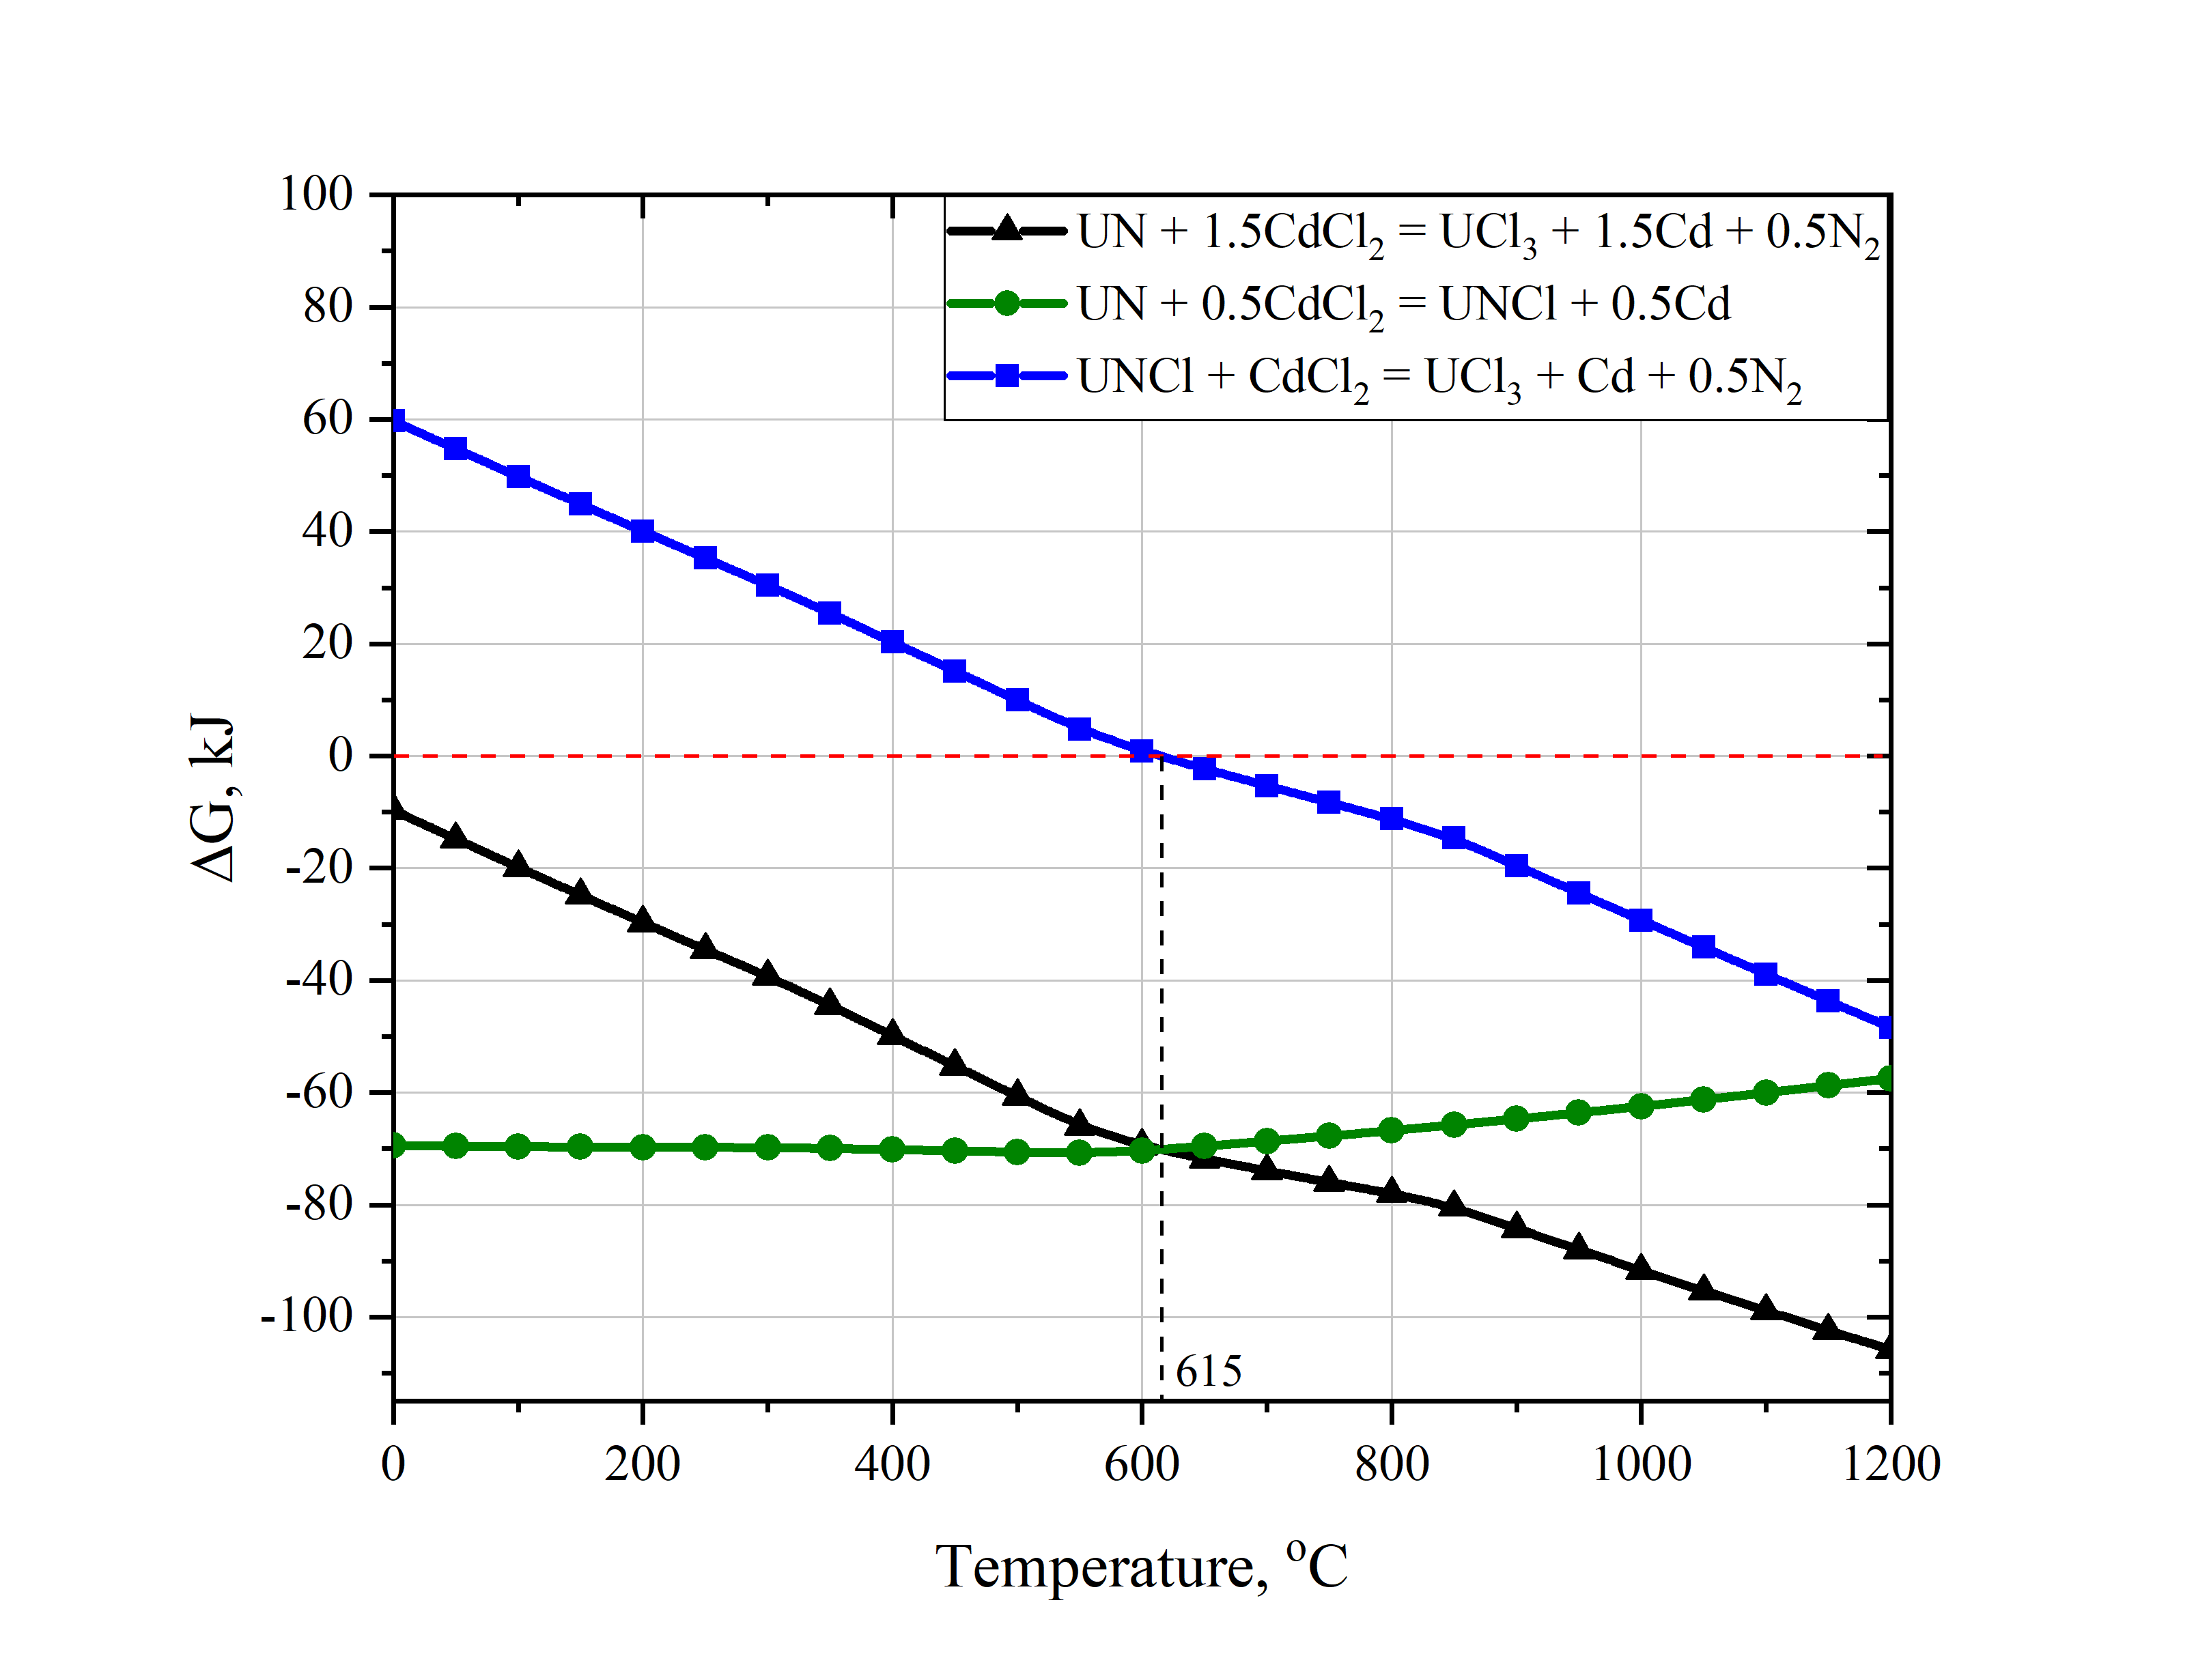
Fig. 1. Temperature dependence of the Gibbs energy change for reactions 3 - 5.
Up to 600 °C, the reactions with the formation of UCl₃ and UNCl proceed in parallel and the chlorination products of uranium nitride will be these two compounds, as well as a mass of non-stoichiometric uranium nitrides. However, at temperatures above 615 °C, UNCl and other insoluble nitrides begin to interact with an excess of CdCl₂ to give the target product, UCl₃.

$${UN}_{1.69}+1.5Cd{Cl}_{2}=U{Cl}_{3}+1.5Cd+0.845N_{2}↑$$ | $$∆G≈0 kJ at 500°C$$ | (8)
$${UN}_{1.69}+1.5Cd{Cl}_{2}=U{Cl}_{3}+1.5Cd+0.845N_{2}↑$$ | $$∆G= -23 kJ at 650°C$$ | (9)
$${UN}_{1.5}+1.5Cd{Cl}_{2}=U{Cl}_{3}+1.5Cd+0.75N_{2}↑$$ | $$∆G≈0 kJ at 500°C$$ | (10)
$${UN}_{1.5}+1.5Cd{Cl}_{2}=U{Cl}_{3}+1.5Cd+0.75N_{2}↑$$ | $$∆G= -25 kJ at 500°C$$ | (11)

Thus, it can be concluded that there are two stages in the chlorination process. At temperatures below 615 °C, only the first stage takes place with the formation of UNCl, U₂N₃, UN₂ and nonstoichiometric nitrides UN_{1.55}, UN_{1.69}, UN_{1.73}. Above 615 °C, the second stage becomes thermodynamically possible, in which all intermediate products react with an excess of CdCl₂. Note that at 615 °C the Gibbs energy of the reactions only changes sign from plus to minus. It is possible that in order to achieve reaction rates sufficient for practice, a higher temperature will be needed. For example, in [2, 18] it was demonstrated that at 750 °C and some excess of CdCl₂, the interaction of UN and CdCl₂ proceeds according to the overall reaction (3). No insoluble products were found.
FIG. 2 shows the result of thermodynamic modeling of the chlorination process of 1 mol of UN at 750 °C in a simplified form that is easy to understand. The figure shows the stages through which the process goes. The abscissa shows the amount of CdCl₂ added to the system.
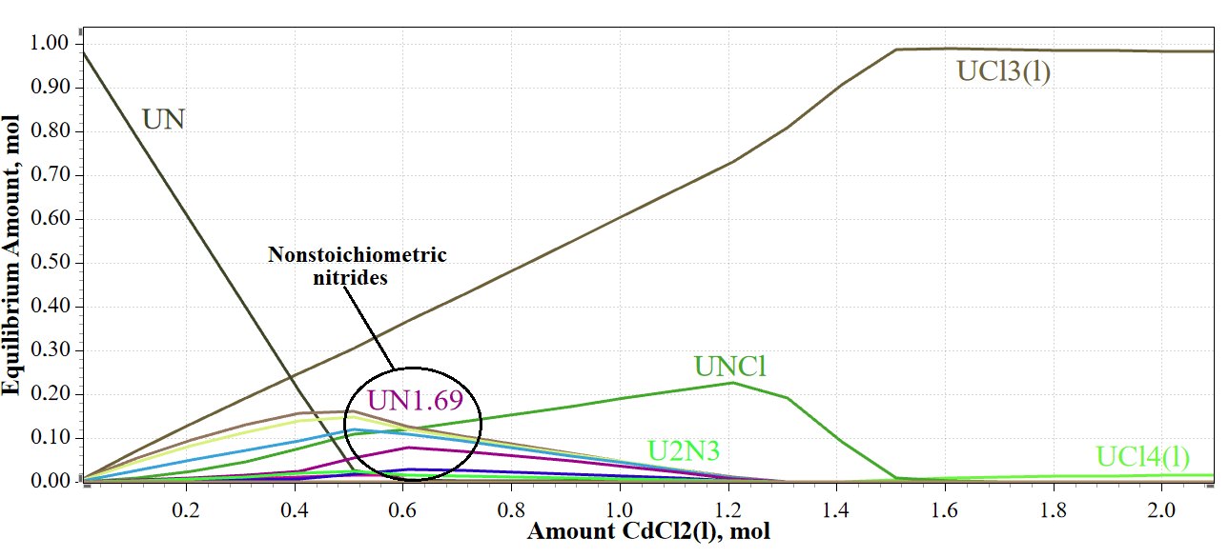
Fig. 2. Equilibrium composition of the UN + CdCl₂ system depending on the amount of CdCl₂ added to the system at 750 °C.

Looking at FIG. 2, two stages of the soft chlorination process can be distinguished. The first stage with the formation of UNCl and nonstoichiometric uranium nitrides occurs in the region of a lack of cadmium chloride in the system with respect to the stoichiometry of reaction (3). When cadmium chloride is added to the system, the formed non-target products are chlorinated with the formation of UCl₃ and partially UCl₄.
For visual clarity of the calculation, we will take the amount of the substance of the compounds equal to their molar percentages from TABLE 1. Thus, the calculation will be carried out for 100 mol of SNF. We will choose argon in the amount of 50 mol as the atmosphere. The amount of the eutectic substance will be taken as 100 mol (58.8 mol LiCl and 42.2 mol KCl). We’ll take a twofold excess of the chlorinating agent (300 mol). The calculation results are presented in TABLE 3.

TABLE 3. COMPONENTS FORMED AFTER SOFT CHLORINATION OF NITRIDE SNF USING CdCl₂ IN LiCl-KCl EUTECTIC AT 750 °C BASED ON THE RESULTS OF THERMODYNAMIC MODELING

№ | Compound/  element | Amount of substance, mol. % | № | Compound/  element | Amount of substance, mol. %
1 | UCl₃(l) | 70.9 | 25 | SmCl₂ | 0.149
2 | PuCl₃(l) | 13.0 | 26 | MoC | 0.147
3 | UCl₄(l) | 2.18 | 27 | Kr(g) | 0.144
4 | Xe(g) | 1.70 | 28 | YCl₃(l) | 0.141
5 | Ru | 1.46 | 29 | RbCl(l) | 0.123
6 | CsCl(l) | 1.40 | 30 | Sn | 0.0669
7 | ZrN | 1.36 | 31 | Li₃Cl₃(g) | 0.0662
8 | NdCl₃(l) | 1.22 | 32 | C(g) | 0.0605
9 | Mo | 0.892 | 33 | MoN_{0.5} | 0.0597
10 | CeCl₃(l) | 0.760 | 34 | ZrCl₄(g) | 0.0432
11 | Rh | 0.448 | 35 | LiCl(g) | 0.0416
12 | Tc | 0.399 | 36 | EuCl₂(l) | 0.0390
13 | UPd₃ | 0.376 | 37 | GdCl₃(l) | 0.0362
14 | BaCl₂ | 0.356 | 38 | Ag₃I₃(g) | 0.0318
15 | LaCl₃ | 0.271 | 39 | Li₂Cl₂(g) | 0.0318
16 | SrCl₂(l) | 0.259 | 40 | PmCl₂ | 0.0307
17 | CdTe | 0.247 | 41 | Mo₃C₂ | 0.0294
18 | PrCl₃ | 0.215 | 42 | NpCl₃ | 0.0276
19 | Mo₂C | 0.211 | 43 | CdSe | 0.0241
20 | BaCl₂(l) | 0.195 | 44 | KCl(g) | 0.0239
21 | SmCl₃(l) | 0.192 | 45 | CdI(g) | 0.0230
22 | PrCl₃(l) | 0.176 | 46 | Li₂Cl₂ | 0.0204
23 | AmN | 0.157 | 47 | PmCl₃ | 0.0150
24 | LaCl₃(l) | 0.150 | 48 | AmCl₃ | 0.0144
Total |  |  | 99.89%

For clarity, only some of the compounds are shown. The sum of the amount of the substance of the compounds not included in the table does not exceed 0.11 mol.%.
The main compounds, as expected, were the chlorides of uranium and plutonium, as well as the chlorides of rare earth elements and other actinides and lanthanides.

Chlorinating agent: PbCl₂
The Pb²⁺/Pb potential is much more positive than the Cd²⁺/Cd potential. Hence PbCl₂ is a stronger chlorinating agent than CdCl₂. The chlorination process will also proceed according to reactions 1-11, where instead of CdCl₂ there will be PbCl₂, and metallic lead will be formed, not cadmium. As follows from FIG. 3 process in this case can be carried out at lower temperatures, because chlorination of UNCl occurs at a lower temperature.
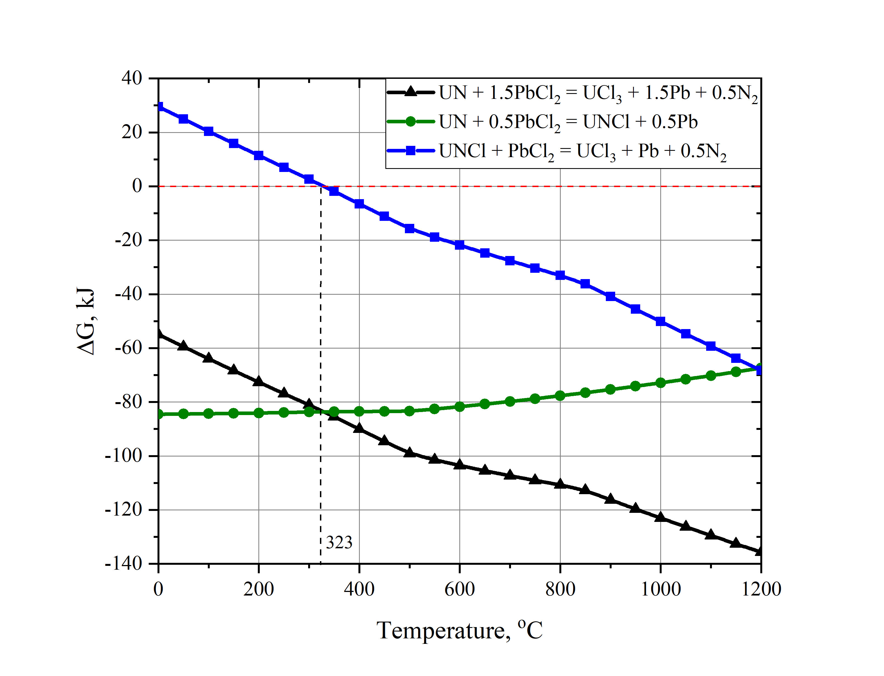
Fig. 3. Dependence of Gibbs energy on temperature for chlorination reactions of UN with lead chloride.

FIG. 3 shows that already starting from a temperature of 323 °C, the chlorination reaction of the formed UNCl to UCl₃ becomes possible. Therefore, presumably, the process can be carried out at temperatures only slightly higher than the melting point of lead chloride (501 °C).
For thermodynamic modeling of the chlorination process using PbCl₂, we use the same initial data as for the chlorination of CdCl₂. Since theoretically the process can be carried out at relatively low temperatures, we will choose 650 °C as the working temperature. The result of calculating the equilibrium composition of the mixture formed during the chlorination of nitride SNF with lead chloride in the LiCl-KCl melt is presented in TABLE 4.

TABLE 4. COMPONENTS FORMED AFTER SOFT CHLORINATION OF NITRIDE SNF USING PbCl₂ IN LiCl-KCl EUTECTIC AT 750 °C BASED ON THE RESULTS OF THERMODYNAMIC MODELING

№ | Compound/  element | Amount of substance, mol. % | № | Compound/  element | Amount of substance, mol. %
1 | UCl₃(l) | 67.5 | 25 | YCl₃(l) | 0.141
2 | PuCl₃(l) | 13.0 | 26 | MoC | 0.139
3 | UCl₄(l) | 5.25 | 27 | RbCl(l) | 0.123
4 | Xe(g) | 1.70 | 28 | PrCl₃(l) | 0.117
5 | Ru | 1.45 | 29 | LaCl₃(l) | 0.0957
6 | CsCl(l) | 1.39 | 30 | CdCl₂(l) | 0.0818
7 | Mo | 1.38 | 31 | Sn | 0.0682
8 | NdCl₃(l) | 1.22 | 32 | SmCl₂ | 0.0625
9 | ZrN | 1.21 | 33 | PmCl₃ | 0.0425
10 | Rh | 0.447 | 34 | EuCl₂(l) | 0.0389
11 | BaCl₂ | 0.399 | 35 | GdCl₃(l) | 0.0361
12 | Tc | 0.397 | 36 | Ag₃I₃(g) | 0.0351
13 | CeCl₃(l) | 0.757 | 37 | Mo₂C | 0.0322
14 | UPd₃ | 0.374 | 38 | NpCl₃ | 0.0275
15 | LaCl₃ | 0.323 | 39 | PbSe | 0.0233
16 | C | 0.298 | 40 | Sb | 0.0202
17 | SmCl₃(l) | 0.277 | 41 | CmCl₃ | 0.0141
18 | PrCl₃ | 0.273 | 42 | MoN_{0.5} | 0.0118
19 | SrCl₂(l) | 0.259 | 43 | He(g) | 0.0105
20 | PbTe | 0.241 | 44 | PbCl(g) | 0.00935
21 | ZrCl4(g) | 0.188 | 45 | PbI₂(g) | 0.00800
22 | AmCl3 | 0.171 | 46 | PbCl₂(g) | 0.00780
23 | BaCl2(l) | 0.149 | 47 | Li₃Cl₃(g) | 0.00524
24 | Kr(g) | 0.143 | 48 | TeI₂(g) | 0.00477
Total |  |  | 99.95%

The sum of the amount of the substance of the compounds not included in the table does not exceed 0.05 mol.%. In both cases, during chlorination, the main products are UCl₃, UCl₄, and PuCl₃. Inert gases Xe, Kr are released from the fuel.
Noble metals form intermetallic compounds for example UPd₃, but they are also present in the form of Ru, Rh metals. Silver forms silver iodide.
Lanthanides are chlorinated and are present in the form of chlorides LaCl₃, CeCl₃, NdCl₃, etc. Actinides are also chlorinated (AmCl₃, CmCl₃).
During chlorination, zirconium remains in the form of its nitride ZrN and a small amount of ZrCl₄. Molybdenum remains partly in the form of its nitride MoN_{0.5}, but most of it is in free form.

Conclusions
The material composition of the nitride SNF was calculated by the methods of thermodynamic modeling. The equilibrium composition of mixtures, which are formed during the chlorination of SNF using CdCl₂ or PbCl₂ in molten LiCl-KCl eutectic, has been calculated. It is shown that in both cases chlorination proceeds in two main stages through several parallel reactions. The results obtained can be used to select the technological parameters of chlorination operations.
References
- SOUCEK, P. et al., “Status of R&D on pyrochemical processes for spent nuclear fuel treatment in Europe within the SACSESS Project” Actinide and Fission Product Partitioning and Transmutation (Fourteenth Information Exchange Meeting, San Diego, United States, 2016) Nuclear Energy Agency (2017).
- POTAPOV, A. et al., “Pyrochemical Recycling of the Nitride SNF of Fast Neutron Reactors in Molten Salts as a Part of the Short-Circuited Nuclear Fuel Cycle”, Fast Reactors and Related Fuel Cycles: Next Generation Nuclear Systems for Sustainable Development FR17 (Proc. Int. Conf., Yekaterinburg, 2017), IAEA, Vienna (2018), Paper CN245-259
- POTAPOV, A. et al., “The peculiarities of Pyrochemical Reprocessing of Spent Nuclear Fuel”, Global 2017 (Int. Nuclear Fuel Cycle Conf. Seoul, Korea, Republic Of, 2017), Seoul, Korea (2017).
- ZAIKOV, Yu. Et al., Research and Development of the pyrochemical processing for the mixed nitride uranium-plutonium fuel, J.Phys.: Conf. Ser. 1475 (2020) 012027
- ROINE, A., HSC Chemistry® [Software]. Outotec. Pori 2018. Software available at www.outotec.com/HSC.
- WHITE, W., JOHNSON, S., DANTZIG, G., Chemical equilibrium in complex mixtures, J. Chem. Phys. 28, (1958) 751-755.
- YANG, L., HUDSON, R., Equilibrium electrode potentials of some metal-chlorine galvanic cells and activities of some metal chlorides in LiCl-KC1 eutectic melt, Trans.Met.Soc.AIME 215 (1959) 589-601.
- OGAWA, T., MINATO, K., Dissolution and formation of nuclear materials in molten media, Vol. 73, No. 5, Pure Appl. Chem., (2001) 799–806.
- MASSET, P., BOTTOMLEY D., KONINGS R. et al., Electrochemistry of uranium in molten LiCl-KCl eutectic, J.Electrochem. Soc., 152 № 6, (2005) 1109-1115.
- ARAI, Y., MAEDA, A., SHIOZAVA, K., OHMICHI, T., Chemical forms of solid fission products in the irradiated uranium—plutonium mixed nitride fuel, Journal of Nuclear Materials, 210 (1994) 161-166.
- IMOTO, S., Chemical state of fission products in irradiated UO₂, Journal of Nuclear Materials 140 (1986) 19-27.
- KLEYKAMP, H., The chemical state of the fission products in oxide fuels, Journal of Nuclear Materials 131 (1985) 221-246.
- DOLGODVOROV, A., Modeling the behavior of fission products in nitride fuel, Ph.D. thesis in Engineering Science. IBRAE. Moscow. 2017. 128 p. (In Russian)
- GORDIENKO, S., PHENOCHKA, B., VIKSMAN, G., Thermodynamics of lanthanide compounds. Handbook, Nauk. Dumka., Kiev (1979) 376. (In Russian)
- BOLGAR, A., LITVINENKO, V., Thermodynamic properties of nitrides, Nauk. Dumka., Kiev, (1980) 284. (In Russian)
- ARAI, Y., “Nitride fuel”, Comprehensive Nuclear Materials, Elsevier, Amsterdam (2012) Vol. 3, 41–54.
- ZHITKOV, A., POTAPOV, A., KARIMOV, K et al., Interaction between UN and CdCl2 in molten LiCl-KCl eutectic. I. Experiment at 773 K, Nuclear Engineering and Technology 52 (2020) 123-134.
- POTAPOV, A. et al., “Mechanism of UN + CdCl₂ interaction in LiCl-KCl molten eutectic” (Int. Pyroprocessing Research Conf. Tokai-mura, Ibaraki, Japan, 2018), Tokai‐mura, Ibaraki, Japan, (2018).

