VERSATILE TEST REACTOR (VTR) PROJECT

MISSION AND STATUS

J. ROGLANS-RIBAS
Argonne National Laboratory
Argonne, Illinois, U.S.A
Email: roglans@anl.gov

K.O. PASAMEHMETOGLU
Idaho National Laboratory
Idaho Falls, Idaho, U.S.A

T.J. O’CONNOR
U.S. Department of Energy
Germantown, Maryland, U.S.A.

Abstract

To support the deployment of advanced nuclear technologies and enable long term innovation, the U.S. Department of Energy (DOE) has initiated a project to build a Versatile Test Reactor (VTR) with a compelling and urgent mission: testing innovative fuels, materials, sensors and instrumentation for various advanced reactor types under development. VTR will enable testing with very high fast neutron spectrum flux over large volumes and representative irradiation lengths. VTR’s design will support the use of self-contained internally circulating loops for sodium, lead, lead-bismuth eutectic, helium and molten salt coolants to support commercial technology development efforts. It will also support a rabbit system to enable rapid irradiation testing. Additional experimental positions throughout the core will be available for instrumented and un-instrumented test vehicles. VTR project management follows DOE regulations on capital assets acquisition. The first critical decision, reached in February 2019, confirmed the need for a fast spectrum irradiation capability and authorized the analysis of alternatives and development of a conceptual design for the preferred strategy. The second critical decision, signed in September 2020, approved the preferred strategy and established cost and schedule ranges based on the conceptual design of a sodium-cooled fast reactor. VTR is being designed using recently approved U.S. NRC advanced reactor design criteria and risk-informed performance-based safety basis development guides. VTR will support re-establishing parts of the U.S. nuclear supply chain and will modernize the design and construction process through the use of digital engineering design tools and integrated requirements management systems.

INTRODUCTION
The United States (U.S.) has been an international leader in the development and testing of advanced nuclear reactor technologies since the advent of nuclear power generation. The U.S. Department of Energy (DOE) and its predecessor organizations appropriately provided nuclear fuels and materials development capabilities and large-scale testing facilities in support of all currently deployed nuclear reactor technologies. Included in today’s DOE’s mission is the advancement of the energy, environmental, and nuclear security of the U.S. and the promotion of scientific and technological innovation in support of that mission. DOE’s current Strategic Plan states that DOE “will continue to explore advanced concepts in nuclear energy that may lead to new types of reactors with further safety improvements and reduced environmental and proliferation concerns.”
Development of next generation advanced reactor technologies is being actively pursued by DOE national laboratories, and U.S. universities and industries, with similar efforts by international organizations. Many commercial organizations and universities are pursuing advanced nuclear energy fuels, materials, and reactor designs that complement the efforts of DOE and its laboratories in achieving DOE’s goal of advancing nuclear energy. These designs include thermal and fast-spectrum reactors targeting improved fuel resource utilization and waste management and utilizing materials other than water for cooling. Common to advanced nuclear reactor technology development is the urgent need to perform accelerated testing and qualification of advanced nuclear fuels, materials, instrumentation, and sensors. Furthermore, innovation in the current generation of nuclear power technology requires continuous fuel and material testing programs before improvements and technological advances can be incorporated into operating plants.
Advanced nuclear technology development, as well as technology innovation in support for the current nuclear power industry, requires an adequate infrastructure for experimentation, testing, design evolution, and component qualification. Existing irradiation test capabilities are aging, and some are over 50 years old. Additionally, the U.S. has not maintained a domestic fast neutron spectrum testing capability for over two decades. This gap in testing capability is severely limiting the U.S. ability to move forward in the development of next-generation nuclear reactors – many of which require a fast neutron spectrum for operation – and equally impacts the U.S. ability to regain technology leadership in this arena. The existing capabilities are focused on testing of materials, fuels, and components in the thermal neutron spectrum and do not have the ability to support the needs for fast reactors. Only 3 fast-neutron-spectrum operational test reactors currently exist outside the U.S., thus resulting in a limited availability of testing capabilities for U.S. advanced reactor developers.
DOE performed a mission needs assessment to determine current testing capabilities (domestic and foreign) against the testing needs to support the development of advanced nuclear technologies. The assessment identified a gap in the technology development infrastructure for testing fuels and materials in a fast neutron spectrum. In February 2017, the U.S. Department of Energy Office of Nuclear Energy’s (DOE-NE) Nuclear Energy Advisory Committee (NEAC) released a final report evaluating the needs and requirements for a new U.S. test reactor. The key recommendation of this report, Assessment of Missions and Requirements for a New U.S. Test Reactor (1), was for DOE to “proceed immediately with pre-conceptual design planning activities to support a new test reactor (including cost and schedule estimates).” The NEAC study confirmed the conclusions of an earlier study, Advanced Demonstration and Test Reactor Options Study (2). That study established the strategic objective that DOE “provide an irradiation test reactor to support development and qualification of fuels, materials, and other important components/items (e.g., control rods, instrumentation) of both thermal and fast neutron-based … advanced reactor systems.”

The VTR PROJECT
The Nuclear Energy Innovation Capabilities Act (NEICA) of 2017 (3), in line with the NEAC study recommendations, directed DOE, to the maximum extent practicable, to approve the start of operations for the user facility no later than December 31, 2025. Note that since NEICA was enacted in 2018, DOE has targeted the start of operations for December 2026. DOE recognized that a near-term deadline would require the technology selected for the user facility to be a mature technology, one not requiring significant testing or experimental efforts to qualify the technology needed to provide the required capabilities.
The NEAC study established the basic considerations for such required testing capability:

- An intense, neutron-irradiation environment with prototypic fast neutron spectrum to determine irradiation tolerance and chemical compatibility with other reactor materials, particularly the coolant;
- Testing that provides a fundamental understanding of materials performance, validation of models for more rapid future development, and engineering-scale validation of materials performance in support of licensing efforts;
- A versatile testing capability to address diverse technology options and sustained and adaptable testing environments;
- Focused irradiations, either long- or short-term, with heavily instrumented experimental devices, and the possibility to do in-situ measurements and quick extraction of samples; and
- An accelerated schedule to regain and sustain U.S. technology leadership and to enable the competitiveness of U.S-based industry entities in the advanced reactor markets.

DOE established the Versatile Test Reactor (VTR) Program in 2017 to fulfil the DOE NEAC recommendations and later to meet the direction provided in NEICA. The generation of a high flux of high-energy, or fast, neutrons requires a departure from the light-water-moderated technology of current U.S. power reactors and use of other reactor cooling technologies.
The starting phase of the VTR Program consisted of an initial planning period to determine the preferred technology. The planning phase included extensive user interviews to understand desired capabilities, and a requirements document (4) that selected a preferred technology that best satisfied the user needs and had the technical maturity to be operational within the timeframe specified in NEICA. The requirements document articulated the potential user requirements that were obtained through extensive interviews of the user community, then reviewed and selected the technology at a high level. A set of preliminary key performance parameters (KPP), shown in Table 1, were developed based on the VTR requirements document.

TABLE 1. VTR KEY DESIGN PERFORMANCE PARAMETERS*

Key Performance Parameter | Target Objective | KPP Threshold Validation
Provide a high peak neutron flux (neutron energy > 0.1 MeV) with a prototypic fast reactor neutron energy spectrum | ≥ 4 x 10¹⁵ n/cm² s | Constructed fast-spectrum reactor with adequate power level and ability to reject heat, and completion of authorization to operate
Provide high neutron dose rate for materials testing, quantified as displacements per atom (dpa) | > 30 dpa/year | Constructed fast-spectrum reactor with adequate power level and ability to reject heat, and completion of authorization to operate
Provide an irradiation length that is typical of fast reactor designs | 0.6 m ≤ L ≤ 1 m | Constructed fast-spectrum reactor with irradiation length minimum of 0.6 m
Provide a large irradiation volume within the core region | ≥ 7 Liters | Constructed fast-spectrum reactor with designed irradiation volume meeting or exceeding seven Liters
Provide experiment hardware such as casks and storage locations to support experimental mission | Provide capability for open core, closed loops, and rabbit facility for testing  Na, Pb, Pb-Bi, He, and Molten Salts loops | Operational experiment hall, casks, storage locations, experiment handling equipment are adequate to support experiment mission
Provide lifecycle management for the reactor driver fuel | Fuel is available for startup and a pathway for used fuel management is established | Two fuel core loads are manufactured and capability to handle used fuel is established
- Based on the VTR requirements document
After the initial planning phase, the VTR Project was subsequently established in 2018 as a capital acquisition project to be executed under the guidelines of DOE Order 413.3B, Program and Project Management for the Acquisition of Capital Assets (5). DOE Order 413.3B establishes the process for initiating, planning, and executing the project by going through a set of critical decisions (CDs) as the project progresses. Each critical decision requires approvals by different DOE Offices and the Energy Systems Acquisition Advisory Board (ESAAB).
The first CD milestone was reached on February 22, 2019, when the Mission Need Statement (6) was approved, and then Secretary of Energy Rick Perry announced the launch of the VTR Project as a part of modernizing the U.S. nuclear R&D infrastructure. Work started in earnest on the definition and analysis of alternatives, the conceptual design of the VTR based on the preferred technology alternative, the conceptual safety design, acquisition strategy, and cost and schedule range. The second major CD milestone was completed on September 11, 2020, with the approval by the Deputy Secretary of Energy of the Approval of Alternative Selection and Cost Range for the Versatile Test Reactor Project.

The critical decision milestones defined under the DOE capital acquisition process, and the schedule planning at the first and second milestones are defined in Fig.1. The schedule for the VTR was initially estimated during the establishment of the mission need and was approved at critical decision (CD-0). Updated schedules were estimated with the development of the conceptual design and the acquisition plan that was approved during critical decision (CD-1). Future project schedule updates will be made as the design matures and to reflect project funding profiles. The process will lead to a performance baseline schedule to be approved as part of critical decision (CD-2).

CD | CD-0 | CD-1 | CD-2 | CD-3 | CD-4
Critical Decisions | Approve Mission Need | Approve Alternative Selection and Cost Range | Approve Performance Baseline | Approve Start of Construction | Approve Start of Operations
Critical Decision Schedule | Approved at CD-0 | Actual*/  Approved at CD-1**
CD-0 | Feb. 22, 2019 | Feb. 22, 2019*
CD-1 | 4th Quarter 2020 | Sept. 11, 2020*
CD-2/3 | 3rd Quarter 2022 | 2nd Quarter 2023**
CD-4 | 3rd Quarter 2026  (Range: 2026-2030) | 4th Quarter 2026**  (Range: 2026-2031)

FIG.1. DOE process for acquisition of capital assets and VTR planned schedule

To develop the information and documentation necessary for the conceptual design documents, the first step was to establish a project organization that would make the most efficient use of the existing resources in DOE’s National Laboratories and U.S. universities and industries. The VTR Project is led by Idaho National Laboratory (INL) but is substantially supported by other DOE laboratories (Argonne National Laboratory [ANL], Los Alamos National Laboratory [LANL], Oak Ridge National Laboratory [ORNL], Pacific Northwest National Laboratory [PNNL], and Savannah River National Laboratory [SRNL]). Multiple universities and subcontractors have also been engaged. The main areas of work in the conceptual design phase have been as follows:
- DOE National Laboratories – Manage the overall project and provided the fuel system design and supply studies, the core design, the safety basis, and the safety analysis
- Industry – Provide the conceptual plant design (General Electric-Hitachi Nuclear Company [GEH], and Bechtel National Inc. [BNI]) and other consulting companies support with specific elements of the design and cost estimate process
Universities – Contribute to the design of the experimental capabilities, organized in teams by reactor technology (sodium cooled, lead/lead-bismuth cooled, gas cooled, and molten salt) to which laboratories and the commercial sector also contribute

The DOE acquisition process requires the performance of an analysis of alternatives. The recommendation of the preferred technology was based on several technical considerations to provide high confidence that the conceptual design would meet the mission need requirements, in a safe and economic manner, and with high confidence that the technology is mature enough to meet the schedule requirements and be able to support advanced technology development in a timely manner.
Recognizing that the schedule for the VTR project is aggressive, the design approach implements a series of mitigating actions to reduce unique risks associated with nuclear acquisition. These involve:
- Early stabilization and substantial completion of design at each project stage, including
  - Leveraging an existing design
  - Leveraging existing fuel designs and fabrication methods
  - Extensive use of digital engineering
- Early stabilization and regulatory approval of the safety basis documentation, including
  - Use of safety and transient analysis to inform the design
  - Use of a performance-based risk-informed safety basis
  - Early and frequent interaction with the regulatory authority
- Early investigation and confirmation of the supply chain, including
  - Assessment of capabilities of vendors to perform at the required quality levels
  - Early prototyping of critical components

A sodium-cooled, pool-type, metal-fueled reactor was considered the most practical and cost-effective strategy to meet the mission needs and address project schedule constraint because of the maturity of the technology among fast spectrum reactor concepts. The evaluation of technology options is consistent with the conclusions of the test reactor options study and the NEAC recommendations. U.S. experience with a pool-type configuration and qualification of metallic alloy fuels affords the desired level of technology maturity and safety approach. Sodium-cooled reactor technology was successfully used at the Experimental Breeder Reactor (EBR)-II operated by Argonne National Laboratory in Idaho, and the Fast Flux Test Facility (FFTF), operated at the Hanford Engineering Development Laboratory, in Washington. EBR-II and FFTF combined provided over 50 years of successful operation as a test facility and were instrumental in irradiating and qualifying advanced fuels and materials as well as demonstrating the technology. The experience includes a set of tests conducted at EBR-II in 1986, the Inherent Safety Demonstration Tests, which demonstrated that this technology can be designed to provide inherent and passive safety.

The preferred VTR concept will leverage the proven, existing technologies incorporated in the small, modular GE-Hitachi Power Reactor Innovative Small Module (PRISM) design (6). The PRISM design meets the recommended alternative of using a sodium-cooled, pool-type reactor of proven (mature) technology. The VTR would be a smaller (approximately 300 megawatts) version of the GE-Hitachi PRISM power reactor (Version Mod A, of approximately 470 megawatts thermal). The reactor, primary heat removal system, and safety systems would be similar to those of the PRISM design. VTR, like PRISM, would use metallic alloy fuels.
The VTR project is subject to the National Environmental Policy Act (NEPA) process, which requires the evaluation of alternative potential sites for the construction of the VTR. This includes the construction of the VTR plant as well as the construction of the VTR fuel fabrication facility. Desirable sites that have been evaluated are those DOE sites that already have existing infrastructure that could support the VTR (e.g., fuel fabrication facilities or post-irradiation examination capabilities) in order to utilize existing infrastructure. Two DOE sites are being evaluated for hosting the VTR, one at the INL and another at the ORNL, while two sites are also being evaluated for hosting the VTR fuel fabrication, one at the INL and another at the Savannah River Site (SRS).

The environmental impacts at the sites evaluated are assessed, and compared with a no action alternative, under an Environmental Impact Statement (EIS). Fig. 2 shows the timeframe for the completion of the NEPA process. It started with the announcement of the intent to proceed with evaluation of sites for the VTR project and ends with the DOE record of decision on the selected VTR site. Selection of the fuel fabrication location will occur later.

The VTR CONCEPTUAL DESIGN
In the early stages of the VTR program, efforts were focused on trade-off studies to determine the relationship between the maximum achievable peak fast flux (E_{n}>0.1 MeV) as a function of the core power, while respecting basic thermal-hydraulics and temperatures limits. A metallic fuel system was selected with the objective of meeting the performance requirements while using fuels that had previously undergone extensive irradiation that would facilitate qualification for their use in the VTR. These early studies resulted in a target core power level of 300 MW to achieve the desired flux levels (>4.0x10¹⁵ n/cm²-s) with the selected metallic fuel.

Notice of Intent published in the Federal Register
DOE hosts public scoping meetings via webinar
Draft Environmental Impact Statement (EIS) (6) undergoing DOE review
EIS looks at
- No Action Alternative, Build VTR at INL and Build VTR at Oak Ridge National Lab
- Will also look at fuel fabrication at INL and Savannah River Site
Draft EIS (6) published
Public Review of Draft EIS
- At least 45-day comment period
- At least one públic (via Webinar) Meeting required with 15 days Advanced notice
DOE releases final EIS
- Respond to oral and written comments on the Draft EIS
- 30 day waiting period (after EPA Note of Availability is published)
DOE issues record of decision
- Reactor site
- Fuel fabrication site
FIG. 2. Timeline for the National Environmental Policy Act (NEPA) process for VTR

Conceptual core design
The VTR reference core layout designed as part of the conceptual design (7) to support the CD-1 decision is shown in Fig. 3. The core is composed of 66 fuel assemblies, six control rods, three safety rods, 114 radial reflectors, 114 radial shield reflectors. All assembly ducts are made of HT-9 and have a pitch of 12 cm. The fuel assemblies contain 217 fuel pins having an 80 cm column of fuel and an 80 cm fission gas plenum above the fuel. The fuel is contained in a HT-9 cladding wrapped in a thin wire. These assemblies also contain a 90 cm lower reflector region and a 60 cm upper reflector region. Extensive design analyses have been performed to characterize the major aspect of the reactor to ensure feasibility from all perspectives. This includes a thermal-hydraulic assessment of the core, determination of the reactivity coefficients and of the required shutdown worth, assessment of the control and safety rods performance, in-vessel shielding calculations for secondary sodium activation, and preliminary safety analyses (8).

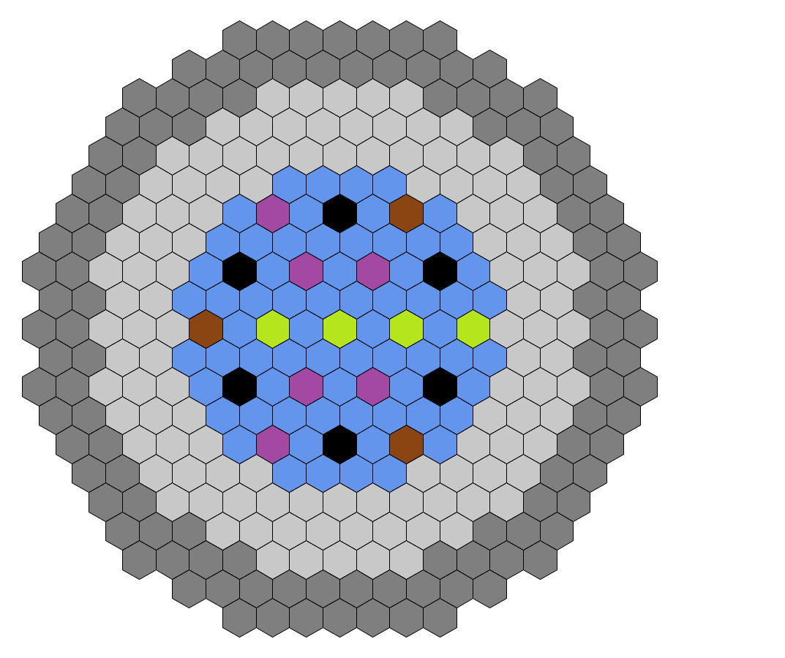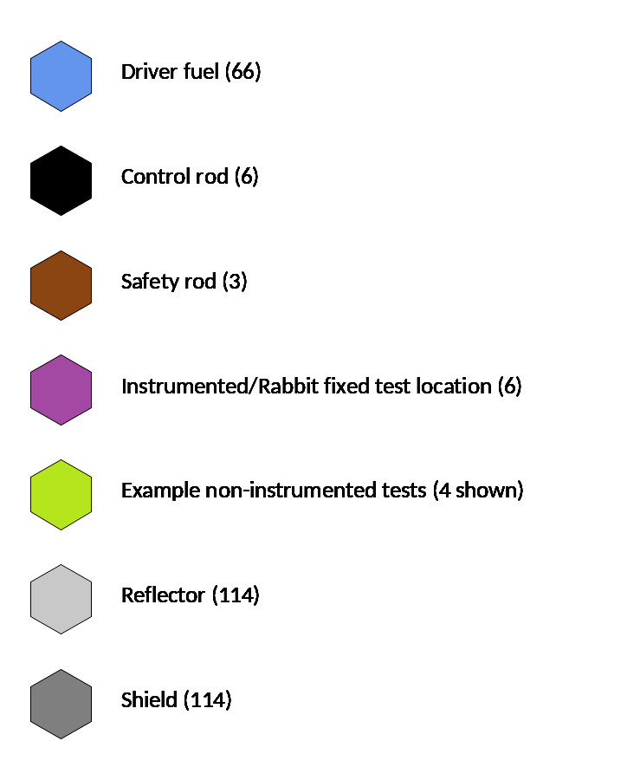

FIG. 3. VTR conceptual design core map

Experimental capabilities
There are multiple test locations in the VTR core and there are different types of experimental positions (9). Non-instrumented experiments (i.e., test specimens) could be placed in multiple locations in the reactor core or in the reflector regions, by replacing a fuel or reflector assembly. Fig. 3 shows an example of 4 potential such locations. Instrumented experiments, which can provide real-time information while the reactor is operating, require a penetration in the reactor cover for the instrumentation stalk and can only be placed in any of six fixed locations. One of these six locations can accommodate a “rabbit” test facility, where samples can be inserted/removed while the reactor is in operation. The number of instrumented test locations, plus the flexibility in the number and location of non-instrumented tests would strengthen the versatility of the reactor as a test facility. VTR uses the following definition for the different types of experiment devices:
- Normal test assembly: these are standard non-instrumented or passively instrumented open test assemblies that are the same size, flat-to-flat, as the driver fuel assemblies. They can contain fuel or materials for testing.
- Extended length test assembly: these test assemblies extend through the reactor head, and typically have various instrumentation leads that run to the Non-Radiation and/or Radiation Experiment Rooms that are adjacent to the Head Access Area above the reactor cover. These experiments can contain fuels or materials or can be cartridge loops that contain coolants separate from the primary sodium.
- Rabbit test assembly: This test facility uses a capsule that contains the experiment specimens, which is propelled down a thimble into the core position, where the sample is irradiated. This facility is intended for small samples to be irradiated for short times and insertion/extraction can be done while the reactor is operating.
- In addition, the capability to handle dismountable test assemblies (fuel assemblies that can accommodate a small sector of test fuel rods) is also being designed for the VTR. The dismountable test assemblies can be inserted in a driver fuel position and the replacement of the test section will be designed to be performed under sodium.

The cartridge loop capability in the extended length test assemblies is one of the key experimental capabilities of VTR. These cartridge loops will contain coolant (sodium, lead, lead/bismuth, molten salt, helium) other than the primary sodium coolant to allow the testing of fuel and materials under the conditions that would exist in the reactor designs under development utilizing different coolant technologies.

Reactor system
As indicated, a pool configuration, inside a double-walled primary vessel, was selected for the VTR. The similarly sized PRISM Mod A design was selected to be adapted to the mission of the VTR. The core of the VTR is designed to provide the required experiment performance. The VTR core replaces the PRISM core but the physical design of the reactor vessel and its internals is maintained, to the extent possible, from the initial PRISM Mod A design. Sodium circulation through the core is accomplished with the use of four electromagnetic pumps, and the primary heat is extracted with the use of two secondary loops through intermediate heat exchangers. A diagram of the primary system can be seen in Fig. 4.
There is a significant amount of storage inside the primary vessel for fuel or test assemblies. More than 90 assembly locations are provided between the region on the upper internal structure close to the reactor cover, and the outermost ring of the reactor core. The extensive in-vessel storage provides flexibility for test assemblies irradiation schemes and for providing a cooling period before removing spent fuel assemblies from the vessel.

The design of the primary vessel cover is significantly modified in order to accommodate all the penetrations necessary to support the extended length test assemblies and cartridge loops. The in-vessel refueling machine design will also be modified to support the higher duty cycle demanded by the test reactor mission. The planned operating cycle for the VTR is 100 days full-power equivalent, followed by a ~20-day refueling outage. Three irradiation cycles would be run annually.

Ensuring a high degree of safety and a proven approach to safety of the reactor (10, 11) is paramount in order to enable the timely licensing of the facility and ensure safe and reliable operations. The approach to the safety design of the reactor is based on several factors:

- Use of a fuel system with an existing qualification database and with safety demonstration experience. Metallic fuels were developed by the DOE under the Advanced Liquid Metal Reactor (ALMR) program. These fuels were developed for their ability to provide inherent safety (significant negative reactivity feedbacks under transient conditions) when the core is properly designed. The inherent safety approach for these fuels was demonstrated in experiments in both EBR-II and FFTF
- Maximum use of inherent and passive safety, accomplished by:
  - Leveraging lessons learned from previous ALMR programs to design for passive safety, which leads also to simplicity and minimization of safety class systems
  - The combination of fuel system, core design, and heat transport systems for the VTR will be such that the benefits of inherent safety and passive heat removal can be effectively utilized. The reactor is being designed to inherently reach a low power condition under typical transients, allowing for heat removal by either the primary and secondary heat transport systems operating in natural circulation mode, or by the completely passive Reactor Vessel Auxiliary Cooling Systems (RVACS)
- Simplicity in design and operation: existing experience in the design and operation of sodium cooled reactors offers the possibility to design the basic safety functions (reactivity control and heat removal) in a very simplified manner compared to reactors that rely heavily on active safety systems. This is primarily due to the reactivity characteristics of the fast neutron spectrum, metallic fuel and core, the thermal capacity and conductivity of the liquid metal coolant, the low (atmospheric) operating pressure, and the capability to easily establish natural circulation in the heat transport system designs, allowing for passive means of removing decay heat

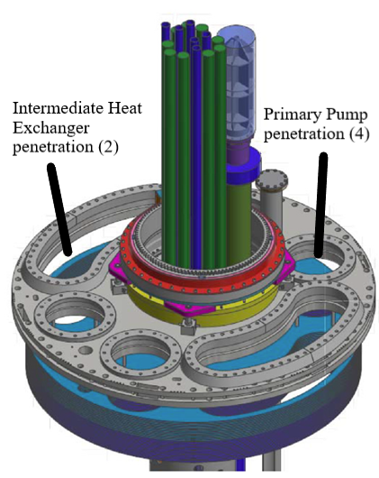
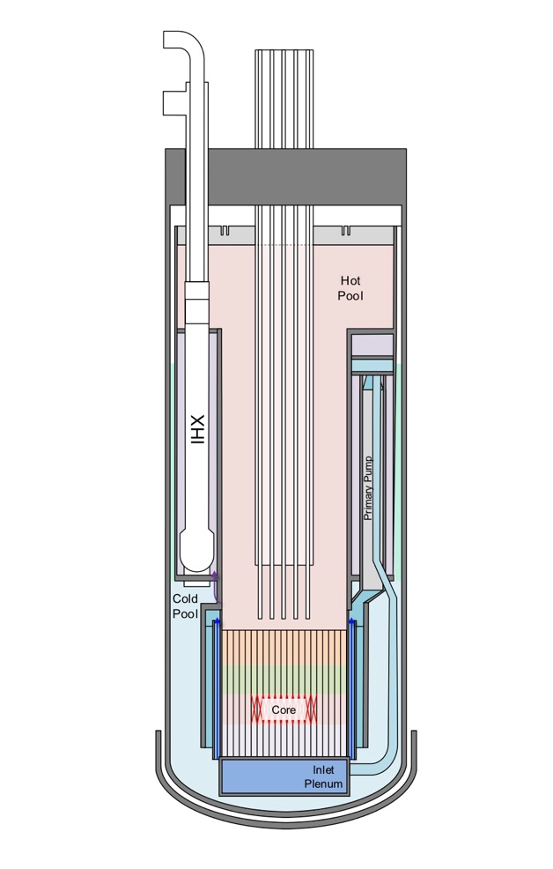
FIG. 4. Diagram of the VTR primary system and detail of the vessel cover indicating the location of the intermediate heat exchangers and primary pumps

Operation of the VTR will be authorized by the DOE. A risk-informed performance-based authorization approach is currently planned (12), following the recent work of the License Modernization Project developed with the support of the industry, the Nuclear Energy Institute, and the DOE, which has been approved by the US Nuclear Regulatory Commission for use in advanced reactor licensing.

Overall VTR plant
Another significant modification of the leveraged PRISM Mod A design is in the final heat transport system. The VTR will be not be a power plant, and the electricity production system is eliminated from the design. This modification eliminates a significant number of systems, lowers the cost of the plant, and avoids conflicts that could potentially be caused by multiple missions.
Fig. 5 shows the overall conceptual design of the VTR. Because there is no electricity production, the secondary heat transport system utilizes sodium-to-air heat exchangers (SAHX) to sink the heat into the atmosphere. With the exception of the SAHX and an operations support building, all other systems are housed in a single building that contains the reactor unit, the head access area and the RVACS system, the secondary pump room, and the experiment hall. Electrical and control equipment are also located in the building. The pump room contains the secondary electromagnetic sodium pumps, dump tanks to drain the secondary loops and sodium fire protection equipment. The experiment hall has the area to manage the fuel and the experiment transfers, including fuel assembly and experiment preparation, experiment disassembly, spent fuel assembly washing and preparations for storage. The reactor vessel cavity, secondary pump room, and storage locations for experiments and fuel are below grade, as can be seen in the cut-out view of the reactor building in Fig. 6. The remaining facilities are above grade, minimizing the excavation needs.

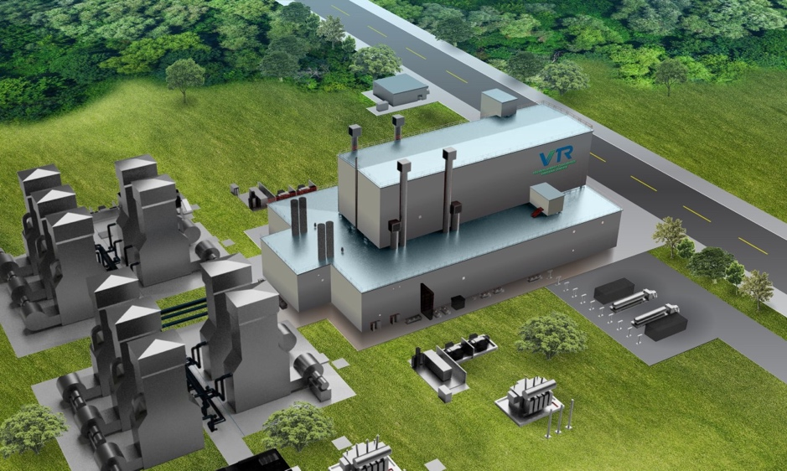
FIG. 5 VTR facility
Fuel discharged from the reactor core will remain in-vessel to allow for decay heat to decrease to a point when the assembly can be removed from the vessel and stored without requirements for forced cooling. After removal from the reactor vessel, spent fuel assemblies will be washed and stored in a storage pad adjacent to the reactor building. DOE has determined that the VTR spent fuel will not be reprocessed or recycled, as the purpose of the VTR is to provide a source of fast neutrons for fuels and materials testing, but not to develop or demonstrate recycling technologies. However, spent fuel rods will need to be treated to remove the sodium bond, which is used inside the rods to enhance heat transfer from the fuel to the cladding. After treatment, the spent fuel will be stored in a form suitable (meeting repository requirements) for future final disposition in a repository.

Current Status
The core team of the VTR has been established and continues to work on advancing the design of the plant. The current focus is on assessing and selecting specific engineering options for key systems identified in the conceptual design and developing the technology maturation plans for the components and systems that are judged to be at lower technology readiness. Part of the technology maturation activities includes the identification and qualification of a supply chain. Several of the primary system components will require the development of prototypes as part of the maturation. This will apply particularly to the components that are unique not only to sodium reactors, but to a test reactor, such as for example the in-vessel fuel and experiment transfer machine.
In parallel, negotiations are ongoing with an industry consortium for the Engineering, Procurement, and Construction (EPC) contract. The industry team is led by Bechtel National Inc. and includes General Electric-Hitachi Nuclear Company and TerraPower.
Work is also ongoing on the establishment of the fuel fabrication capability. Existing facilities at INL and SRS are being considered. The fuel material supply and fabrication process is being developed. Fuel fabrication of the metal alloy fuel will follow the process utilized in the past in fabricating fuel for EBR-II and metal fuel samples for FFTF. Equipment that will be needed to meet the VTR throughput requirements is being designed. The supply chain is being investigated for materials, such as HT-9, the steel planned to be used as fuel cladding and assembly hardware, and equipment.

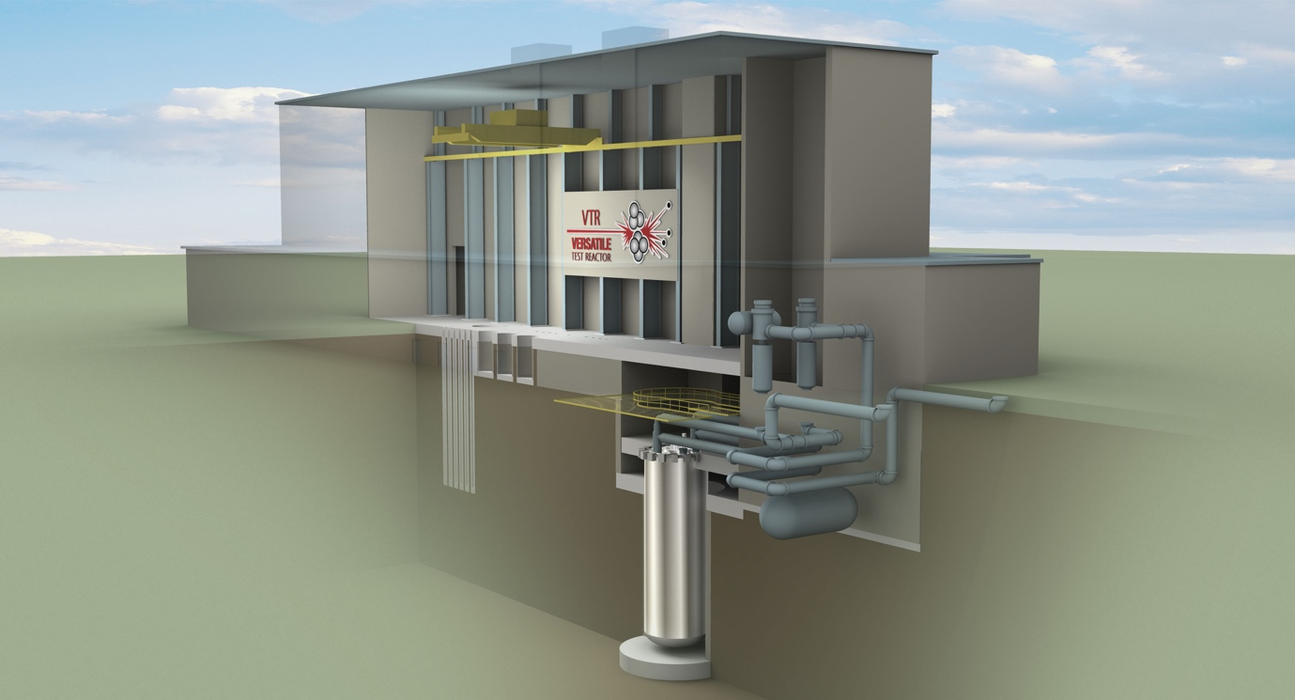
FIG. 6. Cut-away of the VTR reactor building

With the approval of the CD-1, which includes the conceptual design and the authorization to proceed to the next phase of the project, the completion and release of the final EIS, the upcoming completion of the NEPA process expected in late 2022, and the award of the EPC contract, the project will be in a position to initiate the engineering design in earnest that will lead to the preliminary and final safety analyses and the authorization to start construction upon approval of the next combined critical decisions (CD-2/3) as soon as capital acquisition funds are appropriated.
When completed, the versatile fast spectrum test reactor, coupled with the existing supporting research and development (R&D) infrastructure, will provide the basic and applied physics, materials science, nuclear fuels, and advanced sensor communities with a unique research capability. This capability will enable, among other scientific advances, a comprehensive understanding of the multi-scale and multi-physics performance of nuclear fuels and structural materials to support continuous nuclear innovation and the development and deployment of advanced nuclear energy systems.

ACKNOWLEDGEMENTS
The submitted document has been created by UChicago Argonne, LLC, Operator of Argonne National Laboratory (“Argonne”). Argonne National Laboratory’s work was supported by the U.S. Department of Energy, Office of Nuclear Energy under contract DE-AC02-06CH11357. The work reported in this summary is the result of ongoing efforts supporting the Versatile Test Reactor.
References
- Nuclear Energy Advisory Committee (NEAC), Assessment of Missions and Requirements for a New U.S. Test Reactor, NEAC, Washington, DC (2017).
- D. Petti, et al., Advanced Demonstration and Test Reactor Options Study, INL/EXT-16-37867, Revision 3, Idaho National Laboratory, Idaho Falls (2017).
- 115th Congress (2017-2018) S.97 - Nuclear Energy Innovation Capabilities Act of 2017, https://www.congress.gov/bill/115th-congress/senate-bill/97
- INL, Versatile Test Reactor Program Requirements Document, INL/EXT-17-43230, Draft, Idaho National Laboratory, Idaho Falls, (2017)
- US Department of Energy, ORDER 413.3B, Program and Project Management for the Acquisition of Capital Assets, https://www.directives.doe.gov/directives-documents/400-series/0413.3-BOrder-b
- NRC (U.S. Nuclear Regulatory Commission), Preapplication Safety Evaluation Report for the Power Reactor Innovative Small Module (PRISM) Liquid-Metal Reactor, NUREG-1368, Washington, DC, (1994).
- F. Heidet and J. Roglans, Core Design Activities of the Versatile test Reactor – Conceptual Phase, PHYSOR 2020: Transition to a Scalable Future (Proc. Int. Conf. on Physics of Reactors 2020, Cambridge, UK), Nuclear Energy Group, Cambridge, UK (2020).
- T. Sumner, T. Fei, N. Stauff, T. Fanning, F. Heidet, Versatile Test Reactor Preliminary Safety Analysis, Transactions of the 2019 ANS Annual Meeting, American Nuclear Society, La Grange Park, IL (2019).
- S. Balderrama, P. Sabharwall, K. Weaver, D. Wachs, M. Farmer, and F. Heidet, Versatile Test Reactor: Irradiation Testing Vehicles for Fast Reactors and Proposed Experimental Loadings, INL/EXT-18-15762, Rev. 0, Idaho National Laboratory, Idaho Falls, (2019).
- D. Gerstner, J. Andrus, D. Grabaskas, M. Bucknor, Safety Design Strategy for the Versatile Test Reactor, Transactions of the 2019 ANS Winter Meeting, American Nuclear Society, La Grange Park, IL (2019).
- T. Sumner, T. Fanning, and J. Thomas, Safety Analysis of the Conceptual Versatile Test Reactor Design, Transactions of the 2020 ANS Winter Meeting, American Nuclear Society, La Grange Park, IL (2020).
- D. Grabaskas, et al., Application of the Licensing Modernization Project Approach to the Authorization of the Versatile Test Reactor, Transactions of the 2019 ANS Winter Meeting, American Nuclear Society, La Grange Park, IL (2019).

