DESIGN Studies towards raising fbtr to

FULL POWER

- RAGHUPATHY¹, K. DEVAN¹, JOHN ARUL¹, K. NATESAN¹, G. S. SRINIVASAN¹,
D. NAGA SIVAYYA¹, V. L. ANURAJ¹, D. SUNIL KUMAR¹, JAMDADE NIRAJ GANESH¹

¹Indira Gandhi Center for Atomic Research, Kalpakkam, India.

Email contact of corresponding author: rags@igcar.gov.in

Abstract

Fast Breeder Test Reactor (FBTR) is a loop type SFR, operating at Kalpakkam. FBTR core is originally designed to operate at 40 MW(th) using mixed oxide (MOX) fuel. However, due to the non-availability of enriched Uranium, mixed carbide fuel (Mark-I) was chosen for the initial core with a maximum power of 10.6 MW(th). Since then, the reactor power has been increased gradually based on operating experience and Post irradiation examination (PIE) results. The power of FBTR has been raised to its rated power from 32 to 40 MW(th), with Mark-I subassemblies during the 30th campaign. The new core has 70 fuel SAs with the peak LHR restricted to 400 W/cm. For ensuring a minimum shutdown margin of 4200 pcm, four poison subassemblies (¹⁰B enrichment 50%) are added in the second ring along with existing 6 control rod subassemblies (¹⁰B enrichment 90%) provided in the 4th ring. Various core design and safety studies have been carried out. Perturbation worths & kinetic parameters have been estimated. Shielding analysis show that there is an increase in neutron and gamma fluxes at various locations of core and shield regions with respect to the 32 MW(th) core. However, the present shielding provided for the core and reactor assembly meets the safety requirements. Hypothetical Core Disruptive Accidents (HCDA) have been analysed for ULOFA, ULOCA and UTOPA. In order to demonstrate the inherent safety characteristics and the capability of plant protection system with respect to various plant transients, analyses of various enveloping design basis events have been carried out using the plant dynamics code DYNAM and safety is demonstrated. Detectable and permissible flow reduction for different SAs has been estimated and found to be safe. This paper summarizes the design studies carried out towards raising the power of FBTR to 40 MW(th).

INTRODUCTION
FBTR core is originally designed to operate at 40 MW(th) using mixed oxide (MOX) fuel with 30% PuO₂ and 70% UO₂ (85% enriched Uranium). However, due to the non-availability of enriched uranium, mixed carbide fuel (Mark-I (70% PuC + 30% UC)) was chosen for the initial core. After first criticality in 1985, the initial core had operated with a maximum power of 10.6 MW(th). Subsequent operations have been carried out by adding many variants of carbide and oxide fuel sub-assemblies (FSAs) and increasing the operating linear heat rating (LHR), based on the encouraging post irradiation examination (PIE) results. The plant operated at the power level of 32 MW(th) during its 27th campaign. The power of FBTR was raised to its design target power of 40 MW(th) by using Mark-I subassemblies (SAs). This paper covers the design studies carried out towards raising the power of FBTR to 40 MW(th).

CORE AND PHYSICS DESIGN
The 32 MW(th) core had 58 FSAs; 49 Mark-I, 1 Mark-II (55% PuC + 45% UC) and 8 MOX (44% PuO₂ + 56% UO₂). The transition to 40 MW(th) core was achieved during the 30th campaign. The new core had 70 fuel SAs and the peak LHR was restricted to 400 W/cm. In order to ensure a minimum shutdown margin of 4200 pcm as per the technical specification for operation, four poison SAs (with 50% ¹⁰B enrichment) in the 2nd ring were added along with the existing 6 control rod SAs (¹⁰B enrichment of 90%) provided in the 4th ring. The core design studies were carried out and final core configuration with fuel SAs surrounded by Ni reflector, Thoria blanket and steel shielding SAs is shown in Fig 1.
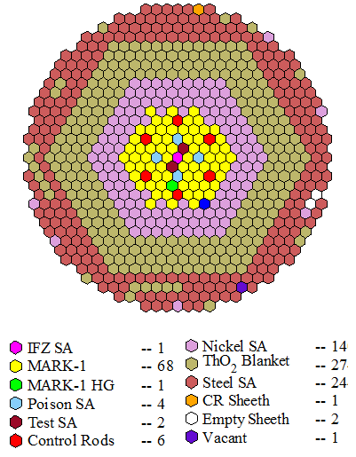
Fig. 1. Proposed FBTR 40 MW(th) Core Configuration
A comparison of the important measured values of FBTR process and physics parameters for 40 MW(th) operation with previous 32 MW(th) operation is given in Table 1. All the parameters were verified to be within the technical specification requirements.
TABLE 1 COMPARISON OF FBTR PARAMETERS

Parameter | 27th Campaign | 30th Campaign
Reactor power / TG power | 32 MW(th) / ~7 MW(e) | 40MWt/10 MW(e)
Reactor inlet/outlet temperature | 380°C /484°C | 385°C /491°C
SG inlet/outlet temperatures | 479°C /309°C | 485°C /295°C
Primary sodium loop flow | 504.4 m³/h | 620 m³/h
Secondary sodium loop flow | 295 m³/h | 325 m³/h
Feed water flow | 53.35 m³/h | 75 m³/h
Feed water / steam temperature | 190°C / 450°C | 190°C / 430°C
Steam pressure | 122 kg/cm² | 122 kg/cm²
Temperature coefficient of reactivity | -4.2 pcm/°C | -3.47pcm/°C
Power coefficient of reactivity | -8 pcm/MWt | -7.06 pcm/MWt
Shutdown margin (at 180°C) | 5462 pcm | 4485 pcm
Total control rod (CR) worth | 9650 pcm | 9685 pcm

The kinetics parameters like delayed neutron fractions, decay constants and prompt neutron generation time are estimated for the 40 MW(th) core. Using the perturbation worth data, the isothermal temperature coefficient and power coefficients are estimated. Perturbation worths and kinetic parameters have been estimated using ABBN-93 cross section library (2D analysis). The fuel slumping worth is estimated using a conservative 1/3rd slumping model and a maximum value of 1.12 $/cm is obtained for the 4th channel. It is found that sodium void reactivity worth is -1035 pcm (-3.82 $). The whole core voiding of steel and fuel reduces reactivity by -7 $ and -219 $ respectively. Doppler feedback is found to be negligible due to the hard spectrum. The estimated effective delayed neutron fraction and prompt neutron lifetime are 271 pcm and 0.16 micro second respectively. This data forms the major input for the safety analysis, plant dynamics analysis and severe accident analysis.

Poison subassembly design
The poison SA consists of a single B₄C rod with plugs welded at both bottom and top. Above and below the rod, hexagonal blocks are kept to increase the weight of the SA to prevent hydraulic lifting. As the poison SA has to be loaded in fuel region of the FBTR core, the foot is designed similar to that of fuel SA. The head of the SA is designed such that its handling is similar to that of a control rod assembly. In order to differentiate Poison SA during handling, poison SA length was designed to be 73 mm shorter than the fuel SA. Schematic representation of a poison SA is shown in Fig. 3 [6].

Fig. 3. Schematic of FBTR Poison Subassembly

Maximum power produced in poison SA is 35.73kWt with a peak LHR of 1140 W/cm at core center location. The Poison SA is designed with a flow rate of 0.409 kg/s. For this flow rate, the maximum clad midwall hotspot temperature and absorber hotspot centreline temperature for nominal power condition are estimated as 538 °C and 2056 °C respectively and the design safety limits are 650 °C and 2450 °C respectively. The above estimates satisfy the respective design safety limits for nominal and 16% overpower conditions. The estimated sodium temperature rise from inlet to outlet of the SA is 97.7 °C which also respects the temperature limits from thermal striping considerations (100 °C).
The required SA pressure drop of 278 kPa for the designed flow rate is realized by installing comb type labyrinths orifice structure in the SA foot and also by suitable orificing in upper and lower hexagonal blocks. The above configuration of the flow restricting approach ensures that SA is free from cavitation even at 110% flow condition. Hydraulic tests have been carried out to verify the pressure drop across the subassembly, margin against lifting and absence of cavitation.

Shielding studies
In the 40 MW(th) core, the fuel SA boundary extends up to 24.14 cm in the radial direction with 70 Mark-I sub-assemblies whereas, the core boundary for the existing 32MWt core is 21.82 cm. Therefore, there is a reduction in the thickness of Nickel reflector region. The reduction in nickel reflector thickness and the increase in core size have been studied in terms of neutron and gamma flux, dose rates at critical areas, heating effects on biological concrete, radiation damage and helium production in structures.
Calculations have been performed using 2D transport code DORT in RZ geometry using multigroup cross section set IGC-S3. Details of the model used is shown in Fig 4. The neutron energy ranges from 10⁻⁵ eV to 19.6 MeV whereas that of gamma flux is from 1.0 keV to 50 MeV. IGC-S3 is a 217 (175 neutron groups and 42 gamma groups) neutron-gamma coupled cross section set developed in IGCAR from ENDFB-VI in VITAMIN-J structure.

Fig. 4. 2D R-Z Model of FBTR

The axi-symmetric (R-Z) model extends up to the biological shielding radially and from grid plate to top shield axially. The model domain is divided into 269 and 417 meshes in the radial and axial directions respectively for the calculation. Vacuum boundary condition is used at the bottom, top and right ends, whereas reflective boundary condition is used at the left end. The angular approximation used is S8 and the order of scattering cross section anisotropy is P5. The core centre flux is 3.3E+15 n/cm²/sec which is almost same as that of previous core.
Shielding analysis shows that there is an increase in neutron and gamma fluxes at various locations of core and shield regions as compared to the 32MW(th) core. As a typical case, an increase in neutron / gamma flux of 20/30 % respectively is estimated at the top shield exit location (above working platform). This results in a slight increase in dose rates above working platform, which is acceptable being a controlled access area, The dose at various accessible areas are within acceptable values.
The increase in radiation damage rate (in dpa) seen by the grid plate is 11 % at the centre of grid plate top region. Based on the limit of 6.3 dpa for the grid plate, the residual life of grid plate reduces from 8.14 full power year (fpy) to 7.25 fpy. The variation of dpa along grid plate in the radial direction is given in Fig. 5. The reactor vessel dpa for 1 efpy is 1.73E-03 for 40 MW(th) and for 32 MWt the same value is 1.14E-03. For the time period of 7.25 efpy, the dpa experienced by the reactor vessel is 0.02 dpa which is very less. Similarly, the dpa experienced by core cover plate is also very small and does not govern the life of the reactor. Since the grid plate dpa is governing, FBTR can be operated for another 7.25 fpy at 40 MW(th).

Fig. 5. Radial Variation of Dose at Grid Plate
Neutron flux increase in the detector pit location is 40 %. The increase in detector flux to 1.0E+11 n/cm²/s favors 40 MW(th) operation of FBTR.
The total heating due to neutrons and gammas at the inner radius of reactor vault concrete increases from 7 W/m³ to 10 W/m³. The biological shield cooling system is designed for 40 MW(th) and hence this increase could be accommodated by the existing cooling system provided. The temperature in the rotating plug region of FBTR is maintained below 130 ⁰C for which Wigner energy release from graphite used for shielding inside the plugs due to the increase in total neutron flux from 4.82E+10 to 6.40E+10 n/cm²/s does not have significant effect.
Overall, the present shielding provided meets the design and safety requirements.

Safety and severe accident studies
Hypothetical Core Disruptive Accidents (HCDAs) have been analysed for three accident situations: Unprotected Loss of Flow Accident (ULOFA), Unprotected Transient Over Power Accident (UTOPA) and Unprotected Loss of Coolant Accident (ULOCA). The accident potential of these transients and the associated energy release have been studied. The accident analysis is carried out through pre-disassembly, disassembly and mechanical energy release phases. In the pre-disassembly phase, the course of the accident is evaluated deterministically until the geometry of fuel pin or FSA is intact. The space dependent reactivity feedbacks from the fuel, clad and coolant are taken into account together with core radial expansion feedback.
The initiating event for ULOFA is loss of power supply to primary pump and the ensuing flow coast down. In case of ULOFA, the reactor power falls below the decay heat level. FBTR is a small test reactor with negative sodium void worth and negligible Doppler feedback. The reduction in the flow results in rise in coolant temperature and the consequent strong negative feedback due to coolant and core radial expansions make the reactor subcritical and the fission power drops to decay heat level with time. The only positive component of reactivity feedback during this accident is due to fuel axial contraction because of decrease in fuel temperature. Giving due credit to decay heat removal system, the transient does not lead to core disruptive accident.
Under UTOPA, the reactivity addition due to control rod withdrawal makes the reactor power to rise. Variation of reactor power and net reactivity profile for the transient with time is given in Fig 6. Even with negative reactivity feedback, the net reactivity remains positive due to external reactivity addition and power increases. This leads to coolant boiling and fuel melting. The slumping of molten fuel causes a large positive reactivity addition. The disassembly phase calculations are done assuming a conservative positive reactivity addition to the molten core using an ANL hydrodynamics code VENUS-II. The disassembly phase ends when the reactor becomes subcritical. The thermal energy stored at the end of disassembly phase is transformed as the mechanical work potential by the isentropic expansion of core bubble to one atmospheric pressure. A subroutine named MERC is developed and integrated with VENUS-II for performing this calculation.
In the case of ULOCA, the heat removal from fuel is assumed not available and this leads to coolant boiling, fuel slumping and disassembly.
For conservative reactivity addition rate of 50 $/s input during disassembly phase, the estimated mechanical energy release under UTOPA is 6.9 kJ and under ULOCA, it is 11.94 MJ. Hence, for this core, 12 MJ can be considered as the maximum possible mechanical energy release under HCDA. The reactor vessel can safely withstand up to 9 TNT (39 MJ) of mechanical energy release without failure.
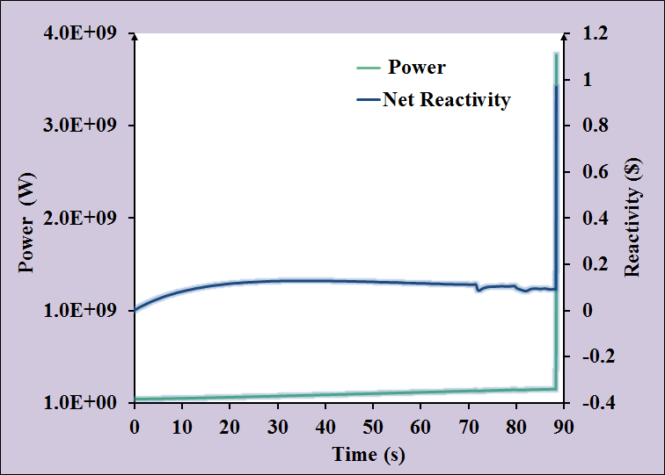
Fig. 6. Variation of Reactor Power and Reactivity under UTOPA

Allowable flow reduction in MK-I fuel subassemblies respecting the DSL
The maximum allowable flow reduction in MK-I fuel SAs operating in various rings of FBTR core shall respect the design safety limit (DSL) of fuel and clad. Allowable flow reduction shall be higher than the detectable flow reduction for safe operation of the core. For 40 MW(th) core, the peak power of the SA and LHR are less than the 32 MW(th) core due to flattening of the power. The details of the Peak LHR, SA power and locations are given in Table 2. The peaking in third ring SA in 40 MW(th) is due to more burnup in the central SAs. In case of flow reduction, the DSL limits of next higher category (category-2) limits are applicable. The allowable flow reduction without violation of the clad and fuel DSL is worked out and the details are given below:
TABLE 2 COMPARISON OF SA OPERATING PARAMETERS IN 32 MW(th) AND 40 MW(th) CORES

 | Core Power | Peak Power Location | Type |  | Linear Power  (W/cm) |  | SA Power  (kW)
32 MW(th) |  | (01 01) | Mark I | 386.9 |  | 632
40 MW(th) |  | (03 12) | Mark I | 374.5 |  | 625

Clad Temperature
FBTR has uniform flow rate for all the fuel SAs which is 3.26 kg/s. For the third ring fuel SA, LHR is highest value of 374.5 W/cm at middle of the core and 238.6 W/cm at top of the core [1]. For postulated flow reduction, the temperature rise in sodium is found out (including the inter-SA heat transfer) and then the clad mid-wall hotspot temperature is estimated. For the third ring, the clad mid-wall temperature reaches the limit of 800°C when the flow is reduced by 44.5% [2]. For the other rings, allowable flow reduction varies from 44.5% to 53%. Thus, it is concluded that the maximum allowable flow reduction in the any ring of fuel SA is 44.5% from clad temperature limit point of view.

Fuel Temperature
With the reduction in the flow, the fuel centreline temperature also increases. The nominal fuel centreline temperature and hotspot fuel centreline temperature with full flow and hotspot fuel centreline temperature with 50 % flow are shown in Fig. 7 as a function of burnup. The maximum nominal and hotspot centreline temperatures were found to be 1420 ⁰C and 1680 ⁰C respectively at core mid-plane at beginning of life (BOL). The hotspot centreline temperature with 50 % flow reduction is 1794 ⁰C which is well below the melting point of 1850 ⁰C. Hence, up to a flow reduction of 50 % in the SA, there is no concern over fuel melting.
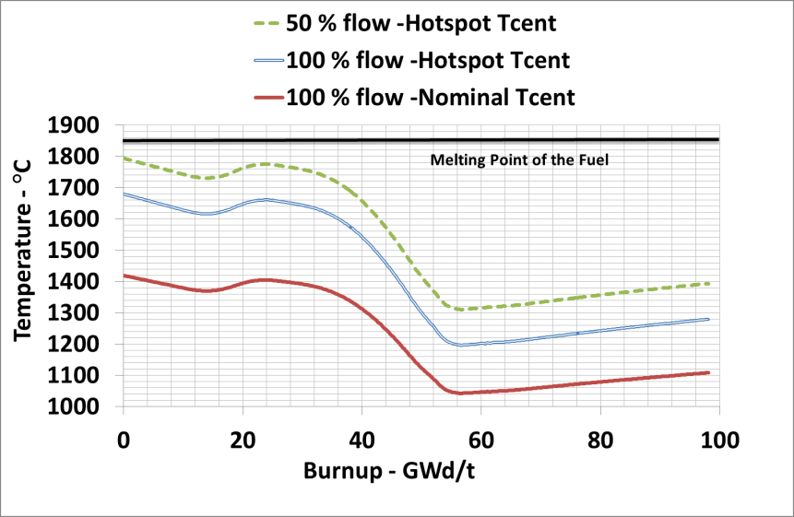
Fig. 7. Fuel Centerline Temperature variation with Burnup

Hence, clad is dictating the flow reduction limit with a maximum allowable flow reduction of 44.5 % in the SA.

Plant dynamics analysis
In order to demonstrate the inherent safety characteristics and the capability of plant protection system with respect to various plant transients, analyses of various enveloping design basis events have been carried out using the plant dynamics code DYNAM [3]. It is an in-house developed plant dynamics code validated against commissioning tests carried out in FBTR. The code has models for simulation of neutronic power and thermal hydraulics of primary and secondary sodium circuits. All the enveloping events have been analysed first without crediting of automatic trip triggered by the plant protection system of the plant [4]. It is seen that during these events, except ‘off-site power failure’, ‘station black out’ and ‘one control rod withdrawal’, the clad hotspot and fuel hotspot temperatures are limited below the design safety limits even without safety actions demonstrating the inherent safety characteristics of the plant. Moreover, safety of the plant is demonstrated with good margin against the respective design safety limits under off-site power failure, station blackout and one control rod withdrawal events with reactor trip credited based on the second appearing SCRAM parameter. During loss of feed water flow in one loop event, no parameter is available to initiate automatic trip of the reactor. However, there is no concern on core safety during this event even without any safety action. Nevertheless, an additional automatic trip parameter based on high reactor inlet temperature has been proposed to be added to the safety logic.
As a typical case, the variation of clad hot spot temperature with and without safety action under station blackout condition is shown in Fig. 8. The clad hot spot temperature exceeds the limit of 800ºC without safety action in ~ 20 s time. With safety action, reactor power reduces to below decay power condition within 8 s. The steam generator trap doors are considered to be opened at 1800 s. Two peaks are observed in the clad hotspot temperature. First peak (733°C) occurs close to the SCRAM instant and the second peak (754°C) occurs during the evolution of natural convection, which are much lower than the limiting value of 800°C. In a similar way, the safety of the plant is verified for all other plant transients.

- Without Safety Action (b) With Safety Action
Fig. 8. Clad Hotspot Temperature variation with Time

Another important event against which safety of the plant is essential to be demonstrated is the single FSA blockage. This analysis is essential for the proposed core configuration due to the introduction of poison SAs which may induce large temperature dilution (due to low heat generation in them) in the measurement of sodium outlet temperature of nearby FSAs. The main objective of the analysis was to estimate the detectable flow reduction in FSAs at various locations in the core. For analysing this event, three dimensional CFD analysis of pool hydraulics in the region above core has been carried out [5]. Typical temperature distribution for the case of a partially blocked SA with 15% flow reduction in fourth ring is shown in Fig. 9. It is seen that the detectable flow reduction in various rings of SAs varies between 9 % and 15 % from center to periphery which are much less than the permissible flow reduction of 44.5 %. Thus, safety of the plant is ensured for operation at 40 MW(th) power.
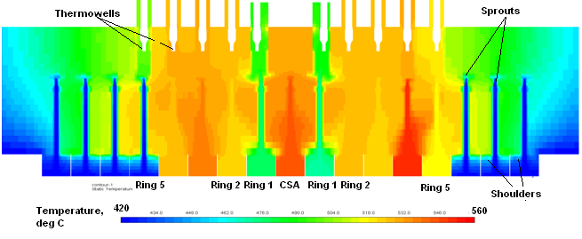
Fig. 9. Temperature Distribution in Core Outlet Region under Simulated Blockage of a Fourth Ring SA

Summary
The power of FBTR has been raised to its design target power of 40 MW(th) with 70 Mark I subassemblies. The peak LHR of the subassembly remains restricted at 400 W/cm. In order to ensure a minimum shutdown margin of 4200 pcm, four poison subassemblies (with 50% ¹⁰B enrichment) are added in the 2nd ring. Perturbation worths and kinetic parameters have been estimated for this core. Hypothetical Core Disruptive Accidents have been analysed for ULOFA, ULOCA and UTOPA. For this core, 12 MJ can be considered as the maximum possible mechanical energy release under HCDA. The reactor vessel can safely withstand up to 39 MJ of mechanical energy release without failure. In order to demonstrate the inherent safety characteristics and the capability of plant protection system with respect to various plant transients, analyses of various enveloping design basis events have been carried out using the plant dynamics code DYNAM and safety is demonstrated. Detectable flow reduction in various rows of SAs varies between 9 % and 15 % which are much less than the permissible flow reduction of 44.5 %. Thus, safety of the plant is demonstrated for the operation at 40 MW(th) power. Shielding analysis show that in general, there is an increase in neutron and gamma fluxes at various locations of core and shield regions with respect to the 32MWt core. The present shielding provided for the core & reactor assembly is verified to meet the safety requirements. Based on the limiting dpa of Grid Plate, FBTR is safe to operate for another 7.25 fpy at 40 MW(th).
References
- Fast Breeder Test Reactor Safety Report on 40 MWt Core, Internal Report, Indira Gandhi Center for Atomic Research, Kalpakkam, 2019
- T. RAJKUMAR, Allowable Flow Reduction in MK-I Fuel Subassemblies of FBTR 40 MWt core, Internal Report, Indira Gandhi Center for Atomic Research, Kalpakkam, 2019.
- Vaidyanathan G., Kasinathan N., Velusamy K., Dynamic Model of Fast Breeder Test Reactor, Annals of Nuclear Energy, 37, 2010.
- K. Natesan et al. , Event analysis of 40 MWt core configuration of FBTR, Internal Report, Indira Gandhi Center for Atomic Research, Kalpakkam, 2019.
- Dhrumil Ganatra et al., Analysis of blockage detection capability of 40 MWt configuration of FBTR, Internal Report, Indira Gandhi Center for Atomic Research, Kalpakkam, 2019.
- NIRAJ GANESH JAMDADE, Design of Poison Subassembly for 40 MWt FBTR Core, Internal Report, Indira Gandhi Center for Atomic Research, Kalpakkam, 2019.

