A REACTION MEASUREMENT EXPERIMENTAL PROGRAM OF CHINA EXPERIMENTAL FAST REACTOR

HU XIAO¹, CHEN XIAOXAIN¹, CHEN XIAOLIANG¹, HUO XINGKAI¹

¹China Institute of Atomic Energy, Beijing, China

Email contact of corresponding author::chenxiaoxian2007@126.com

Abstract

The study of the nuclear reaction rate distribution in the MOX core of China Experimental Fast Reactor is a necessary condition for obtaining the operating license. From the characteristics of core structure, both the experimental principle and experimental system are studied, emphasizes on the scheme design. Firstly, based on the Monte Carlo Code（MCNP）and NJOY codes, the distribution of the axial and radial reaction rates is obtained through theoretical calculation. MCNP is a general-purpose Monte Carlo N-Particle code that can be used for neutron, photon, electron, and so on. The NJOY nuclear data processing system is a comprehensive computer code package for producing cross sections and related nuclear parameters from ENDF/B evaluated nuclear data. Secondly, the count rate of each nuclide activity measurement was deduced using relative formula, and the irradiation power, irradiation time and foil quality were determined in combination. It is worth noting that the experimental reactivity introduction has a negligible effect on the reactor core by MCNP simulated calculation. Finally, a set of activation experiment scheme that is suitable for CEFR MOX core is formed, which provides technical guidance to carry out activation method experiments.

INTRODUCTION
The distribution of nuclear reaction rate is an important parameter for reactor operation, and it is also one of the necessary test data for obtaining the operating license. CEFR is a sodium-cooled fast reactor, and its complex structural characteristics, harsh operating conditions and even no special probe channels make the measurement of reaction rate distribution many restrictions, so the activation method becomes an inevitable choice.
After four transitions, the CEFR uranium core is converted to a MOX core. 54 boxes of fuel assemblies are loaded inner core, and 30 boxes of fuel assemblies are loaded in outer cores. CEFR MOX is expected to begin physical start-up experiments in 2027, the reaction rate distribution experiment is carried out in the physical start stage of the reactor.

EXPERIMENTAL PRINCIPLE
Using special experimental components, the CEFR MOX core is loaded with the same foils at specific radial or axial positions by an irradiation device. After irradiation in core, the activity data of induced nuclides is measured by high-purity-germanium spectrometer. Finally, the data is normalized to obtain a distribution of reaction rates.
It is necessary to replace the fuel SAs in the stack with experimental SAs loaded with a group of similar detection foils, irradiated at a certain stable low power, then quickly shut down the core and cool down for an appropriate time. Pull out the special experimental SAs, take out the irradiation device, remove sodium, clean, and disassemble, disassemble the irradiation device and take out the activation foils, then place the foils one by one in the sample tray at the suitable distance from the high-purity germanium measurement system to measure the counts of photo peak. Table 1 shows the neutron physical properties of the detection foil^{[1]}.
TABLE 1. THE NEUTRON PHYSICAL PROPERITIES OF THE ACTVATION FOILS

material | Nuclear reaction | Measured  nuclide | E_{γ} (keV) | Radioactive half-time | Branching ratio(%)
U（90%） | ²³⁵U(n.f) | ¹⁴⁰La | 1596 | 40.27h | 95.6
 | ²³⁵U(n.f) | ¹⁴³Ce | 239 | 33.039h | 42.8
U(Depleted uranium) | ²³⁸U(n.f) | ¹⁴⁰La | 1596 | 40.27h | 95.6
 | ²³⁸U(n.f) | ¹⁴³Ce | 239 | 33.039h | 42.8

Take ²³⁵U fission rate distribution measurement as an example. Put a highly enriched uranium foil (²³⁵U of 90% enrichment degree) into the reactor for irradiation, and at a certain moment T_{W} after the irradiation (irradiation time is T_{S}), measure 497 keV ray emitted by fission product nucleus (¹⁰³Ru). As measurement time is very short, the activity change induced by ¹⁰³Ru during measurement can be negligible.
(1) Considering the attenuation correction during the measurement process, the activity of the fission product ¹⁰³Ru is A is shown in Eq.(1).
$A=\frac{C}{I_{γ}εK(1-τ)}×\frac{λ}{1-e^{-λT_{M}} }$ （1）
where,
C is the measured light peak area of ¹⁰³Ru emitted rays (497keV);
I_{γ} is the absolute intensity (branch ratio) of ¹⁰³Ru emitted 497keV radiation;
ε is measure the peak efficiency of 497keV rays for the spectrometer;
K is the self-absorption correction coefficient of the 497keV ray of foil;
T_{M} is the measurement time interval;
τ is the "dead" time (percentage) of the system;
$λ$ is the decay constant of ¹⁰³Ru.
(2) The decay chain of ¹⁰³Ru is shown blow
$${}_{}^{103}{Y\underset{→}{92\%}}{}_{}^{103}{Zr→{}_{}^{103}{Nb→{}_{}^{103}{Mo→{}_{}^{103}{Tc→{}_{}^{103}{Ru→}}}}}γ（497KeV,91.0\%）$$
The activity of ¹⁰³Ru at measurement time A is got by Eq.(2).
$A=Φσ_{f}^{5}Γ_{5}NY_{5}(1-e^{-λT_{s}})e^{-λT_{w}}$ （2）
Where,
σ_{f}⁵is average fission cross-section of ²³⁵U;；
ϕ is measured neutron flux of the core；
N is nucleon number of ²³⁵U;
$Γ_{5}$is ²³⁵U enrichment degree；
Y₅ is the yield of ²³⁵U fission produce ¹⁴³Ce；
T_{s} is the irradiation time;
T_{w} means the holding time after irradiation.
(3) The mononuclear nuclide of ²³⁵U in the foil can be obtained by Eq.(3).
$R_{f}^{5}=Φσ_{f}^{5}$ (3)
Through the formula (1-3), $R_{f}^{5}$ can be obtained by Eq.(4)
$$R_{f}^{5}=\frac{Cλe^{-λT_{w}}}{Γ_{5}NY_{5}(1-e^{-λT_{s}})I_{γ}εK(1-τ)（1-e^{-λT_{M}}）} （4）$$

experiment systrm
In the activation method experiment, special experimental components and irradiation devices are required to enter the reactor. The detector foils are placed in the irradiation device, and the irradiation device is inserted into the experimental component. The experimental component replaces the original core component and enters the reactor for irradiation. The irradiating device is pulled out and cut, and the irradiated foils are taken out to measure the activity. Among the experiment, there are two specialized equipment play a significant role, namely irradiation device pick-up tool disassembly equipment. Otherwise, the high-purity germanium γ-spectrometer is needed to measure the activity of irradiated foils^{[2]}.

Irradiation experiment components
Designed specialized experimental fuel SA，which is attached in Figure 1. The experimental fuel SA was specially designed to contain foils by an irradiation device. The main difference from actual fuel SA is that the 7 fuel rods in the center are replaced by the irradiation device. In addition, the head is redesigned to make the irradiation device can be easily loaded or taken out. For other parts, it is the same with fuel SA.
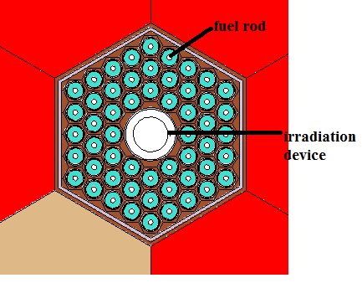
Fig.1.. Experimental Fuel SA
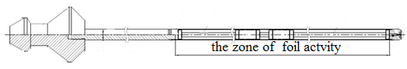
Fig.2. Irradiation device

Irradiation device is illustrated in Figure 2. The design is beneficial to reduce the influence of the irradiation device and foils on the core neutron field characteristics. The irradiation device is comprised of an upper grab head and a lower hollow stainless steel tube. The upper grasp head facilitates irradiating device to load and take out from the experimental fuel SA and the concave stainless steel tube is used to place foils.

Specialized equipment
In order to distinguish different types of foils, which are round thin plate made by stamping by laser，enclosed with aluminium wrapper and vacuum drawer. The internal and external refueling mechanism can be used to put the experimental SA into a certain position of the reactor core. However, irradiated experimental SA has strong radioactivity. It not allows to directly remove the total experimental SA from the core. For this reason, a series of special devices need to be designed to take out the irradiation device from the irradiation experimental SA.
This series of devices includes mechatronics irradiation device pick-and-place tools and irradiation device disassembly platform, which are displayed in Fig.3 and Fig.4. The irradiated experimental SAs are placed in the conversion barrel after being out of the core, and the irradiation device put into or put out the center of the experimental assembly by this special pick-and-place tool.

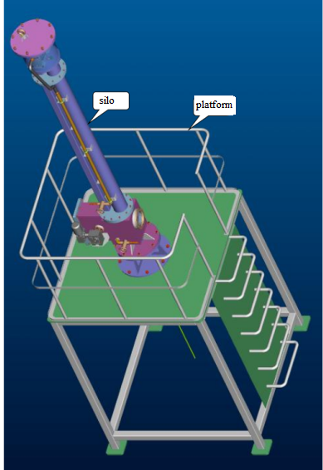
Fig.3. Irradiation device pick-up tool
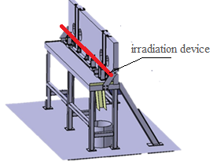
Fig.4. l Irradiation device disassembly equipmen
t
The irradiation device needs to be disassembled in order to obtain the irradiated foils, namely disassembly equipment. After calculating the dose of the irradiation device, the disassembly platform adopts stainless steel as protection, and the viewing window adopts 9cm lead glass, which can protect hand from dose irradiation.

Gamma spectrum measurement system
Due to the large number of activated foils, it is necessary to establish a gamma spectrum measurement system with high measurement accuracy, wide measurement energy range, and low environmental background. a set of automatic detection foil replacement is designed. The automatic refueling and measuring device of the detection foil are shown in Figure 5. It mainly includes a manipulator, a translational lead chamber, a workbench, a programmable logic controller (PLC) electronic control system, an equipment cabinet, a host computer system, etc., through which 100 activation foils can be automatically measured in succession.

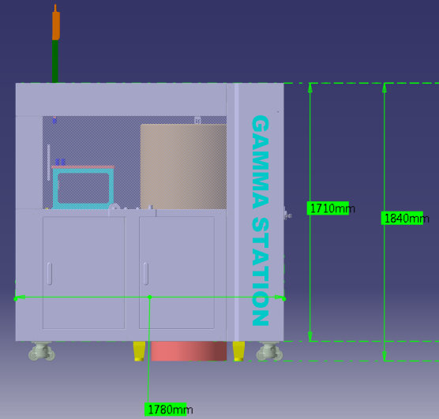
Fig.5 Automatic measuring device for detection foil

SCHEME DESIGN
The paper mainly studies the reaction rate distribution of ²³⁵U and ²³⁸U. Firstly, the reaction rate distribution of the typical position of the core is calculated, the MCNP program is used to calculate the neutron flux density of the MOX core, and the NJOY program is used to process the reaction group fission cross-sections of ²³⁵U and ²³⁸U, and finally ²³⁵U and ²³⁸U axial and radial single-nuclear fission rate distributions are obtained at full power. The counting rate is determined by formula derivation. In order to obtain an appropriate counting rate that meets the measurement requirements, the irradiation power, irradiation time and cooling time are determined. According to the size requirements of irradiation device, the size of the uranium foils is obtained. At the same time, the radial and axial positions of the reaction rate measurement points at typical positions of the core can be obtained. Finally evaluate the effect of the activation method experiment on the introduction of the reactivity of the core.

Single nuclear reaction rate calculation

MCNP simulation
Fig.6 shows the Configuration of CEFR MOX Core, which is Modeled by MCNP code[3] is shown in Fig.7. In order to save the calculation time and optimize the calculation results, the fuel assemblies at the 5 typical positions are described in detail, and the other assemblies are uniformly. Among them, position1 and position5 are selected as the axial calculation points. The calculation results are shown in Fig. 8 and Fig.9. The fuel active zone and conversion area are taken radially and evenly divided into 16 layers.
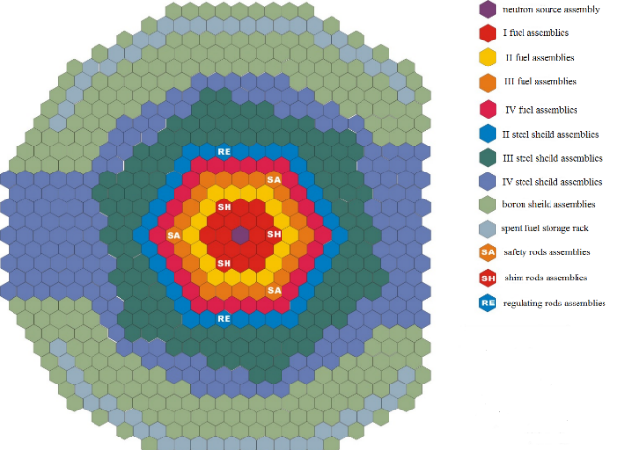
Fig.6 Configuration of CEFR MOX Core
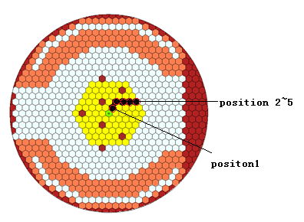
Fig.7 The irradiated location of Experimental Fuel SA
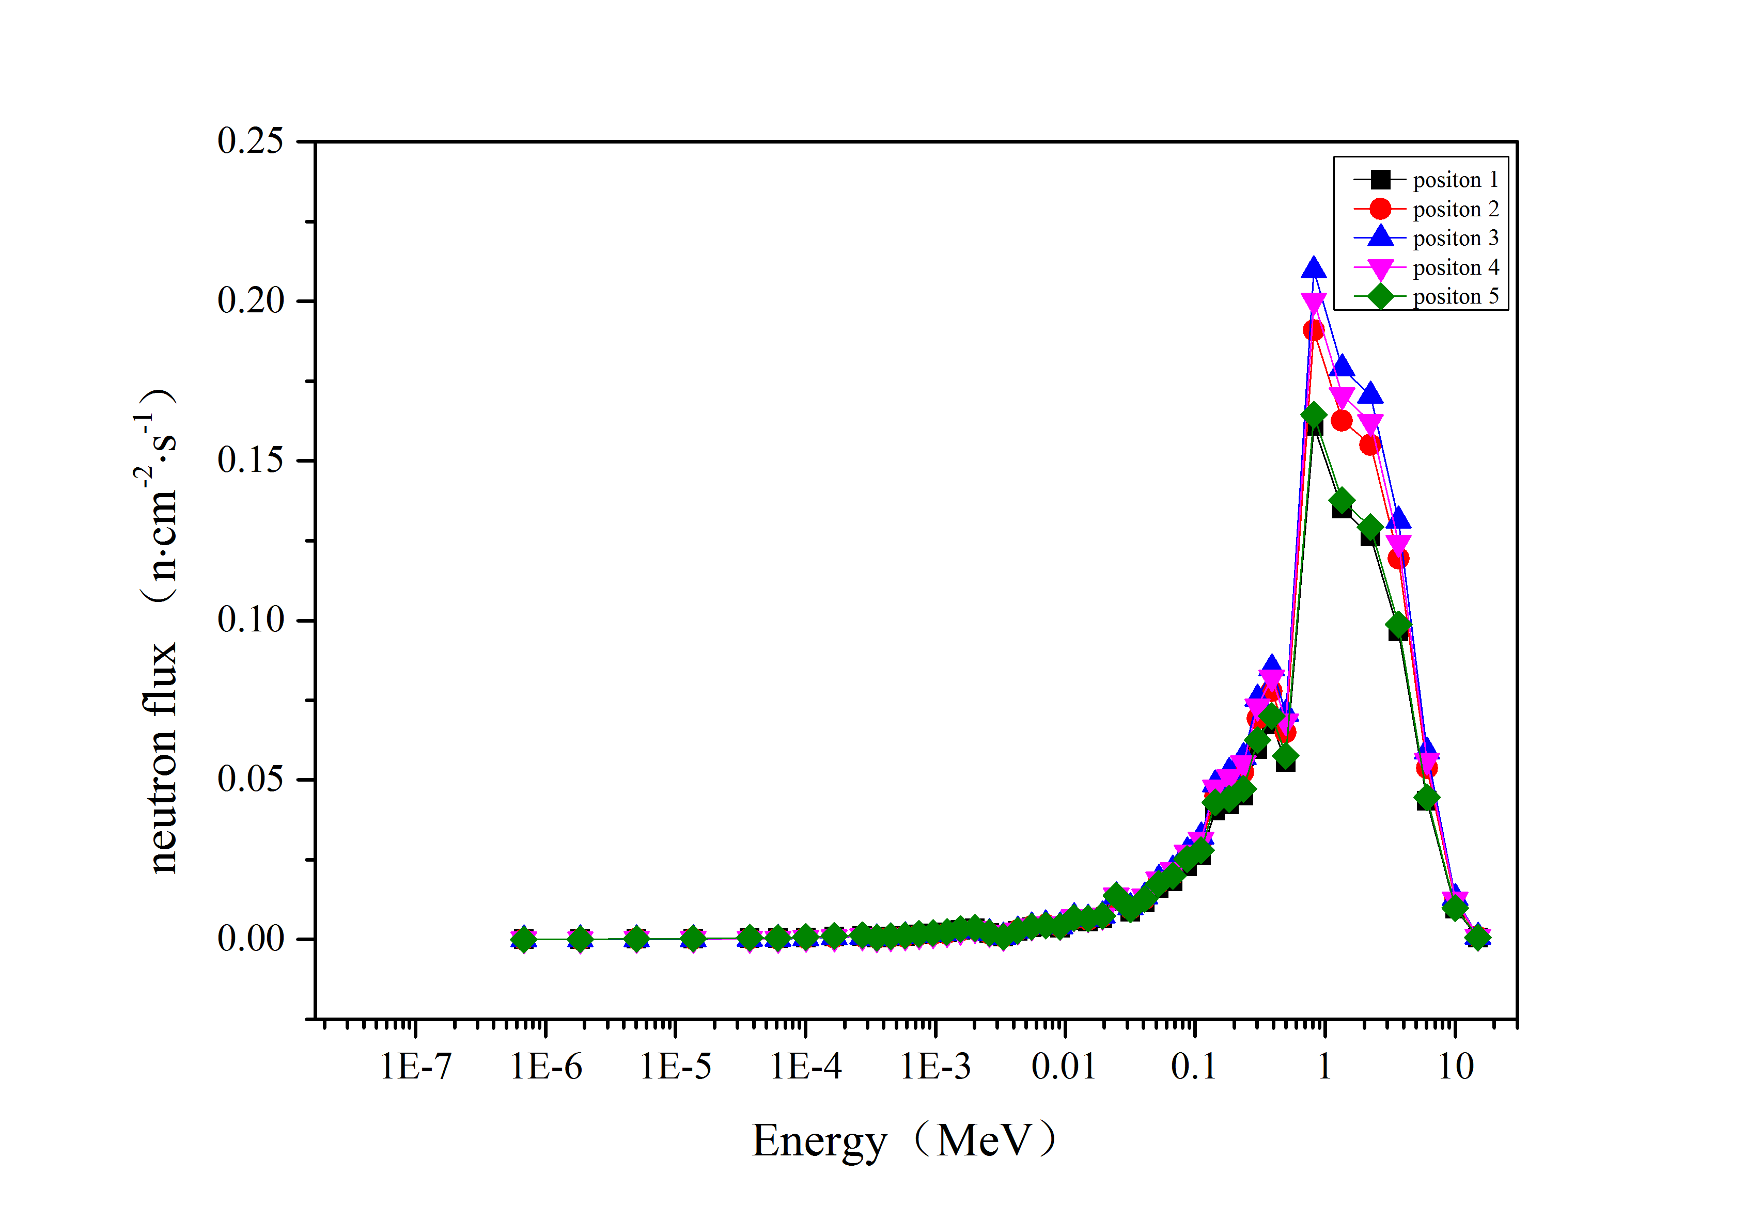
Fig.8 Radial neutron flux relative distribution
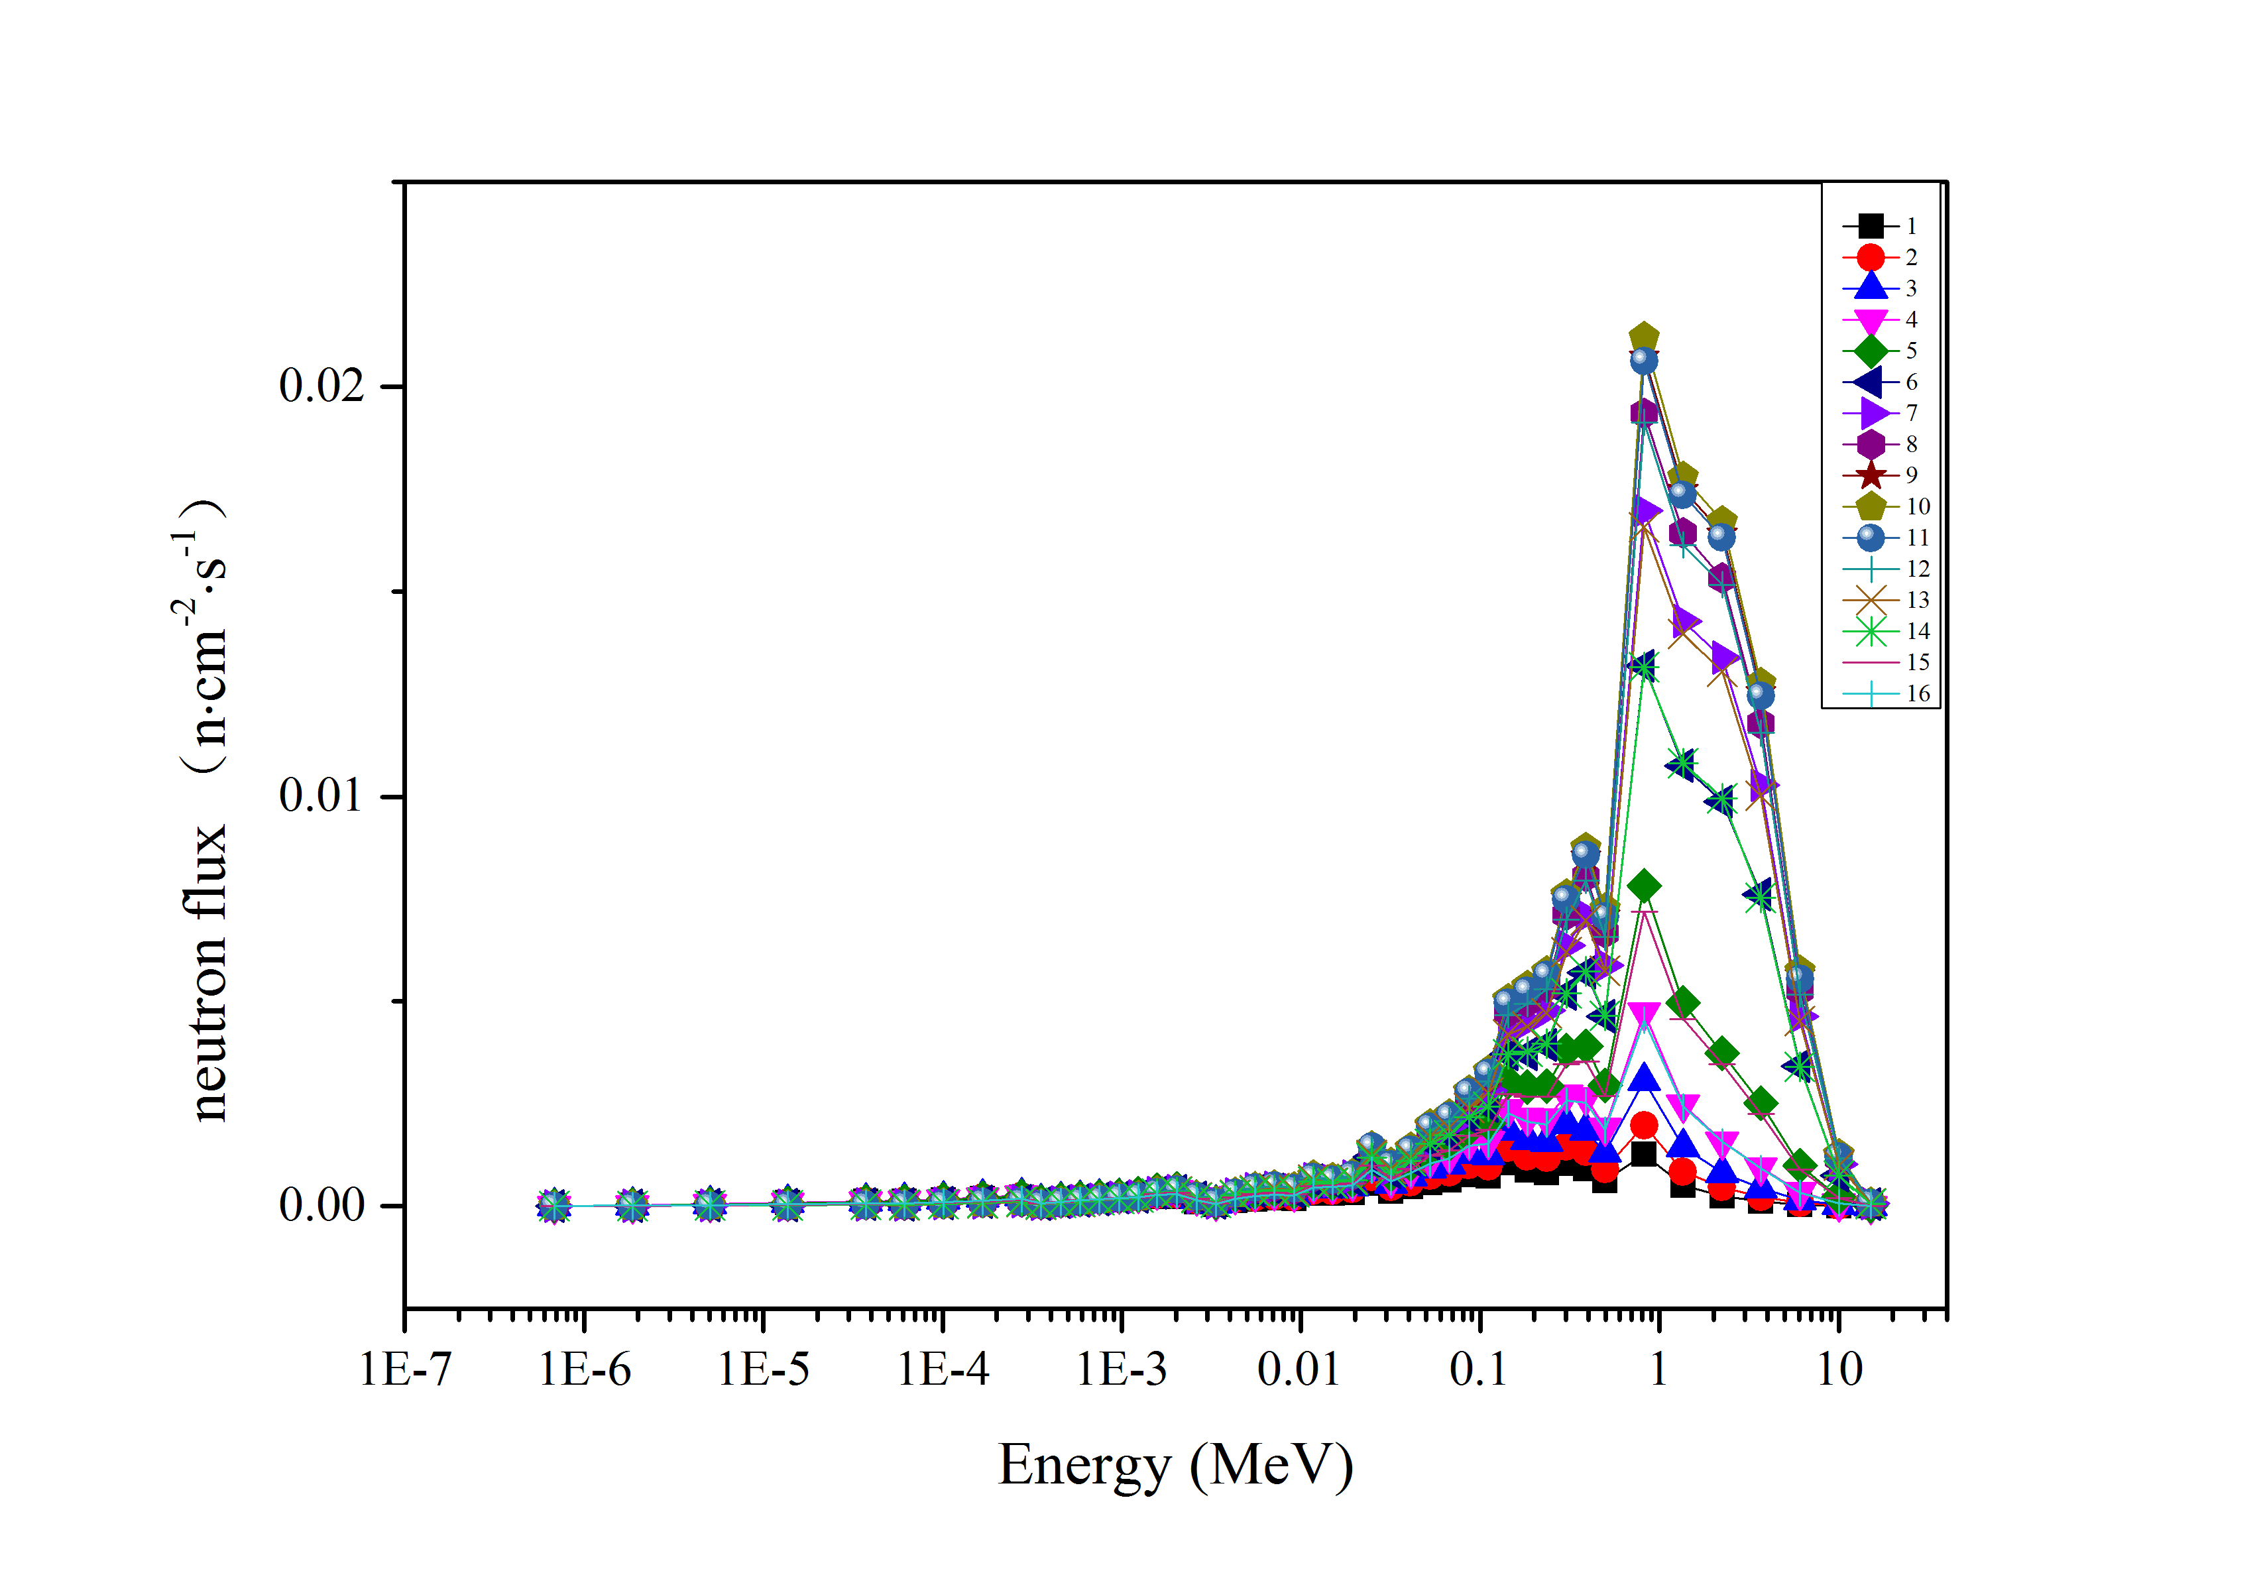
Fig.9 Relative distribution of axial neutron flux of position 1

Group Section Machining
The original data from the database in ENDF/B VIII.0 format by the NJOY[4], and the original data was linearized within 0.1% error range using a special processing program, and then the resonance reconstruction was carried out, and the obtained resonance cross section was The contribution of is added to the linearized section. Doppler broadening is then performed. Finally, the multi-group section processing is carried out. The process is shown in Figure 10. In this paper, the NJOY program is used, corresponding to the above four processes of group section processing, using subroutines such as MODER, RECONR, BROADR, UNRESR, GROUPR, etc., and by appropriately adjusting the corresponding input parameters, the required group section can be obtained. The obtained point section is processed into the required 46 group section, and the fission group section of ²³⁵U and ²³⁸U are shown in Figure 11 and Figure 12.
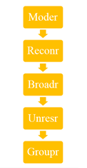
Fig.10 NJOY group cross-section processing flow chart
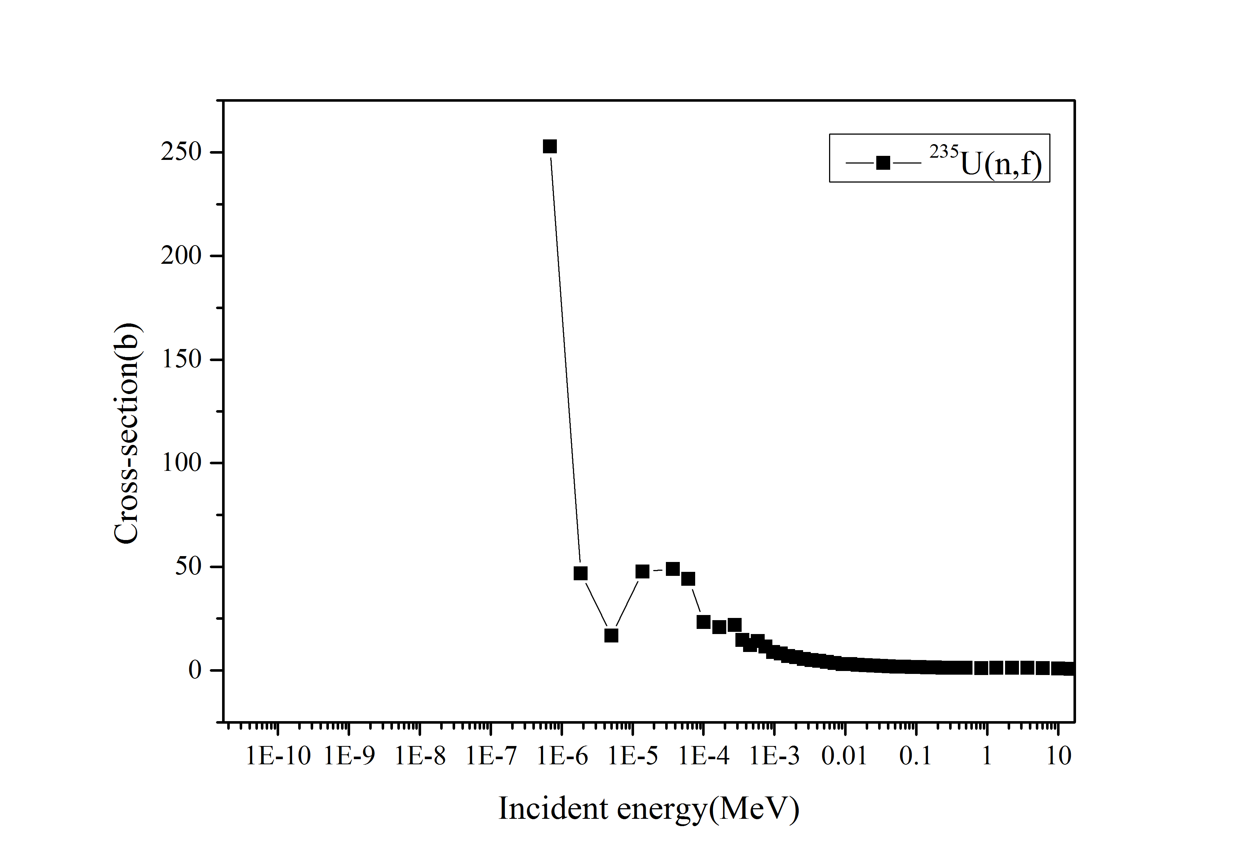
Fig.11 46 group cross section of ²³⁵U(n,f)
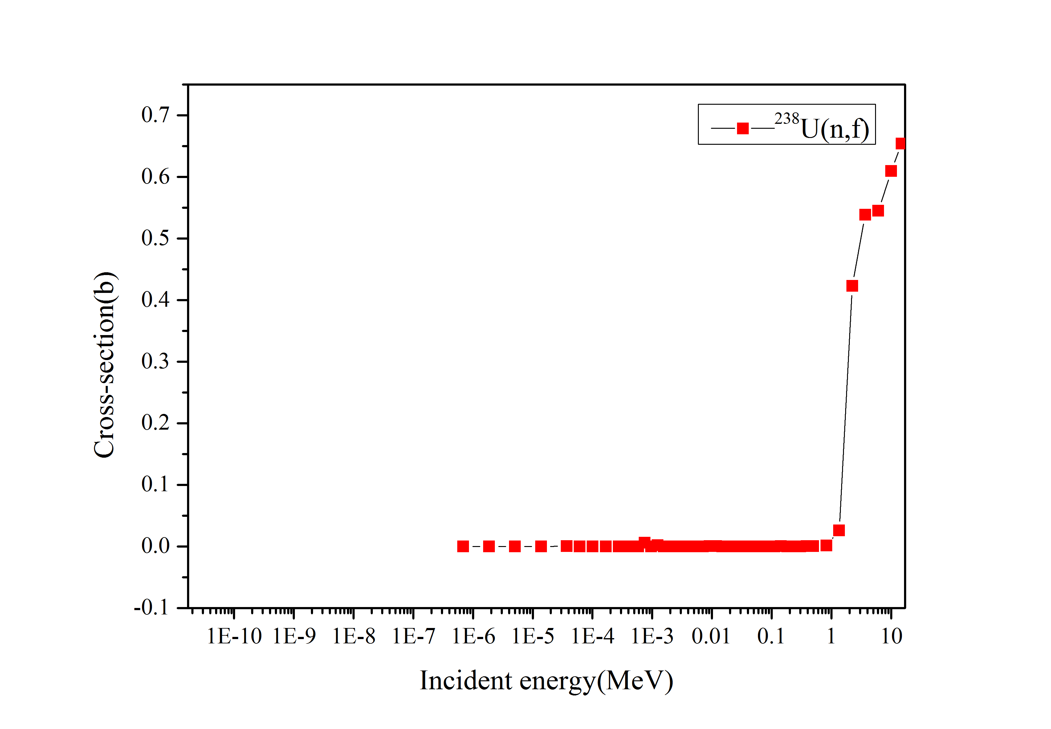
Fig.12 46 group cross section of ²³⁸U(n,f)

Calculation result
Using the formula R=σφ to obtain the fission mononuclear reaction rates of 235U and 238U. When MCNP calculates the neutron flux, it is the normalized neutron flux. In order to obtain the absolute value of the neutron flux, the normalization constant needs to be multiplied, and the absolute value of the neutron flux is obtained by the following formula, the results are shown in Fig13 and Fig.14.
$ϕ_{absolute}=ϕ_{F_{4}}×\frac{\overline{ν}∙P}{k_{eff}×1.602×{10}^{-13}E_{fission}}$ （5）

Where Φabsolute is the absolute value of neutron flux; ΦF4 is the neutron flux count of MCNP; ν is the average number of neutrons released per fission, which is 2.501 for CEFR; P is the power of the reactor, which is 65 MW for CEFR; keff is the effective multiplication coefficient; Efission is the energy released per fission, which is 200 MeV for CEFR.
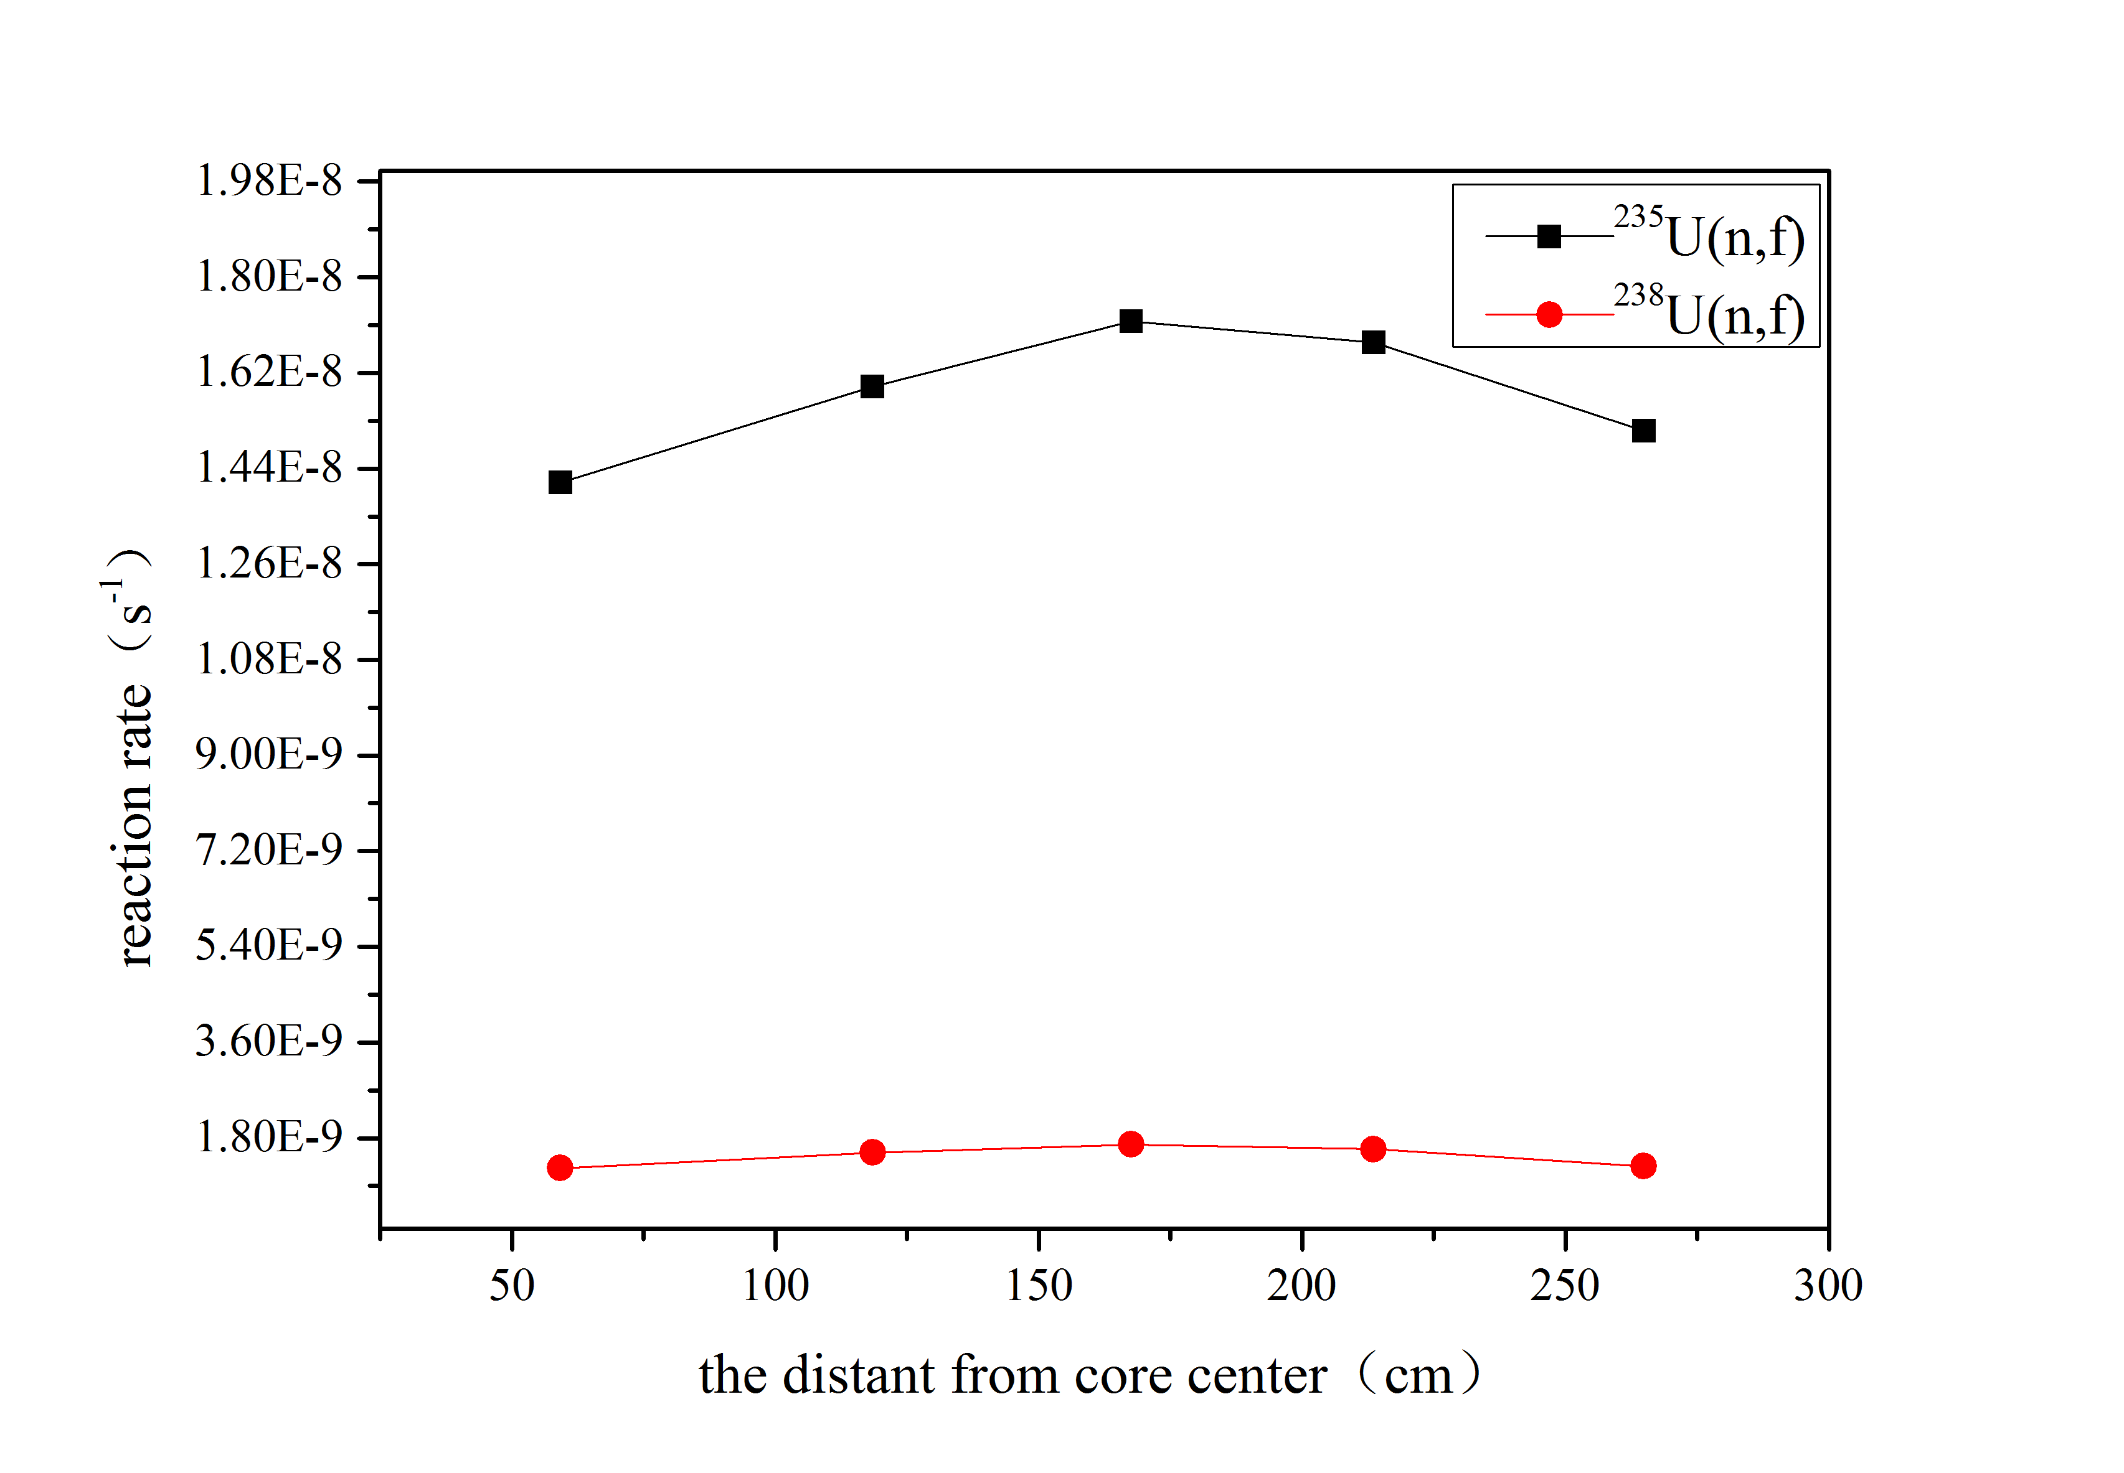
Fig.13 Radial mononuclear reaction rate distribution
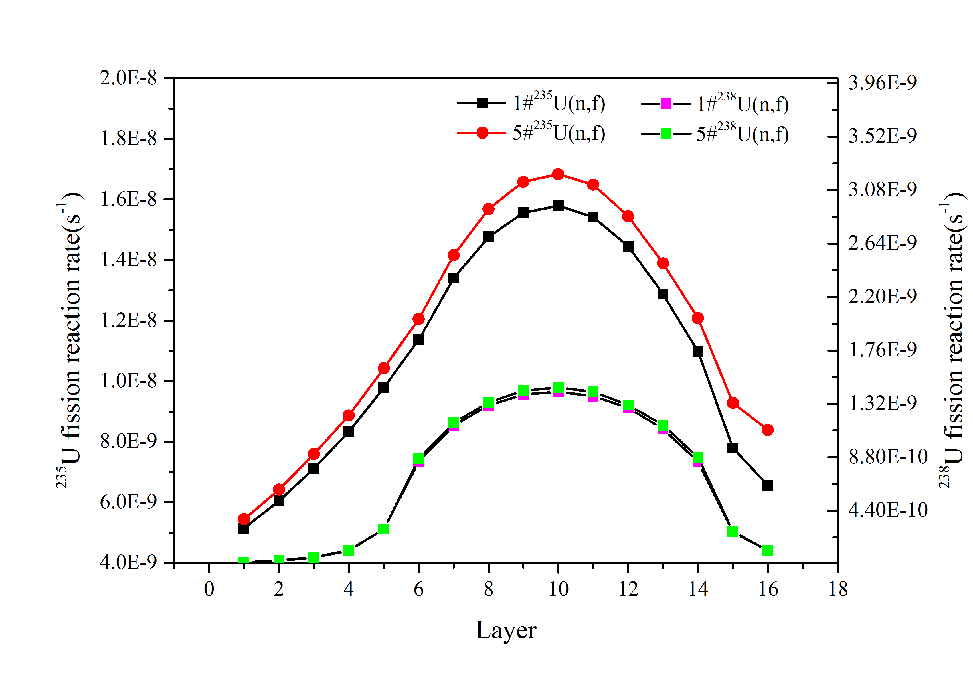
Fig.14 Axial mononuclear reaction rate distribution

Selection of detection foil
According to Section 4.2, the mononuclear fission reaction rates of 235U and 238U are calculated. Given the quality of the detector piece and the irradiation time of 1 hour, under the condition of full power, the count rate of the detector foils after cooling for 3 hours can be obtained from Equation 4. In addition, the Fission foil information are indicated in table 2. Axial measuring point layout diagram is displayed in Fig.16. It is necessary to select the appropriate irradiation power level and irradiation time through theoretical calculation, so that the activity of the detector after irradiation can reach a reasonable level, which can complete the activity measurement quickly and reduce the dose received by the experimenters as much as possible. In general, the count rate needs to be 10~100 count per second, which requires the activity level of the detector after irradiation to be 1 ~ 10 μCi. From the results, the irradiation power needs to be reduced to 0.25‰ FP.

TABLE 2. FISSION FOIL INFORMATION
No. | Material | Enrichment | Nuclear reaction channel | measured Nuclide | $E_{γ}$（keV） | Half-life  /hours | Branching ratio (%) | Mass  /mg
1 | Highly enriched uranium | 90% | ²³⁵U(n，f) | ¹⁴³Ce | 239 | 33.039 | 42.8 | 30
2 | Depleted uranium | 0.335% | ²³⁸U(n，f) | ¹⁴³Ce | 239 | 33.039 | 42.8 | 250

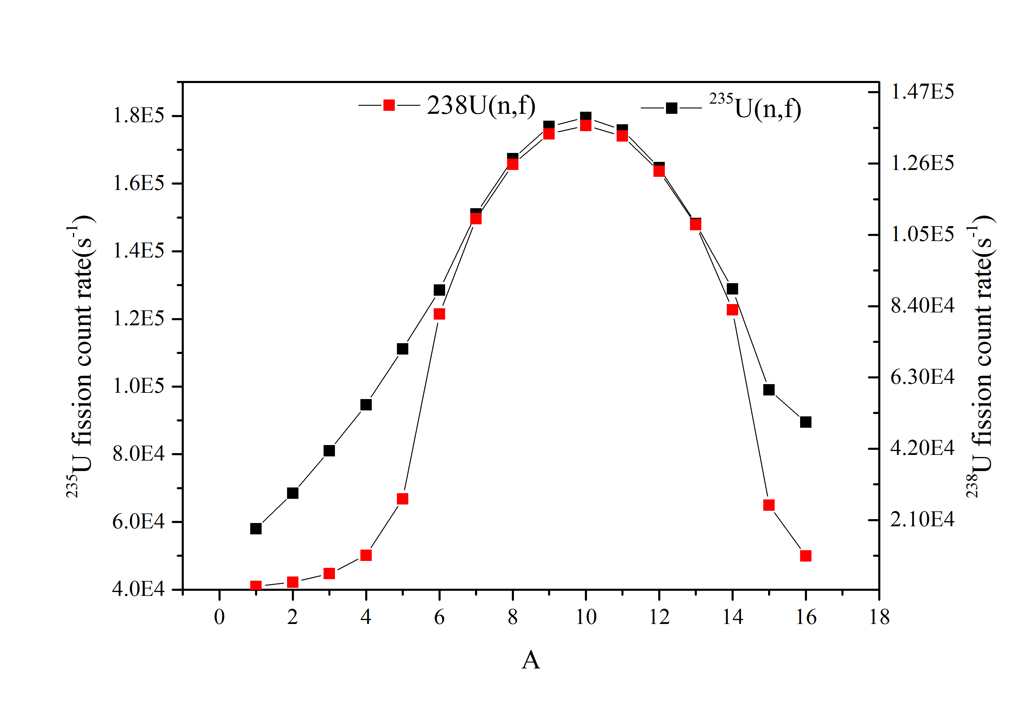
Fig.15 Estimation of counting rate of position 5
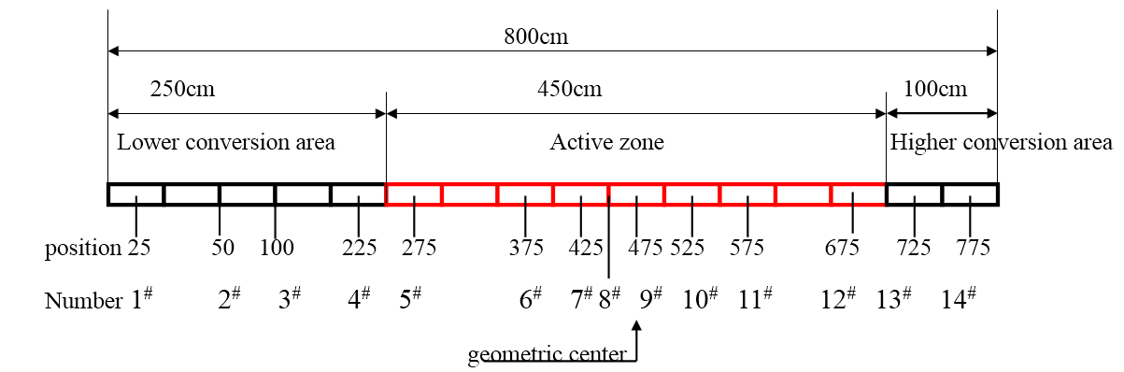
Fig.16 Axial measuring point layout diagram

Reactivity introduced by the experiment
The fuel test assembly used in the activation method experiment is to replace the 7 fuel rods in the center of the fuel assembly with a large irradiator, which introduces negative reactivity to the core. In order to quantitatively analyze the entire experimental process, the activation method is introduced to use MCNP Code to calculate the value of 7 rods in the center of 5 position in the fuel zone，which are shown in Table3.

TABLE 3. THE VALUE OF 7 FUEL RODS
The number of fuel SAs | The value of 7 fuel rods（pcm）
1 | -5.0
2 | -5.0
3 | -5.1
4 | -5.2
5 | -5.1

When replacing 5 cartridges of fuel SAs in the fuel area each time, it is equivalent to introducing a maximum negative reactivity of 25.4 pcm. When the fuel zone replaces 2~3 boxes of fuel SAs at the same time, the impact on the core is small (because there are 169 fuel rods in one box assembly, the experimental assembly only replaces the middle 7 fuel rods. The reactivity is very small.

CONCLUSION
The paper introduces the experimental principle, measurement system and special tools of CEFR MOX fission rate distribution experiment, and formulates a set of feasible schemes for ²³⁵U and ²³⁸U fission rate distribution experiment. Firstly, the radial and axial distributions of ²³⁵U and ²³⁸U single nuclear fission rates at full power of CEFR MOX are obtained through MCNP and NJOY calculation, so as to determine the core measurement position of ²³⁵U and ²³⁸U fission rate distribution experiment; Then, through the activity evaluation of the detection foil at the measurement point before measurement, the quality of the detection foils are obtained, which can be used as a reference for the size of the subsequent detection foil and the size of the irradiation device. It is further determined that the irradiation power of the experiment is 0.25 ‰ FP and irradiation time is 1 hours; Finally, the reactivity introduced in the whole experiment is calculated in detail to evaluate the risk of the experiment. Finally, a relatively sound experimental scheme of CEFR MOX fission rate distribution is formed, which not only provides a theoretical basis for subsequent experiments, but also has guiding significance for the activation method experiment of large commercial fast reactor.

ACKNOWLEDGEMENTS
The author wishes to acknowledge the hard work and support of many of our colleagues at China Institute of Atomic Energy,in particular, the Reactor Physics Research Laboratory and the Core Laboratory, Chen Xiao-liang, Chen Xiao-xian and Xia Zhao-Dong, etc.

References
- FAN Zhen-dong, CHEN Xiao-liang.etc. Experimental research of nuclear reaction rate in China Expeirmental Fast Reactor[J]. Atomic Eenergy Science and Technology. Vol 47, suppl. Jun.2013.
- HU Dapu, ZHENG Fuyu. Nuclear reactor physics experiment method[M]. Beijing: Atomic Energy Press，1988.
- Team X-M C. MCNP-A General Monte Carlo N-Particle Transport Code[R]. Version 5，in LA-UR-03-1987.USA：Los AlarmosNational Laboratory，2003.
- R.E.MacFarlane. The NJOY Nuclear Data processing System version 2016[R]. in LA-UR-17-20093.USA：Los Alarmos National Laboratory，2019.

