Impact of Core Materials on the Fuel Cladding Irradiation Damage
in Breed-and-Burn Fast Reactors
S.ODMAA
School of Engineering and Applied Sciences, National University of Mongolia
Ulaanbaatar, Mongolia
Nuclear Research Center, National University of Mongolia
Ulaanbaatar, Mongolia
Email: odmaa@seas.num.edu.mn, sodmaa1@num.edu.mn

J.NISHIYAMA¹, V.Kh.HOANG², T.OBARA¹

¹ Laboratory for Advanced Nuclear Energy, Institute of Innovative Research, Tokyo Institute of Technology, Japan
² Institute for Nuclear Science and Technology, Vietnam Atomic Energy Institute, Vietnam

Abstract

The breed-and-burn (B&B) fast reactor concept, in which depleted or unenriched fuel is loaded in a core and breeds fissile fuels while burning them, has been familiar to nuclear engineers since the 1950s. Development of B&B reactors has resulted in effective utilization of uranium resources and reduction of spent fuel. However, issues remain to be solved, such as irradiation damage and reduction of DPA in high burnup. The best combination for fuel and coolant core materials and the impact on DPA of these combinations in B&B reactors remains to be elucidated.
The objective of this study was to clarify the impact of several materials on DPA by performing burnup analyses using the Monte Carlo SERPENT code. Neutron balance (NB) analyses for the infinite fuel cell with fixed geometry in which different combinations of metallic (UZr), natural and enriched nitride (UN), and oxide (UO₂) fuels, and helium, sodium, lead, and lead-bismuth coolant, were performed to determine the best combination of core materials and their impact on DPA (displacements per atom).
It is found that the minimum burnup required to sustain a B&B mode of operation in a large fast reactor core is a combination of metallic fuel and any type of coolant. Therefore, the maximum NB value for sustaining the B&B operation condition was also metallic fuel with any type of coolant. Combinations of any fuel and sodium, lead, and lead-bismuth coolants produced no large difference on the minimum burnup results, DPA, or NB value. For oxide fuel, only the core with helium as a coolant could sustain the B&B mode of operation. For nitride fuel, we had considered natural nitrogen and 70% as well as 99% enriched nitrogen-15 for uranium mononitride fuel. Therefore, if the nitrogen-15 isotope is enriched more for nitride fuel, the minimum burnup and corresponding DPA are decreased further than the natural ones due to the softer spectrum.
The conclusion is that the combination of metallic fuel and helium coolant has the least impact on DPA in a large B&B reactor core.

INTRODUCTION
There are over 400 thermal reactors operating in nuclear countries, and they produce large amounts of spent nuclear fuel. There is a way to reprocess this spent nuclear fuel in order to separate useful fission products and fissile nuclides, and reduce the amount of nuclear waste. However, such reprocessing is very costly, and not many countries have such plants.
Alternatively, nuclear engineers have known about the B&B fast reactor concept since the 1950s. In a B&B reactor, depleted or unenriched fuel is loaded into a core and breeds fissile fuel while burning. Development of B&B reactors is an effective way to optimize use of uranium resources and reduce the amount of spent fuel. Small B&B reactors require only modest initial investigation, and have advantages in terms of non-proliferation, as well as less low-radioactivity nuclear waste. However, issues remain to be solved, including irradiation damage and reduced DPA in high burnup. To date, no investigation has clarified the best combination of core material fuel and coolant for B&B reactors, or the impact on DPA of different combinations of core materials.
The objective of this study is to clarify the impact on DPA of several combinations of materials in a B&B reactor.

Methods
Several studies have analyzed B&B reactor core design using the neutron balance (NB) method, in which the NB value is evaluated as the net number of neutrons from production and absorption reactions in a system [1-6]. NB analyses for an infinite one cell with a fixed geometry, in which the cell is composed of different combinations of fuel, such as metallic, natural and enriched nitride, and oxide, and various coolants, such as helium, sodium, lead and lead-bismuth, and cladding such as oxide dispersion strengthened (ODS) steel, are shown in Fig. 1.
Coolant (He, Na, Pb, PbBi)
ODS cladding
Fuel (UZr, U¹⁵Nnat, U¹⁵N50, U¹⁵N99, UO₂)
0.6 cm
0.45 cm
0.51 cm
FIG. 1. Horizontal cross section of the fuel cell

Here, we perform burnup analysis using the Monte Carlo SERPENT code [7] with the ENDF-B/VII nuclear data library [8] to determine the best combination of core materials and their impact on DPA. The neutronic calculation condition was the same for all calculations, in which the number of source neutrons per cycle was 100,000, the total number of active cycles was 100, and the first 20 cycles were omitted from the statistical analysis. Fuel temperature, cladding, and coolant in the operating condition were set as 800, 700 and 700 K, respectively. The neutron flux in a cell was normalized to a total flux of 10¹⁵ n/cm²s during burnup.

Results and discussion
In NB analyses, the infinite neutron multiplication factor and NB curve with burnup are determined to find the minimum possible burnup for B&B operating condition. Figs. 2 and 3 contain example curves for combinations of different fuels with sodium coolant. Similar figures were obtained for other combinations of fuels and coolants, but and the general trend was the same as those in Figs. 2 and 3.
In the figure legends, UNnat-ODS-Na/UN70-ODS-Na/UN99-ODS-Na indicate cells composed of a combination of natural/70% enriched/99% enriched nitride fuel, with ODS cladding and sodium coolant, respectively. Those identified as UZr-ODS-Na and UO2-ODS-Na are cells with metallic fuel, ODS cladding, and Na coolant, and oxide fuel, ODS cladding, and Na coolant, respectively. The first NB point (FNBP), maximum NB point (MNBP), second NB point (SNBP) and NB at MNBP for each combination of fuel cell materials could be determined using the NB curves. As explained in our previous study [9], FNBP is the minimum required burnup for the neutron production rate to equal the neutron absorption rate. In other words, the corresponding burnup of NB first equals zero in Fig. 3. MNBP is the burnup where the NB value has the maximum value in Fig. 3. SNBP is the maximum burnup when the neutron production rate equals the neutron absorption rate, or NB equals zero again. Fig. 3 shows that the NB was always negative for both oxide and natural nitride fuels.
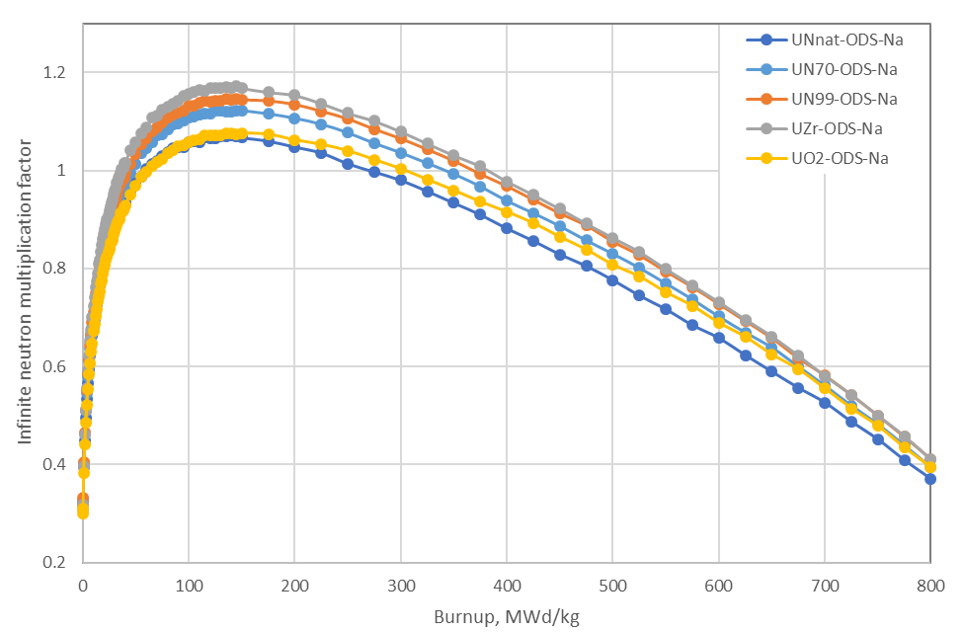
FIG. 2. Change of infinite neutron multiplication factor in burnup for fuel cell made of different fuel materials, ODS cladding and Na coolant.

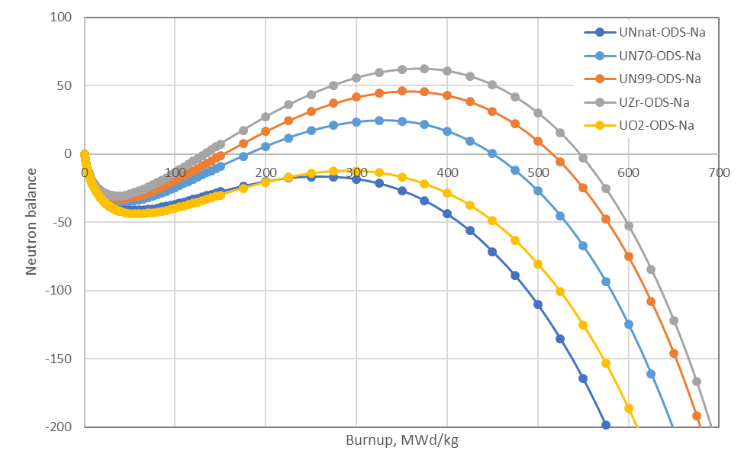
FIG. 3. Change of NB value in burnup for fuel cell made of different fuel materials, ODS cladding and Na coolant

Using these results, the minimum burnup at FNBP and NB at MNBP for the fuel cells composed of different materials is depicted in Figs. 4 and 5, respectively. For natural nitride and oxide fuels with coolants other than He, the B&B operating condition was not achieved. Generally, oxide- and nitride-fueled cores have softer neutron spectra than metallic-fueled cores. When nitride fuel is further enriched with the N-15 isotope, the minimum burnup value is reduced, and NB is increased. This is mainly due to the decreasing amount of N-14 isotope, whose capture cross section is larger than that of N-15. The combination of metallic fuel and any coolant was found to outperform all others. Among all combinations of metallic fuel, that with He coolant was best, with the smallest minimum burnup at FNBP, and largest NB at MNBP. There were no significant differences in the corresponding results for combinations of each fuel with varying coolants (sodium, lead and lead-bismuth).
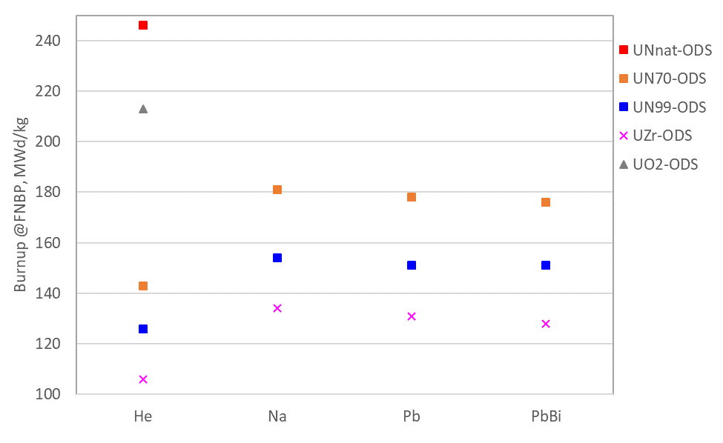
FIG. 4. Minimum burnup at FNBP for fuel cells composed of different fuel materials
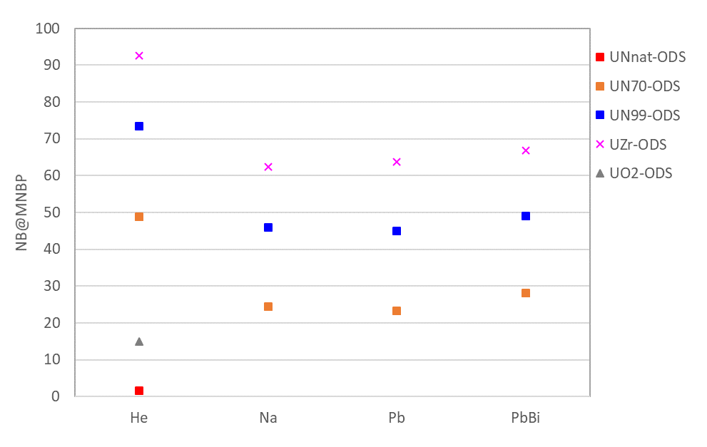
FIG. 5. NB at MNBP for fuel cells composed of different fuel materials

Similar relationships to those shown in Fig. 4 were obtained between corresponding burnup values at MNBP and SNBP for different combinations of fuel and coolant (see Figs. 6 and 7). The general tendency of burnup vs. coolant for each fuel shown in Fig. 4 is the same in Figs. 6 and 7. However, the burnup at MNBP and SNBP was the largest for metallic fuel and smallest for natural nitride fuel, which means that the burnup values for the combinations are in the opposite order to that in Fig. 4.
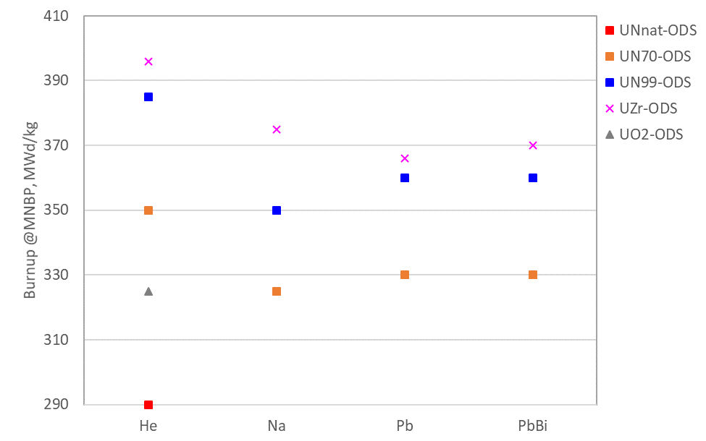
FIG. 6. Burnup at MNBP for fuel cells composed of different fuel materials

Therefore, it is necessary to determine DPA on the cladding to each burnup value of fuel, especially to minimum burnup. In order to ascertain this value, the accumulated neutron fluence at FNBP is first calculated using the volume average neutron flux at the cladding domain. Then, the DPA value is estimated using an approximated formula: 2.0 x 10²⁵ n/m² neutron fluence in neutron energy over 100 keV corresponds to 1 DPA in Fe and Cr atoms [10]. The obtained DPA at FNBP for fuel cells composed of different materials are shown in Fig. 8.
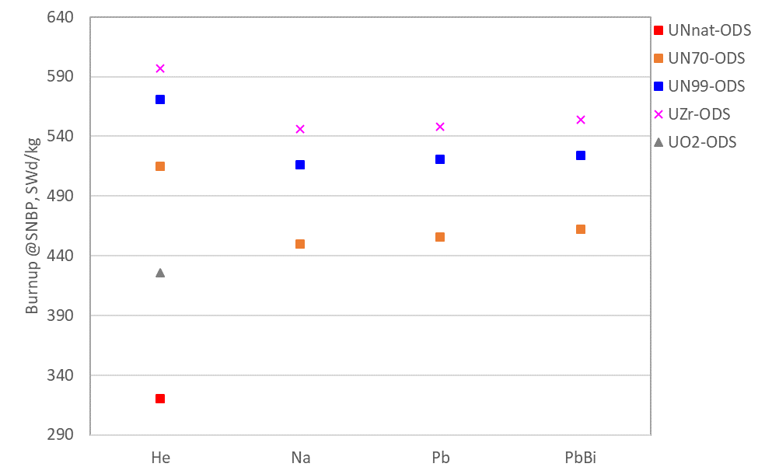
FIG. 7. Burnup at SNBP for fuel cells composed of different fuel materials
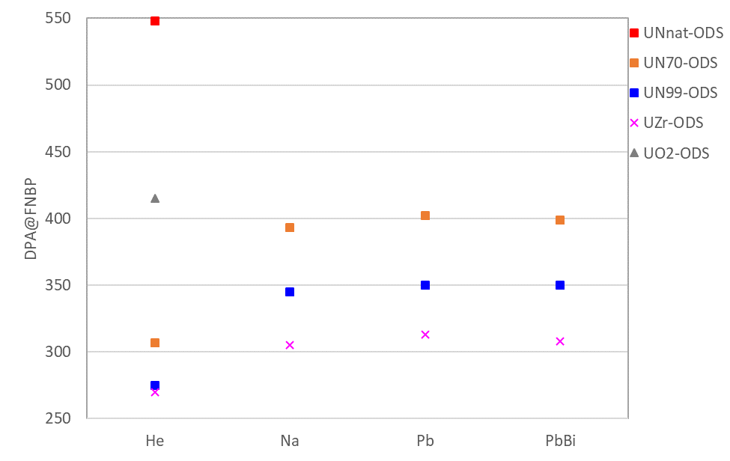
FIG. 8. DPA at FNBP for fuel cell made of different materials
The results in Fig. 8 show that the smallest DPA was estimated for metallic fuel with each coolant. Since there were not large differences on the minimum burnup at FNBP for fuel whether the coolant was sodium, lead, or lead bismuth, DPA values for the corresponding combinations also did not differ much. Fig. 9 shows the relationship between DPA and burnup for combinations of metallic fuel and coolants as an example. The higher burnup produced larger DPA, which is reasonable. Therefore, for an He-cooled core, DPA at the same burnup is larger than others. This kind of relationship was also obtained for nitride fuel and the relationship trend and curve order were the same as those in Fig. 9. However, for oxide fuel there is only one curve corresponding to He coolant.
Fig. 10 shows the relationship between DPA and burnup for combinations of He coolant with different fuels as another example. Here again, when burnup increases, DPA becomes larger. Among the combinations with the same coolant, DPA at the same burnup is larger for metallic fuel. The harder spectrum enhances neutron economy for metallic fuel.
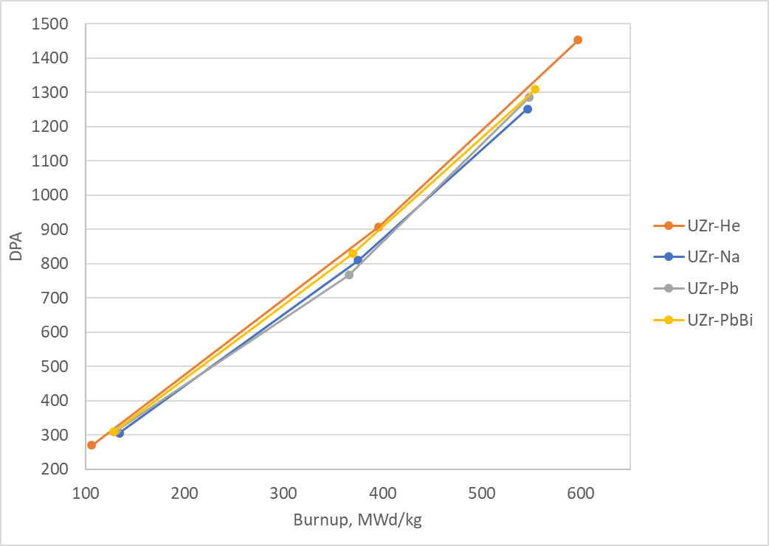
FIG. 9. Relationship between DPA and burnup for combination of UZr fuel with different coolants
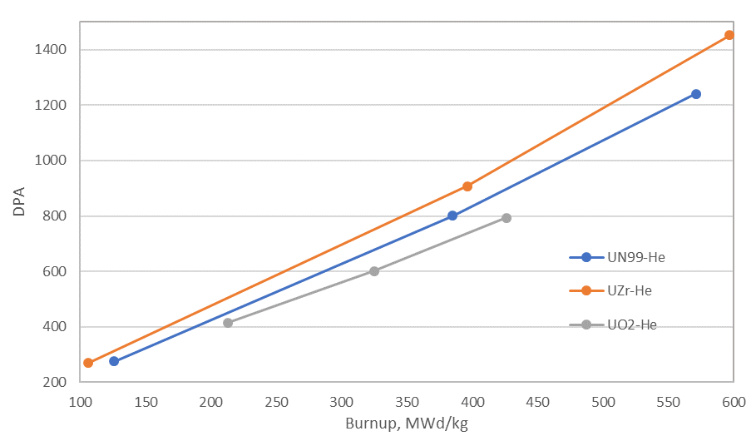
FIG. 10. Relationship between DPA and burnup for combination of He coolant with different fuels

Conclusions
In the present work, we conducted NB analyses for a large fast reactor core with different combinations of core materials to determine the best combination to sustain a B&B mode of operation. The result showed that the required minimum burnup was smallest for metallic fuel paired with any type of coolant compared to other combinations. Therefore, the neutron economy is best with the metallic fuel and any type of coolant in the infinite geometry.
Combinations of any fuel and sodium, lead, and lead-bismuth coolants did not show a large different effect on the results of minimum burnup, DPA, or NB value. For oxide fuel, only the core with helium as a coolant could sustain the B&B mode of operation. Therefore, if nitrogen-15 isotope is enriched more for the nitride fuel, the minimum burnup and corresponding DPA will decrease more than those of the natural ones due to the softer spectrum.
In conclusion, the combination of metallic fuel and helium coolant has less impact on DPA for large-sized B&B reactor core than other core materials.
ACKNOWLEDGEMENTS
This work was supported by the Tokyo Tech World Research Hub Initiative (WRHI）Program of Institute of Innovative Research, Tokyo Institute of Technology, by the Foundation for Science and Technology of Mongolia under grant number 2018/45, and by the Vietnam National Foundation for Science and Technology Development (NAFOSTED) under grant number 103.04-2019.37.
References
- HEIDET, F., GREENSPAN, E., Neutron balance analysis for sustainability of breed-and burn reactors, Nuclear Science and Engineering, 171 (2012) 13-31. http://dx.doi.org/10.13182/NSE10-114.
- HEIDET, F., GREENSPAN, E., “Breed and burn depleted uranium in fast reactors without actinides separation”, PHYSOR 2010: Advances in reactor physics to power the nuclear renaissance (Pittsburgh, Pennsylvania, USA, May 9-14, 2010)
- HEIDET, F., GREENSPAN, E., Energy sustainability and economic stability with breed and burn reactors, Progress in Nuclear Energy, 53 (2011) 794-799. doi:10.1016/j.pnucene.2011.05.002.
- QVIST, S., GREENSPAN, E., Design space analysis for B&B reactor cores, Nuclear Science and Engineering, 182 (2016) 197-212. http://dx.doi.org/10.13182/NSE14-135
- KUWAGAKI, K., NISHIYAMA, J., OBARA, T., Concept of Stationary Wave Reactor with Rotational Fuel Shuffling, Nuclear Science and Engineering, 191:2 (2018) 178-186. https://doi.org/10.1080/00295639.2018.1463744.
- KUWAGAKI, K., NISHIYAMA, J., OBARA, T., Concept of breed and burn reactor with spiral fuel shuffling, Annals of Nuclear Energy, 127 (2019) 130-138. https://doi.org/10.1016/j.anucene.2018.12.006.
- LEPPÄNEN, J., Serpent–a Continuous-energy Monte Carlo Reactor Physics Burnup Calculation Code. VTT Technical Research Centre of Finland (2015).
- CHADWICK, M.B., et al., ENDF/B-VII.0: Next Generation Evaluated Nuclear Data Library for Nuclear Science and Technology, Nuclear data sheets, 107,12 (2006) 2931. https://doi.org/10.1016/j.nds.2006.11.001.
- Odmaa, S., Hoang, V. Kh., Nishiyama, J., Obara, T., Neutron Balance Features in Breed-and-Burn Fast Reactors, Nuclear Science and Engineering, in press.
- Editors CACUCI, D.G, Book Handbook of nuclear engineering, Vol.6, p558. Springer, (2010).

