Influence of preheating temperature on

delta ferrite formation and mechanical

properties of 12%Cr steel weld metals

D Wu¹, S.P. Lu¹, D.Z. Li ¹, Y.Y. Li¹

¹ Shenyang National Laboratory for Materials Science, Institute of Metal Research, Chinese Academy of Sciences, Shenyang, China

Email contact of corresponding author: shplu@imr.ac.cn

Abstract

A 12% Cr ferritic/martensitic (F/M) steel, HT-9, has been used as a primary core material for nuclear reactors. Welding is inevitably used in the nuclear structure design. Fusion welding processes such as gas tungsten arc welding (GTAW) were broadly applied for the F/M steel components. Unfortunately, in the fusion zone (FZ) of F/M steel weldment, delta (δ)-ferrite is frequently produced, which is considered to decay the creep strength and impact toughness. In the work, the FZ microstructure and impact properties of gas tungsten arc weldment of HT-9 have been explored. The FZ solidified with the transformation from the liquid into δ-ferrite, followed by a solid-state transformation from the δ-ferrite to the γ phase. The cooled microstructure was formed by a fresh martensitic matrix and retained δ-ferrite. Two kinds of retained δ-ferrites were observed: one was rich in Cr and depleted in C; the other one was rich in Cr, C, Mo and V. The area fractions and number densities of retained δ-ferrite decreased and then increased as the preheating temperature increased. It was supposed that the preheating treatment increased the content of intragranular δ-ferrite. After the welding process, a tempered treatment was conducted with 760℃/1h. The impact toughness test for the welds in the as-tempered condition showed that the impact energy at -80℃ increased with the decrease of the δ-ferrite content. The δ-ferrite could act as the locations for the nucleation and propagation of the cracks.

INTRODUCTION
The ferrite/martensitic heat-resistant steel has a low thermal stress and high-temperature creep strength, especially has good resistance to radiation swelling, thus it is considered to be an important candidate material for core components in the fourth-generation nuclear reactors [1, 2]. HT9, a 12Cr ferritic/martensitic steel, is selected as the core material of the sodium reactor due to its excellent radiation resistance. It is also the primary candidate for core component materials of the lead-cooled fast reactor HYPERION and SSTAR in the United States. Whether in the sodium-cooled or lead-cooled fast reactor, HT9 needed to undergo a welding process and a fraction of retained δ ferrite was formed. Currently the assembly of the cladding tube and duct in the core structure requires the use of fusion welding processes, such as the argon tungsten arc welding (GTAW). Therefore, the performance of the welded joint is one of the important factors to ensure the safety of the entire components [3, 4].
The fusion welding is a non-equilibrium solidifying process in which the alloy is melted, solidified and cooled rapidly. A large number of studies have shown that after this process delta (δ)-ferrite, formed at high temperature, will remain to the room temperature in the ferrite/martensitic steel [5-7]. Unfortunately, this δ-ferrite will decrease the high temperature creep performance and impact toughness of the welded joint in subsequent service [8, 9]. After the fuel assembly is welded, a normalizing treatment for eliminating the δ-ferrite is invalid because the normalizing treatment is always above 1000°C which may damage the property of the assembly. Therefore, eliminating the δ-ferrite is of great significance for the engineering application of martensitic steel, especially for the core components of the nuclear reactor that need to have a sufficient toughness to deal with subsequent problems of irradiation embrittlement [10].
In fact, the researchers have used Kaltenhauser ferrite factor [11], chromium-nickel equivalents (such as Schaeffler diagram [12] and Schneider diagram [13]) or neural network model [14] to predict and retained δ-ferrite fraction in the FZ of the heat-resistant steel (or austenitic stainless steel). These methods are based on the relationship between the alloy composition and the retained δ content established by the database, and therefore can be used to guide design of the base metal (or welding material) composition to avoid the formation of the retained δ-ferrite. However, in order to achieve the various performance requirements of the steel in service, the final alloy composition sometimes cannot meet the requirement of no retained δ in the FZ.
Generally, the δ formation process in ferrite-martensitic heat-resistant steel is more complicated than the austenite heat-resistant steel. There are two main reasons: firstly, the martensitic heat-resistant steel may be in the solidification process. A peritectic reaction of liquid phase (L) + δ → γ may occur in the final solidification of the martensitic heat-resistant steel, moreover, the δ-ferrite will transform to γ phase and subsequently the γ phase will transform to martensite during the cooling process. The solid phase transformation will cover the original solidification microstructure, thus impeding the development of solidification theory of the martensitic heat-resistant steel. Secondly, laser scanning confocal microscope [15], thermal analysis (for example differential thermal scanning calorimetry) [16] and thermal/kinetic simulation software [17] are generally applied to study the phase transition during the solidification and cooling process, but these analysis methods mentioned above are more difficult to be applied in the welding process since the weld cooling rate is very high in the high temperature range where the phase transition is active.
Apparently δ → γ transformation occurred arranging from the starting temperature of δ → γ transformation to martensite start temperature M_{s}. Therefore, increasing the cooling time in this temperature range, such as decreasing the cooling rate or increasing the heat input, was considered to be effective to reduce the retained δ-ferrite [6, 18]. However, another research by B. Arivazhagan [13] revealed that lower cooling rate improved the δ-ferrite formation in the F/M steel FZ. Zhou et al. [19] also suggested that a low cooling rate would increase the fraction of δ-ferrite and change the phase morphology, and an optimized range of cooling rate existed for reducing the δ-ferrite in F/M steel. It seems that the cooling effect on the δ-ferrite formation is not clear by now.
In the paper, autogenous single-pass weldments of HT9 using gas tungsten arc welding was studied, which aims to understand the cooling rate effect on the δ ferrite formation and the subsequent variation of the impact toughness of HT-9 FZ. The result can help to optimize the welding process of the HT-9 martensitic steel by controlling the retained δ formation during welding.

Experimental procedures

Material
Table 1 lists the measured chemical compositions of HT-9 steel used in this study. The steel was cast as cylindrical ingot by vacuum induction melting. Then the ingot was homogenized at 1200 ℃ in muffle furnace and was subsequently forged and hot rolled to plates with a thickness of 4 - 5 mm. After that, all of the plates were initially normalized in muffle furnace at 1050 ℃ for 15 min, air cooled, and then tempered at 760 ℃ for 1 h，air cooled. Before welding the plates were grinded to dimensions of 300 mm × 130 mm × 3.5 mm.

TABLE 1. CHEMICAL COMPOSITION OF HT-9 STEEL (WT. %)

 | C | Si | Mn | Cr | Ni | Mo | W | V | N | Fe
HT-9 | 0.20 | 0.24 | 0.51 | 11.96 | 0.45 | 0.99 | 0.50 | 0.30 | 0.053 | Bal.

GTAW process
The GTAW was processed by an orbital welding machine Panasonic TA 1600 (FIG. 1). Several tests were performed by varying the welding process parameters i.e., welding current and welding speed for determining the suitable range of the parameters. The welding current, arc voltage, welding speed was optimized and determined to be 132 A, 13-13.5 V, 1.7 mm/s, respectively. Flowing rate of the shielding pure Ar was 15 L/min. Preheat treatments with different temperature were conducted and the HT-9 plates were measured to be 95℃, 125℃ and 205℃ before welding. The schematic diagram of the weldment is shown in FIG. 2. After the welding process, a tempering treatment at 760 ℃ for 1 h in a muffle furnace (furnace cooled) was conducted for the HT-9 weldments.
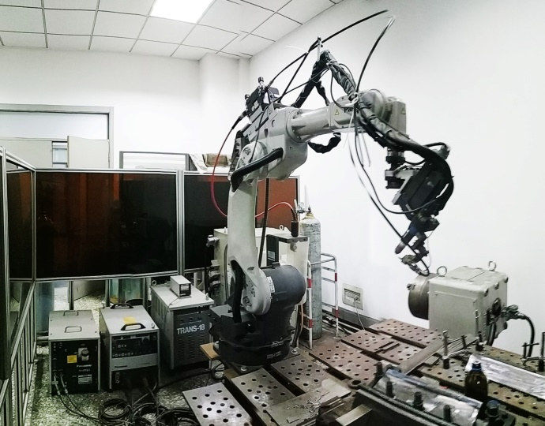
FIG. 1 Orbital welding machine (Panasonic TA 1600) used in this study
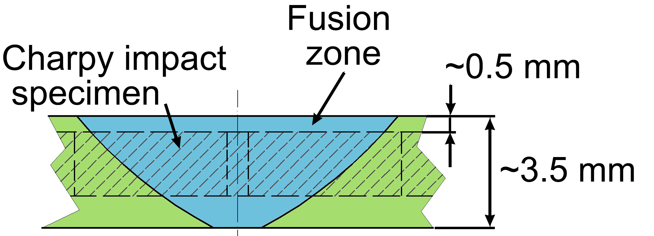
FIG. 2 Schematics of the weldment and location of the mechanical-test specimens

Microstructural characterization
Samples of for microstructural examination were prepared using standard metallurgical techniques and polished using 2.5 µm diamond pastes, and then were etched using a reagent of 5 g ferric chloride, 50 ml hydrochloride and 100 ml H₂O. A Supra 35 field emission scanning electron microscope was used in this research. The element distribution in HT-9 FZ was performed by EPMA (Shimadzu EPMA-1610 system).The area fraction and numbers densities of the δ-ferrite in the FZ at different preheating temperatures were measured by using image process software Image J. 4 pieces of OM images were examined at least for each condition of the HT9 FZ.

Impact toughness
After the tempering treatment, standard Charpy V-notch specimens with dimensions of 55mm×10mm×2.5mm were machined with the V-notch located in the centre of FZ. To determine the effect of preheat temperature on the impact toughness of this steel, the impact tests were carried out at -80℃ and 21℃ and conducted according to GB/T 229-2007, using a Zwick HIT50P machine with a capacity of 0.5 - 50 J.

Results

Formation of δ-ferrite phase
FIG. 3 shows the microstructure of the FZ of HT-9 weldments in as-welded condition at different preheating temperatures. δ-ferrite distributed in the martensitic matrix of the FZ with or without preheating. The shapes and sizes of the δ-ferrite were irregular (block, script-like or rod-like). It can be seen that the number of δ-ferrite decreased significantly due to the preheating treatment regardless of the preheating temperature. FIG. 4 shows statistical results of the number densities and area fractions of the δ-ferrite at different preheating temperatures. It shows that the area fraction and number density was decreased obviously, which indicated that the preheating treatment at 95℃ significantly hindered the formation of retained δ-ferrite. However, the area fraction and number density began to increase as the preheating temperature increased gradually.
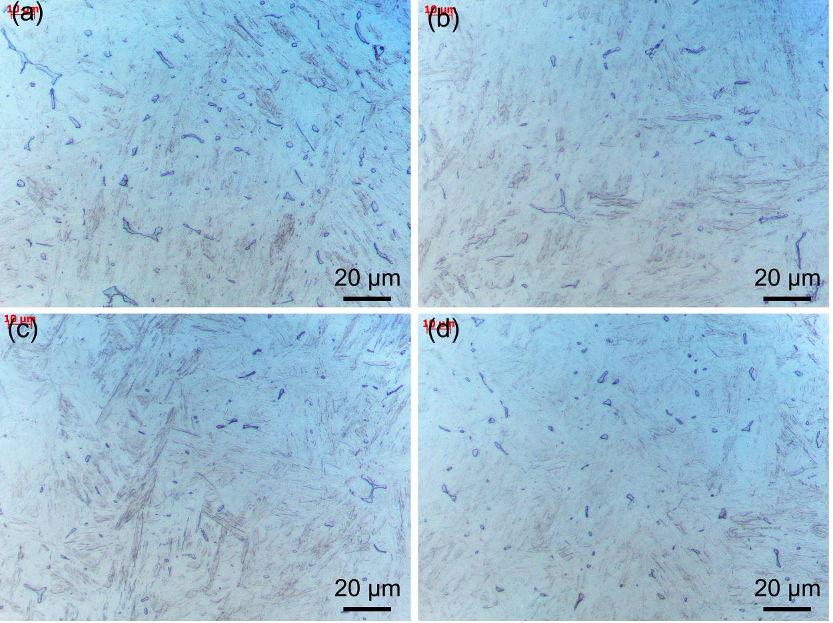
FIG. 3 OM images of the microstructure of HT-9 FZ at different preheating temperatures (a) without preheated,(b) 95℃, (c) 125℃, (d)205℃.
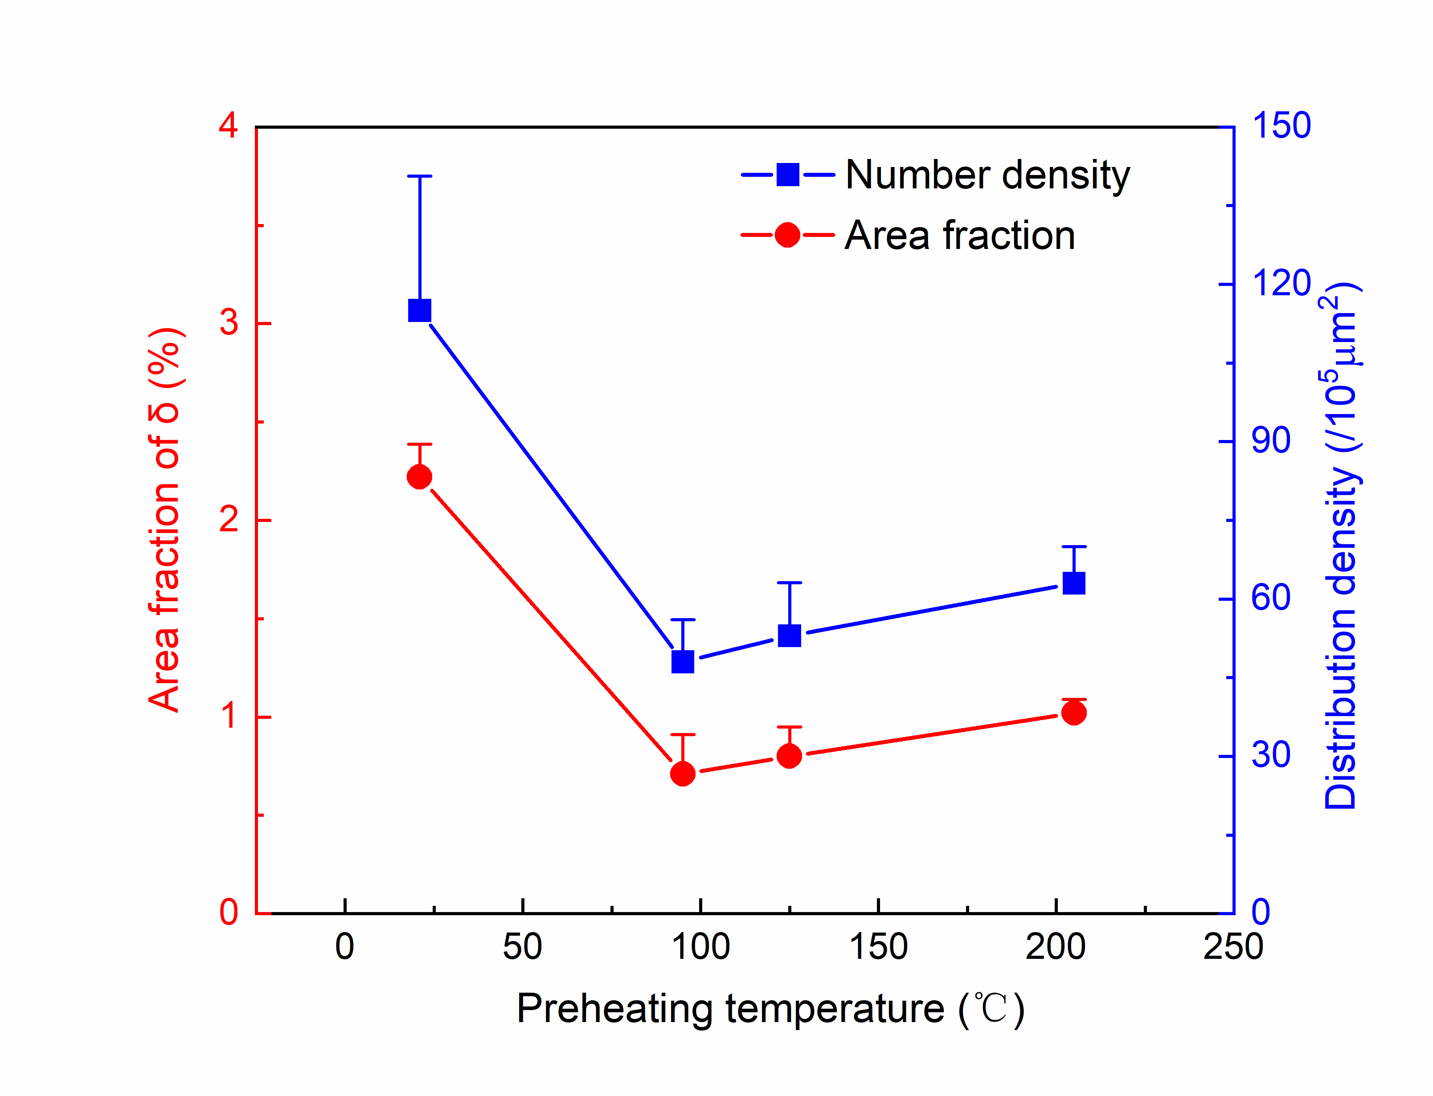
FIG. 4 Number densities and area fractions of the δ-ferrite in the FZ at different preheating temperatures.
A previous work conducting in the same HT-9 FZ showed that the blocky δ-ferrites were rich in Cr and depleted in C when compared with the martensitic matrix [20]. The reason is that C had a lower solid solubility in the δ-ferrite and would be excreted to the liquid during the solidifying process, oppositely Cr preferred to segregate in the δ phase [20]. However, another kind of δ-ferrite was also observed recently in the HT-9 FZ as shown in FIG. 5, where the δ-ferrite was observed to be rich in C, V, Cr, Mo and depleted in Fe. It should be noted that the C was segregated into the δ-ferrite in the current study, which was contrary to our previous study.

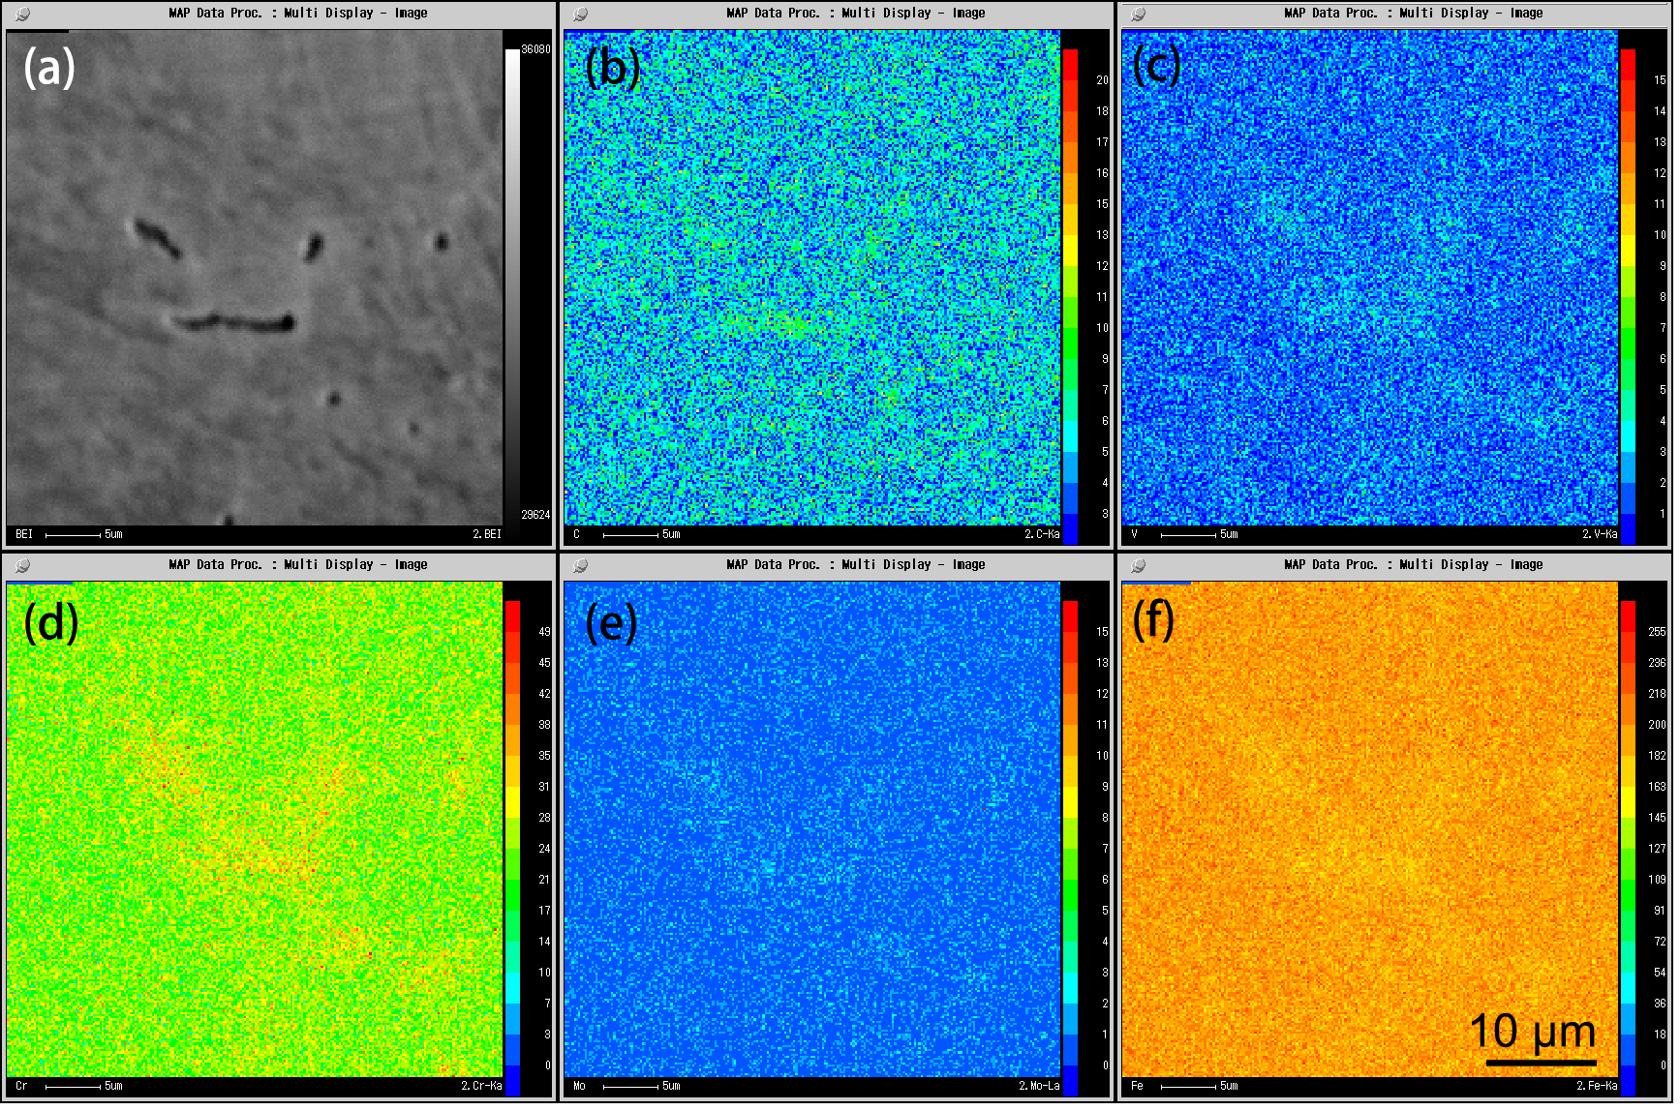
FIG. 5 SEM image of the FZ and the corresponding EPMA mapping of (b) C, (c) V, (d)Cr, (e)Mo and (f)Fe.

Impact toughness
Charpy impact tests were conducted to determine the effect of preheating treatment and the δ-ferrite fraction on the toughness and the impact toughness variation of the FZ. As shown in FIG. 6, phenomenon of ductile-brittle transaction occurred in all the FZ as the tested temperature decreased gradually. The impact toughness at 21℃ was similar at different preheating temperature. However, preheating at 95℃ significantly increased the impact toughness at -80℃ of the FZ significantly, which meant that preheating treatment could improve the impact toughness of HT-9 FZ. When the preheating temperature was raised to 205℃, the impact toughness at -80℃ of the FZ decreased slightly but was still higher than that without preheating treatment.
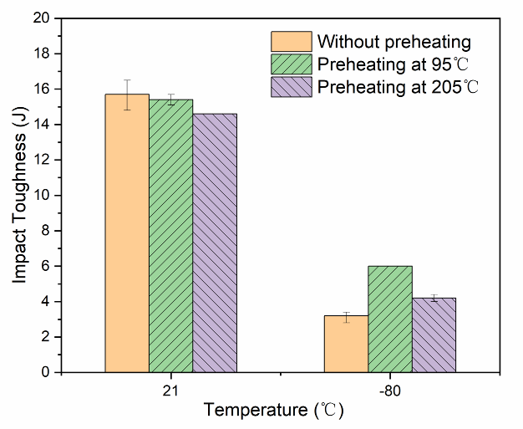
FIG. 6 Charpy impact energy of the FZ at different preheating temperatures.
It is known that the δ-ferrite damages the impact toughness and decreases the ductile-brittle transaction temperature. FIG. 7 shows the typical microstructures near the impact fracture of FZ tested at -80℃ without preheating treatment. It can be seen that a secondary crack existed in the δ-ferrite as indicated in FIG. 7(a) and (b). The interface of the δ-ferritic/martensitic matrix (FIG. 7(c) and (d)) also seemed to be weak and tend to crack, moreover the cavities adjacent to the carbides which had been determined to be M₂₃C₆-type carbides[20] also had bigger sizes compared with those in the matrix nearby.

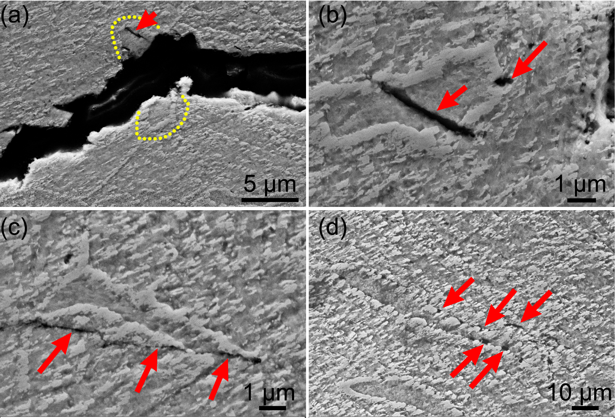
FIG. 7 SEM micrographs showing the microstructure of the longitudinal section near the Charpy impact fracture surface of the FZ tested at -80℃ without preheating treatment:(a, b) the fractured δ-ferrite; (c) cracks along the interface of δ-ferritic/martensitic matrix and (d)cavities nearby the interfacial carbides(the yellow line in (a) denoting the δ ferrite ).

Discussions
The thermodynamic calculation results showed that HT9 would start to solidify by L →δ reaction due to the high Cr content [20]. In last stage of the solidification, the peritectic reaction of L +δ →γ would occur until the whole solidifying process was completed. During the cooling process, the δ-ferrite transformed to the more stable austenite completely. When the δ →γ reaction occurred, the austenite grains preferred to nucleate at the δ-ferrite grain boundaries and grow into the δ-ferrite grains. Eventually, all austenitic grains met each other and the δ →γ reaction finished. Therefore, in the equilibrium phase diagram, no δ-ferrite could be retained at room temperature. During non-equilibrium phase transformation, for example the rapid cooling after welding, the austenitic grains cannot cover the entire δ-ferrite matrix before the transformation stops. Thus, the residual δ-ferrite was observed to distribute at PAGBs. As shown in FIG. 8, massive δ-ferrite distributed at PAGBs. It was reasonable that this kind of δ was depleted in C, which was consistent with the previous EPMA result [20]. However, a kind of δ-ferrite distributed within the martensitic grain was also found in FIG. 8 and its formation could not be explained by the δ →γ transformation process. These intragranular δ-ferrites may be those had been observed to be rich in carbon in EPMA map as shown in FIG. 5. In addition, the intragranular δ-ferrite was also rich in Cr, V, Mo. Therefore, it could be supposed that these δ-phase with enrichment of multiple elements may be formed at the end of the solidification, where the residual liquid is rich in various elements including C due to the much high C content (0.2 wt.%) of HT-9. In other words, at the last stage of the welding solidification, the L +δ →γ reaction did not occur, but the L →δ reaction occurred.
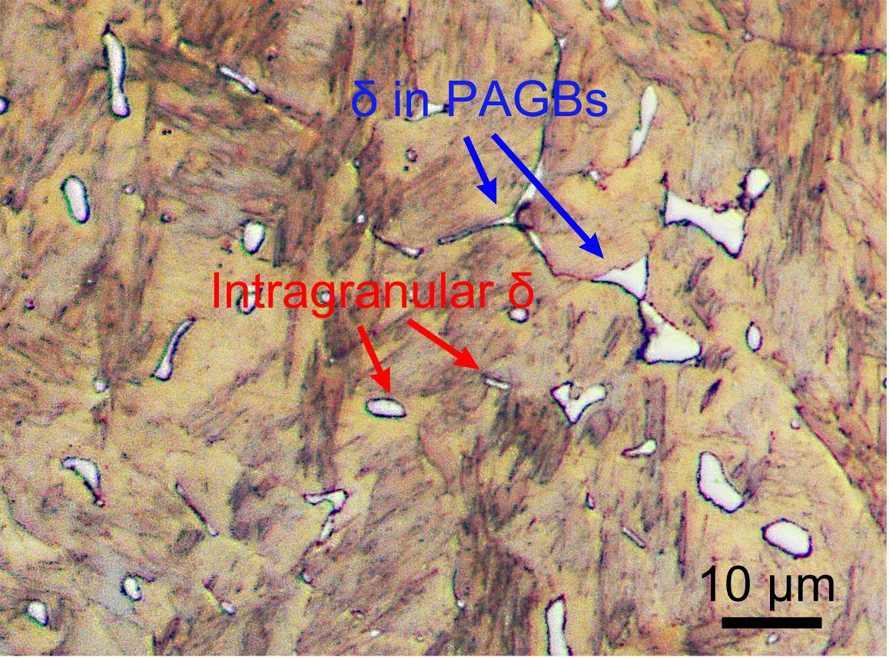
FIG. 8 details of the δ-ferrite distributed in the matrix
Increasing the preheating temperature can effectively reduce the cooling rate of welding, thereby promoting the δ phase on the PAGB to be consumed. However, in this study, when the preheating temperature was higher than 95℃, the fraction and number fraction of the retained δ phase could be seen to increase. It may be explained by that increasing the preheating temperature could reduce the content of the intragranular δ ferrite. Similar phenomenon was also reported by other work but lacked explanation. HT-9 used in our study has complex compositions, which contained Cr, W, V, Mo, etc. These elements were all ferrite stabilized elements and segregated at the end of solidification. Therefore, these elements were likely to cause the solidification path of HT-9 to deviate from the equilibrium phase diagram, and more stable intragranular δ-ferrites were formed at the end of solidification. This was one of the important reasons why the peritectic reaction did not occur. Therefore, increase of the δ-ferrite with the further increase of preheating temperature may be attributed to the increases of the intragranular δ-ferrite and a further study was needed.
It can be seen from FIG. 7 that the δ-ferrite provided locations for nucleation and propagation of the cracks, and similar result were also reported [21]. In our study, the variation of FZ toughness was quite consistent with that of the δ-ferrite contents. It should be pointed out that the effect of the δ phase fraction on the impact energy at room temperature was not obvious. It was mainly because that ductile fracture occurred where the damage proceeded involved with nucleation and growth of dimples [20]. The cracks could not propagate since the matrix around the δ-ferrite has a relatively high plasticity. Therefore, the impact energy at room temperature was not sensitive to the δ phase content. It can be seen from this work that the temperature field had a significant effect on the performance of the FZ of HT-9 weldment, mainly because the δ-ferrite transformation process was very sensitive to the temperature field. The solidification and the subsequent solid-solid transformation of the δ phase are related to the diffusion rate which was relatively high at high temperature, thus the content of the δ phase was very sensitive to the variation of temperature. In addition, the influence of the stress field caused by the phase transformation and the cooling effect after welding was very weak since the yield strength of the steel at high temperature was very low, thus the temperature field was the main factor that determined the kinetics of the δ-ferrite transformation.

Conclusion
In this study，the microstructure and impact toughness of gas tungsten arc (GTA) weldment of HT-9 steel have been explored using OM, SEM and EPMA methods. The following specific conclusions can be drawn:
- Two types of retained δ-ferrites were observed in the fusion zone of HT-9: one was poor in C and rich in Cr element, and the other was rich in C, Cr, Mo, and V elements, the latter δ-ferrite might form at the end of welding solidification and distributed within the prior austenite grains.
- The δ phase content was significantly decreased as the preheating temperature increased to 95℃, however，when the preheating temperature was further increased, the δ content began to increase gradually, which may be attributed to that the preheating treatment increased the content of intragranular δ-ferrite.
- The impact energy at -80℃ increased with the decrease of the δ-ferrite content. The δ-ferrite could act as the locations for the nucleation and propagation of the cracks. The impact energy at room temperature was insensitive to the content of retained δ-ferrite.

ACKNOWLEDGEMENTS
This work was supported by the National Key R&D Program (2018YFA0702902). We are also grateful to Prof Xianchao Hao for providing the material used in the study and for his guidance on the analysis
References
- ZHENG C, REESE ER, FIELD KG, LIU T, MARQUIS EA, Maloy SA, et al. Microstructure response of ferritic/martensitic steel HT9 after neutron irradiation: Effect of temperature. J. Nucl. Mater. 528 (2020) 151845.
- ZHENG C, REESE ER, FIELD KG, MARQUIS E, MALOY SA, KAOUMI D. Microstructure response of ferritic/martensitic steel HT9 after neutron irradiation: effect of dose. J. Nucl. Mater. 523 (2019) 421-33.
- NARITA T, UKAI S, KAITO T, OHTSUKA S, FUJIWARA M. Development of Manufacturing Process of PNC-FMS Wrapper Tube with SUS316 Short Joint. J. Nucl. Sci. Technol. 42 (2005) 825-832.
- WANG CA, GROSSBECK ML, AGLAN H, CHIN BA. The effect of an applied stress on the welding of irradiated steels. J. Nucl. Mater. 239 (1996) 85-89.
- SAM S, DAS CR, RAMASUBBU V, ALBERT SK, BHADURI AK, JAYAKUMAR T, ET AL. Delta ferrite in the weld metal of reduced activation ferritic martensitic steel. J. Nucl. Mater. 455 (2014) 343-348.
- ARIVAZHAGAN B, VASUDEVAN M. A comparative study on the effect of GTAW processes on the microstructure and mechanical properties of P91 steel weld joints. J. Manuf. Process. 16 (2014) 305-311.
- WANG H, ZHANG H, LI J. Microstructural evolution of 9Cr–1Mo deposited metal subjected to weld heating. J. Mater. Process. Tech. 209 (2009) 2803-2811.
- KOBAYASHI S, SAWADA K, HARA T, KUSHIMA H, KIMURA. The formation and dissolution of residual δ ferrite in ASME Grade 91 steel plates. Mater. Sci. Eng. A. 592(2014) 241-248.
- CHANDRAVATHI KS, LAHA K, BHANU SANKARA RAO K, MANNAN SL. Microstructure and tensile properties of modified 9Cr–1Mo steel (grade 91). Mater. Sci. Technol. 17 (2001) 559-565.
- KLUEH RL, ALEXANDER DJ. Heat treatment effects on impact toughness of 9Cr–1MoVNb and 12Cr–1MoVW steels irradiated to 100 dpa. J Nucl Mater. 258-263 (1998) 1269-1274.
- SIREESHA M, ALBERT SK, SUNDARESAN S. Importance of filler material chemistry for optimising weld metal mechanical properties in modified 9Cr–1Mo steel. Sci Technol Weld Joi. 6 (2001) 247-254.
- GABREL J, LEFEBVRE B, BENDICK W, VANDENBERGHE B. “Status of development of the VM12 steel for application at high temperature in advanced power plants”, Eighth International Conference on Creep and Fatigue at Elevated Temperatures, San Antonio (2008).
- ARIVAZHAGAN B, SRINIVASAN G, Albert SK, Bhaduri AK. A study on influence of heat input variation on microstructure of reduced activation ferritic martensitic steel weld metal produced by GTAW process. Fusion Eng. Des. 86 (2011) 192-197.
- CARROUGE D. Phase transformations in welded supermartensitic stainless steels: University of Cambridge; 2002.
- GRIESSER S, BERNHARD C, DIPPENAAR R. Effect of nucleation undercooling on the kinetics and mechanism of the peritectic phase transition in steel. Acta Mater. 81 (2014) 111-120.
- HAJRA RN, RAI AK, TRIPATHY HP, RAJU S, SAROJA S. Influence of tungsten on transformation characteristics in P92 ferritic–martensitic steel. J. Alloys Compd. 689 (2016) 829-836.
- SUN Q, DI H, WANG X, CHEN X. Suppression of δ-ferrite formation on Al-Si coated press-hardened steel during laser welding. Mater Lett. 245 (2019) 106-109.
- PANDEY C, MAHAPATRA MM, KUMAR P, SAINI N, THAKRE JG., VIDYARTHY RS., NARANG HK. Some studies on P91 steel and their weldments. J. Alloys Compd. 743 (2018) 332-364.
- ZHOU X, LIU Y, QIAO Z, GUO Q, LIU C, YU L, ET AL. Effects of cooling rates on δ-ferrite/γ-austenite formation and martensitic transformation in modified ferritic heat resistant steel. Fusion Eng. Des. 125 (2017) 354-360.
- WU D, WEI S, LU S. A study of microstructure and mechanical properties for the autogenous single-pass butt weldment of a ferritic/martensitic steel using gas tungsten arc welding. Acta Metall. Sin-Engl. 34 (2021) 628-638.
- WANG P, LU SP, XIAO NM, LI DZ, LI YY. Effect of delta ferrite on impact properties of low carbon 13Cr–4Ni martensitic stainless steel. Mater. Sci. Eng. A. 527 (2010) 3210-3216.

